Session-1

1.Install MySQL Workbench on your computer, connect to the local MySQL server, and take a screenshot of the default databases shown in the Schemas panel.

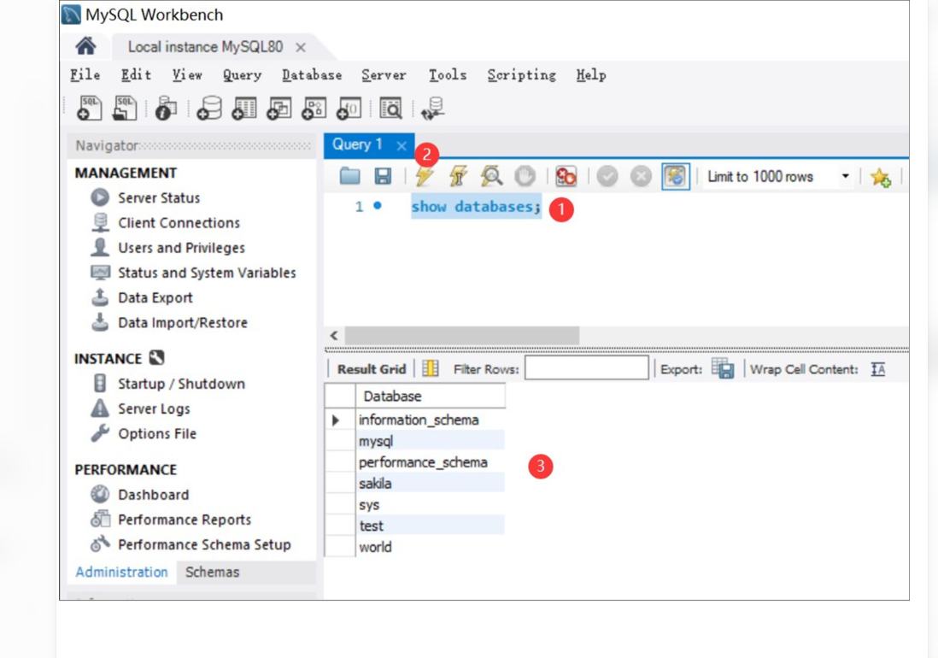
2.Create a new database called InstaClone in MySQL Workbench, then create a table named Users with columns: user_id (INT, primary key), username (VARCHAR), email (VARCHAR), and followers_count (INT).

CREATE DATABASE InstaClone;

USE InstaClone;

CREATE TABLE Users (
user_id INT PRIMARY KEY,
username VARCHAR(100),
email VARCHAR(150),
followers_count INT
);

SHOW TABLES;

DESCRIBE Users;
3.Insert 3 sample users into the Users table you created, using realistic Instagram-style usernames and follower counts.

USE InstaClone;

INSERT INTO Users (user_id, username, email, followers_count)
VALUES
(1, 'fashion_diaries', 'fashion@gmail.com', 12500),
(2, 'travel_with_riya', 'riya@gmail.com', 8500),
(3, 'tech_world_2026', 'techworld@gmail.com', 3200);

SELECT * FROM Users;
4.Create another table in the InstaClone database called Posts with columns: post_id (INT, primary key), user_id (INT), caption (VARCHAR), and post_date (DATE). Add a foreign key from Posts.user_id to Users.user_id to establish a relationship.

USE InstaClone;

CREATE TABLE Posts (
post_id INT PRIMARY KEY,
user_id INT,
caption VARCHAR(255),
post_date DATE,
FOREIGN KEY (user_id) REFERENCES Users(user_id)
);

DESCRIBE Posts;

5.Write a short comparison (3-4 lines each) of MySQL, PostgreSQL, Oracle, and SQLite, focusing on where each one is commonly used (for example: web apps, mobile apps, enterprise systems, etc.).
1. MySQL
- MySQL is commonly used in web applications and websites.
- It is used in platforms like WordPress and many e-commerce websites.
- It is popular because it is easy to learn and reliable.
- It is suitable for storing and managing website data.
2. PostgreSQL
- PostgreSQL is used in web applications and data-intensive systems.
- It supports advanced queries and complex data operations.
- It is suitable for applications requiring data accuracy and reliability.
- It is commonly used in analytics and business applications.
3. Oracle Database
- Oracle is commonly used in large enterprise systems.
- It is used by banks, insurance companies, and large organizations.
- It provides advanced security and high-performance database management.
- It is suitable for managing large amounts of critical business data.
4. SQLite
- SQLite is commonly used in mobile applications and desktop software.
- It stores data directly in a local file without requiring a separate database server.
- It is widely used in Android apps and embedded systems.
- It is suitable for small applications and offline data storage.

