EcoGro (Hip trendy name)

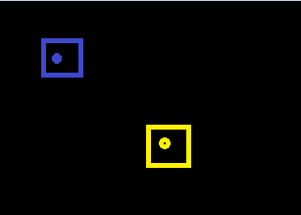
The premise of the simulation is there are three (?) Resources, Food, Materials and gold. At the start of the simulation there will be two (nodes/person) , A Farmer and a Crafter. Each will start with 50 gold (?). There will also be a farm tile and a workshop tile.

The farmer needs material to expand his farm and food to live. The crafter needs material to expand his workshop and needs food to survive.

Now the simulation has been initialized the prices are set and the (nodes/person) begin to work on their stations. Each will make 1 resource per tick and each will consume 0.5 food per tick

The economy is based on supply and demand, for example if there is more food then it becomes cheaper, allowing more craftsmen to flourish, and if there is less food it encourages growth.

