Vulnhub Writeup – CEng

Intro

CEng is a Vulnhub boot2root box, with 2 goals:
1 – Find the user flag
2 – Find the root flag

For this box, I used the following methodology and tools:
- Reconnaissance
  - Nmap
  - Dirb

- Exploitation
  - SQLmap
  - File Upload
  - PHP Reverse Shell
  - NetCat

- Privilege Escalation
  - Pspy
  - Python Reverse Shell
  - Meterpreter Session

Walkthrough

Reconnaissance

I knew that because I set my DHCP pool to only give out 1 IP address, I knew where to find the machine (192.168.56.101). So it was straight to Nmap to get as much juicy info as possible on the machine:

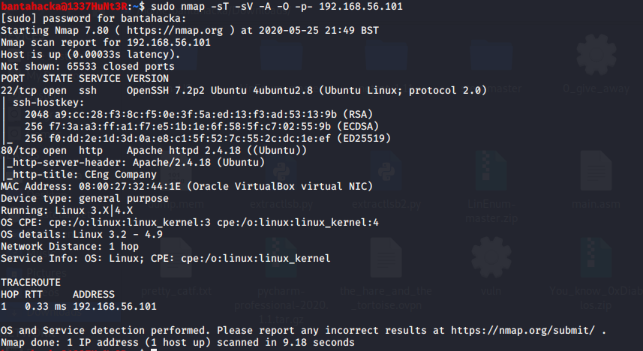

I saw it was running Apache 2.4.18 on port 80, so I took a look at the website. After having a look through the source and testing the subscribe form, I found absolutely nothing. I also used OWASP ZAP to spider the site and see if anything jumped out in the headers, again drawing a blank. Therefore I turned to Dirb in order to see if there was anything else.
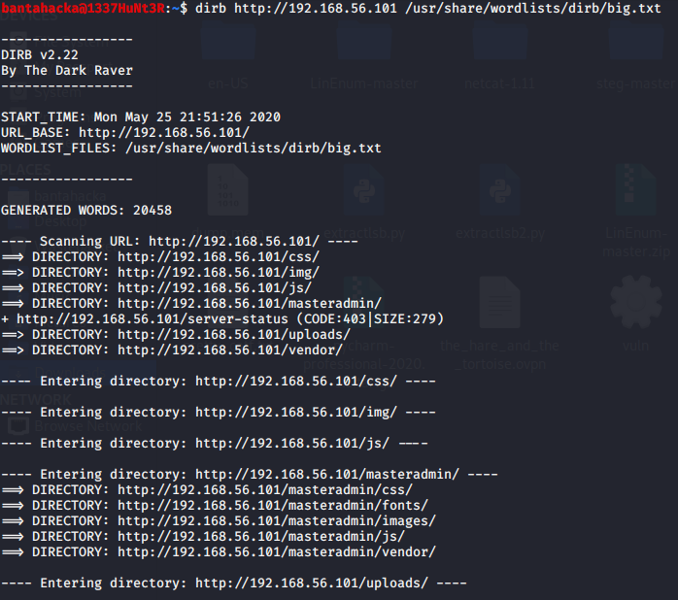

A couple of interesting directories turned up: /uploads and /masteradmin. Navigating to /masteradmin gave me a 403 error, so I decided to enumerate the /masteradmin directory by using Dirb with the -X switch to look for any php files.
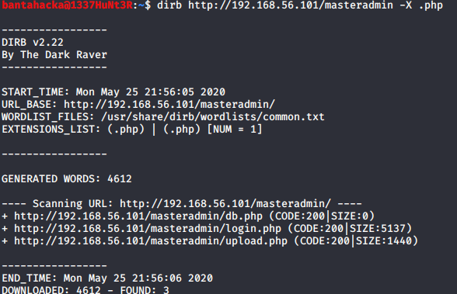
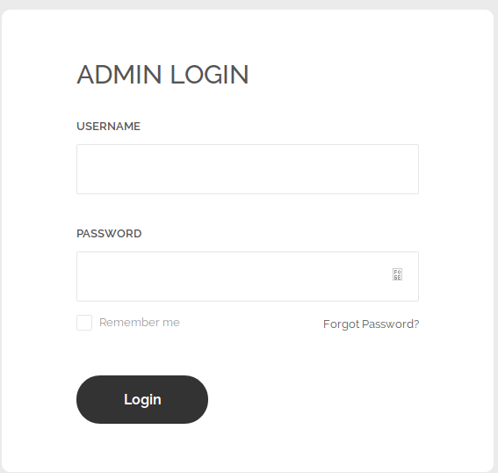

3 files pop up, and two of these caught my eye: login.php and db.php, suggesting some sort of login form and database interaction was going on here. Login.php presented the following form:

The “Forgot Password” button did nothing, so instead it was straight to SQLmap and see if I could access any databases!

Exploitation

As I didn't know what database version was being used, and no variables were displayed in the URL bar, I decided to run SQLmap with the URL of the login page as the URL parameter, --forms and --dbs. From this, I managed to retrieve a number of databases, one of those being cengbox.

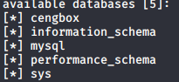
It was time to enumerate the cengbox database further to see what information could be extracted from there.

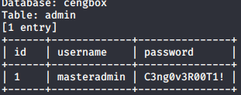
An admin table with a username and password appeared, time to test those credentials in the login page I found.
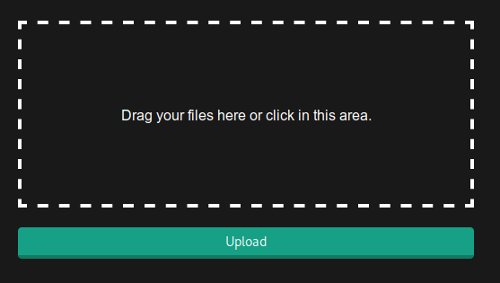
Those credentials brought me to this file uploader, so I tried uploading a simple text file called test.txt to see what would happen. This produced an error: “extension not allowed, please choose a CENG file”. So I changed the extension of the text file to .ceng, and hey presto – it uploaded! Remember that /uploads directory I found earlier? I guessed the file had been uploaded to that directory, so I navigated to 192.168.56.101/uploads/test.ceng and it displayed the contents of the text file.
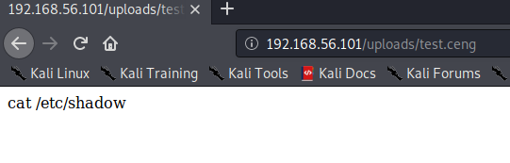

So next thing I tried was uploading a reverse shell written in PHP from pentestmonkey (https://github.com/pentestmonkey/php-reverse-shell), remembering to change the file so that it pointed to my machine and to change the file extension to .ceng. I also started a listener on my machine using Netcat and then navigated to the reverse shell script:

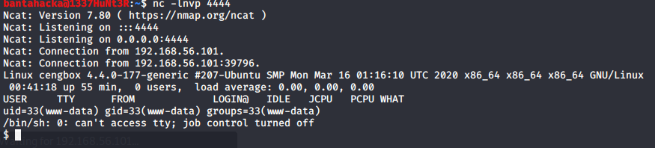
That's what I wanted to see! I now have a shell on the box as user www-data, and got into a bash shell using python3 -c 'import pty;pty.spawn(“/bin/bash”)'. The terminal was now echoing every character that I typed. To sort this, I typed stty raw -echostty. After this I navigated to the /home directory and found a user: cengover. Using su and the password found in the database earlier, I manged to jump to cengover and get the user flag from their home directory.
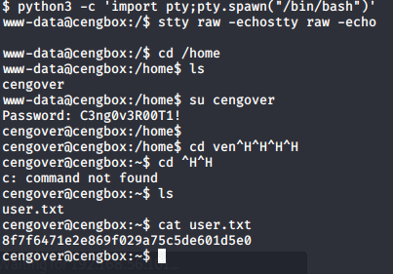
Privilege Escalation

Now time to try and get root! After a bit more poking around the box, I couldn't find anything else of interest. I tried LinEnum, but this didn't show anything out of the ordinary. So I decided to get pspy64s onto the machine and see if any hidden processes were running:

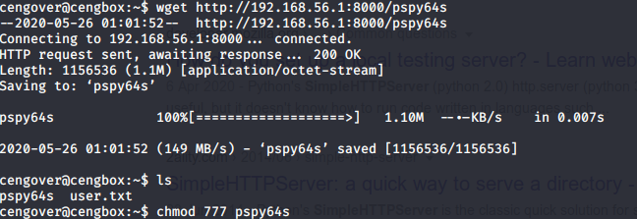
One job caught my eye:
I found a cron job that ran a python script called md5check.py under the opt directory. This cron job was being ran as root once every minute, so decided to see if I could use this to my advantage. The file itself can be written to, so this meant I could potentially drop in a reverse python shell. In a separate terminal window, I fired up metasploit and, using the multi/script/web_delivery exploit, I was able to generate a payload that calls back to my machine and spins up a meterpreter shell.

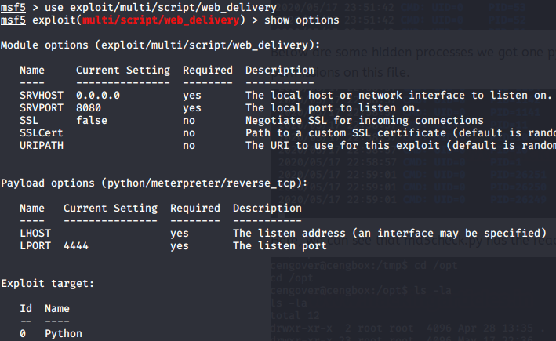
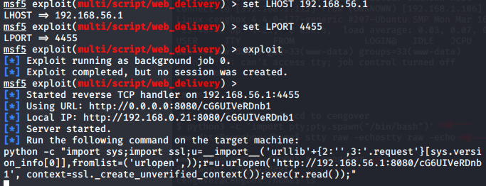
I put this script into the md5check.py file:

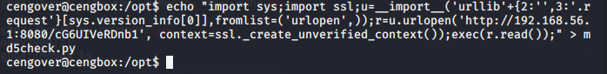
After waiting for the cron job to run, I gained a meterpreter session:

And just like that, I was able to output the home directory for root and get the root flag.

