# Query and Output:

Patient(patient_id, patient_first_name,patient_last_name,patient_age,doctor_id) Doctor(doctor_id,doctor_name)

# Cross join

select patient_id, first_name, last_name, age, patient.doctor_id from patient cross join doctor

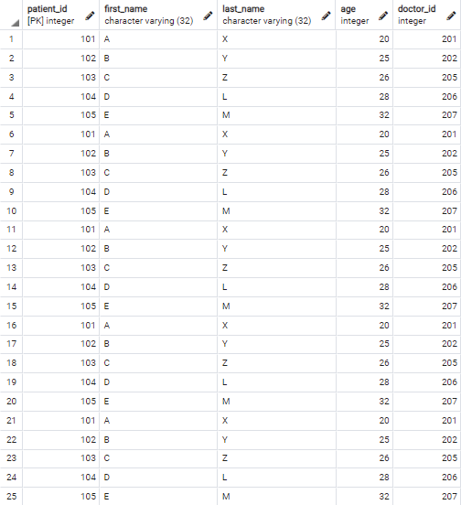

# Inner join

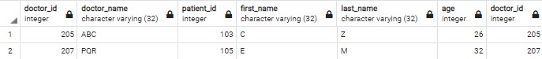select * from doctor inner join patient on doctor.doctor_id= patient.doctor_id

# Left Outer Join

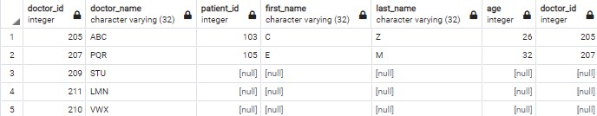select * from doctor left outer join patient on doctor.doctor_id=patient.doctor_id

# Right Outer Join

select * from doctor right outer join patient on doctor.doctor_id=patient.doctor_id

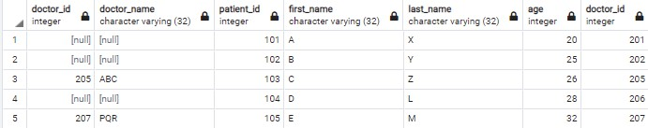

# Full Outer Join

select * from doctor full outer join patient on doctor.doctor_id=patient.doctor_id

