1. Define function to return no of doctors in the doctor table create function alldoctors()

returns int

as $$ begin

return (select count(distinct doctor_id) from Doctors); end;

$$

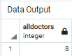language plpgsql; select alldoctors(); Output:

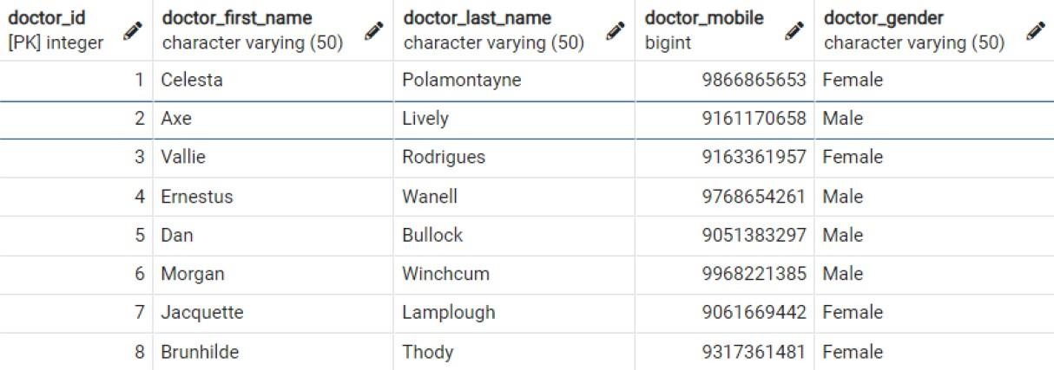

create or replace function updaterecord(new_doctor_id int, new_doctor_mobile bigint)

returns void as $$

begin

update Doctors

set doctor_mobile = new_doctor_mobile where doctor_id = new_doctor_id;

end;

$$ language plpgsql;

select updaterecord(4, 9834562619);

Output:

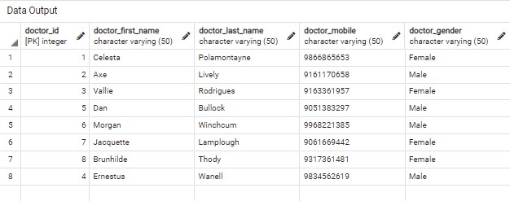

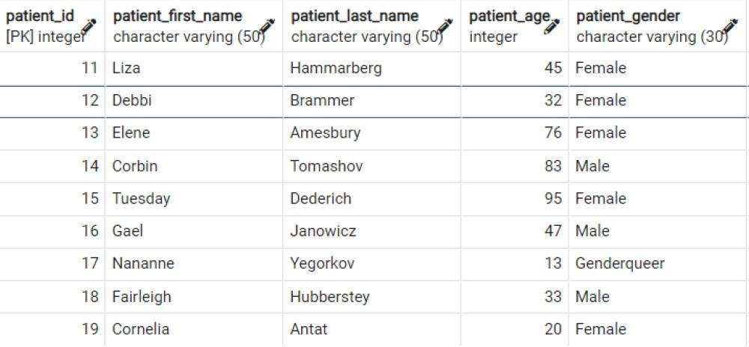

create procedure del_patient() as $$

begin

delete from Patients where patient_age>90; end;

$$

language plpgsql;

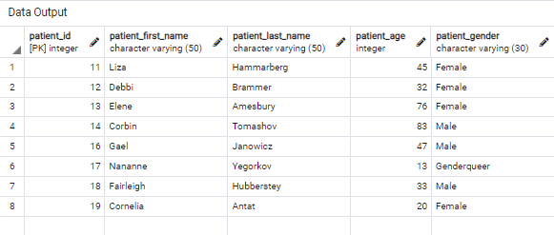call del_patient(); Output:

persons

create procedure patient_proc(new_first_name varchar, new_last_name varchar)

as $$ begin

update Patients set patient_last_name = new_last_name where patient_first_name = new_first_name;

end;

$$

language plpgsql;

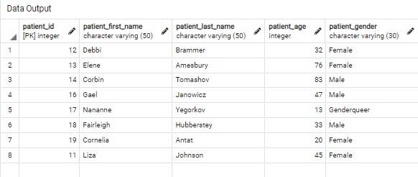call patient_proc('Liza', 'Johnson') Output: