**Django**

1. What is Django
   * Django is a high-level Python full-stack web framework that encourages rapid development and clean, pragmatic design.
   * Django follows the model–template–views (MVT) architectural pattern.
     + **Models**: Represent data structures and interact with the database.
     + **Views**: Handle user requests and determine how to respond.
     + **Templates**: Define the presentation layer (HTML) of the application.
2. Django Project vs Application
   * Project
     + A Django project acts as the top-level directory that houses your entire web application. It includes configurations, and settings.
     + A project can contain multiple apps.
   * Application
     + A Django app is a self-contained module designed to accomplish a specific task within the overall project.
3. Installing django
   * To create a Django project, first, you need to install Django on your operating system.
   * **pip install Django**
   * After installation check django on your system. **django-admin --version**
4. Create django project
   * Once you have installed Django on your operating system, now you can create a project.
   * Commmad:- **django-admin startproject project_name**
   * Navigate to the project directory and start the development server for test - '**python** **manage.py runserver'**.
5. Create an Application
   * Django, it’s a common practice to create a new app for each distinct feature or functionality you want to add to your project.
   * Creating separate apps for each feature helps to keep your code organized and modular.
   * It allows you to reuse apps across different projects, and it makes it easier to maintain and scale your code as your project grows.
   * Command - **python manage.py startapp app_name**
   * Register the app with our Django project by updating **INSTALLED_APPS** tuple in the **settings.py**.
   * 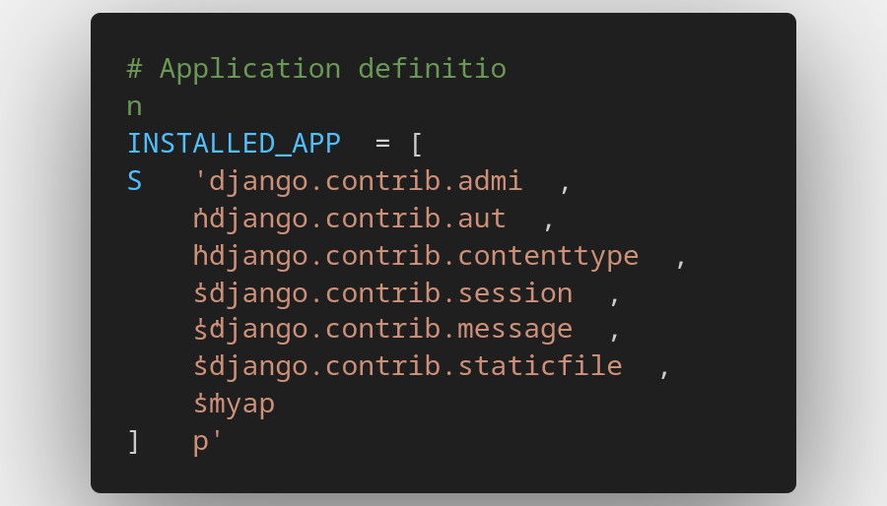
6. Creating Views
   * Django views are Python functions that takes http requests and returns http response
   * 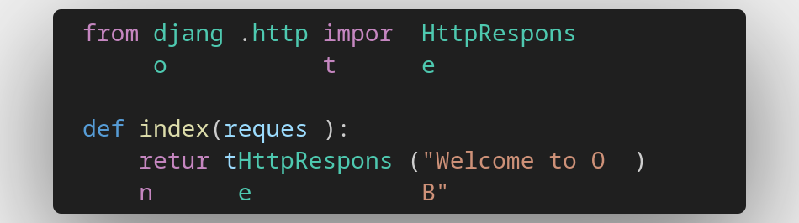
7. URL Mapping in the application
   * To call the view, we need to map it to a URL - and for this we need a URL configuration.
   * To create a URL configuration in the app directory, create a file called **urls.py**.
   * 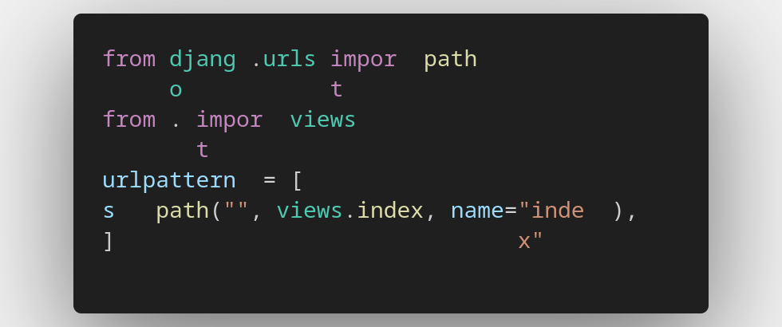The next include your app **urls** in the **root** URL configuration.

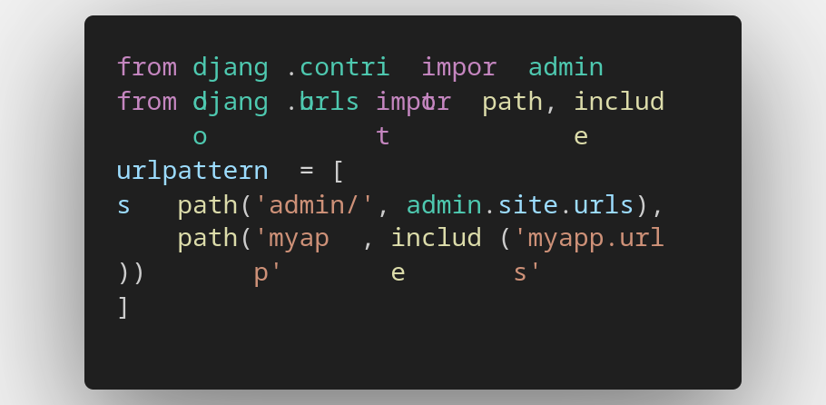

1. Template System
   * In Django, a template is a text document or a Python string marked-up using the Django template language (DTL).
   * It’s used to generate dynamic HTML content.
   * Django’s template engine offers a mini-language to define the user-facing layer of the application.
2. sd