Dear Ma'am/Sir,

Good day Ma'am/Sir, I'm 2/C SEBASTIAN, KIM ELVIN . of Baliwag Maritime Academy Personally informing the shipboard training office that I have already my embarkation order and this is August 22, 2021 and I am going to onboard the M/V LCT GT Express under GT Express Shipping lines. This vessel is a Roro/Passenger Domestic Trade Only. I will do my everything in my best of my ability to do the responsibility of a Engine Cadet for 1 Year in that particular vessel. Thank you for assisting me together with my Co-2nd class to pursue our studies and passion.

Sincerely yours:

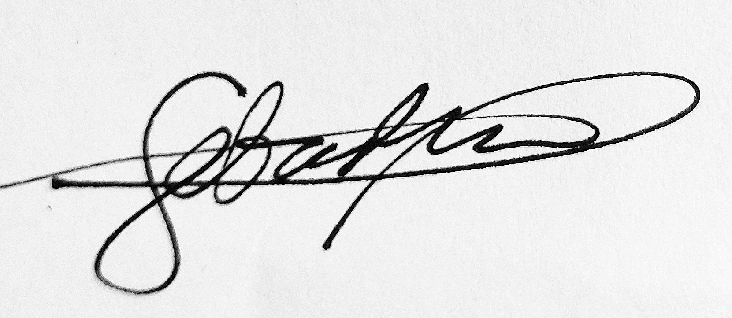

SEBASTIAN, KIM ELVIN H.

Personal letter to OBT