Expense Tracker using XML, Java, and JSP

Aim
The aim of this project is to develop a web-based expense tracker application using Java, JSP, and XML to help users record, organize, and monitor their daily expenses and income in an efficient manner. The system is designed to provide a simple platform for maintaining financial records digitally.

Objective
The main objectives of this project are:
- To design and develop an expense tracker using Java as the programming language.
- To create a dynamic and interactive user interface using JSP (Java Server Pages).
- To use XML for configuration and structured data representation in the application.
- To allow users to add, edit, delete, and view expense records easily.
- To categorize income and expenses for better financial tracking.
- To maintain proper records of transactions for future reference.
- To understand the implementation of Java-based web applications using JSP and XML.

Concepts
This expense tracker application is developed using Java, JSP, and XML, where each technology plays an important role in the system.
Java is used as the core programming language for implementing the business logic of the application. It handles the processing of expense data, validation, calculations, and transaction management. Java provides platform independence, reliability, and object-oriented features, making it suitable for web application development.
JSP (Java Server Pages) is used to create the frontend of the application. It allows dynamic web page generation by combining HTML with Java code. JSP pages are used to design forms for entering expense details, displaying transaction lists, and showing summaries to the user.
XML (eXtensible Markup Language) is used for storing configuration details and structuring application data. In Java web applications, XML files such as web.xml are commonly used for deployment configuration, servlet mapping, and application settings. XML can also be used for representing expense data in a structured format.
In this application, users can enter details such as expense amount, category, date, type, and description. The data is processed by Java classes and displayed through JSP pages. XML helps in organizing application settings and improving maintainability.
The system can be extended with additional features such as monthly reports, expense filtering, login authentication, and category-based summaries. This project is useful for understanding the fundamentals of Java web development and the interaction between Java backend logic, JSP presentation, and XML configuration.
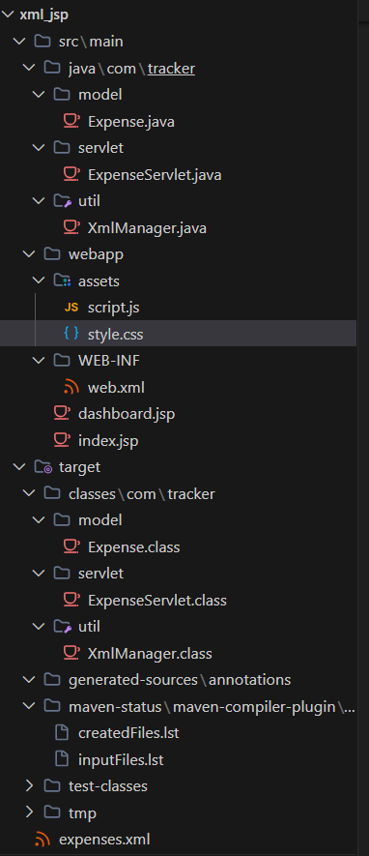
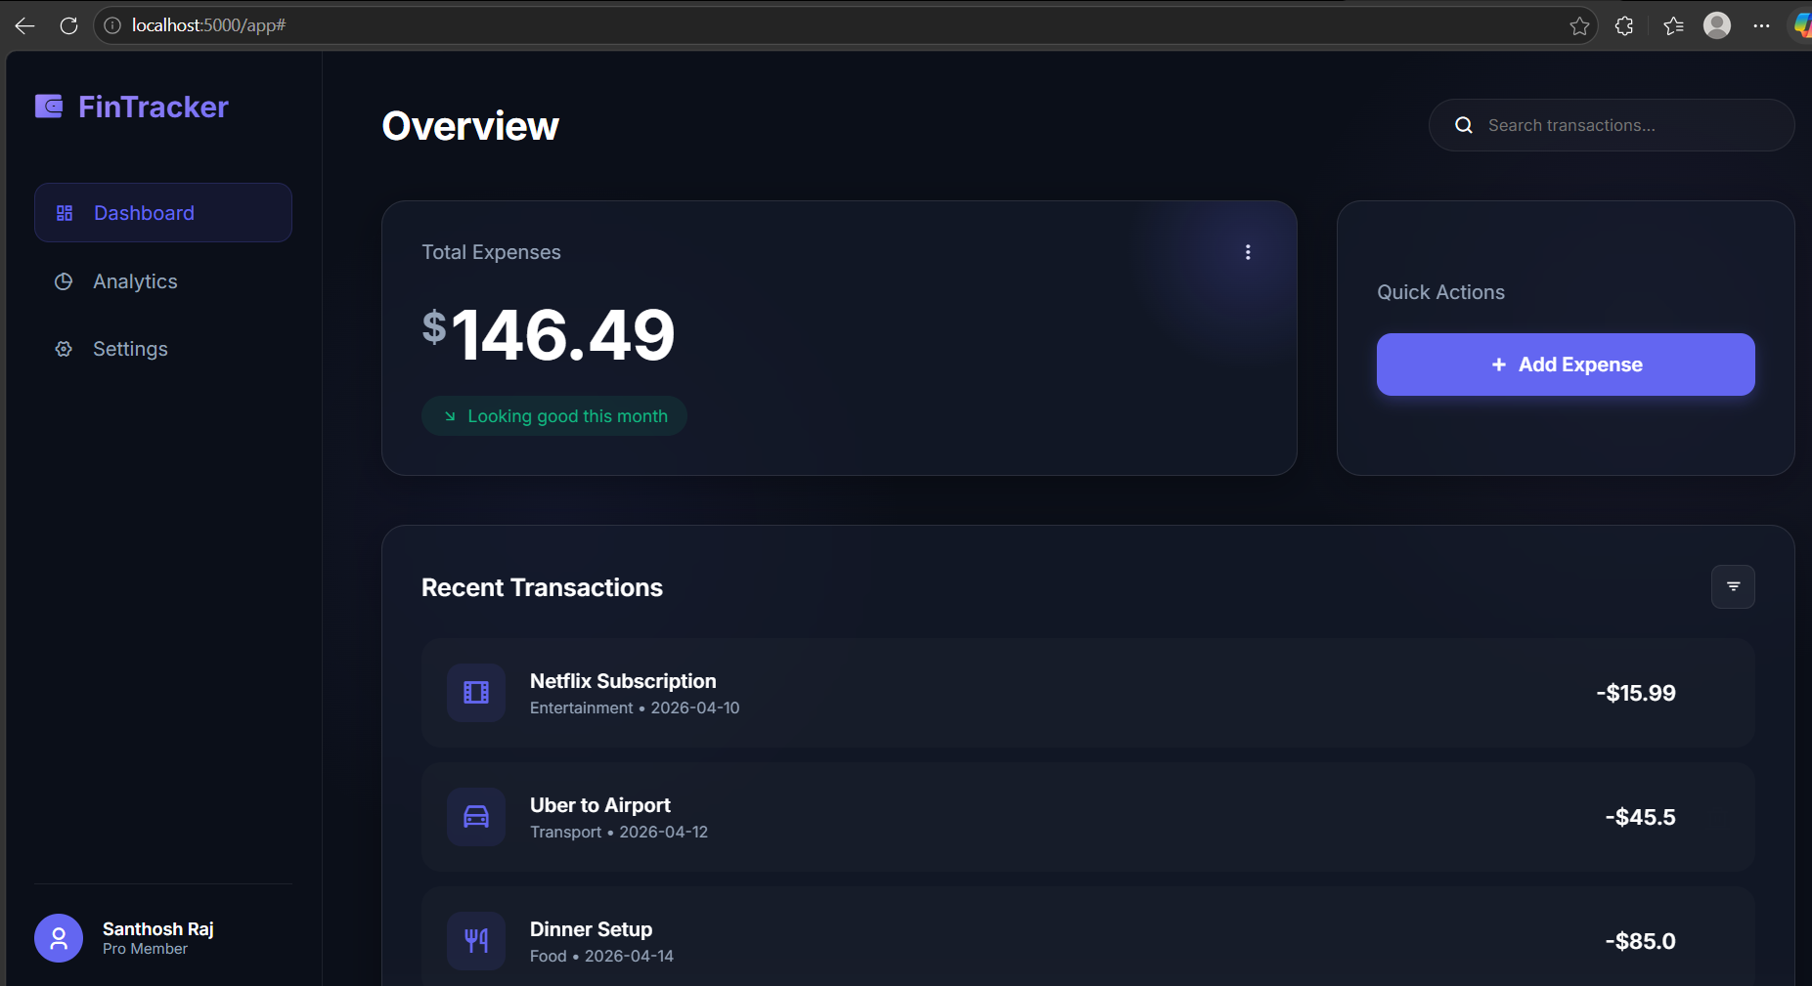
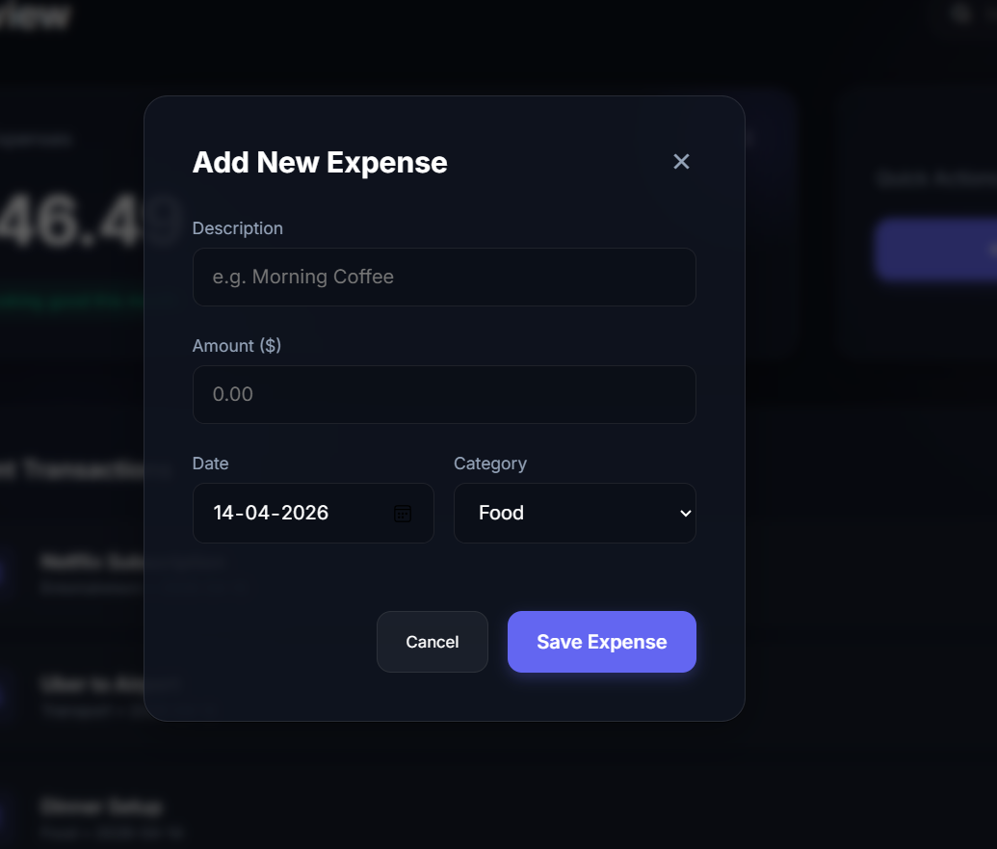
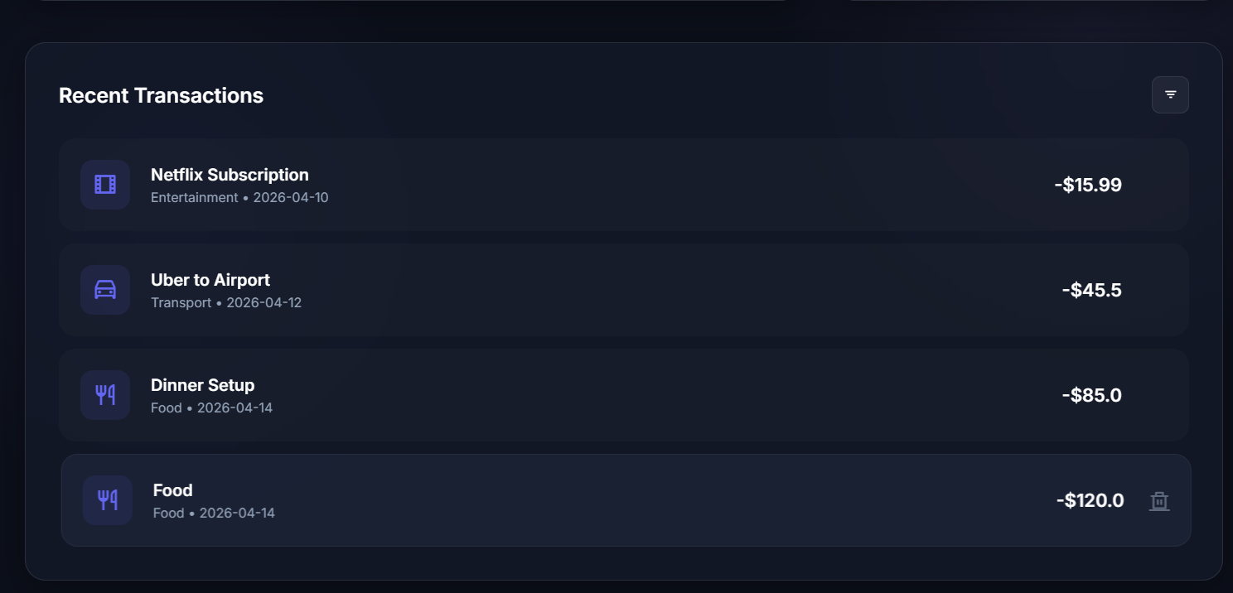

Conclusion
The Expense Tracker using XML, Java, and JSP is a simple and practical project for learning Java web application development. It helps in understanding server-side programming, dynamic web page creation, and configuration management. The project is useful for personal expense management and provides a strong foundation for advanced enterprise application development.

