RISC-V SoC Simulation Results
Simulation waveforms collected during verification of the RISC-V SoC project.

CPU Arithmetic
Figure: CPU Arithmetic waveform verification.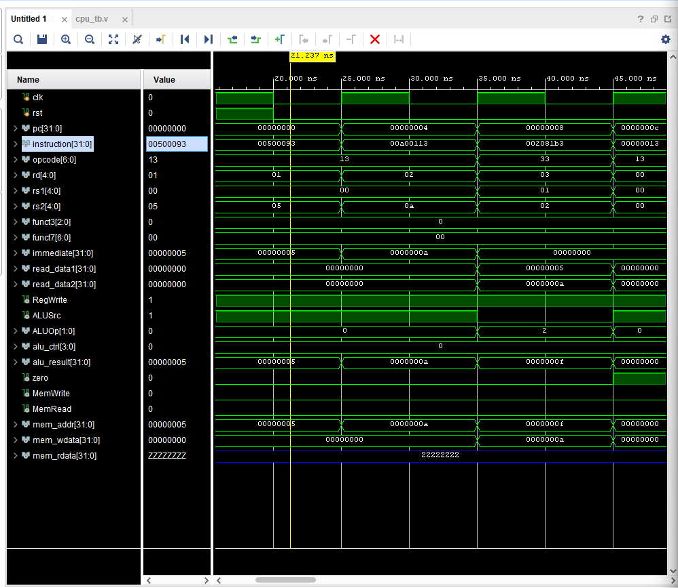

CPU + SoC Integration
Figure: CPU + SoC Integration waveform verification.
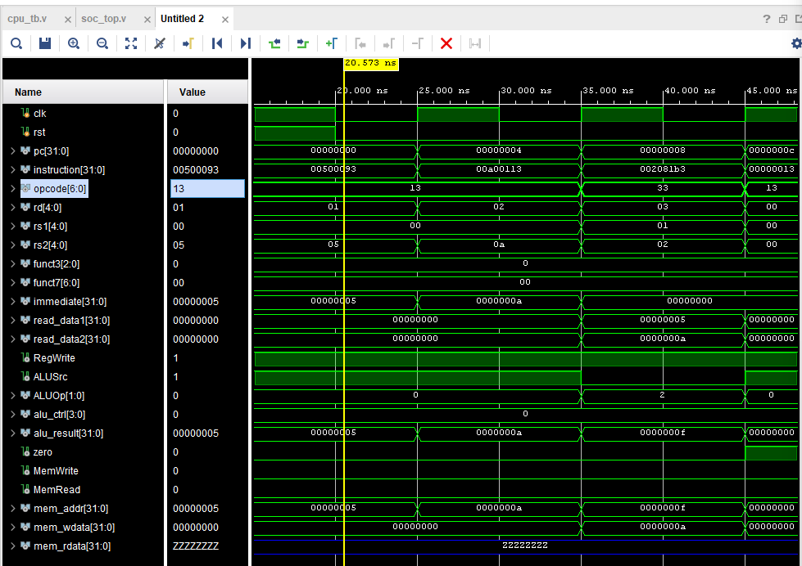

LW Instruction
Figure: LW Instruction waveform verification.
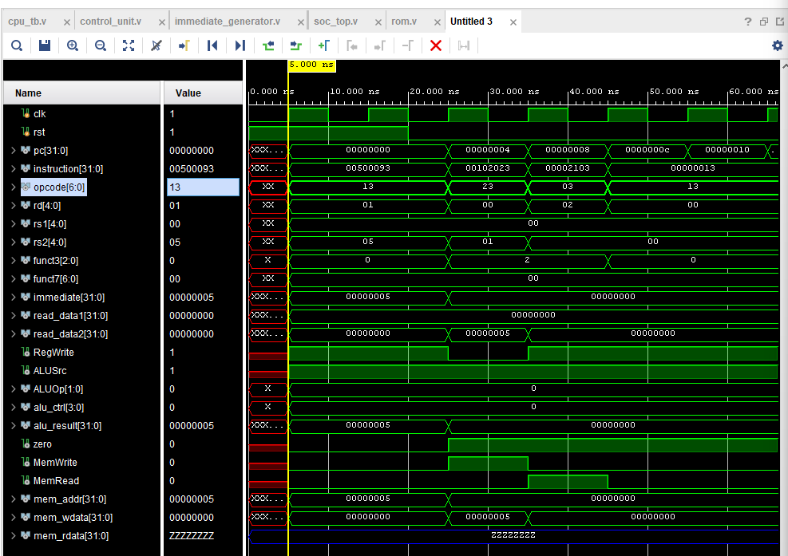

SW Instruction
Figure: SW Instruction waveform verification.
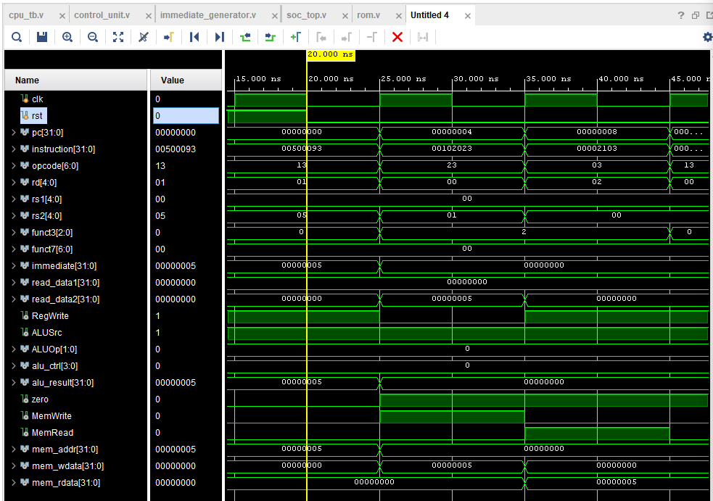

BEQ Instruction
Figure: BEQ Instruction waveform verification.
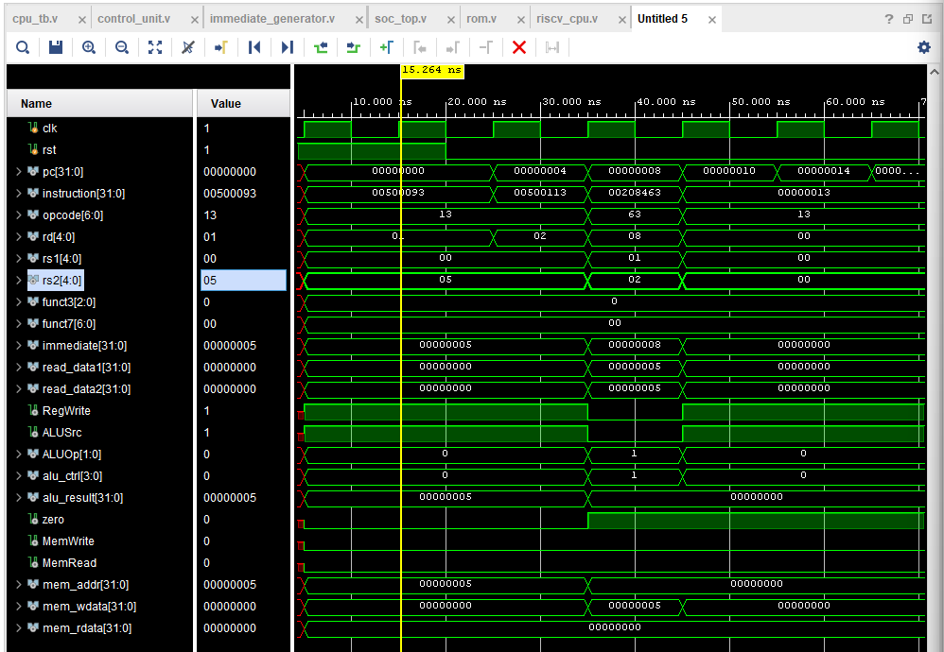

JAL Instruction
Figure: JAL Instruction waveform verification.
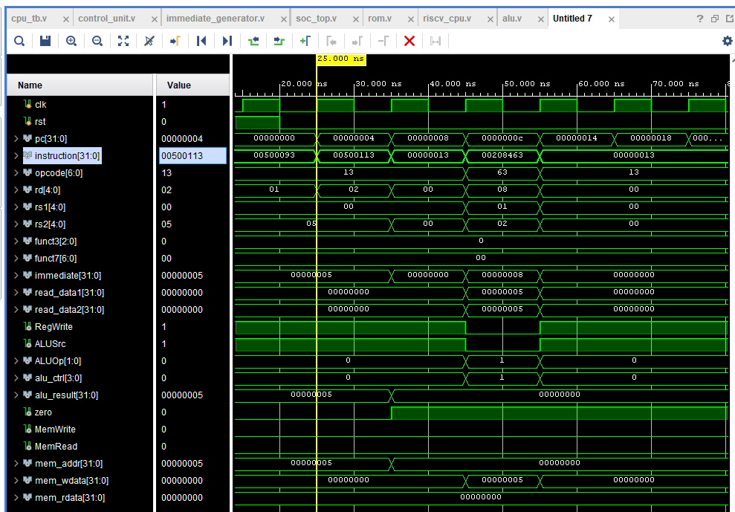

JALR Instruction
Figure: JALR Instruction waveform verification.
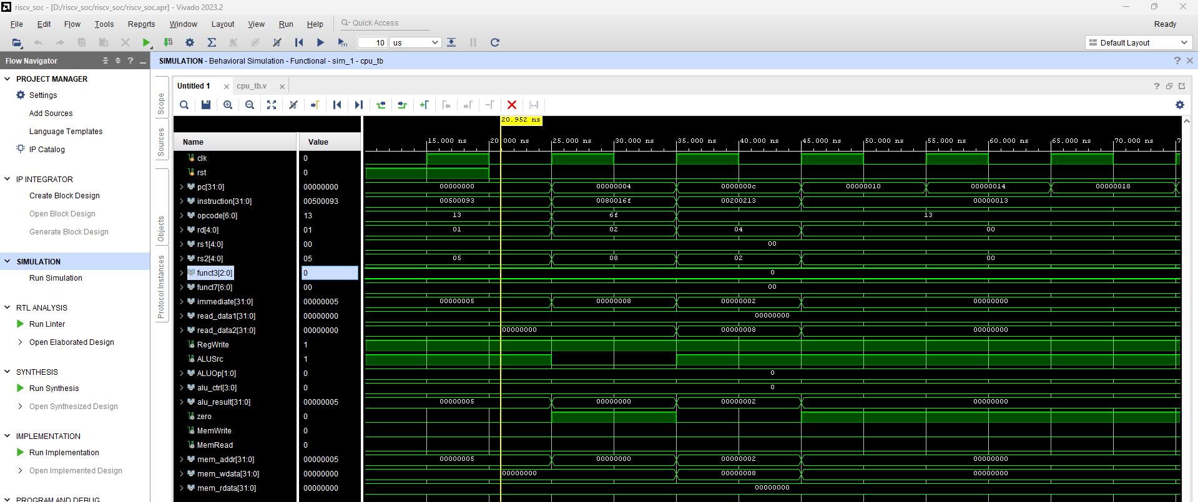

Jump Debug
Figure: Jump Debug waveform verification.
