<https://github.com/banuAndrei99/FLCD>

# **Finite Automaton**## **__print_states()** Prints the states of the automaton.  
 - pre: states are present in input json  
 - post: None  
  
## **__print_alphabet()** Prints the alphabet of the automaton.  
 - pre: alphabet is present in input json  
 - post: None  
  
## **__print_final_states()** Prints the final states of the automaton.  
 - pre: final states are present in input json  
 - post: None  
  
## **__print_transitions()** Prints the transitions of the automaton.  
 - pre: states are transitions in input json  
 - post: None  
  
## **check(sequence, current_state)** Checks if <sequence> can be obtained starting from <current_state>.  
 - pre: None  
 - post: None  
  
## **check_wrapper(sequence)** Initializes the parameters needed for check() method and print a message based on the result.  
 - pre: None  
 - post: None  
  
## **Example:**```  
1. Print states  
2. Print alphabet  
3. Print final states  
4. Print transition dictionary  
5. Check sequence  
6. Close  
  
>>> 5  
  
Enter a sequence: 110  
everything OK  
```

For a DFA that checks if a sequence is a valid identifier

identifier ::= letter | letter{letter}{digit}  
  
letter ::= "A" | "B" | ... | "Z" | "a" | "b" | ... | "z" |  
  
digit ::= "0" | "1" |...| "9"

BNF

FA::= states, alphabet, initial_states, transitions, final_states

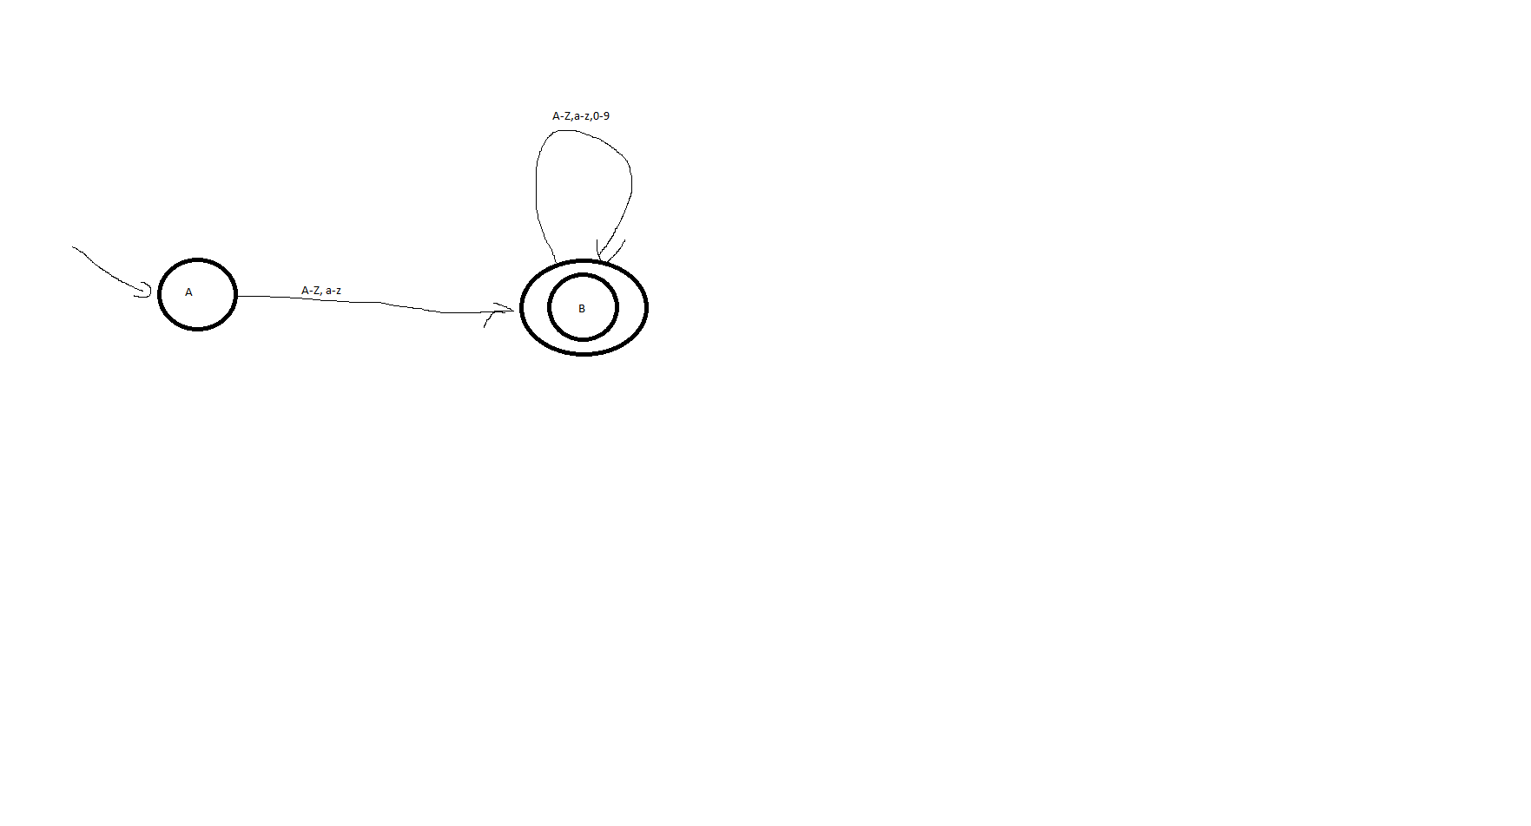

State = A | B

States::= State{State}

Alphabet::= A-Z, a-z, 0-9

Final_states::= B

Transitions::= {State, “:”, Alphabet, B}