https://github.com/banuAndrei99/FLCD

# Lexical Analyzer  
## __set_program(program: string)  
 Reads the text content of the program and formats it.  
 - pre: program should be a valid path  
 - post: attribute __program_text is set  
  
## get_pif()  
 Returns the pif  
 - pre: None  
 - post: None  
  
## get_st()  
 Returns the SymbolTable object  
 - pre: None  
 - post None  
  
## get_ct()  
 Returns the ConstantsTable object  
 - pre: None  
 - post: None  
  
## analyze():  
 Analyzes the program, filling up the ST, CT and PIF.  
 - pre: __set_program() was called  
 - post: PIF, ST and CT contain the data from the program  
  
### __detect_atom(start_index: 0):  
 Returns the next atom and its end index. The search begins from `start_index`  
 - pre: __set_program() was called  
 - post: None  
  
### __place(atom: str, pos: int):  
 Places the atom in st or ct if needed and adds a new entry in pif.  
 Raises error in case syntax issues  
 - pre: None  
 - post: adds a new entry to __pif. Can also add new entries to __symbol_table and __constant_table.  
  
#### __is_identifier(var: string):  
 Checks if var is a valid identifier.  
 - pre: None  
 - post: None  
  
#### __is_constant(var: string):  
 Checks if var is a valid constant.  
 - pre: None  
 - post: None  
  
#### __gen_pif(code: str, pos: int | tuple):  
 Adds a new entry in pif.  
 - pre: None  
 - post: pif is modified or error is raised.  
## Input example:  
```python  
main{  
 int a = 36, b = 30, gcd;  
 while(b != 0){  
 gcd = a % b;  
 a = b;  
 b = gcd;  
 }  
 gcd = a;  
 out(gcd);  
}  
```  
## Output:  
ANALYZING p2  
Symbol Table:  
0 --> []  
1 --> [gcd,]  
2 --> []  
3 --> [a,b,]  
4 --> []  
5 --> []  
6 --> []  
Constant Table:  
0 --> []  
1 --> []  
2 --> []  
3 --> []  
4 --> [36,0,]  
5 --> [30,]  
6 --> []  
PIF:  
main | 0  
{ | 4  
int | 5  
ID | (3, 0)  
= | 11  
CONST | (4, 0)  
, | 15  
ID | (3, 1)  
= | 19  
CONST | (5, 0)  
, | 23  
ID | (1, 0)  
; | 28  
while | 29  
( | 34  
ID | (3, 1)  
!= | 37  
CONST | (4, 1)  
) | 41  
{ | 42  
ID | (1, 0)  
= | 47  
ID | (3, 0)  
% | 51  
ID | (3, 1)  
; | 54  
ID | (3, 0)  
= | 57  
ID | (3, 1)  
; | 60  
ID | (3, 1)  
= | 63  
ID | (1, 0)  
; | 68  
} | 69  
ID | (1, 0)  
= | 74  
ID | (3, 0)  
; | 77  
out | 78  
( | 81  
ID | (1, 0)  
) | 85  
; | 86  
} | 87  
VERDICT: LEXICALLY CORRECT  
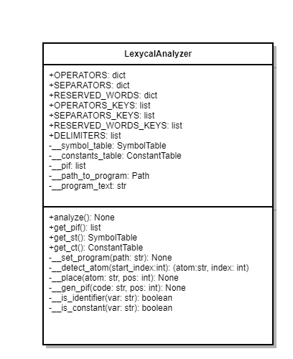

More examples can be found on github.