Daniel Banuelos

4/6/20

CPSC 362-03

Professor Velasco

# Assignment 3

**Design your solution using established design techniques in class**

Solution Design: For the UI: There will be a home screen which prompts the user to sign in or log-in. Once logged in, the user will have access to their account information, order history and their favorite items. The user can of course order a new food or drink with the help of search categories. For the database: The information per person will be stored via a key, which is the user’s email. The email is how we will determine uniqueness. The information will not reset after every log in, so we will need possible cloud storage to assist in holding large amounts of data. For the search capability: we will utilize yelp’s API to allow to search various restaurants and have information of the menus they have. Using the data flow architecture, we can break it down into several interactions between the objects at work. Using behavioral-design I can elaborate on what is required from each interaction and create object-based functionality. By reviewing the architecture, I created in assignment 2, I marked all of the relationships we need to look at. 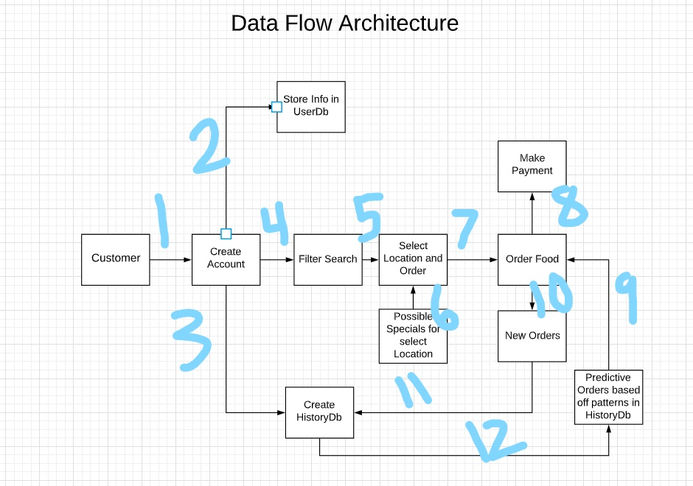

There are 12 different data interactions that are happening with this architecture. Using a chain of responsibility, we go through the flow and end at the relation where the request can be served.

**Cite the techniques and patterns used to perform your design**

I will use a behavioral-based design pattern to create a solution to building my app. I chose a behavioral based design because as stated in the notes, they address problems associated with the assignment of responsibility between objects and the manner in which communication is affected between objects. This method will be useful because with the architecture I chose to work with is the data-flow architecture. With that architecture it is easy to see which objects hold responsibility with other objects. So, finding the problems and addressing them should be easy with this pattern.

## What should be turned in:

* A textual and diagram description of your design, citing your design techniques, you MUST map to establish design techniques covered in class or cite your sources of design.
* Code for your application, link in git, or a package of your code I can open and view.