Technologies & Tools
1 | FRONTEND | HTML,CSS AND JS
2 | DESIGN FRAMEWORK | BOOTSTRAP
3 | BACKEND | SPRING BOOT (with spring webflux)
4 | DATABASE | MONGODB
5 | API TESTING | SWAGGER
6 | TESTING | JUnit , Mockito
8 | Documentation | PDF with ScreenShots

Features to Include (Minimum Requirements):
- View All Employees
- ➕ Add New Employee
- ✏ Update Employee Details
- ❌ Delete Employee
- 🔎 Search or Filter Employees
- 📋 Validation (name, email, etc.)
- ✅ Unit Testing
- API Testing with Swagger
- Secure with Spring Security
- Final PDF Documentation with Screenshots
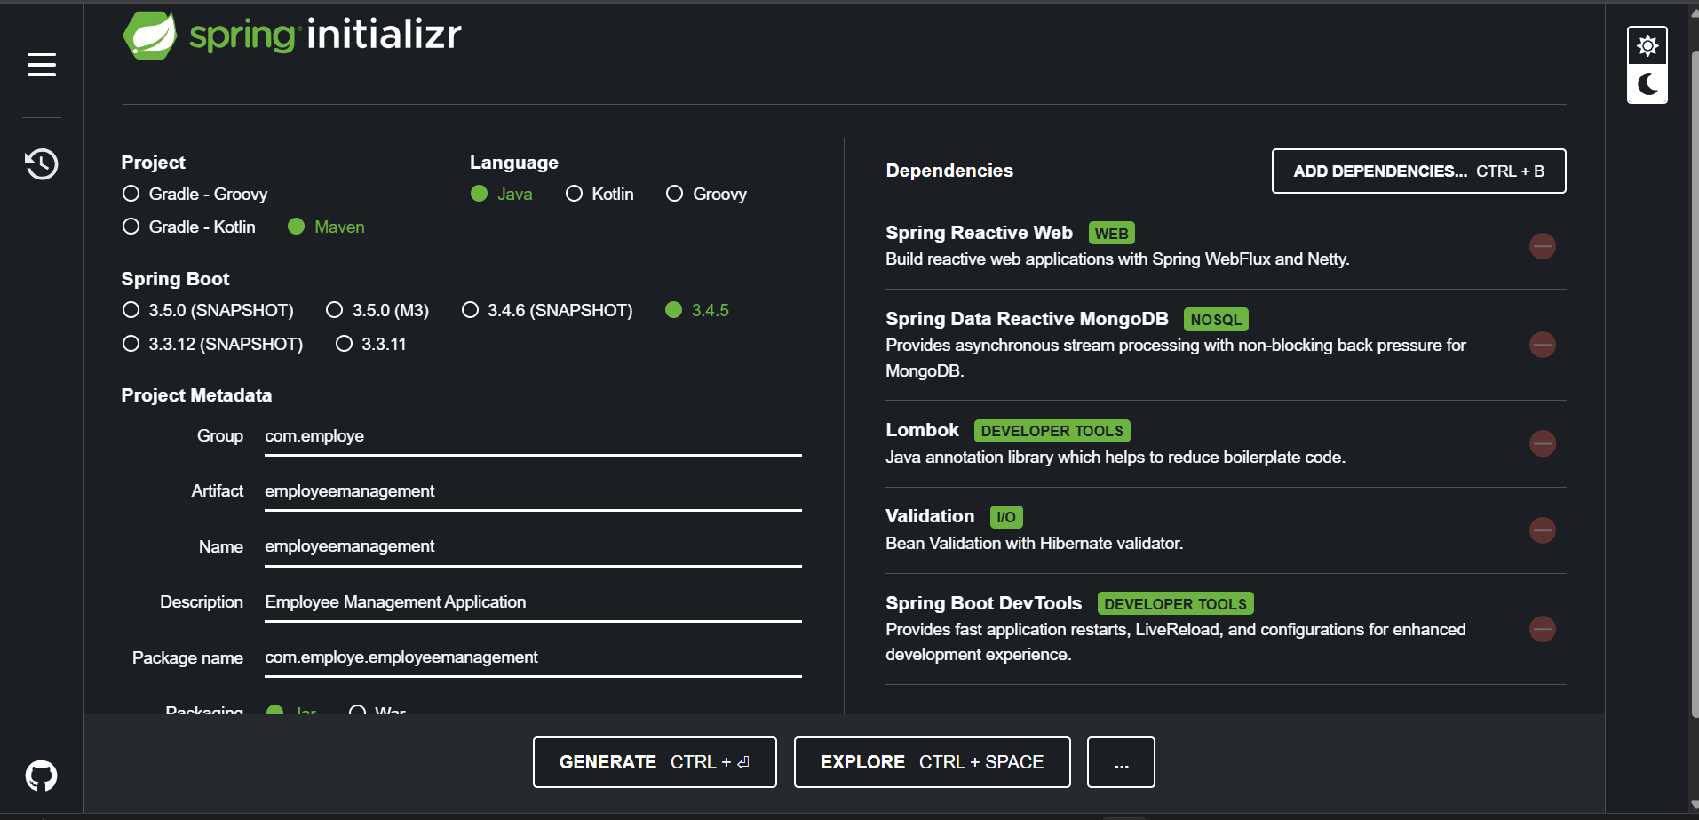

Project Setup Plan (Employee Management System – using Fetch + MongoDB)

Step 1: Spring Boot Initializer Setup
- Go to : https://start.spring.io/
- Project: Maven
- Language: Java
- Spring Boot Version: Use latest stable
- Project Metadata:
  - Group: com.employee
  - Artifact: employeemanagement
  - Name: employeemanagement
  - Package Name: com.employe.employeemanagement
- Dependencies:
  - Spring Reactive Web
  - Spring Data Reactive MongoDB
  - Lombok
  - Validation
  - Spring Boot DevTools
  - Spring Security
  - Spring Boot TestSpringdoc OpenAPI (Swagger UI)- springdoc-openapi-starter-webflux-ui

- Then click Generate, unzip, and open in your IDE (IntelliJ, VS Code, etc.)

Step 2: Create packages
- Model
- Repository
- Service
- Controller

MODEL PACKAGE :
- CLASS EMPLOYEE

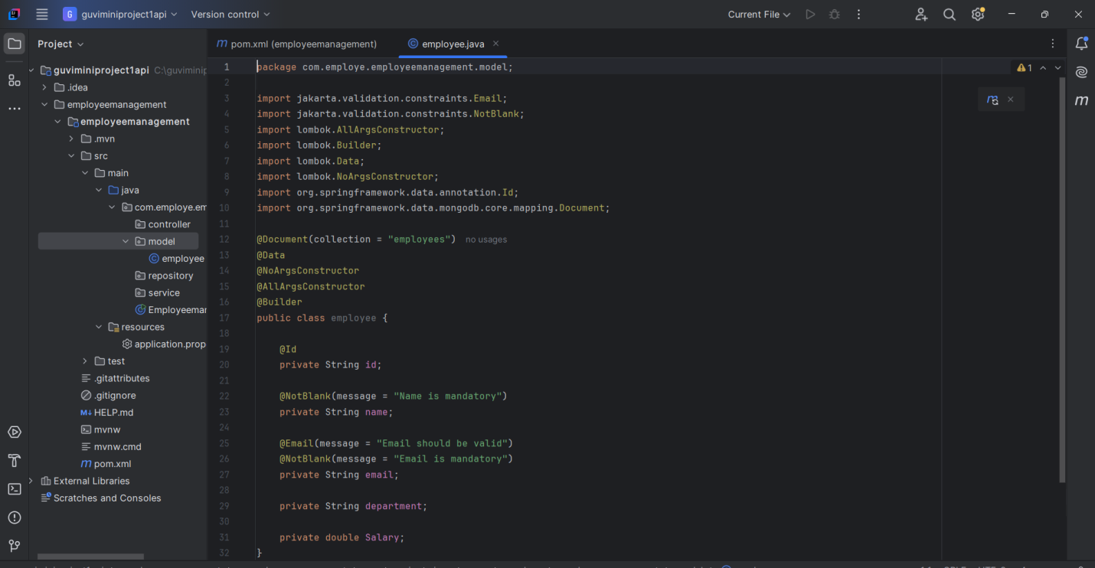
 | Annotation | Purpose
 | @Document(collection = "employees") | Tells Spring that this class maps to a MongoDB collection named employees.
 | @Data | Lombok annotation that creates all the boilerplate (getters, setters, toString(), equals(), etc.) automatically.
 | @NoArgsConstructor | Lombok creates a no-argument (default) constructor.
 | @AllArgsConstructor | Lombok creates a constructor with all fields as parameters.
 | @Builder | Helps you create objects in a clean, step-by-step way using the Builder pattern.
@NotBlank |  | Validates that the field is not null and not empty (it must contain at least one non-whitespace character). Mostly used for String fields.
@Email |  | Validates that the string provided is in a valid email format (like abc@example.com).

REPOSITORY PACKAGE :
- INTERFACE EMPLOYEEREPOSITORY

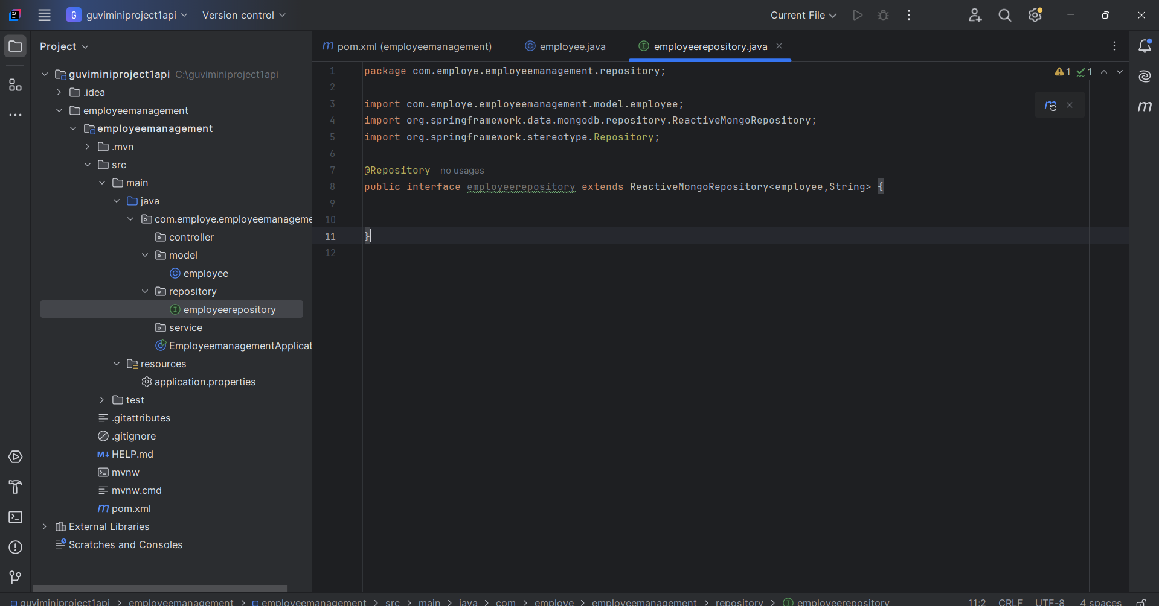

Explanation
- We extend ReactiveMongoRepository<employee, String>
  - employee → the model NAME
  - String → the Id type
- Spring Data automatically creates MongoDB queries.
SERVICE PACKAGE :
- CLASS SERVICE

We’ll use Mono and Flux from Project Reactor, since we’re using WebFlux.
This layer contains the business logic:
→ Add employee
→ Get all employees
→ Update employee
→ Delete employee
→ Get employee by ID

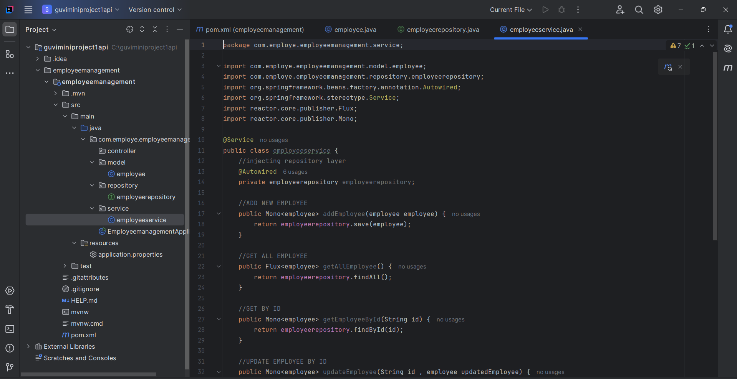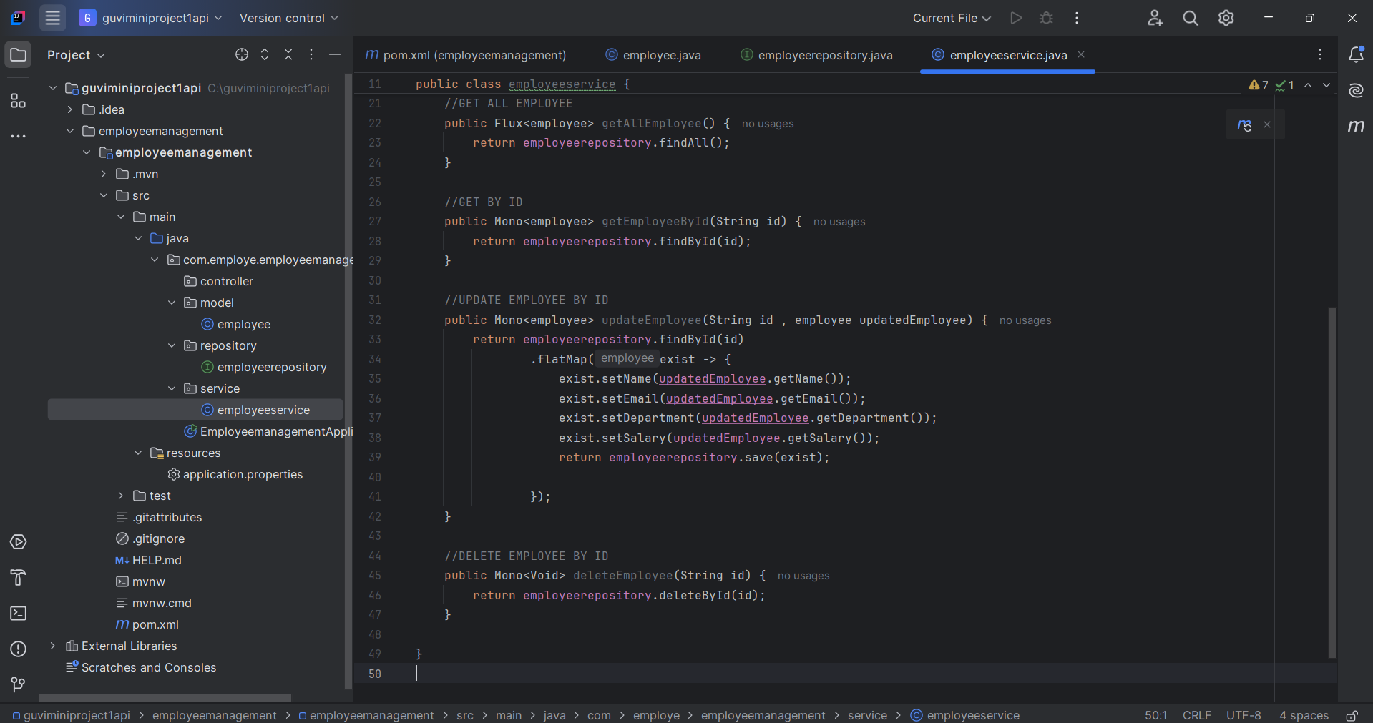

Explanation
Method | Purpose
Mono<Employee> | Mono means single value (used for single employee)
Flux<Employee> | Flux means stream of multiple values (used for list of employees)
save() | Save to MongoDB
findById() | Find one By Id
findAll() | Get all
deleteById() | Delete by Id

CONTROLLER PACKAGE :
- CLASS EMPLOYEECONTROLLER
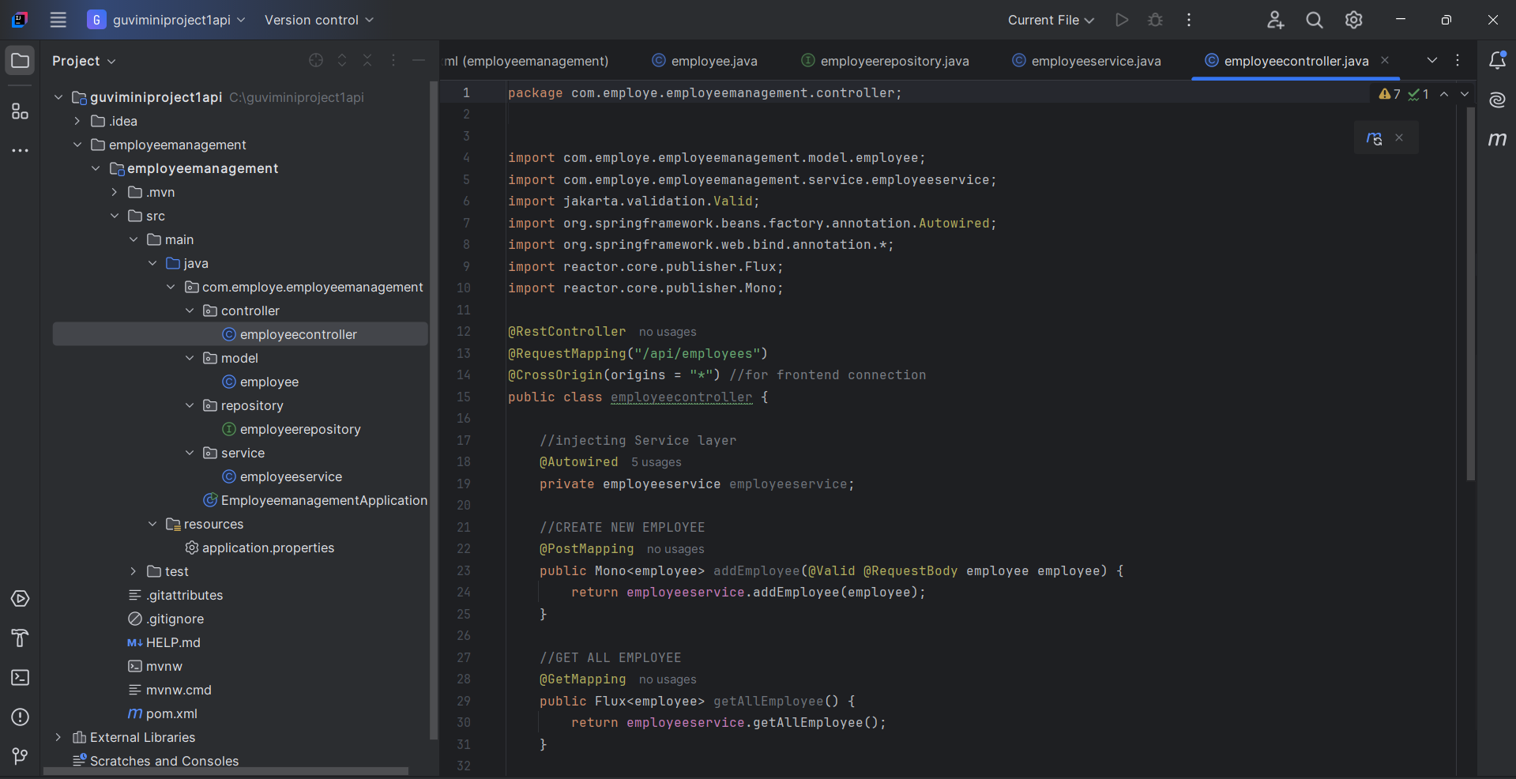

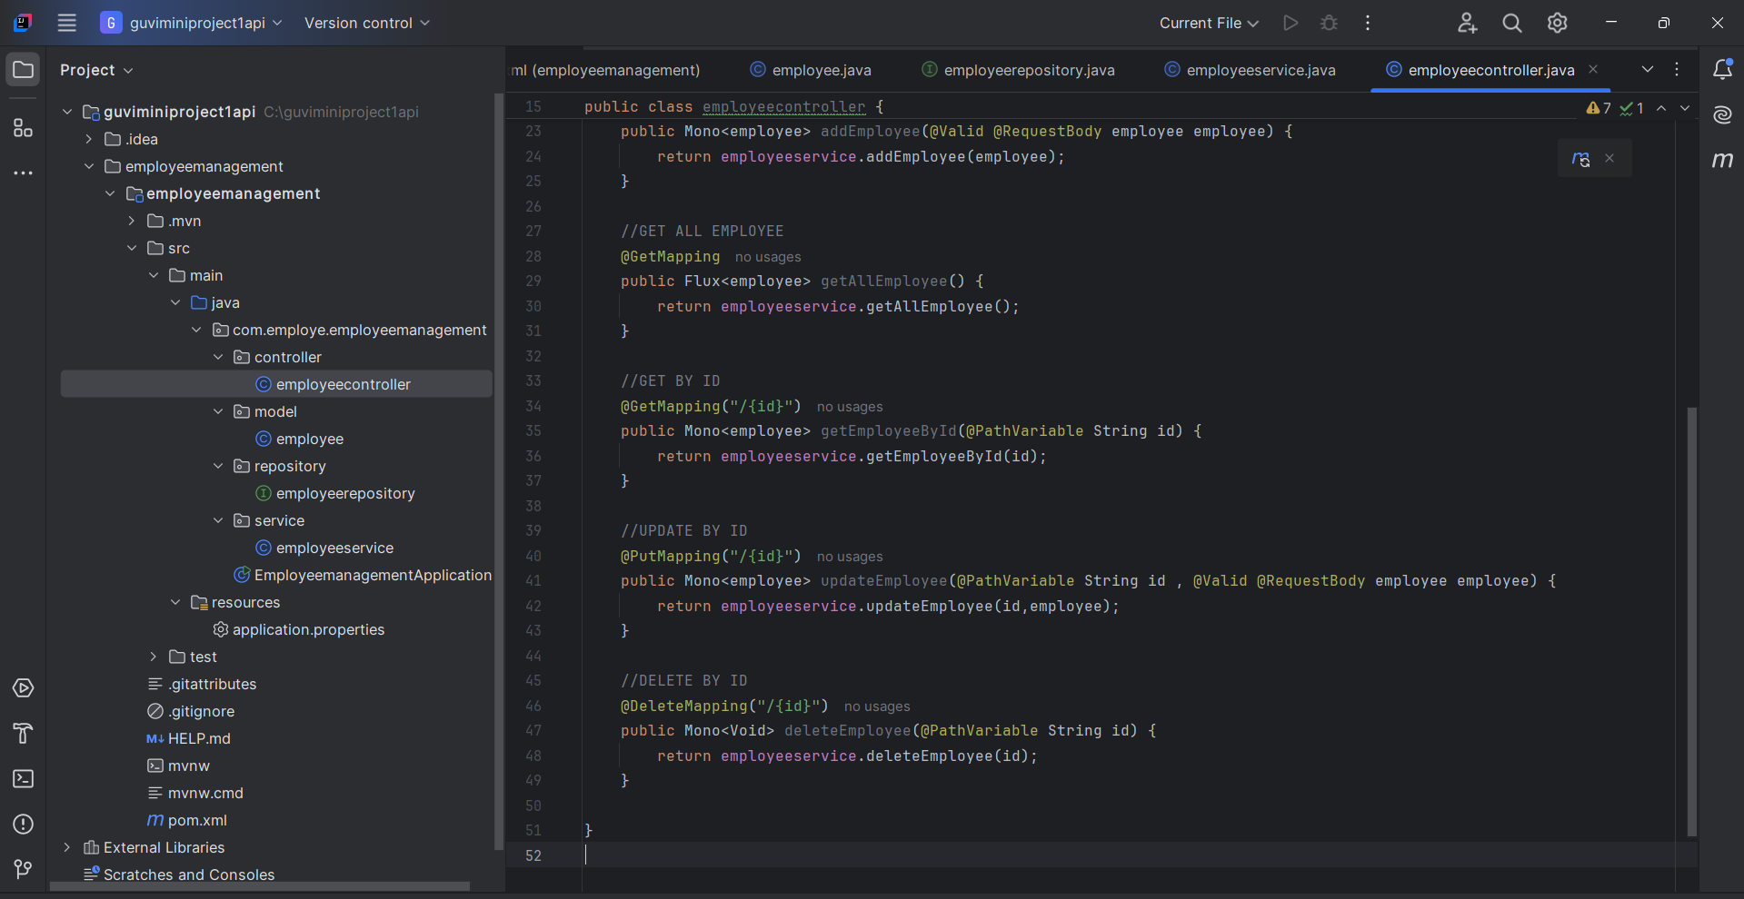

API ENDPOINTS SUMMARY
Operation | HTTP Method | API Path | What it Does
Add Employee | POST | /api/employees | Adds new employee
Get All | GET | /api/employees | Gets all employees
Get by ID | GET | /api/employees/{id} | Get one employee
Update | PUT | /api/employees/{id} | Update by ID
Delete | DELETE | /api/employees/{id} | Delete by ID

Annotations Used:
Annotation | Meaning (English)
@RestController | Marks this class as a REST API controller.
@RequestMapping("/api/employees") | All API URLs will start with /api/employees.
@CrossOrigin(origins = "*") | Allows requests from any frontend (CORS).
@Autowired | Spring will inject (auto-wire) the service here.
@PostMapping, @GetMapping, etc. | Define API methods for POST, GET, PUT, DELETE.

CONFIG PACKAGE
SwaggerConfiguration class:
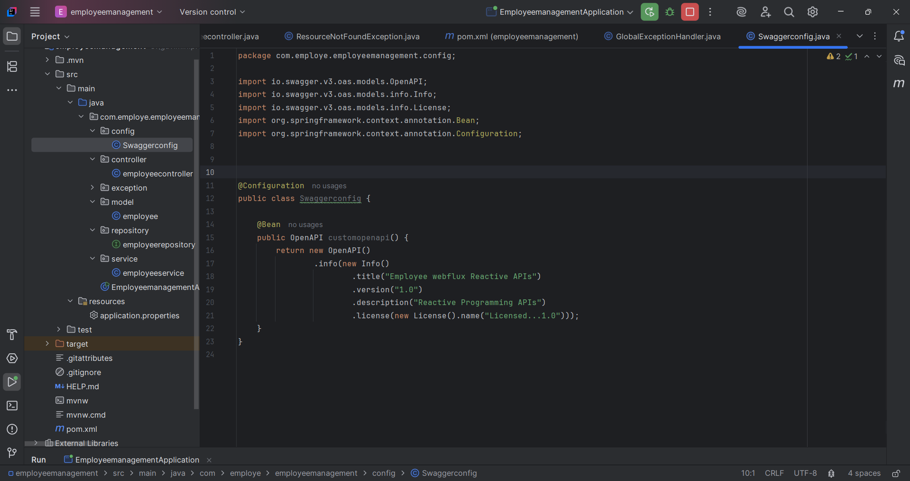

Purpose of this File
This file configures Swagger/OpenAPI for your Spring Boot application.
Swagger helps to automatically generate documentation and a UI page to test your REST APIs easily.
@Configuration Annotation
- @Configuration
- This tells Spring Boot that this class provides Spring configuration.
- Spring will scan and load this as part of the application context.
2.@Bean
public OpenAPI customopenapi() {
- This method returns a custom OpenAPI configuration
- @Bean means Spring will manage this object in its container.

3. return new OpenAPI()
.info(new Info()
.title("Employee webflux Reactive APIs")
.version("1.0")
.description("Reactive Programming APIs")
.license(new License().name("Licensed...1.0")));
Method | Meaning (English)
title(...) | Title of the Swagger UI page
version(...) | Version number
description(...) | Small explanation of your API
license(...) | Any license info you want to show
So the output will be a Swagger UI page like:
Title: Employee webflux Reactive APIs
Version: 1.0
Description: Reactive Programming APIs
License: Licensed...1.0
EXCEPTION PACKAGE
GlobalExceptionHandling class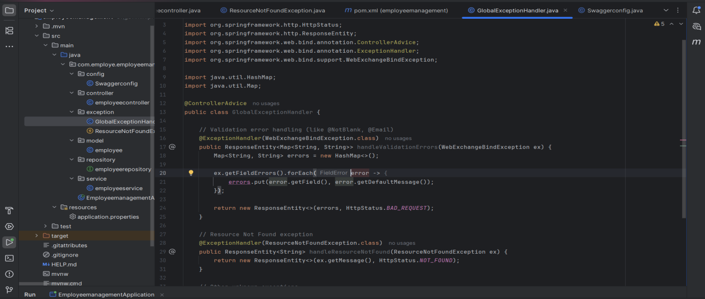
This code handles all types of errors (validation, not found, unknown errors) in one central place using @ControllerAdvice.
@ControllerAdvice
public class GlobalExceptionHandler {
@ControllerAdvice: Special Spring annotation to handle exceptions globally across the whole application.
  - Validation Error Handling
@ExceptionHandler(WebExchangeBindException.class)
public ResponseEntity<Map<String, String>> handleValidationErrors(WebExchangeBindException ex) {
Map<String, String> errors = new HashMap<>();

ex.getFieldErrors().forEach(error -> {
errors.put(error.getField(), error.getDefaultMessage());
});

return new ResponseEntity<>(errors, HttpStatus.BAD_REQUEST);
}

- This method handles backend validation errors (like @NotBlank, @Email, @Min).
- Catches the validation errors from WebFlux (that’s why it uses WebExchangeBindException).
- For each invalid field, it creates a map:

Return:
- HTTP Status: 400 BAD REQUEST
- Body: Field name → Error message
2.Resource Not Found Handling
@ExceptionHandler(ResourceNotFoundException.class)
public ResponseEntity<String> handleResourceNotFound(ResourceNotFoundException ex) {
return new ResponseEntity<>(ex.getMessage(), HttpStatus.NOT_FOUND);
}
- If employee ID not found in DB, we throw ResourceNotFoundException.
- This method catches it and returns a 404 error with a message

3.General Exception (Fallback for all other errors)

@ExceptionHandler(Exception.class)

public ResponseEntity<String> handleGeneral(Exception ex) {

return new ResponseEntity<>("Internal Server Error: " + ex.getMessage(), HttpStatus.INTERNAL_SERVER_ERROR);

}
- This is the fallback for any unhandled exceptions.
- Useful for debugging and preventing server crashes.
- Returns a 500 Internal Server Error.

FILE 2 :ResourceNotFoundException.java

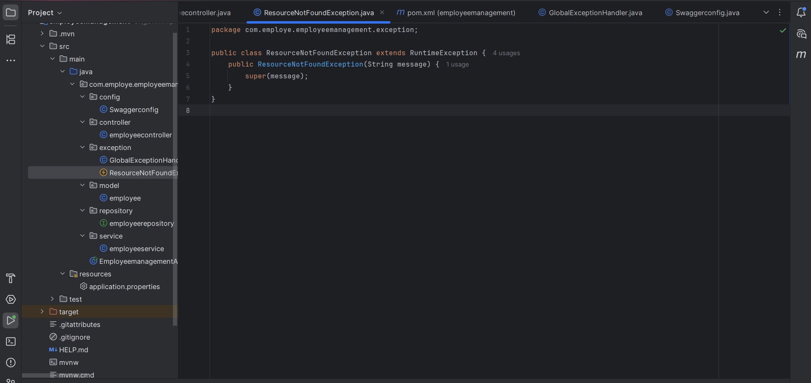

public class ResourceNotFoundException extends RuntimeException {

public ResourceNotFoundException(String message) {

super(message);

}

}
- This is a custom exception.
- We use it to throw errors when a specific employee is not found.
Exception Type | Caught By | HTTP Status | Description
Validation errors | WebExchangeBindException | 400 (Bad Request) | Form validation miss
Resource not found | ResourceNotFoundException | 404 (Not Found) | IF EMPLOYEE ID NOT PRESENT
General/Other exceptions | Exception | 500 (Internal Server Error) | Unknown issue
APPLICATION PROPERTIES :
Property | Meaning
server.port=8080 | Starts your backend server on port 8080
spring.data.mongodb.uri | Tells Spring where your MongoDB is running
springdoc.swagger-ui.path | Enables Swagger UI at http://localhost:8080/swagger-ui.html

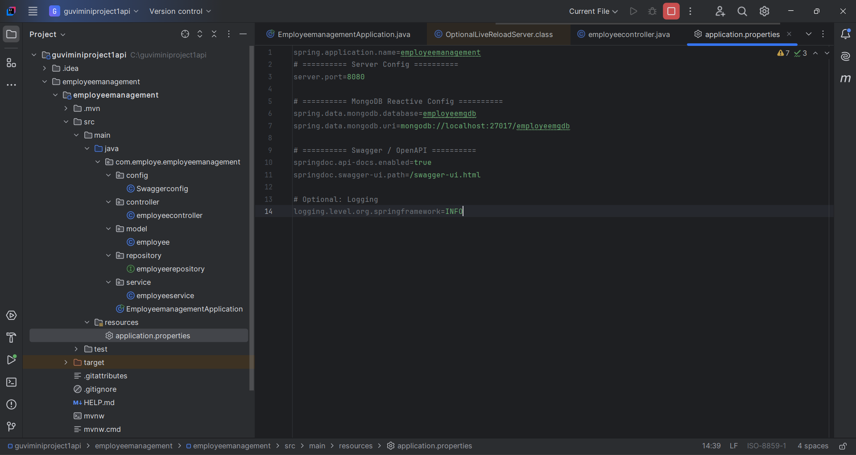

Now start MongoDB
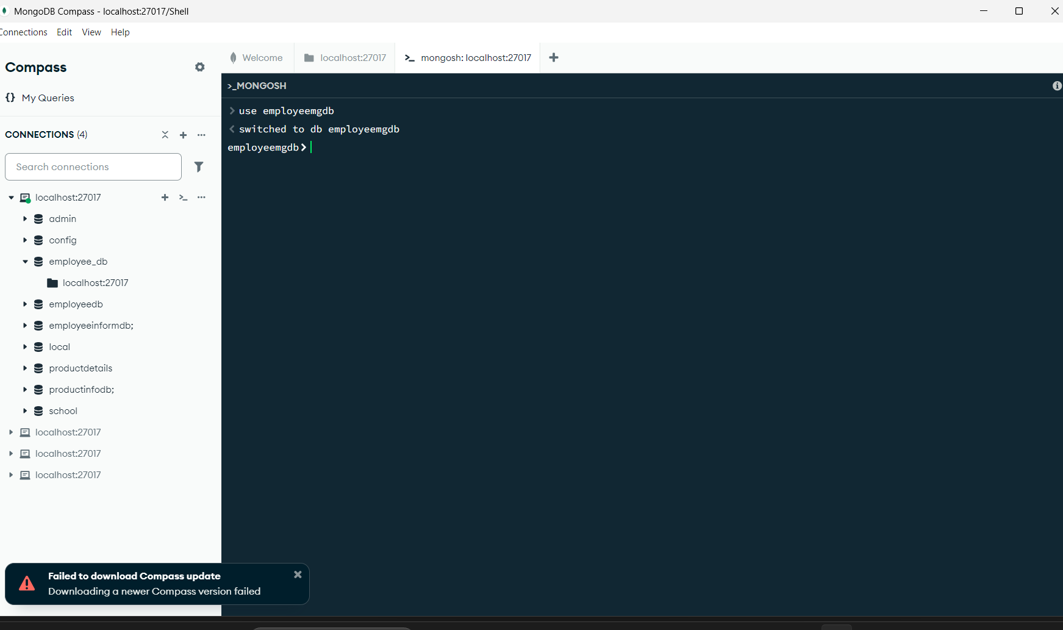
INSERT DATABASE “employeemgdb”
Then run your Spring Boot app and go to:
http://localhost:8080/swagger-ui.html
You’ll see all your APIs displayed neatly.

API Testing using Swagger (OpenAPI)
If you followed Step 5, Swagger should already be enabled.

🔗 Test URL:
After running the backend, open your browser and visit:
👉 http://localhost:8080/swagger-ui.html
You will see:
- POST /api/employees → Add Employee
- GET /api/employees → Get All
- PUT /api/employees/{id} → Update
- DELETE /api/employees/{id} → Delete
- GET /api/employees/{id} → Get One
You can click “Try it out”, enter request data, and see live responses ✅
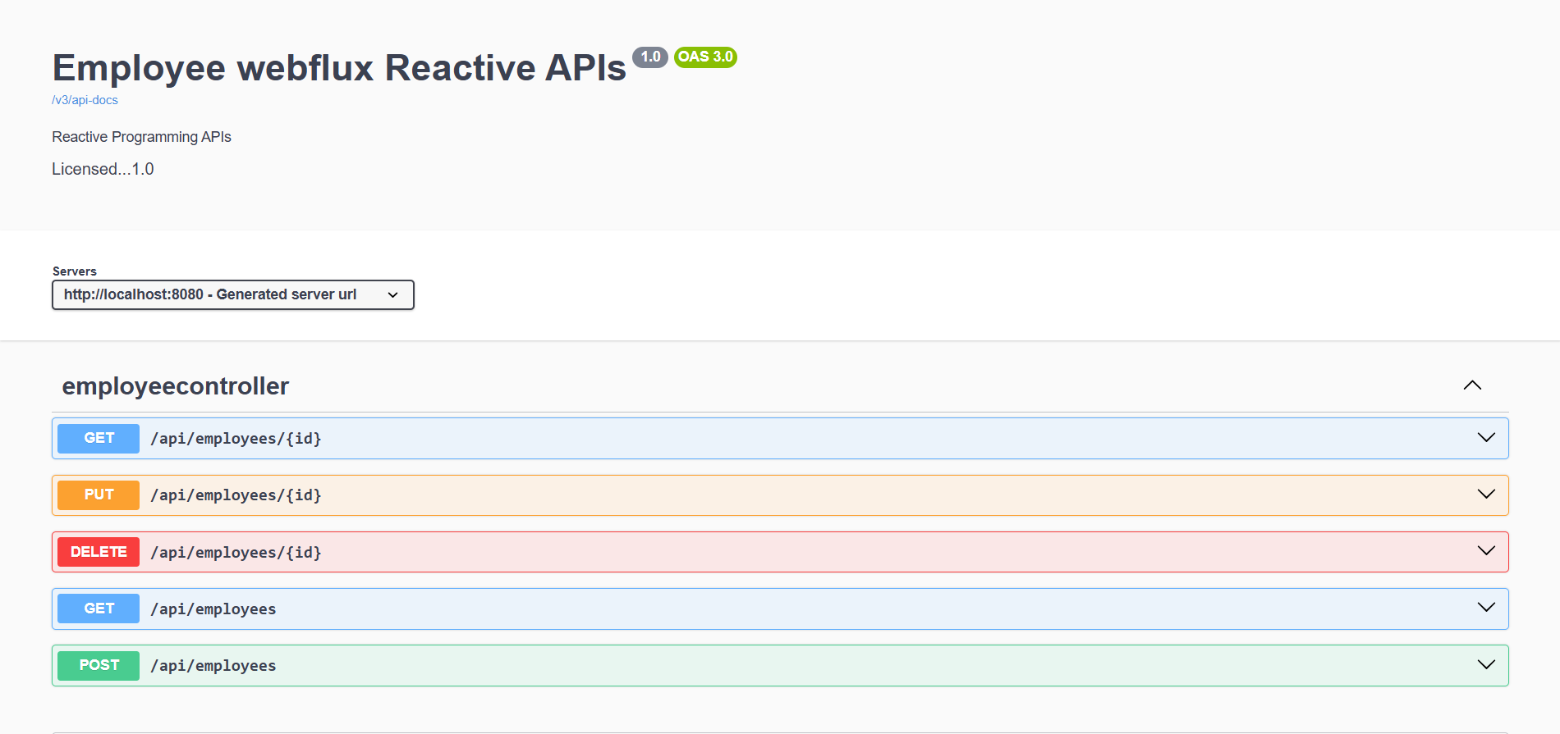

POST
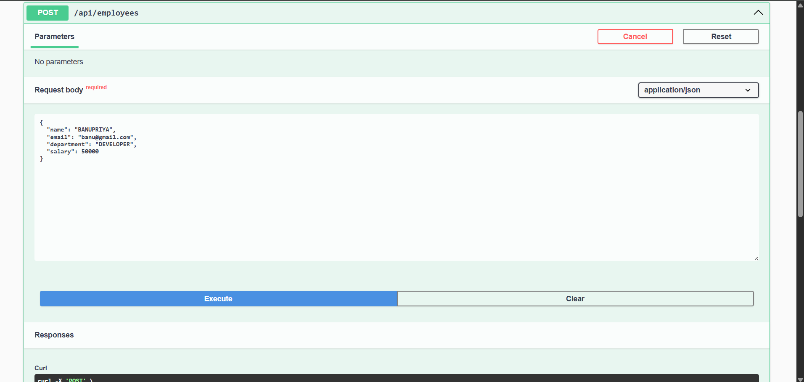

RESPONSE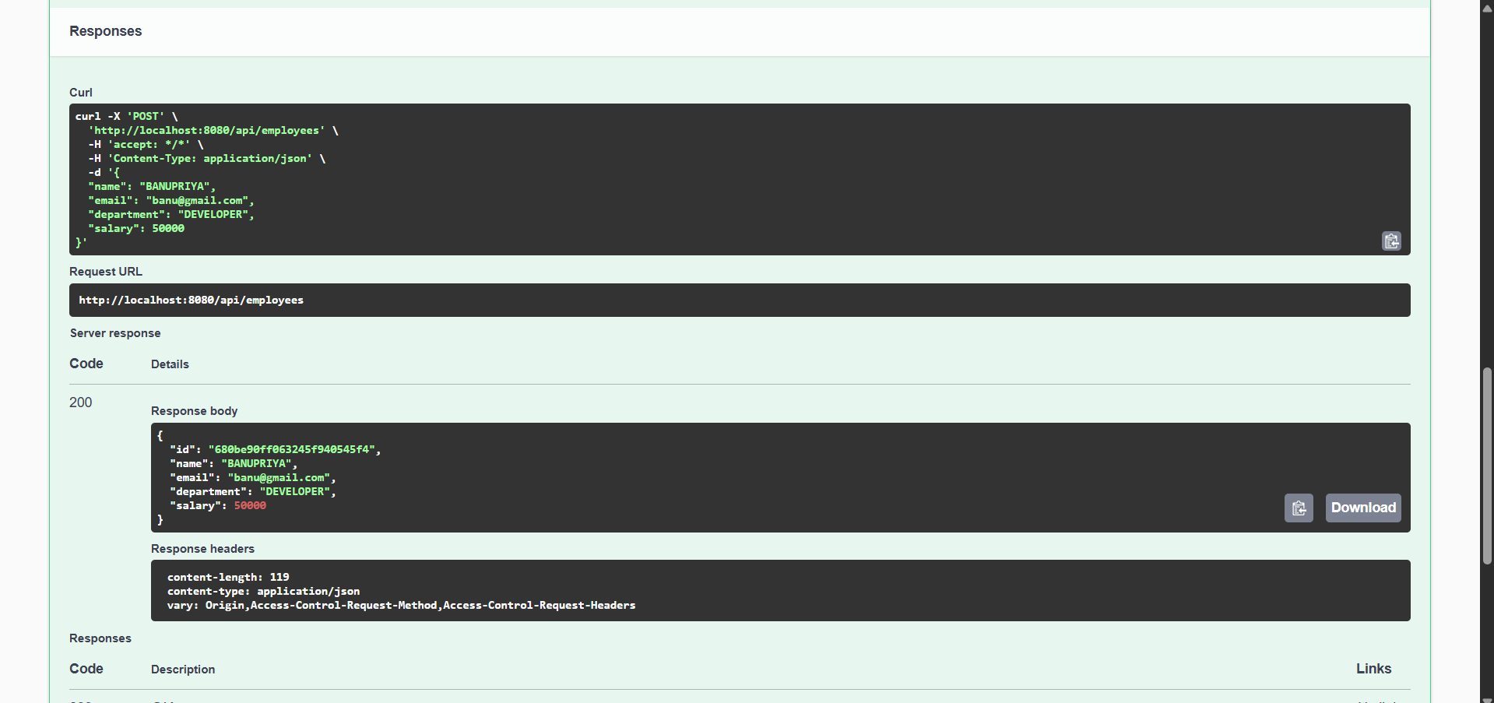
DATABASE CONNECTION
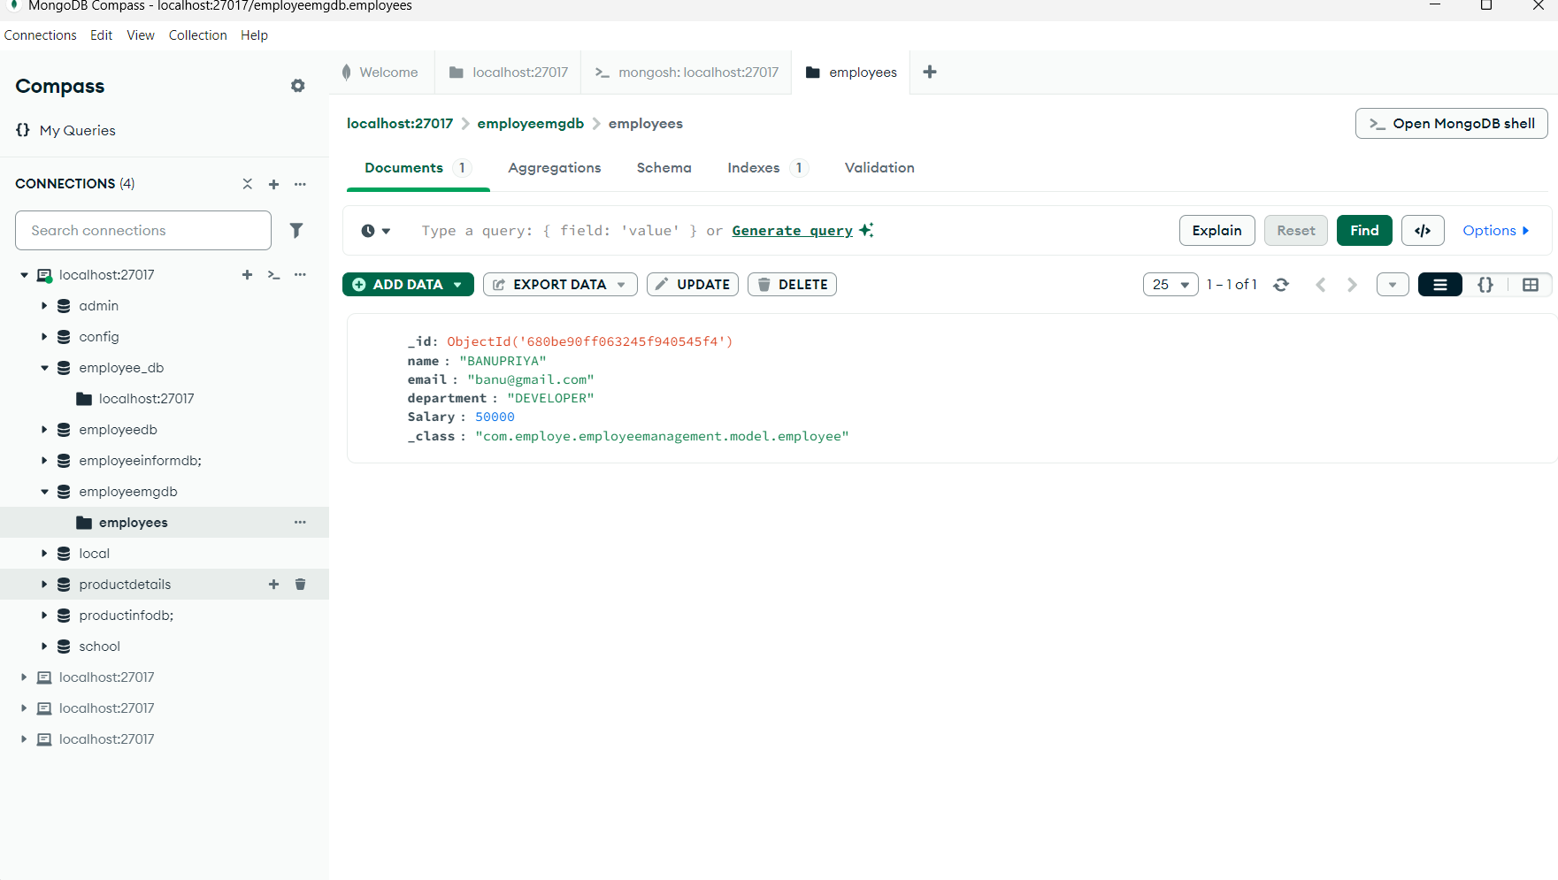
GET
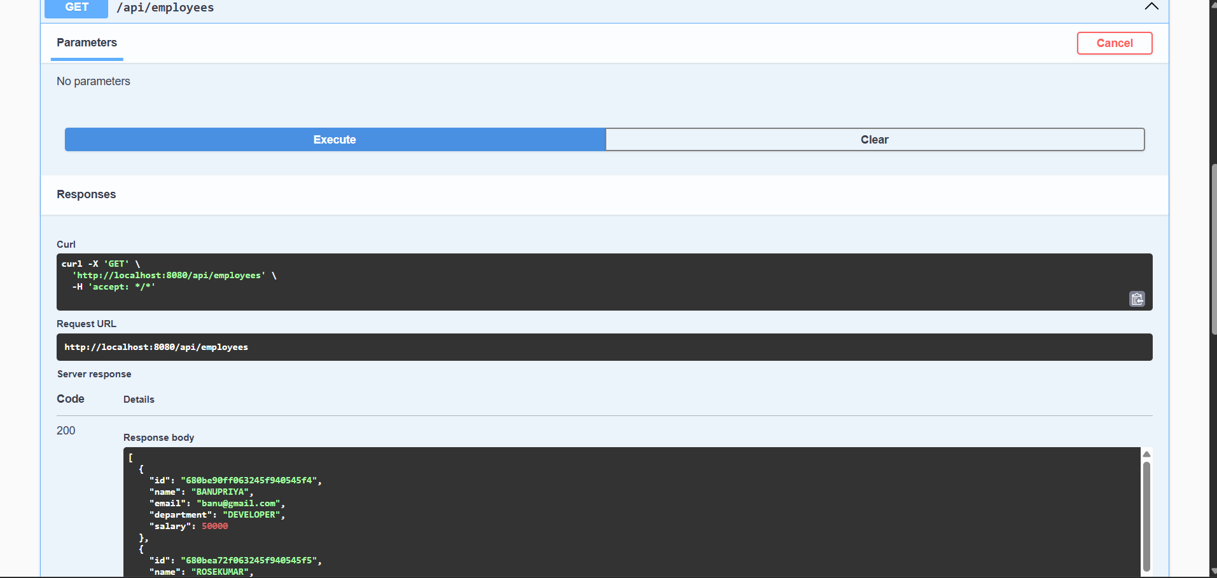
RESPONSE
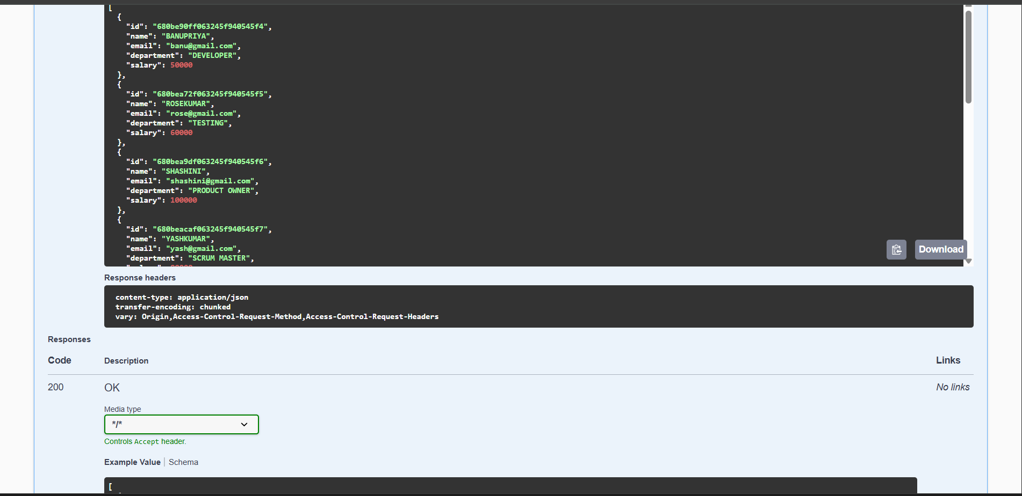

GET BY ID
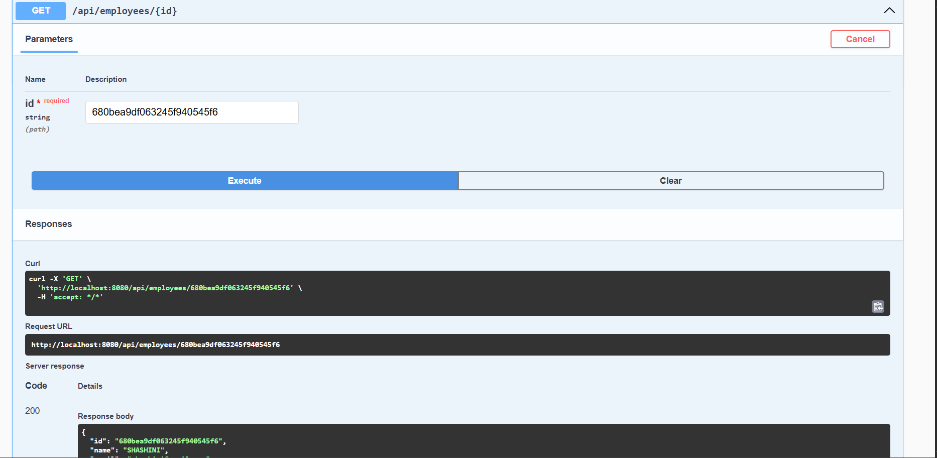
TOTAL EMPLOYEE LIST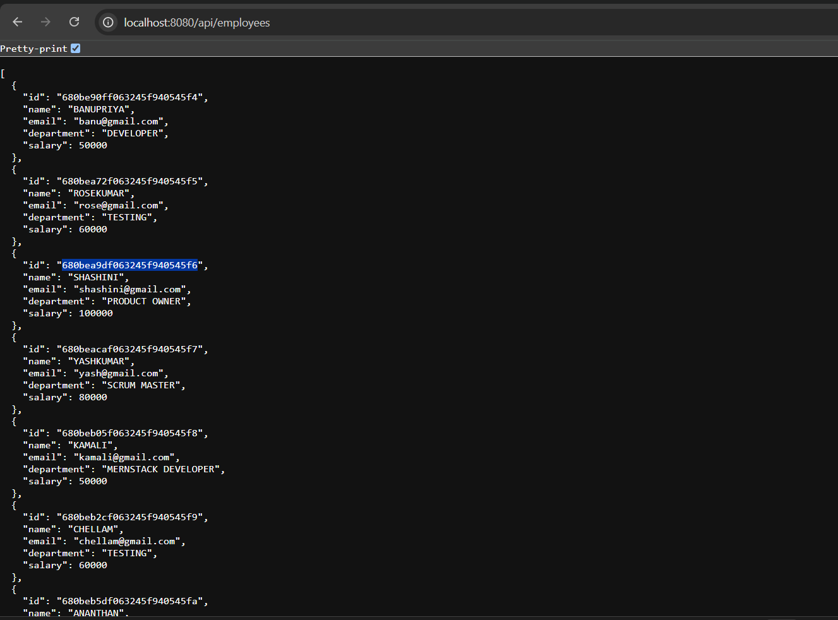
DELETE
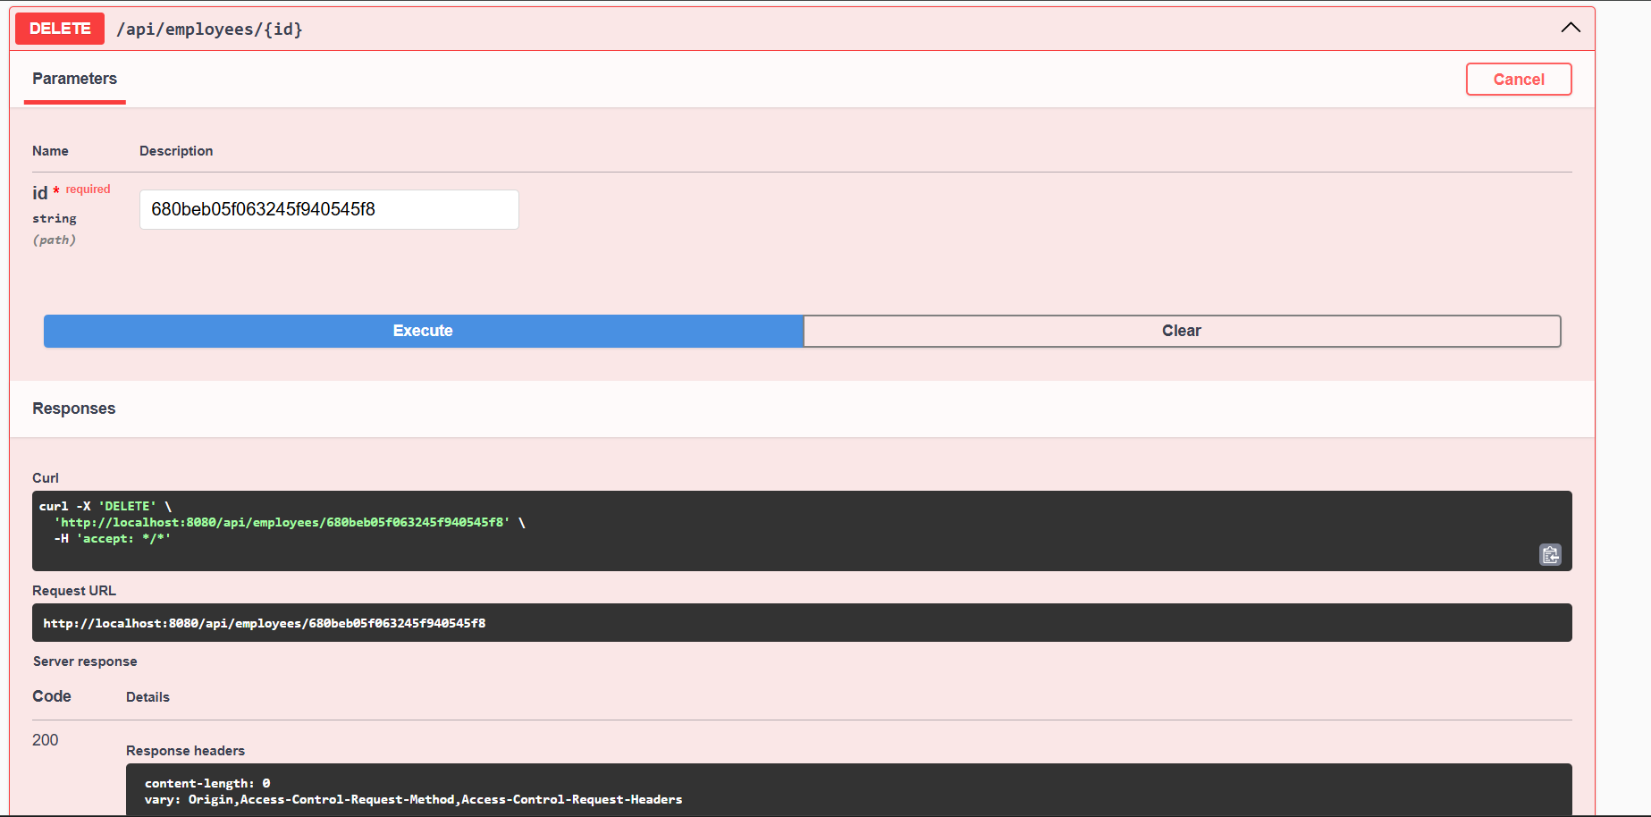

First — Overall Structure of Unit Test:
In any Unit Test, we always follow 4 steps:
Step | What We Do | Why?
1. Mock | Fake/mock the backend/database behavior | So test will not touch real database
2. Action | Call the service method you want to test | Main method we are checking
3. Verify Data | Check the result using StepVerifier | Confirm if output is correct
4. Verify Behavior | Check if repository method was called properly | Confirm method flow

Test 1: Get All Employees — testGetAllEmployees()
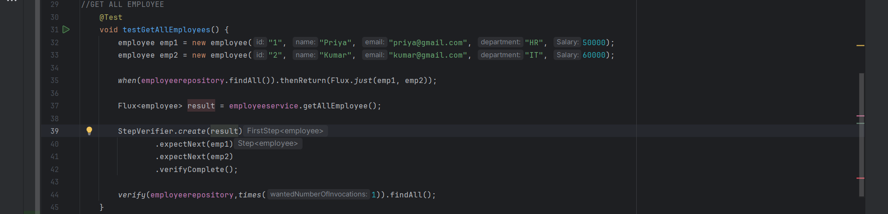
EXPLANATION :TEST 1
Step | Code | Meaning
1. Mock | when(employeerepository.findAll()).thenReturn(Flux.just(emp1, emp2)); | If someone calls findAll, return two employees (Priya and Rose)
2. Action | Flux<employee> result = employeeservice.getAllEmployees(); | Call the service method to get all employees
3. Verify Data | StepVerifier.create(result).expectNext(emp1).expectNext(emp2).verifyComplete(); | Check that first Priya, then Rose are returned
4. Verify Behavior | verify(employeerepository, times(1)).findAll(); | Confirm that findAll method was called exactly once

Test 2: CREATE NEW EMPLOYEE — testCreateEmployee();
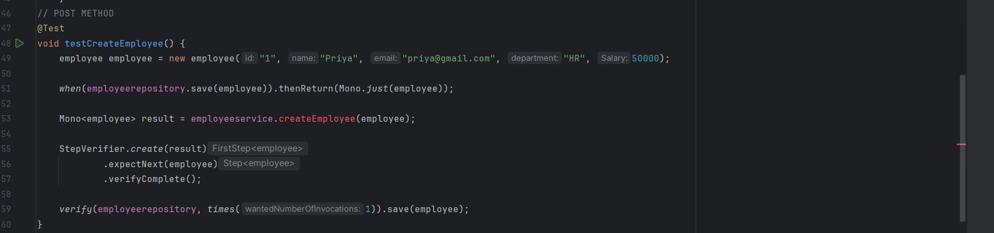

Step | Code | Meaning
1. Mock | when(employeerepository.save(employee)).thenReturn(Mono.just(employee)); | If someone saves an employee, return the same employee (fake)
2. Action | Mono<employee> result = employeeservice.createEmployee(employee); | Call service method to save an employee
3. Verify Data | StepVerifier.create(result).expectNext(employee).verifyComplete(); | Check if the result gives the same employee correctly
4. Verify Behavior | verify(employeerepository, times(1)).save(employee); | Confirm that the save method was called exactly once

Test 3: GET THE ELEMENT BY ID — testGetEmployeeById()
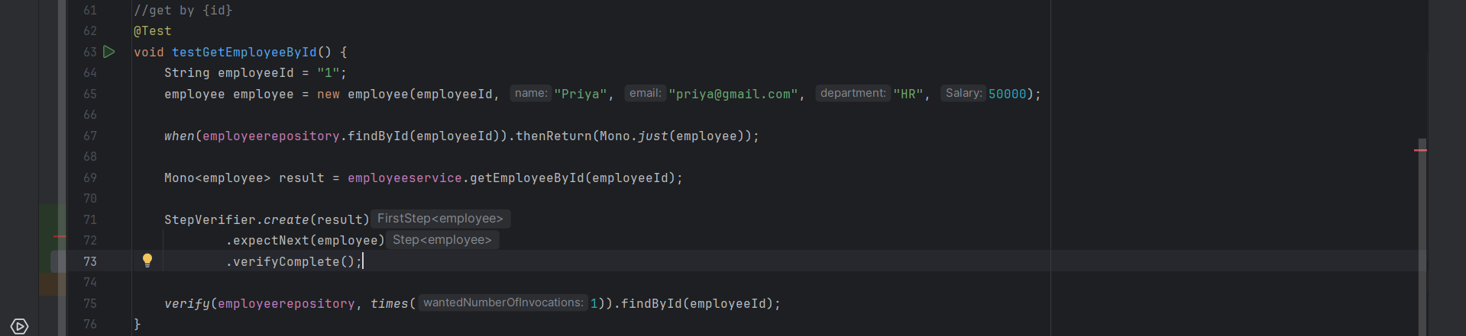
Step | Code | Meaning
1. Mock | when(employeerepository.findById(employeeId)).thenReturn(Mono.just(employee)); | If someone searches for ID 1 give employee priya
2. Action | Mono<employee> result = employeeservice.getEmployeeById(employeeId); | Call service method to get employee by ID
3. Verify Data | StepVerifier.create(result).expectNext(employee).verifyComplete(); | Check if the correct employee is returned
4. Verify Behavior | verify(employeerepository, times(1)).findById(employeeId); | Confirm that the findById method was called exactly once

Test 3: DELETE EMPLOYEE BY ID — testDeleteEmployee()
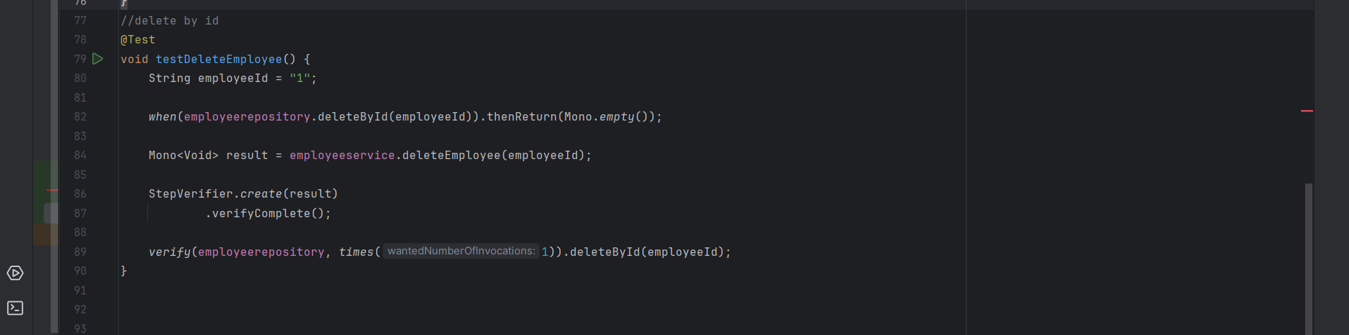
Step | Code | Meaning
1. Mock | when(employeerepository.deleteById(employeeId)).thenReturn(Mono.just(employee)); | If someone delete for ID 1 ,just return empty(nothing)
2. Action | Mono<void> result = employeeservice.deleteEmployee(employeeId); | Call service method to delete employee by ID
3. Verify Data | StepVerifier.create(result).verifyComplete(); | No data should return –just complete.
4. Verify Behavior | verify(employeerepository, times(1)).deleteById(employeeId); | Confirm that the deleteById method was called exactly once

Important Concepts
Concept | Simple Meaning
Mono | Single value async (like promise)
Flux | Multiple values async (like list of promises)
Mockito when() | Create fake behaviors
Mockito verify() | Confirm correct methods were called
StepVerifier | Testing reactive flows

TEST RESULTS
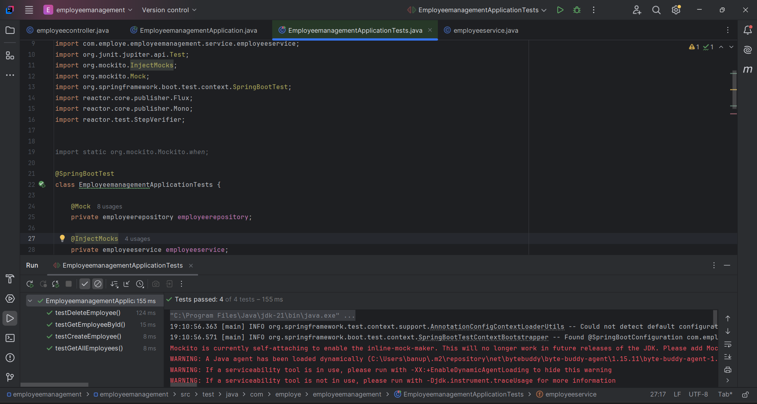
All the test cases are passed
FRONTEND DEVELOPMENT
HTML,CSS,JAVASCRIPT ALSO USING BOOTSTRAP
In it we using fetch method to fetch the data from the database

HTML FILE
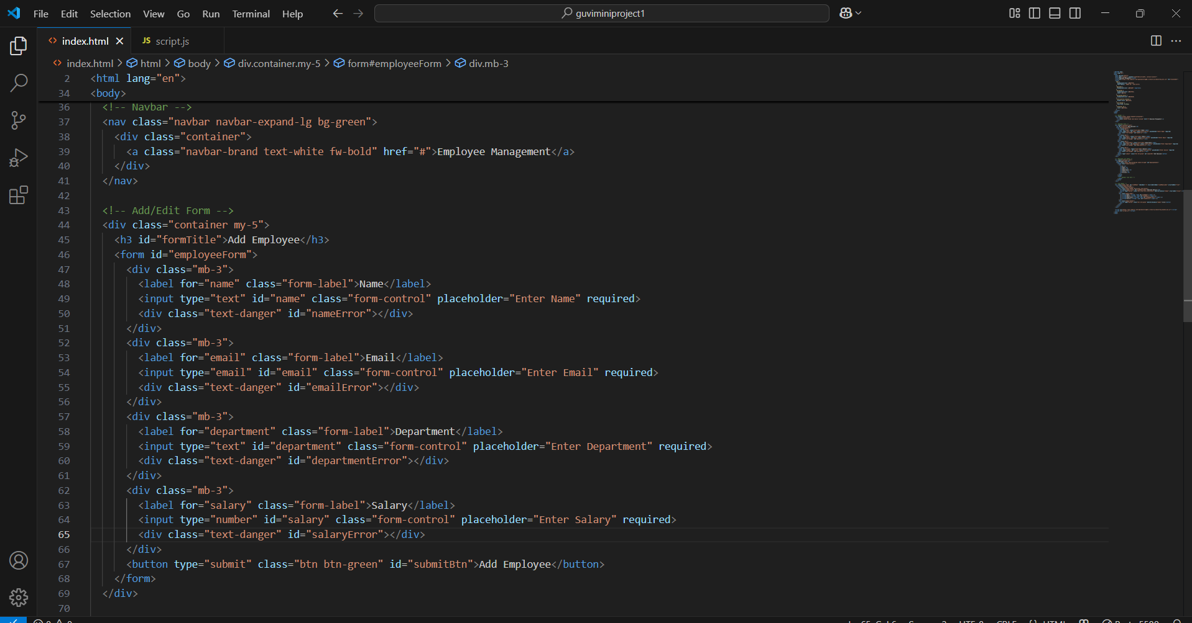
IN LINE STYLE WITH BOOTSTRAP
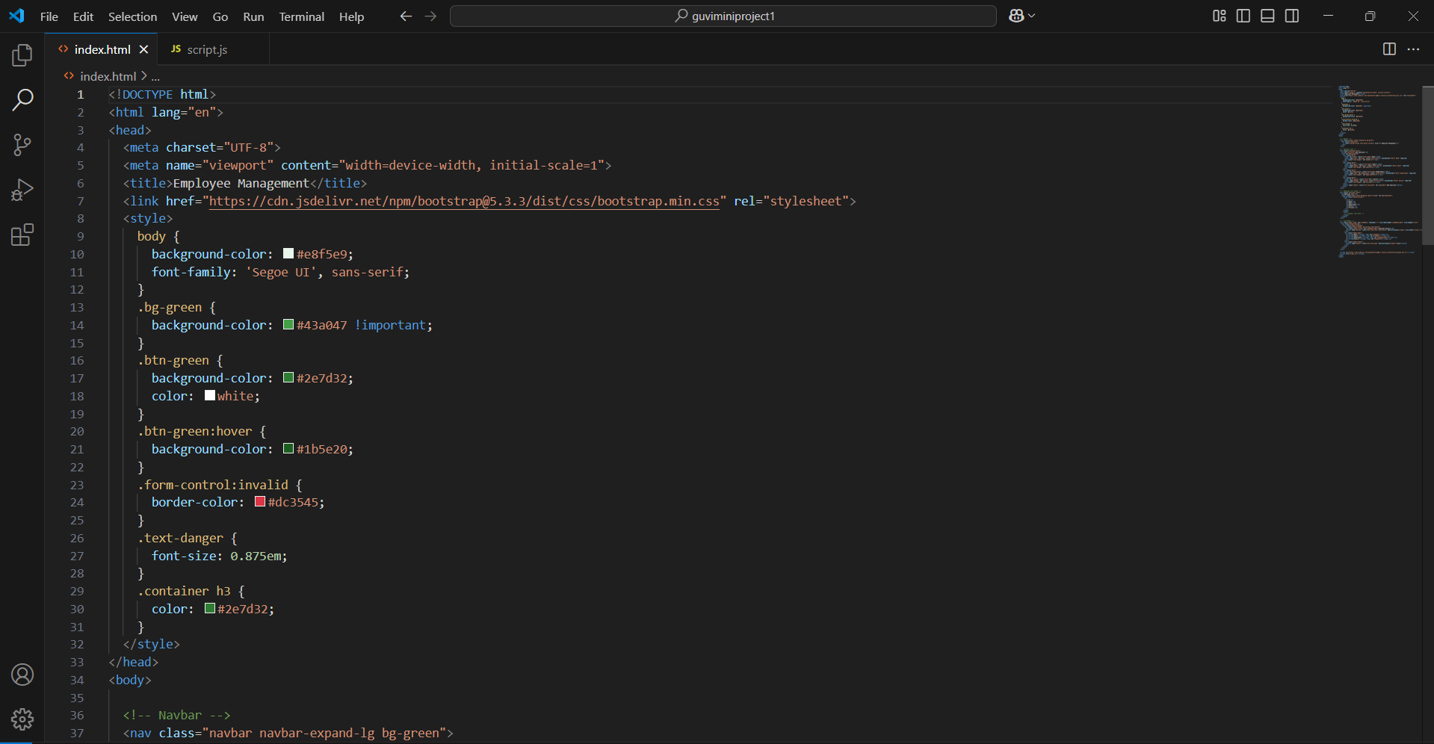

JAVASCRIPT FILE
1.Global Declaration
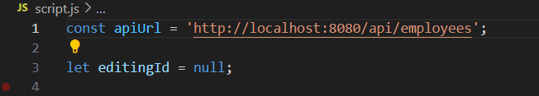
- apiUrl: The base URL to call your Spring Boot backend API.
- editingId: Tracks the current employee being edited. It's null if you're adding a new employee.
2.DOMContentLoaded Event
- This runs after the HTML page is fully loaded.
- Calls fetchEmployees() to load employee data from the backend.
- Adds a submit event listener to the form to handle add/update.

3.Loader Toggle
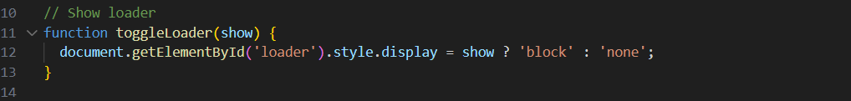
- Shows or hides a loading spinner based on the show flag (true or false).
4.Fetch All Employees
- Fetches all employees from the backend API.
- Builds and displays the employee table dynamically.
- Shows a loader during fetch and handles errors gracefully.

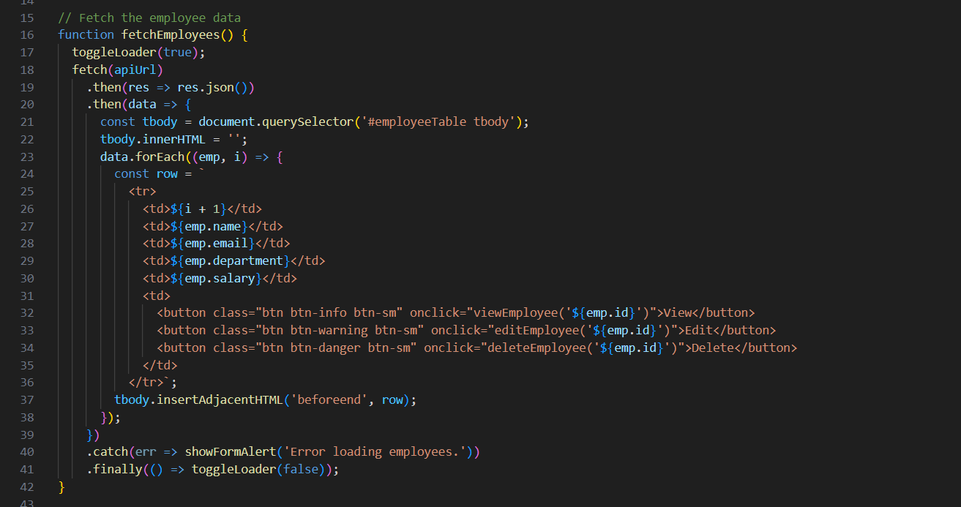
5.Form Alert Display
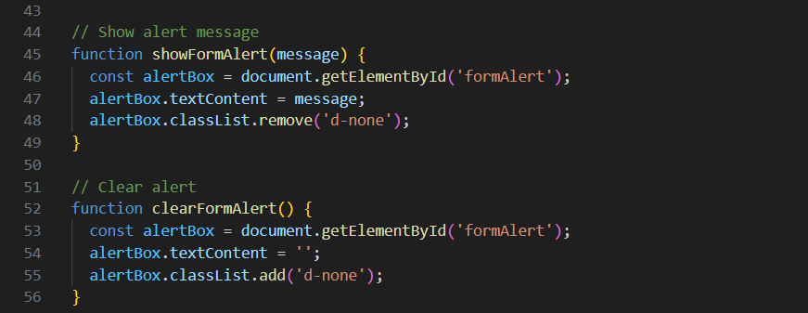
- showFormAlert(msg): Shows error messages in an alert box.
- clearFormAlert(): Hides the alert box and clears text.
6. Handle Add/Update Form Submit
- Prevents the page from reloading (e.preventDefault()).
- Builds the employee object from form inputs.
- Validates form (frontend).
- Sends POST (new) or PUT (update) request to backend.
- Shows validation errors from backend if any.
- On success, reloads the employee table and resets the form.
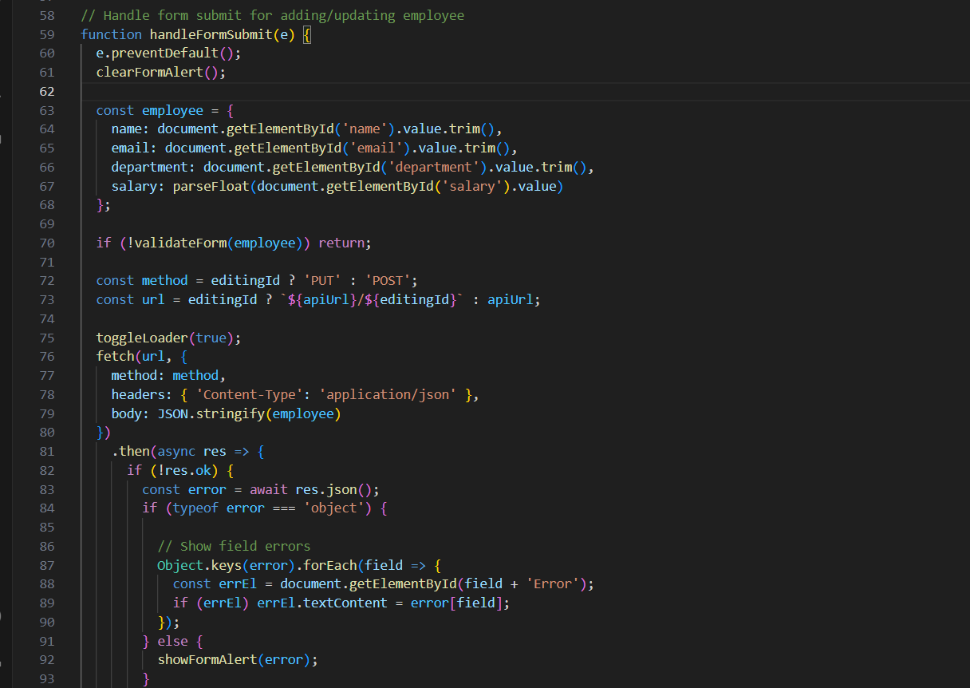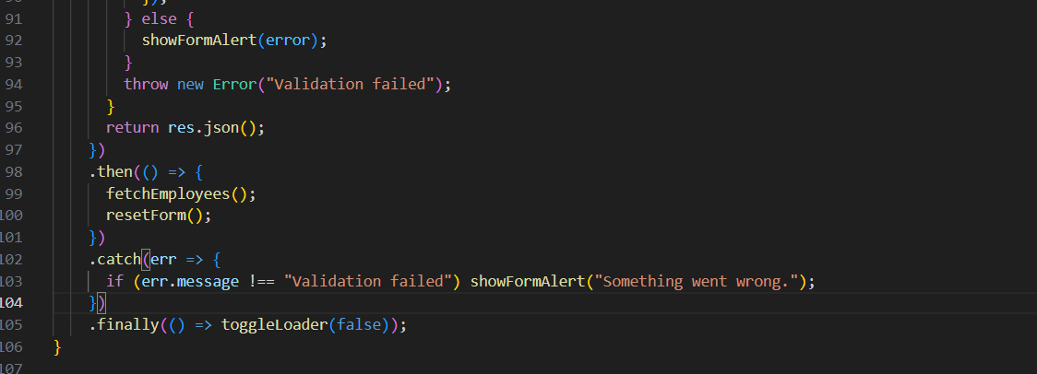
7.Frontend Form Validation
- Checks if all fields are filled properly.
- Checks if email format is valid.
- Checks if salary is a positive number.
- Displays error messages near respective form fields.
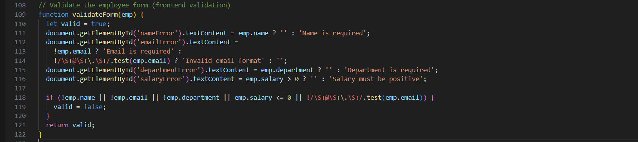
8. Edit Employee
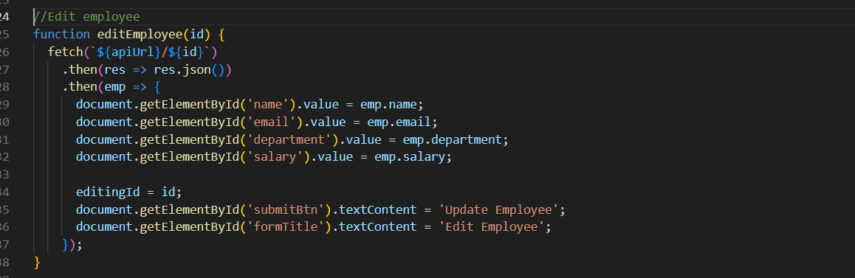
- Fills the form with the employee's data for editing.
- Changes the form title and button to “Update Employee”.
8.Reset Form
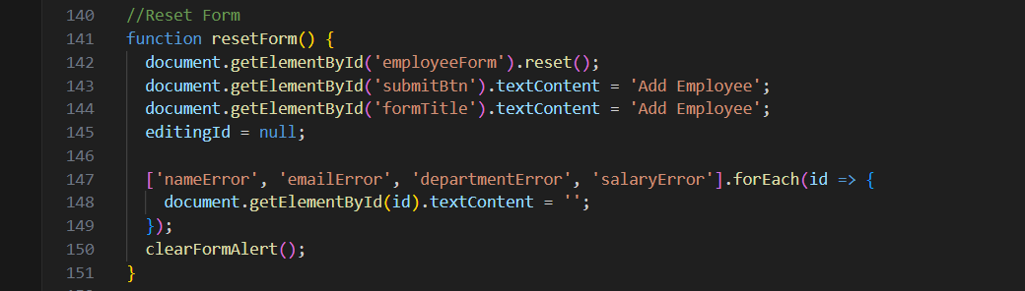
- Clears the form after adding or updating an employee.
- Resets button and title to "Add Employee".
- Clears validation messages and alert box.
10. Delete Employee
- Asks confirmation before deleting
- Sends DELETE request to backend.
- Refreshes the employee list.
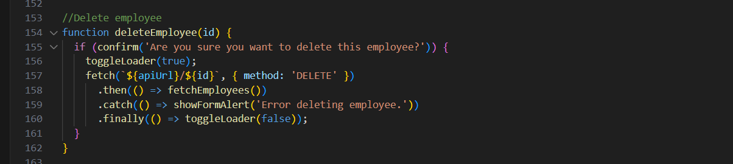
11. View Employee Details (Modal)
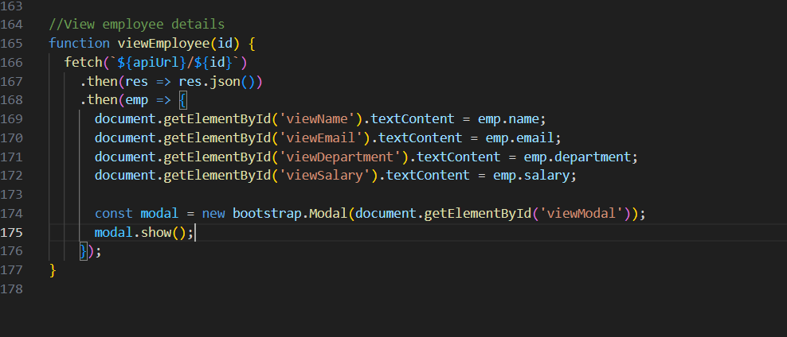
- Gets full employee details from backend by ID.
- Fills and opens a Bootstrap modal to display them.
MY FRONTEND VIEW
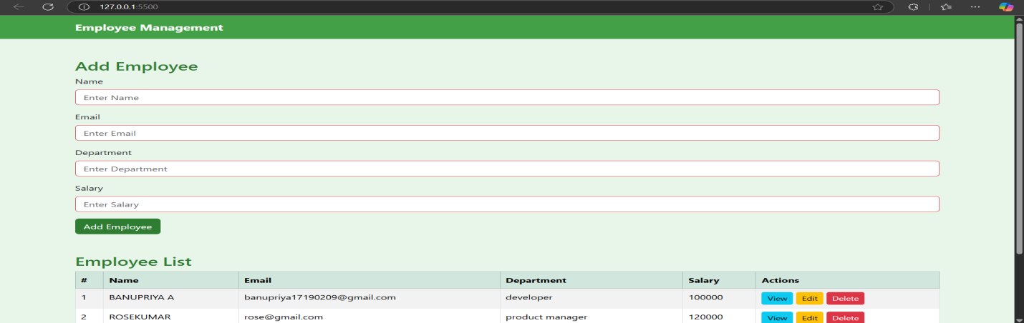
VIEW EMPLOYEE
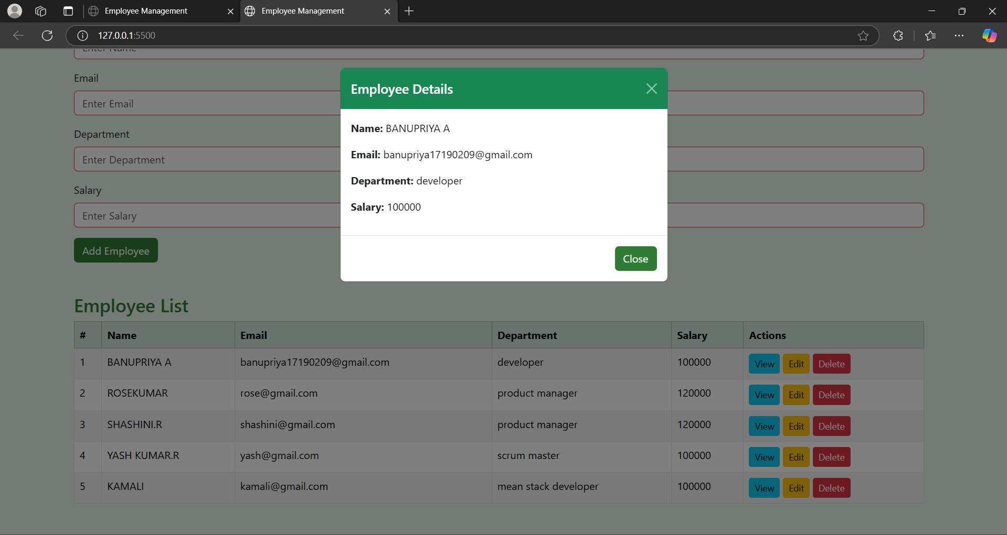
EDIT EMPLOYEE
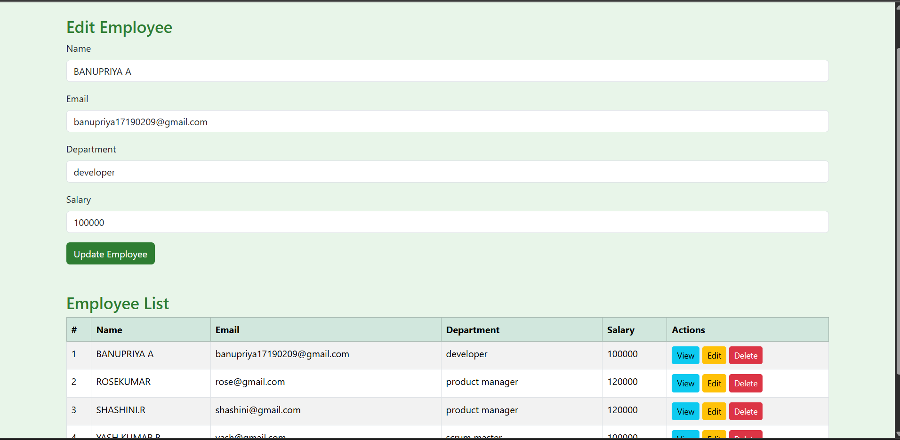

DELETE EMPLOYEE
