  - FULL-STACK APPLICATION

Banking Management System
  - Project Presentation & Technical Overview

React Frontend | Java 8 + Spring Boot Backend | H2 Database

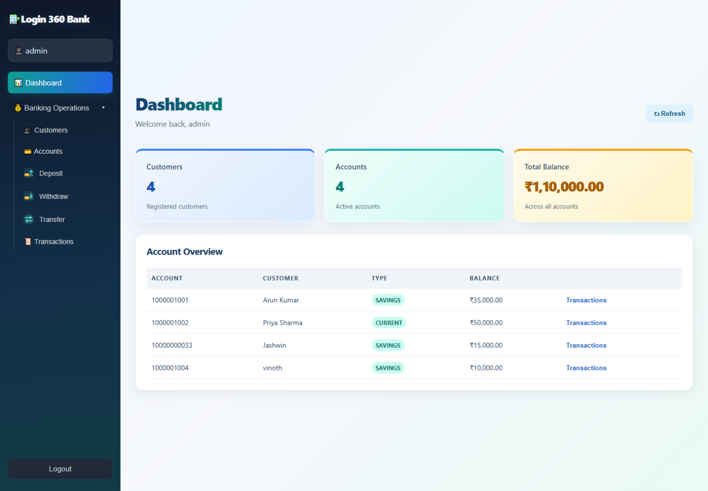

Prepared: 2 October 2026
Application: http://localhost:5173/
Repository: https://github.com/banupriya92/banking-management-system

1. Executive Summary
The Banking Management System is a browser-based full-stack demonstration application for managing customers, bank accounts, and everyday account operations. A React user interface communicates with a Spring Boot REST API. The backend uses Spring Data JPA and Hibernate to persist the demo records in an H2 file database.
The primary goal is to show a complete, understandable banking workflow: register a customer, open an account, carry out a deposit, withdrawal, or account-to-account transfer, and review the resulting transaction history.

Presentation highlights
• Dedicated Deposit, Withdraw, and Transfer screens instead of combining operations on one form.
• Dashboard summaries and account overview provide a quick operational snapshot.
• Customer and account screens connect ownership, balances, and transaction records.
• Two independent local development servers form one end-to-end application.

Project objectives
• Demonstrate frontend-to-backend REST integration.
• Keep account balances and transaction history consistent for each supported operation.
• Provide a beginner-friendly demonstration setup with a local persistent database and sample records.
Intended audience: students, reviewers, and project presenters exploring a small full-stack application. This is an educational demo, not a production banking platform.

2. Features and Screen Map
After entering the demo interface, the sidebar exposes the application areas. Each screen has a focused purpose and uses the shared customer or account data.
• Dashboard — customer and account counts, total balance, account type, owner, and balance overview.
• Customers — add customers and review the registered customer list.
• Accounts — create an account associated with a customer and view account details.
• Deposit — select one account, enter a positive amount, and record a deposit.
• Withdraw — select one account and withdraw a positive amount when funds are sufficient.
• Transfer — choose different source and destination accounts and enter an amount.
• Transactions — inspect activity recorded for a selected account, ordered newest first.

Typical user journey
Sign in to the demo UI → review the dashboard → create a customer if needed → open a linked savings or current account → deposit funds → make a withdrawal or transfer → open transaction history to review the activity.

Demonstration seed data
On an empty database, the backend initializes an admin record and sample customers and accounts. The screenshots in this document reflect the local demo database when captured; balances and records can change during use. Replace demonstration records with approved, non-sensitive examples before distributing the document publicly.

3. Technology and Architecture

Technology stack
• Frontend: React 19, JavaScript, CSS, and Vite 7.
• Backend: Java 8 and Spring Boot 2.7.18, using Spring Web and Spring Data JPA.
• Persistence: Hibernate ORM with a file-based H2 database.
• Build and development: npm for the frontend and Maven for the backend.

Request and data flow
Administrator browser → React page and form → frontend API helper (fetch/JSON) → Spring MVC REST controller → BankingService business rules → Spring Data JPA repository → H2 database. The REST response updates the UI and the refreshed account information appears on the dashboard and account lists.

Services and local addresses
• Frontend development server: http://localhost:5173/.
• Backend REST API base: http://localhost:8080/api.
• H2 browser console: http://localhost:8080/h2-console.
• The backend CORS configuration allows the Vite origin http://localhost:5173.

Data model
• Customer — name, unique email, phone, and address.
• Account — unique account number, account type, decimal balance, and owning customer.
• Transaction — account, operation type, amount, timestamp, and description.
• Admin — demo username and password record used by the backend login endpoint.

4. Banking Operations and Business Rules

Deposit
The backend locates the selected account by account number, requires a positive amount, increases the balance, and records a DEPOSIT transaction.

Withdrawal
The backend requires a valid account and positive amount, checks the available balance, reduces the balance, and records a WITHDRAW transaction. A withdrawal greater than the balance is rejected.

Transfer
The backend checks that both accounts exist, the source and destination are different, the amount is positive, and the source has enough funds. It updates both balances in a transaction and records TRANSFER_OUT and TRANSFER_IN entries.

Other workflows
New accounts are associated with an existing customer. Customers and account balances are loaded from the API. Transaction-history lookups use the numeric database account ID, while deposit and withdrawal paths use the account number.

UI feedback
Successful operations show confirmation and reload account information. The API returns HTTP 400 for invalid banking operations and HTTP 500 for unexpected server errors.

5. REST API Reference
Base address: http://localhost:8080/api. Requests and responses use JSON.
• POST /auth/login — verify demo admin credentials; returns success/message/username. This does not issue a session token.
• GET /customers — list customers.
• POST /customers — create a customer (name and unique email required by the database model).
• GET /accounts — list accounts with their associated customer.
• POST /accounts — create an account with accountNumber, accountType, balance, and customer.id.
• POST /accounts/{accountNumber}/deposit — apply an amount and optional description.
• POST /accounts/{accountNumber}/withdraw — withdraw an amount and optional description.
• POST /transfers — transfer fromAccount to toAccount with amount and optional description.
• GET /accounts/{accountId}/transactions — list transaction history using a database ID.

Sample transfer request 2
{"fromAccount":"1000001001","toAccount":"1000001002","amount":500.00,"description":"Fund transfer"}

Sample amount request 2
{"amount":1000.00,"description":"Cash deposit"}

Useful response behavior 2
Invalid amounts, insufficient funds, same-account transfers, and unknown account numbers are rejected by backend service rules. The account transaction feed records operation types and timestamps.

6. Run and Build Instructions

Requirements 2
• Java 8 JDK and Maven.
• Node.js 20.19+ or 22.12+ and npm (Vite 7 requirement).

Start the backend 2
From the repository root, change to backend/banking-backend/banking-backend-java8 and run: mvn spring-boot:run. The backend listens on port 8080.

Start the frontend 2
In a second terminal, change to frontend/banking-frontend/banking-frontend and run: npm install, then npm run dev. Open http://localhost:5173/.

Database settings 2
• JDBC URL: jdbc:h2:file:./data/bankingdb.
• Database user: sa; password: blank for the local demo.
• The relative data directory is resolved from the backend working directory.
• The H2 console is at /h2-console while the backend is running.

Build verification 2
Frontend production build: npm run build in the frontend project directory. Backend test/build check: mvn test in the backend project directory.

8. Presentation Screenshots
The following screenshots were captured from the running local frontend at http://localhost:5173/ using the existing demo data. Each operation is shown on its own screen.

Sign-in Screen
Application capture from the running local project. Sample names and balances shown are demonstration data.
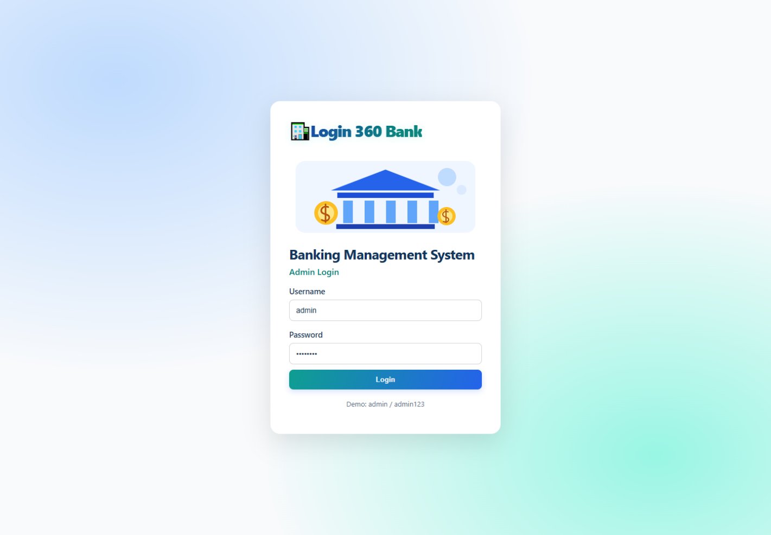
Screen file: presentation-assets/08-login.png

Dashboard
Application capture from the running local project. Sample names and balances shown are demonstration data.
Screen file: presentation-assets/01-dashboard.png

Customer Management
Application capture from the running local project. Sample names and balances shown are demonstration data.
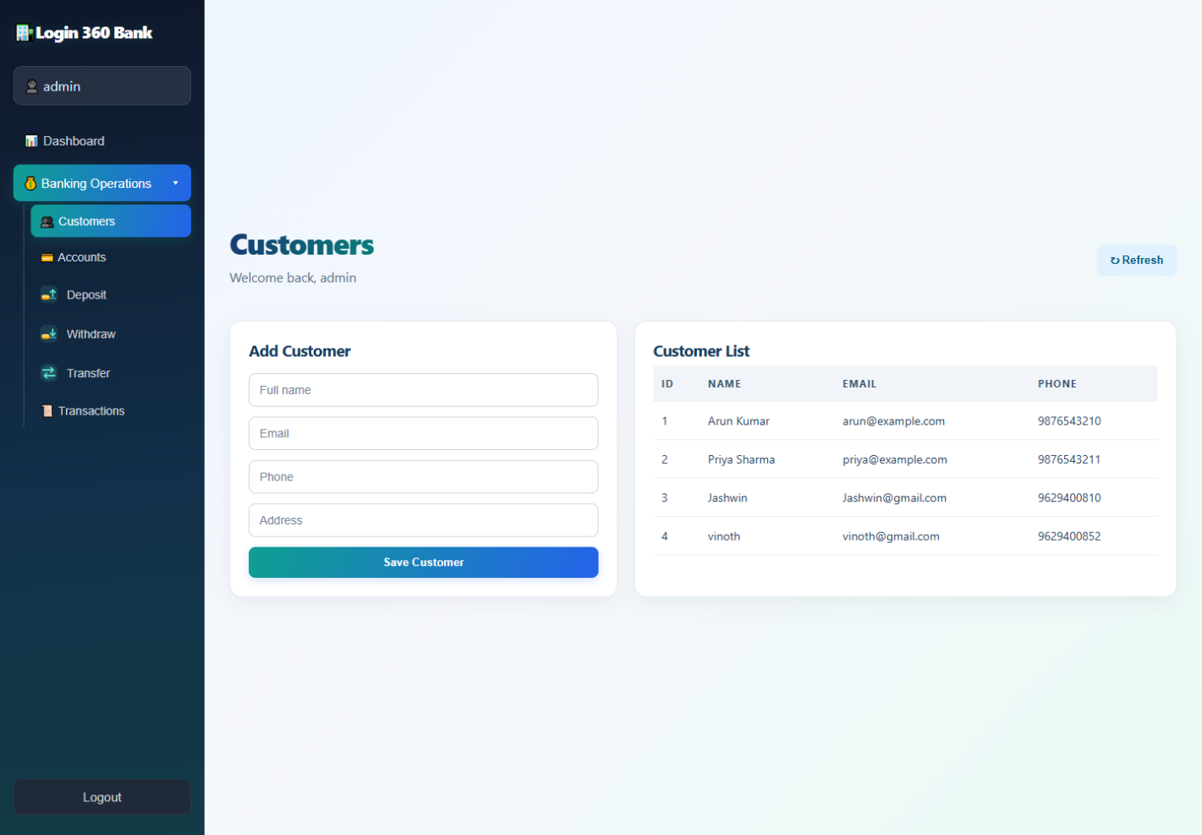
Screen file: presentation-assets/02-customers.png

Account Management
Application capture from the running local project. Sample names and balances shown are demonstration data.
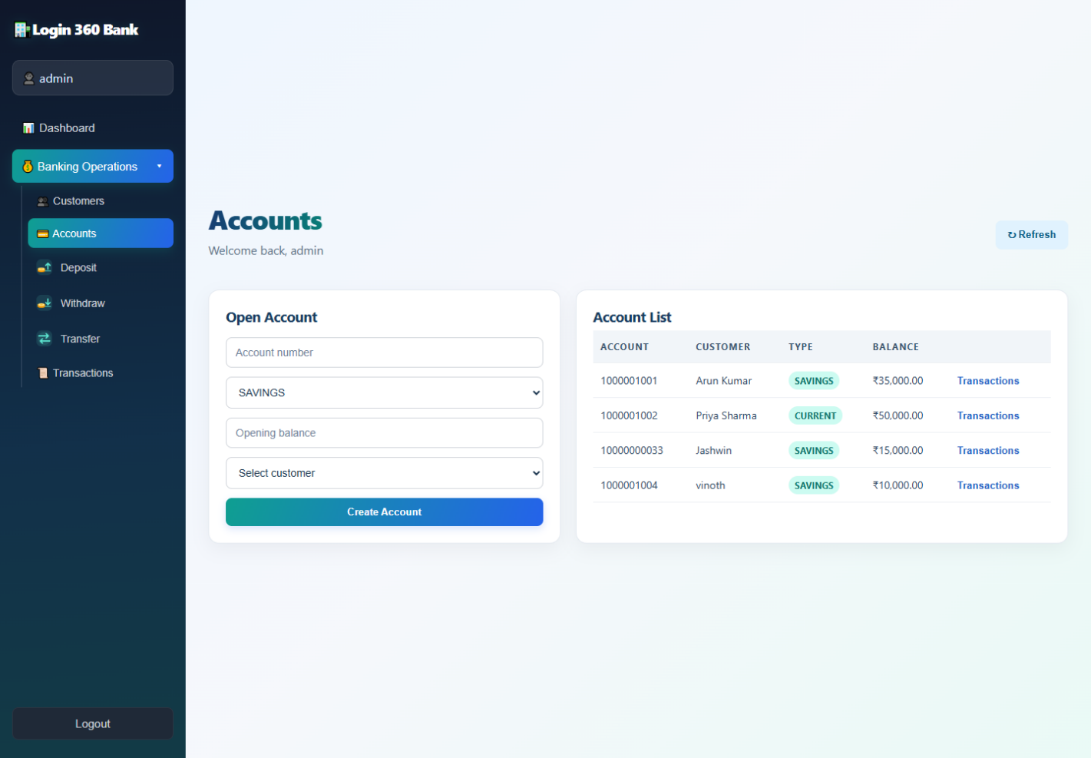
Screen file: presentation-assets/03-accounts.png

Deposit Screen
Application capture from the running local project. Sample names and balances shown are demonstration data.
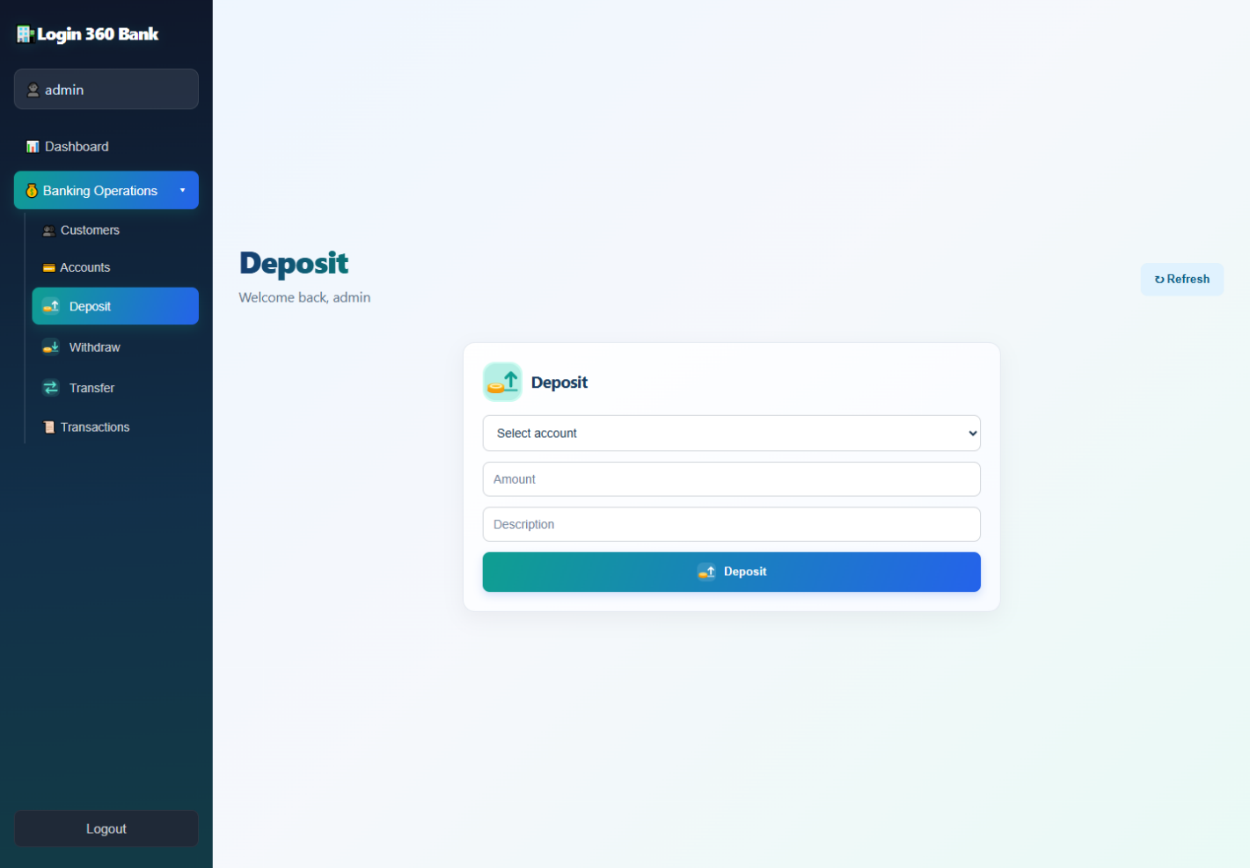
Screen file: presentation-assets/04-deposit.png

Withdrawal Screen
Application capture from the running local project. Sample names and balances shown are demonstration data.
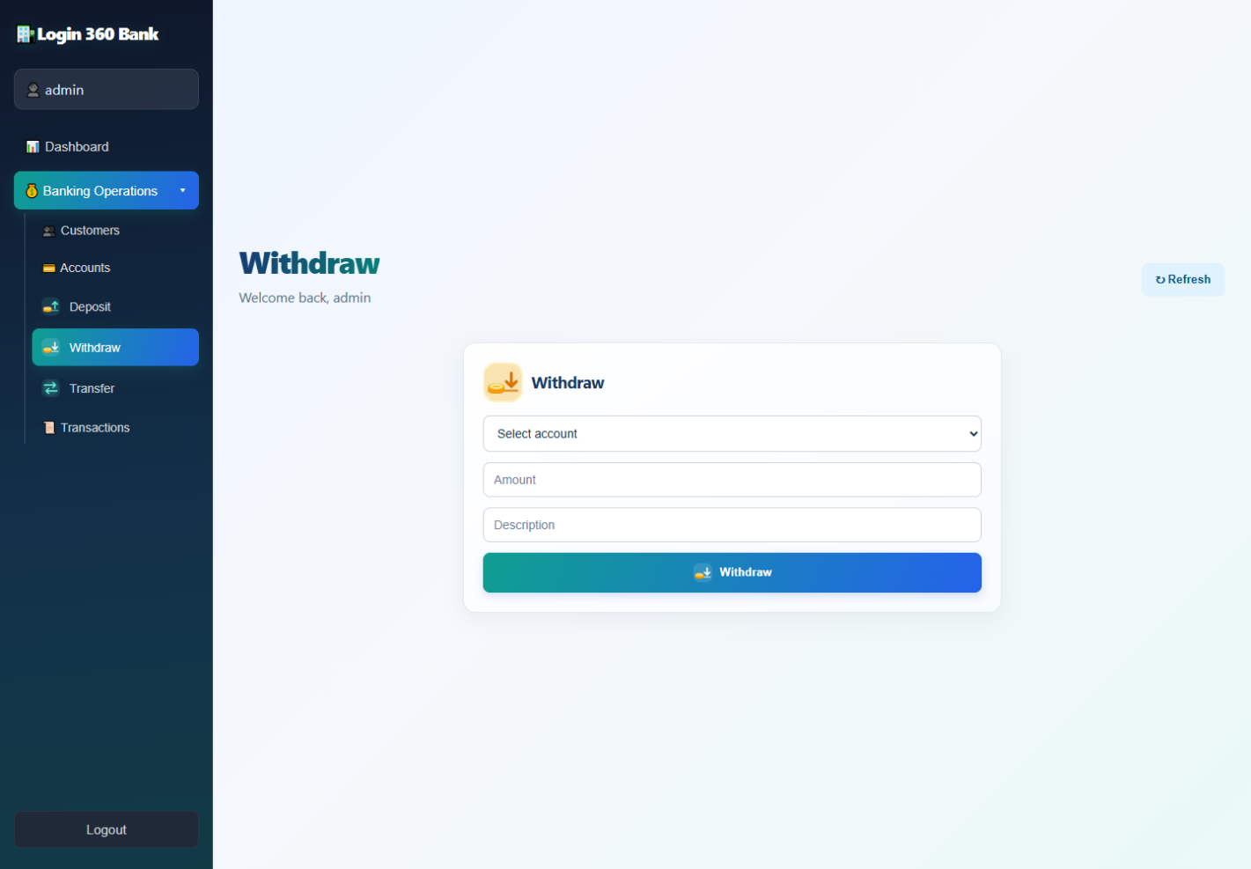
Screen file: presentation-assets/05-withdraw.png

Transfer Screen
Application capture from the running local project. Sample names and balances shown are demonstration data.
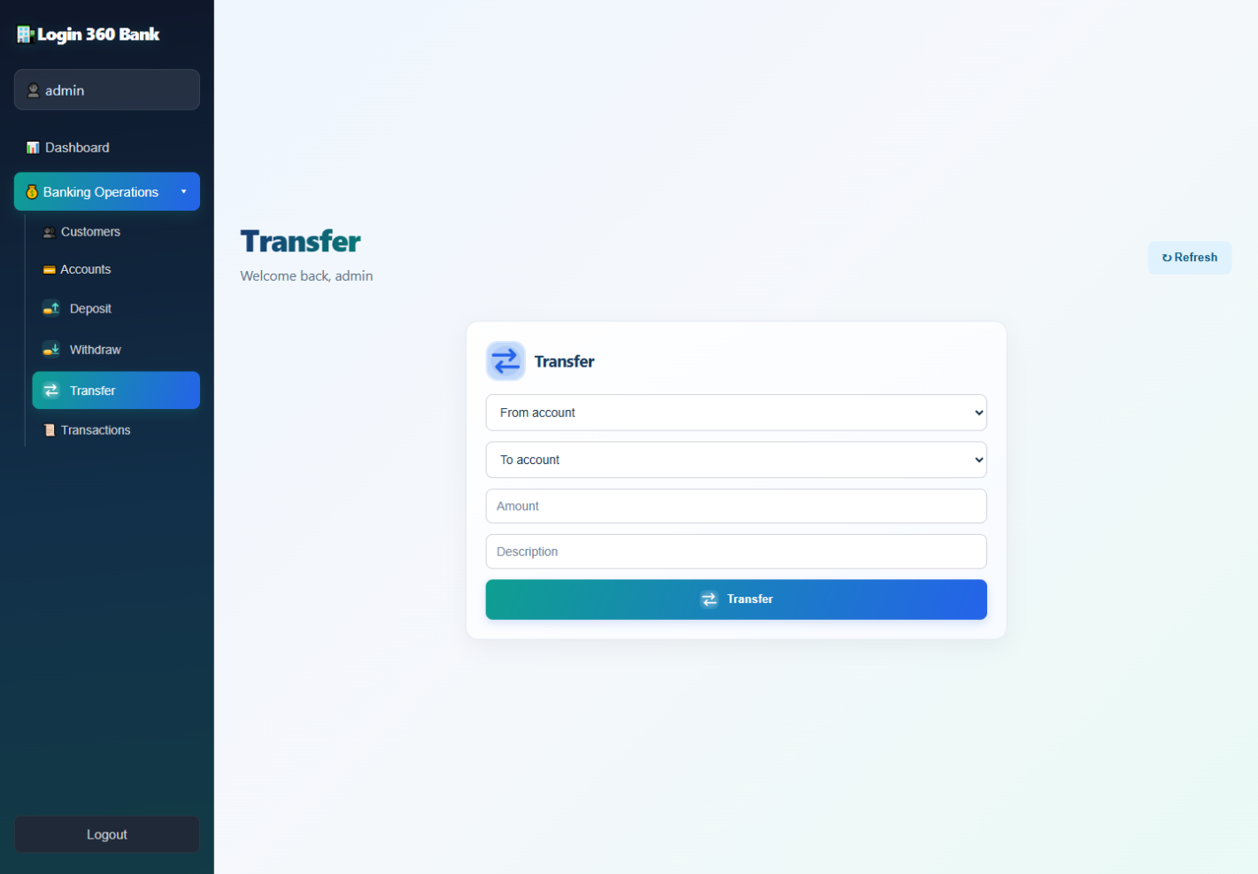
Screen file: presentation-assets/06-transfer.png

Transaction History
Application capture from the running local project. Sample names and balances shown are demonstration data.
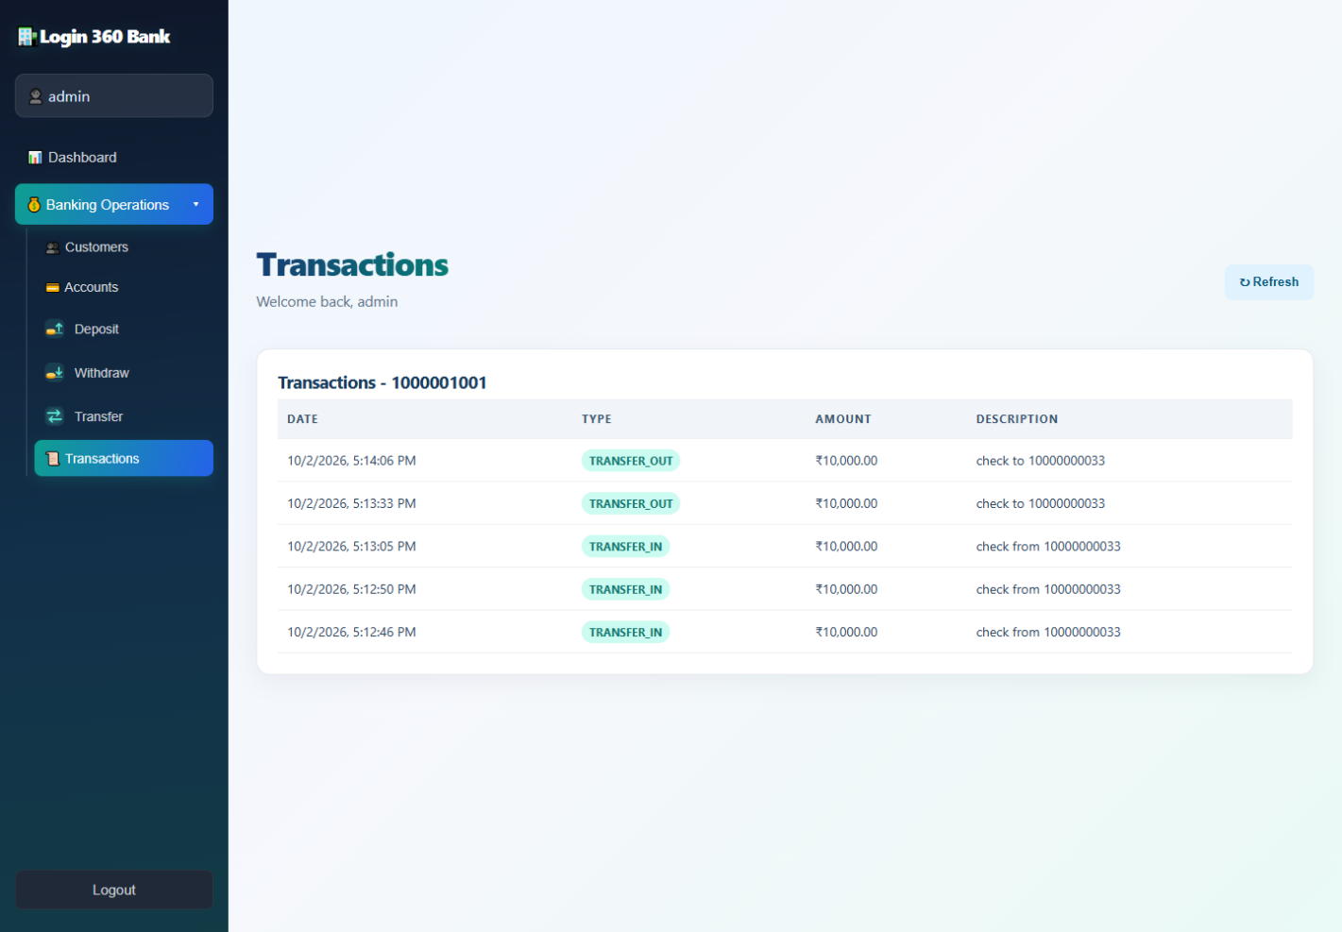
Screen file: presentation-assets/07-transactions.png

9. Future Improvements
• Connect the login form to the backend and introduce a secure session or token strategy with role-based authorization.
• Add request validation and structured API documentation, for example OpenAPI/Swagger.
• Add automated unit and integration tests for balance and transfer invariants.
• Move from the demo H2 file to a managed production-grade database where appropriate.
• Add pagination, search, date filters, downloadable statements, and clearer transaction receipts.
• Improve accessibility and responsive behavior, and add confirmation and loading states for financial operations.

Project links 2
Local frontend: http://localhost:5173/
GitHub repository: https://github.com/banupriya92/banking-management-system
Project documentation: README.md at the repository root.

