**Agile Methodology Followed**

* Sprint Planning Meeting
* User stories were created in the product backlog. The team mutually assigned work to themselves. Story points were given to User Stories for calculating development efforts involved in the project.
* Daily stand-up calls conducted
* All reports were generated at the conclusion of the sprint

**JiraBacklog:**

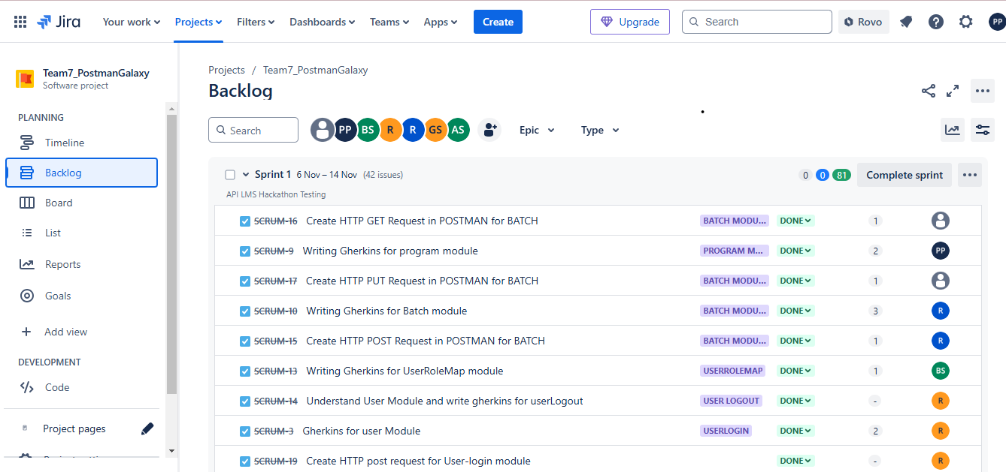

**Burndown Chart**

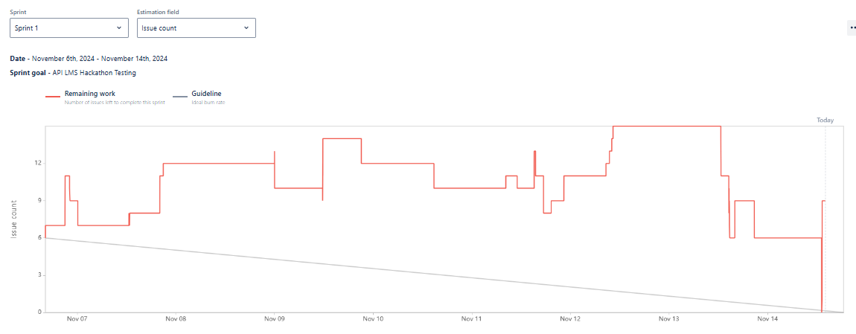

**Cumulative flow**

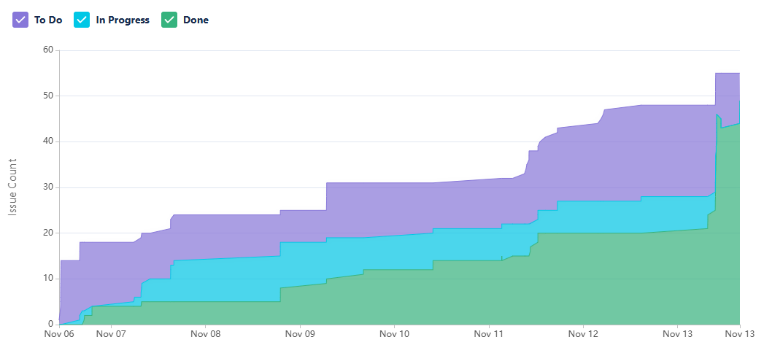

**SprintProgress**

