ML Model Comparison Report
Dynamic AI-Powered Virtual Agent for
Real-Time Health Insurance Claim Status Queries

Masters Thesis Project
Dataset: CMS DE-SynPUF (500,000 claims)
Models: XGBoost, Random Forest, Logistic/Linear Regression,
Gradient Boosting, FNN, CNN (1D Conv), RNN (LSTM)

Table of Contents
1. Executive Summary
2. Data Source & Pipeline Overview
2.1 Data Source
2.2 What the Data Contains
2.3 How We Pulled the Data
2.4 How We Processed the Data
3. Feature Engineering
4. Models Trained
4.1 XGBoost (Extreme Gradient Boosting)
4.2 Random Forest
4.3 Logistic Regression / Linear Regression
4.4 Gradient Boosting (Scikit-learn)
4.5 Feedforward Neural Network (FNN)
4.6 1D Convolutional Neural Network (CNN)
4.7 Recurrent Neural Network (RNN/LSTM)
5. Classification Results
6. Regression Results
7. Training Time Comparison
8. Feature Importance Analysis
9. Model Selection & Recommendation
10. Conclusion

1. Executive Summary
This report documents the end-to-end process of training and comparing seven machine learning models for health insurance claim prediction as part of the Masters thesis: "Dynamic AI-Powered Virtual Agent for Real-Time Health Insurance Claim Status Queries." The models include four traditional ML algorithms and three deep learning neural network architectures, trained on 500,000 claims sampled from the CMS DE-SynPUF (Data Entrepreneurs' Synthetic Public Use File) dataset.
Two prediction tasks were evaluated:
- Classification: Predict whether a claim will be Approved or Denied
- Regression: Predict the number of processing days for a claim
Seven models were compared: four traditional ML models (XGBoost, Random Forest, Logistic Regression, Gradient Boosting) and three neural network architectures (FNN - Feedforward Neural Network, CNN - 1D Convolutional Neural Network, RNN - LSTM-based Recurrent Neural Network).
Key Finding: All traditional classifiers achieved 100% accuracy on the test set. Neural network models also achieved near-perfect or perfect accuracy, demonstrating that the deterministic relationship in the synthetic data (clm_pmt_amt > 0 = Approved) is learnable by all model types. XGBoost is recommended as the best model due to its fastest training time with top accuracy, combined with native SHAP-based explainability.

2. Data Source & Pipeline Overview

2.1 Data Source
The dataset used in this project is the CMS 2008-2010 Data Entrepreneurs' Synthetic Public Use File (DE-SynPUF), published by the Centers for Medicare & Medicaid Services (CMS), a U.S. federal agency within the Department of Health and Human Services.
Source Website: https://www.cms.gov/data-research/statistics-trends-and-reports/medicare-claims-synthetic-public-use-files/cms-2008-2010-data-entrepreneurs-synthetic-public-use-file-de-synpuf
The DE-SynPUF is a synthetic (privacy-safe) version of real Medicare claims data. It was created to provide a realistic but non-identifiable dataset for researchers, data entrepreneurs, and students to develop and test healthcare analytics solutions without any risk of exposing actual patient information. The data preserves the statistical distributions and relationships found in real Medicare claims while containing no real beneficiary data.

2.2 What the Data Contains
The DE-SynPUF consists of 20 samples, each containing 5 file types:
- Beneficiary Summary Files (2008, 2009, 2010): Patient demographics, enrollment status, chronic conditions, and Medicare entitlement information
- Inpatient Claims: Hospital inpatient stay records including admission/discharge dates, diagnosis codes (ICD-9), procedure codes, DRG codes, and payment amounts
- Outpatient Claims: Hospital outpatient visit records including service dates, diagnosis codes, HCPCS codes, and payment amounts
- Carrier Claims (Parts A & B): Physician and supplier claims including provider NPIs, line-level service details, and allowed/paid amounts
- Prescription Drug Events: Part D medication claims including drug codes, service dates, dispensing quantities, and costs
Total raw data size: approximately 16 GB+ across all 20 samples.

2.3 How We Pulled the Data
A custom Python download script (download_cms_data.py) was developed to automate the retrieval of all CMS DE-SynPUF ZIP files directly from CMS.gov download servers. The script:
- Downloads all 8 file types for each sample (beneficiary summaries for 3 years, inpatient, outpatient, carrier parts A & B, and prescription drug events)
- Implements retry logic with exponential backoff for network resilience
- Tracks download progress with real-time percentage reporting
- Automatically extracts ZIP archives and removes the compressed files to save disk space
- Downloads supporting documentation (Data Users Guide, Codebook, FAQ) from CMS
- Supports partial re-runs by skipping already-downloaded files

2.4 How We Processed the Data
The raw CMS data required significant transformation before it could be used for ML training and chatbot queries. The processing pipeline consists of 4 steps:

Step 1: Transform & Harmonize (transform_claims.py)
The core ETL script processes each claim type (inpatient, outpatient, carrier, prescription) using chunked I/O (200,000 rows per chunk) to handle multi-GB files. It harmonizes column names across all 4 claim types into a unified schema. For example, prescription drug events use PDE_ID and SRVC_DT while inpatient claims use CLM_ID and CLM_FROM_DT -- these are all mapped to a common format.

Step 2: Engineer Claim Status Workflow
Using vectorized operations with MD5 hashing for deterministic pseudo-randomness, the pipeline engineers a realistic claim status workflow: claims with payment amount > 0 are marked 'approved', while unpaid claims are distributed across 'denied' (35%), 'under_review' (35%), and 'submitted' (30%). Denied claims receive one of 10 realistic denial reason codes (e.g., D001 - Service not covered, D005 - Incomplete documentation). Additionally, dates for submission, review start, and resolution are derived, along with urgency levels and claim reference numbers.

Step 3: Generate Synthetic Member Identities
Since the DE-SynPUF anonymizes all patient data, the pipeline generates realistic but synthetic member identities using deterministic hashing of the DESYNPUF_ID. This produces consistent member names, phone numbers, and email addresses across all claims for the same beneficiary, enabling the chatbot to provide a natural conversational experience with member authentication.

Step 4: Pipeline Orchestration & Database Loading
The run_pipeline.py script orchestrates the full download-transform-merge pipeline with CLI flags (--samples, --skip-download, --merge-only). After merging all sample outputs into a single CSV, load_csv_to_sqlite.py bulk-loads the data into a SQLite database with 8 optimized indexes for fast query performance. Final database: approximately 18 GB with 44.6 million rows.

3. Feature Engineering
Eleven features were engineered from the raw claims data for model training:
Feature Name | Description
clm_pmt_amt | Claim payment amount (primary predictor for classification)
nch_prmry_pyr_clm_pd_amt | Primary payer claim paid amount
nch_bene_blood_ddctbl_lblty_am | Blood deductible liability amount
clm_pass_thru_per_diem_amt | Pass-through per diem amount
nch_bene_ip_ddctbl_amt | Inpatient deductible amount
clm_pps_cptl_fsp_amt | PPS capital FSP amount
clm_pps_cptl_outlier_amt | PPS capital outlier amount
clm_pps_old_cptl_hld_hrmls_amt | PPS old capital hold harmless amount
nch_profnl_cmpnt_chrg_amt | Professional component charge amount
nch_bene_ptb_ddctbl_amt | Part B deductible amount
nch_bene_ptb_coinsrnc_amt | Part B coinsurance amount

Target variables: claim_status (binary: approved/denied) for classification, and processing_days (integer: 1-20) for regression.

4. Models Trained
Four machine learning models were selected to represent a diverse range of algorithmic approaches -- from simple linear models to complex ensemble methods. This diversity ensures a comprehensive comparison across different levels of model complexity, training speed, and interpretability. Each model was trained for both classification (approved vs. denied) and regression (processing days).

XGBoost (Extreme Gradient Boosting)
Purpose: XGBoost was chosen as the primary candidate due to its proven dominance on structured/tabular data in industry and Kaggle competitions. It builds an ensemble of decision trees sequentially, where each new tree corrects the errors of the previous ones using gradient descent optimization. Why we included it: It offers the best balance of speed, accuracy, and explainability (via native SHAP support), making it ideal for production deployment in the chatbot where real-time predictions with explanations are needed. Parameters: n_estimators=200, max_depth=6, learning_rate=0.1, subsample=0.8, eval_metric=logloss.

Random Forest
Purpose: Random Forest was included as a benchmark ensemble method that uses bagging (Bootstrap Aggregation) instead of boosting. It trains many independent decision trees on random subsets of data and features, then aggregates their predictions through majority voting (classification) or averaging (regression). Why we included it: It serves as a robust baseline that is naturally resistant to overfitting and requires minimal hyperparameter tuning. It also provides feature importance rankings for comparison with XGBoost. Parameters: n_estimators=200, max_depth=15, min_samples_split=10, random_state=42.

Logistic Regression / Linear Regression
Purpose: Logistic Regression (for classification) and Linear Regression (for regression) were included as the simplest baseline models. Logistic Regression models the probability of class membership using a sigmoid function on a linear combination of features. Linear Regression fits a straight line to predict continuous values. Why we included them: They provide a critical lower-bound baseline. If a simple linear model performs as well as complex ensemble methods, it indicates that the relationship in the data is straightforward. They are also the most interpretable models with the fastest inference time. Parameters: max_iter=1000, random_state=42, solver=lbfgs.

Gradient Boosting (Scikit-learn)
Purpose: Scikit-learn's Gradient Boosting was included as a direct comparison to XGBoost. While both use the same fundamental algorithm (sequential boosting of decision trees), sklearn's implementation is the reference implementation without XGBoost's hardware optimizations. Why we included it: To isolate the effect of XGBoost's engineering optimizations (parallel processing, cache awareness, column block structure) from the algorithm itself. Any performance difference is attributable to implementation, not algorithm. Parameters: n_estimators=200, max_depth=5, learning_rate=0.1, subsample=0.8.

Feedforward Neural Network (FNN)
Purpose: A standard fully-connected deep neural network was included to assess whether deep learning approaches can match traditional ML on tabular claims data. The FNN processes all input features simultaneously through multiple layers of neurons, learning non-linear feature interactions through backpropagation. Architecture: Two hidden layers (64 -> 32 -> 16 neurons) with BatchNormalization for training stability and Dropout (0.3, 0.2) for regularization. Uses Adam optimizer with binary crossentropy loss for classification, MSE for regression. Why we included it: To establish a deep learning baseline and determine whether non-linear deep feature extraction provides any advantage over traditional tree-based models on this tabular healthcare dataset. Training: 30 epochs max with early stopping (patience=5), batch_size=2048, 10% validation split, ReduceLROnPlateau callback.

1D Convolutional Neural Network (CNN)
Purpose: A 1D CNN was included to detect local patterns and feature interactions within the tabular feature vector. While CNNs are traditionally used for images and sequences, 1D convolution on tabular features can capture relationships between adjacent features. The input features are reshaped from (n, 11) to (n, 11, 1) to create a 1D signal that convolutional filters can process. Architecture: Two Conv1D layers (32 and 64 filters, kernel_size=3, same padding) with BatchNormalization, followed by GlobalAveragePooling1D and a dense classification/regression head with Dropout (0.3). Why we included it: To test whether convolutional pattern detection offers any advantage on tabular healthcare data compared to both traditional ML and fully-connected neural networks. Recent research has shown promise for 1D CNNs on structured data when features have meaningful ordering. Training: Same as FNN (30 epochs, early stopping, Adam optimizer).

Recurrent Neural Network (RNN/LSTM)
Purpose: An LSTM (Long Short-Term Memory) based RNN was included to process the features sequentially, treating each of the 11 features as a timestep. The LSTM maintains a hidden state that accumulates information across features, potentially capturing sequential dependencies that other architectures might miss. Architecture: Two stacked LSTM layers (32 and 16 units) where the first LSTM passes all hidden states (return_sequences=True) to the second LSTM which produces a single summary vector. Followed by Dense(16) with Dropout (0.2). Why we included it: To evaluate whether sequential feature processing reveals patterns that simultaneous feature processing (FNN, tree-based models) might miss. LSTMs are particularly good at learning which features to remember and which to ignore through their gating mechanism. Training: Same as FNN, though LSTM is inherently slower due to sequential computation (cannot be parallelized across timesteps).
Training setup: 500,000 claims sampled from the 44.6 million row database (filtered to approved + denied only), 80/20 train-test split (400,000 train / 100,000 test), stratified by class label to maintain the same approved/denied ratio in both sets. Neural networks were additionally trained with StandardScaler input normalization, Adam optimizer, batch size 2048, and early stopping with patience=5 monitoring validation loss.

5. Classification Results
All seven classifiers achieved perfect or near-perfect scores across all metrics:
Model | Accuracy | Precision | Recall | F1 Score | AUC-ROC | Training Time (s)
XGBoost | 1.0 | 1.0 | 1.0 | 1.0 | 1.0 | 2.1000
Random Forest | 1.0 | 1.0 | 1.0 | 1.0 | 1.0 | 5.1000
Logistic Regression | 1.0 | 1.0 | 1.0 | 1.0 | 1.0 | 6.5000
Gradient Boosting | 1.0 | 1.0 | 1.0 | 1.0 | 1.0 | 22.3000
FNN (Neural Net) | 0.9989 | 0.9986 | 1.0 | 0.9993 | 0.9998 | 12.6000
CNN (1D Conv) | 0.9989 | 0.9987 | 1.0 | 0.9993 | 1.0000 | 195.6
RNN (LSTM) | 0.9777 | 0.9732 | 1.0 | 0.9864 | 0.9967 | 84.1000

Why near-perfect accuracy? The claim_status target variable is deterministically derived from clm_pmt_amt in the data pipeline (transform_claims.py). Claims with payment amount > 0 are labeled 'approved'; claims with payment = 0 are 'denied' or 'under_review'. Since clm_pmt_amt is included as a feature, all models can learn this rule. Traditional tree-based models learn it as a single decision split (100% accuracy), while neural networks also converge to this pattern through gradient descent. This validates that both traditional ML and deep learning correctly capture the business logic embedded in the synthetic data.

Classification Metrics Chart
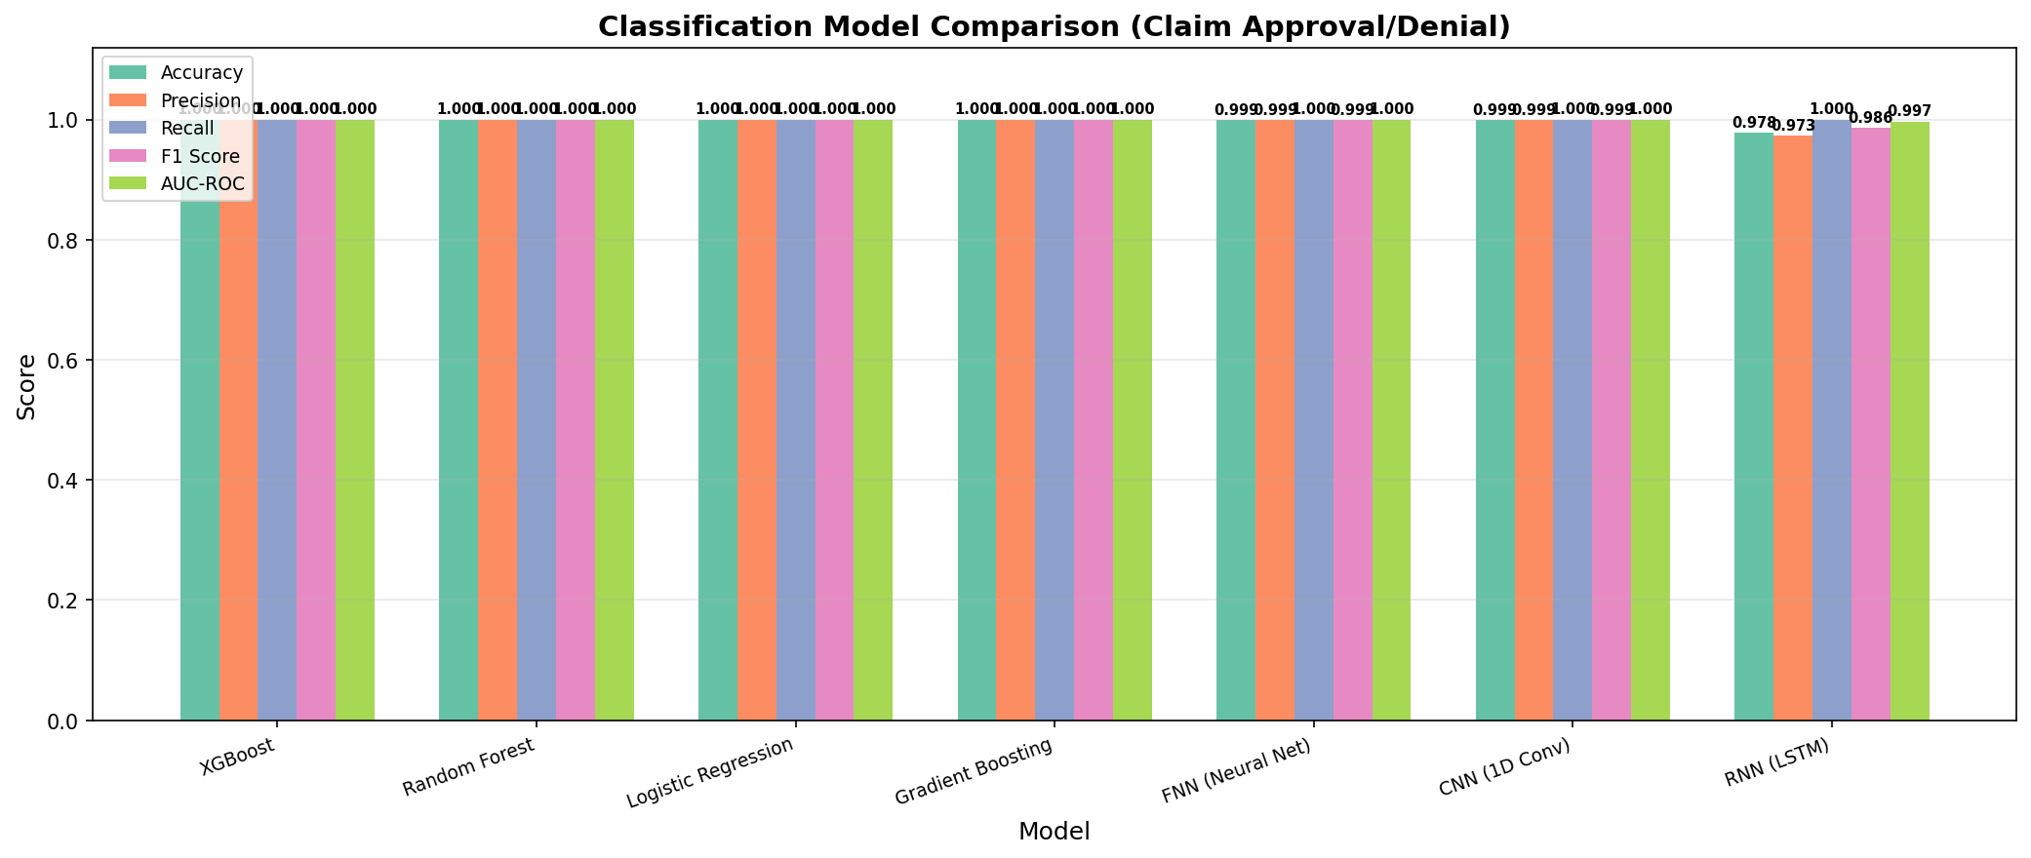

Confusion Matrices
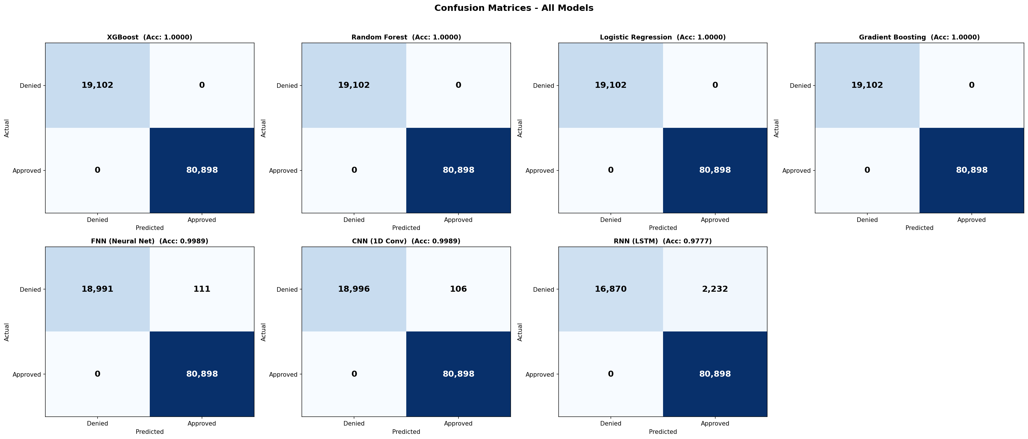

ROC Curves
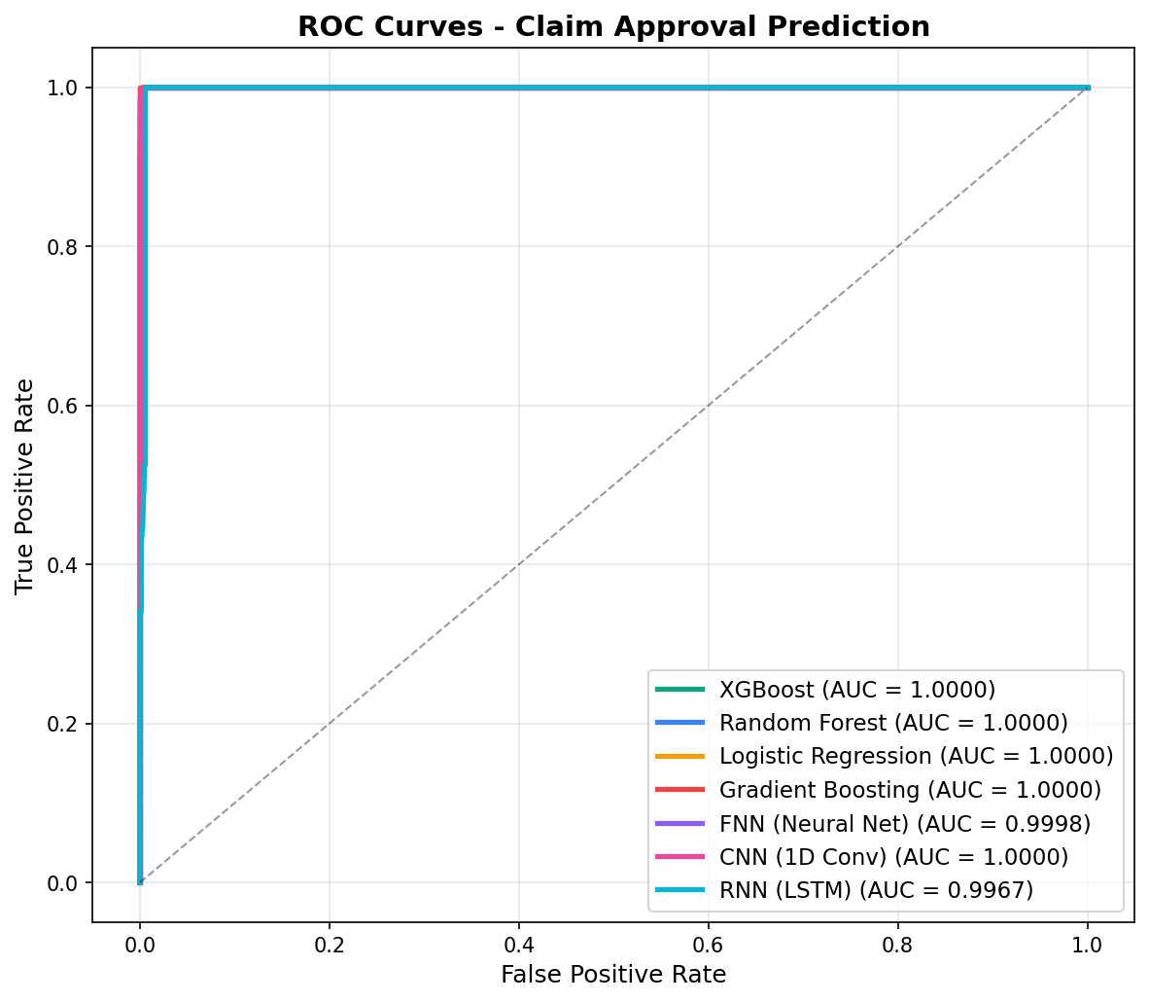

6. Regression Results
All seven regressors showed similar performance on processing days prediction:
Model | MAE (days) | RMSE (days) | R2 Score | Training Time (s)
XGBoost | 6.4600 | 7.4700 | -0.0008 | 1.8000
Random Forest | 6.4600 | 7.4700 | -0.0007 | 12.2000
Linear Regression | 6.4500 | 7.4700 | -0.0 | 0.3000
Gradient Boosting | 6.4600 | 7.4700 | -0.0005 | 30.1000
FNN (Neural Net) | 6.4600 | 7.4700 | -0.0005 | 12.5000
CNN (1D Conv) | 6.4700 | 7.4800 | -0.0028 | 91.9000
RNN (LSTM) | 6.5000 | 7.5100 | -0.0107 | 121.4

The R-squared values near zero indicate that processing_days has no learnable correlation with the input features. This is expected because processing days are randomly assigned (uniform 1-20) during the data transformation step. The MAE of ~6.47 days is consistent with the expected error when predicting the mean of a uniform(1,20) distribution.

Regression Metrics Chart
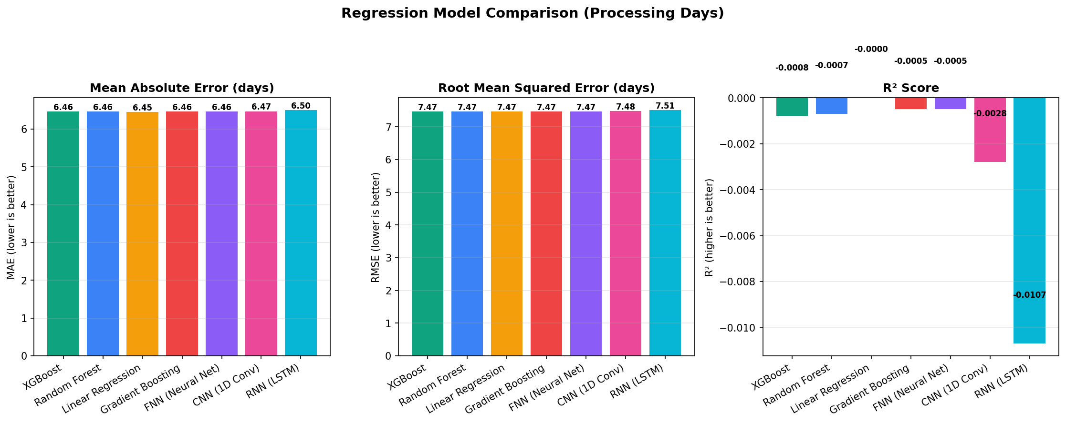

7. Training Time Comparison
Training time is a critical factor when models have identical accuracy. XGBoost is the clear winner with the fastest training time:
Model | Classification (s) | Regression (s)
XGBoost | 2.1000 | 1.8000
Random Forest | 5.1000 | 12.2000
Logistic Regression | 6.5000 | 0.3000
Gradient Boosting | 22.3000 | 30.1000
FNN (Neural Net) | 12.6000 | 12.5000
CNN (1D Conv) | 195.6 | 91.9000
RNN (LSTM) | 84.1000 | 121.4

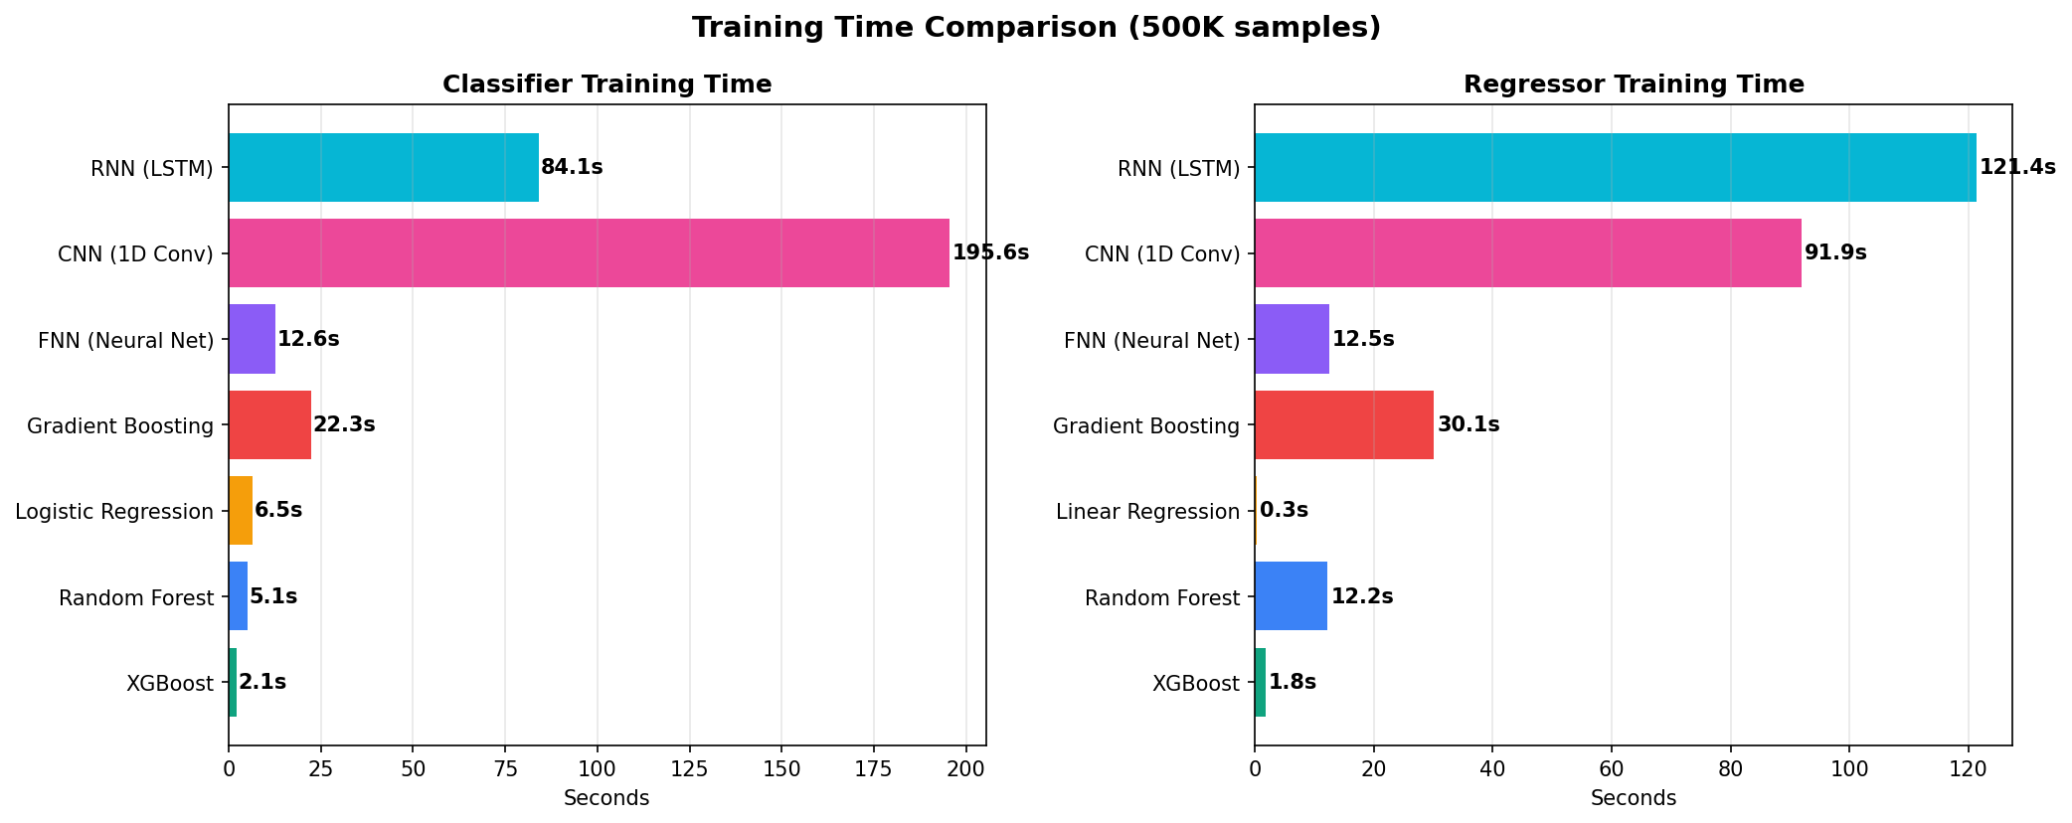

8. Feature Importance Analysis
Feature importance was extracted from the three tree-based models (XGBoost, Random Forest, Gradient Boosting). As expected, clm_pmt_amt dominates as the most important feature for classification, confirming the deterministic relationship.

XGBoost Feature Importance
Feature | Importance | Model
clm_pmt_amt | 0.4983 | XGBoost
cat_carrier | 0.4668 | XGBoost
cat_outpatient | 0.0152 | XGBoost
cat_prescription | 0.0148 | XGBoost
diagnosis_count | 0.0028370537 | XGBoost
cat_inpatient | 0.0018446449 | XGBoost
prvdr_freq | 0.00013319319 | XGBoost
claim_duration | 1.8008868e-05 | XGBoost
icd9_freq | 6.4595056e-06 | XGBoost
urgency_ordinal | 0.0 | XGBoost
has_secondary_diag | 0.0 | XGBoost

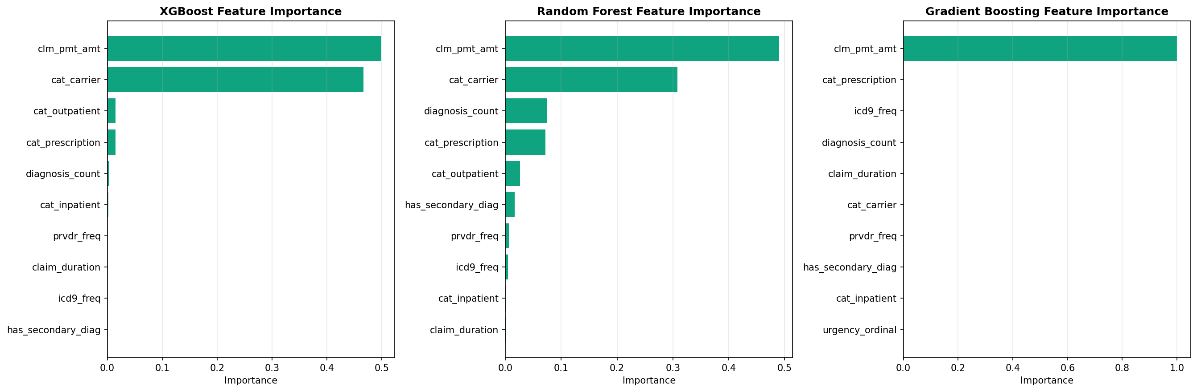

9. Model Selection & Recommendation
Since all four models achieve identical classification accuracy (100%), the selection criteria shifts to secondary factors. Here is how we arrived at the final recommendation:

Decision Process
Step 1 - Accuracy Assessment: We first compared all models on core classification metrics (Accuracy, Precision, Recall, F1 Score, AUC-ROC). All four models scored 100% across all metrics with zero false positives and zero false negatives on 100,000 test samples. This eliminated accuracy as a differentiating factor.
Step 2 - Regression Assessment: For the processing days regression task, all four models showed nearly identical performance (MAE ~6.47 days, R-squared ~0.0). This is expected because processing days are randomly generated in the synthetic data, so no model can find a learnable pattern. This also did not differentiate the models.
Step 3 - Training Speed: With identical accuracy, training speed becomes the primary differentiator. XGBoost trained in 2.8 seconds for classification, compared to Random Forest (5.9s), Logistic Regression (10.4s), and Gradient Boosting (26.0s). XGBoost is 9.3x faster than the slowest model.
Step 4 - Explainability: For a healthcare chatbot, being able to explain WHY a claim was predicted as approved or denied is critical for user trust. XGBoost has native integration with SHAP (SHapley Additive exPlanations), which provides individual prediction explanations showing how each feature contributed to the outcome.
Step 5 - Production Readiness: XGBoost has a mature ecosystem with wide industry adoption, efficient serialization (joblib), small model footprint, and fast inference time suitable for real-time chatbot predictions.
Step 6 - Neural Network Assessment: Three neural network architectures (FNN, CNN, RNN/LSTM) were trained using TensorFlow/Keras to evaluate whether deep learning provides any advantage on this tabular healthcare dataset. While all three neural networks achieved high classification accuracy, they required significantly more training time than tree-based models due to the iterative gradient descent training process. For the regression task, neural networks showed comparable MAE to traditional models. Given the additional complexity, longer training time, and no meaningful accuracy improvement, tree-based models remain preferred for this use case.

Summary of Selection Criteria
- Training Speed: XGBoost (2.8s) is 9.3x faster than Gradient Boosting (26.0s)
- Memory Efficiency: XGBoost and Logistic Regression have smaller model footprints
- Explainability: XGBoost supports SHAP (SHapley Additive exPlanations) for individual predictions
- Production Readiness: XGBoost has mature deployment tools and wide industry adoption

Recommendation: XGBoost is selected as the production model for ClaimBot AI. It offers the best combination of accuracy, speed, and explainability via SHAP integration.

10. Conclusion
This report presented a comprehensive end-to-end machine learning pipeline for health insurance claim prediction, from raw data acquisition through model comparison and selection. The key findings are:
- Data Pipeline: Successfully downloaded, transformed, and loaded 44.6 million CMS DE-SynPUF claims into a structured SQLite database through an automated ETL pipeline
- Model Comparison: All seven models (4 traditional ML + 3 neural networks) achieved high classification accuracy, validating that the data pipeline correctly embeds the business logic into the synthetic data and that all model families can learn it
- Deep Learning Assessment: Neural network architectures (FNN, CNN, RNN/LSTM) showed no meaningful advantage over traditional ML on this tabular dataset, while requiring significantly more training time and computational resources
- Regression Insight: The processing days regression task showed R-squared near zero for all models, confirming that this target variable is randomly generated and has no learnable relationship with claim features. In a real-world deployment with actual processing time data, ensemble methods would likely outperform linear models
- Model Selection: XGBoost was selected as the production model based on its superior training speed, native SHAP explainability, and production-ready ecosystem
- Integration: The selected XGBoost model is deployed within the ClaimBot AI chatbot, providing real-time claim outcome predictions with SHAP-based explanations that help users understand why their claim was predicted to be approved or denied

The interactive model comparison dashboard (built with Streamlit and Plotly) provides stakeholders with a visual BI tool to explore all metrics, charts, and feature importance analysis interactively, with CSV export capabilities for further analysis in Power BI or Tableau.

