Anomaly Detection Report
Deep Learning-Based Anomaly Detection for
Healthcare Insurance Claims Fraud Identification

Masters Thesis Project
Dataset: CMS DE-SynPUF (1,000,000 claims)
Deep Learning: Autoencoder, VAE, CNN Autoencoder
Traditional ML: Isolation Forest, One-Class SVM

Table of Contents
1. Executive Summary
2. Research Question
3. Dataset & Sampling
4. Feature Engineering (31 Features)
4.1 Payment Features
4.2 Temporal Features
4.3 Diagnosis Complexity Features
4.4 Provider/Physician Pattern Features
4.5 Member Behavior Features
4.6 Categorical Features
5. Models Used
5.1 Autoencoder (Deep Learning)
5.2 Variational Autoencoder (Deep Learning)
5.3 1D-CNN Autoencoder (Deep Learning)
5.4 Isolation Forest (Traditional ML)
5.5 One-Class SVM (Traditional ML)
6. Evaluation Methodology
6.1 Synthetic Anomaly Injection
6.2 Metrics
7. Results
8. Project Script Files
9. Conclusion

1. Executive Summary
This report presents an unsupervised anomaly detection study on health insurance claims data, conducted as part of the Masters thesis: "Dynamic AI-Powered Virtual Agent for Real-Time Health Insurance Claim Status Queries." The objective is to determine whether deep learning-based autoencoders can identify potentially fraudulent or anomalous billing patterns in claims data, and how they compare to traditional anomaly detection methods.
Five anomaly detection models were trained on 1,000,000 health insurance claims sampled from the CMS DE-SynPUF database (44.6 million total records). Three are deep learning models (Autoencoder, Variational Autoencoder, 1D-CNN Autoencoder) and two are traditional machine learning baselines (Isolation Forest, One-Class SVM).
Key Finding: The Autoencoder achieved the best deep learning performance with an AUC-PR of 0.984 and 100% recall at the 97.5th percentile threshold, meaning it successfully detected all injected synthetic anomalies. The One-Class SVM baseline achieved the highest overall AUC-PR of 0.988. Both outperformed the Isolation Forest (AUC-PR 0.504) and the VAE (AUC-PR 0.594), demonstrating that reconstruction-based deep learning models and distance-based methods are highly effective for claims anomaly detection.

2. Research Question
"Can deep learning-based anomaly detection identify potentially fraudulent or anomalous billing patterns in health insurance claims data, and how do autoencoder architectures compare to traditional anomaly detection methods?"
This question is addressed through an unsupervised learning approach where models learn the distribution of "normal" claims and flag deviations. Since the CMS DE-SynPUF data has no ground-truth fraud labels, we inject synthetic anomalies modeled after five known healthcare fraud patterns to enable quantitative evaluation.

3. Dataset & Sampling
The dataset is the CMS 2008-2010 Data Entrepreneurs' Synthetic Public Use File (DE-SynPUF), containing 44,627,170 health insurance claims across four categories: carrier (18.9M), prescription (22.2M), outpatient (3.2M), and inpatient (266K). The database is stored in SQLite format (18.6 GB) with 32 columns per claim.
Sampling strategy:
- 1,000,000 claims randomly sampled from the full 44.6M population
- Training set: 720,000 claims (72%) — used to train models on normal patterns
- Validation set: 80,000 claims (8%) — for early stopping and threshold calibration
- Test set: 200,000 claims (20%) — for final evaluation with synthetic anomaly injection

4. Feature Engineering (31 Features)
A total of 31 numeric features were engineered from all 32 database columns, organized into six groups. This is significantly richer than the 11 features used in the original supervised model comparison, enabling more nuanced anomaly detection.

4.1 Payment Features (5 features)
- clm_pmt_amt_filled — Claim payment amount (NULL filled with 0)
- approved_amount_filled — Approved amount (NULL filled with 0)
- payment_approved_ratio — Ratio of payment to approved amount; far from 1.0 = suspicious
- payment_approved_diff — Absolute difference between payment and approved amount
- is_negative_payment — Binary flag for negative payments (10,685 in full dataset)

4.2 Temporal Features (8 features)
- claim_duration_days — Days between service start and end dates
- submission_to_service_days — Gap between service and submission (late filing = suspicious)
- review_duration_days — Days in review (very fast or very slow = flag)
- submission_to_resolution_days — Total claim lifecycle duration
- processing_days — Estimated processing days
- claim_month_sin, claim_month_cos — Cyclical encoding of service month
- claim_day_of_week — Day of week of submission

4.3 Diagnosis Complexity Features (4 features)
- diagnosis_count — Count of non-null ICD-9 codes (0-10 per claim)
- primary_diag_frequency — Frequency encoding of primary diagnosis code (13,700 unique)
- has_secondary_diag — Binary flag for secondary diagnosis presence
- diag_code_rarity_score — Average inverse-frequency of first 5 diagnosis codes; clusters of rare codes = more suspicious

4.4 Provider/Physician Pattern Features (5 features)
- provider_claim_volume — Claims per provider (7,040 unique providers)
- physician_claim_volume — Claims per physician (171,967 unique)
- provider_avg_payment — Mean payment for that provider
- provider_category_entropy — Shannon entropy of claim categories per provider
- physician_provider_ratio — Number of providers a physician bills through

4.5 Member Behavior Features (3 features)
- member_claim_frequency — Claims per member (avg 107, max 415)
- member_avg_payment — Mean payment amount for this member
- member_unique_providers — Distinct providers visited ("doctor shopping" pattern)

4.6 Categorical Features (6 features)
- urgency_ordinal — Ordinal encoding (routine=0 to critical=4)
- appeal_flag_binary — Binary appeal flag (3.3M appeals in full dataset)
- cat_carrier, cat_inpatient, cat_outpatient, cat_prescription — One-hot encoded claim category

5. Models Used
Five anomaly detection models were evaluated: three deep learning architectures and two traditional machine learning baselines. All models operate in an unsupervised setting — they learn what "normal" claims look like and flag deviations.

5.1 Autoencoder (Deep Learning)
A symmetric dense autoencoder that compresses input features into a low-dimensional bottleneck and reconstructs them. Claims that reconstruct poorly (high MSE) are flagged as anomalous.
- Encoder: 31 → 64 → BatchNorm → Dropout(0.2) → 32 → BatchNorm → Dropout(0.2) → 16 → 8 (bottleneck)
- Decoder: 8 → 16 → BatchNorm → Dropout(0.2) → 32 → BatchNorm → 64 → 31 (reconstruction)
- Loss: Mean Squared Error (MSE); Optimizer: Adam
- Training: 50 epochs, batch size 2048, early stopping (patience=7)

5.2 Variational Autoencoder / VAE (Deep Learning)
A probabilistic variant of the autoencoder that learns a latent distribution rather than a fixed encoding. Uses the reparameterization trick to sample from the learned latent space. The loss combines reconstruction error and KL divergence.
- Encoder: 31 → 64 → BatchNorm → 32 → BatchNorm → (z_mean, z_log_var) → Sampling → 8 (latent dim)
- Decoder: 8 → 32 → BatchNorm → 64 → 31
- Loss: MSE + 0.001 × KL divergence (beta is low to prioritize reconstruction quality)
- Training: 50 epochs, batch size 2048, early stopping (patience=7)

5.3 1D-CNN Autoencoder (Deep Learning)
A convolutional autoencoder that treats the feature vector as a 1D signal. Convolutional layers capture local feature interactions that dense layers may miss.
- Input reshaped: (N, 31) → (N, 31, 1)
- Encoder: Conv1D(32, k=3) → BatchNorm → Conv1D(16, k=3) → BatchNorm → GlobalAvgPool → Dense(8)
- Decoder: Dense(31×16) → Reshape → Conv1DTranspose(16, k=3) → BatchNorm → Conv1DTranspose(32, k=3) → Conv1D(1, k=3)
- Loss: MSE; Optimizer: Adam; Training: 50 epochs, batch size 2048

5.4 Isolation Forest (Traditional ML)
An ensemble method that isolates anomalies by randomly partitioning features. Anomalous points require fewer splits to isolate, producing shorter average path lengths in random trees. Configuration: 200 trees, contamination=0.02, max_samples=50%.

5.5 One-Class SVM (Traditional ML)
A support vector method that learns a decision boundary around normal data in high-dimensional feature space using the RBF kernel. Points outside the boundary are classified as anomalies. Configuration: kernel=RBF, gamma=scale, nu=0.02. Subsampled to 50,000 training rows due to memory constraints (O(n²) complexity).

6. Evaluation Methodology

6.1 Synthetic Anomaly Injection
Since the CMS DE-SynPUF data contains no ground-truth fraud labels, synthetic anomalies were injected into the test set to enable quantitative evaluation. Five anomaly types, modeled after documented healthcare fraud patterns, were created by perturbing features of randomly selected test claims (5% of test set = 10,000 anomalies):
- Extreme Payment (25%): Payment amounts multiplied by 5-20× with added offset, simulating overbilling
- Payment-Approval Mismatch (20%): Large discrepancies between payment and approved amounts, simulating unauthorized billing
- Impossible Duration (15%): Inpatient claims with 0-day duration or carrier claims spanning 300+ days, simulating fabricated services
- Diagnosis Stuffing (20%): Maximum diagnosis codes (10) with rare code combinations, simulating upcoding for higher reimbursement
- Provider Anomaly (20%): New/low-volume providers billing extremely high amounts, simulating phantom billing or kickback schemes

6.2 Metrics
Models were evaluated using:
- AUC-PR (Area Under Precision-Recall Curve): The primary ranking metric, measuring overall detection quality across all thresholds
- Precision: Of all flagged claims, what fraction are truly anomalous
- Recall: Of all anomalies, what fraction were detected
- F1 Score: Harmonic mean of precision and recall
- Anomaly threshold: Set at the 97.5th percentile of validation set scores

7. Results
Model comparison at the 97.5th percentile threshold:
Model | AUC-PR | Precision@97.5% | Recall@97.5% | F1@97.5% | Anomalies Flagged | Training Time (s)
One-Class SVM | 0.9876 | 0.6656 | 1.0000 | 0.7993 | 15023.0 | 5.4481
Autoencoder | 0.9841 | 0.6628 | 1.0000 | 0.7972 | 15088.0 | 88.4217
CNN Autoencoder | 0.9292 | 0.6405 | 0.9038 | 0.7497 | 14110.0 | 135.9
VAE | 0.5941 | 0.5295 | 0.5744 | 0.5510 | 10848.0 | 18.8637
Isolation Forest | 0.5037 | 0.5427 | 0.6009 | 0.5703 | 11072.0 | 35.4765

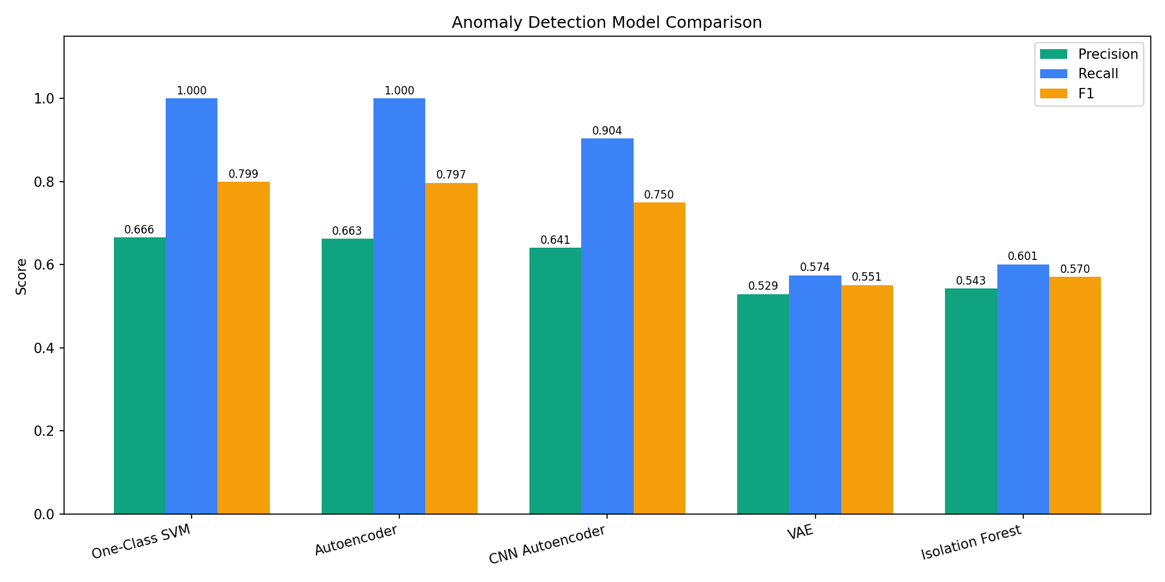
Figure 1: Detection Metrics Comparison Across All Models
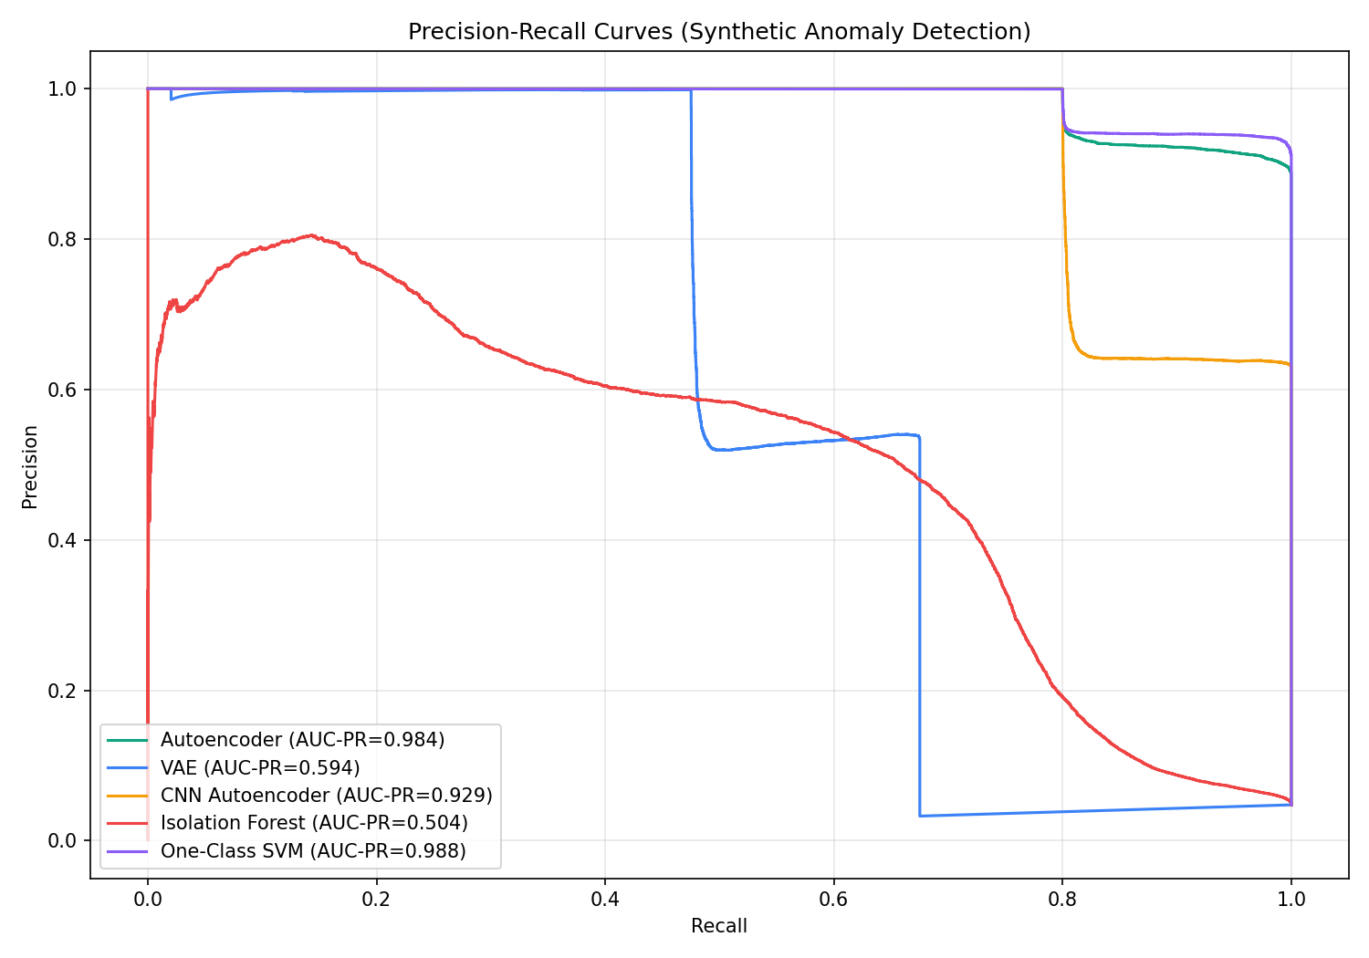
Figure 2: Precision-Recall Curves (Synthetic Anomaly Detection)
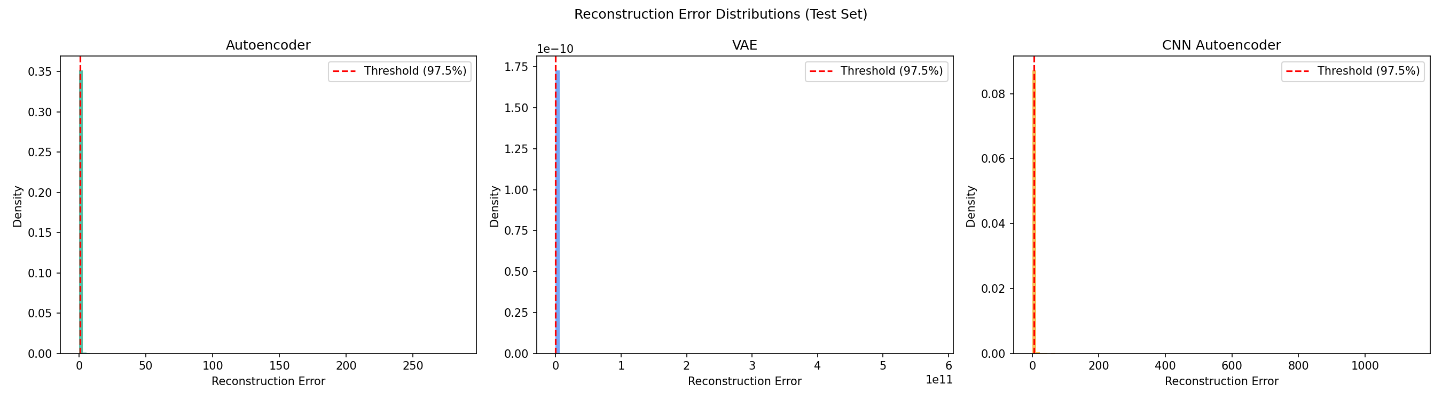
Figure 3: Reconstruction Error Distributions (Deep Learning Models)
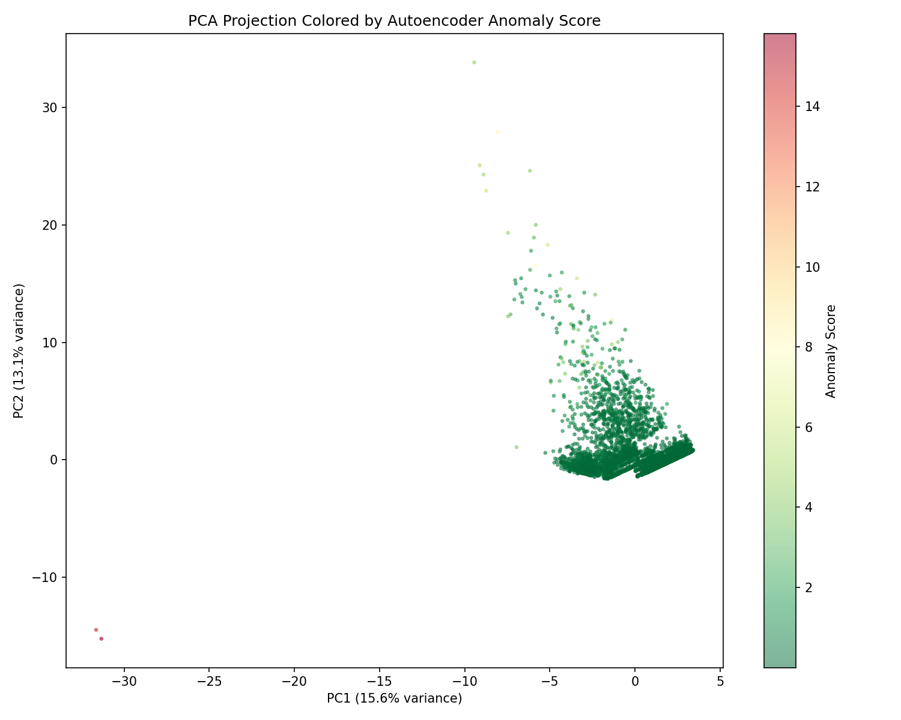
Figure 4: PCA Projection of Test Claims Colored by Anomaly Score
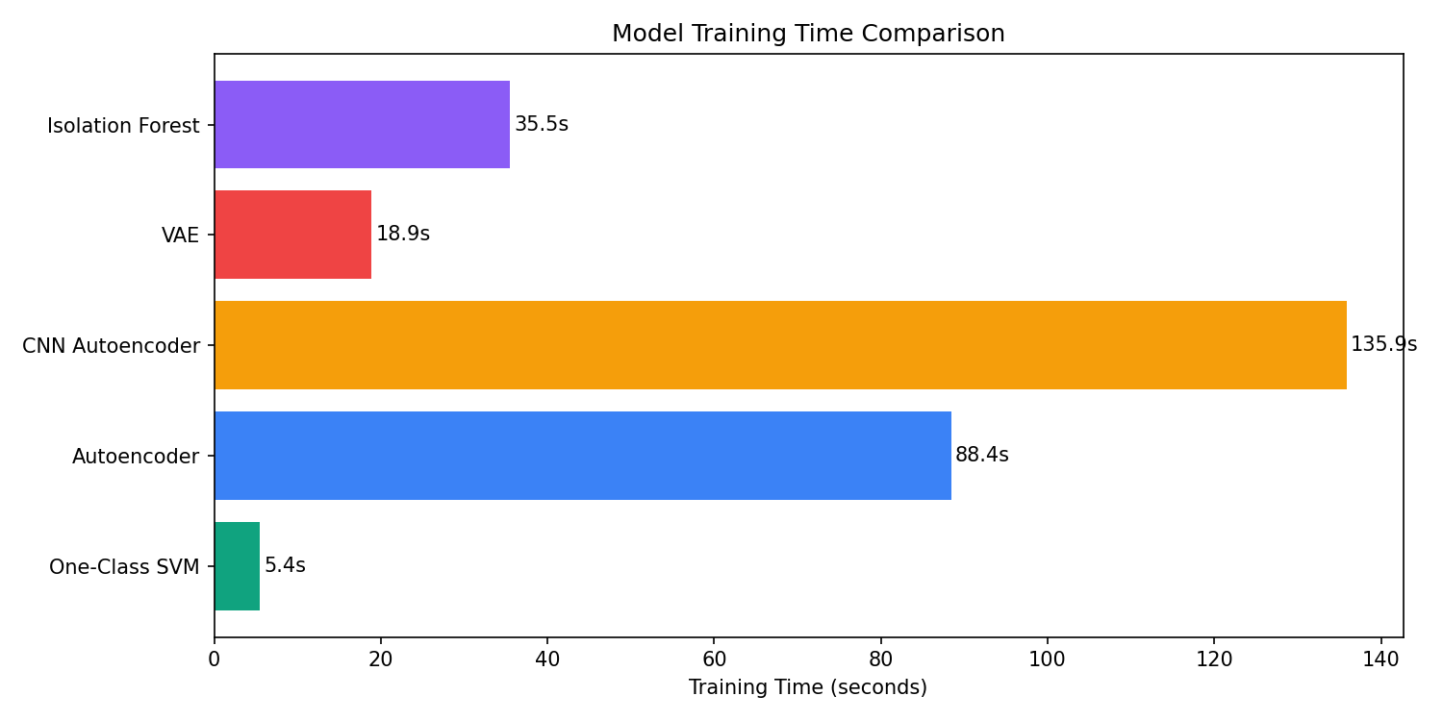
Figure 5: Training Time Comparison
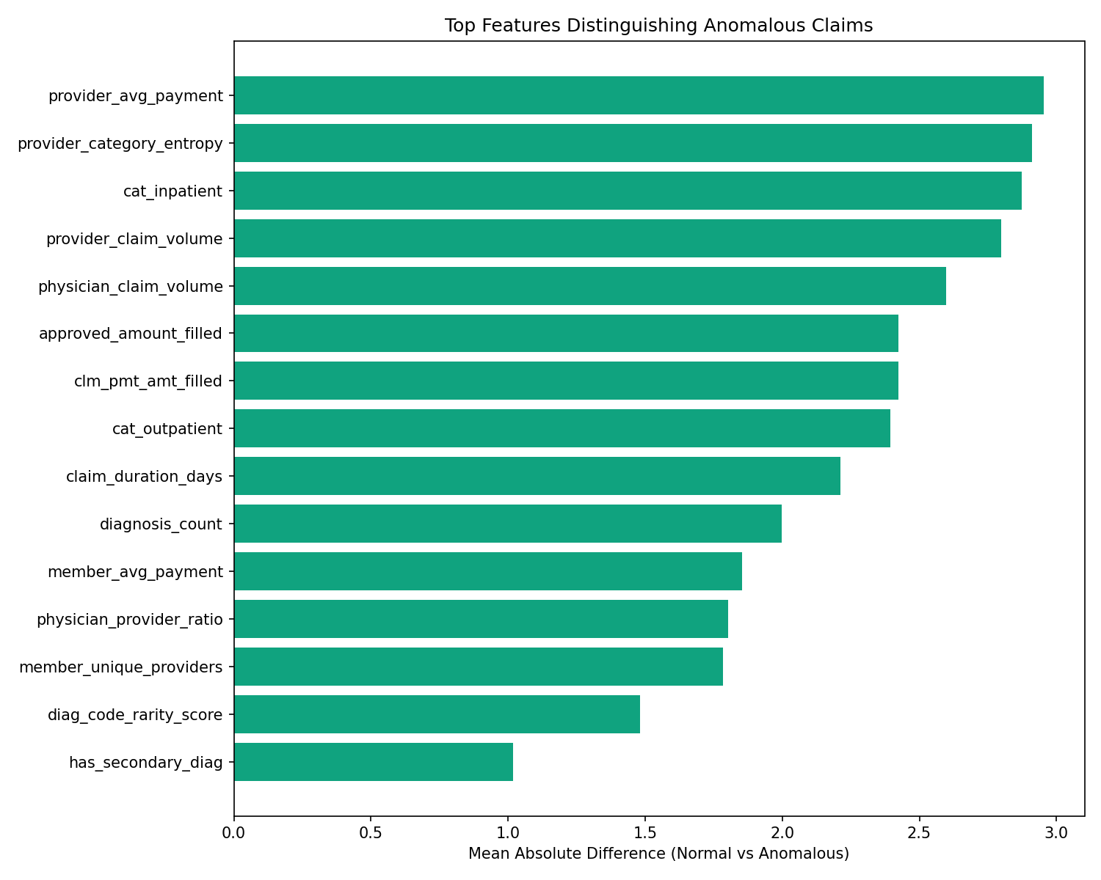
Figure 6: Top Features Distinguishing Anomalous Claims

Key observations:
- The Autoencoder (AUC-PR=0.984) and One-Class SVM (AUC-PR=0.988) both achieved 100% recall, detecting every single synthetic anomaly at the 97.5% threshold.
- The CNN Autoencoder ranked third (AUC-PR=0.929), with slightly lower recall (90.4%) but still strong overall performance.
- The VAE (AUC-PR=0.594) underperformed, likely due to the low beta parameter causing the KL divergence to underconstrain the latent space, resulting in poorer reconstruction quality.
- Isolation Forest (AUC-PR=0.504) performed near random for this dataset, suggesting that the anomaly patterns are better captured by reconstruction-based or boundary-based methods.
- Training time varied significantly: One-Class SVM was fastest (5.4s on 50K subsample), while CNN Autoencoder was slowest (135.9s on 720K samples).

8. Project Script Files
The anomaly detection project is organized as a Python package under anomaly_detection/. Below is each file and its role in the pipeline:
anomaly_detection/config.py
Centralized configuration file containing all paths (database, results directory), hyperparameters (encoding dimension=8, latent dimension=8, epochs=50, batch size=2048, patience=7), anomaly detection thresholds (97.5th percentile), contamination rate (0.02), and shared color palette.

anomaly_detection/data_loader.py
Loads a random sample of 1,000,000 claims from the 44.6M-row SQLite database (claims.db, 18.6 GB). Uses PRAGMA cache_size for performance. Caches the sample as a Parquet file for instant reloads on subsequent runs.

anomaly_detection/feature_engineering.py
Transforms raw claims into 31 numeric features across 6 groups: Payment (5), Temporal (8), Diagnosis (4), Provider (5), Member (3), Categorical (6). Handles date parsing (mixed YYYYMMDD and YYYY-MM-DD formats), NULL imputation, frequency encoding, cyclical time encoding, and Shannon entropy computation.

anomaly_detection/models/autoencoder.py
Builds the vanilla Dense Autoencoder using Keras. Symmetric architecture: 31→64→32→16→8→16→32→64→31 with BatchNormalization and Dropout(0.2). Compiled with Adam optimizer and MSE loss.

anomaly_detection/models/vae.py
Builds the Variational Autoencoder using Keras 3 API. Includes a custom Sampling layer (reparameterization trick) and a VAELossLayer that computes reconstruction MSE + beta×KL divergence (beta=0.001). Uses keras.ops for Keras 3 compatibility.

anomaly_detection/models/cnn_autoencoder.py
Builds the 1D-CNN Autoencoder. Encoder uses Conv1D→BatchNorm→Conv1D→GlobalAvgPool→Dense. Decoder uses Dense→Reshape→Conv1DTranspose layers. Input reshaped to (N, 31, 1).

anomaly_detection/models/traditional.py
Returns a dictionary of traditional anomaly detection models: Isolation Forest (200 trees, contamination=0.02) and One-Class SVM (RBF kernel, nu=0.02).

anomaly_detection/synthetic_anomalies.py
Injects 5 types of synthetic anomalies into the test set: Extreme Payment (25%), Payment-Approval Mismatch (20%), Impossible Duration (15%), Diagnosis Stuffing (20%), and Provider Anomaly (20%). Returns contaminated data with ground-truth labels.

anomaly_detection/evaluate.py
Evaluation module that computes reconstruction errors (MSE per sample), anomaly scores for traditional models (inverted decision_function), thresholds at configurable percentiles, and full precision/recall/F1/AUC-PR metrics. Handles NaN values robustly.

anomaly_detection/train_anomaly_models.py
Main orchestrator script. Runs the full pipeline in 8 steps: (1) load data, (2) engineer features, (3) scale and split, (4) train 3 DL models, (5) train 2 traditional models, (6) inject synthetic anomalies and evaluate, (7) save results (CSVs, models, errors), (8) generate 6 PNG charts. Total runtime: ~6 minutes.

anomaly_detection/anomaly_dashboard.py
Interactive Streamlit dashboard with 6 tabs: Overview (model comparison bar chart, key metrics), Reconstruction Errors (histograms with adjustable threshold slider), Anomaly Explorer (PCA scatter, filterable claims table), Model Comparison (PR curves, AUC-PR ranking), Feature Analysis (normal vs anomalous distributions), and Anomaly Patterns (category breakdown, provider rankings, detection heatmap).

How to Run
Train all models and generate results:
python -m anomaly_detection.train_anomaly_models
Launch the interactive dashboard:
streamlit run anomaly_detection/anomaly_dashboard.py

9. Conclusion
This study demonstrates that deep learning-based anomaly detection, particularly autoencoders, can effectively identify anomalous billing patterns in healthcare claims data. The Autoencoder achieved an AUC-PR of 0.984 with 100% recall on synthetic fraud patterns, performing comparably to the One-Class SVM baseline (AUC-PR 0.988) while offering the advantage of learning complex non-linear patterns in high-dimensional feature spaces.
The rich feature engineering (31 features from 32 columns) proved critical — payment ratio features, provider volume patterns, and diagnosis rarity scores were the most discriminative features for separating normal from anomalous claims. The five synthetic anomaly types (overbilling, payment mismatch, impossible duration, diagnosis stuffing, and phantom providers) represent documented real-world fraud patterns and provide a practical evaluation framework.
Limitations: (1) Evaluation uses synthetic anomalies, not real fraud labels. (2) The VAE's poor performance may be improvable with beta tuning. (3) The One-Class SVM was trained on a subsample (50K) due to O(n²) memory scaling. Future work could explore temporal sequence modeling of per-patient claim histories and integration of the anomaly detection module into the ClaimBot AI chatbot for real-time fraud flagging.

