Technical Assessment -- Implementation Approach

1. Requirements Analysis and Technical Planning
I have Reviewed and understood the requirements in the technical assessment document received.
Shared the assessment document with ChatGPT for requirements analysis and technical planning using the following prompts.

Prompt 1 -- Requirements Review and Technical Architecture
I have received a technical assessment from my client and want to implement it using Cursor AI. Please review the requirements and recommend the best technical architecture and technology stack to build the application.
Goal: Develop a well-structured, scalable, and maintainable solution using AI-assisted development while following best practices.
Action/Correction: The initial recommendation considered IEventPublisher with an in-memory event publisher. I rejected this response because I wanted to integrate Azure Service Bus to demonstrate cloud integration for the messaging service.

Prompt 2 -- Azure Service Bus Integration
Can we consider integrating Azure Service Bus instead of relying solely on in-memory event publishing? Please evaluate its suitability and recommend the best integration approach for our existing architecture.
Goal: Implement a scalable, reliable, and loosely coupled event-driven architecture using Azure Service Bus for publishing TicketCreated events.
Action/Correction: The plan was updated to include Azure Service Bus, but the suggested authentication used DefaultAzureCredential or Azure CLI (az login). I rejected that setup for this assessment because I did not want to authenticate using my personal Azure account in the local AI-assisted development workflow. I selected a dedicated Send-only SAS connection string to restrict the application to message-publishing permissions. This was a project-specific decision, not a claim that SAS is inherently more secure than Microsoft Entra ID.

Prompt 3 -- Secure Azure Service Bus Configuration
For Azure Service Bus integration, use a dedicated Send-only SAS connection string instead of DefaultAzureCredential or Azure CLI (az login). Securely store sensitive credentials using environment variables or .NET User Secrets (Secret Manager) during local development. For production, use Azure Key Vault for centralized secret management. Ensure no credentials are hardcoded, logged, or committed to source control.
Goal: Implement secure Azure Service Bus message publishing while protecting my personal Azure account, enforcing least-privilege access, and following environment-specific secret management best practices.
Action/Correction: The response was revised, but storing sensitive connection strings in appsettings.json was still suggested. I rejected that approach and chose environment variables or .NET User Secrets (Secret Manager) for local development, keeping credentials outside the Git repository and out of Cursor prompts and application logs. For a future production deployment, the configuration can use Azure Key Vault.

Prompt 4 -- Technical Specification and Implementation Plan
Please create two professional Markdown documents, SPEC.md and PLAN.md, based on the client's assessment requirements and our finalized technical architecture. Include functional and technical specifications, architecture decisions, implementation phases, testing strategy, and acceptance criteria.
Goal: Establish clear, structured technical documentation to guide Cursor AI development, ensure consistent implementation, and track progress against the client's requirements.
Action/Outcome: SPEC.md and PLAN.md were prepared and subsequently revised to version 2.0 to document the selected architecture, mandatory Azure Service Bus publishing, implementation sequence, testing, and acceptance criteria.

Prompt 5 -- High-Level Technical Architecture Diagram
Please design a professional, enterprise-grade high-level technical architecture diagram using official technology and Azure service icons. Include all finalized components, their integrations, data flow, and event publishing workflow, ensuring alignment with our SPEC.md and PLAN.md.
Goal: Create a clear, visually appealing, and technically accurate architecture diagram that demonstrates the overall solution design, component interactions, and Azure integrations for client review and presentation.
Action/Outcome: A high-level technical architecture diagram was prepared and simplified to communicate the API, AI analysis, SQLite persistence, Azure Service Bus queue publishing, and verification flow for client review.

Prompt 6 -- Implementation Review and Verification
Review the implemented Support Ticket Intake & AI Triage API against the approved specification. Validate API responses, SQLite persistence, AI classification, Azure Service Bus event publishing, and error handling. Identify any gaps or improvements before final submission.
Goal: Verify alignment with the client requirements and demonstrate critical review of AI-assisted development through testing and validation.
Action/Outcome: Manual screenshots provide evidence of successful ticket creation (HTTP 201), ticket retrieval and listing (HTTP 200), SQLite ticket and analysis persistence, and a TicketCreated event visible in Azure Service Bus. The screenshots do not independently establish passing automated tests, all error-handling scenarios, or a non-destructive Peek verification. Any additional review corrections should be recorded only after they are performed.

Engineering Decision Summary
Azure Service Bus instead of in-memory publishing — Demonstrate real Azure messaging integration.
Dedicated Send-only SAS connection string — Restrict application permissions and avoid using a personal Azure CLI login in local development.
.NET User Secrets / environment variables — Keep local credentials outside source control and AI prompts.
Azure Key Vault for production — Provide a planned centralized secret-management option for production.
SQLite — Keep relational persistence lightweight for the assessment.
Deterministic Mock AI — Provide repeatable offline analysis and testing.
Direct event publishing after database commit — Meet the assessment timeline while documenting partial-failure and duplicate-message risks.

2. Planned Solution Architecture Diagram
The following diagram summarizes the planned development architecture, covering ticket intake, configurable AI analysis, SQLite persistence, Azure Service Bus event publishing, and verification through Service Bus Explorer.

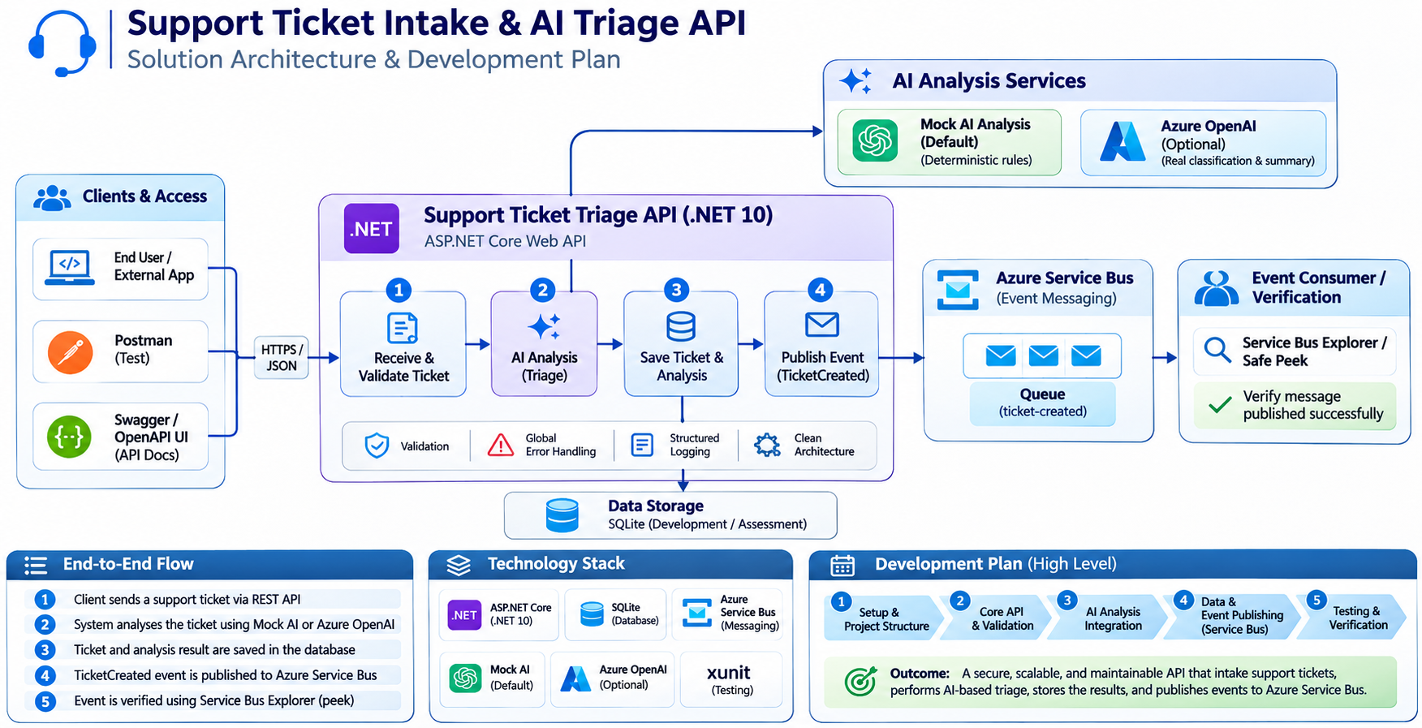
Figure 1. Planned solution architecture and development workflow
Architecture scope: ASP.NET Core 10 Web API; deterministic Mock AI by default, with Azure OpenAI optional; EF Core with SQLite; mandatory Azure Service Bus ticket-created queue; and non-destructive Service Bus Explorer peek verification. No consumer implementation is required for the assessment.

3. Cursor AI -- Recommended Next Step
Place both files inside the project's docs/ folder and use the following initial instruction:
Read docs/SPEC.md and docs/PLAN.md version 2.0. Treat these documents as the approved technical baseline. Follow the nine implementation phases sequentially, preserving all five fixed architectural decisions. Azure Service Bus integration is mandatory. Complete each phase with actual build and test verification before proceeding. Do not introduce unapproved technologies or change the architecture without identifying the trade-offs.

4. Implementation
Use Cursor AI to implement the application by following the approved requirements, technical specifications, architecture, and implementation plan.
The implementation process covers:
- Requirements analysis
- Technical planning
- Architecture and design
- Development
- Azure Service Bus integration
- Testing
- Building and running the application

5. Implementation Testing Evidence
The following screenshots document manual verification of the Support Ticket Intake & AI Triage API, SQLite persistence, and Azure Service Bus queue integration. These screenshots are evidence of observed development test runs, not a substitute for the automated xUnit test report.

Observed verification summary
Area | Observed evidence
API surface | Swagger shows three required endpoints.
Ticket creation | POST returned HTTP 201 with AI analysis.
Database | Tickets and TicketAnalyses each show the persisted record.
Azure Service Bus | An active TicketCreated message is visible in the ticket-created queue.
Ticket retrieval | GET by ID returned HTTP 200 and the persisted analysis.
Ticket listing | GET list returned HTTP 200 and pagination metadata.
Not demonstrated in screenshots | Automated test results, failure cases, priority filtering and date-sort behavior.
Note: The initial Azure Service Bus screenshot shows Peek Mode with zero messages; the later populated queue screenshot is in Receive Mode. A separate non-destructive Peek verification should be captured if strict Peek-mode evidence is required.

5.1 API endpoints documented in Swagger UI
Swagger displays POST /api/tickets, GET /api/tickets and GET /api/tickets/{id}, together with the request/response schemas.
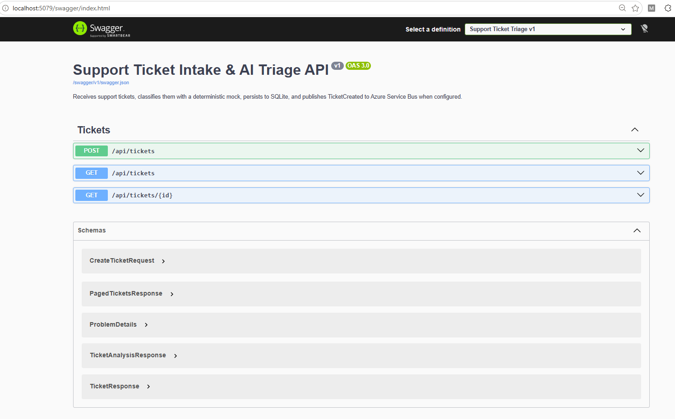
Evidence 1. API endpoints documented in Swagger UI

5.2 Azure Service Bus queue before testing
Service Bus Explorer shows the ticket-created queue with zero messages at the time of the initial screenshot.
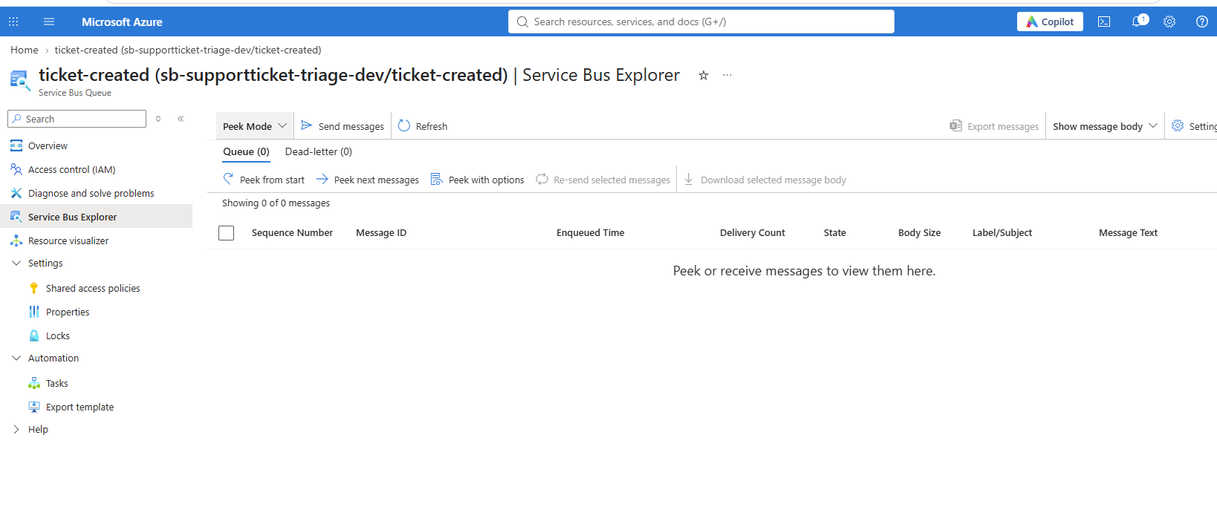
Evidence 2. Azure Service Bus queue before testing

5.3 SQLite schema and initial database state
SQLite database contains the EF Core migrations history, Tickets and TicketAnalyses tables; ticket data had not yet been inserted.
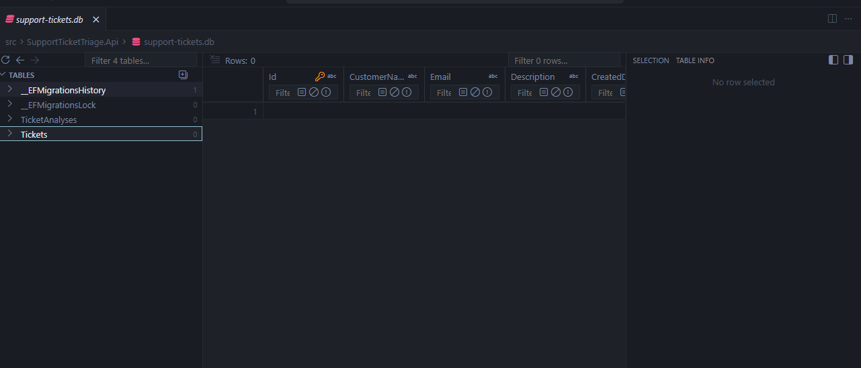
Evidence 3. SQLite schema and initial database state

5.4 Ticket creation through Swagger (HTTP 201)
POST /api/tickets returned HTTP 201 and a response containing a ticket ID and mock AI analysis: Account / Low.
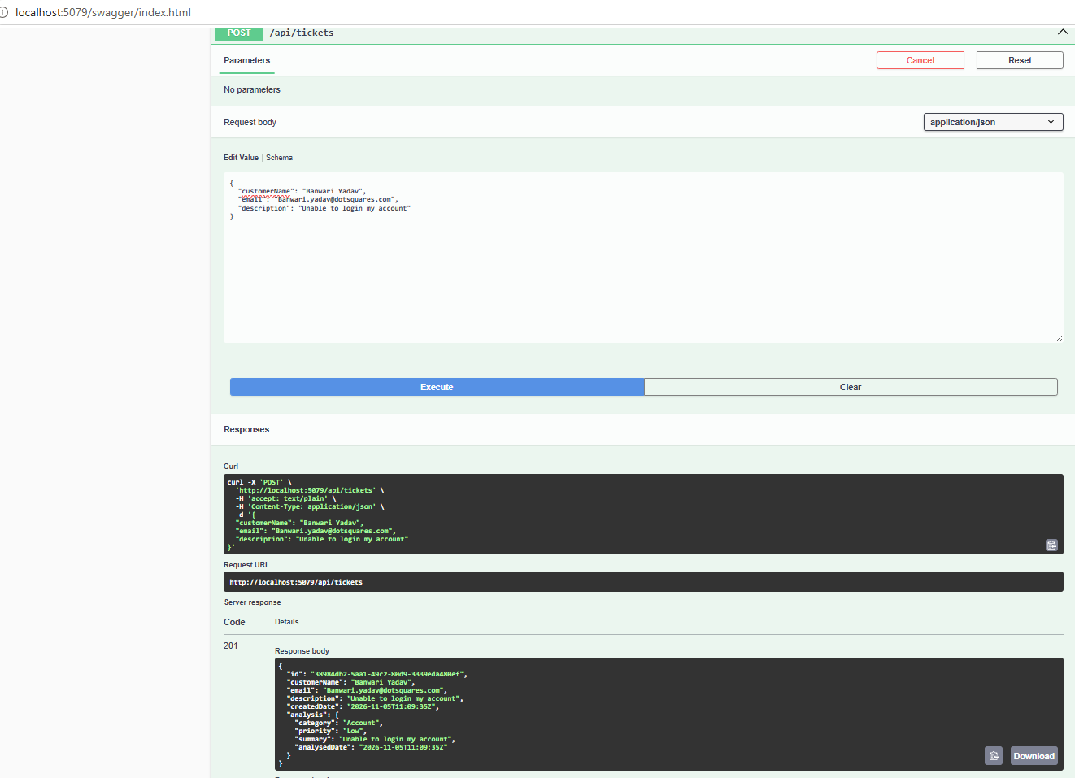
Evidence 4. Ticket creation through Swagger (HTTP 201)

5.5 Ticket stored in SQLite
The Tickets table contains the newly created record, confirming ticket persistence.
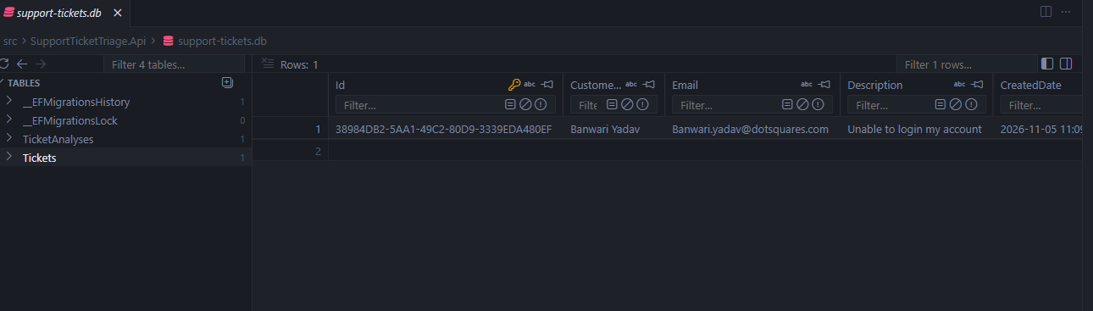
Evidence 5. Ticket stored in SQLite

5.6 AI analysis stored in SQLite
The TicketAnalyses table contains the linked analysis record (Account, Low), confirming persistence of AI results.
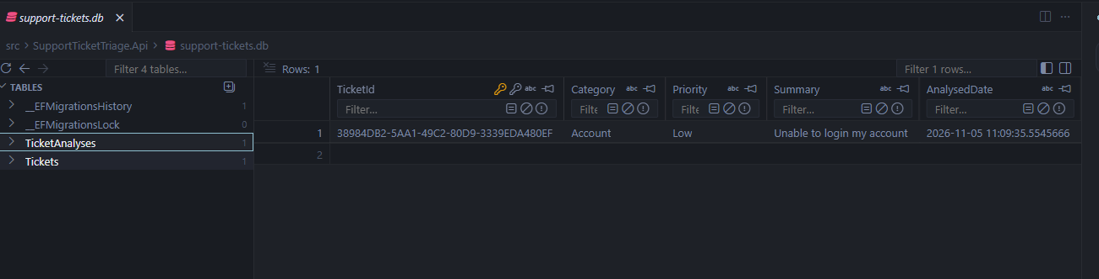
Evidence 6. AI analysis stored in SQLite

5.7 TicketCreated message present in Azure Service Bus
Service Bus Explorer displays an active TicketCreated queue message, including its event envelope and matching ticket ID. The screenshot is in Receive Mode.
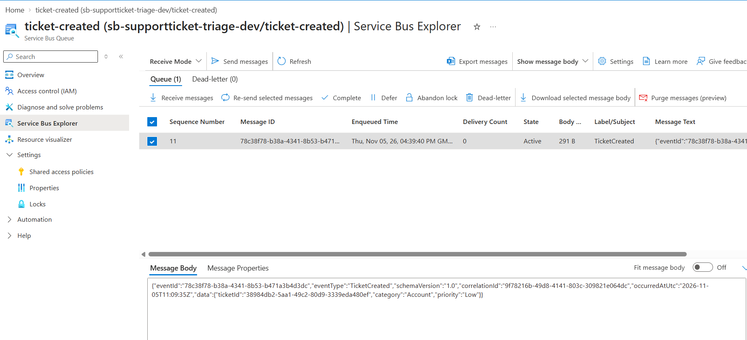
Evidence 7. TicketCreated message present in Azure Service Bus

5.8 Ticket retrieval by ID (HTTP 200)
GET /api/tickets/{id} returned HTTP 200 with the previously created ticket and its AI analysis.
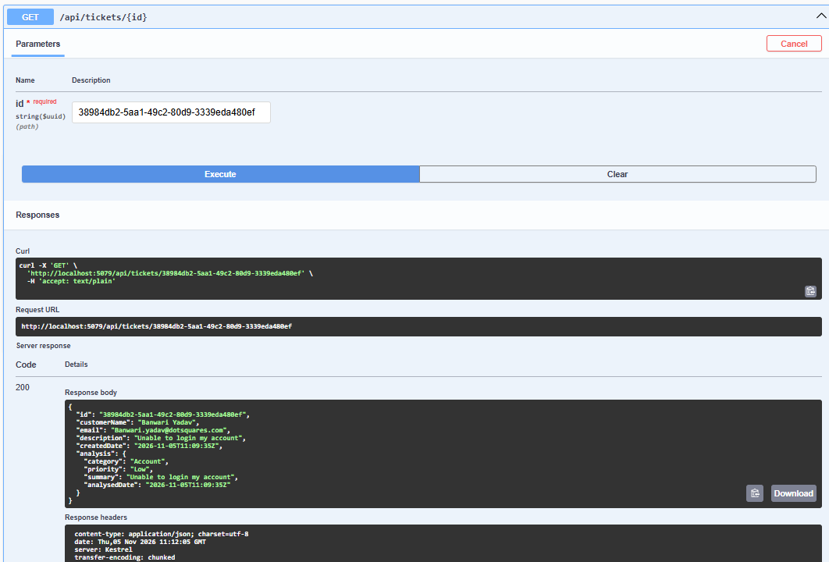
Evidence 8. Ticket retrieval by ID (HTTP 200)

5.9 Paginated ticket listing (HTTP 200)
GET /api/tickets returned HTTP 200, a ticket collection and pagination metadata (page number, page size, total count, total pages).
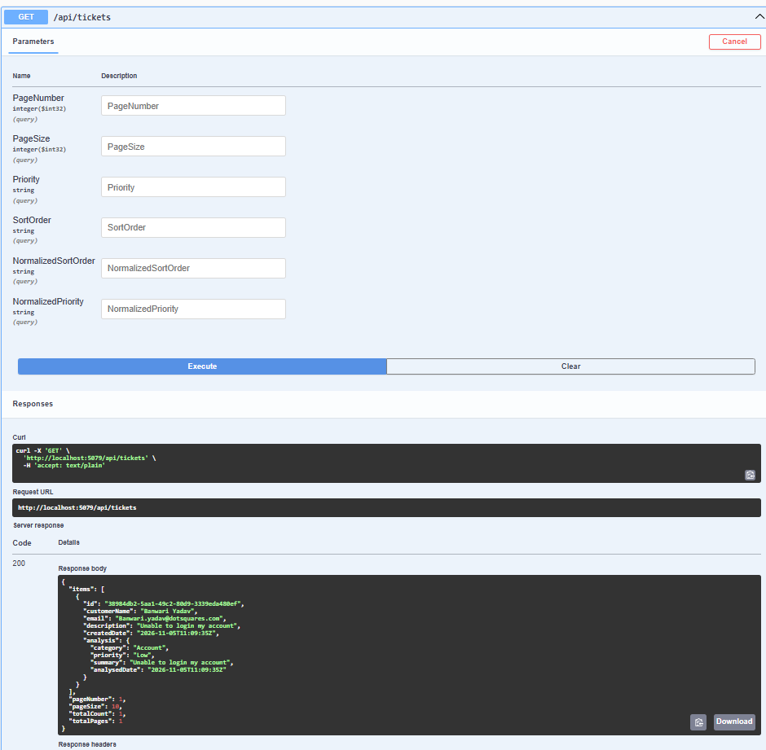
Evidence 9. Paginated ticket listing (HTTP 200)

