

课程实验报告

课 程 名 称： 计算机网络
实验项目名称： 套接字及客户服务器应用程序基础
专 业 班 级： 软件2003班
姓 名： 曾佳宝
学 号： 202026010324
指 导 教 师： 周军海
完 成 时 间： 2022 年 10 月 25 日

信息科学与工程学院
实验题目 | 套接字及客户服务器应用程序基础
实验目的 | - 熟悉Visual C++的基本操作，亦可采用Java等其它面向对象的编程语言。  - 基本了解基于对话框的windows应用程序的编写过程。  - 实现UDP或TCP套接字编程（1人1组）。
实验环境 | windows电脑
实验内容及操作步骤：
- 项目架构及代码介绍
- 项目总体架构基于MVC实现分层架构。其中entity包表示实体类，mapper表示数据库的增删改查等操作，util表示一些通用函数，例如：获取当前时间，view表示视图层，controller表示逻辑层。
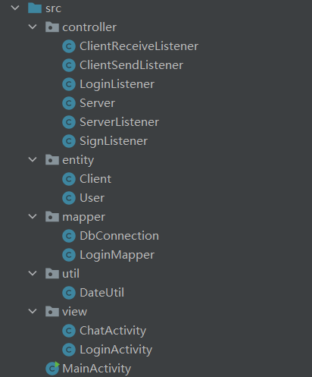
- view包：用户的可视化界面
- LoginActivity类：用户信息认证界面，连接数据库实现验证。
- 入口界面，用户选择“登录”或者“注册”：
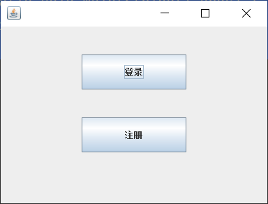
- public LoginActivity() {
- JFrame jf = new JFrame();
- jf.setSize(400, 300);
- jf.setDefaultCloseOperation(WindowConstants.EXIT_ON_CLOSE);
- // 窗口居中
- jf.setLocationRelativeTo(null);

- JPanel panel = new JPanel(new FlowLayout(FlowLayout.CENTER, 200, 40));

- JButton btnLogin = new JButton("登录");
- JButton btnSign = new JButton("注册");
- btnLogin.setPreferredSize(new Dimension(150, 50));
- btnSign.setPreferredSize(new Dimension(150, 50));

- panel.add(btnLogin);
- panel.add(btnSign);
- jf.setContentPane(panel);
- jf.setVisible(true);
- jfIndex = jf;

- // 登录按钮监听
- btnLogin.addActionListener(e -> {
- jf.setVisible(false);
- login();
- });

- // 注册按钮监听
- btnSign.addActionListener(e -> {
- jf.setVisible(false);
- sign();
- });
- }
- 登录界面，用户输入用户名和密码实现登录，每次确定都会有提示：
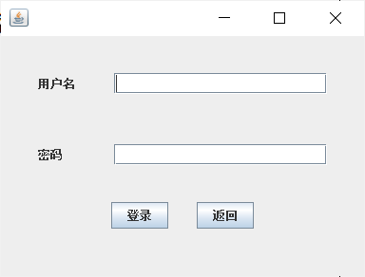
- private void login() {
- JFrame jf = new JFrame();
- jf.setSize(400, 300 );
- jf.setDefaultCloseOperation(WindowConstants.EXIT_ON_CLOSE);
- jf.setLocationRelativeTo(null);

- JPanel panel = new JPanel(new FlowLayout(FlowLayout.CENTER, 30, 25));

- // 用户
- JLabel userText = new JLabel("用户名");
- JTextField userInput = new JTextField(20);
- userText.setPreferredSize(new Dimension(50, 50));

- // 密码
- JLabel passwordText = new JLabel("密码");
- JPasswordField passwordInput = new JPasswordField(20);
- passwordText.setPreferredSize(new Dimension(50, 50));

- // 登录
- JButton btnLogin = new JButton("登录");
- JButton btnReturn = new JButton("返回");

- panel.add(userText);
- panel.add(userInput);
- panel.add(passwordText);
- panel.add(passwordInput);
- panel.add(btnLogin);
- panel.add(btnReturn);

- jf.setContentPane(panel);
- jf.setVisible(true);

- // 登录按钮监听器
- LoginListener loginListener = new LoginListener(userInput, passwordInput, jf);
- btnLogin.addActionListener(loginListener);

- // 返回
- btnReturn.addActionListener(e -> {
- jf.setVisible(false);
- index();
- });
- }
- 注册界面：用户输入自定义的用户名和密码，此处需要再次确定密码，且验证该用户是否已注册：
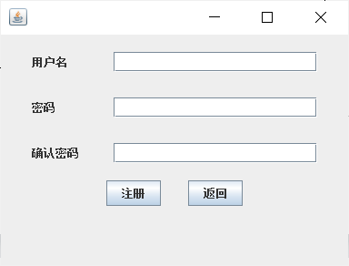
- private void sign() {
- JFrame jf = new JFrame();
- jf.setSize(400, 300 );
- jf.setDefaultCloseOperation(WindowConstants.EXIT_ON_CLOSE);
- jf.setLocationRelativeTo(null);

- JPanel panel = new JPanel(new FlowLayout(FlowLayout.CENTER, 30, 10));

- // 用户
- userText = new JLabel("用户名");
- JTextField userInput = new JTextField(20);
- userText.setPreferredSize(new Dimension(60, 40));

- // 密码
- JLabel passwordText = new JLabel("密码");
- JPasswordField passwordInput = new JPasswordField(20);
- passwordText.setPreferredSize(new Dimension(60, 40));

- // 确认密码
- JLabel surePasswordText = new JLabel("确认密码");
- JPasswordField surePasswordInput = new JPasswordField(20);
- surePasswordText.setPreferredSize(new Dimension(60, 40));

- // 登录
- JButton btnSign = new JButton("注册");
- JButton btnReturn = new JButton("返回");

- panel.add(userText);
- panel.add(userInput);
- panel.add(passwordText);
- panel.add(passwordInput);
- panel.add(surePasswordText);
- panel.add(surePasswordInput);
- panel.add(btnSign);
- panel.add(btnReturn);

- jf.setContentPane(panel);
- jf.setVisible(true);

- // 注册按钮监听器
- SignListener signListener = new SignListener(userInput, passwordInput, surePasswordInput);
- btnSign.addActionListener(signListener);

- // 返回按钮监听
- btnReturn.addActionListener(e -> {
- jf.setVisible(false);
- index();
- });
- }
- 提示界面：根据不同的情况提示不同的内容：
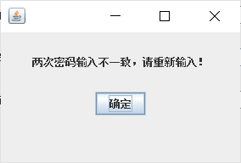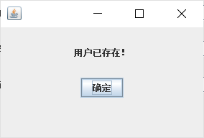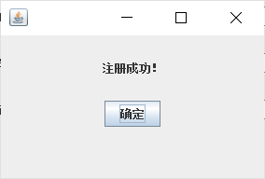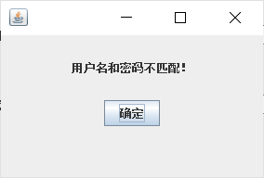
- public static void dialog(String message) {
- JFrame jf = new JFrame();
- jf.setSize(300, 200 );
- jf.setDefaultCloseOperation(WindowConstants.EXIT_ON_CLOSE);
- jf.setLocationRelativeTo(null);

- JPanel panel = new JPanel(new FlowLayout(FlowLayout.CENTER, 20, 10));

- // 用户
- JLabel userText = new JLabel(message);
- userText.setPreferredSize(new Dimension(230, 50));
- userText.setHorizontalAlignment(SwingConstants.CENTER);

- // 确定
- JButton btn = new JButton("确定");

- panel.add(userText);
- panel.add(btn);
- jf.setContentPane(panel);
- jf.setVisible(true);

- // 监听器
- btn.addActionListener(new ActionListener() {
- @Override
- public void actionPerformed(ActionEvent e) {
- jf.setVisible(false);
- }
- });
- }
- ChatActivity类：聊天界面，标题显示当前登录用户，左侧栏显示当前在线用户数量和列表，右侧栏显示聊天内容，底部显示用户输入待发送的文本和“发送”、“清空”按钮。
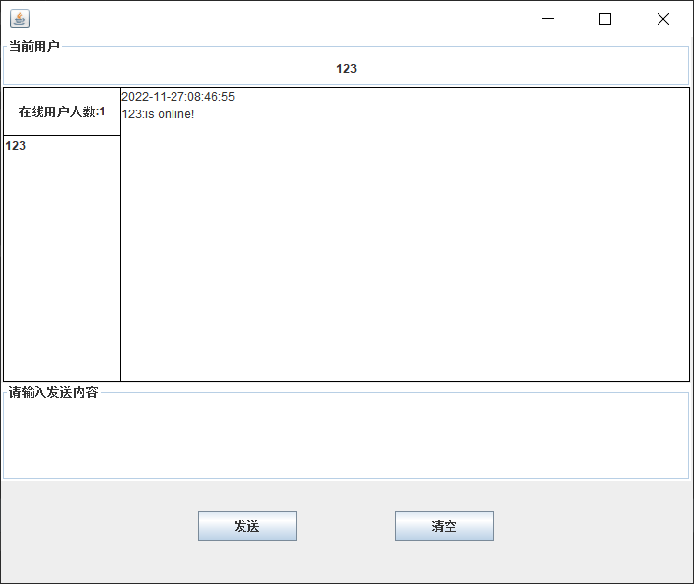
- public ChatActivity(String userName) {
- JFrame jf = new JFrame();
- jf.setSize(720, 600);
- jf.setDefaultCloseOperation(WindowConstants.EXIT_ON_CLOSE);
- jf.setLocationRelativeTo(null);
- JPanel panel = new JPanel(null);

- // 当前用户
- JLabel title = new JLabel(userName, SwingConstants.CENTER);
- title.setBorder(BorderFactory.createTitledBorder("当前用户"));
- title.setSize(new Dimension(700, 50));
- title.setLocation(0, 0);
- title.setBackground(Color.white);
- title.setOpaque(true);

- // 在线用户数目
- online = new JLabel("在线用户人数:" + onlineNum.toString(), SwingConstants.CENTER);
- online.setBorder(BorderFactory.createLineBorder(Color.BLACK));
- online.setBackground(Color.white);
- online.setOpaque(true);
- online.setLocation(2, 50);
- online.setSize(new Dimension(120, 50));

- // 在线用户列表
- userList = new JList<>();
- userList.setBorder(BorderFactory.createLineBorder(Color.BLACK));
- userList.setSize(new Dimension(120, 250));
- userList.setLocation(2, 99);

- // 聊天框
- text = new JTextArea();
- text.setBorder(BorderFactory.createLineBorder(Color.BLACK));
- text.setEditable(false);
- text.setLocation(121, 50);
- text.setSize(new Dimension(578, 299));

- // 输入文本
- JTextArea input = new JTextArea();
- input.setBorder(BorderFactory.createTitledBorder("请输入发送内容"));
- input.setLocation(0, 350);
- input.setSize(new Dimension(700, 100));

- // 发送按钮
- JButton send = new JButton("发送");
- send.setLocation(200, 480);
- send.setSize(new Dimension(100, 30));

- // 清除文本按钮
- JButton clear = new JButton("清空");
- clear.setLocation(400, 480);
- clear.setSize(new Dimension(100, 30));

- panel.add(title);
- panel.add(online);
- panel.add(userList);
- panel.add(text);
- panel.add(input);
- panel.add(send);
- panel.add(clear);
- jf.setContentPane(panel);
- jf.setVisible(true);

- try {
- Socket socket = new Socket("localhost", 8888);
- Client client = new Client(userName, socket);
- String time = DateUtil.getDate();
- // 向服务器发送登录消息
- DataOutputStream writer = new DataOutputStream(socket.getOutputStream());
- writer.writeBytes(time + "\n");
- writer.flush();
- writer.writeBytes(userName + ":is online!\n");
- writer.flush();

- // 发送消息监听器
- ClientSendListener clientSendListener = new ClientSendListener(text, input, client, userList);
- send.addActionListener(clientSendListener);

- // 接收消息线程
- ClientReceiveListener clientReceiveListener = new ClientReceiveListener(client, text, online, userList);
- new Thread((Runnable) clientReceiveListener).start();
- } catch (IOException e) {
- e.printStackTrace();
- }

- // 清空消息
- clear.addActionListener(e -> input.setText(""));
- }
- util包：目前仅有一个DateUtil类，用于获取当前时间，并转化为字符串形式
- public class DateUtil {
- public static String getDate() {
- Date date = new Date();
- SimpleDateFormat dateFormat= new SimpleDateFormat("yyyy-MM-dd:hh:mm:ss");
- return dateFormat.format(date);
- }
- }
- mapper包：用于数据库连接和对数据库的增删改查等操作
- DbConnection类：获得数据库的连接
- public class DbConnection {

- public static Connection getConnection() {
- String name = "root";
- String password = "zjb15973958319";
- String url = "jdbc:mysql://localhost:3306/chat";
- Connection connection;
- // 1、加载驱动
- try {
- Class.forName("com.mysql.cj.jdbc.Driver");
- // 2、建立连接
- connection = DriverManager.getConnection(url, name, password);
- return connection;
- } catch (Exception e) {
- e.printStackTrace();
- }
- return null;
- }
- }
- LoginMapper类：用户登录操作，需要验证用户名和密码，以及添加用户等
- login方法：判断用户的用户名和密码是否匹配
- public static Boolean login(User user) {
- Connection connection = DbConnection.getConnection();
- PreparedStatement stmt = null;
- ResultSet rs = null;
- try {
- String sql = "select * from user where name=? and password=?";
- assert connection != null;
- stmt = connection.prepareStatement(sql);
- stmt.setString(1, user.getUserName());
- stmt.setString(2, user.getPassword());
- rs = stmt.executeQuery();
- // 若用户名密码匹配，则next指向该行数据，返回true，否则返回false
- return rs.next();
- } catch (Exception e) {
- e.printStackTrace();
- return false;
- } finally {
- // 关闭数据库连接操作
- try {
- if (rs != null) {
- rs.close();
- }
- if (stmt != null) {
- stmt.close();
- }
- if (connection != null) {
- connection.close();
- }
- } catch (Exception e) {
- e.printStackTrace();
- }
- }
- }
- register方法：完成用户注册操作，需要判断用户是否存在和插入是否成功。
- public static String register(User user) {
- String userName = user.getUserName();
- String userPassword = user.getPassword();
- System.out.println("用户注册" + userName);

- Connection connection = DbConnection.getConnection();
- assert connection != null;
- PreparedStatement stmt = null;
- ResultSet rs = null;

- try {
- // 查找用户，判断该用户是否已注册
- String sql = "select * from user where name=?";
- stmt = connection.prepareStatement(sql);
- stmt.setString(1, userName);
- rs = stmt.executeQuery();
- if (!rs.next()) {
- // 插入用户数据
- String sql2 = "insert into user(name, password) values(?, ?)";
- stmt = connection.prepareStatement(sql2);
- stmt.setString(1, userName);
- stmt.setString(2, userPassword);
- int result = stmt.executeUpdate();
- System.out.println("插入新用户结果：" + result);
- if (result == 1) {
- return "注册成功！";
- }
- } else {
- System.out.println("注册失败，用户已存在！");
- return "用户已存在！";
- }
- } catch (Exception e) {
- e.printStackTrace();
- } finally {
- try {
- if (rs != null) {
- rs.close();
- }
- if (stmt != null) {
- stmt.close();
- }
- connection.close();
- } catch (Exception e) {
- e.printStackTrace();
- }
- }
- return "注册失败";
- }
- entity包：实体类，主要有User类和Client类。
- User类：主要成员变量有name和password，主要用于用户登录
- public class User {
- private String userName;
- private String password;

- public User(String userName, String password) {
- this.userName = userName;
- this.password = password;
- }

- public String getUserName() {
- return userName;
- }

- public void setUserName(String userName) {
- this.userName = userName;
- }

- public String getPassword() {
- return password;
- }

- public void setPassword(String password) {
- this.password = password;
- }

- @Override
- public String toString() {
- return "User{" +
- "userName='" + userName + '\'' +
- ", password='" + password + '\'' +
- '}';
- }
- }
- Client类：主要成员变量有name，socket和reader，主要用于用户线程之间的通信
- public class Client {

- private String name;
- private Socket socket;
- private BufferedReader reader;

- public Client(String name, Socket socket) {
- this.name = name;
- this.socket = socket;
- try {
- this.reader = new BufferedReader(new InputStreamReader(socket.getInputStream()));
- } catch (Exception e) {
- e.printStackTrace();
- }
- }

- public String getName() {
- return name;
- }

- public void setName(String name) {
- this.name = name;
- }

- public Socket getSocket() {
- return socket;
- }

- public void setSocket(Socket socket) {
- this.socket = socket;
- }

- public BufferedReader getReader() {
- return reader;
- }

- public void setReader(BufferedReader reader) {
- this.reader = reader;
- }

- public void closeSocket() {
- try {
- reader.close();
- System.out.println(11111);
- socket.close();
- } catch (IOException e) {
- e.printStackTrace();
- }
- }

- @Override
- public String toString() {
- return "Client{" +
- "name='" + name + '\'' +
- ", socket=" + socket +
- '}';
- }
- }
- controller包：主要用于逻辑层的实现，例如：按钮的监听器、服务器线程的实现和客户端线程等
- ClientReceiveListener类：客户端接收信息的监听线程
- public class ClientReceiveListener implements Runnable {
- private Client client;
- private JTextArea text;
- private JLabel online;
- private JList<String> userList;

- public ClientReceiveListener(Client client, JTextArea text, JLabel online,
- JList<String> userList) {
- this.client = client;
- this.text = text;
- this.online = online;
- this.userList = userList;
- }

- @Override
- public void run() {
- try {
- Socket socket = client.getSocket();
- BufferedReader reader = client.getReader();
- // 接收服务器传来的内容
- while (true) {
- String msg = reader.readLine();
- String[] clients= msg.split(":");
- System.out.println(msg);
- if (clients[0].equals("online")) {
- String[] names = clients[1].split(" ");
- userList.setListData(names);
- online.setText("在线用户人数:" + names.length);
- continue;
- }
- else {
- text.append(msg + "\n");
- }
- }
- } catch (Exception e) {
- e.printStackTrace();
- }
- }
- }
- ClientSendListener类：用户点击发送按钮的监听器，用于向服务器发送消息
- public class ClientSendListener implements ActionListener {

- private JTextArea textArea;
- private final String userName;
- private JTextArea input;
- private Client client;
- private JList<String> list;

- public ClientSendListener(JTextArea textArea, JTextArea input, Client client,
- JList<String> list) {
- this.textArea = textArea;
- this.userName = client.getName();
- this.input = input;
- this.client = client;
- this.list = list;
- }

- @Override
- public void actionPerformed(ActionEvent e) {
- String send = input.getText();
- String time = DateUtil.getDate() + "\n";
- Integer index = list.getSelectedIndex();
- String content = userName + ":";
- // 私聊消息
- if (index >= 0) {
- content += "(" + list.getSelectedValue() + ")";
- }
- content += send + "\n";
- StringBuilder total = new StringBuilder(time + content);
- try {
- // 向服务器线程发送消息
- Socket socket = new Socket("localhost", 8888);
- DataOutputStream writer = new DataOutputStream(socket.getOutputStream());
- writer.writeBytes(total.toString());
- writer.flush();
- writer.close();
- socket.close();

- // 清空输入框
- input.setText("");
- // 终端输出
- System.out.print(total);

- if (send.equalsIgnoreCase("BYE")) {
- client.getSocket().close();
- System.exit(1);
- }
- } catch (IOException ex) {
- ex.printStackTrace();
- }
- }
- }
- LoginListener类：用户点击登录按钮的监听器，用于和数据库对接，验证用户信息
- public class LoginListener implements ActionListener {
- private JTextField userName;
- private JPasswordField passwordField;
- private JFrame jf;

- public LoginListener(JTextField userName, JPasswordField passwordField, JFrame jf) {
- this.userName = userName;
- this.passwordField = passwordField;
- this.jf = jf;
- }

- @Override
- public void actionPerformed(ActionEvent e) {
- String name = userName.getText();
- String password = new String(passwordField.getPassword());
- User user = new User(name, password);
- System.out.println("用户" + name + "正在登录中……");
- if (LoginMapper.login(user)) {
- System.out.println("用户" + name + "登录成功！");
- jf.setVisible(false);
- new ChatActivity(name);
- }
- else {
- LoginActivity.dialog("用户名和密码不匹配！");
- }
- }
- }
- Server类：服务器端创建服务器线程，并接收客户端的发送消息，交给ServerListener进行处理
- public class Server {
- private static List<Client> clientList = new ArrayList<>();
- private ServerSocket serverSocket = null;

- public Server() {
- try {
- serverSocket = new ServerSocket(8888);
- while (true) {
- Socket socket = serverSocket.accept();
- BufferedReader reader = new BufferedReader(new InputStreamReader(socket.getInputStream()));
- // 创建线程对象
- ServerListener serverListener = new ServerListener(reader, socket);
- Thread t = new Thread(serverListener);
- // 启动线程
- t.start();
- }
- } catch (IOException e) {
- e.printStackTrace();
- }
- }

- public static List<Client> getClientList() {
- return clientList;
- }

- public void setClientList(List<Client> clientList) {
- clientList = clientList;
- }

- public ServerSocket getServerSocket() {
- return serverSocket;
- }

- public void setServerSocket(ServerSocket serverSocket) {
- serverSocket = serverSocket;
- }

- public static void addClient(Client client) {
- clientList.add(client);
- }

- public static void removeClient(String name) {
- Iterator<Client> iterator = clientList.iterator();
- while (iterator.hasNext()){
- Client next = iterator.next();
- if(next.getName().equals(name)){
- iterator.remove();
- }
- }
- }

- public static String getClientsName() {
- String name = "";
- for (Client client: clientList) {
- name += client.getName() + " ";
- }
- return name;
- }
- }
- ServerListener类：服务器处理客户端传来的数据，进行处理后传给客户端
- public class ServerListener implements Runnable {

- private final BufferedReader reader;
- private final Socket socket;

- public ServerListener(BufferedReader reader, Socket socket) {
- this.reader = reader;
- this.socket = socket;
- }

- @Override
- public void run() {
- try {
- // 获取传来的信息
- String time = reader.readLine();
- String message = reader.readLine();
- String name = message.split(":")[0];
- String head = message.split(":")[1];
- String content = message + "\n";
- // 打印传来的信息
- System.out.println(time);
- System.out.println(message);
- // 接收到用户登录的消息，向在线用户列表添加该用户
- if (head.equals("is online!")) {
- Client client = new Client(name, socket);
- Server.addClient(client);
- String clients = "online:" + Server.getClientsName();
- // 向所有在线用户广播上线通知
- for (Client tmp : Server.getClientList()) {
- Socket send = tmp.getSocket();
- DataOutputStream writer = new DataOutputStream(send.getOutputStream());
- writer.writeBytes(clients + "\n");
- writer.flush();
- }
- }
- // 接收到用户下线的消息，在在线用户列表删除该用户
- else if (head.toUpperCase().contains("BYE")) {
- System.out.print(name + " leaves！");
- Server.removeClient(name);
- String clients = "online:" + Server.getClientsName();
- // 向所有在线用户广播下线通知
- for (Client tmp : Server.getClientList()) {
- Socket send = tmp.getSocket();
- DataOutputStream writer = new DataOutputStream(send.getOutputStream());
- writer.writeBytes(clients + "\n");
- writer.flush();
- }
- }
- // 私聊消息
- if (head.startsWith("(")) {
- // 获得私聊对象的名字和私聊内容
- String certainName = "";
- for (int i = 1; i < head.length(); i++) {
- if (head.charAt(i) == ')') {
- certainName = head.substring(1, i);
- head = head.substring(i + 1);
- break;
- }
- }
- // 向私聊对象和自身发送消息
- for (Client client : Server.getClientList()) {
- if (client.getName().equals(certainName) || client.getName().equals(name)) {
- Socket send = client.getSocket();
- DataOutputStream writer = new DataOutputStream(send.getOutputStream());
- writer.writeBytes(time + "\n");
- writer.flush();
- content = name + ":" + head + "\n";
- writer.writeBytes(content);
- writer.flush();
- }
- }
- return;
- }
- // 向所有在线用户广播消息
- for (Client client : Server.getClientList()) {
- Socket send = client.getSocket();
- DataOutputStream writer = new DataOutputStream(send.getOutputStream());
- writer.writeBytes(time + "\n");
- writer.flush();
- writer.writeBytes(content);
- writer.flush();
- }
- } catch (IOException e) {
- e.printStackTrace();
- }
- }
- }
- SignListener类：用户点击注册按钮的监听器，用于和数据库对接，完成用户注册功能
- public class SignListener implements ActionListener {

- private JTextField userName;
- private JPasswordField passwordField;
- private JPasswordField surePasswordInput;

- public SignListener(JTextField userName, JPasswordField passwordField,
- JPasswordField surePasswordInput) {
- this.userName = userName;
- this.passwordField = passwordField;
- this.surePasswordInput = surePasswordInput;
- }

- @Override
- public void actionPerformed(ActionEvent e) {
- String name = userName.getText();
- String password1 = new String(passwordField.getPassword());
- String password2 = new String(surePasswordInput.getPassword());
- System.out.println(password1);
- System.out.println(password2);
- // 验证两次输入的密码是否一致
- if (password1.equals(password2)) {
- User user = new User(name, password1);
- // 对接数据库
- String ans = LoginMapper.register(user);
- LoginActivity.dialog(ans);
- } else {
- LoginActivity.dialog("两次密码输入不一致，请重新输入！");
- }
- }
- }
- 功能演示
- 注册功能
- 用户注册账号zjb，第一次输入密码123，第二次输入密码12345，界面提示“两次密码输入不一致，请重新输入！”
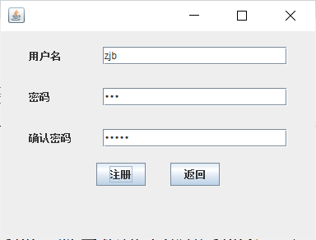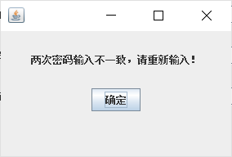
- 用户注册账号zjb，两次输入密码均为123456，界面提示“注册成功”
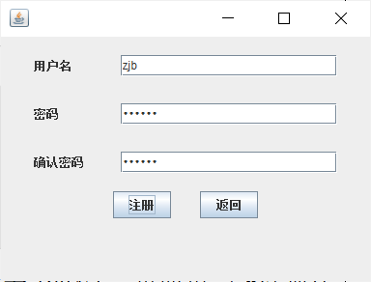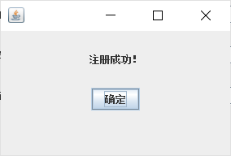
- 用户再次注册账号zjb，两次输入密码均为123456，界面提示“用户已存在！”
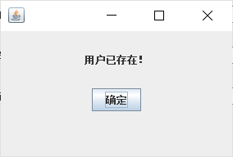
- 登录功能
- 用户登录账号zjb，输入密码为123，界面提示“用户名和密码不匹配！”
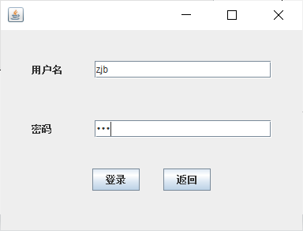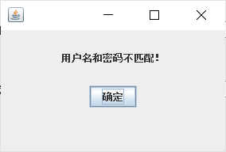
- 用户登录账号zjb，输入密码为123456，登录成功后直接进入界面
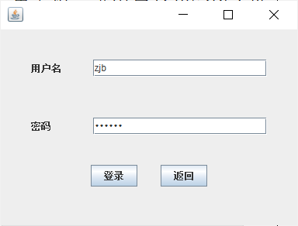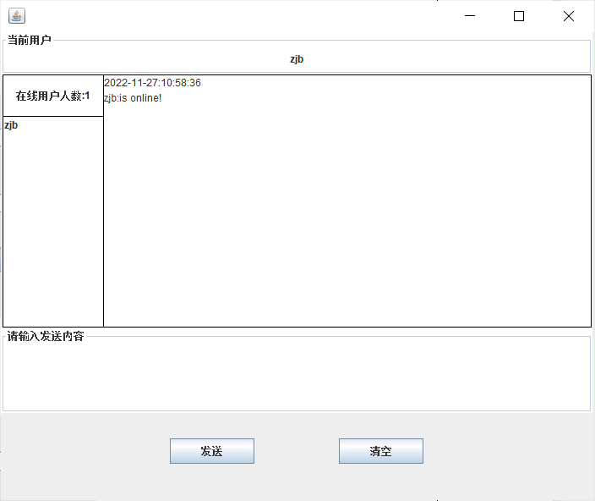
- 聊天功能
- 用户上线提示：先后登录账号123和test，可以看到聊天框显示“xxx:is online!”
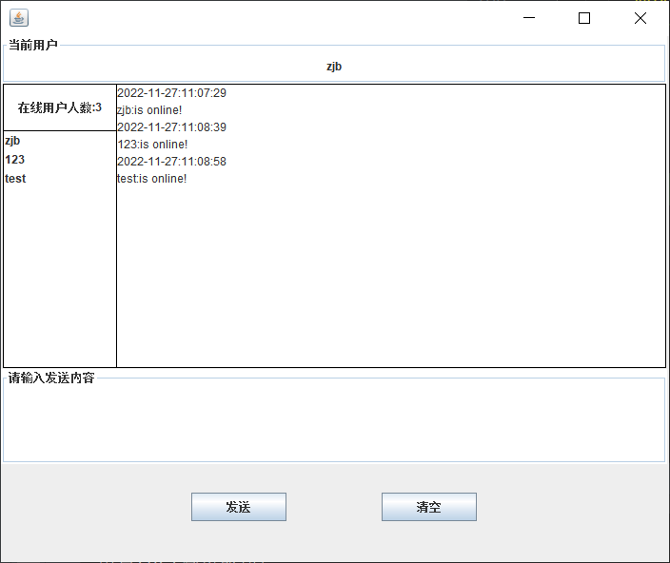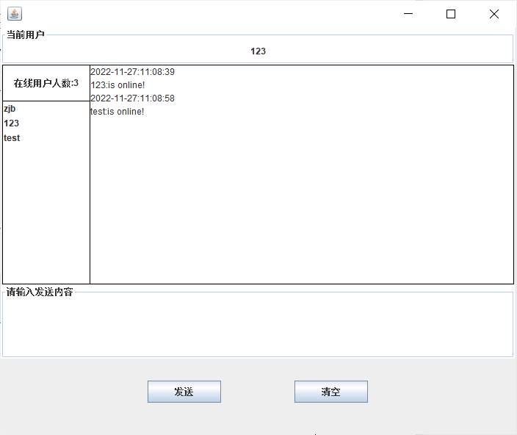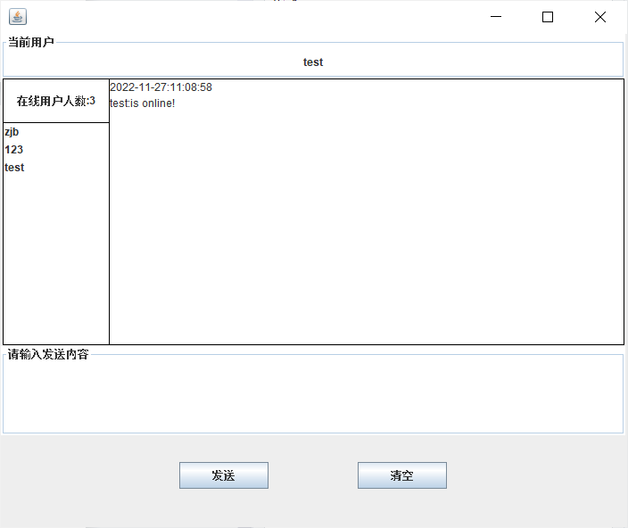
- 群发消息：账号zjb输入hello，可以看到其他用户均能够接收到消息
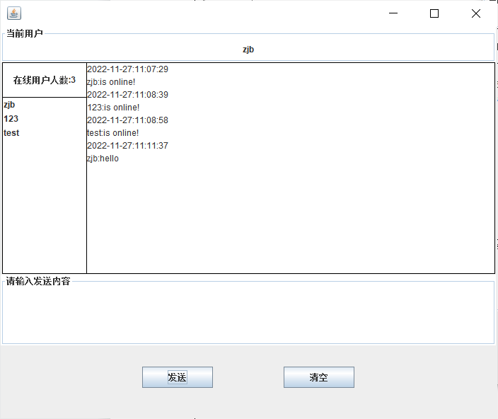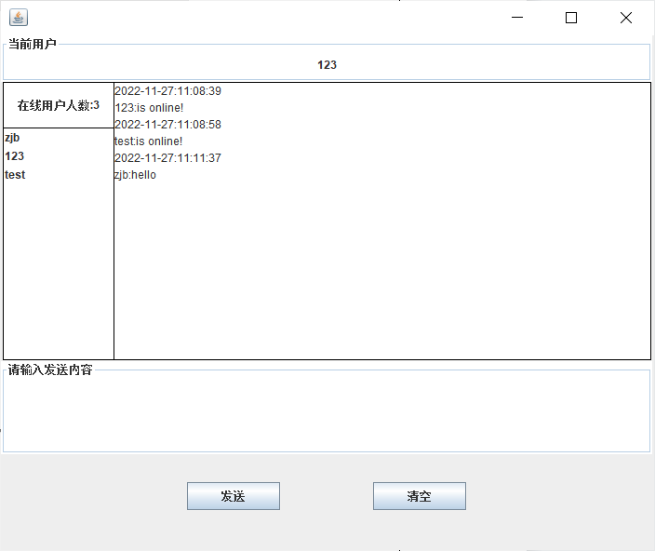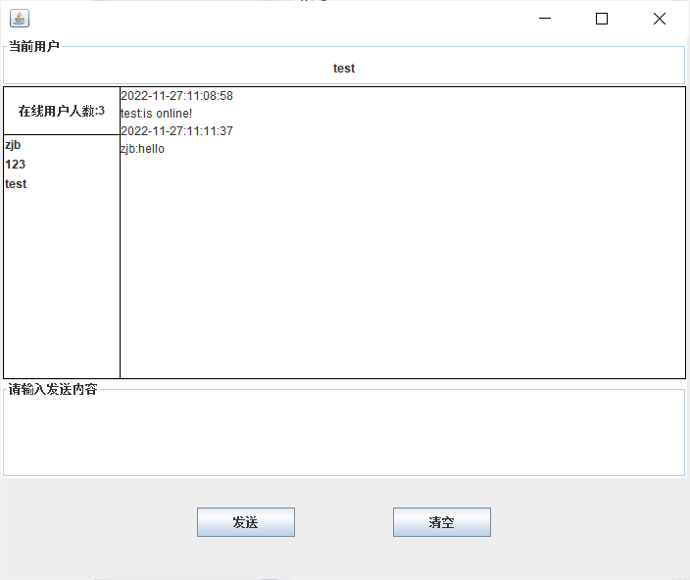
- 私聊用户：账号zjb选择用户123私聊信息，发送nice，可以看到仅有用户123接收到信息，而用户test并没有接收到消息
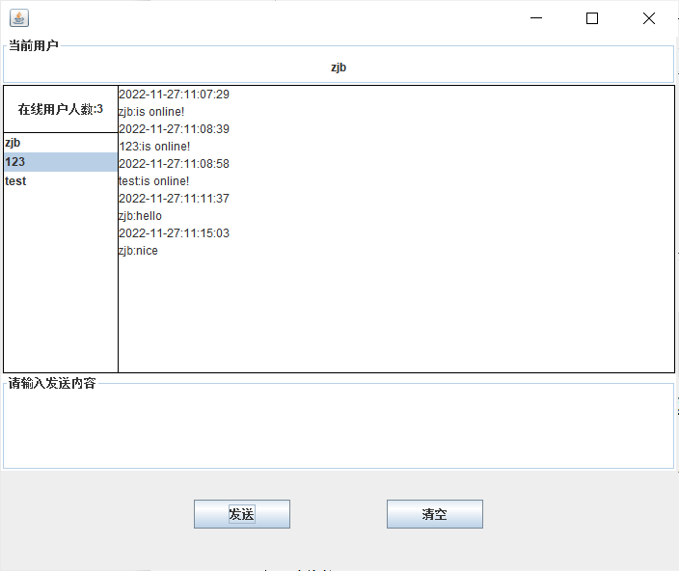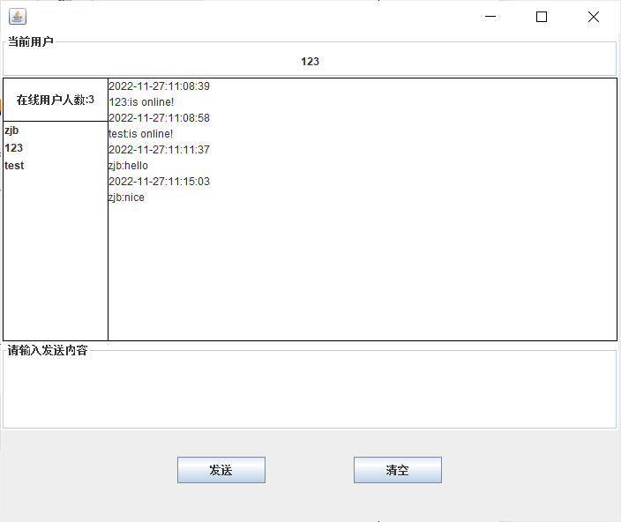
- 清空输入文本：用户输入一长串文本，点击“清空”按钮，可以看到发送内容清空
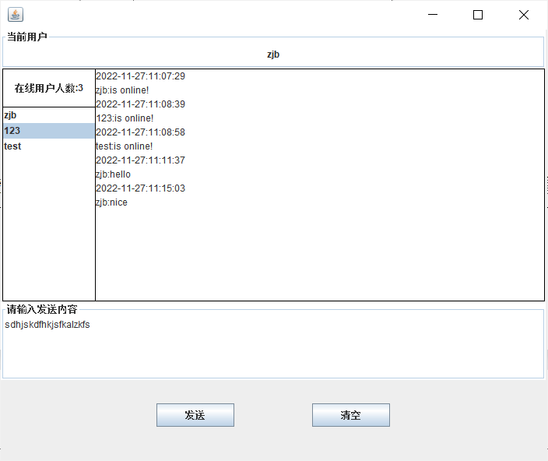 =>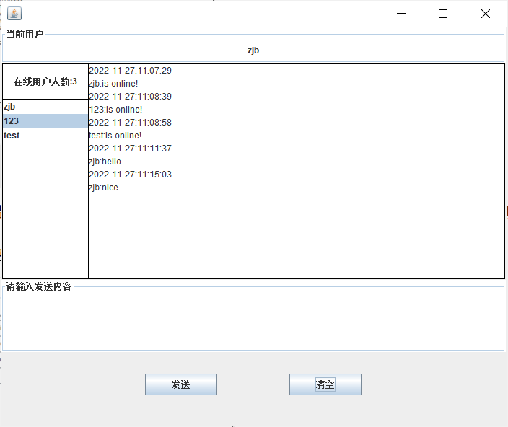
- 退出登录：用户输入bye（不区分大小写）实现下线功能，可以看到其他用户的在线列表已经不存在该用户，但是由于zjb私发给123，所以只有123接收到zjb发送的Bye：
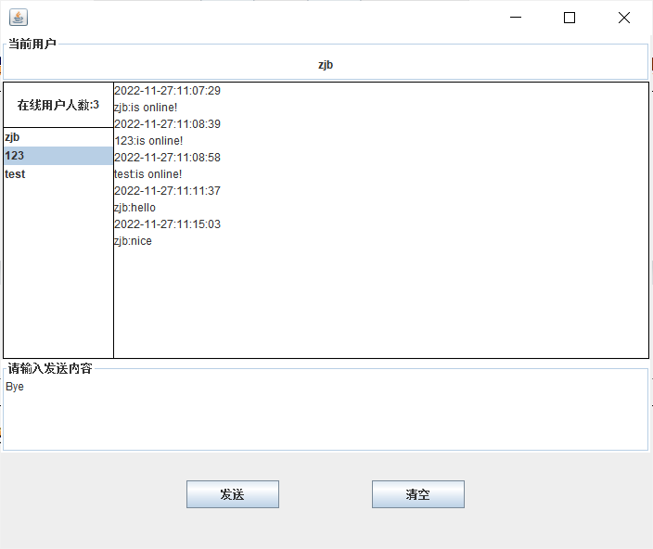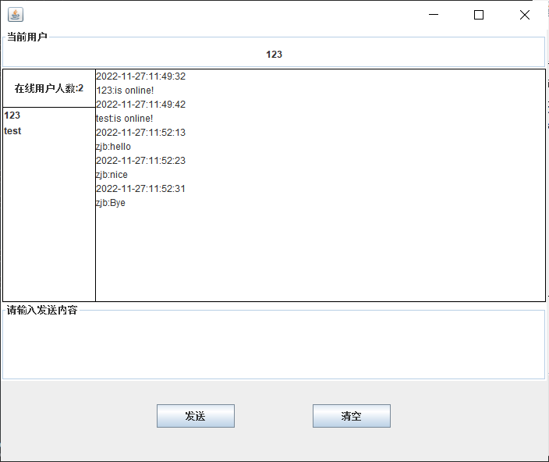
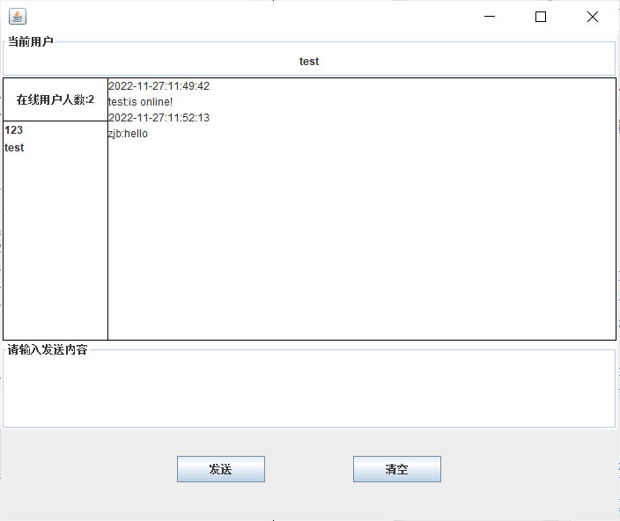
- 数据库
- User表：存储用户的账号密码
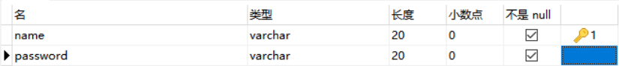
- CREATE TABLE `user` (
- `name` varchar(255) CHARACTER SET utf8mb4 COLLATE utf8mb4_0900_ai_ci NOT NULL,
- `password` varchar(255) CHARACTER SET utf8mb4 COLLATE utf8mb4_0900_ai_ci NOT NULL,
- PRIMARY KEY (`name`)
- ) ENGINE=InnoDB DEFAULT CHARSET=utf8mb4 COLLATE=utf8mb4_0900_ai_ci;

实验结果及分析：
本次实验主要通过实操编写代码来完成一个能够在局域网中进行点对点聊天的实用程序。根据课程所学知识，运输层可以使用传输控制协议（TCP，面向连接，使用字节流传送服务，可靠）来封装数据，也可以使用用户数据报协议（UDP，提供高效传输）来封装数据。本次实验采用TCP封装数据，基于JAVA语言中swing库和Socket相关知识完成，并且使用MySQL数据库实现用户的登录等。在此基础上，该项目也尝试实现MVC架构，其中entity包表示实体类，mapper表示数据库的增删改查等操作，util表示一些通用函数，例如：获取当前时间，view表示视图层，controller表示逻辑层。
本次实验的主要功能有：用户的登录和注册、查看在线用户、群发消息、私聊等，较为完备地完成了实验指导书相关要求，并且基于实验指导书完成了一些拓展性功能，例如：清空输入文本等。

收获与体会：
在本次实验中，通过回顾课堂知识，掌握了如何基于socket实现多线程之间的通信，尤其是基于swing库实现图形化界面的同时实现监听器，能够在线接收和发送消息，并且通过swing库中的JList类实现查看在线用户列表，并且向特定用户发送信息。

实验成绩

实验报告撰写说明
1．实验题目和目的
请从实验指导资料中获取。
2．实验步骤和内容
包括：
（1）本次实验的要求；
（2）源程序清单或者主要伪代码；
（3）预期结果；
（4）上机执行或调试结果：包括原始数据、相应的运行结果和必要的说明（截图）；
3．实验体会
调试中遇到的问题及解决办法；若最终未完成调试，要试着分析原因；调试程序的心得与体会；对课程及实验的建议等。

