POSTMAN

-Accounts:

+Get: <http://locallhost:8080/rest/accounts>

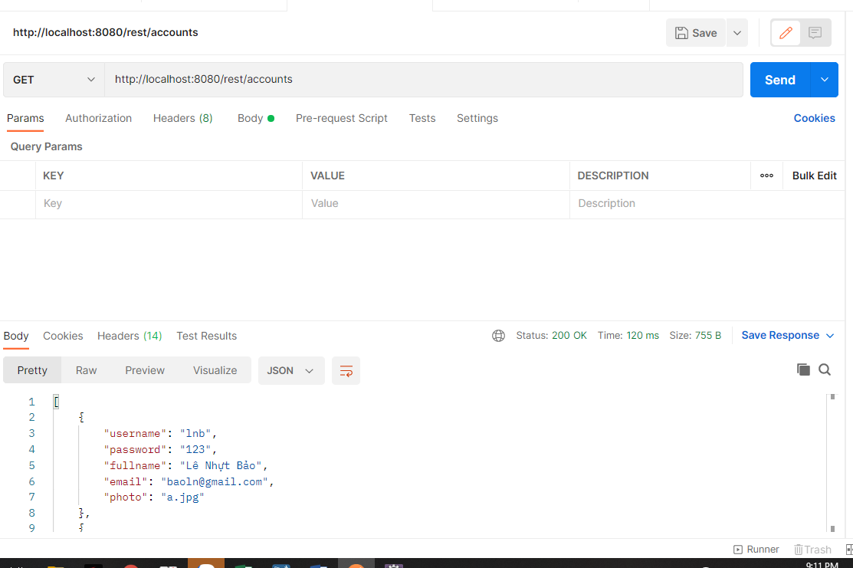

+Post dữ liệu: <http://locallhost:8080/rest/accounts>

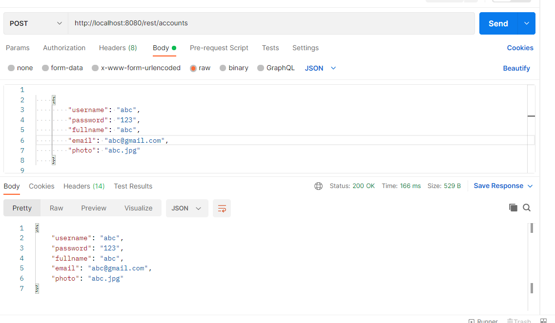-Product:

+Get dữ liệu: <http://localhost:8080/rest/products>

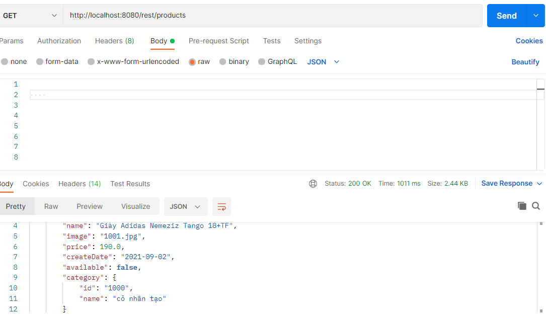

+Post dữ liệu: <http://localhost:8080/rest/products>

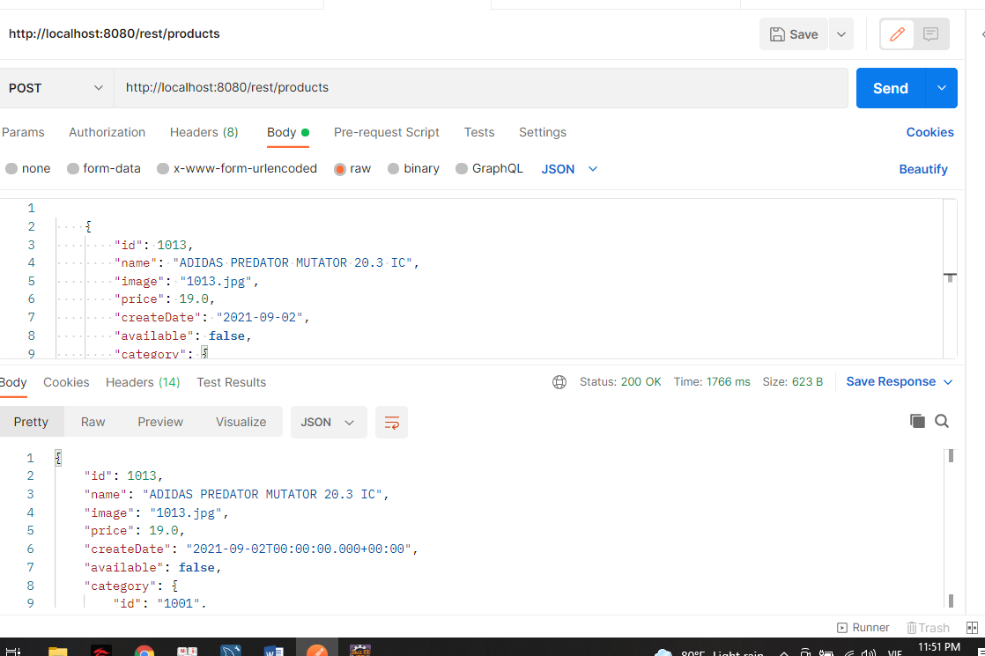

Put dữ liệu: <http://localhost:8080/rest/products/1013>

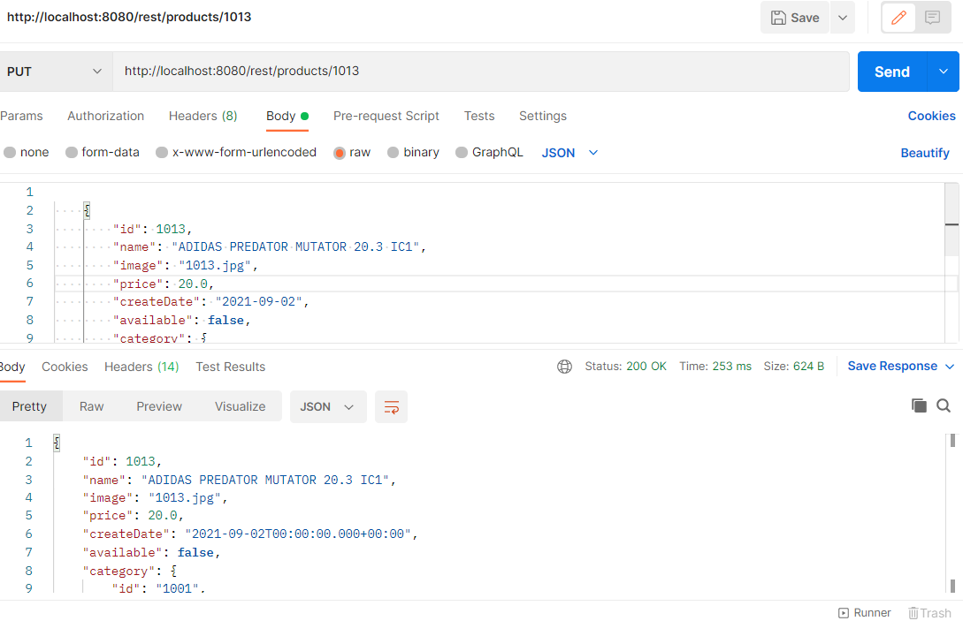

+Delete dữ liệu: <http://localhost:8080/rest/products/1013>

