Nguyễn Trung Thành – 20176874

Assignment 1

Create a new project to implement the code in Home Assignment 1. Home Assignment . Initialize for i and j variable. Compile and upload to the simulator. Run this program step by step, observe the changing of memory and the content of registers at each step.

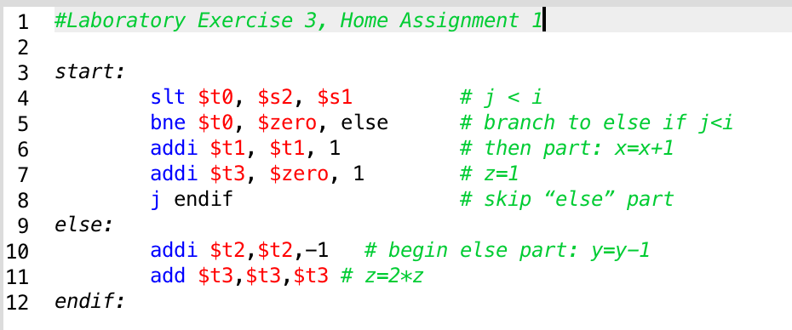

Trường hợp 1: (i <= j).



Sau lệnh:

1. slt $t0, $s2, $s1 # j < i

* $t0 = 0; do $s1 < $s2 (i <= j).

1. bne $t0, $zero, else # branch to else if j<i

* Lệnh bne so sánh $t0 != $zero; Nhưng ở đây $t0 = $zero nên tiếp tục

1. addi $t1, $t1, 1 # then part: x=x+1

* Gán $t1 = $t1 + 1 => $t1 = 1

1. addi $t3, $zero, 1 # z=1

* Gán $t3 = 1

1. j endif # skip “else” part

* Lệnh jump nhảy xuống endif

1. endif:

* Hết chương trình.

Trường hợp 2: (i > j).



1. slt $t0, $s2, $s1 # j < i

* $t0 = 1; do $s1 > $s2 (i > j).

1. bne $t0, $zero, else # branch to else if j<i
2. Lệnh bne so sánh $t0 != $zero;

* Đúng, nhảy xuống else

1. addi $t2,$t2,-1 # begin else part: y=y-1

* $t2 = $t2 – 1 => $t2 = -1 (0xffffffff)

1. add $t3,$t3,$t3 # z=2\*z

* $t3 = $t3 + $t3 => $t3 = 0