|  |
| --- |
| Nguyễn Trung Thành - 20176874 |

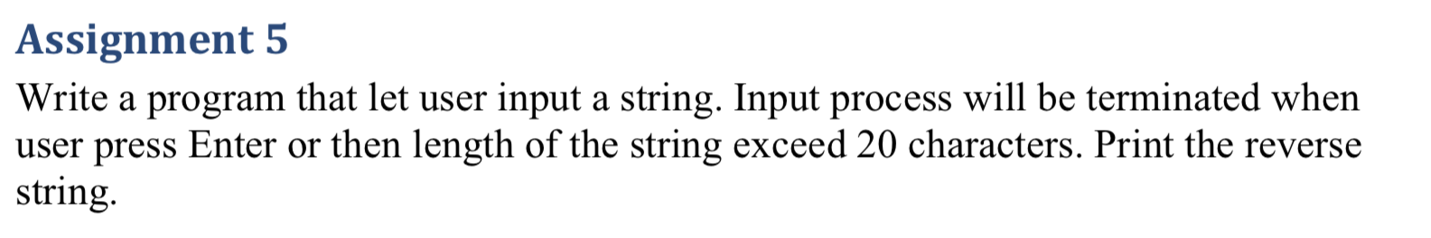

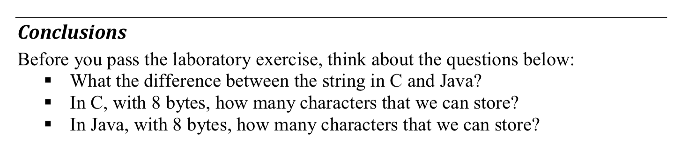

* Code:

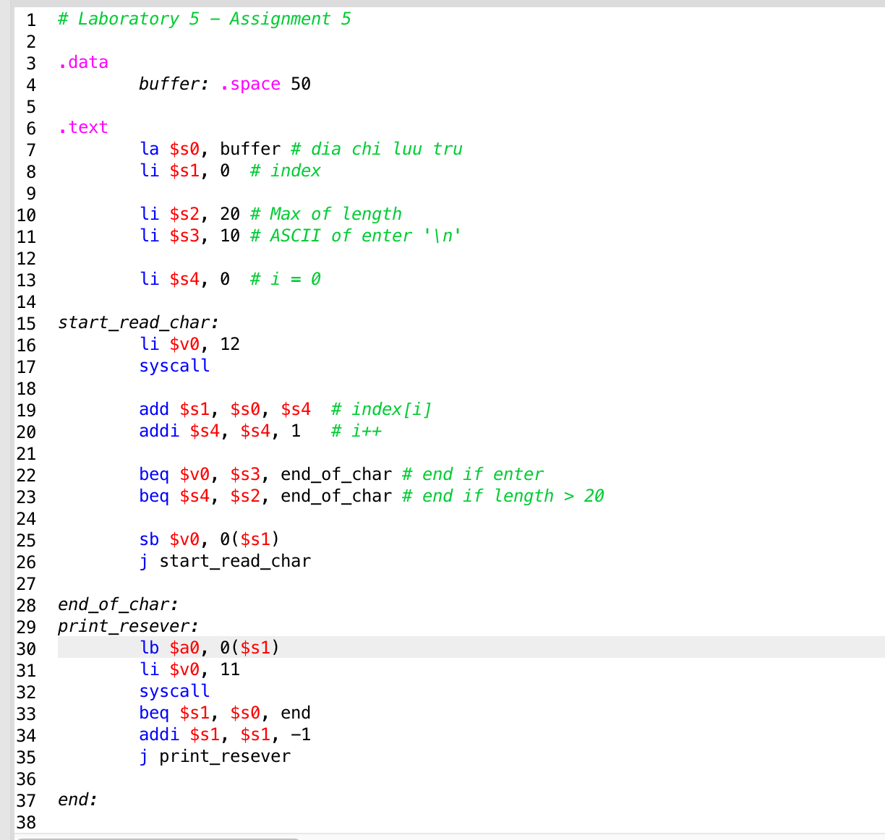

* Kết quả:



* **Conclusion:**

+ What the difference between the string in C and Java?

* A string in C is a nul-terminated sequence of chars. That sequence occupies a contiguous set of memory locations.
* A string in Java is more abstract. It has methods that allow a programmer to perform operations on the string and to obtain information about the string.

+ In C, with 8 bytes, how many characters that we can store?

Chars in C are typically (not always) 8-bit

+ In Java, with 8 bytes, how many characters that we can store?

Java chars are 16-bits (always).