|  |
| --- |
|  |
| Capstone Project Document |

**Mini Explorer System**

----------------------------------------------------------------

|  |  |  |
| --- | --- | --- |
| **MEx Team** | | |
| **Group Members** | Luyện Bảo Anh | SE03747 |
| Phạm Minh Hoàng | SE03769 |
| Lê Xuân Hướng | SE03388 |
| Phùng Đức Luật | SE03164 |
| Đỗ Cao Phong | SE03196 |
| Đặng Ngọc Tú | SE03591 |
| **Supervisor** | Hoàng Xuân Sơn | |
| **Project code** | MEx | |

**- Hoa Lac, 08/2017 –**

Contents

1. INTRODUCTION 3

**1.1** Purpose 3

**1.2** Acronyms and Definitions 3

**1.3** The People 3

1.3.1 Supervisor 3

1.3.2 Team member 3

**1.4** Project information 4

**1.5** The idea 4

**1.6** Proposal of system 4

1.6.1 The scope 4

1.6.2 Existing system 5

**1.7** Benefit from project 6

1.7.1 For team members 6

1.7.2 For community 6

**1.8** Critical assumption and constraints 6

1.8.1 Critical assumption 6

1.8.2 Critical constraints 6

**1.9** Potential risks 7

2. Project management plan 7

**2.1** Definition Problem 7

2.1.1 Name of this Capstone Project 7

2.1.2 Boundaries of the System 7

2.2 Project organization 8

2.2.1 System Process Model 8

2.2.2 Roles and Responsibilities 9

2.2.3 Tools and Techniques 10

2.3 Project management plan 11

2.3.1 Human Resource 14

2.3.2 Meeting Minutes 14

2.3.3 Risk Management Plan 15

2.3.4 Communication Plan 17

2.4 Project Directory 18

# INTRODUCTION

## Purpose

This document is created as the introduction for project MEx – our Capstone Project at FPT University. In this document, we will descript the overview of some existing systems, the initial idea for our project, a brief description about our expected system and some potential risks, critical assumptions, constrains. Moreover, this document also shows opportunities what it offers for users.

## Acronyms and Definitions

|  |  |
| --- | --- |
| **Acronym & Abbreviation** | **Definition** |
| MEx | Mini Explorer |
| FU | FPT University |
| VR | Virtual Reality |
| Remote Controller | The devices include steering wheel, pedals, gear stitch, used for driving simulator |
| PiCar | The model of automobile, with the Raspberry Pi inside used in this project |

*Table 1-1:* *Definitions and Acronyms*

## The People

### Supervisor

|  |  |  |  |  |
| --- | --- | --- | --- | --- |
|  | **Full name** | **Phone** | **Email** | **Title** |
| Supervisor | Hoàng Xuân Sơn | 0936232008 | [SonhHX@fe.edu.vn](mailto:SonhHX@fe.edu.vn) |  |

Table 1-2: Supervisor’s information

### Team member

|  |  |  |  |  |  |
| --- | --- | --- | --- | --- | --- |
| **No** | **Full name** | **StudentID** | **Phone** | **Email** | **Role** |
| 1 | Luyện Bảo Anh | SE03747 | 01672788452 | [anhlbse03747@fpt.edu.vn](mailto:anhlbse03747@fpt.edu.vn) | Team Leader |
| 2 | Phạm Minh Hoàng | SE03769 | 0904882411 | [hoangpmse03769@fpt.edu.vn](mailto:hoangpmse03769@fpt.edu.vn) | Team Member |
| 3 | Lê Xuân Hướng | SE03388 | 01649132648 | [huonglxse03388@fpt.edu.vn](mailto:huonglxse03388@fpt.edu.vn) | Team Member |
| 4 | Phùng Đức Luật | SE03164 | 01656885023 | [luatpdse03164@fpt.edu.vn](mailto:luatpdse03164@fpt.edu.vn) | Team Member |
| 5 | Đỗ Cao Phong | SE03196 | 0979064208 | [phongdcse03196@fpt.edu.vn](mailto:phongdcse03196@fpt.edu.vn) | Team Member |
| 6 | Đặng Ngọc Tú | SE03591 | 0868463132 | [tudnse03591@fpt.edu.vn](mailto:tudnse03591@fpt.edu.vn) | Team Member |

Table 1-3: Team member information

## Project information

* Project name: Mini Explorer System
* Project code: MEx
* Project group name: MEx Team
* Product type: Embedded System
* Timeline: From May 8th to August 26th, 2017

## The idea

Nowadays, the rapid development of technology has a strong impact on the life of human beings. Along the rapid expansion of economic, the improvement of living standard, the demand of people about a comfort, safe and convenience life, car is going to one of main means of transportation. But in Vietnam, the prices of cars are still too high for people to own one. Therefore, they have to take driving courses so that they can practice in the real car at relatively high prices. Not to mention, during the practice, can cause accidents for the user when they are not proficient yet.

MEx is the idea of first-person view - driving simulation system through virtual reality (VR) technology. The user controls an automobile model by wheel controller, pedals as in the real car. The camera will be set up and provide first-person view to a virtual reality lens to observe all vehicle movements.

The system simulates the whole process of driving a car so that user can learn how to drive easily at home rather than going to the driving courses.

## Proposal of system

### The scope

The scope of MEx is a prototype of control device. It includes both hardware and software. Finally, product must be satisfied some below specification.

* Streaming video with following feature:
  + Frame rate: 24 frames/second.
  + Delay: Depend on network rate.
  + Resolution: 640x480
* Controllers and models must have minimum functions such as running (forward, backward), steering, braking.
* Working on the terrain is relatively flat, not too rough, not too complex, no waves or interference obstructions.
* Tracking the motion of the head to provide the most sensible viewing angle

### Existing system

Recently, there are various products like MEx with good functions, attractive design interface. Below are some of these products:



#### FPW Driving - Drive an RC Car with First person view

FPW Driving is a prototype of Paul Yan – Arduino Team member. With an old PS2 wheel controller, two Arduinos, a mini FPV camera, and a headset as a standalone monitor, he made a system to control a RC car with first-person view very smoothly. The RC car–which is equipped with a Micro–interfaces with the wheel using an Uno and a PS2 Shield. Both Arduinos communicate via a pair of nRF24L01 modules

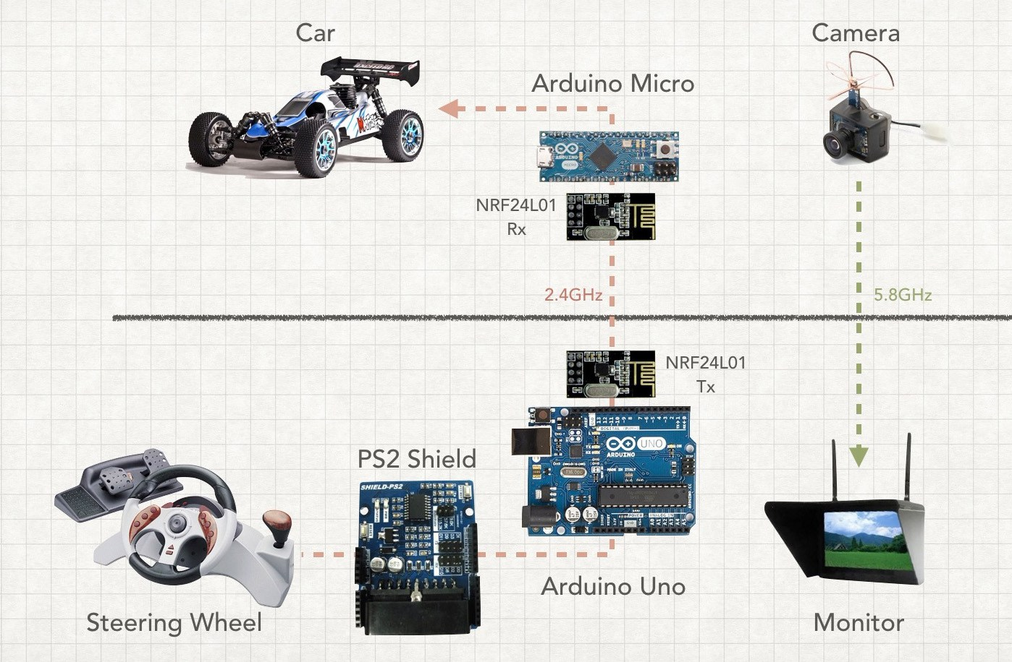

***Figure 1****: FPW-Driving Diagram*

Without tracking the movement of the head, this system can only provide the front sight from straight view of the car. It will become difficult for users when they want to look to the right or left. This is the biggest shortcoming of Yan’s FPW Driving.

#### RACEROOM with Oculus Rift

Raceroom is the one of the most typical driving simulation games. This game offers players a system of more than 20 arcades and more than 60 vehicles to enter the race. With Oculus Rift (VR lens from Microsoft), playing Raceroom will be more fun and realistic with live sound and various gameplay modes.

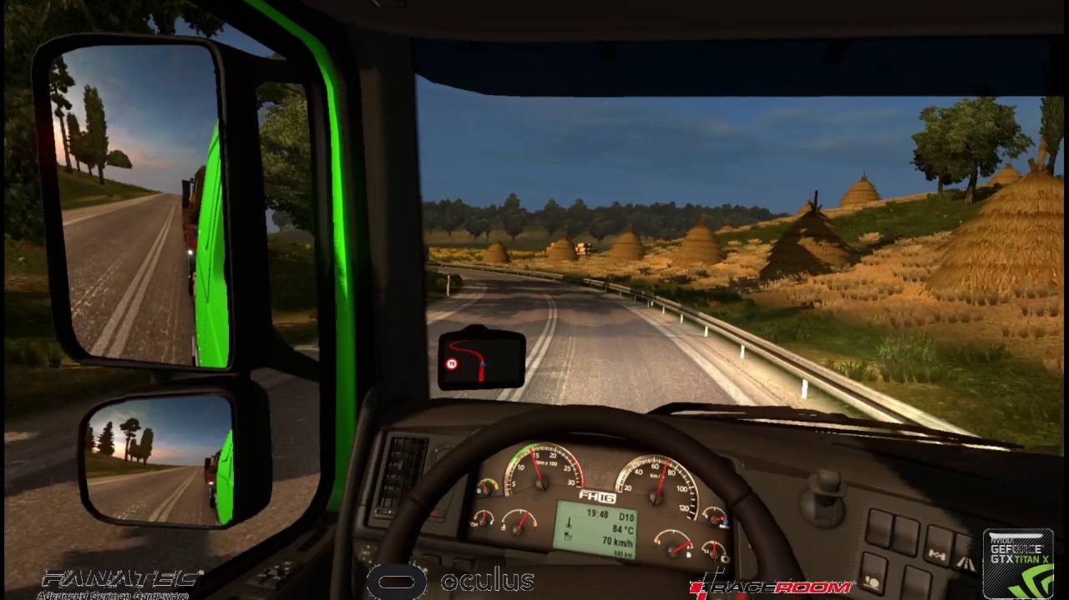Player can skip racing mode, and practice driving in a virtual environment. With Driving Force from Logitech or steering wheel from other suppliers, Raceroom would be suitable for those who want to practice driving.

***Figure 2:*** *Screen from Playing Raceroom with Oculus Rift*

As a product that has been commercialized, Raceroom is being sold on Steam for around $ 20. Along with the expensive equipment that comes with the Oculus glass, Logitech's controllers make the price of this kit close to $2000. It is very expensive for drive learner.

## **1.7** Benefit from project

### For team members

* Have more experiences in working in project, project management.
* Have more knowledge about Arduino, Raspberry Pi, Android and mechanical.
* Improve skill about communicate with team members and how to work in team more effective.

### For community

* Have a new feeling of driving.
* Learn or get more driving practice anytime.
* Explore the distant area without the need for actual movement.



## Critical assumption and constraints

### Critical assumption

* Training: Developers can self-training Arduino and Raspberry Pi Programming with Python in 3 Weeks.
* Human resources: Assume that all members in team have a good healthy to work

### Critical constraints

* Time & Deadline: We must complete task on time. We have 14 weeks for working, each member works 4 hours/day and 5 days/week. We do not have more time for us to complete developing and deliver application to teachers. Besides, we have to submit report documents before deadline to teacher can review.
* Quality: The products must be run well
* Process: We have to follow the software processing of FPT Software
* Human resources: There are 6 members in our team, each member have to study 4 subjects at school.

## Potential risks

After studying about this project, we find out some problem that we may be encountered:

* Under-estimate scope and time or miss deadline because lack of experience in group working, managing and controlling work.
* Equipment got broken because of careless or accident.
* Human resources: Team member cannot complete their works because of health reasons, key member leave team or un-cooperating on team.
* Change requirements: Requirement changed when some functions can not be completed or some technologies is not suitable.

# Project management plan

## Definition Problem

The Introduction is clearly specified reason why MEx project was chose to develop. It is an overview concept about MEx system and be discussed some main function of existing system.

You now have the knowledge of the system’s scope. This document will present project planning to get the target. All the tasks and time to implement, the resource of the system, and the risk maybe meet during development.

### Name of this Capstone Project

This Capstone project named Mini Explorer System, abbreviated as MEx.

### Boundaries of the System

#### 2.1.2.1 Boundaries of the System

The system under development of this Capstone Project will include:

* The controller has the task of sending the request via wireless, saving control information, controlling device.
* Wireless is an information bridge between the controller and car.
* A central circuit board in the car has responsible for data exchange with the gateway through Arduino to transmit, receive and process information from user.
* User manual, Test Document
* Design circuit broad, Design Document
* Source code Android App and Arduino

#### 2.1.2.2 Development Environment

Below is the list of hardware and software requirements needed for development environment:

***Hardware requirements:***

Develop:

* + Arduino/WeMos
  + Raspberry Pi
  + Sensor, servo motor, resistors, capacitors, wire…
  + Personal Computers with 4 Gigabytes of RAM or more

Test:

* + - Personal Computers

***Software requirements:***

* + - Operating System: Windows 8.1, 10 Pro – 64bit
    - Design software: Proteus 7.8
    - IDEs: Android Studio v5.0 and SDK tools, JDK 7, Arduino-1.6.4-windows,Python
    - Document: Microsoft Office 2016, Microsoft Project 2016

## Project organization

### 2.2.1 System Process Model

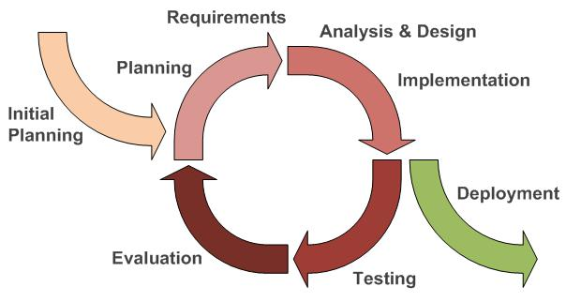

*Figure 2-1: Iterative and Incremental Software Process Model*

This figure above describes the information and products flow lifecycle process model. MEx project uses the Iterative and Incremental Software Process Model.

Iterative and Incremental Software Process Model is a method of software development that is model around a gradual increase in feature additions and a cyclical release and upgrade pattern.

The Iterative and Incremental Software Process Model is most use when the scope of the project is big, the major requirements were defined clearly, some more detail will be added in time, and for the newbie group in software development.

By using this software process model, we break down the developing system task into series of smaller tasks are completed separately, evaluated, and subsequently re-worked until the system’s performance adequately. In addition, the iterative model is easier than other models when the issues were discovery. They are feedback to the team, and solution found while the project is still in development.

### Roles and Responsibilities

#### Organization and Structure

|  |  |  |  |  |  |
| --- | --- | --- | --- | --- | --- |
| **No** | **Name** | **Role** |  | **Responsibilities** |  |
| 1 | Hoàng Xuân Sơn | Supervisor |  | - Approving and supporting process |  |
|  |  |  |  | to run project. |  |
|  |  |  |  | - Suggesting solution when the |  |
|  |  |  |  | project meets issue. |  |
|  |  |  |  |  |  |
| 2 | Luyện Bảo Anh | Project Manager |  | - Select methodology to identify risk. |  |
|  |  |  |  | - Set common rule to all members in |  |
|  |  |  |  |  |
|  |  |  |  | project to avoid risk. |  |
|  |  |  |  |  |  |
|  |  |  |  | - Approve solution to resolve issues. |  |
| 3 | Lê Xuân Hướng | Technical Leader |  | - Investigate technical issues. |  |
|  |  |  |  | - Review source codes. |  |
|  |  |  |  |  |  |
| 4 | Phùng Đức Luật | QA Leader |  | - Keeping all of member on process |  |
|  |  |  |  | and follow common rule. |  |
|  |  |  |  |  |
|  |  |  |  | - Reviewing quality of resolved |  |
|  |  |  |  | issues. |  |
| 5 | Đỗ Cao Phong | Sofware Dev |  | - Follow process of project. |  |
|  |  |  |  | - Follow common rule of project. |  |
|  |  |  |
|  |  |  |  | - Develop android product |  |
|  |  |  |  |  |  |
| 6 | Phạm Minh Hoàng | Hardware Dev |  | - Follow process of project. |  |
|  |  |  |  | - Follow common rule of project. |  |
|  |  |  |  | - Develop arduino product and remote controller |  |
| 7 | Đặng Ngọc Tú | Test Leader |  | - Invole to test product |  |
|  |  |  |  | -Responsible for test execution, test set-up, test run, evaluation of test run and error recovery |  |

*Table 2-1: Project Structure*

#### 2.2.2.2 Project Team Member

|  |  |
| --- | --- |
|  |  |
|  |  |
| **Team Member** | **Roles** |
|  |  |
| AnhLB | Project Manager, |
|  |  |
| HuongLX | Technical Leader |
|  |  |
| PhongDC | Software Dev |
|  |  |
| HoangPM | Hardware Dev |
|  |  |
| LuatPD | QA leader |
|  |  |
| TuDN | Test leader |
|  |  |

*Table 2-2: Project Team Member*

SonHX  
(Supervisor)

AnhLB  
(Project Manager)

Technical Leader

Test leader

QA leader

Hardware Dev

Software Dev

- HuongLX

- TuDN

- LuatPL

- HoangPM

- PhongDC

*Figure 2-2: Project Team Member*

### Tools and Techniques

* Programing languages: Java, Python 3.5, Arduino
* Process Model: Iterative and Incremental Software Process Model.
* IDEs: Android Studio, Arduino IDE, Python IDLE
* Design tool: Fritzing, Photoshop, Proteus
* Other:
  + Revision control: Gitkraken &Tortoise GIT
  + Office tools: MS Office 2016

## Project management plan

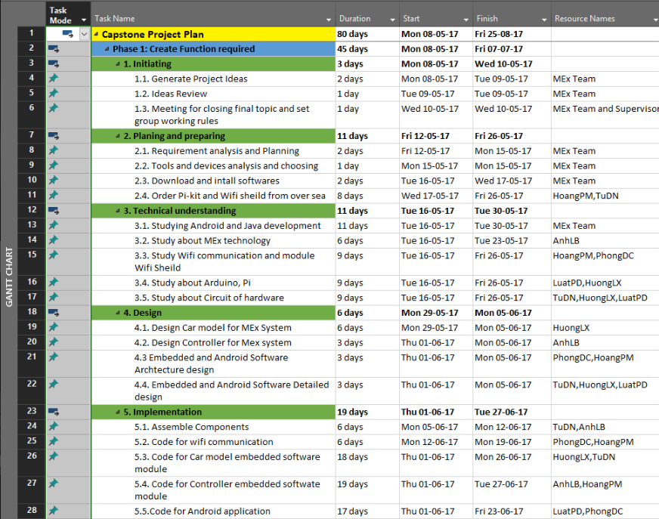

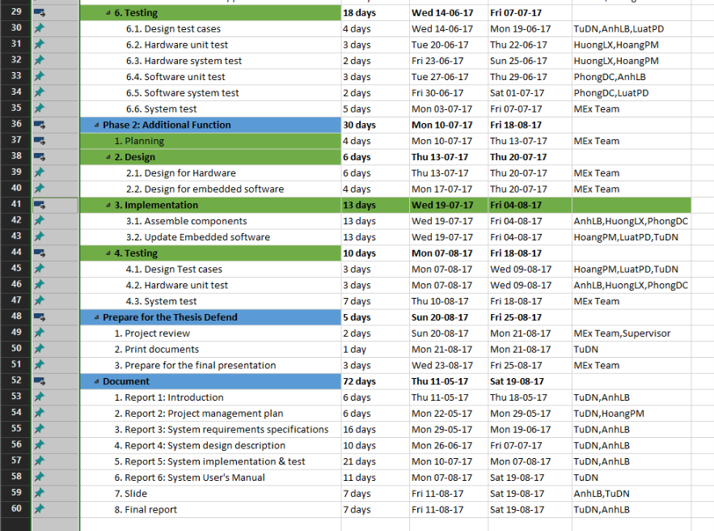

*Figure 2-3: Project Management Plan*

Refer to [MEx_ProjectPlan.mpp]

### 2.3.1 Human Resource

Human resource:

* + - Team member
    - Supervisor

Non – human resource:

* + Equipment: Personal Computers, Arduino, Raspberry PI
  + Building: FPT University, Thachhoa, Thachthat, Hanoi
  + Building: FPT University’s Library, Thachhoa, Thachthat, Hanoi

### Meeting Minutes

An example of group’s meeting minute during the time executed project:

|  |  |  |  |  |  |  |  |  |  |  |
| --- | --- | --- | --- | --- | --- | --- | --- | --- | --- | --- |
| ***Meeting/Project*** |  |  | MEx |  |  |  |  |  |  |  |
| ***Name:*** |  |  |  |  |  |  |  |  |  |  |
|  |  |  |  |  |  |  |  |  |  |  |
| ***Date of Meeting:*** | 15/052017 |  | ***Time: (Type)*** |  |  |  |  |  | 2 hours |  |
|  |  |  |  |  |  |  |  |  |  |  |
| ***Facilitator:*** | AnhLB |  | ***Location:*** | Library of FPT University | | | | | | |
|  |  |  |  |  | | | | | |  |
| ***Note Taker:*** | TuDN |  |  |  |
|  |  |  |  |  |  |  |  |  |
|  |  |  |  |  |  |  |  |  |  |  |
| Kick off and create Project Charter. | |  |  |  |  |  |  |  |  |  |
|  |  |  |  |  |  |  |  |  |  |  |
| 2. Attendance |  |  |  |  |  |  |  |  |  |  |
|  |  |  |  |  |  |  |  |  |  |  |
| ***Name*** | ***Roles*** |  | ***E-mail*** |  |  |  |  |  | ***Phone*** |  |
|  |  |  | | |  |  |  |  | | |
| Luyện Bảo Anh | Project Manager | AnhlbSE03747@fpt.edu.vn | | | | |  | 01672788452 | | |
|  |  |  | | |  |  | |  | | |
| Lê Xuân Hướng | Technical Leader | HuongLXSE03388@fpt.edu.vn | | | | | | 01649132648 | | |
|  |  |  | | | |  |  |  | | |
| Đỗ Cao Phong | Developer | PhongDCSE03196@fpt.edu.vn | | |  | | | 0979064208 | | |
|  |  |  | | | |  | |  | | |
| Phạm Minh Hoàng | Developer | HoangPMSE03769@fpt.edu.vn | | | | | | 0904882411 | | |
|  |  |  | | | | | |  | | |
| Phùng Đức Luật | QA Leader | LuatPDSE03164@fpt.edu.vn | | | | | | 01656885023 | | |
|  |  |  | |  |  |  |  |  |  |  |
| Đặng Ngọc Tú | Test Leader | TuDNSE03591@fpt.edu.vn | | |  |  | |  | 0868463132 | |
|  |  |  | | |  |  |  |  |  |  |
| 3. Content: |  |  |  |  |  |  |  |  |  | |
|  |  |  |  |  |  |  |  |  |  |  |
|  | | | | | | | | | | |

|  |
| --- |
| 1. Kick off meeting. 2. Identify Goals and Objectives. 3. Specify roles and responsibilities. 4. Estimate project budget. 5. Identify main project success criteria. 6. Develop Project Charter. 7. Assign mission for each member. 8. Set up time for next meeting. |

*Table 2-3: Meeting minutes template*

### Risk Management Plan

|  |  |  |  |  |  |  |  |  |  |  |  |
| --- | --- | --- | --- | --- | --- | --- | --- | --- | --- | --- | --- |
| **No** | **Name** | **Probability** | |  | **Prevention** |  |  | **Correction** |  | **Impact** |  |
|  |  |  | |  |  |  |  |  |  |  |  |
| 1 | **Miscommunication** | Medium | |  | After a meeting, one |  |  | When it becomes |  | High |  |
|  |  |  | |  | group member |  |  | clear that |  |  |  |
|  |  |  | |  | creates an interview |  |  | miscommunication |  |  |  |
|  |  |  | |  | report. Every |  |  | is causing problem, |  |  |  |
|  |  |  | |  | participant or |  |  | the team members |  |  |  |
|  |  |  | |  | absence person |  |  | are gathered in a |  |  |  |
|  |  |  | |  | should get a copy of |  |  | meeting to clear |  |  |  |
|  |  |  | |  | this report. Team |  |  | thing up. |  |  |  |
|  |  |  | |  | members should not |  |  |  |  |  |  |
|  |  |  | |  | hesitate to ask |  |  |  |  |  |  |
|  |  |  | |  | questions if they are |  |  |  |  |  |  |
|  |  |  | |  | unclear. |  |  |  |  |  |  |
|  |  |  | |  |  |  |  |  |  |  |  |
| 2 | **Design Error** | High | |  | The design should be |  |  | When errors in the |  | Medium |  |
|  |  |  | |  | reviewed very |  |  | design are noticed by |  |  |  |
|  |  |  | |  |  |  |  |  |  |
|  |  |  | |  | critically. Team leader |  |  | PM or team leader |  |  |  |
|  |  |  | |  | should be consulted |  |  | should be consulted |  |  |  |
|  |  |  | |  | frequency on his |  |  | to help correct the |  |  |  |
|  |  |  | |  | opinion about the |  |  | design errors as soon |  |  |  |
|  |  |  | |  | feasibility and the |  |  | as possible. All |  |  |  |
|  |  |  | |  | correctness of certain |  |  | the work, that |  |  |  |
|  |  |  | |  | design decisions. |  |  | depends on the |  |  |  |
|  |  |  | |  |  |  |  | faulty design, should |  |  |  |
|  |  |  | |  |  |  |  | be halted until the |  |  |  |
|  |  |  | |  |  |  |  | error is corrected. |  |  |  |
|  |  |  | |  |  |  |  |  |  |  |  |
| 3 | **Hardware Failure** | Low | |  | Check all of hardware |  |  | Creating a list of |  | High |  |
|  |  |  | |  | before buying. Make |  |  | store that is selling |  |  |  |
|  |  |  | |  | sure the current and |  |  | this hardware. |  |  |  |
|  |  |  | |  | volt of this hardware |  |  | Checking it exist if |  |  |  |
|  |  |  | |  | before using. |  |  | having plan goes to |  |  |  |
|  |  |  | |  |  |  |  | buy. |  |  |  |
|  |  |  | |  |  |  |  |  |  |  |  |
| 4 | **Illness or absence** | Medium |  |  | Team members should |  |  | By ensuring that |  | Medium |  |
|  | **of team member** |  |  |  | warn their team leader |  |  | knowledge is shared |  |  |  |
|  |  |  |  |  | timely before a |  |  | between team |  |  |  |
|  |  |  |  |  | planned period of |  |  | members, work can |  |  |  |
|  |  |  |  |  |  |
|  |  |  |  |  | absence. |  |  | be taken over |  |  |  |
|  |  |  |  |  |  |  |  | quickly by someone |  |  |  |
|  |  |  |  |  |  |  |  | else if a person gets |  |  |  |
|  |  |  |  |  |  |  |  | ill. |  |  |  |
|  |  |  |  |  |  |  |  |  |  |  |  |
|  |  |  |  |  |  |  |  |  |  |  |  |
| 5 | **Requirement** | Medium |  |  | Carefully brainstorm |  |  | Team meetings with |  | High |  |
|  | **change** |  |  |  | system’s features |  |  | supervisor to |  |  |  |
|  |  |  |  |  | among team members. |  |  | determine whether |  |  |  |
|  |  |  |  |  | Regularly hold |  |  | new feature should |  |  |  |
|  |  |  |  |  | meeting to define and |  |  | be implemented or |  |  |  |
|  |  |  |  |  | discuss all the features |  |  | not. Team leaders |  |  |  |
|  |  |  |  |  | of systems. Design |  |  | create |  |  |  |
|  |  |  |  |  | system carefully. |  |  | implementation plan |  |  |  |
|  |  |  |  |  | Analyze all the |  |  | for implemented |  |  |  |
|  |  |  |  |  | possible cases to |  |  | features and sent to |  |  |  |
|  |  |  |  |  | minimize the change |  |  | team members. |  |  |  |
|  |  |  |  |  |  |  |  |  |  |  |  |
| 6 | **Time shortage** | High |  |  | Project manager |  |  | Lacking time is the |  | High |  |
|  |  |  |  |  | should create more |  |  | fatal problem, can |  |  |  |
|  |  |  |  |  |  |  |  |  |  |
|  |  |  |  |  | spare time and |  |  | run project to failure. |  |  |  |
|  |  |  |  |  | calculate plus 20% |  |  | PM should analysis |  |  |  |
|  |  |  |  |  | buffer time. |  |  | and has change on |  |  |  |
|  |  |  |  |  |  |  |  | the next phase. |  |  |  |
|  |  |  |  |  |  |  |  |  |  |  |  |

*Table 2-4: Risk Management Plan*

### 2.3.4 Communication Plan

#### 2.3.4.1 Communication between team members

* *Weekly meeting schedule*: By using Iterative and Incremental Process Model, MExProject System will be divided into a series of small tasks, each task will be assigned to team members by Technical Leader and depend on difficulty, and Technical Leader will be assigned deadlines for each task. We will have a meeting every Thursday, Friday and Monday to report

the progress of whole team’s tasks. Any member who doesn’t finish his/her task (without reasonable explanation), will be fined. If there is any issue, we will discuss and find solution together. If it is too difficult and can’t be solved by ourselves, we will ask our supervisor for advises.

* Unscheduled meeting: If someone has an important problem want to be solved immediately, we will have a meeting for discussion.
* Communication channel: Our main communication channels are face-to-face meeting, email, Facebook, Skype. However, we sometimes can make a phone call or instant message if someone has problem.

#### 2.3.4.2 Communication with Supervisor

* + *Face-to-face* meeting: Weekly on every Thursday afternoons to make sure thatsupervisor can keep tracking of the team’s progress.
  + *E-*mail: Gmail is the fastest way to get device and document checking fromsupervisor.
  + *Mobile phone:* is used to get time and place arranged for the meeting every weekly.

## Project Directory

|  |  |  |
| --- | --- | --- |
| Main folder | Sub-folder | Purpose |
| Document | Design | Diagrams |
| Reports | Store deliverables of reports |
| Plan | Schedule and task list for member |
| Slide | Presentation slideshow and resource |
| Source | Android | Store android app source code |
| Raspi | Store Python code for Raspberry Pi |
| Arduino | Firmware source of Remote Controller |
| Users | Each team members own a folder | Team member’s working area |
| Reference |  | Store reference needed in project |

*Table 2-5: Project Directory*