|  |
| --- |
|  |
| Capstone Project Document |

**Mini Explorer System**

----------------------------------------------------------------

|  |  |  |
| --- | --- | --- |
| **MEx Team** | | |
| **Group Members** | Luyện Bảo Anh | SE03747 |
| Phạm Minh Hoàng | SE03769 |
| Lê Xuân Hướng | SE03388 |
| Phùng Đức Luật | SE03164 |
| Đỗ Cao Phong | SE03196 |
| Đặng Ngọc Tú | SE03591 |
| **Supervisor** | Hoàng Xuân Sơn | |
| **Project code** | MEx | |

**- Hoa Lac, 01/2017 –**

# SIGNATURE PAGE

AUTHOR:

REVIEWERS:

APPROVAL: Hoang Xuan Son

Supervisor

Record of change

*A - Added M - Modified D – Deleted

|  |  |  |  |  |  |  |
| --- | --- | --- | --- | --- | --- | --- |
| Effective Date | Changed Item | A,M,D | Change Description | Reason for Change | Rev. Number | Author |
| 12/05/2017 | Create Introduction | A | Create Introduction | Report 1 | 1.0 | TuDN |
|  |  |  |  |  |  |  |
|  |  |  |  |  |  |  |
|  |  |  |  |  |  |  |
|  |  |  |  |  |  |  |
|  |  |  |  |  |  |  |
|  |  |  |  |  |  |  |
|  |  |  |  |  |  |  |
|  |  |  |  |  |  |  |
|  |  |  |  |  |  |  |
|  |  |  |  |  |  |  |
|  |  |  |  |  |  |  |
|  |  |  |  |  |  |  |
|  |  |  |  |  |  |  |
|  |  |  |  |  |  |  |
|  |  |  |  |  |  |  |
|  |  |  |  |  |  |  |
|  |  |  |  |  |  |  |
|  |  |  |  |  |  |  |
|  |  |  |  |  |  |  |
|  |  |  |  |  |  |  |

Contents

SIGNATURE PAGE 1

1. INTRODUCTION 3

1.1 Purpose 3

1.2 Acronyms and Definitions 3

1.3 The People 3

1.3.1 Supervisor 3

1.3.2 Team member 3

1.4 Project information 4

1.5 The idea 4

1.6 Proposal of system 4

1.6.1 The scope 4

1.6.2 Existing system 4

1.8 Benefit from project 6

1.8.1 For team members 6

1.8.2 For community 6

1.9 Critical assumption and constraints 6

1.9.1 Critical assumption 6

1.9.2 Critical assumption 7

1.10 Potential risks 7

# INTRODUCTION

## Purpose

This document is created as the introduction for project MEx – our Capstone Project at FPT University. In this document, we will descript the overview of some existing systems, the initial idea for our project, a brief description about our expected system and some potential risks, critical assumptions, constrains. Moreover, this document also shows opportunities what it offers for users.

## Acronyms and Definitions

|  |  |
| --- | --- |
| **Acronym & Abbreviation** | **Definition** |
| MEx | Mini Explorer |
| FU | FPT University |
| VR | Virtual Reality |

Table 1-1: *Definitions and Acronyms*

## The People

### Supervisor

|  |  |  |  |  |
| --- | --- | --- | --- | --- |
|  | **Full name** | **Phone** | **Email** | **Title** |
| Supervisor | Hoàng Xuân Sơn | 0936232008 | [SonhHX@fe.edu.vn](mailto:SonhHX@fe.edu.vn) |  |

1. Supervisor’s information

### Team member

|  |  |  |  |  |  |
| --- | --- | --- | --- | --- | --- |
| **No** | **Full name** | **StudentID** | **Phone** | **Email** | **Role** |
| 1 | Luyện Bảo Anh | SE03747 | 01672788452 | [anhlbse03747@fpt.edu.vn](mailto:anhlbse03747@fpt.edu.vn) | Team Leader |
| 2 | Phạm Minh Hoàng | SE03769 | 0904882411 | [hoangpmse03769@fpt.edu.vn](mailto:hoangpmse03769@fpt.edu.vn) | Team Member |
| 3 | Lê Xuân Hướng | SE03388 | 01649132648 | [huonglxse03388@fpt.edu.vn](mailto:huonglxse03388@fpt.edu.vn) | Team Member |
| 4 | Phùng Đức Luật | SE03164 | 01656885023 | [luatpdse03164@fpt.edu.vn](mailto:luatpdse03164@fpt.edu.vn) | Team Member |
| 5 | Đỗ Cao Phong | SE03196 | 0979064208 | [phongdcse03196@fpt.edu.vn](mailto:phongdcse03196@fpt.edu.vn) | Team Member |
| 6 | Đặng Ngọc Tú | SE03591 | 0868463132 | [tudnse03591@fpt.edu.vn](mailto:tudnse03591@fpt.edu.vn) | Team Member |

1. Team member information

## Project information

* Project name: Mini Explorer System
* Project code: MEx
* Project group name: MEx Team
* Product type: Embedded System
* Timeline: From May 8th to August 26th, 2017

## The idea

Nowadays, the rapid development of technology has a strong impact on the life of human beings. Along the rapid expansion of economic, the improvement of living standard, the demand of people about a comfort, safe and convenience life, car is going to one of main means of transport . But in Vietnam, the prices of cars are still too high for people to own one. Therefore, they have to take driving courses so that they can practice in the real car at relatively high prices. Not to mention, during the practice, can cause accidents for the user when they are not proficient yet.

MEx is the idea of first-person view - driving simulation system through virtual reality (VR) technology. The user controls an automobile model by wheel controller, pedals as in the real car. The camera will be set up and provide first-person view to a virtual reality lens to observe all vehicle movements.

The system simulates the whole process of driving a car so that user can learn how to drive easily at home rather than going to the driving courses.

## Proposal of system

### The scope

The scope of MEx is a prototype of control device. It includes both hardware and software. Finally, product must be satisfied some below specification.

* Streaming video with following feature:
  + Frame rate: 24 frames/second.
  + Delay: Depend on network rate.
  + Resolution: 640x480
* Controllers and models must have minimum functions such as running (forward, backward), steering, braking.
* Working on the terrain is relatively flat, not too rough, not too complex, no waves or interference obstructions.
* Tracking the motion of the head to provide the most sensible viewing angle

### Existing system

Recently, there are various products like MEx with good functions, attractive design interface. Below are some of these products:

* + - 1. *FPW Driving – Drive an RC Car with First person view*

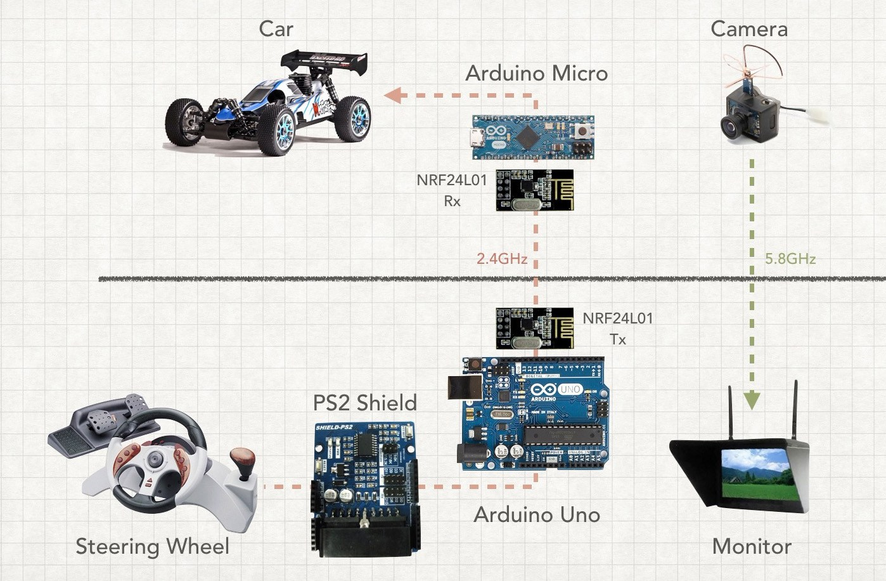 FPW Driving is a prototype of Paul Yan – Arduino Team member. With an old PS2 wheel controller, two Arduinos, a mini FPV camera, and a headset as a standalone monitor, he made a system to control a RC car with first-person view very smoothly. The RC car–which is equipped with a Micro–interfaces with the wheel using an Uno and a PS2 Shield. Both Arduinos communicate via a pair of nRF24L01 modules.

***Figure 1****: FPW-Driving Diagram*

Without tracking the movement of the head, this system can only provide the front sight from straight view of the car. It will become difficult for users when they want to look to the right or left. This is the biggest shortcoming of Yan’s FPW Driving.

* + - 1. *RACEROOM with Oculus Rift*

Raceroom is the one of the most typical driving simulation games. This game offers players a system of more than 20 arcades and more than 60 vehicles to enter the race. With Oculus Rift (VR lens from Microsoft), playing Raceroom will be more fun and realistic with live sound and various gameplay modes.

Player can skip racing mode, and practice driving in a virtual environment. With Driving Force from Logitech or steering wheel from other suppliers, Raceroom would be suitable for those who want to practice driving.

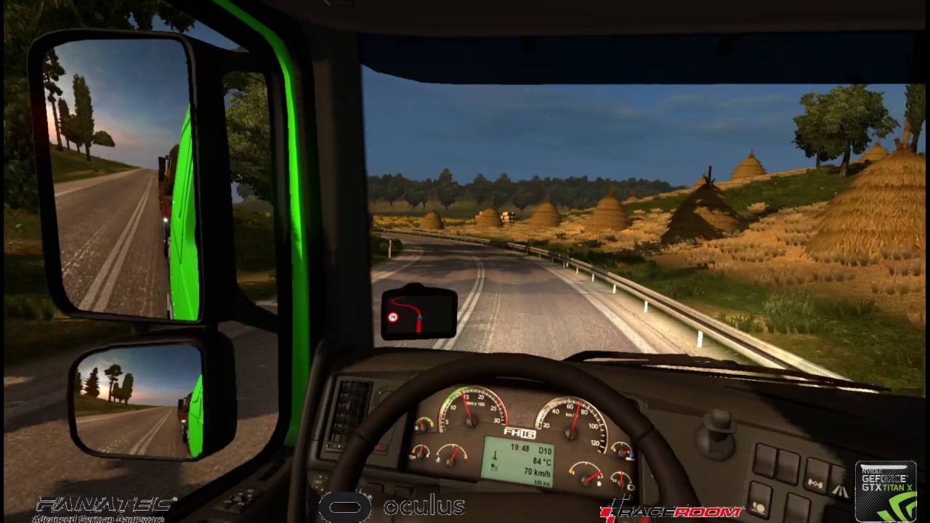***Figue 2:*** *Screen from Playing Raceroom with Oculus Rift*

As a product that has been commercialized, Racerook is being sold on Steam for around $ 20. Along with the expensive equipment that comes with the Oculus glass, Logitech's controllers make the price of this kit close to $2000. It’s very expensive for drive learner.

## Benefit from project

### For team members

* Have more experiences in working in project, project management.
* Have more knowledge about Arduino, Raspberry Pi, Android and mechanical.
* Improve skill about communicate with team members and how to work in team more effective.

### For community

* Have a new feeling of driving.
* Learn or get more driving practice anytime.
* Explore the distant area without the need for actual movement.

## Critical assumption and constraints

### Critical assumption

* Training: Developers can self-training Arduino and Raspberry Pi Programming with Python in 3 Weeks.
* Human resources: Assume that all members in team have a good healthy to work

### Critical assumption

* Time & Deadline: We must complete task on time. We work on 14 weeks, each member works 5 hours/day and 5 days/week. We do not have more time for us to complete developing and deliver application to teachers. Besides, we have to submit report documents before deadline to teacher can review.
* Quality: The products must be run well
* Process: We have to follow the software processing of FPT Software
* Human resources: There are 6 member in our team, each member have to study 4 subjects at school.

## Potential risks

After studying about this project, we find out some problem that we may be encountered:

* Under-estimate scope and time or miss deadline because lack of experience in group working, managing and controlling work.
* Equipment got broken because of careless or accident.
* Human resources: Team member cannot complete their works because of health reasons, key member leave team or un-cooperating on team.
* Change requirements: Requirement changed when some functions cannot be completed or some technologies is not suitable.