The Student’s Guide of Capstone Project Document for the FU Students
(For ES specific)
--- * ---

The Student’s Guide of Capstone Project Document for the FU Students includes:
- Regulations by FU Academic Department.
- Capstone Project Document includes the Milestone Table and the Evaluation of this Capstone Project
The following statements are only about the ES Capstone Project (CPro) Document.

General introduction:
Students are strongly encouraged to complete an independent Capstone project as one of their elective choices during the final semester. Here you will find details on choosing a project, choosing an advisor, writing your proposal, and completing the process.
The goal of the Capstone project is to demonstrate fluency with the tools of scholarship and professional practice in your field, an ability to independently plan and carry out a non-trivial piece of work, and an ability to present your work in written and oral formats.
Your Capstone project can take many forms, depending on your interests. It must be educational, have a research component, and relate to the Software Engineering program. It should also have a clear focus and well-defined success criteria.
Unlike the design of a software application on a standard platform, the design of an embedded system implies that both software and hardware are being designed in parallel. Although this isn’t always the case, it is a reality for many designs today. The profound implications of this simultaneous design process heavily influence how systems are designed.

The embedded design life cycle can be divided into 7 phases:

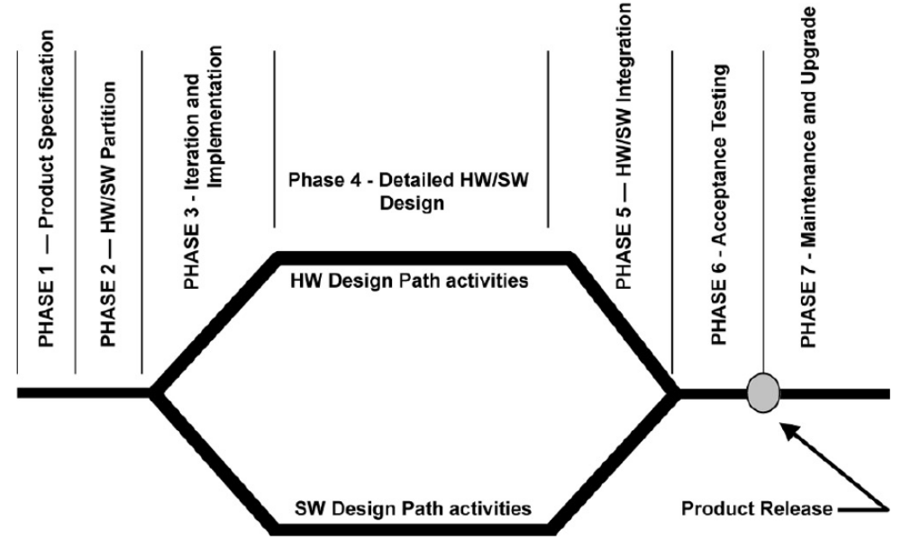

The embedded design process is not as simple as above figure depicts. A considerable amount of iteration and optimization occurs within phases and between phases. Defects found in later stages often cause you to “go back to square 1.” For example, when product testing reveals performance deficiencies that render the design non-competitive, you might have to rewrite algorithms, redesign custom hardware — such as Application-Specific Integrated Circuits (ASICs) for better performance — speed up the processor, choose a new processor, and so on.
The economics and reality of a design requirement often force decisions to be made before designers can consider the best design trade-offs for the next project. In fact, designers use the term “clean sheet of paper” when referring to a design opportunity in which the requirement constraints are minimal and can be strictly specified in terms of performance and cost goals.
This CPro will focus the most necessary contents in ES projects.

Reports:
The ES Capstone Project Document Template is composed of 6 parts called Reports:
- Report No.1: Introduction
- Report No.2: Project Management Plan
- Report No.3: Requirements
- Report No.4: Implementation
- Report No.5: Results
- Report No.6: Conclusion
(Annex, References)

Milestones:
- At begin of week 2 submit: Report No.1 (duration: 1 week)
- At begin of week 3 submit: Report No.2 (duration: 1 week)
- At begin of week 4 submit: Report No.3 (duration: 1 week)
- At begin of week 12 show: All RESULTS (development duration: 8 weeks) (continue to complete Report No.1-3; weekly show RESULTS for the Lecturer)
- At begin of week 13 submit: Report No.4 and Report No.5 (duration: 1 week) (Net Total Duration: 12 weeks)
- In weeks 13&14: Report No.6, demo, submit the last document
(composed of Report No. 1-6 + ANNEX + REFERENCES)
and CD-SourceCode_Execuable_ProgramPackage.
- In week 15 represent Capstone Project

Evaluation of this Capstone Project:
Based on Group Mark (GM), Personal Mark (in range: from -100%GM to + 20%GM) will be given for all Reports.
Project Mark = Process Mark (6 Reports) x 50% + Presentation Mark (by Committee) x 50%
Weights of Reports in Process Mark are:
- Report No.1: Introduction (5%)
- Report No.2: Project Management Plan (10%)
- Report No.3: Requirements (20%)
- Report No.4: Implementation (50%)
- Report No.5: Results (10%)
- Report No.6: Conclusion (5%)

ES Capstone Project Document Template

Report No.1: Introduction

This part is about: the developer group (Roles and Responsibilities); the initial idea of the group’s Cpro; overview of similar existing solutions, and overview of existing methods; business outline, limitations of existing system, improvement objectives, and benefits of expected system.
<Introduction to this document, how it is organized, (what it contains>
Report No.2: Project Management Plan

2.1. Problem Definition
2.1.1. Name of this CPro Project
2.1.2. Problem Abstraction
<Write down the problem abstract. This can be paraphrased from the Customer’s Requirement>
2.1.3. Project Overview
2.1.3.1. The Current System
<Describe the current system/situation. This can be paraphrased from the Customer’s Requirement>
2.1.3.2. The Proposed System
<Describe the system under-developed. This can be paraphrased from the Customer’s Requirement>
2.1.3.3. Boundaries of the System
<List the scope/boundaries of the system under-developed. This can be paraphrased from the Customer’s Requirement>

2.2. Project management plan
2.2.1. Tasks:
2.2.1.n Task-n:
- Description
- Deliverables
- Resources Needed
- Dependencies and Constraints
- Risks
2.2.2. Task Sheet: Assignments and Timetable
2.2.3. All Meeting Minutes
<Put all your-team’s meeting minutes in Annex)
2.3. Other material (if any)
Report No.3: Requirements

3.1. User Requirement Specification
<Summarize the customer requirement into the compact form>
3.2. System Requirement Specification (Specific Requirements)
<Summarize the system requirement into the compact form>
3.2.1. External Interface Requirements
3.2.1.1. User Interfaces
3.2.1.2. Hardware Interfaces
3.2.1.3. Software Interfaces
3.2.1.4. Communications Protocol
3.2.2. System Features
3.2.2.n. System Feature n
3.3. Other material (if any)

Report No.4: Implementation
4.1. Proposed system architecture
4.2 Analysis and selection of tools, devices
4.3. Introduction/Resume a theory problem (optional)
4.4 Algorithm analysis (optional)
4.5 Solution analysis (optional)
4.6. Circuit design (optional)
4.7. Interface design (optional)
4.8. Database design (optional)
4.9. Protocol design (optional)
4.10. Testing (Co-Design in Embedded System).

Report No.5: Results
5.1. Risk or limitation of system
5.2. Strategies or solution for reducing limitations
5.3. Perspectives

Report No.6: Conclusions
It's a summary of the outcomes of the experiment/project compared to the expectations. There should be also a brief explanation so that someone can only read the introduction and conclusion of the project but know exactly what went on.

Annex:
1 Installation Guide
2. User’s Guide
3. Detail codes
4. Product images
5. Meeting minutes

REFERENCES
Figures, Tables, Websites, Books, Articles…

