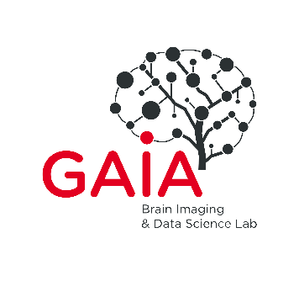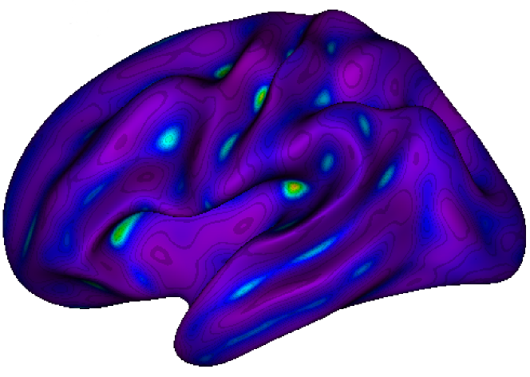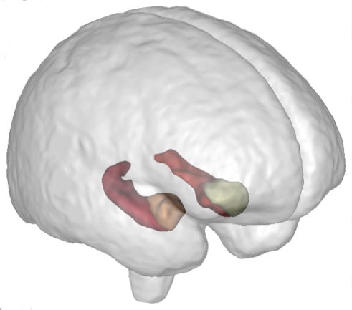

**NeuroSpin** is an outstanding research center working on the **human brain**. Being a part of the CEA (Atomic Energy Commission) and Paris-Saclay University, the NeuroSpin teams are leaders in very high field MRI and carry out studies in **fundamental and clinical neurosciences**. The **BrainOmics** team works in **imaging-genetics**, at the crossroad where **neuroinformatics, bioinformatics** and **machine learning** meet, and in collaboration with CNRGH in Evry.

**Association of rare variants with medical image derived phenotypes in a large biobank with WES and WGS**

Materials

NeuroSpin groups **have access to the UK Biobank,** a large biobank with WES/WGS data in ~500k participants and medical images in ~100K participants. The UK Biobank data will be used for the analysis described in the next section.

Methods

The work will be consisting of implementing analysis and annotation tools on the UKB-RAP analysis platform. A first objective will be **to establish potential associations** for different **medical** **imaging features** currently studied at NeuroSpin. A second objective will be **to investigate the links** between the **rare variant** associations found and the results currently obtained with methods using **common variants**.

Benefits of the training

The proposed training introduces to the research job in Data Science. The work will be applied to an exceptional world-class resource in imaging-genetics: UK-BioBank. It offers the opportunity to investigate original and new uses of machine/deep learning for genome wide association studies.

Job-related skills

* **Good skills in statistics and applied mathematics**
* Knowledge in **bioinformatics tools for genomic association studies** is an asset.
* Programming : **Python**, R for data engineering and data science
* **Curiosity, taste for multi-disciplinary environment and for innovation.**

Profile

-Engineering school and/or Master 2 student in bioinformatics, machine learning or computational neurosciences.

* **Genotype microarray, brain anatomical and functional MRI data integration**.
* Develop innovative and integrative **machine learning** prediction and stratification models.
* **Applications in clinical neurosciences, ASD.**

Duration**: 6 months**, starting in spring 2025.

Location : NeuroSpin-CEA, Plateau de Saclay, Gif-sur-Yvette.

Please email your CV + cover letter **by mid-february** to [vincent.frouin@cea.fr](mailto:vincent.frouin@cea.fr)

https://brainomics.org