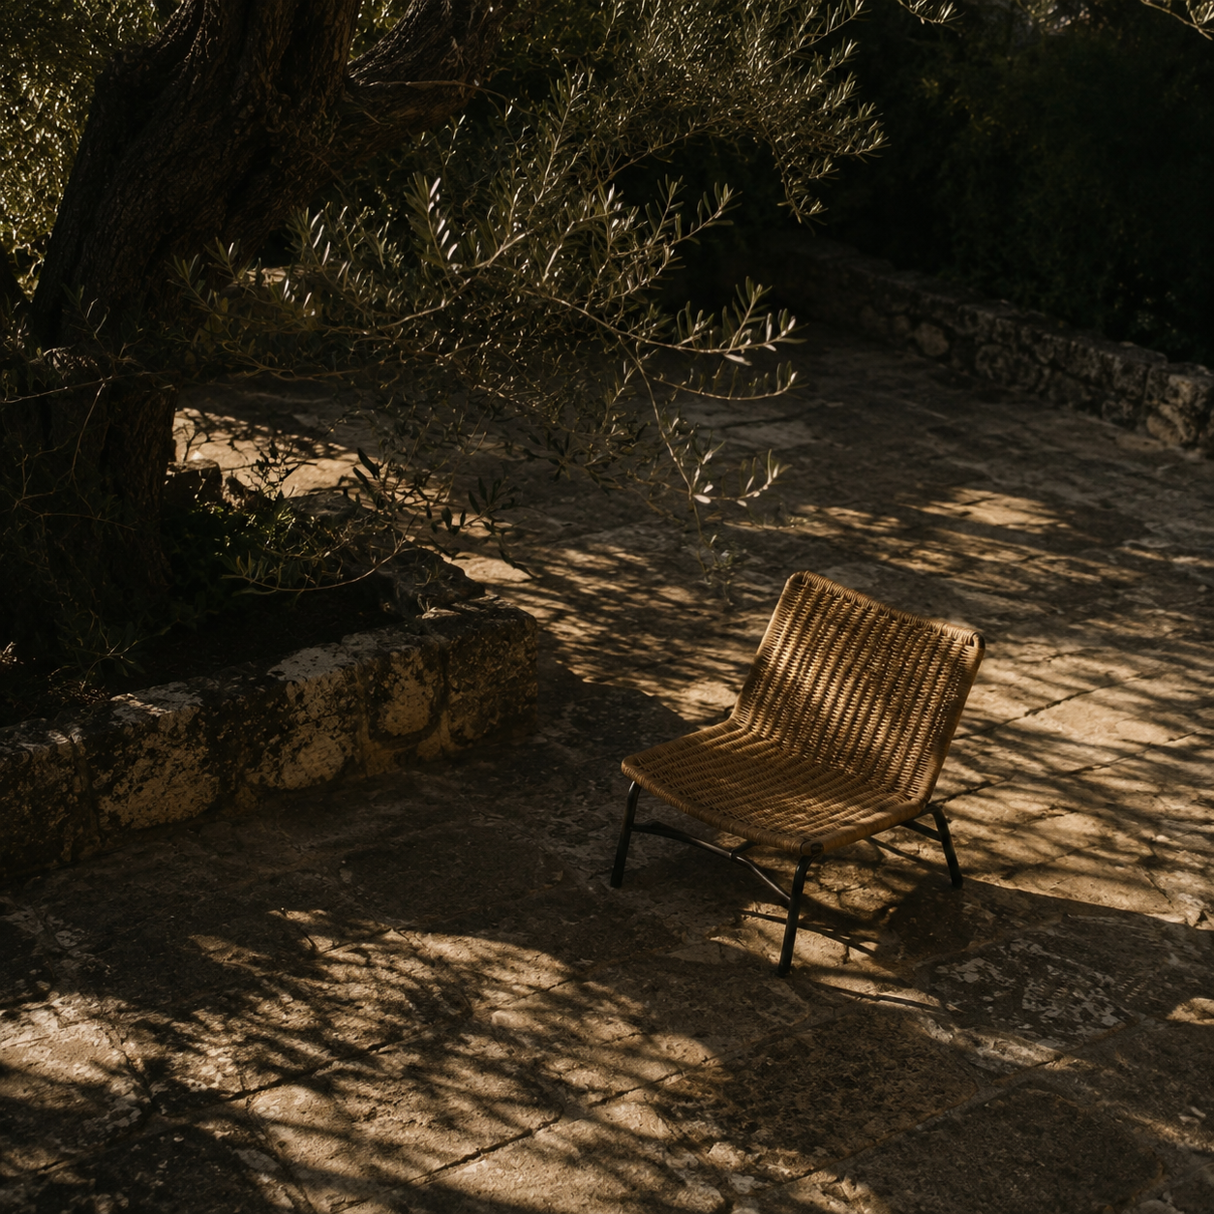

Tuominwang Interface Design Report
Desktop project-space interface revision |  | Tuominwang project  September 2026

Contents

Executive summary 2
At a glance 2
Introduction 2
Key findings 3
Layout and spacing 3
Navigation pattern 3
Implications 3
Recommendations 4
Conclusion 4
Appendix 5
Verification 5
Sources 5

Executive summary
The project page needed a clearer hierarchy and better use of space. Several tools could expand into a long stack, while dictionary fields stretched across wide displays. The revised page groups the tools into one navigation row and limits the reading width.
The revision follows the existing blue-gray desktop design. It keeps the real dictionary, mapping, batch review, member, and audit functions. No conversation history or engineering status appears in the product interface.

At a glance
- The work area has a maximum width, so forms remain readable on wide screens.
- Only the selected project tool is visible at one time.
- The fixed sidebar supports a name filter when the project list is long.

Introduction
This report reviews the desktop web project space, especially the dictionary screen shown in the supplied screenshot. It also considers the project navigation and material list. It does not evaluate detection accuracy or redaction safety.
The design references the existing LegalOS member-management and record-detail previews: a white sidebar, blue active states, restrained borders, and clear headings. It does not copy their sample records or features.

Key findings
The former layout made forms and empty space grow together. Import, export, editing, and saving were separated by long horizontal distances.

Layout and spacing
The dictionary panel used the full content width, with file actions at opposite ends. The new layout places import and export together and gives the name, category, and list fields deliberate widths.

Navigation pattern
The five project tools remain available in one row. Switching shows one tool panel at a time. Unsubmitted dictionary changes remain in page state, and leaving the project still requires confirmation.

Key takeaway. The first priority is the work-area hierarchy and reading width.

Implications
The update does not change recognition, review, export, or permission APIs. It changes React presentation state, project-name filtering, and CSS layout only. Existing materials and review data are not migrated.
Theme | Previous screen | Revision
Work area | Excessive horizontal span | Bounded and centered
Tool panels | Multiple panels could stack | One panel shown at a time
Dictionary form | Fields and file actions apart | Compact fields and nearby actions

Recommendations
Keep this scale across the remaining pages: show the current user task first, then filters and actions. Preserve explicit notices for sensitive values, permissions, and blocked exports.
- Bound the width. Limit the main work area and size form fields according to their content.
- Focus the tools. Switch among five project tools instead of stacking long cards.
- Review the result. Check layout, switching, and overflow at standard and wide desktop sizes.

Conclusion
The project screen now has a fixed sidebar, bounded content width, one visible tool panel, and a compact dictionary form. The main actions fit at both 1440 and 1920 pixel desktop widths without page-level horizontal overflow.
These checks confirm a concrete layout improvement, not complete product acceptance. Continue evaluating the design with longer project names, larger lists, and regular use.

Appendix

Verification
TypeScript checking and the web build passed. Isolated browser checks exercised the dictionary-to-mapping switch and verified visibility and horizontal overflow at 1440 and 1920 pixels.
The browser checks used a separate database and a synthetic project. This report is not displayed in the product interface.

Sources
- User-supplied screenshot of the project dictionary screen, 24 September 2026.
- LegalOS member-management and record-detail previews in the ui design directory.
- Tuominwang source files apps/web/main.tsx and apps/web/style.css.
- Tuominwang browser check tests/e2e/design-qa.spec.ts and desktop screenshots.

Verification note. This visual check does not establish detection accuracy or redaction safety.

