Linfeng Li

barcode recognition

# Introduction:

Barcodes are something that we are using every day, they are usually consist with vertical black and white lines. And they are designed by American Norman Woodland and Bernard Silver in 1949 to recognize food products in a local Food Fair. The barcode standard that we are going discussed in is this article is the Global Trade Item Number developed by GS1. And the representation of the standard is Code 128 which is alphanumeric and numeric only. Each Code 128 barcode consists of seven parts.

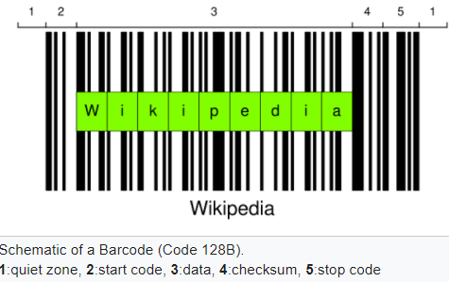

1. Quiet zone
2. Start Symbol
3. Encoded data
4. Check symbol
5. Stop symbol
6. Final bar
7. Quiet zone

The bar code first starts with a quiet area which is free of any text, characters, graphics, or marks. Which allows the algorithm to be able to “know” where the barcode begins. Then, the start symbol and stop symbol is indicating which side of the barcode should the algorithm be starting from. The actual data encoded comes after the start symbol, where each symbol is represented by 6 bars and spaces, starting with a black space and end with a white space. And with each bar or space, it can have a wide varying from 1 unit, 2 units, 3 units to 4 units. Therefore, each character can be represented by the pattern. For example, if the data is “11011001100”, we can see that the width of the first bar is 2, then 1, 2, 2, 2 and 2; totaling in 6 bars. With this width information and the Code 128 lookup table. The information encoded in the barcode can be interpreted. It is important to that the

# Procedure:

# Results: