Video virtual assistant is divided into 2 Clickup tasks. This one covers the widget related requirements.

User Journey:

1. A user lands on the client's home page and finds the video bot icon. This is different from the standard bot icon (see example below). There is a **configurable** text on the icon at the bottom fifth (different from the example below) - this can be used to invite the user to click on the bot, or to introduce the bot etc.

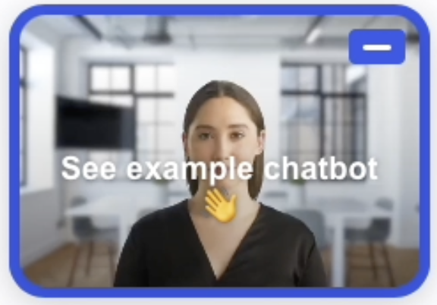

1. When the user hovers over the icon, it does a slight zoom as a micro-interaction to imply it's an interact-able element. (See attached video from 0:02 to 0:04)
2. Once the user clicks the bot, the bot transitions to a full size (see attached video from 0:04 to 0:05).
3. Once the bot has transition to its full size, it shows a configurable loading message with an animation. In parallel load the video in the background while showing loading animation. - See example below. Also, attached video from 0:05 to 0:06.

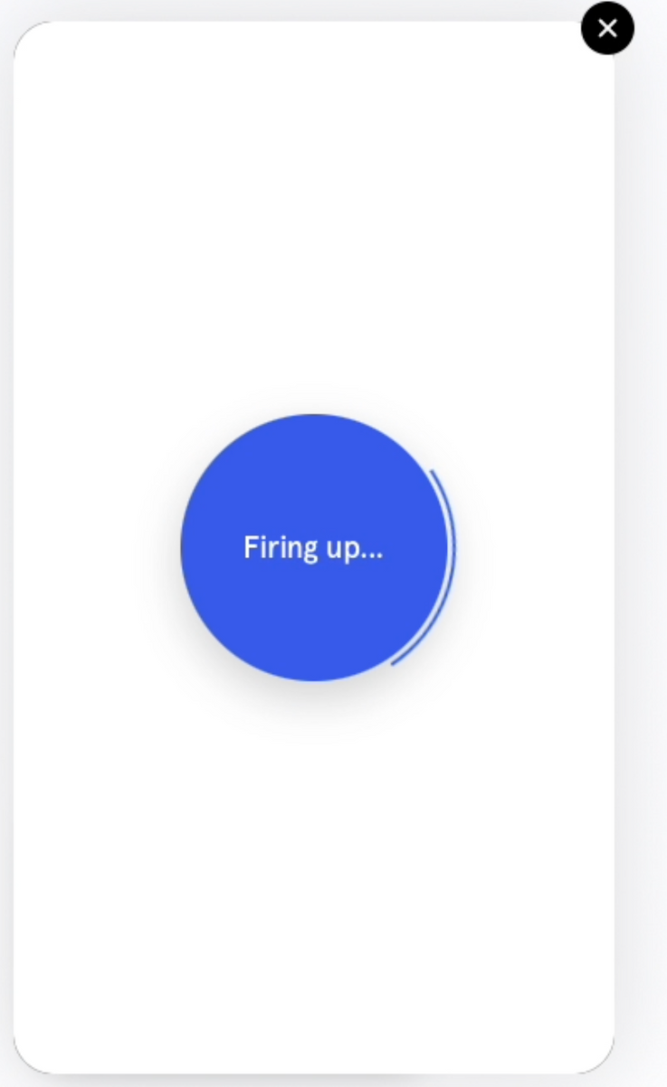

1. Once enough of the video is loaded (smart buffering like YouTube), we show the fully loaded bot. See example below:
2. The user then clicks on play to start the video (see image). Once the video stops playing, we bring it back to the start and let them click play again to re-start the video.
3. When the user hovers over an option, we highlight it. See example below
4. When the user clicks an option, we transition to the video content on the other option. See transition in attached video from 00:25 to 00:28 and again at 00:39 to 00:41.
5. We can use a similar transition to transition to other content types such as micro-site.
6. How the bot will finally look like

Features:

1. Allow users to pause the video bot, as well as play again once the video is over
2. Cache videos locally so that when users go "back" in any flow, they don't have wait for the video to buffer before it starts
3. Use a video player which enables features simultaneous buffering and viewing (see note below)
4. Show a "Loading" or similar message while video is loading
5. Video enabled chatbot to look different from text-only chatbot.

Future enhancements - not part of this clickup task

1. Analytics of user interactions with the video -> plug into our analytics ecosystem
2. During first start of bot, we load the video in the background while showing the loading animation. Instead of waiting for the video to completely download before allowing user to interact with it, we account for the time a user will take to click play on the video as well. So we can transition to the fully loaded video bot faster.
3. Smart pre-buffering of options most often selected by users
4. Multiple video view options i.e. different layouts
5. Video storage for on-premise installations

Notes:

1. Synthesia themselves seem to be using<https://videojs.com> on their own website
2. Example of synthesia's bot is attached as a video