DESIGN REVIEW
DOCUMENT

Project BEE-DAL
Subsystem OBC
Version V1.0
Document Version V1.0.0
Author BAO BUI
Review Owner BAO BUI
Date 2026-July-13

DOCUMENT HISTORY
Version | Date | Author | Description
V1.0.0 | 2026-June-10 | BAO BUI | Review Round 1

REVIEW SUMMARY
Review Round | Reviewer(s) | Description | Total Issues | Closed | Open

REVIEW ROUND 1

Review Information
Schematic Design Version: V1.0.0
PCB Design Version: V1.0
Review Date: 2026-June-10
Git link:
Reviewer: HIEU CAO

Issue 1.0.0.1
Description | Zenner/BJT bảo vệ CONN_IN_SEL
Location | CONNECTOR_IN.Schdoc
Severity | 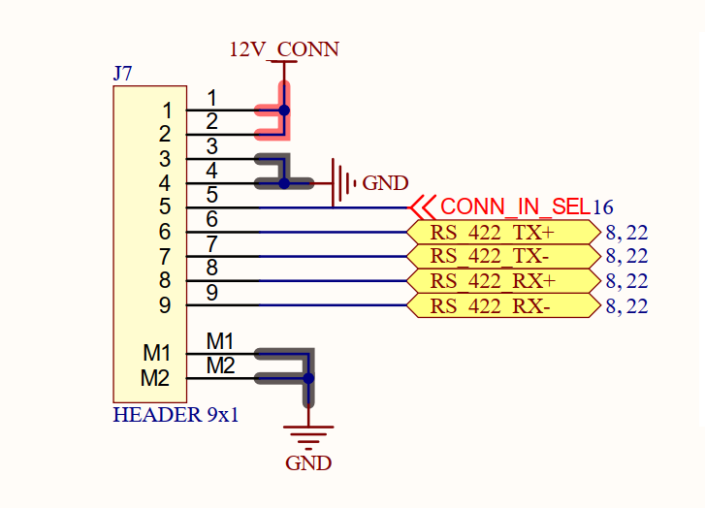
Recommendation | - Zenner/BJT bảo vệ CONN_IN_SEL
Owner | CAM DOAN
Status | CLOSED
Resolution Version | 1.0.1
Related Change | Change 1.1

Issue 1.0.0.2
Description | 12V IN chua co eFuse
Location | CONNECTOR_IN.Schdoc
Severity | 
Recommendation | Thêm eFuse
Owner | CAM DOAN
Status | Closed
Resolution Version | 1.0.1
Related Change | Change 1.2

Issue 1.0.0.3
Description | IC 74HC244 điện áp hoạt động là 5V => sai
Location | CONNECTOR_OUT
Severity | 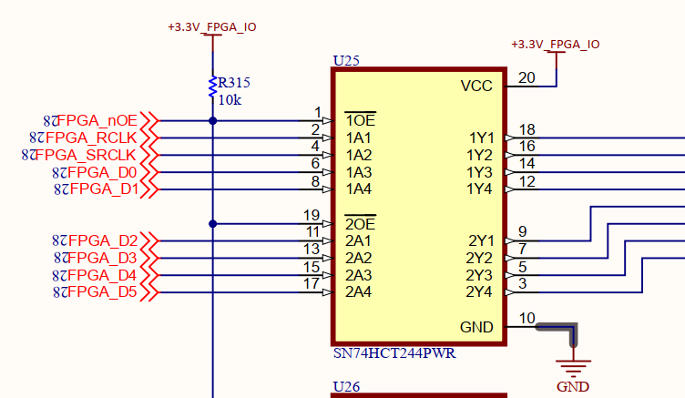  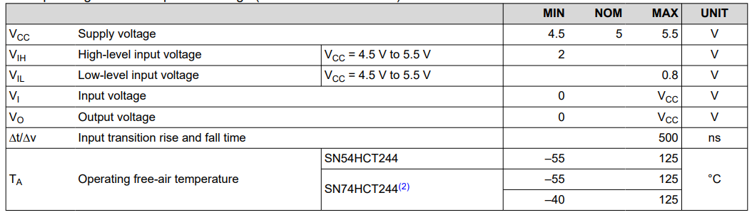
Recommendation | Dùng SN74AVC4T245
Owner | CAM DOAN
Status | Closed
Resolution Version | 1.0.1
Related Change | Change 1.3

Issue 1.0.0.4
Description | R31 cần DNP
Location
Severity | 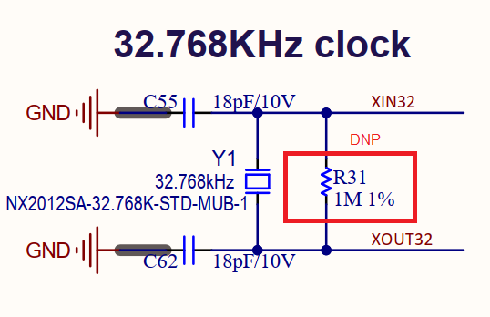
Recommendation | R31 đổi thành DNP/1M
Owner | CAM DOAN
Status | Closed
Resolution Version | 1.0.1
Related Change | Change 1.3

Issue 1.0.0.5
Description | PROGRAM_B chưa được điều khiển
Location
Severity | 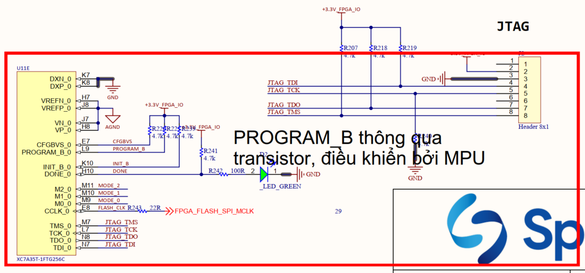
Recommendation | Thêm điều khiển PROGRAM_B bởi MPU qua bjt đệm
Owner | CAM DOAN
Status | Closed
Resolution Version | 1.0.1
Related Change | Change 1.3

Issue 1.0.0.6
Description | FPGA chưa có IO vào MPU, thêm 2 LED, thêm 2 button, thêm 1 uart để debug
Location
Severity | 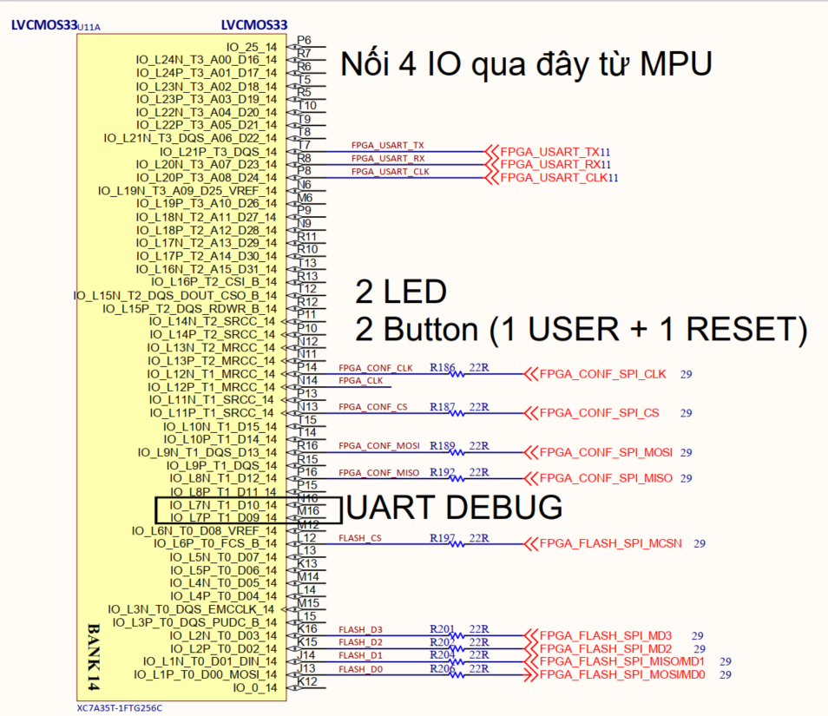
Recommendation | FPGA chưa có  - 4 IO vào MPU,  - 2 LED,  - 2 button,  - 1 uart để debug
Owner | CAM DOAN
Status | Closed
Resolution Version | 1.0.1
Related Change | Change 1.3

Issue 1.0.0.7
Description | MPU và FPGA không có giao tiếp SPI
Location
Severity
Recommendation
Owner | CAM DOAN
Status | OPEN
Resolution Version | 1.0.1
Related Change | Change 1.3

Issue 1.0.0.8
Description
Location
Severity | 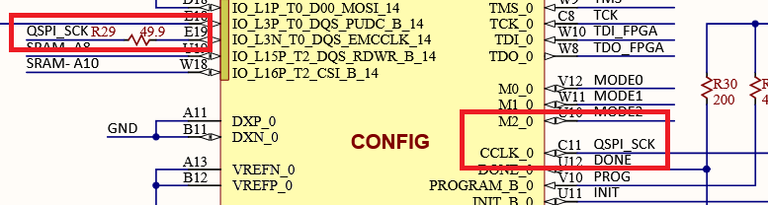
Recommendation | - QSPI_SCK đấu thêm 1 gpio vào clock của CC_CLOCK0
Owner | CAM DOAN
Status | Closed
Resolution Version | 1.0.1
Related Change | Change 1.3

Issue 1.0.0.9
Description
Location
Severity | 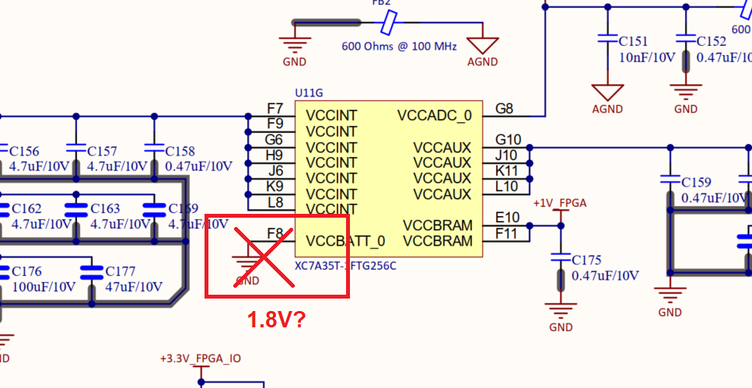
Recommendation | VCCBAT nối 1.8V
Owner | CAM DOAN
Status | Closed
Resolution Version | 1.0.1
Related Change | Change 1.3

Issue 1.0.0.10
Description
Location
Severity | 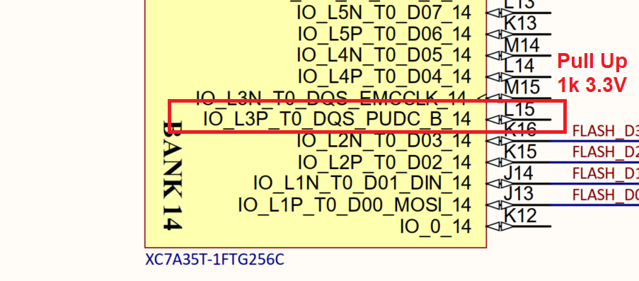
Recommendation | PDUC_B cần pull up lên 3.3V
Owner | CAM DOAN
Status | Closed
Resolution Version | 1.0.1
Related Change | Change 1.3

DESIGN V1.0.1

Version Information
Previous Version: V1.0.0
Current Version: V1.0.1
Purpose: Fix Review Round 1 findings

Issue Resolution Matrix
Change ID | Related Issue | Description | Status
Change 1.1 | Issue 1.1 | Add TVS diode | Fixed

Change 1.0.1
Linked Issue | Issue 1.0.0.1
Modified Documents
Description | Zenner/BJT bảo vệ CONN_IN_SEL
Evidence | 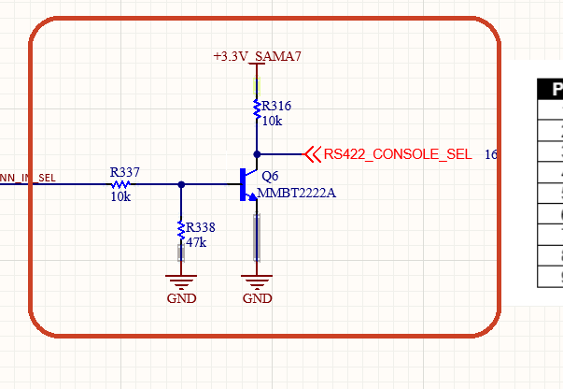

Change 1.0.2
Linked Issue | Issue 1.0.0.2
Modified Documents
Description | Thêm eFuse
Evidence | 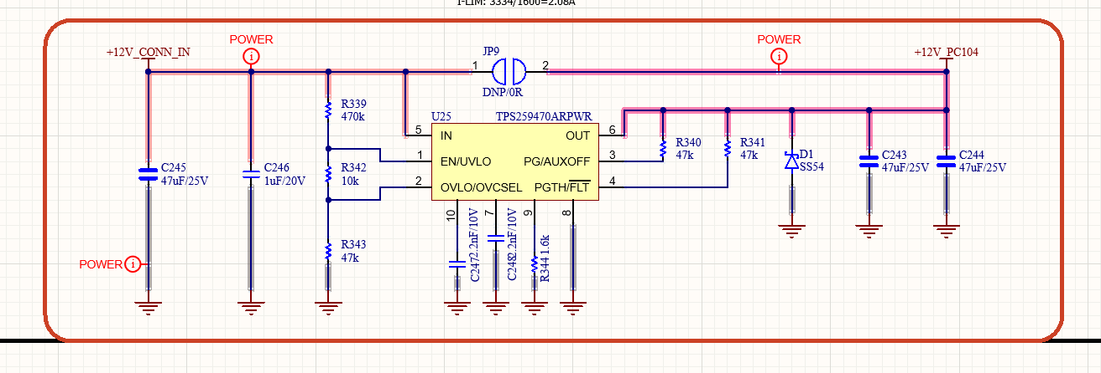

Change 1.0.3
Linked Issue | Issue 1.0.0.3
Modified Documents
Description | Dùng SN74AVC4T245
Evidence | 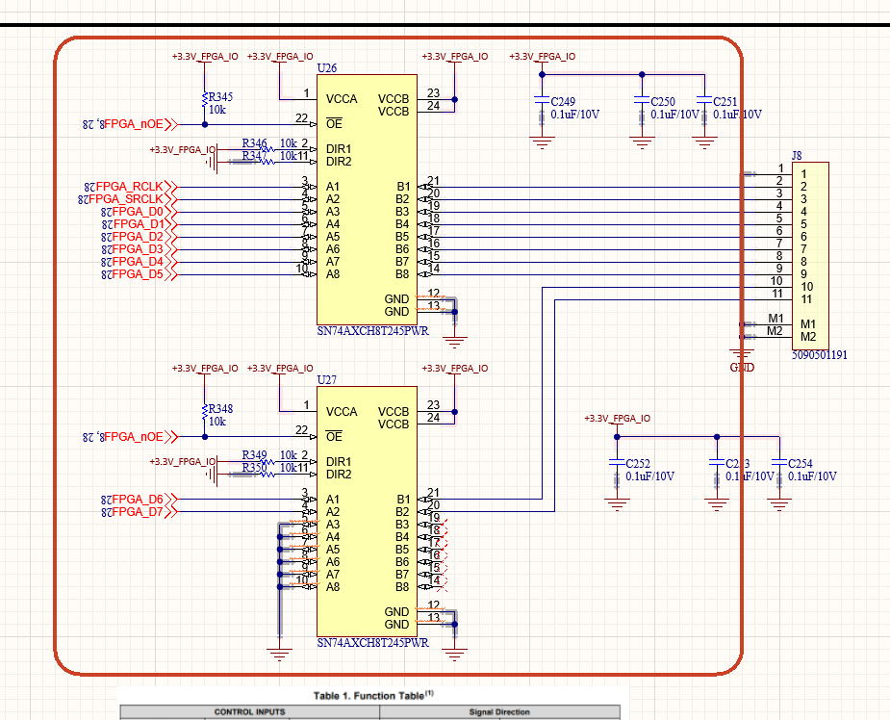

Change 1.0.4
Linked Issue | Issue 1.0.0.5
Modified Documents
Description | R31 DNP
Evidence | 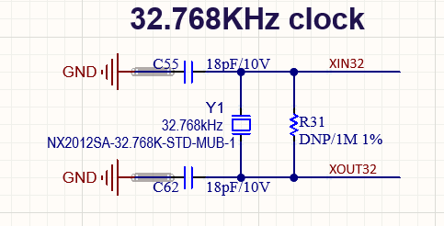

Change 1.0.5
Linked Issue | Issue 1.0.0.5
Modified Documents
Description | Thêm điều khiển PROGRAM_B bởi MPU qua bjt đệm
Evidence | 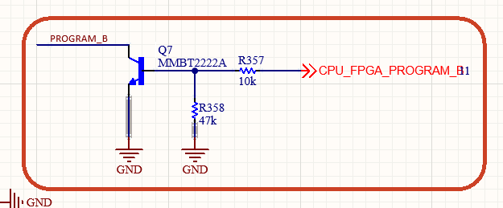

Change 1.0.6
Linked Issue | Issue 1.0.0.6
Modified Documents
Description | FPGA chưa có  - 4 IO vào MPU,  - 2 LED,  - 2 button,  - 1 uart để debug
Evidence | - 4 IO vào MPU,  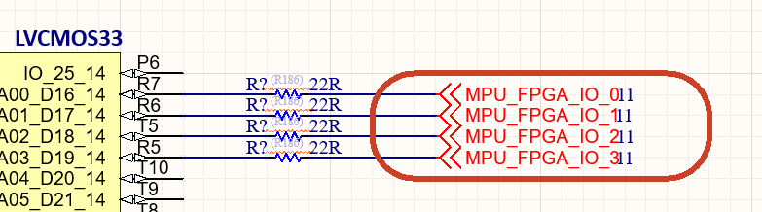  - 2 LED,  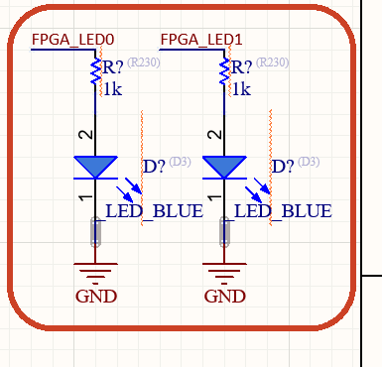  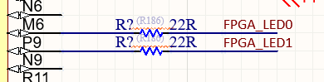  - 2 button,  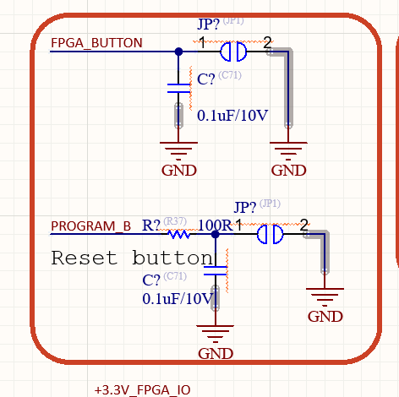  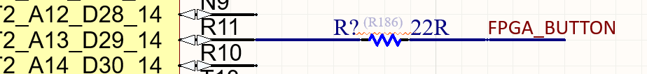  - 1 uart để debug  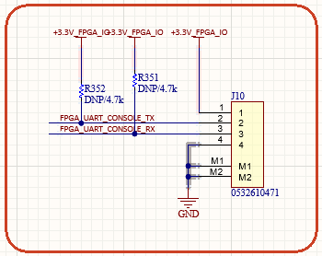

Change 1.0.7
Linked Issue
Modified Documents
Description
Evidence

Change 1.0.8
Linked Issue
Modified Documents | FPGA clock nối với QSPI CLK?
Description | 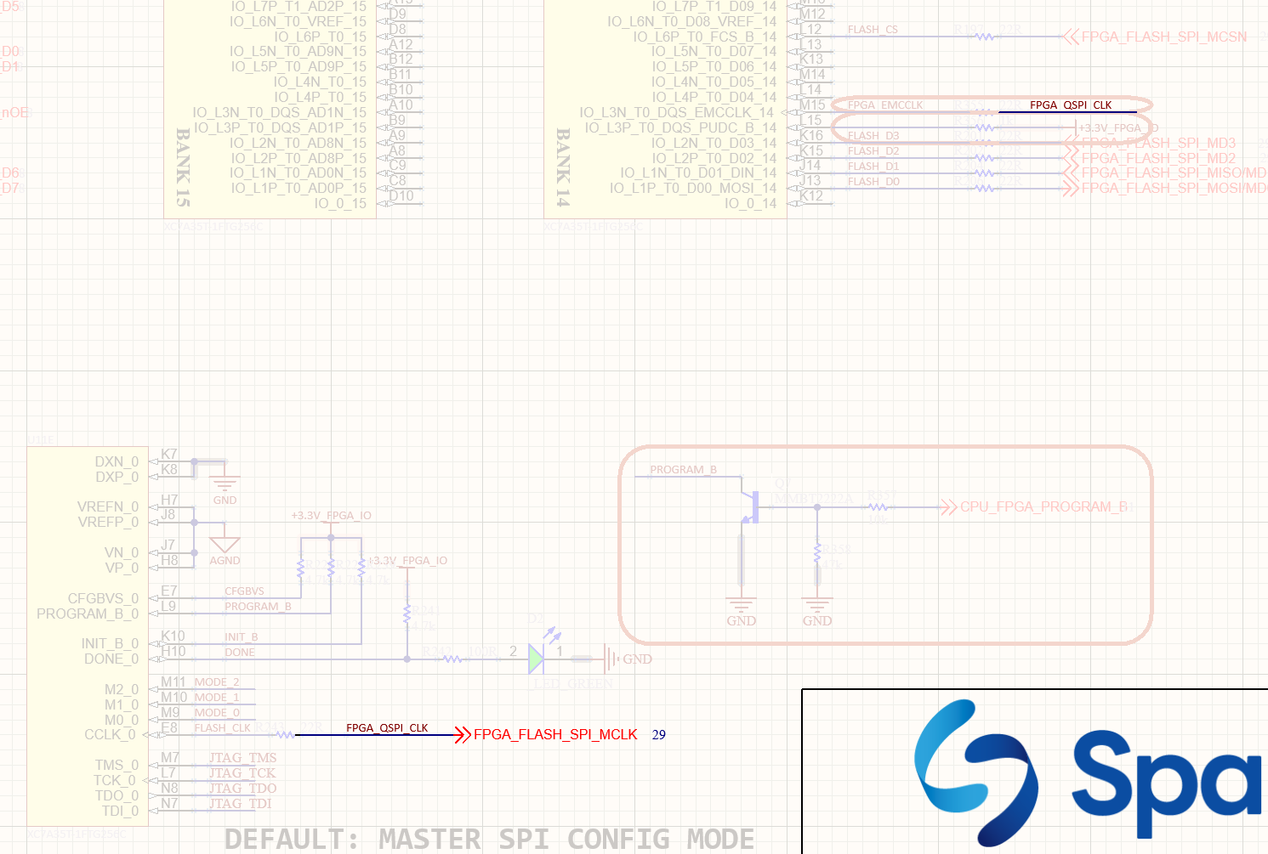
Evidence

Change 1.0.9
Linked Issue
Modified Documents
Description | Nối VCCBAT vào 1.8V
Evidence | 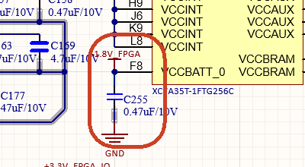

Change 1.0.10
Linked Issue
Modified Documents
Description | PDUC_B cần pull up lên 3.3V
Evidence

Change 1.0.x
Linked Issue
Modified Documents
Description
Evidence

Change 1.0.x
Linked Issue
Modified Documents
Description
Evidence

REVIEW ROUND 2

Review Information
Schematic Design Version: V1.0.1
PCB Design Version: V1.0
Review Date: 2026-June-10
Phase: Bring up
Reviewer: HIEU CAO

Issue 1.0.1.1
Description | MIPI CSI2 Camera xuyên qua nhiều board có nguy cơ tín hiệu không đảm bảo -> gây ra hiện tượng timerout trên dây, phải chỉnh nhẹ dây mới hoạt động.
Location | OBC ISS HW10
Severity | High
Recommendation | Sử dụng Retimer/Redriver cho ứng dụng này. Có 2 mã thường dùng chính: SN65DPHY440SS [TI] và PI2MEQX2503A[DI]. Recommend PI2MEQX2503A vì độ đơn giản trong thiết kế.  - EQ/SCL, 9dB (VIH), 10kΩ VCC 1.8V  - ERC/SDA, 150ps, NC  - PRE_CFG, 10dB (VIL), 10kΩ GND  - VSADJ_CFG0, 250mV, NC
Owner | CAM DOAN
Status | Opened
Resolution Version | 1.1.0
Related Change | Change

Issue 2.2
Description | Power Leak EXP thông qua đường UART, 1.7V nếu UART có hoạt động nhưng không có nguồn đi vào EXP
Location | OBC ISS HW10
Severity | Low
Recommendation | Sử dụng MAX232/UART Buffer để có HighZ nếu bên kia không có nguồn
Owner | CAM DOAN
Status | Opened
Resolution Version | 1.1.0
Related Change | Change

Issue 2.3
Description | OBC đang không đọc được input  Do chưa nhận slow clock  Trở 1M ở mọi board dùng 32.768 đều
Location | OBC ISS HW10
Severity | Low
Recommendation
Owner | CAM DOAN
Status | Opened
Resolution Version | 1.1.0
Related Change | Change

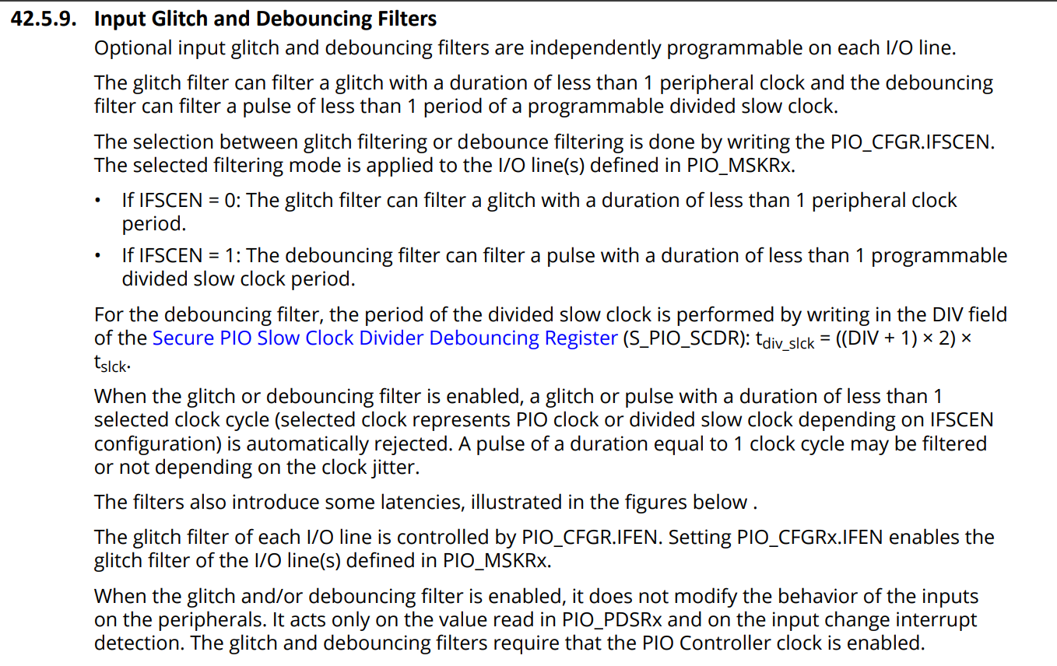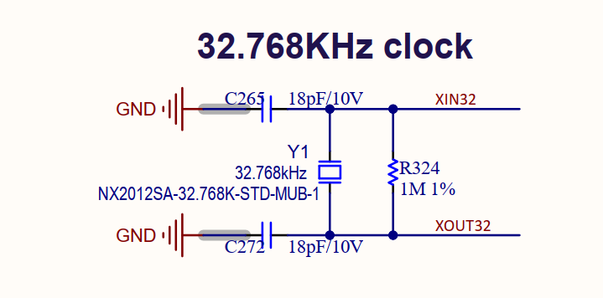
Check điện trở 1M
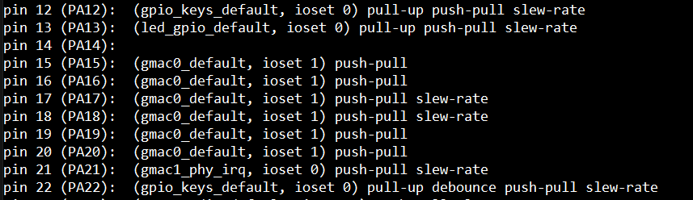Debounce không chạy, bỏ debounce mới nhận --> slow clock lỗi
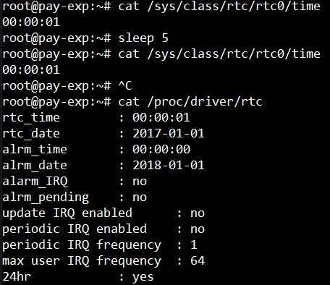

Issue 2.4
Description | Power Leak EXP thông qua đường UART, 1.7V nếu UART có hoạt động nhưng không có nguồn đi vào EXP
Location | EXP ISS HW10
Severity | Low
Recommendation | Sử dụng MAX232/UART Buffer để có HighZ nếu bên kia không có nguồn
Owner | HUY HUNG
Status | Opened
Resolution Version | 1.0
Related Change | Change

Issue 2.5
Description | MCU PB12 cần bắt buộc Pull Down
Location | EXP ISS HW10
Severity | Low
Recommendation | Hiện tại PB12 đang Float, cần pull down trở 10k
Owner | HUY HUNG
Status | Opened
Resolution Version | 1.0
Related Change | Change

Issue 2.6
Description | Recommend dùng EXT Laser đấu riêng cho OBC thay vì hiện tại OBC phải command xuống EXP để bật Laser
Location | EXP ISS HW10
Severity | Low
Recommendation
Owner | HUY HUNG
Status | Opened
Resolution Version | 1.0
Related Change | Change

