Problem 4

Reimplementation of

Exact One-pass Synthesis of Digtal Microfluidic Biochips

计81 包涵 2018011289

1. Problem Description

The paper proposes a one-pass solution to the designing problems of DMFB (Digital MicroFluidic Bio-chips). Instead of considering each step separately, the researchers combine the binding, scheduling, placement and routing stages and form an SAT problem, which can be solved by corresponding solvers.

1. Implementation

- QT was used to create the GUI and Z3 for solving the SAT problem.

- Under the **src/** directory, header files are placed in the “**include**” folder and image resources are placed in the “**res**” folder.

- **main.cpp, mainwindow.cpp** and **rederarea.cpp** are used to construct the GUI.

- **Module.h** contains the definition for **class Module**, which is used to store information of mixers, detectors, dispensers etc.

- **Architecture.h/cc** defines the **class Architecture**, which reads input files and generate the flow diagram for class Solver.

- **Solver.h/cc** defines the **class Solver**. It is the core of this application. A **Solver** class takes the graph constructed by **Architecture** and forms it into a number of constraints for the SAT solver to compute.

- **OnePassSynth.h** is a wrapper and users can conveniently access the functionality of this application through this interface.

1. Input/Output files

- Formats for corresponding files are defined in the **readme.md** file in the **testcase** folder.

1. Experiment results

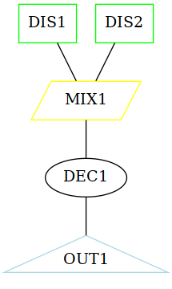

- testcase: 4_mix_detect.txt

|  |  |  |  |
| --- | --- | --- | --- |
| Result | Size | Time steps | Time used (ms) |
| Unsat | 4*4 | 4 | 18 |
| Unsat | 4*4 | 5 | 82 |
| Unsat | 4*4 | 6 | 172 |
| Unsat | 4*4 | 7 | 326 |
| Unsat | 4*4 | 8 | 536 |
| Sat | 4*4 | 9 | 1073 |

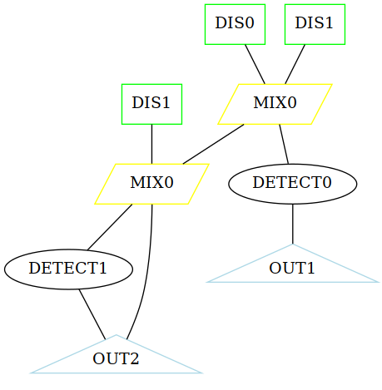- testcase: 8_complex.txt

|  |  |  |  |
| --- | --- | --- | --- |
| Result | Size | Time steps | Time used (ms) |
| Unsat | 2*5 | 15 | 9,259 |
| Unsat | 2*5 | 16 | 10,643 |
| Sat | 2*5 | 17 | 14,788 |
|  |  |  |  |
| Unsat | 4*4 | 15 | 32,335 |
| Unsat | 4*4 | 16 | 33,163 |
| Sat | 4*4 | 17 | 34,974 |
|  |  |  |  |
| Unsat | 5*5 | 15 | 88,053 |
| Unsat | 5*5 | 16 | 86,864 |
| Sat | 5*5 | 17 | 103,378 |

1. Environments

- OS: Manjaro

- Compiler: g++

- Libraries: Z3, QT