




Model Evaluation

MSc. Bui Quoc Khanh
khanhbq@hanu.edu.vn


MODEL EVALUATION

- How do we assess the generalization capabilities of a learned hypothesis?
- Metrics for Performance Evaluation
  - How to evaluate the performance (prediction capability) of a model?
- Methods for Performance Evaluation
- How to obtain reliable estimates?

Testing the classifier

- We are given a learning algorithm A and a data set S of labeled instances <x, f(x)>
- The general idea to assess the generalization capabilities of A is that of splitting S into a subset used for training and a subset used for testing

Testing the classifier
<x,f(x)>
Test Set (Unseen Data)
Training Set
Learning Algorithm
Classifier
h(x) = f(x) ?
<x,f(x)>

Testing the classifier
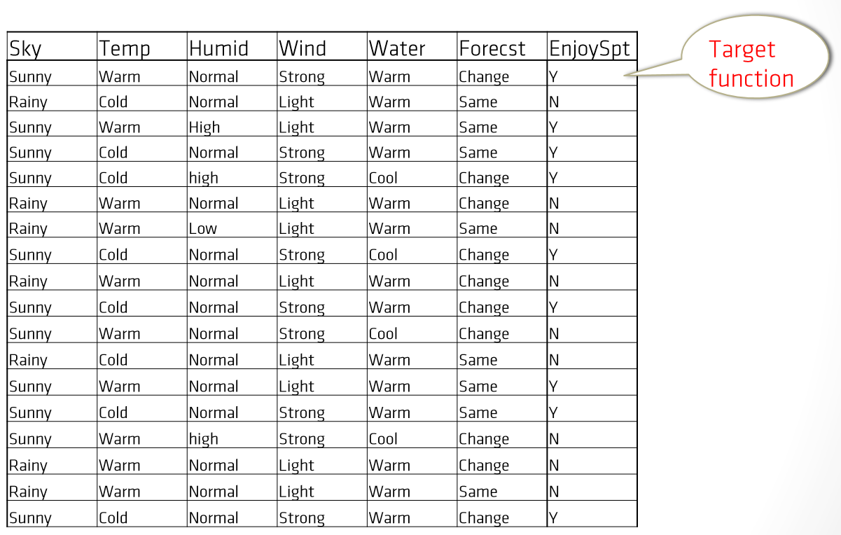

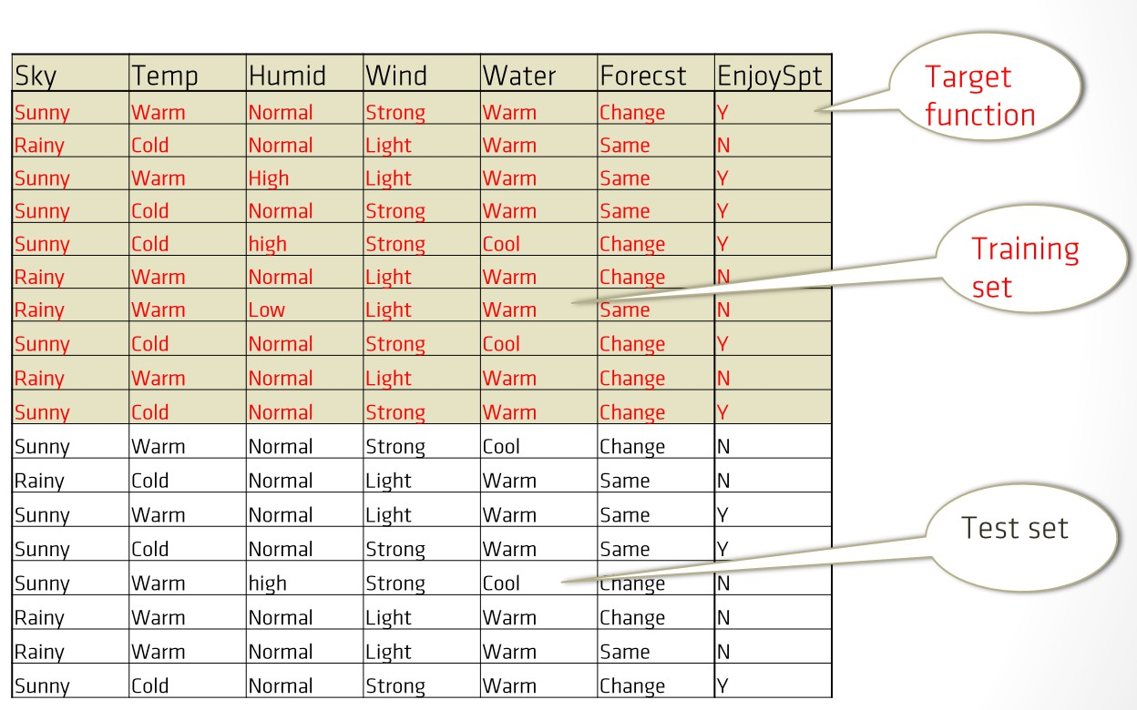
Testing the classifier

Testing the classifier
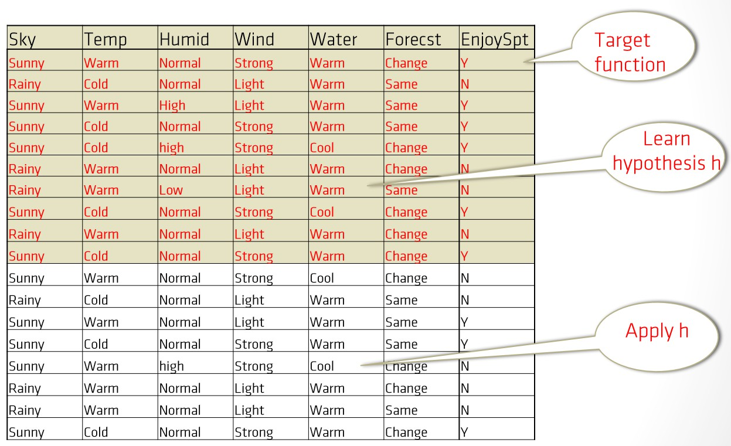

Testing the classifier
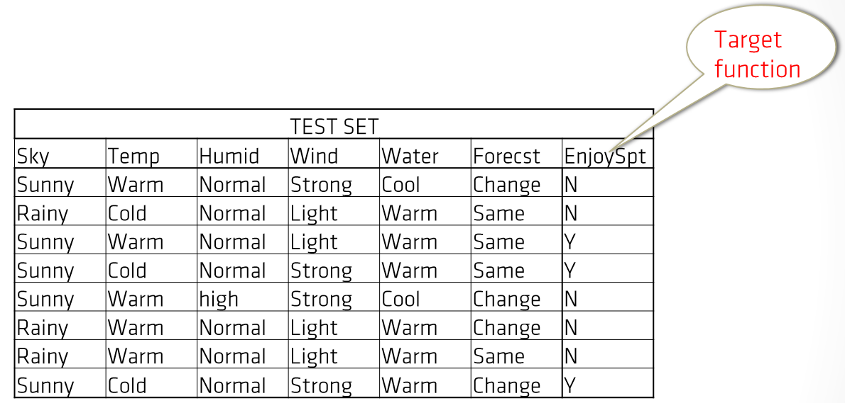

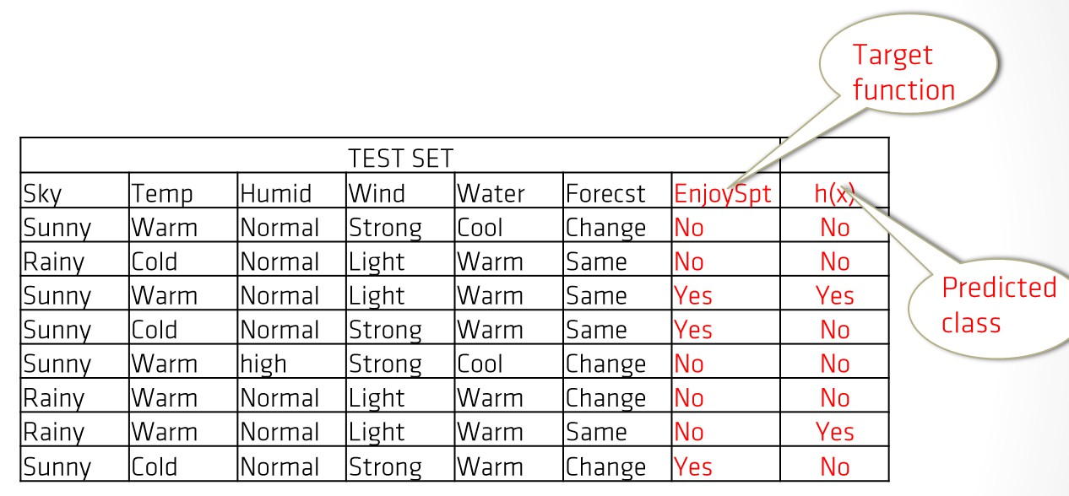
Testing the classifier

Is h a good predictive capability?

Testing the classifier

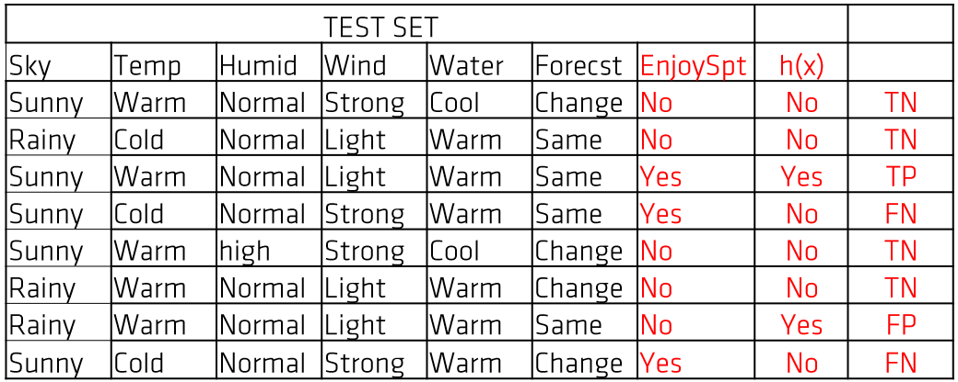

Has h a good predictive capability?
To answer this question we compare h(x) with the target function EnjoySpt

Metrics for Performance Evaluation

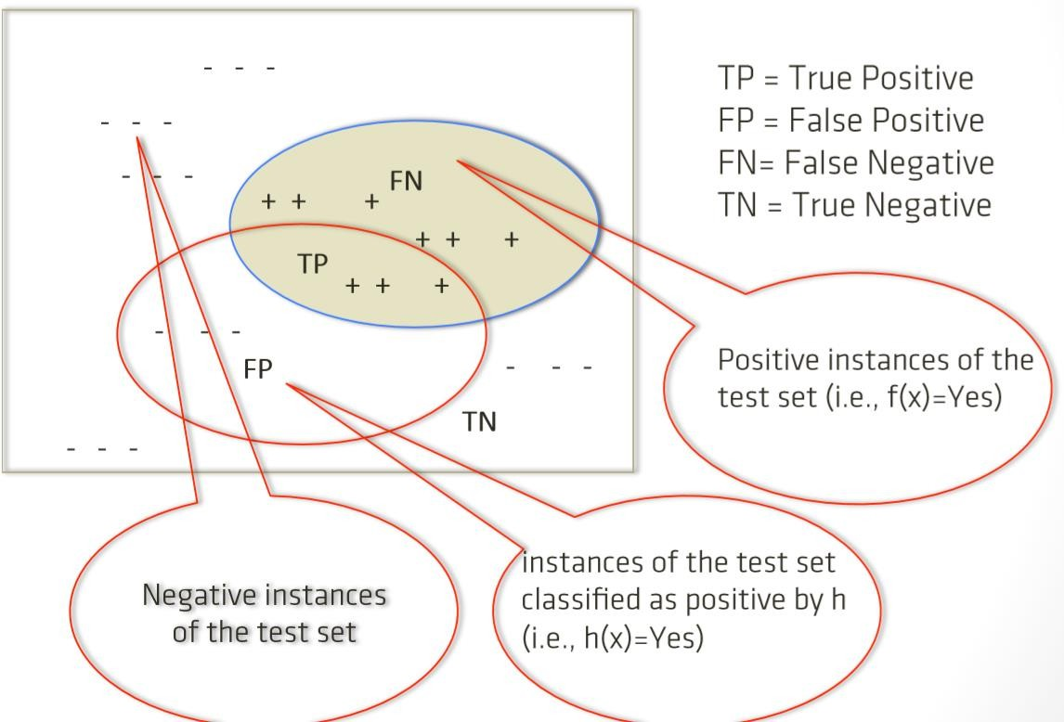

Metrics for Performance Evaluation Error and Accuracy
- Accuracy: number of instances correctly classified over the total
number of predictions

  - 𝐴𝑐𝑐𝑢𝑟𝑎𝑐𝑦 = (𝑇𝑃+𝑇𝑁)
𝑁
where N = TP+TN+FN+FP

- Error: number of instances misclassified over the total number of
predictions

  - 𝐸𝑟𝑟𝑜𝑟 = (𝐹𝑃+𝐹𝑁)
𝑁
= 1 − 𝐴𝑐𝑐𝑢𝑟𝑎𝑐𝑦

Metrics for Performance Evaluation An Example

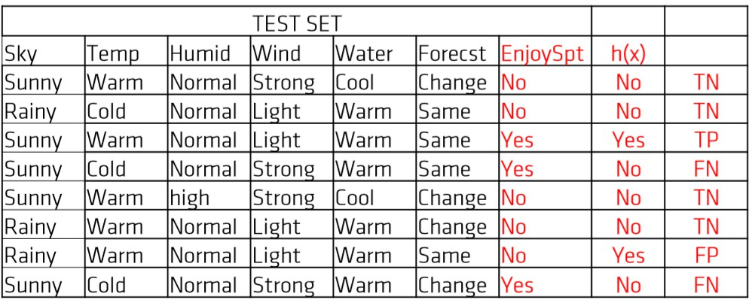

TP = 1 FP= 1 FN = 2 TN = 4
    - Acc = 5/8 = 62,5%
    - Err = 3/8 = 37,5%

Metrics for Performance Evaluation An Example (cont’ed)
- Assume that no instance is classified positively by h (rejector)
  - TP=0, FP=0, FN=3, TN=5 (Acc= 62,5% (!!))
- The accuracy may not be an adequate performance measure when the number of negative cases is much greater than the number of positive ones
- Suppose there are 1000 examples, 995 of which are negative cases and 5 are positive cases. If the
system classifies them all as negative (rejector)
  - TP=0, TN=995, FP=0, FN=5
- the accuracy would be 99.5%, even though the classifier missed all positive cases

Metrics for Performance Evaluation Precision
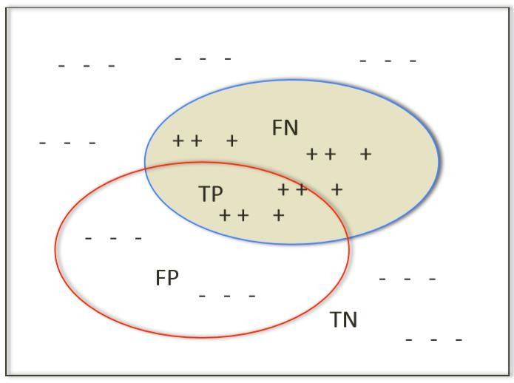
  - 𝑃𝑟𝑒𝑐𝑖𝑠𝑖𝑜𝑛 = 𝑇𝑃
𝑇𝑃+𝐹𝑃
  - fraction of instances correctly classified

Metrics for Performance Evaluation An Example
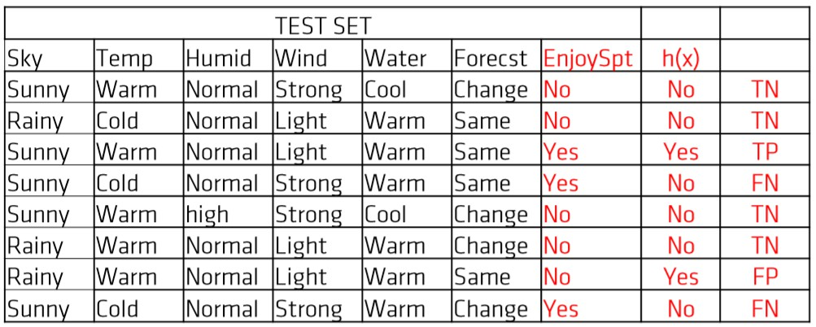
  - TP = 1 FP= 1 FN = 2 TN = 4
  - Pr= TP/(TP+FP) = 1/2 = 0.5

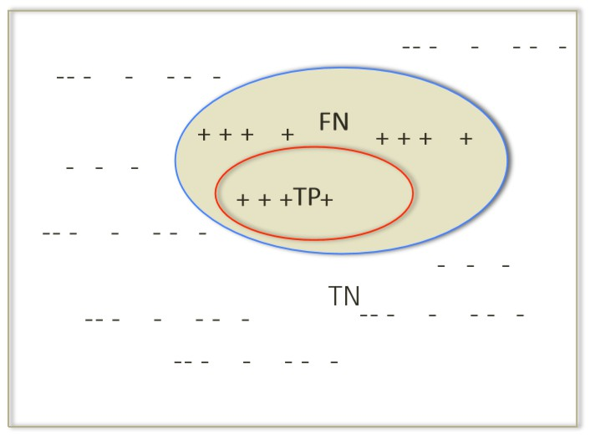
Metrics for Performance Evaluation Precision

  - FP=0 => Pr=1 – i.e., no negative examples classified as positive
  - A classifier may have high precision but low coverage
  - Precision alone not sufficient

Metrics for Performance Evaluation Recall
  - 𝑅𝑒𝑐𝑎𝑙𝑙 = 𝑇𝑃
𝑇𝑃+𝐹𝑁
  - Fraction of positive examples in the test set that have been correctly classified
  - Also called coverage, sensitivity or True Positive Rate

Metrics for Performance Evaluation An Example

TP = 1 FP= 1 FN = 2 TN = 4
    - Re= TP/(TP+FN) = 1/3 = 0.33

Metrics for Performance Evaluation Recall

  - FN=0 => Re=1 – i.e., all positive examples have been correctly classified
  - A classifier may have high coverage but low precision
  - Recall alone not sufficient

Metrics for Performance Evaluation F-measure

- 𝐹 − 𝑀𝑒𝑎𝑠𝑢𝑟𝑒 𝐹 = 2𝑃𝑟𝑅𝑒
𝑃𝑟+𝑅𝑒
- F ≈ min(Pr, Re)
- F is high when both Pr and Re are high (good classifier)

Metrics for Performance Evaluation An Example

TP = 1 FP= 1 FN = 2 TN = 4
  - Pr = 0.5
  - Re= 0.33
  - F = 2PrRe/(Pr+Re) = 0,37

Metrics for Performance Evaluation F- Measure

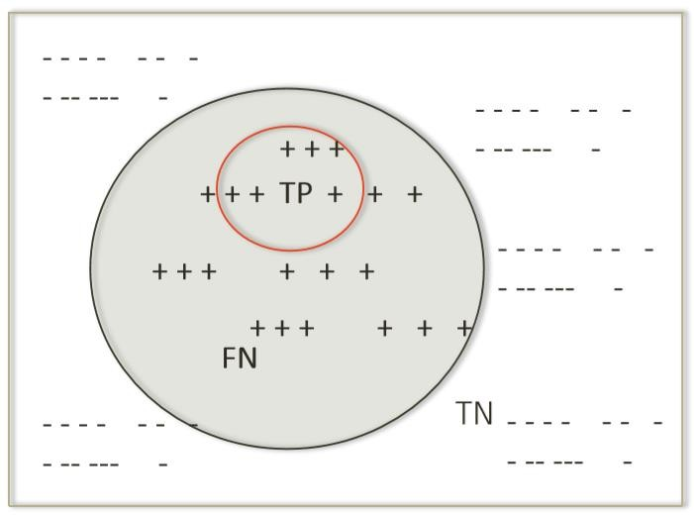
    - Pr=1, Re=0.2
    - F = 0.33
    - F ≈ min(Pr, Re)

Metrics for Performance Evaluation F- Measure

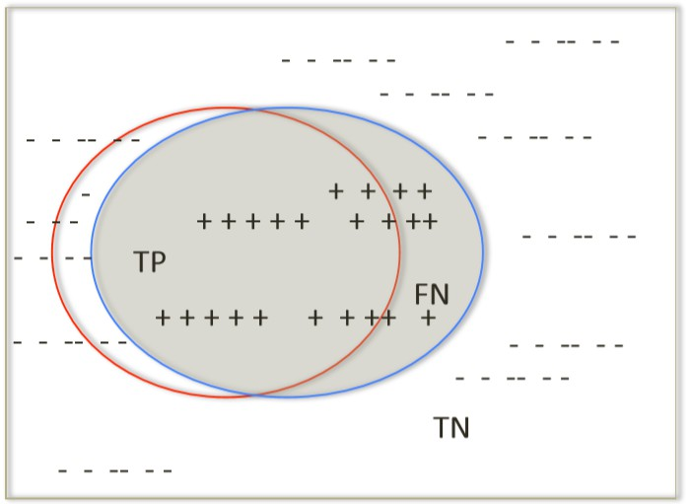
- Pr=0.9, Re=0.8
- F = 0.85
- F ≈ min(Pr, Re)
- High F-measure is indicative of both high precision and high recall

Metrics for Performance Evaluation Summary
- Let N = TP+TN+FN+FP
  - Precision P = TP/(TP+FP)
  - Recall R = TP/(TP+FN)
  - F-measure F1 = 2PxR/(P+R)
  - Accuracy A = (TP+TN)/N
  - Error E = (FP+FN)/N= 1- A

Metrics for Performance Evaluation Confusion Matrix
- A classification system has been trained to distinguish between
dogs, mouses and chickens
- The classification results can be summarized by the following
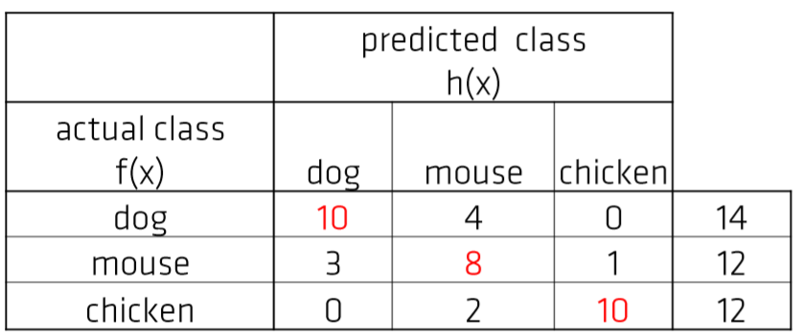
Confusion Matrix

Metrics for Performance Evaluation Confusion Matrix
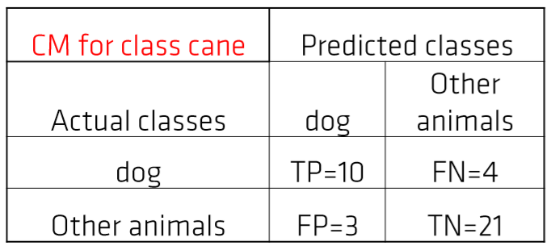
- A binary confusion matrix for a class, is a table with 2 rows and 2 columns that reports the number of false positives, false negatives, true positives, and true negatives.

Testing the classifier
Holdout
- We split the data set into a training set and a test set – as in the previous examples
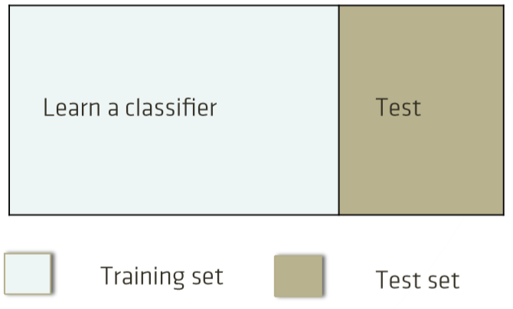
- We use the former to learn a hypothesis, and the latter to test its generalization capability

Compute performance measures over the test set

Methods for Performance Cross validation

K-fold-cross-validation :
  - the data set is segmented into k equal-sized partitions.
  - During each run, one of the partitions is chosen for testing, and the remaining k-1 for training.
  - The procedure is repeated k times
  - The average (over the k folds) performance measures are finally
given

Methods for Performance Cross validation
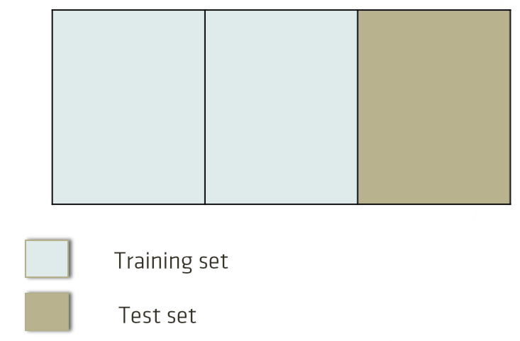
- 3-fold Cross Validation:
  - 2 folds for learning
  - 1 fold for testing

Compute performance measures over the test set, e.g., Pr1, Re1, F1

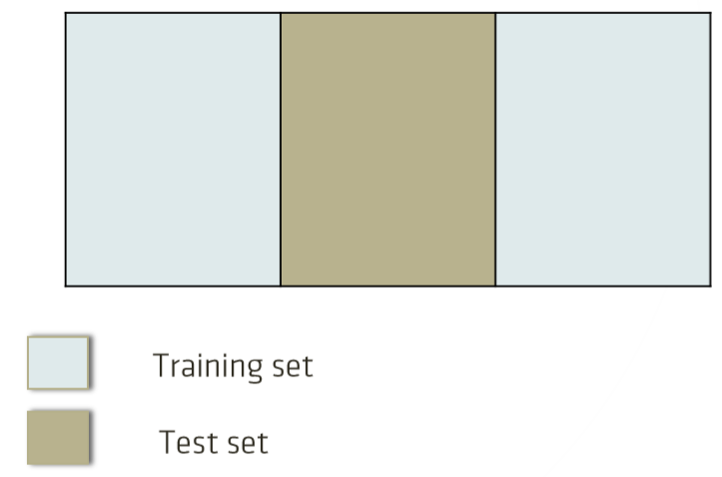
Methods for Performance Cross validation
- 3-fold Cross Validation:
  - 2 folds for learning
  - 1 fold for testing

Compute performance measures over the test set, e.g., Pr2, Re2, F2

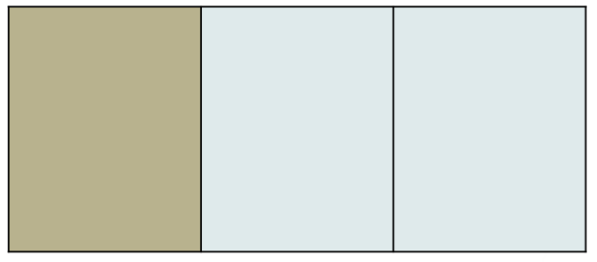
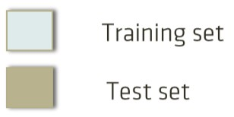
Methods for Performance Cross validation
- 3-fold Cross Validation:
  - 2 folds for learning
  - 1 fold for testing

Compute performance measures over the test set, e.g., Pr3, Re3, F3

Finally compute average performance measures



Holdout vs Cross Validation

Performance assessment based on holdout may be affected by the choice of the training and test data

Cross validation exploits all the available data, so more reliable performance measures are obtained

Quality of a Classifier

Predictive capability: accuracy, precision, recall, …
- Descriptive capability:
  - Interpretability of the model
  - Decreases with the size of the classifier (e.g., number of
rules)

The Simplicity Bias of Occam’s Razor
- Entities should not be multiplied without necessity
- Given two models with the same generalization capability, the simpler one should be preferred as simplicity is desirable by itself
- Its easier to work with simple hypotheses than with complex ones
- Simple hypotheses deals better with the overfitting problem

