Learning Outcomes
After learning this chapter, you should be able to:
- Choose the right SDLC depends on context of use
- Describe the RUP methodology and its stages
- Describe the Agile methodologies and their stages
- Have your own idea of the great methodologies debate
Slide: Software development life cycle

1. Select The Right SDLC
According to an IAG Consulting Report, 68% of software projects fail. We wanted to further dive into the question of why in order to save you from falling into this huge percentage of failures. But before you fall down on your knees and resort to praying to make it into the 32% of successes, try to understand the pros and cons of types of SDLC to ensure you give your software the best chances from the beginning.

The SDLC approach is not only for developers. Nowadays it is used by cross-functional teams to collaborate across various stages of the SDLC and perform collectively. Following SDLC practices, you’ll be able to accelerate the software development process without extra headaches. Selecting the right SDLC is a process in itself that the organization can implement internally or consult for. There are some steps to get the right selection

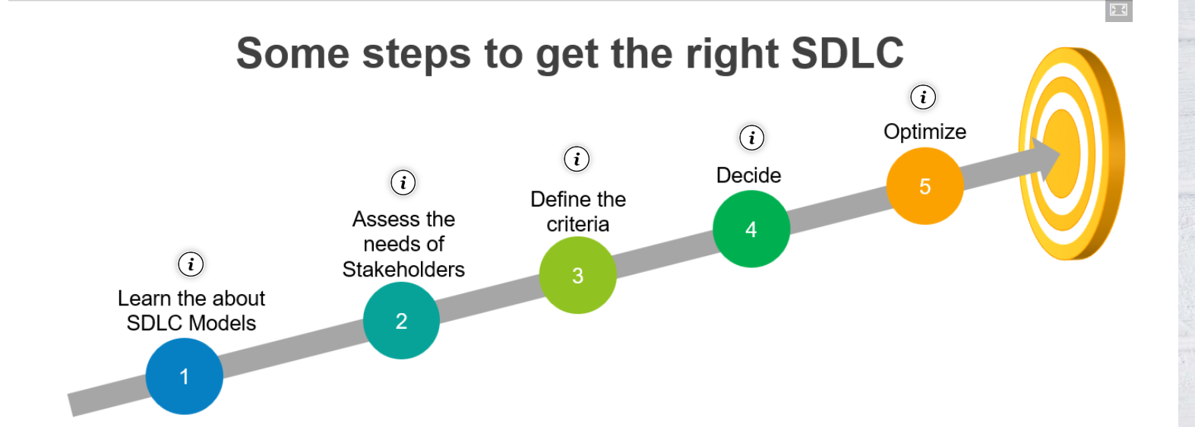
:Questions:
- Can SDLC be used in some business fields?
- Which SDLC is suitable for implementing software projects in subjects at the faculty?
- Explain some criterion of selecting right SDLC?
- List some well-known SDLCs in Unified process?

2. RUP Methodology
The Unified Software Development Process or Unified Process is a popular iterative and incremental software development process framework. The best-known and extensively documented refinement of the Unified Process is the Rational Unified Process (RUP). Profile of a typical project showing the relative sizes of the four phases of the Unified Process. The Unified Process is not simply a process, but rather an extensible framework which should be customized for specific organizations or projects. The Rational Unified Process is, similarly, a customizable framework. As a result, it is often impossible to say whether a refinement of the process was derived from UP or from RUP, and so the names tend to be used interchangeably.

2.1. Unified Software Development Process
The name Unified Process as opposed to Rational Unified Process is generally used to describe the generic process, including those elements which are common to most refinements. The Unified Process name is also used to avoid potential issues of trademark infringement since Rational Unified Process and RUP are trademarks of IBM. The first book to describe the process was titled The Unified Software Development Process and published in 1999 by Ivar Jacobson, Grady Booch and James Rumbaugh. Since then, various authors unaffiliated with Rational Software have published books and articles using the name Unified Process, whereas authors affiliated with Rational Software have favored the name Rational Unified Process.
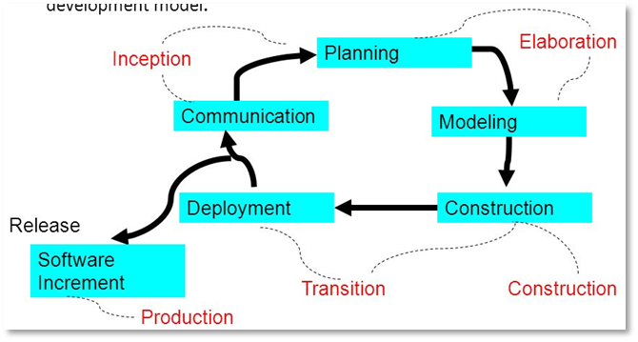

Figure 2.2.1: Unified Process
There are some well-known variations of Unified software development process:
- Rational Unified Process (RUP) - we'll use RUP templates for Final project!
- Agile Unified Process
- Basic Unified Process
- Enterprise Unified Process
- Essential Unified Process
- Open Unified Process
- Oracle Unified Method
- RUP-Systems Engineering
The Unified Software Development Process (USDP), or Unified Process (UP), is an iterative methodology by Ivar Jacobson, Grady Booch, and James Rumbaugh. It fosters quality software through collaboration, communication, and iterative development. Variations include:
- Rational Unified Process (RUP): Developed by Rational Software (IBM), RUP extends UP with detailed guidelines and practices. It spans phases (Inception, Elaboration, Construction, Transition) and iterations.
- Agile Unified Process (AUP): An agile adaptation, AUP maintains UP's core while emphasizing simplicity, agility, and iterative development. Ideal for dynamic projects and changing requirements.
- OpenUP: An open-source version by Eclipse Foundation, OpenUP is lightweight, customizable, and emphasizes agility and collaboration. It provides guidance while enabling process tailoring.

2.2. Rational Unified Process
Why should use RUP?
The Rational Unified Process (RUP) stands out as a structured software development framework that finds favor in larger organizations with distributed teams or smaller companies needing remote support. By emphasizing development control and security, RUP enables effective collaboration across geographic boundaries. Operating from a centralized server, it facilitates project progression while offering a secure environment for step-by-step approvals. RUP is particularly valuable for projects demanding accuracy and security, and it unifies software processes while accommodating customization. However, its complexity demands skilled implementation, making it suitable for diverse projects that range from modest endeavors to the reconfiguration of software systems within extensive organizations.
The Rational Unified Process (RUP) divides development into the four consecutive phases:
Inception:
- Communication and planning are the main ones.
- Identifies the scope of the project using a use-case model allowing managers to estimate costs and time required.
- Customers’ requirements are identified and then it becomes easy to make a plan for the project.
- The project plan, Project goal, risks, use-case model, and Project description, are made.
- The project is checked against the milestone criteria and if it couldn’t pass these criteria then the project can be either canceled or redesigned.
Elaboration:
- Planning and modeling are the main ones.
- A detailed evaluation and development plan is carried out and diminishes the risks.
- Revise or redefine the use-case model (approx. 80%), business case, and risks.
- Again, checked against milestone criteria and if it couldn’t pass these criteria then again project can be canceled or redesigned.
- Executable architecture baseline.
Construction:
- The project is developed and completed.
- System or source code is created and then testing is done.
- Coding takes place.
Transition:
- The final project is released to the public.
- Transit the project from development into production.
- Update project documentation.
- Beta testing is conducted.
- Defects are removed from the project based on feedback from the public.
- The project is maintained and updated accordingly.

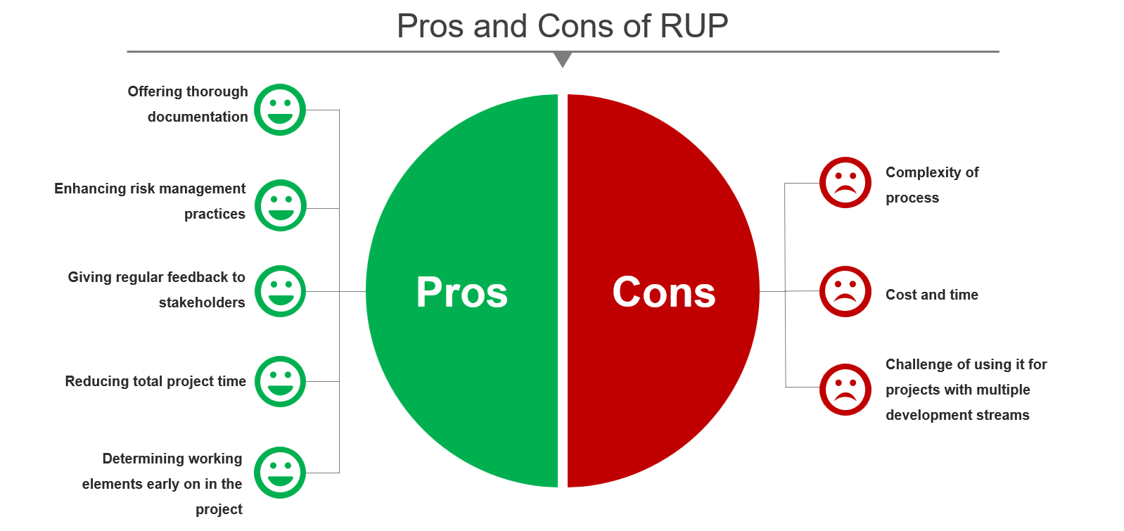
Questions:
- Which phase in RUP that we build a new system with a programming language?
- How each phase in RUP differ to others?
- List all main workflows and supporting workflows in RUP?
- What is a terminology in Agile for a short cycle of building some user functionnalities?

3. Agile Methodologies
Agile Methodology is a people-focused, results-focused approach to software development that respects our rapidly changing world. It’s centered around adaptive planning, self-organization, and short delivery times. It’s flexible, fast, and aims for continuous improvements in quality, using tools like Scrum and eXtreme Programming.
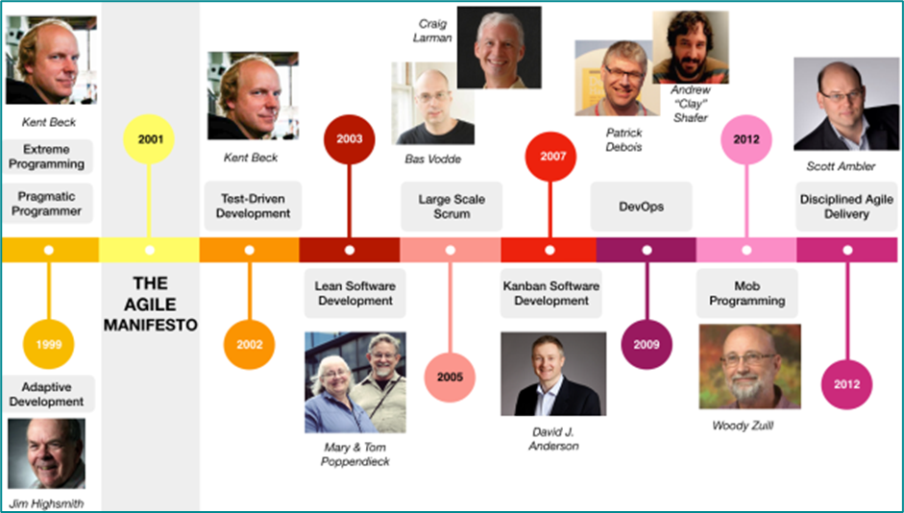

3.1. How It Works
It works by first admitting that the old “waterfall” method of software development leaves a lot to be desired. The process of “plan, design, build, test, deliver,” works okay for making cars or buildings but not as well for creating software systems. In a business environment where hardware, demand, and competition are all swiftly-changing variables, agile works by walking the fine line between too much process and not enough.

3.2. Agile Methodology Overview
It abandons the risk of spending months or years on a process that ultimately fails because of some small mistake in an early phase. It relies instead on trusting employees and teams to work directly with customers to understand the goals and provide solutions in a fast and incremental way.
- Faster, smaller: Traditional software development relied on phases like outlining the requirements, planning, design, building, testing, and delivery. Agile methodology, by contrast, looks to deploy the first increment in a couple weeks and the entire piece of software in a couple months.
- Communication: Agile teams within the business work together daily at every stage of the project through face-to-face meetings. This collaboration and communication ensure the process stays on track even as conditions change.
- Feedback: Rather than waiting until the delivery phase to gauge success, teams leveraging Agile methodology track the success and speed of the development process regularly. Velocity is measured after the delivery of each increment.
- Trust: Agile teams and employees are self-organizing. Rather than following a manifesto of rules from management intended to produce the desired result, they understand the goals and create their own path to reach them.
- Adjust: Participants tune and adjust the process continually, following the KIS or Keep It Simple principle.

3.3. The 12 agile principles
The Agile Manifesto established the concept of agile product development. The brief but bold declaration was written and signed in 2001 by 17 seasoned software engineers, some of whom have been writing code since the 1960s and ’70s. To review and for quick reference, the 12 Agile Manifesto principles (in shorthand) are as follows:
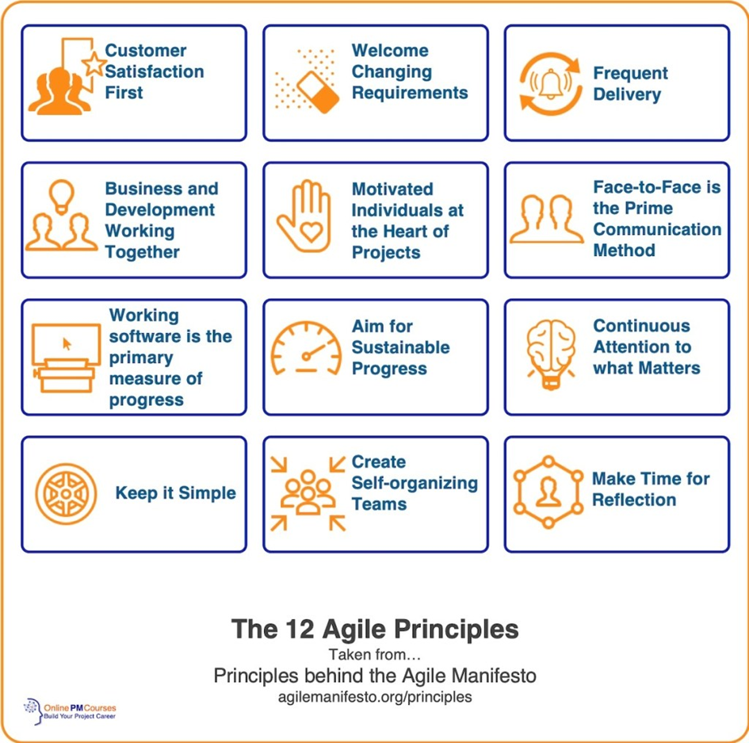

3.4. Agile Umbrella
The most popular and common examples of Agile methodology are Scrum, eXtreme Programming (XP), Feature Driven Development (FDD), Dynamic Systems Development Method (DSDM), Adaptive Software Development (ASD), Crystal, and Lean Software Development (LSD). Teams generally pick one or two methods depend on type of projects. The most widely used methodologies are Scrum and XP, which dovetail nicely.\
