EXE Group Management System
Design document
Course: PRN232 – Building Cross-Platform Back-End Application with .NET
Assignment: Final Assignment
Architecture: Microservices architecture, documented with the C4 model (Level 1 & Level 2)
Instructor: PhuongLHK
Semester: Fall 2026 (FA26)
Version: 3.2 · November 5, 2026

Version history
Version | Date | Changes
2.2 | November 5, 2026 | Versioned routes (/api/v1), refresh tokens and sign-out (Identity Service).
3.2 | November 5, 2026 | Lecturer feedback: FAP terms (Subject, Course = subject + class + semester), admin-led rooms instead of student-created groups, group types with major minimums, skills, deadline and finalize, group chat. Join requests move into the Group Service; new Recommendation Service (gRPC) and Realtime Service (SignalR).

Contents
1. Context 3
2. Problems 3
3. Solutions 3
4. Main Actors 4
5. Main Features 4
5.1 Features 4
5.2 Business rules 5
5.3 Statuses and codes 5
5.4 Grouping workflow 6
6. System Architecture (C4 model, Levels 1 and 2) 7
6.1 Level 1: System Context 8
6.2 Level 2: Containers 9
6.3 Communication 10
6.4 Key flows 10
6.5 Events (Redis stream group-events) 11
6.6 Background jobs 11
6.7 gRPC contract: Recommendation Service 11
6.8 Layered architecture and API conventions 12
7. Technology 13
8. ERD (conceptual) 13
9. Physical Database 14
9.1 IdentityDb (Identity Service) 15
9.2 GroupDb (Group Service) 17
9.3 ChatDb (Realtime Service) 24
Appendix A. REST API 26
Identity Service 26
Group Service: master data 26
Group Service: students and courses 26
Group Service: rooms and applications 27
Realtime Service 27
Appendix B. Assignment requirements 27

1. Context
At FPT University the EXE subjects (EXE101 Experiential Entrepreneurship 1 and EXE201) are taught to classes such as SE1919 every semester. In every class the students work in project groups of four to six members from at least two different majors, so that each start-up team covers technology, design and business. Forming the groups is the first task of the semester and blocks everything that follows: topic registration, checkpoints and grading.
Today the groups form informally through chat groups and spreadsheets, and the academic staff only see the result. The PRN232 lecturer's feedback describes the process the school wants instead: the staff prepare the semester, the subjects and the courses, add the students with their major, create rooms for each course from a simple formula and publish them. Students rate their own strengths and join rooms; the first student in a room leads it, may lock it and then reviews applications. When the deadline passes the staff arrange the remaining students and finalize the official groups, which everyone can then see.
The EXE Group Management System implements this process as a distributed .NET application. It is also the PRN232 Final Assignment, so it demonstrates REST APIs, background jobs, a message broker, a gRPC service and a containerized deployment.

2. Problems
ID | Problem | Impact
P1 | Groups form informally | Chat groups and spreadsheets: the staff have no live view and find the students without a group too late.
P2 | Major-mix rules are hard to keep by hand | Groups miss a required major (for example no marketing student) and have to be rebuilt.
P3 | Nobody knows who is good at what | Students pick friends instead of complementary strengths.
P4 | Deadline and final list are handled by hand | Late changes and disputes about who is in which group.
P5 | Group communication is scattered | Leaders cannot reach applicants and members in one place.
P6 | Lecturers cannot see their class's groups | They mentor groups they have no list of.

3. Solutions
ID | Solution | How | Solves
S1 | Admin-led rooms | The admin generates the rooms of a course (rooms = ceil(students / MaxGroupSize x k), k = 1.2) and publishes them; students join rooms instead of creating groups. | P1
S2 | Rules in the backend | One room per student per course, seats reserved for the majors a group type still needs, eligibility (minimum size and majors), deadline lock. | P2, P4
S3 | Skills and suggestions | Students rate their strengths 1-5; a gRPC Recommendation Service ranks rooms for a student and placements for the admin. | P3
S4 | Deadline and finalize | The course expires at ExpireAt (background job); the admin places the remaining students and finalizes numbered, read-only official groups. | P4
S5 | Built-in chat and notifications | One chat per room and real-time notifications (Realtime Service, SignalR). | P5
S6 | Lecturer view | Lecturer accounts with a read-only view of the courses they teach. | P6
S7 | Distributed .NET platform | Microservices behind an API gateway, a database per service, transactional outbox and Redis Streams, Docker Compose, CI and a demo deployment. | Assignment

4. Main Actors
The Admin is the moderator described in the lecturer's feedback; in the system it is the Administrator role. A Room Leader is a student, not a separate account.
Actor | Role in the token | Description | Main permissions
Admin | Administrator | Academic staff who runs group formation: the moderator of the lecturer's feedback. | Accounts and roles; semesters, subjects, majors, skills, group types; courses and rosters; generate, publish and expire rooms; move and place students; finalize.
Lecturer | Lecturer | Teaches one or more EXE classes. | Read-only: progress, rooms and members, students without a room and the official groups of their courses.
Student | Student | EXE student enrolled in courses of a semester. | Rate skills; browse rooms and get suggestions; join, leave and apply; chat with the room; see the official groups.
Room Leader | Student (leader of a room) | First student to join a room, or the member the leader hands over to. | Set the topic; lock and unlock; approve and reject applications; remove a member with a reason; hand over leadership.
Scheduler | - | Background jobs of the services. | Publish and expire courses on time; publish and consume events; clean up.

5. Main Features

5.1 Features
ID | Feature | Actors | Service
F01 | Sign in, refresh the token, sign out, edit own profile | All | Identity
F02 | Manage accounts and roles: create, import students, lock and unlock | Admin | Identity
F03 | Manage semesters, subjects, majors and skills | Admin (read: all) | Group
F04 | Manage group types (minimum students per major, minimum different majors) and allow them per semester | Admin | Group
F05 | Add students to a semester with their major; enroll them in courses | Admin | Group
F06 | Create courses (subject + class + semester): lecturer, group sizes, k, PublishAt, ExpireAt | Admin | Group
F07 | Generate the rooms of a course with their group type | Admin | Group
F08 | Publish and expire a course, manually or on time; move the deadline later | Admin, Scheduler | Group
F09 | Rate own skills 1-5 | Student | Group
F10 | Browse rooms with search, filters, sorting and paging; see members, majors, skills and topic | Student, Lecturer, Admin | Group
F11 | Get room suggestions | Student | Group + Recommendation (gRPC)
F12 | Join an open room; leave a room | Student | Group
F13 | Apply to a locked room; withdraw the application | Student | Group
F14 | Set the topic, lock and unlock, approve and reject, remove a member, hand over leadership | Room Leader | Group
F15 | Course overview: students without a room, rooms that are not eligible | Admin, Lecturer | Group
F16 | Move and place students after the deadline, with placement suggestions | Admin | Group + Recommendation (gRPC)
F17 | Finalize the course into numbered, read-only official groups | Admin | Group
F18 | Chat with the members of the room | Student | Realtime
F19 | Receive notifications: applications, decisions, removals, phase changes | All | Realtime
F20 | Scheduled work: publish and expire on time, publish events, clean up | Scheduler | Group, Realtime

5.2 Business rules
The Group Service enforces these rules in its Services layer; the database keeps the invariants it can check (keys, filtered unique indexes, checks).
ID | Rule
BR-01 | A course is one subject taught to one class in one semester; the class code is unique per subject and semester.
BR-02 | A student takes part in a semester with exactly one major (imported by the admin) and can be enrolled only in courses of that semester.
BR-03 | Rooms of a course = ceil(enrolled students / MaxGroupSize x k), k = RoomFactor (default 1.2). Every room has Capacity = MaxGroupSize and a group type allowed in the semester.
BR-04 | Rooms are generated, renamed or deleted only while the course is in Setup.
BR-05 | Students join, leave and apply only while the course is Published.
BR-06 | A student is in at most one room per course. Joining a room cancels their pending applications in that course (JOINED_ANOTHER_ROOM).
BR-07 | The first student to join an empty room becomes its leader. When the leader leaves, the earliest remaining member takes over; the leader may also hand over leadership.
BR-08 | Open room: enrolled students join directly. Locked room: students apply and the leader decides. Unlocking, or the room becoming empty, cancels its pending applications (ROOM_REOPENED).
BR-09 | Every join or approval must keep enough free seats for the majors the group type still needs: the minimum per major and the minimum number of different majors (COMPOSITION_RULE).
BR-10 | A full room accepts no one. When a room becomes full its pending applications are rejected (ROOM_FULL).
BR-11 | Until the course expires the leader may remove a member and must give a reason; the removed student cannot join or apply to that room again (REMOVED_FROM_ROOM). Memberships are kept as history: Left, Removed, Moved.
BR-12 | At ExpireAt, or when the admin expires the course, pending applications are rejected (GROUPING_EXPIRED) and students can no longer change rooms; only the admin moves or places students (JoinedVia = Admin, EndReason = Moved). While the course is Published the admin may move ExpireAt later.
BR-13 | A room is eligible when it has at least MinGroupSize members and the majors its group type requires.
BR-14 | Finalize needs every enrolled student in a room and every non-empty room eligible; the admin may confirm an exception (for example a class too small for the rules). Empty rooms are deleted; the others get GroupNo 1..n and become read-only official groups.
BR-15 | Skills are self-rated 1-5 per semester. They are shown to students and leaders and used for suggestions; they never block an action.
BR-16 | A lecturer sees only the courses they teach. Only the members of a room can read its chat.

5.3 Statuses and codes
Course phase (Courses.Phase)
Value | Meaning
Setup | The admin imports students, generates rooms and sets group types; students rate skills.
Published | Students join, leave and apply; leaders lock, review applications and remove members.
Expired | Students are frozen; the admin moves and places students.
Finalized | Rooms are numbered official groups; the list is read-only.

Room status (Rooms.Status)
Value | Meaning
Open | Enrolled students join directly.
Locked | Students apply; the leader approves or rejects.
Finalized | Official group (GroupNo set); read-only.

Membership (RoomMembers.JoinedVia / EndReason)
Value | Meaning
Open / Application / Admin | How the student entered: direct join, approved application, admin placement.
Left / Removed / Moved | How the membership ended: the student left, the leader removed them, the admin moved them.

Application (JoinRequests.Status)
Value | Meaning
Pending | Waiting for the leader.
Approved | The student became a member.
Rejected | By the leader or automatically (see ReasonCode).
Cancelled | Withdrawn by the student or cancelled automatically (see ReasonCode).

Reason codes stored on rejected or cancelled applications (JoinRequests.ReasonCode)
Code | Meaning
REJECTED_BY_LEADER | The room leader rejected the request (optional text in ReasonText).
WITHDRAWN | The student cancelled their own application.
ROOM_FULL | The room reached its capacity; its pending applications are rejected.
ROOM_REOPENED | The room was unlocked (by its leader, or it became empty); students join directly.
COMPOSITION_RULE | Adding the student would make the group type's major minimums impossible.
JOINED_ANOTHER_ROOM | Automatic cancellation: the student joined another room of the course.
GROUPING_EXPIRED | The course expired (by the admin or at ExpireAt); pending applications are rejected.

Business error codes returned with HTTP 409 (nothing is stored)
Code | Meaning
COURSE_NOT_PUBLISHED | Students join, leave and apply only while the course is Published.
NOT_ENROLLED | The student is not on the course roster.
ALREADY_IN_ROOM | The student is already a member of a room of the course.
ROOM_NOT_LOCKED | The room is Open: the student joins it directly.
ROOM_LOCKED | The room is Locked: the student must apply.
ROOM_FULL | The room has no free seat.
COMPOSITION_RULE | The join would make the group type's major minimums impossible.
REMOVED_FROM_ROOM | The leader removed the student from this room; they cannot join or apply to it again.
NOT_ROOM_LEADER | Only the room leader can do this.
COURSE_NOT_EXPIRED | The admin moves students only after the course expired.
FINALIZE_BLOCKED | Some students have no room, or some rooms are not eligible and no exception was accepted.

5.4 Grouping workflow
Figure A puts the phases of a course, the statuses of a room and the main rules on one page.
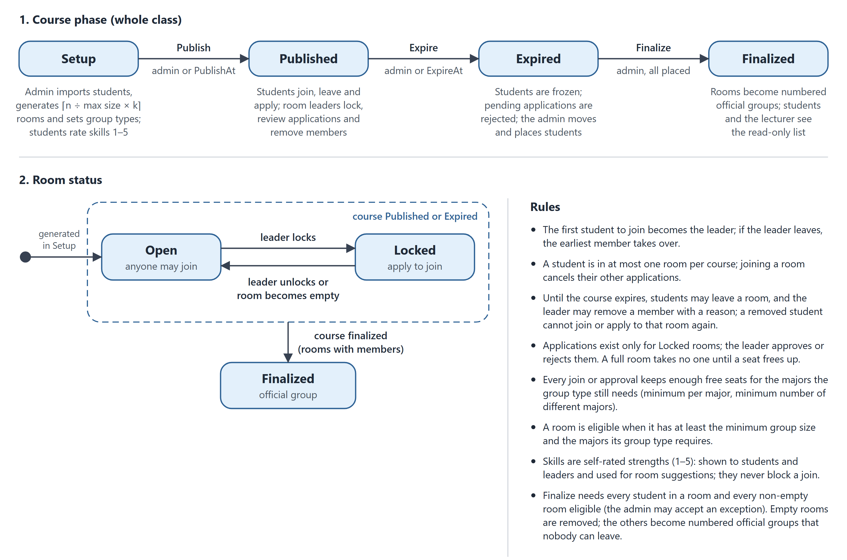
Figure A. Grouping workflow: course phases, room statuses and rules

6. System Architecture (C4 model, Levels 1 and 2)
The architecture follows the C4 model; this document uses Level 1 (System Context) and Level 2 (Container). The same model, with component and deployment views, is kept as code in docs/architecture/workspace.dsl.

6.1 Level 1: System Context
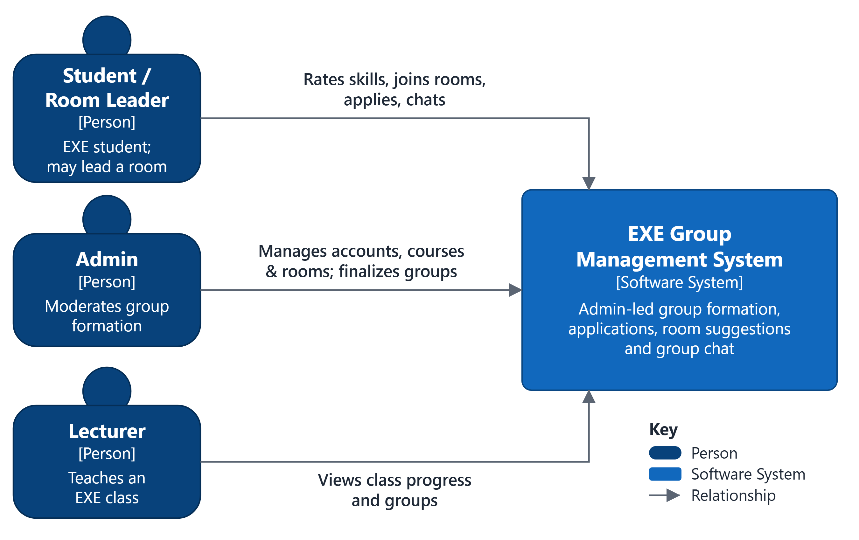
Figure 1. System Context diagram (C4 Level 1)
Three kinds of people use the system through the browser. There is no external system: accounts and rosters are imported by the admin, and notifications are shown in the application.

6.2 Level 2: Containers
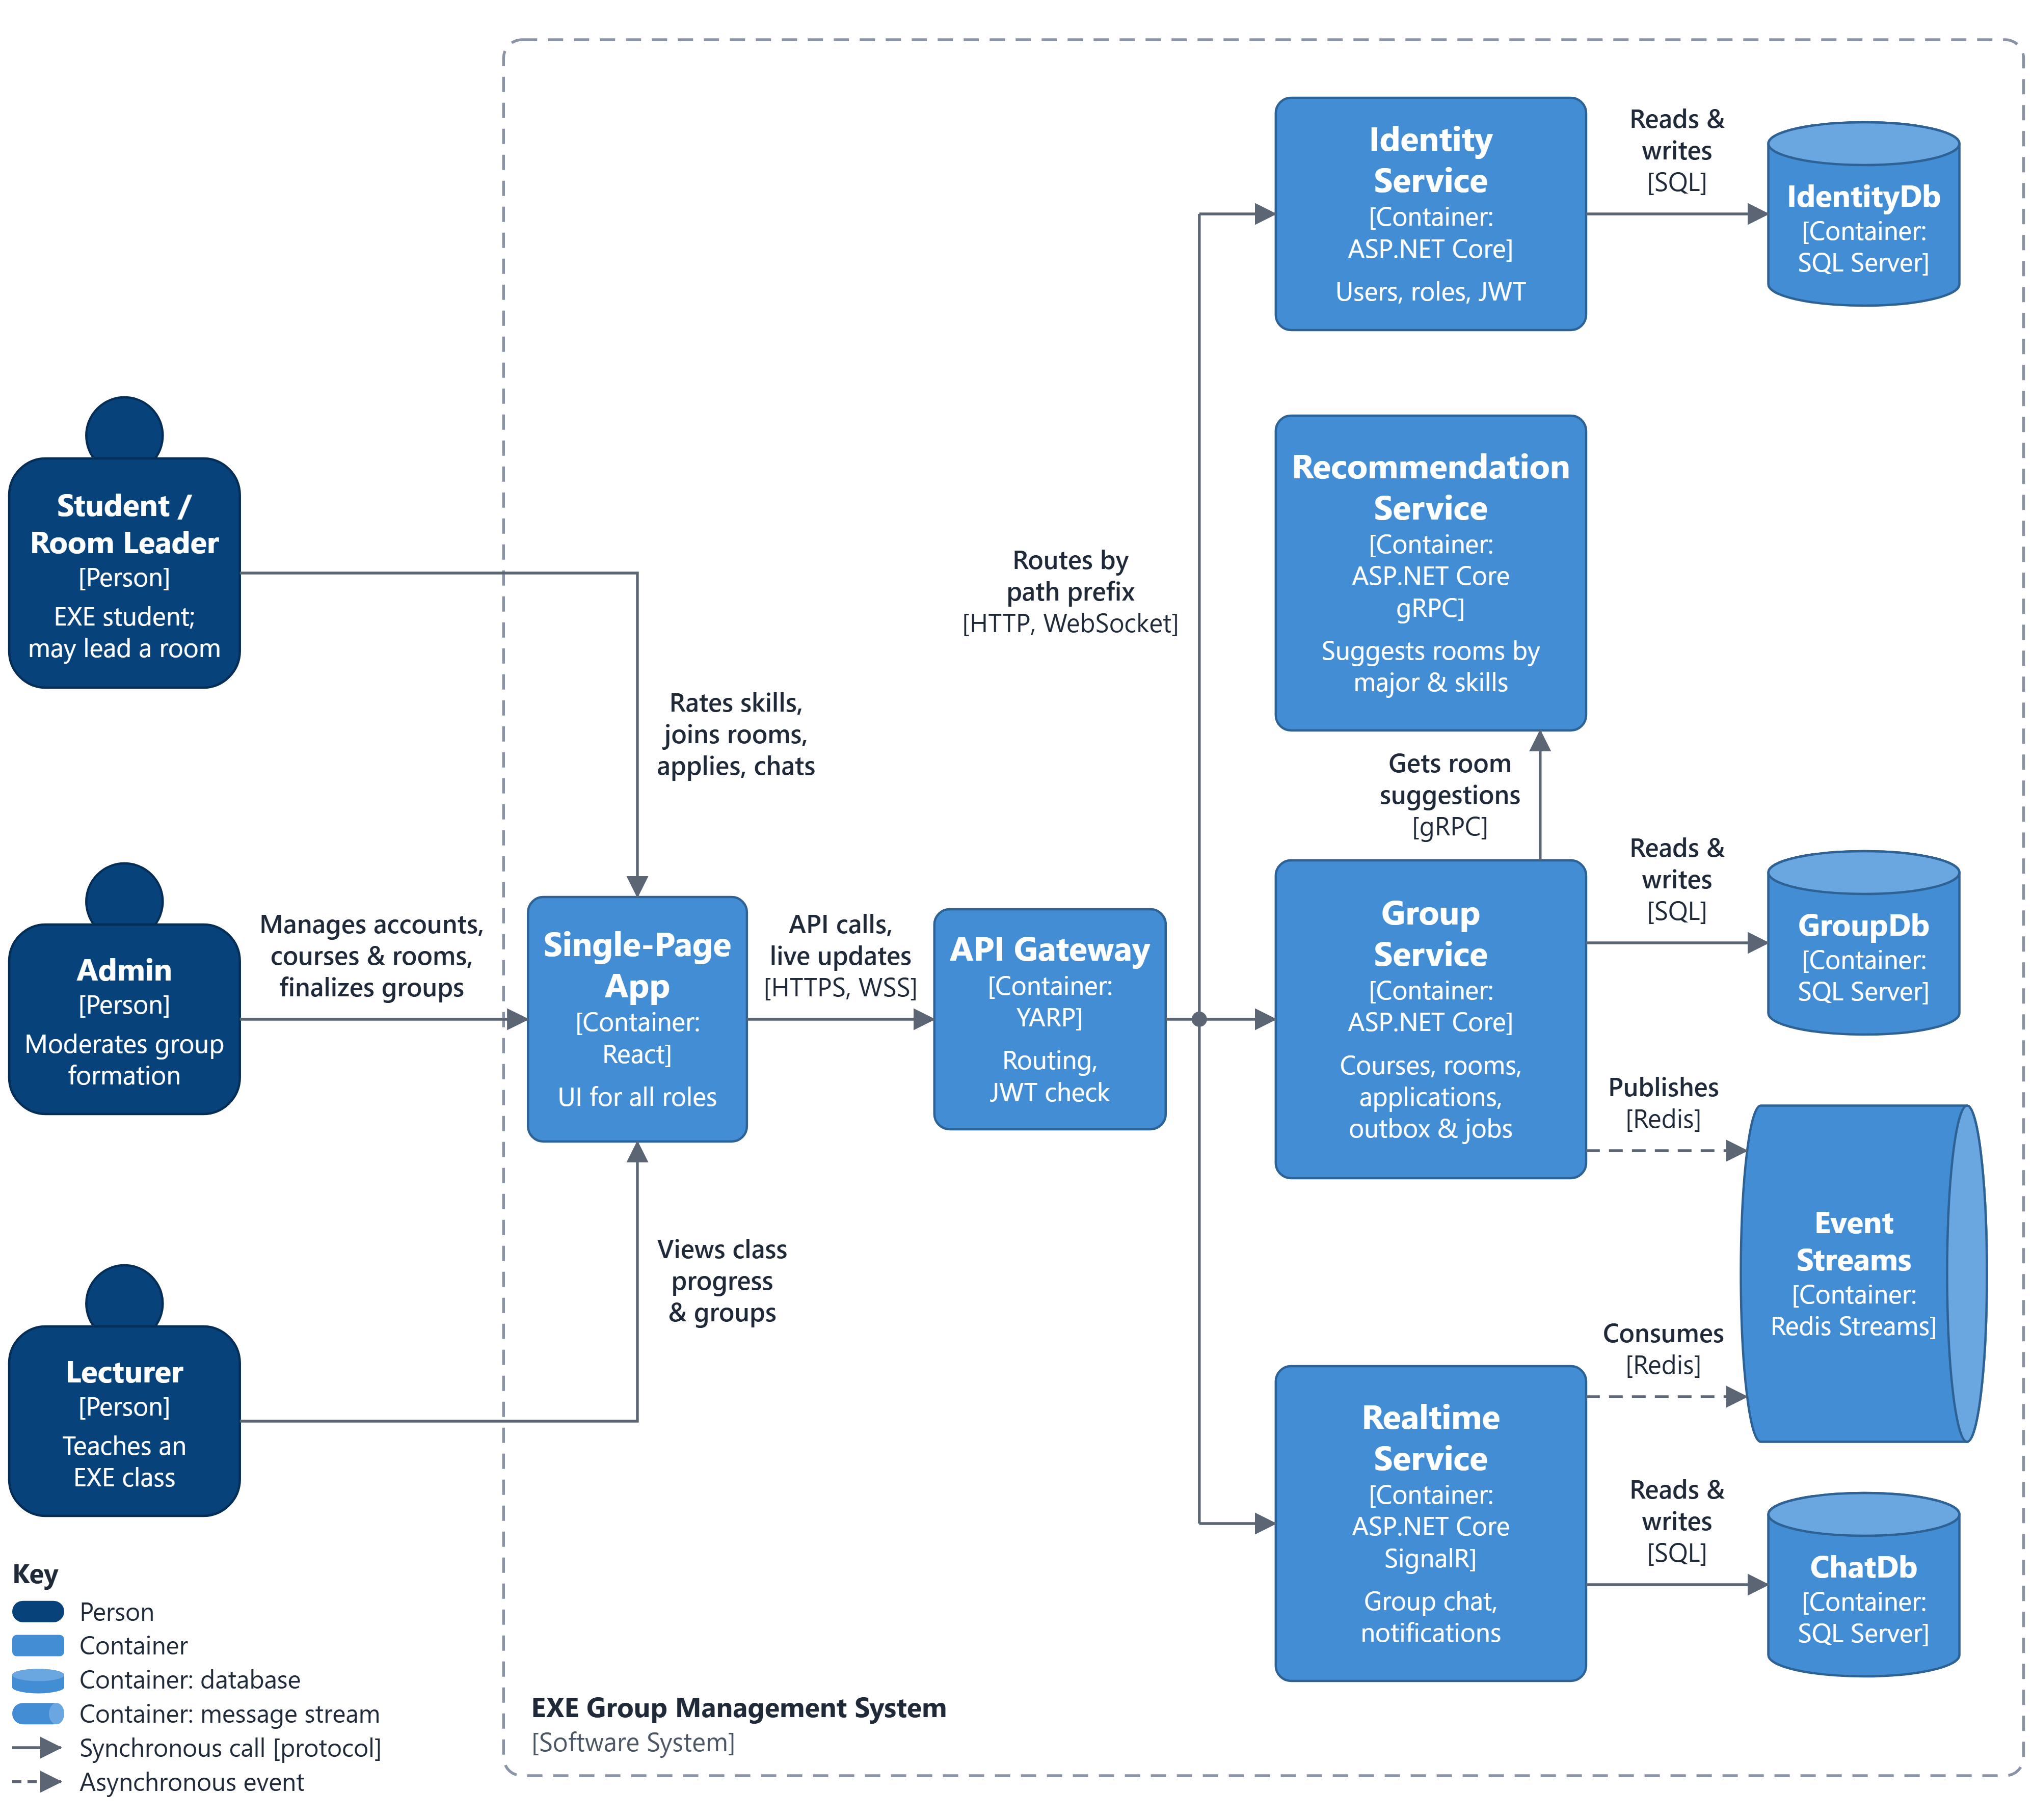
Figure 2. Container diagram (C4 Level 2)
Container | Technology | Responsibility | Port / data
Single-Page App | React 19, TypeScript, Vite, nginx | UI for all roles; nginx serves the app and proxies /api, /hubs and /swagger to the gateway. | web: 3000 -> 80
API Gateway | ASP.NET Core 10, YARP 2.3 | Single entry point: JWT check at the edge, routing by path prefix, WebSocket pass-through, sign-in rate limit, merged Swagger UI. | 8080
Identity Service | ASP.NET Core 10 Web API | Sign-in, JWT access and refresh tokens, users and roles. | IdentityDb
Group Service | ASP.NET Core 10 Web API | Semesters, subjects, majors, skills, group types, courses and rosters, rooms, memberships, applications and finalize; calls the Recommendation Service; writes the outbox; schedules publish and expiry. | GroupDb
Recommendation Service | ASP.NET Core 10 gRPC | Ranks rooms for a student and placements for students without a room from majors and skills. Stateless, no database, not routed by the gateway. | 8081 (HTTP/2)
Realtime Service | ASP.NET Core 10 Web API + SignalR | Group chat and notifications; consumes the group events and pushes them to browsers. | ChatDb, /hubs
IdentityDb, GroupDb, ChatDb | SQL Server 2022 | One database per service; no cross-database foreign keys. | 1433
Event Streams | Redis 7 Streams | Stream group-events; consumer group realtime. | 6379

6.3 Communication
Style | Between | Protocol | Used for
REST (synchronous) | Browser -> Gateway -> services | HTTPS, JSON envelope, /api/v1, JWT | Every user action.
gRPC (synchronous) | Group Service -> Recommendation Service | Protobuf over HTTP/2 (:8081), 2 s deadline | Room suggestions and placement suggestions; the Group Service falls back to unranked lists.
Events (asynchronous) | Group Service -> Redis Streams -> Realtime Service | XADD from the outbox; XREADGROUP and XACK | Notifications, chat membership, live room board.
WebSocket | Browser <-> Realtime Service (through the gateway) | SignalR hub /hubs/realtime | Chat messages, notifications and room changes pushed to the browser.

Rule of thumb: the browser calls REST; a service that needs an answer now calls gRPC; a service that only announces that something happened publishes an event.

6.4 Key flows

Apply to a locked room and approval (single transaction)
1. The student calls POST /api/v1/join-requests {roomId, message}. The Group Service checks BR-05, BR-06, BR-08 and BR-11, stores the application as Pending and writes JoinRequestSubmitted to the outbox.
2. The OutboxPublisher adds the event to group-events; the Realtime Service notifies the leader.
3. The leader calls POST /api/v1/join-requests/{id}/approve. In one transaction the Group Service checks the seat and the majors again (BR-09, BR-10), inserts the membership (JoinedVia = Application), updates Rooms.MemberCount (RowVersion), cancels the student's other pending applications, rejects the room's pending applications if it is now full and writes the events.
4. The Realtime Service notifies the applicant, adds them to the room chat and refreshes the room board.

Room suggestions (REST -> gRPC)
1. The student calls GET /api/v1/courses/{id}/rooms/suggestions?top=3.
2. The Group Service loads the student's major and skills, the rooms with a free seat, their members' majors and skills and the group type minimums.
3. It calls Recommendation.SuggestRooms with a 2 s deadline.
4. The Recommendation Service drops the rooms the student cannot join, scores the others and returns them ranked, with reasons.
5. If the call fails the Group Service returns the rooms without ranking.

Deadline (background job)
1. Every minute the PhaseScheduler finds Published courses whose ExpireAt has passed.
2. In one transaction it sets Phase = Expired, rejects the pending applications (GROUPING_EXPIRED) and writes CoursePhaseChanged.
3. The Realtime Service notifies the students of the course and the admin.

Finalize
1. The admin opens GET /api/v1/courses/{id}/overview: students without a room and rooms that are not eligible.
2. The admin places students with POST /api/v1/courses/{id}/placements, helped by GET /api/v1/courses/{id}/placement-suggestions (gRPC).
3. POST /api/v1/courses/{id}/finalize {acceptExceptions} checks BR-14, deletes empty rooms, numbers the others, sets them Finalized and writes CoursePhaseChanged.
4. Students and the lecturer are notified and see the official list.

6.5 Events (Redis stream group-events)
The Group Service writes every event to OutboxEvents in the same transaction as the change; the OutboxPublisher adds it to the stream. Every payload also carries eventId, occurredAt and correlationId.
Event | Produced when | Payload | Realtime Service reaction
CoursePhaseChanged | Publish, expire, finalize | courseId, phase | Notify the enrolled students (and the lecturer when finalized).
RoomMemberJoined | Join, approval, admin placement | courseId, roomId, studentId, joinedVia | Add the student to the room chat (create it for the first member); notify the leader; refresh the board.
RoomMemberLeft | Leave, removal, admin move | courseId, roomId, studentId, endReason, endNote | Remove the student from the chat; notify a removed or moved student; refresh the board.
RoomLeaderChanged | First join, leader left, hand-over | roomId, leaderId | Notify the new leader.
RoomStatusChanged | Lock, unlock, finalize | roomId, status | Refresh the board.
JoinRequestSubmitted | Application stored | requestId, roomId, studentId, leaderId | Notify the leader.
JoinRequestDecided | Approve, reject, automatic rejection or cancellation | requestId, roomId, studentId, status, reasonCode | Notify the applicant.

6.6 Background jobs
Job | Service | Schedule | What it does
OutboxPublisher | Group | Every 2 s | XADD unpublished OutboxEvents to group-events and set PublishedAtUtc; RetryCount and LastError on failure.
PhaseScheduler | Group | Every 1 min | Publish courses at PublishAt; expire courses at ExpireAt (BR-12).
OutboxCleanup | Group | Daily | Delete published events older than 7 days.
GroupEventsConsumer | Realtime | Continuous | XREADGROUP (group realtime); skip ids found in ProcessedEvents; apply; XACK after commit; XAUTOCLAIM stale entries.
ProcessedEventsCleanup | Realtime | Daily | Delete processed event ids older than 7 days.

6.7 gRPC contract: Recommendation Service
The Recommendation Service is the system's independent gRPC service. It owns no data: the Group Service sends the student, the rooms and the rules in each call (src/Contracts, recommendation.proto).
syntax = "proto3";
option csharp_namespace = "ExeGroup.Contracts.Recommendation";
package exegroup.recommendation.v1;
service Recommendation {
rpc SuggestRooms (SuggestRoomsRequest) returns (SuggestRoomsReply);
rpc SuggestPlacements (SuggestPlacementsRequest) returns (SuggestPlacementsReply);
}
message Student {
string student_id = 1;
string major_code = 2;
map<string, int32> skills = 3;
}
message Room {
string room_id = 1;
string name = 2;
int32 capacity = 3;
repeated Student members = 4;
map<string, int32> min_per_major = 5;
int32 min_distinct_majors = 6;
int32 min_group_size = 7;
}
message Reason {
string code = 1;
string detail = 2;
}
message SuggestRoomsRequest {
Student student = 1;
repeated Room rooms = 2;
int32 top = 3;
}
message RoomSuggestion {
string room_id = 1;
double score = 2;
repeated Reason reasons = 3;
}
message SuggestRoomsReply {
repeated RoomSuggestion suggestions = 1;
}
message SuggestPlacementsRequest {
repeated Student unassigned = 1;
repeated Room rooms = 2;
}
message Placement {
string student_id = 1;
string room_id = 2;
repeated Reason reasons = 3;
}
message SuggestPlacementsReply {
repeated Placement placements = 1;
repeated string unplaced_student_ids = 2;
}
Scoring
- Rooms the student cannot join are dropped: full rooms and rooms where the join would break BR-09.
- MAJOR_NEEDED: the room still needs the student's major (minimum per major or a new distinct major).
- SKILL_GAP: for every skill, the student's level above the best level in the room (detail = skill code).
- BELOW_MINIMUM: the room has fewer than MinGroupSize members.
- Placements: students with the scarcest majors are placed first, each into the best-scoring room that keeps BR-09; students that fit nowhere are returned as unplaced.

6.8 Layered architecture and API conventions
- Three projects per service: API -> Services -> Repositories. Architecture tests fail the build when the API uses EF Core, when Services or Repositories use ASP.NET Core, or when a service references another one.
- Four model types: Entity (Repositories), business model (Services), Request and Response (API).
- Every response is an envelope {success, message, data, errors, traceId, pagination}; failures are coded exceptions mapped to 400, 401, 403, 404 and 409 with a business code (the codes of section 5.3).
- Versioned routes /api/v{version}/<plural-resource>; authentication is required unless an endpoint is marked anonymous; roles through [Authorize(Roles = ...)], room leadership and lecturer ownership checked in the Services layer.
- List endpoints accept search, sort (several fields, '-' for descending), page, pageSize (default 20, at most 100), fields and expand, plus their own filters.
- Serilog with a correlation id (X-Correlation-ID) carried across REST, gRPC and events; health checks per service; one OpenAPI document per service, merged at the gateway.

7. Technology
Area | Technology
Runtime | .NET 10 (SDK pinned in global.json), C# latest, nullable enabled, warnings as errors
Backend | ASP.NET Core 10; three projects per service (API -> Services -> Repositories)
Data | Entity Framework Core 10, SQL Server 2022, code-first migrations matching database/schema.sql
Gateway | YARP 2.3
Synchronous service calls | gRPC: Grpc.AspNetCore / Grpc.Net.ClientFactory 2.85, Protobuf over HTTP/2
Messaging | Redis 7 Streams (StackExchange.Redis 3.x), transactional outbox, idempotent consumer
Real time | ASP.NET Core SignalR (chat, notifications, live room board)
Background jobs | BackgroundService + PeriodicTimer through a shared PeriodicBackgroundService base
Security | JWT Bearer HS256, rotating refresh tokens, ASP.NET Core PasswordHasher
API surface | URL versioning (Asp.Versioning 10), JSON and XML, DataAnnotations + FluentValidation
API documentation | Swashbuckle 10 (OpenAPI), one document per service, merged Swagger UI at the gateway
Logging | Serilog with correlation id; request-logging and exception middleware
Frontend | React 19, TypeScript, Vite, React Router 7, TanStack Query 5, nginx
Tests | xUnit v3, Testcontainers (real SQL Server), NetArchTest
Deployment | Docker, Docker Compose (8 containers), GitHub Actions CI and demo deployment

8. ERD (conceptual)
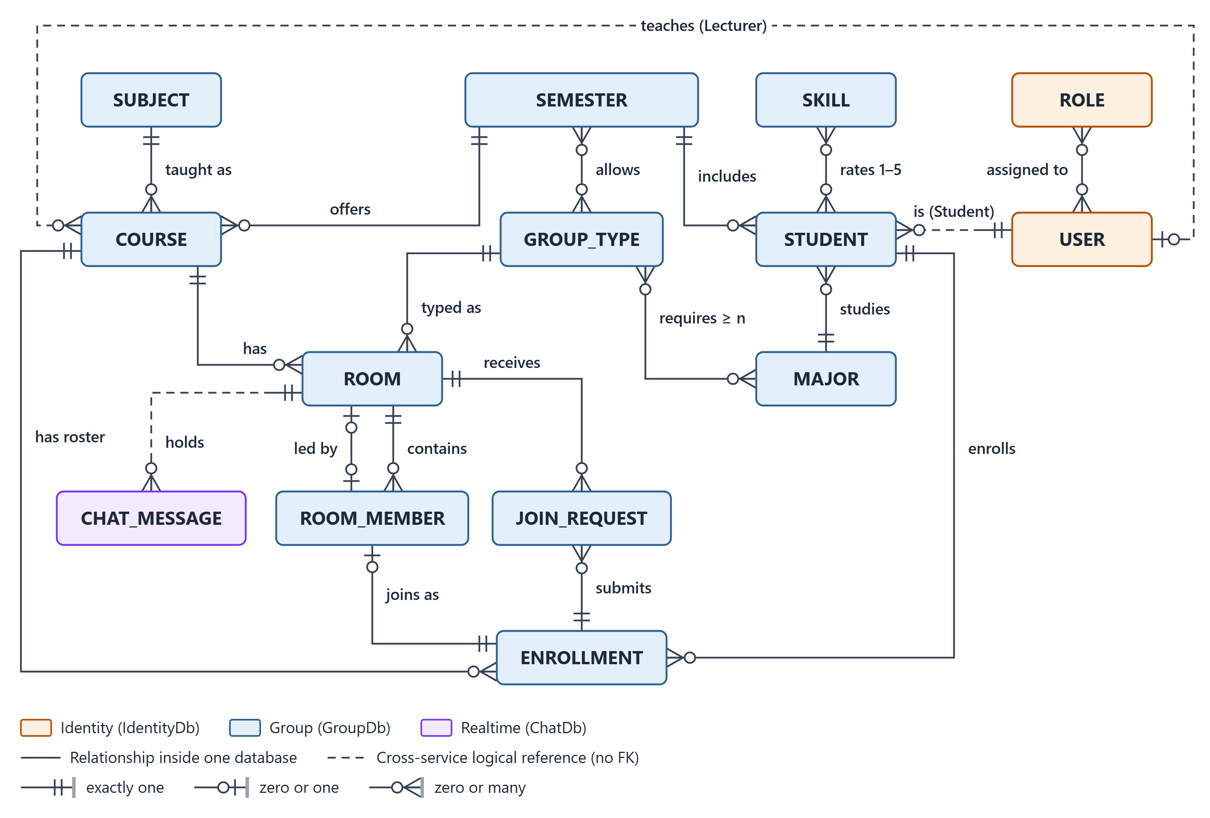
Figure 3. Conceptual ERD
Colours show the database that owns an entity; dashed lines are logical references across services (no foreign key).
Entity | Meaning | Database
USER, ROLE | Accounts and their global roles. | IdentityDb
SEMESTER | Academic term, e.g. FA26. | GroupDb
SUBJECT | Subject such as EXE101. | GroupDb
COURSE | A subject taught to one class in one semester, with grouping settings, phase and lecturer. | GroupDb
STUDENT | A user taking part in a semester, with one major. | GroupDb
MAJOR, SKILL | Study majors; strengths students rate (rates 1-5). | GroupDb
ENROLLMENT | A student on the roster of a course. | GroupDb
GROUP_TYPE | Major mix rules (requires >= n of a major); allowed per semester. | GroupDb
ROOM | A slot of a course; becomes an official group at finalize. | GroupDb
ROOM_MEMBER | A membership of an enrolled student in a room, current or ended; the room is led by one. | GroupDb
JOIN_REQUEST | An application of an enrolled student to a locked room. | GroupDb
CHAT_MESSAGE | A message in the room's chat. | ChatDb

9. Physical Database
One SQL Server database per service. database/schema.sql is generated from the same design data as these figures, and the EF Core migrations must produce the same tables, keys, indexes and checks. Key column: PK primary key, FK foreign key, UK member of a unique key, LR logical reference to another database (no FK). Filtered unique indexes (WHERE ...) cover only the rows that match.

9.1 IdentityDb (Identity Service)
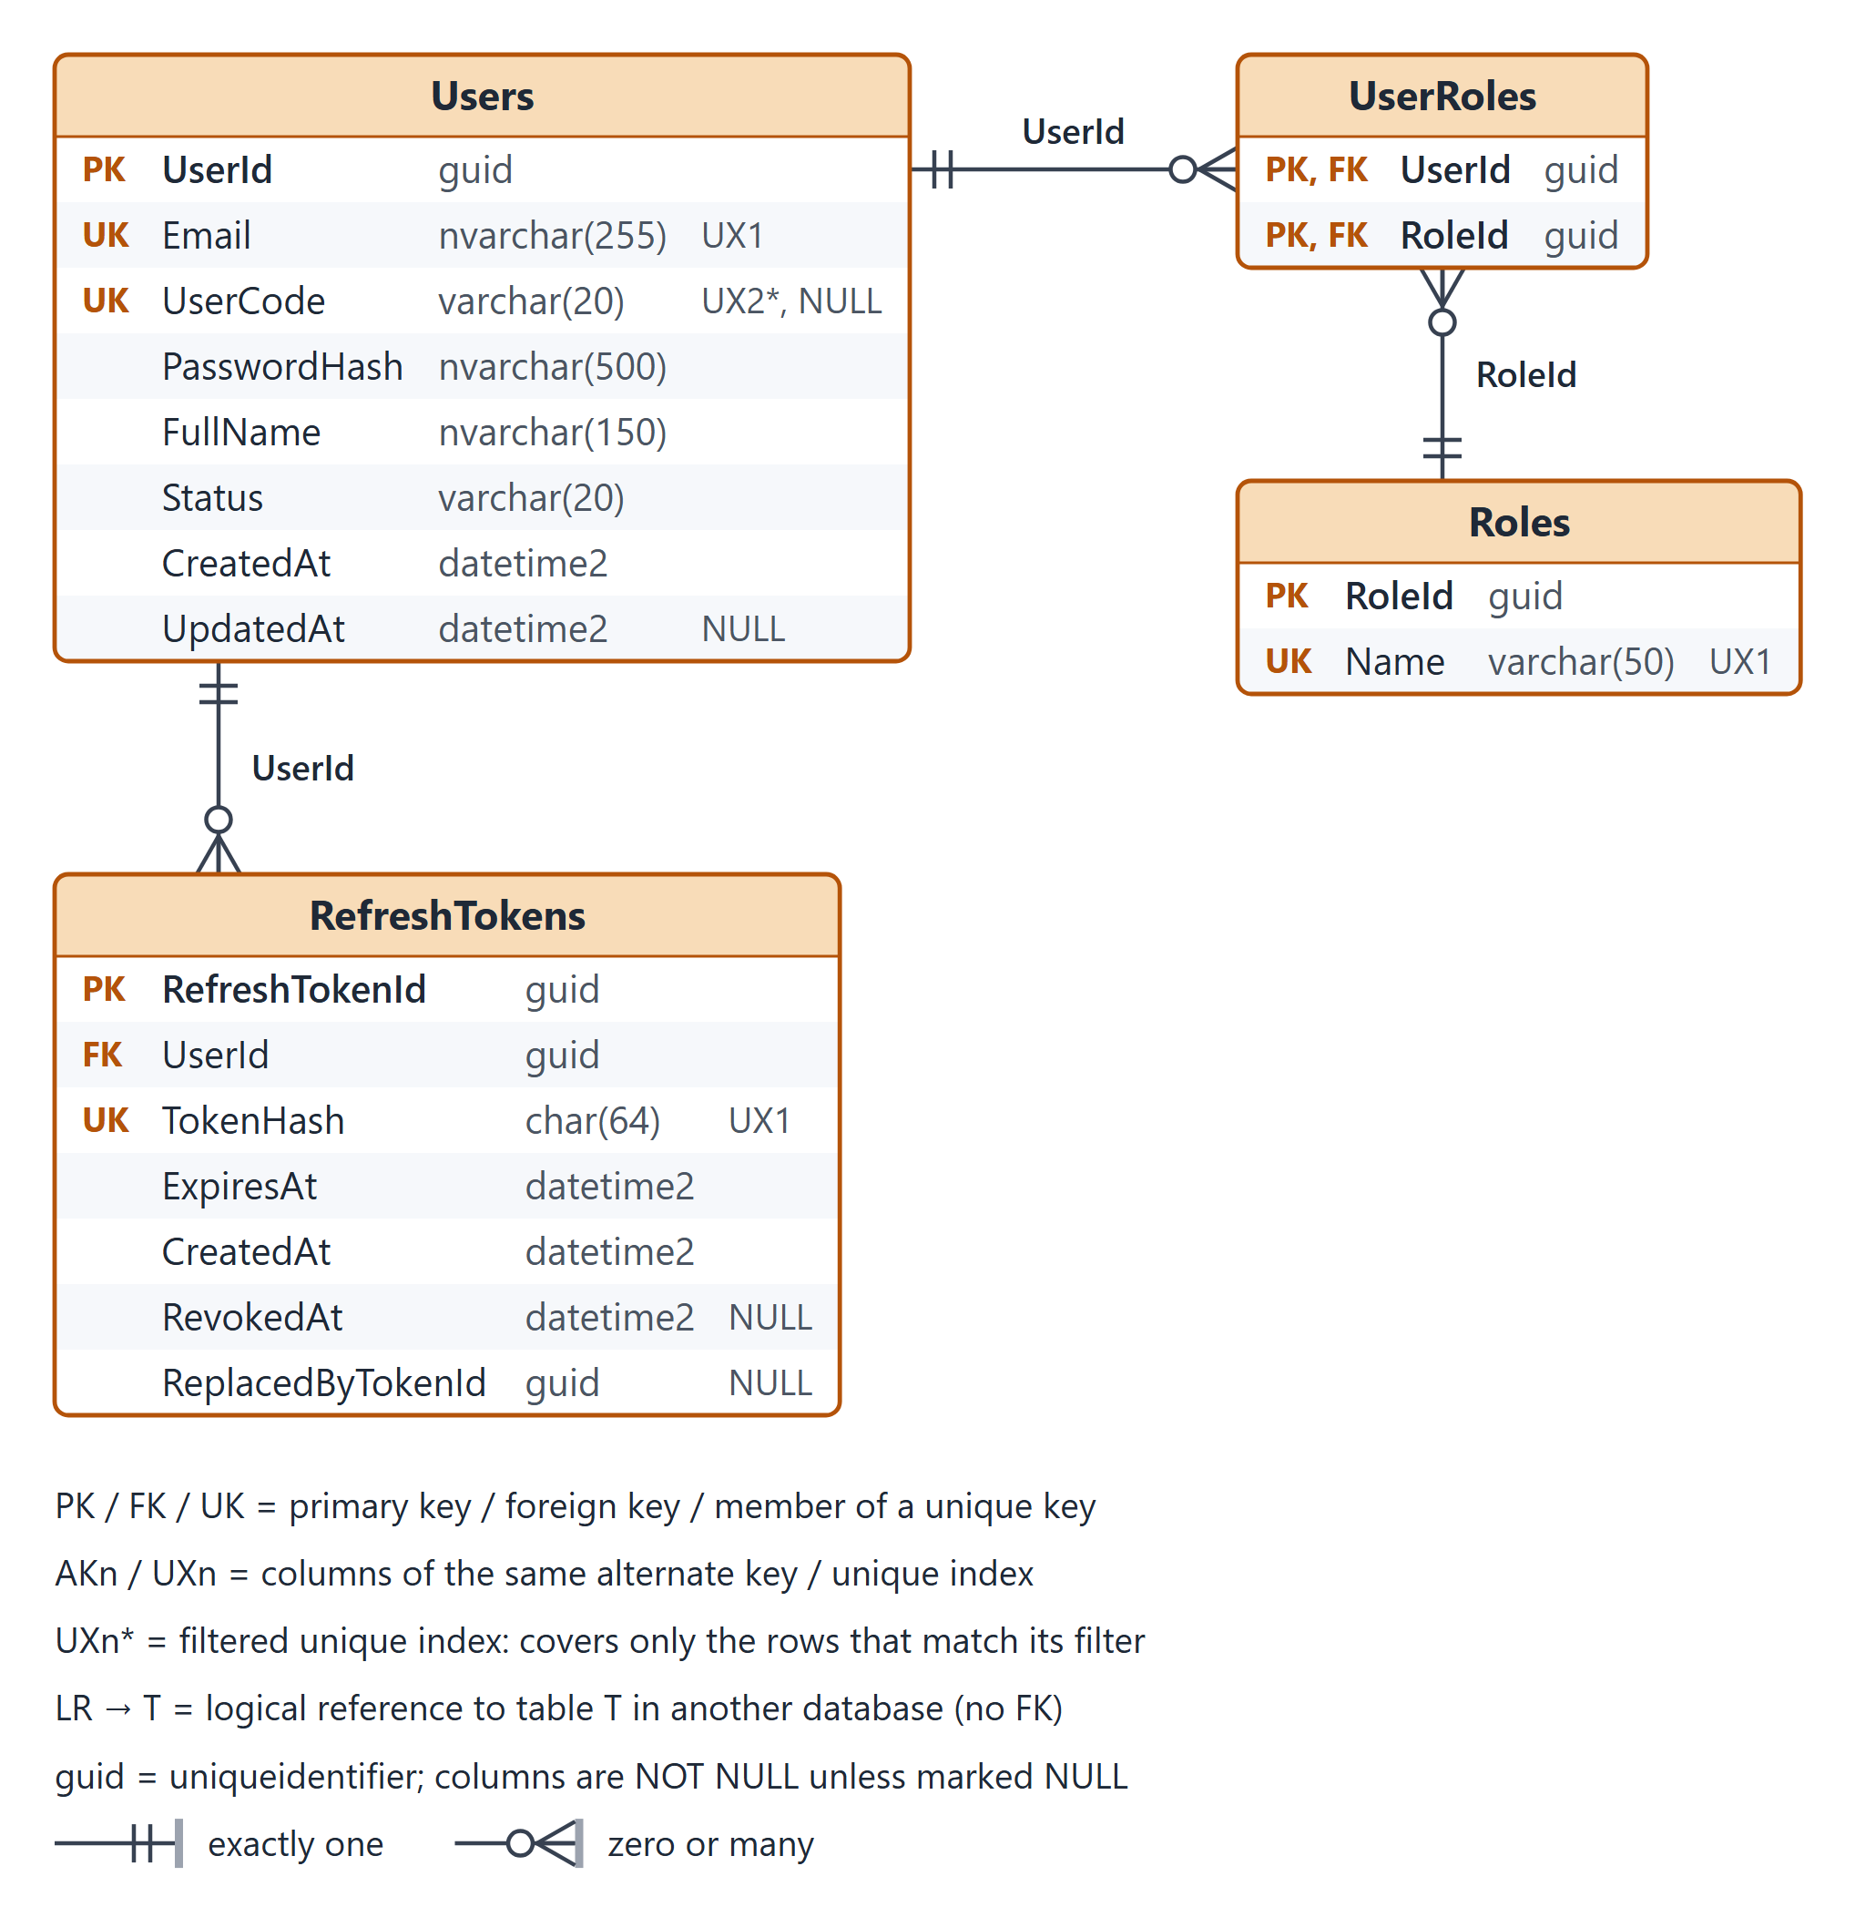
Figure 4. Physical database: IdentityDb

Users
User accounts for all roles.
Column | Type | Null | Key | Default | Description
UserId | uniqueidentifier |  | PK |  | Surrogate key (sequential GUID generated by EF Core).
Email | nvarchar(255) |  | UK |  | University e-mail used to sign in.
UserCode | varchar(20) | NULL | UK |  | Student code (e.g. SE180001) or staff code; required for Student accounts; unique when present.
PasswordHash | nvarchar(500) |  |  |  | Salted PBKDF2 hash (ASP.NET Core PasswordHasher).
FullName | nvarchar(150) |  |  |  | Display name.
Status | varchar(20) |  |  | 'Active' | Account state: Active, Locked.
CreatedAt | datetime2 |  |  | SYSUTCDATETIME() | Creation time (UTC).
UpdatedAt | datetime2 | NULL |  |  | Last update time (UTC).

Keys: PK_Users (UserId)
Unique indexes: UX_Users_Email (Email); UX_Users_UserCode (UserCode) WHERE [UserCode] IS NOT NULL
Checks: CK_Users_Status: [Status] IN ('Active', 'Locked')

Roles
Global roles (seeded): Student, Lecturer, Administrator (the Admin actor).
Column | Type | Null | Key | Default | Description
RoleId | uniqueidentifier |  | PK |  | Surrogate key (fixed seed values).
Name | varchar(50) |  | UK |  | Role name: Student, Lecturer, Administrator.

Keys: PK_Roles (RoleId)
Unique indexes: UX_Roles_Name (Name)
Seed rows: Student, Lecturer, Administrator

UserRoles
Many-to-many assignment of roles to users.
Column | Type | Null | Key | Default | Description
UserId | uniqueidentifier |  | PK, FK |  | References Users(UserId); cascade delete.
RoleId | uniqueidentifier |  | PK, FK |  | References Roles(RoleId).

Keys: PK_UserRoles (UserId, RoleId)
Indexes: IX_UserRoles_RoleId (RoleId)
Foreign keys: FK_UserRoles_Users (UserId) -> Users (UserId), ON DELETE CASCADE; FK_UserRoles_Roles (RoleId) -> Roles (RoleId), ON DELETE NO ACTION

RefreshTokens
Rotating refresh tokens; only a hash is stored.
Column | Type | Null | Key | Default | Description
RefreshTokenId | uniqueidentifier |  | PK |  | Surrogate key.
UserId | uniqueidentifier |  | FK |  | References Users(UserId); cascade delete.
TokenHash | char(64) |  | UK |  | SHA-256 (hex) of the refresh token; the token itself is never stored.
ExpiresAt | datetime2 |  |  |  | Expiry (UTC); default lifetime 7 days (Jwt:RefreshTokenDays).
CreatedAt | datetime2 |  |  | SYSUTCDATETIME() | Issue time (UTC).
RevokedAt | datetime2 | NULL |  |  | Set when the token is rotated, on sign-out or when the account is locked.
ReplacedByTokenId | uniqueidentifier | NULL |  |  | Token issued when this one was rotated; reuse of a revoked token revokes the whole chain.

Keys: PK_RefreshTokens (RefreshTokenId)
Unique indexes: UX_RefreshTokens_TokenHash (TokenHash)
Indexes: IX_RefreshTokens_UserId (UserId)
Foreign keys: FK_RefreshTokens_Users (UserId) -> Users (UserId), ON DELETE CASCADE

9.2 GroupDb (Group Service)
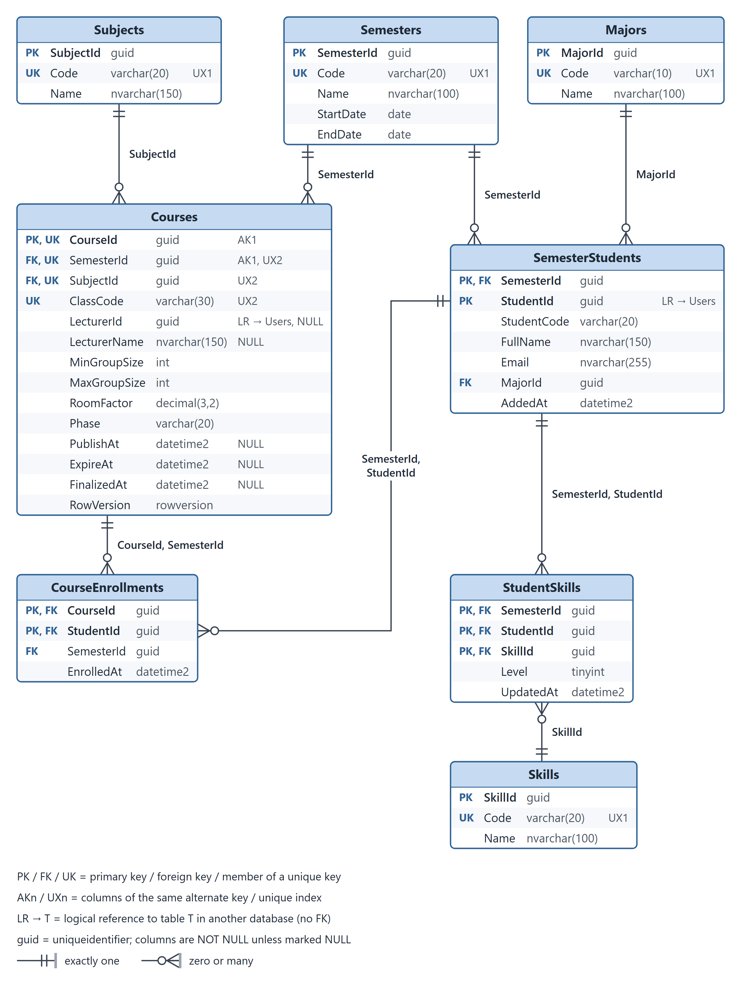
Figure 5a. Physical database: GroupDb (1/2), semesters, courses and students
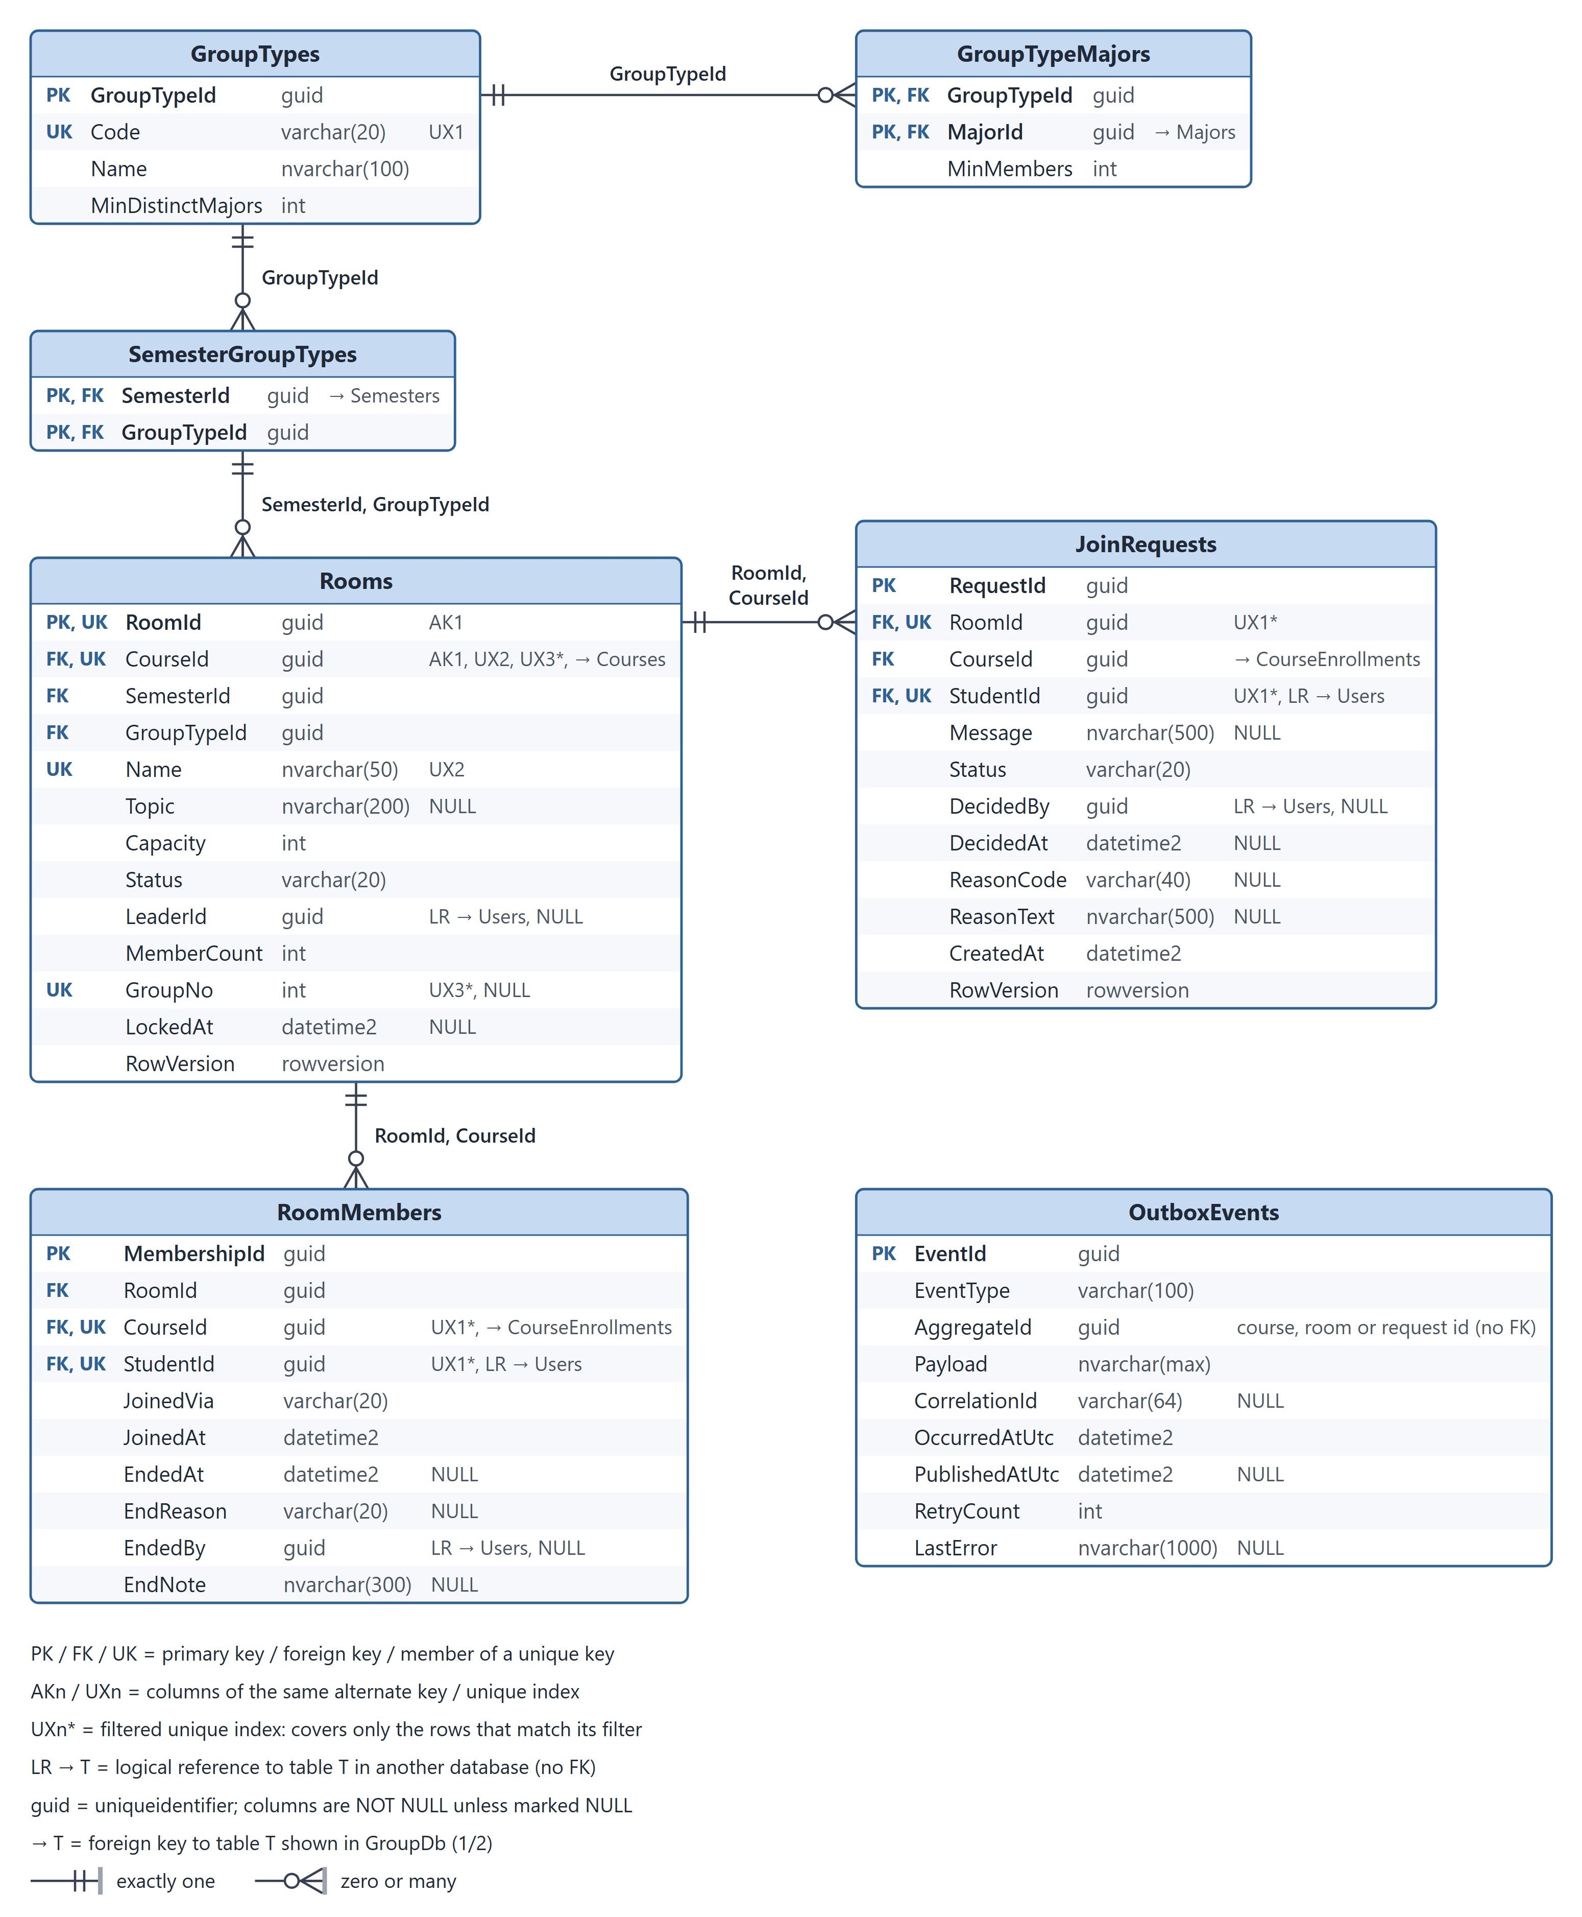
Figure 5b. Physical database: GroupDb (2/2), group types, rooms and applications

Semesters
Academic semesters.
Column | Type | Null | Key | Default | Description
SemesterId | uniqueidentifier |  | PK |  | Surrogate key.
Code | varchar(20) |  | UK |  | Semester code, e.g. FA26.
Name | nvarchar(100) |  |  |  | Display name, e.g. Fall 2026.
StartDate | date |  |  |  | First day of the semester.
EndDate | date |  |  |  | Last day; after StartDate.

Keys: PK_Semesters (SemesterId)
Unique indexes: UX_Semesters_Code (Code)
Checks: CK_Semesters_Dates: [EndDate] > [StartDate]

Subjects
Subjects taught across semesters, e.g. EXE101, EXE201.
Column | Type | Null | Key | Default | Description
SubjectId | uniqueidentifier |  | PK |  | Surrogate key.
Code | varchar(20) |  | UK |  | Subject code, e.g. EXE101.
Name | nvarchar(150) |  |  |  | Subject name.

Keys: PK_Subjects (SubjectId)
Unique indexes: UX_Subjects_Code (Code)

Majors
Study majors, e.g. SE, GD, MKT.
Column | Type | Null | Key | Default | Description
MajorId | uniqueidentifier |  | PK |  | Surrogate key.
Code | varchar(10) |  | UK |  | Major code, e.g. SE.
Name | nvarchar(100) |  |  |  | Major name.

Keys: PK_Majors (MajorId)
Unique indexes: UX_Majors_Code (Code)

Skills
Strengths students rate themselves on, e.g. Programming, Design, Marketing, Management.
Column | Type | Null | Key | Default | Description
SkillId | uniqueidentifier |  | PK |  | Surrogate key.
Code | varchar(20) |  | UK |  | Skill code.
Name | nvarchar(100) |  |  |  | Skill name.

Keys: PK_Skills (SkillId)
Unique indexes: UX_Skills_Code (Code)

SemesterStudents
Students taking part in a semester, with their major for that semester (imported by the admin).
Column | Type | Null | Key | Default | Description
SemesterId | uniqueidentifier |  | PK, FK |  | References Semesters.
StudentId | uniqueidentifier |  | PK, LR |  | UserId of the student in IdentityDb.
StudentCode | varchar(20) |  |  |  | Copied from IdentityDb at import, for lists and search.
FullName | nvarchar(150) |  |  |  | Copied from IdentityDb at import.
Email | nvarchar(255) |  |  |  | Copied from IdentityDb at import.
MajorId | uniqueidentifier |  | FK |  | Major of the student in this semester.
AddedAt | datetime2 |  |  | SYSUTCDATETIME() | Import time (UTC).

Keys: PK_SemesterStudents (SemesterId, StudentId)
Indexes: IX_SemesterStudents_MajorId (MajorId)
Foreign keys: FK_SemesterStudents_Semesters (SemesterId) -> Semesters (SemesterId), ON DELETE NO ACTION; FK_SemesterStudents_Majors (MajorId) -> Majors (MajorId), ON DELETE NO ACTION
Logical references (no FK): StudentId -> Users

StudentSkills
Self-rated strengths (1-5) of a student in a semester.
Column | Type | Null | Key | Default | Description
SemesterId | uniqueidentifier |  | PK, FK |  | With StudentId: references SemesterStudents.
StudentId | uniqueidentifier |  | PK, FK |  | With SemesterId: references SemesterStudents.
SkillId | uniqueidentifier |  | PK, FK |  | References Skills.
Level | tinyint |  |  |  | Self-assessment 1..5.
UpdatedAt | datetime2 |  |  | SYSUTCDATETIME() | Last change (UTC).

Keys: PK_StudentSkills (SemesterId, StudentId, SkillId)
Indexes: IX_StudentSkills_SkillId (SkillId)
Checks: CK_StudentSkills_Level: [Level] BETWEEN 1 AND 5
Foreign keys: FK_StudentSkills_SemesterStudents (SemesterId, StudentId) -> SemesterStudents (SemesterId, StudentId), ON DELETE NO ACTION; FK_StudentSkills_Skills (SkillId) -> Skills (SkillId), ON DELETE NO ACTION

Courses
One subject taught to one class in one semester (FAP course), with its grouping settings and phase.
Column | Type | Null | Key | Default | Description
CourseId | uniqueidentifier |  | PK, UK |  | Surrogate key.
SemesterId | uniqueidentifier |  | FK, UK |  | References Semesters.
SubjectId | uniqueidentifier |  | FK, UK |  | References Subjects.
ClassCode | varchar(30) |  | UK |  | Class, e.g. SE1919.
LecturerId | uniqueidentifier | NULL | LR |  | UserId of the lecturer (read-only access).
LecturerName | nvarchar(150) | NULL |  |  | Copied from IdentityDb for display.
MinGroupSize | int |  |  | 4 | Minimum members of an eligible room.
MaxGroupSize | int |  |  | 6 | Capacity of every generated room.
RoomFactor | decimal(3,2) |  |  | 1.20 | k in rooms = ceil(students / MaxGroupSize * k).
Phase | varchar(20) |  |  | 'Setup' | Setup, Published, Expired, Finalized.
PublishAt | datetime2 | NULL |  |  | Optional automatic publish time (UTC).
ExpireAt | datetime2 | NULL |  |  | Grouping deadline (UTC); the course expires automatically.
FinalizedAt | datetime2 | NULL |  |  | Set when the admin finalizes.
RowVersion | rowversion |  |  |  | Optimistic concurrency token.

Keys: PK_Courses (CourseId); AK_Courses_CourseId_SemesterId (CourseId, SemesterId)
Unique indexes: UX_Courses_Semester_Subject_Class (SemesterId, SubjectId, ClassCode)
Indexes: IX_Courses_SubjectId (SubjectId); IX_Courses_LecturerId (LecturerId) WHERE [LecturerId] IS NOT NULL; IX_Courses_Phase (Phase)
Checks: CK_Courses_GroupSize: [MinGroupSize] >= 1 AND [MaxGroupSize] >= [MinGroupSize]; CK_Courses_RoomFactor: [RoomFactor] >= 1.00; CK_Courses_Phase: [Phase] IN ('Setup', 'Published', 'Expired', 'Finalized'); CK_Courses_Schedule: [PublishAt] IS NULL OR [ExpireAt] IS NULL OR [ExpireAt] > [PublishAt]
Foreign keys: FK_Courses_Semesters (SemesterId) -> Semesters (SemesterId), ON DELETE NO ACTION; FK_Courses_Subjects (SubjectId) -> Subjects (SubjectId), ON DELETE NO ACTION
Logical references (no FK): LecturerId -> Users

CourseEnrollments
Students enrolled in a course (class roster).
Column | Type | Null | Key | Default | Description
CourseId | uniqueidentifier |  | PK, FK |  | With SemesterId: references Courses.
StudentId | uniqueidentifier |  | PK, FK |  | With SemesterId: references SemesterStudents.
SemesterId | uniqueidentifier |  | FK |  | Keeps the course and the student in the same semester.
EnrolledAt | datetime2 |  |  | SYSUTCDATETIME() | Enrolment time (UTC).

Keys: PK_CourseEnrollments (CourseId, StudentId)
Indexes: IX_CourseEnrollments_Semester_Student (SemesterId, StudentId)
Foreign keys: FK_CourseEnrollments_Courses (CourseId, SemesterId) -> Courses (CourseId, SemesterId), ON DELETE NO ACTION; FK_CourseEnrollments_SemesterStudents (SemesterId, StudentId) -> SemesterStudents (SemesterId, StudentId), ON DELETE NO ACTION

GroupTypes
Kinds of groups with their major mix rules.
Column | Type | Null | Key | Default | Description
GroupTypeId | uniqueidentifier |  | PK |  | Surrogate key.
Code | varchar(20) |  | UK |  | Group type code.
Name | nvarchar(100) |  |  |  | Group type name.
MinDistinctMajors | int |  |  | 2 | At least this many different majors per group.

Keys: PK_GroupTypes (GroupTypeId)
Unique indexes: UX_GroupTypes_Code (Code)
Checks: CK_GroupTypes_MinDistinctMajors: [MinDistinctMajors] >= 1

GroupTypeMajors
Minimum number of students of a major in a group of this type (n:n GroupTypes - Majors).
Column | Type | Null | Key | Default | Description
GroupTypeId | uniqueidentifier |  | PK, FK |  | References GroupTypes.
MajorId | uniqueidentifier |  | PK, FK |  | References Majors.
MinMembers | int |  |  |  | Minimum students of this major per group.

Keys: PK_GroupTypeMajors (GroupTypeId, MajorId)
Indexes: IX_GroupTypeMajors_MajorId (MajorId)
Checks: CK_GroupTypeMajors_MinMembers: [MinMembers] >= 1
Foreign keys: FK_GroupTypeMajors_GroupTypes (GroupTypeId) -> GroupTypes (GroupTypeId), ON DELETE NO ACTION; FK_GroupTypeMajors_Majors (MajorId) -> Majors (MajorId), ON DELETE NO ACTION

SemesterGroupTypes
Group types allowed in a semester.
Column | Type | Null | Key | Default | Description
SemesterId | uniqueidentifier |  | PK, FK |  | References Semesters.
GroupTypeId | uniqueidentifier |  | PK, FK |  | References GroupTypes.

Keys: PK_SemesterGroupTypes (SemesterId, GroupTypeId)
Indexes: IX_SemesterGroupTypes_GroupTypeId (GroupTypeId)
Foreign keys: FK_SemesterGroupTypes_Semesters (SemesterId) -> Semesters (SemesterId), ON DELETE NO ACTION; FK_SemesterGroupTypes_GroupTypes (GroupTypeId) -> GroupTypes (GroupTypeId), ON DELETE NO ACTION

Rooms
Admin-created slots of a course; a room becomes an official group when the course is finalized.
Column | Type | Null | Key | Default | Description
RoomId | uniqueidentifier |  | PK, UK |  | Surrogate key.
CourseId | uniqueidentifier |  | FK, UK |  | With SemesterId: references Courses.
SemesterId | uniqueidentifier |  | FK |  | Keeps the room's group type allowed in the course's semester.
GroupTypeId | uniqueidentifier |  | FK |  | With SemesterId: references SemesterGroupTypes.
Name | nvarchar(50) |  | UK |  | Room 01, Room 02 ...; unique in the course.
Topic | nvarchar(200) | NULL |  |  | Project idea, set by the leader to attract members.
Capacity | int |  |  |  | = course MaxGroupSize when the rooms are generated.
Status | varchar(20) |  |  | 'Open' | Open, Locked, Finalized.
LeaderId | uniqueidentifier | NULL | LR |  | First member by default; NULL when the room is empty.
MemberCount | int |  |  | 0 | Current members (EndedAt IS NULL).
GroupNo | int | NULL | UK |  | Official group number, set at finalize.
LockedAt | datetime2 | NULL |  |  | When the leader locked the room.
RowVersion | rowversion |  |  |  | Optimistic concurrency token.

Keys: PK_Rooms (RoomId); AK_Rooms_RoomId_CourseId (RoomId, CourseId)
Unique indexes: UX_Rooms_Course_Name (CourseId, Name); UX_Rooms_Course_GroupNo (CourseId, GroupNo) WHERE [GroupNo] IS NOT NULL
Indexes: IX_Rooms_Semester_GroupType (SemesterId, GroupTypeId)
Checks: CK_Rooms_Status: [Status] IN ('Open', 'Locked', 'Finalized'); CK_Rooms_MemberCount: [MemberCount] >= 0 AND [MemberCount] <= [Capacity]; CK_Rooms_Leader: ([MemberCount] = 0 AND [LeaderId] IS NULL) OR ([MemberCount] > 0 AND [LeaderId] IS NOT NULL)
Foreign keys: FK_Rooms_Courses (CourseId, SemesterId) -> Courses (CourseId, SemesterId), ON DELETE NO ACTION; FK_Rooms_SemesterGroupTypes (SemesterId, GroupTypeId) -> SemesterGroupTypes (SemesterId, GroupTypeId), ON DELETE NO ACTION
Logical references (no FK): LeaderId -> Users

RoomMembers
Room memberships, current and ended (left, removed by the leader, moved by the admin).
Column | Type | Null | Key | Default | Description
MembershipId | uniqueidentifier |  | PK |  | Surrogate key.
RoomId | uniqueidentifier |  | FK |  | With CourseId: references Rooms.
CourseId | uniqueidentifier |  | FK, UK |  | With StudentId: references CourseEnrollments.
StudentId | uniqueidentifier |  | FK, UK, LR |  | UserId of the student.
JoinedVia | varchar(20) |  |  |  | Open, Application, Admin.
JoinedAt | datetime2 |  |  | SYSUTCDATETIME() | Join time (UTC).
EndedAt | datetime2 | NULL |  |  | NULL while the student is a member.
EndReason | varchar(20) | NULL |  |  | Left, Removed (by the leader), Moved (by the admin).
EndedBy | uniqueidentifier | NULL | LR |  | Leader or admin who ended the membership.
EndNote | nvarchar(300) | NULL |  |  | Reason given by the leader; required when Removed.

Keys: PK_RoomMembers (MembershipId)
Unique indexes: UX_RoomMembers_Course_Student (CourseId, StudentId) WHERE [EndedAt] IS NULL
Indexes: IX_RoomMembers_Room_Student (RoomId, StudentId)
Checks: CK_RoomMembers_JoinedVia: [JoinedVia] IN ('Open', 'Application', 'Admin'); CK_RoomMembers_End: ([EndedAt] IS NULL AND [EndReason] IS NULL) OR ([EndedAt] IS NOT NULL AND [EndReason] IN ('Left', 'Removed', 'Moved')); CK_RoomMembers_RemovedNote: [EndReason] IS NULL OR [EndReason] <> 'Removed' OR [EndNote] IS NOT NULL
Foreign keys: FK_RoomMembers_Rooms (RoomId, CourseId) -> Rooms (RoomId, CourseId), ON DELETE NO ACTION; FK_RoomMembers_CourseEnrollments (CourseId, StudentId) -> CourseEnrollments (CourseId, StudentId), ON DELETE NO ACTION
Logical references (no FK): StudentId -> Users; EndedBy -> Users

JoinRequests
Applications of students to locked rooms.
Column | Type | Null | Key | Default | Description
RequestId | uniqueidentifier |  | PK |  | Surrogate key.
RoomId | uniqueidentifier |  | FK, UK |  | With CourseId: references Rooms.
CourseId | uniqueidentifier |  | FK |  | With StudentId: references CourseEnrollments.
StudentId | uniqueidentifier |  | FK, UK, LR |  | UserId of the applicant.
Message | nvarchar(500) | NULL |  |  | Note from the student to the leader.
Status | varchar(20) |  |  | 'Pending' | Pending, Approved, Rejected, Cancelled.
DecidedBy | uniqueidentifier | NULL | LR |  | Leader; NULL for automatic decisions.
DecidedAt | datetime2 | NULL |  |  | Decision time (UTC).
ReasonCode | varchar(40) | NULL |  |  | Why it was rejected or cancelled (see the reason codes).
ReasonText | nvarchar(500) | NULL |  |  | Optional text from the leader.
CreatedAt | datetime2 |  |  | SYSUTCDATETIME() | Submission time (UTC).
RowVersion | rowversion |  |  |  | Optimistic concurrency token.

Keys: PK_JoinRequests (RequestId)
Unique indexes: UX_JoinRequests_Pending (RoomId, StudentId) WHERE [Status] = 'Pending'
Indexes: IX_JoinRequests_Course_Student_Status (CourseId, StudentId, Status); IX_JoinRequests_Room_Status (RoomId, Status)
Checks: CK_JoinRequests_Status: [Status] IN ('Pending', 'Approved', 'Rejected', 'Cancelled'); CK_JoinRequests_ReasonCode: [ReasonCode] IS NULL OR [ReasonCode] IN ('REJECTED_BY_LEADER', 'WITHDRAWN', 'ROOM_FULL', 'ROOM_REOPENED', 'COMPOSITION_RULE', 'JOINED_ANOTHER_ROOM', 'GROUPING_EXPIRED')
Foreign keys: FK_JoinRequests_Rooms (RoomId, CourseId) -> Rooms (RoomId, CourseId), ON DELETE NO ACTION; FK_JoinRequests_CourseEnrollments (CourseId, StudentId) -> CourseEnrollments (CourseId, StudentId), ON DELETE NO ACTION
Logical references (no FK): StudentId -> Users; DecidedBy -> Users

OutboxEvents
Transactional outbox: events written in the same transaction as the business change.
Column | Type | Null | Key | Default | Description
EventId | uniqueidentifier |  | PK |  | Event id; also the idempotency key of the consumers.
EventType | varchar(100) |  |  |  | CoursePhaseChanged, RoomMemberJoined, RoomMemberLeft, ...
AggregateId | uniqueidentifier |  |  |  | Course, room or join request the event is about (no FK).
Payload | nvarchar(max) |  |  |  | Event body as JSON.
CorrelationId | varchar(64) | NULL |  |  | X-Correlation-ID of the request that caused the event.
OccurredAtUtc | datetime2 |  |  | SYSUTCDATETIME() | When the change was committed.
PublishedAtUtc | datetime2 | NULL |  |  | Set by the OutboxPublisher after XADD.
RetryCount | int |  |  | 0 | Failed publish attempts.
LastError | nvarchar(1000) | NULL |  |  | Last publish error.

Keys: PK_OutboxEvents (EventId)
Indexes: IX_OutboxEvents_Unpublished (OccurredAtUtc) WHERE [PublishedAtUtc] IS NULL; IX_OutboxEvents_PublishedAtUtc (PublishedAtUtc) WHERE [PublishedAtUtc] IS NOT NULL
Checks: CK_OutboxEvents_Payload: ISJSON([Payload]) = 1

9.3 ChatDb (Realtime Service)
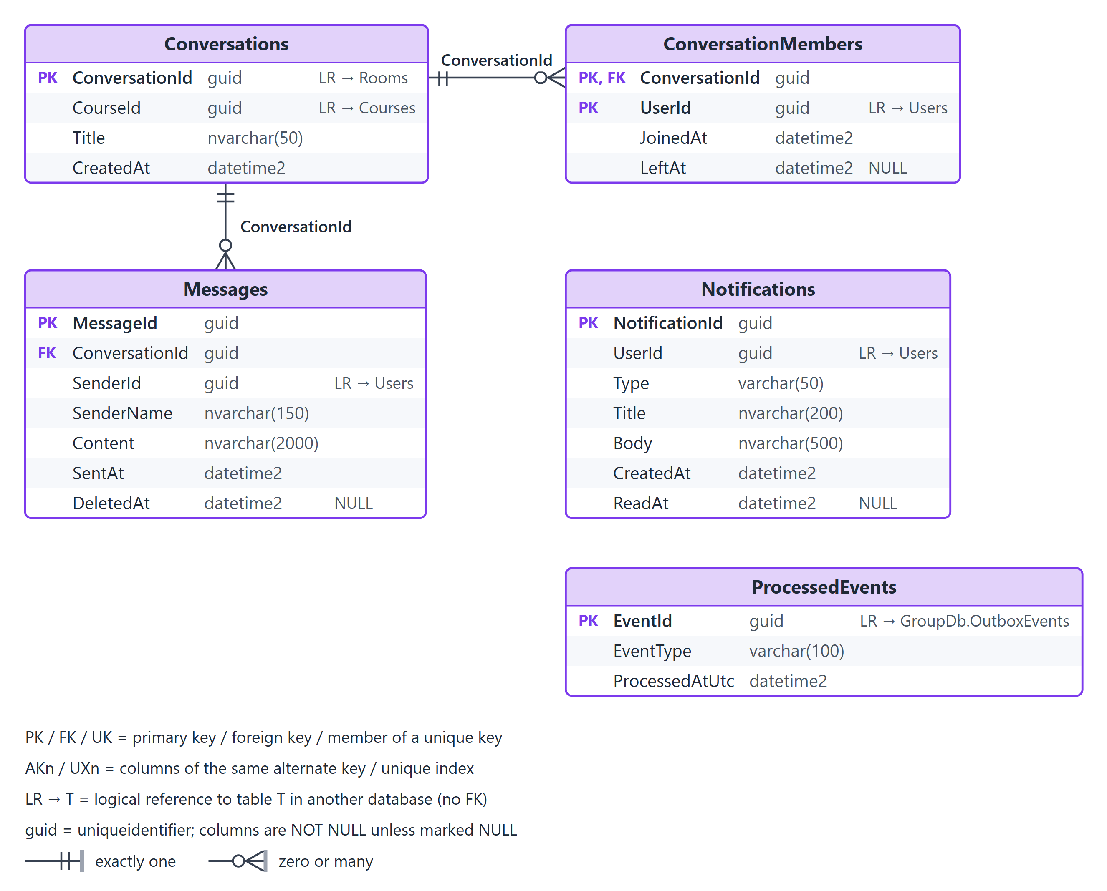
Figure 6. Physical database: ChatDb

Conversations
One conversation per room, created when the room gets its first member.
Column | Type | Null | Key | Default | Description
ConversationId | uniqueidentifier |  | PK, LR |  | = RoomId: one chat per room.
CourseId | uniqueidentifier |  | LR |  | Course of the room.
Title | nvarchar(50) |  |  |  | Room name snapshot.
CreatedAt | datetime2 |  |  | SYSUTCDATETIME() | Creation time (UTC).

Keys: PK_Conversations (ConversationId)
Indexes: IX_Conversations_CourseId (CourseId)
Logical references (no FK): ConversationId -> Rooms; CourseId -> Courses

ConversationMembers
Who can read and write in a conversation, kept in sync from room events.
Column | Type | Null | Key | Default | Description
ConversationId | uniqueidentifier |  | PK, FK |  | References Conversations.
UserId | uniqueidentifier |  | PK, LR |  | Member (student) of the room.
JoinedAt | datetime2 |  |  |  | From RoomMemberJoined.
LeftAt | datetime2 | NULL |  |  | From RoomMemberLeft; the member keeps read access to older messages.

Keys: PK_ConversationMembers (ConversationId, UserId)
Indexes: IX_ConversationMembers_UserId (UserId)
Foreign keys: FK_ConversationMembers_Conversations (ConversationId) -> Conversations (ConversationId), ON DELETE NO ACTION
Logical references (no FK): UserId -> Users

Messages
Chat messages.
Column | Type | Null | Key | Default | Description
MessageId | uniqueidentifier |  | PK |  | Surrogate key.
ConversationId | uniqueidentifier |  | FK |  | References Conversations.
SenderId | uniqueidentifier |  | LR |  | UserId of the sender.
SenderName | nvarchar(150) |  |  |  | Name snapshot for display.
Content | nvarchar(2000) |  |  |  | Text of the message.
SentAt | datetime2 |  |  | SYSUTCDATETIME() | Send time (UTC).
DeletedAt | datetime2 | NULL |  |  | Set when the sender deletes the message.

Keys: PK_Messages (MessageId)
Indexes: IX_Messages_Conversation_SentAt (ConversationId, SentAt)
Foreign keys: FK_Messages_Conversations (ConversationId) -> Conversations (ConversationId), ON DELETE NO ACTION
Logical references (no FK): SenderId -> Users

Notifications
In-app notifications created from events.
Column | Type | Null | Key | Default | Description
NotificationId | uniqueidentifier |  | PK |  | Surrogate key.
UserId | uniqueidentifier |  | LR |  | Receiver.
Type | varchar(50) |  |  |  | Event that caused it, e.g. JoinRequestDecided.
Title | nvarchar(200) |  |  |  | Short title.
Body | nvarchar(500) |  |  |  | Text shown to the user.
CreatedAt | datetime2 |  |  | SYSUTCDATETIME() | Creation time (UTC).
ReadAt | datetime2 | NULL |  |  | Set when the user reads it.

Keys: PK_Notifications (NotificationId)
Indexes: IX_Notifications_Unread (UserId, CreatedAt) WHERE [ReadAt] IS NULL; IX_Notifications_User_CreatedAt (UserId, CreatedAt)
Logical references (no FK): UserId -> Users

ProcessedEvents
Inbox of consumed event ids (idempotent consumer).
Column | Type | Null | Key | Default | Description
EventId | uniqueidentifier |  | PK, LR |  | EventId of GroupDb.OutboxEvents.
EventType | varchar(100) |  |  |  | Type of the consumed event.
ProcessedAtUtc | datetime2 |  |  | SYSUTCDATETIME() | Processing time (UTC).

Keys: PK_ProcessedEvents (EventId)
Indexes: IX_ProcessedEvents_ProcessedAtUtc (ProcessedAtUtc)
Logical references (no FK): EventId -> GroupDb.OutboxEvents

Appendix A. REST API
Every route is served by the gateway under /api/v1 (shown without the prefix) and answers with the envelope of section 6.8. List endpoints also accept search, sort, page, pageSize, fields and expand.

Identity Service
Method | Route | Roles | Purpose
POST | /auth/login | Anonymous | Sign in; returns an access token and a refresh token.
POST | /auth/refresh-token | Anonymous | Rotate the refresh token and get a new access token.
POST | /auth/logout | Signed in | Revoke the refresh token.
GET, PUT | /auth/me | Signed in | Read or update own name and password.
GET | /users | Administrator | List users: search name, e-mail or code; filter role, status; sort; page.
GET, PUT | /users/{id} | Administrator | Read or update a user: name, roles, status (lock revokes tokens).
POST | /users | Administrator | Create an account with its roles, e.g. a lecturer.
POST | /users/import | Administrator | Create or update student accounts in bulk (by e-mail); returns their ids.

Group Service: master data
Method | Route | Roles | Purpose
GET, POST | /semesters | Read: all; write: Administrator | List (search, sort, page) and create.
GET, PUT, DELETE | /semesters/{id} | Read: all; write: Administrator | Read, update, delete.
GET, POST, PUT, DELETE | /subjects, /majors, /skills (+ /{id}) | Read: all; write: Administrator | Same CRUD and list conventions.
GET, POST, PUT, DELETE | /group-types (+ /{id}) | Read: all; write: Administrator | Group types; PUT /group-types/{id}/majors sets the minimum per major.
GET, PUT | /semesters/{id}/group-types | Read: all; write: Administrator | Group types allowed in the semester.

Group Service: students and courses
Method | Route | Roles | Purpose
GET, POST | /semesters/{id}/students | Administrator | List (search, filter majorId, sort, page); add or update students with their major (bulk).
DELETE | /semesters/{id}/students/{studentId} | Administrator | Remove a student not enrolled anywhere.
GET | /semesters/{id}/students/me | Student | Own major and skills.
PUT | /semesters/{id}/students/me/skills | Student | Rate own skills 1-5.
GET, POST | /courses | Read: all (mine=true); write: Administrator | List (filter semesterId, subjectId, phase, mine; search class code; sort; page) and create.
GET, PUT, DELETE | /courses/{id} | Read: course members, lecturer, Administrator; write: Administrator | Read; update settings, lecturer, PublishAt and ExpireAt; delete in Setup.
GET, POST | /courses/{id}/students | Read: Administrator, lecturer; write: Administrator | Roster (filter majorId, hasRoom; search; sort; page); enroll semester students.
DELETE | /courses/{id}/students/{studentId} | Administrator | Remove a student without a room.
POST | /courses/{id}/rooms/generate | Administrator | Setup: create the rooms (BR-03).
POST | /courses/{id}/publish, /courses/{id}/expire | Administrator | Change the phase now.
GET | /courses/{id}/overview | Administrator, lecturer | Counts, students without a room, rooms that are not eligible.
GET | /courses/{id}/placement-suggestions | Administrator | Expired: suggestions (gRPC).
POST | /courses/{id}/placements | Administrator | Expired: move or place students.
POST | /courses/{id}/finalize | Administrator | Finalize (BR-14) with acceptExceptions.

Group Service: rooms and applications
Method | Route | Roles | Purpose
GET | /courses/{id}/rooms | Course members, lecturer, Administrator | Filter status, hasSeat, groupTypeId; search name or topic; sort name or memberCount; page.
GET | /courses/{id}/rooms/suggestions | Student | Top rooms with reasons (gRPC).
GET, PUT | /rooms/{id} | Read: course members, lecturer, Administrator; write: leader (topic), Administrator (Setup) | Room with members, majors, skills and leader.
DELETE | /rooms/{id} | Administrator | Delete an empty room in Setup.
POST | /rooms/{id}/join, /rooms/{id}/leave | Student | Join an open room; leave a room.
POST | /rooms/{id}/lock, /rooms/{id}/unlock | Room leader | Switch between Open and Locked.
POST | /rooms/{id}/leader | Room leader | Hand over leadership to a member.
POST | /rooms/{id}/members/{studentId}/remove | Room leader | Remove a member with a reason (BR-11).
GET, POST | /join-requests | Read: own, leader of the room, Administrator; write: Student | List (filter roomId, courseId, status; sort; page); apply to a locked room.
GET | /join-requests/{id} | Applicant, leader, Administrator | One application.
POST | /join-requests/{id}/approve, /reject, /withdraw | Leader (approve, reject); applicant (withdraw) | Decide or withdraw.

Realtime Service
Method | Route | Roles | Purpose
GET | /conversations | Signed in | Own room chats with the last message.
GET, POST | /conversations/{id}/messages | Room members | Messages, newest first (before, pageSize); send a message.
DELETE | /messages/{id} | Sender | Delete own message.
GET | /notifications | Signed in | Own notifications (filter unread; page).
POST | /notifications/{id}/read, /notifications/read-all | Signed in | Mark as read.
WebSocket | /hubs/realtime | Signed in | Server to client: notificationReceived, messageReceived, roomChanged.

Appendix B. Assignment requirements
Requirement (assignment brief) | Where it is met
2.1 REST API service | Identity, Group and Realtime services (Appendix A); CRUD for semesters, subjects, majors, skills, group types, courses, rooms and users; layered architecture and JWT (section 6.8); search, filters, sorting and paging on every list.
2.2 Background job | PhaseScheduler, OutboxPublisher, clean-ups and the GroupEventsConsumer (section 6.6).
2.3 Message broker | Redis Streams: the Group Service produces, the Realtime Service consumes (section 6.5).
2.4 gRPC service | Recommendation Service: independent, gRPC only, called by the Group Service REST API (sections 6.4 and 6.7).
3 Deployment | Docker Compose with all containers; demo server deployed by GitHub Actions.
4 Technical requirements | .NET 10, EF Core 10, SQL Server 2022, dependency injection, configuration, Serilog and exception middleware, JWT, REST, gRPC, Redis, BackgroundService, Docker (section 7).
5 Deliverables | Source code, EF Core migrations and database/schema.sql, Dockerfiles, docker-compose.yml, Swagger at the gateway, README.md.
6 Demonstration | README demo script: setup, publish, join, apply and approve, suggestions, expiry by the job, placement, finalize, chat.

