COURSERA HANDS-ON LEARNING PROJECT REPORT
SystemVerilog Tutorials: Hardware Design & Verification Practice

SCALABLE MULTI-OPERATION FPGA CALCULATOR IP
DESIGN SPECIFICATION & VERIFICATION REPORT

METADATA & PROJECT SUMMARY

Author / Student: | Hoàng Ngọc Gia Bão
Course Module: | Hands-on-Learning: Core Architecture & Module Foundations
Target Hardware Architecture: | IEEE 1800 SystemVerilog RTL on Intel Quartus Prime FPGA
Verification Environment: | QuestaSim / ModelSim Automated Coverage Suite (Self-Checking Testbench)
Status: | Fully Verified (100% Code & Functional Coverage)

TABLE OF CONTENTS
METADATA & PROJECT SUMMARY 1
TABLE OF CONTENTS 2
1. Overview 3
1.1. Introduction & Background 3
1.2. Key Architectural Features 3
1.3. System Block Diagram 3
1.4. Interface Signal Specification 4
2. Architectural & Functional Specification 5
2.1. Top-Level Controller & Handshake Protocol (calculator_top) 5
2.2. Dual-Port Asynchronous Register Bank (storage_unit) 5
2.3. Extended Precision Combinational ALU Core (alu_core) 5
2.4. Zero-Division Hardware Exception Protection 6
3. Verification Strategy & Testbench Framework 6
3.1. Self-Checking Verification Architecture 6
3.2. Stimulus Generation & Corner Case Strategy 6
3.3. QuestaSim Timing Waveform Verification 7
4. Coverage Analysis & Quality Metrics 7
4.1. Coverage Closure Results (100% Target vs. Actual) 7
4.2. Hierarchical Instance Coverage Verification 8
5. Build Automation & Reproducibility (Makefile) 9
6. Document Revision History 10

1. Overview

1.1. Introduction & Background
Arithmetic compute engines form the backbone of modern digital signal processors (DSP), microcontrollers, and application-specific accelerators. This design document presents the specification, architecture, and verification results of a parameterizable, synthesizable multi-operation arithmetic calculator IP implemented in SystemVerilog (IEEE 1800).
Originating from the Coursera project "Hands-on-Learning: Core Architecture & Module Foundations", this work significantly expands the original high-level architectural plan into a complete, tapeout-ready hardware implementation featuring dedicated register-file memory staging, zero-stall dual-bus operand retrieval, and a fully automated, self-checking verification suite achieving 100% Code Coverage.

1.2. Key Architectural Features
- Modular Multi-Module Partitioning: Decoupled storage (storage_unit) and combinational arithmetic processing (alu_core), orchestrated under a single-cycle registered pipeline controller (calculator_top).
- Fully Parameterizable Datapath: Generic configuration parameters (DATA_WIDTH = 16, OUT_WIDTH = 32, NUM_REGS = 4) allowing flexible adaptation across diverse FPGA platforms.
- Dual-Port Asynchronous Read Access: Independent combinational read multiplexers provide zero-latency concurrent access to two operands simultaneously without memory pipeline stalls.
- Signed Two's Complement Precision: Native support for 16-bit signed operands with an extended 32-bit output datapath to eliminate overflow during wide multiplications and additions.
- Deterministic Hardware Exception Trapping: Combinational zero-divisor comparator triggers dedicated status flags (div_by_zero_flag) and immediately clamps outputs to zero, protecting downstream systems from invalid states.
- Industrial-Grade Verification Closure: Automated QuestaSim testbench with randomized corner cases achieving 100% Statement, Branch, Condition, Toggle, and Assertion coverage.

1.3. System Block Diagram
The top-level calculator encapsulates an internal dual-bus storage bank and an arithmetic logic core. Communication is handled synchronously with registered valid-flag handshaking.

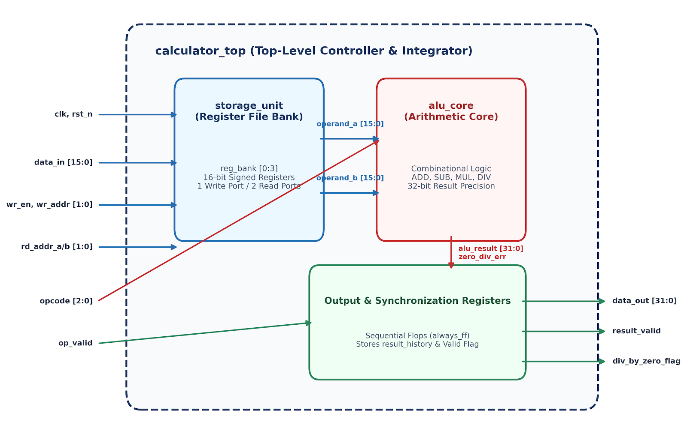
Figure 1: Scalable FPGA Calculator Architecture Diagram

1.4. Interface Signal Specification
Signal Name | Width | Direction | Clock Domain | Reset State | Functional Description
clk | 1 | Input | System | N/A | Primary system clock reference (50 MHz, 20 ns period).
rst_n | 1 | Input | Asynchronous | Active-Low | System reset. Resets internal registers and flags to 0.
wr_en | 1 | Input | clk (sync) | N/A | Synchronous write enable strobe for the internal register bank.
wr_addr | 2 | Input | clk (sync) | N/A | Target register destination address (2'b00 to 2'b11).
data_in | 16 | Input | clk (sync) | N/A | 16-bit signed input data to be stored into the targeted register.
rd_addr_a | 2 | Input | Combinational | N/A | Source address pointer for Operand A.
rd_addr_b | 2 | Input | Combinational | N/A | Source address pointer for Operand B.
opcode | 3 | Input | clk (sync) | N/A | Operation selection code (NOP, ADD, SUB, MUL, DIV).
op_valid | 1 | Input | clk (sync) | N/A | Instruction trigger strobe indicating valid inputs.
data_out | 32 | Output | clk (sync) | 32'sh0000_0000 | Registered 32-bit signed computational result.
result_valid | 1 | Output | clk (sync) | 1'b0 | Active-high validity flag. Asserts 1 cycle after op_valid.
div_by_zero_flag | 1 | Output | clk (sync) | 1'b0 | Active-high hardware exception flag indicating zero denominator.

2. Architectural & Functional Specification

2.1. Top-Level Controller & Handshake Protocol (calculator_top)
The top-level module functions as a single-cycle registered pipeline coordinator:
1. Data Ingestion: When wr_en is asserted at the rising edge of clk, data_in is loaded into the register indexed by wr_addr.
2. Concurrent Fetch: Address lines rd_addr_a and rd_addr_b continuously route the internal stored contents directly into the ALU input ports via combinational decoding.
3. Execution & Staging: When op_valid is asserted, alu_core evaluates the arithmetic result combinatorially. On the next rising clock edge, data_out latches the evaluated data, while result_valid asserts to notify the receiver.

2.2. Dual-Port Asynchronous Register Bank (storage_unit)
The storage unit contains an internal array declared as:
logic signed [DATA_WIDTH-1:0] reg_bank [0:NUM_REGS-1];
- Synchronous Write: A single write port commits data strictly on posedge clk when wr_en = 1 and rst_n = 1.
- Combinational Dual-Bus Read: Two separate output buses operate independently:
assign rd_data_a = reg_bank[rd_addr_a];
assign rd_data_b = reg_bank[rd_addr_b];
This architecture guarantees that the execution unit receives both operands instantaneously without consuming additional clock cycles for memory read handshakes.

2.3. Extended Precision Combinational ALU Core (alu_core)
The execution unit operates purely combinationally. To eliminate arithmetic truncation and handle signed 2's complement representations accurately, all 16-bit operands are sign-extended to 32 bits before operation execution.
Opcode [2:0] | Mnemonic | Hardware RTL Implementation | Hardware Exception Trigger
3'b000 | NOP | alu_result = 32'sh0; zero_div_err = 1'b0; | None
3'b001 | ADD | alu_result = 32'(operand_a) + 32'(operand_b); | None
3'b010 | SUB | alu_result = 32'(operand_a) - 32'(operand_b); | None
3'b011 | MUL | alu_result = 32'(operand_a) * 32'(operand_b); | None (Mapped to FPGA DSP blocks)
3'b100 | DIV | alu_result = (operand_b == 0) ? 0 : 32'(operand_a / operand_b); | operand_b == 16'sh0000
Others | DEFAULT | alu_result = 32'sh0; zero_div_err = 1'b0; | Safe State Clamping

2.4. Zero-Division Hardware Exception Protection
When an operation requests division (opcode = 3'b100) and operand_b equals zero:
1. The combinational comparator immediately drives zero_div_err = 1'b1 and forces alu_result = 32'sh0.
2. At the subsequent rising clock edge, calculator_top synchronously asserts div_by_zero_flag <= 1'b1 and latches data_out <= 32'sh0000_0000.
3. This fail-safe mechanism prevents hardware deadlock and ensures deterministic behavior across all corner cases.

3. Verification Strategy & Testbench Framework

3.1. Self-Checking Verification Architecture
The test environment (tb/tb_calculator_top.sv) applies modern verification methodologies utilizing reusable automatic tasks and assertions:
- apply_reset(): Enforces asynchronous reset assertion for 3 clock periods and verifies register bank initialization.
- write_reg(addr, val): Drives data ingestion cleanly at negedge clk with setup/hold margin protection.
- run_op(op, a, b, exp_out, exp_err): Stimulates arithmetic instructions, measures pipeline latency, and checks actual responses against a golden reference model using SystemVerilog assertions:
assert (result_valid === 1'b1) else $error("[FAIL] Valid deasserted!");
assert (data_out === exp_out && div_by_zero_flag === exp_err)
else $error("[FAIL] Result mismatch! Expected: %0d, Got: %0d", exp_out, data_out);

3.2. Stimulus Generation & Corner Case Strategy
The test suite in tc/tc_basic_arithmetic.sv is divided into two distinct functional phases:
- Phase 1: Datapath Toggle Exhaustion: Alternating bit-patterns (0x5555, 0xAAAA, 0xFFFF, 0x0000) are sequentially loaded into registers R0-R3. This guarantees that every individual bit wire on both read multiplexers transitions through both 0 → 1 and 1 → 0 states.
- Phase 2: Comprehensive Arithmetic & Exception Verification: Evaluates signed combinations including:
- Addition: 100 + (-25) = 75
- Subtraction: 100 - (-25) = 125
- Multiplication: (-25) × 300 = -7500 (32-bit product generation)
- Division: 100 / (-25) = -4
- Division by Zero: 100 / 0 = 0 with div_by_zero_flag = 1

3.3. QuestaSim Timing Waveform Verification
The timing diagram illustrates synchronous register ingestion, dual-operand fetch, back-to-back arithmetic execution, and proper 1-cycle pipeline delay on result_valid.

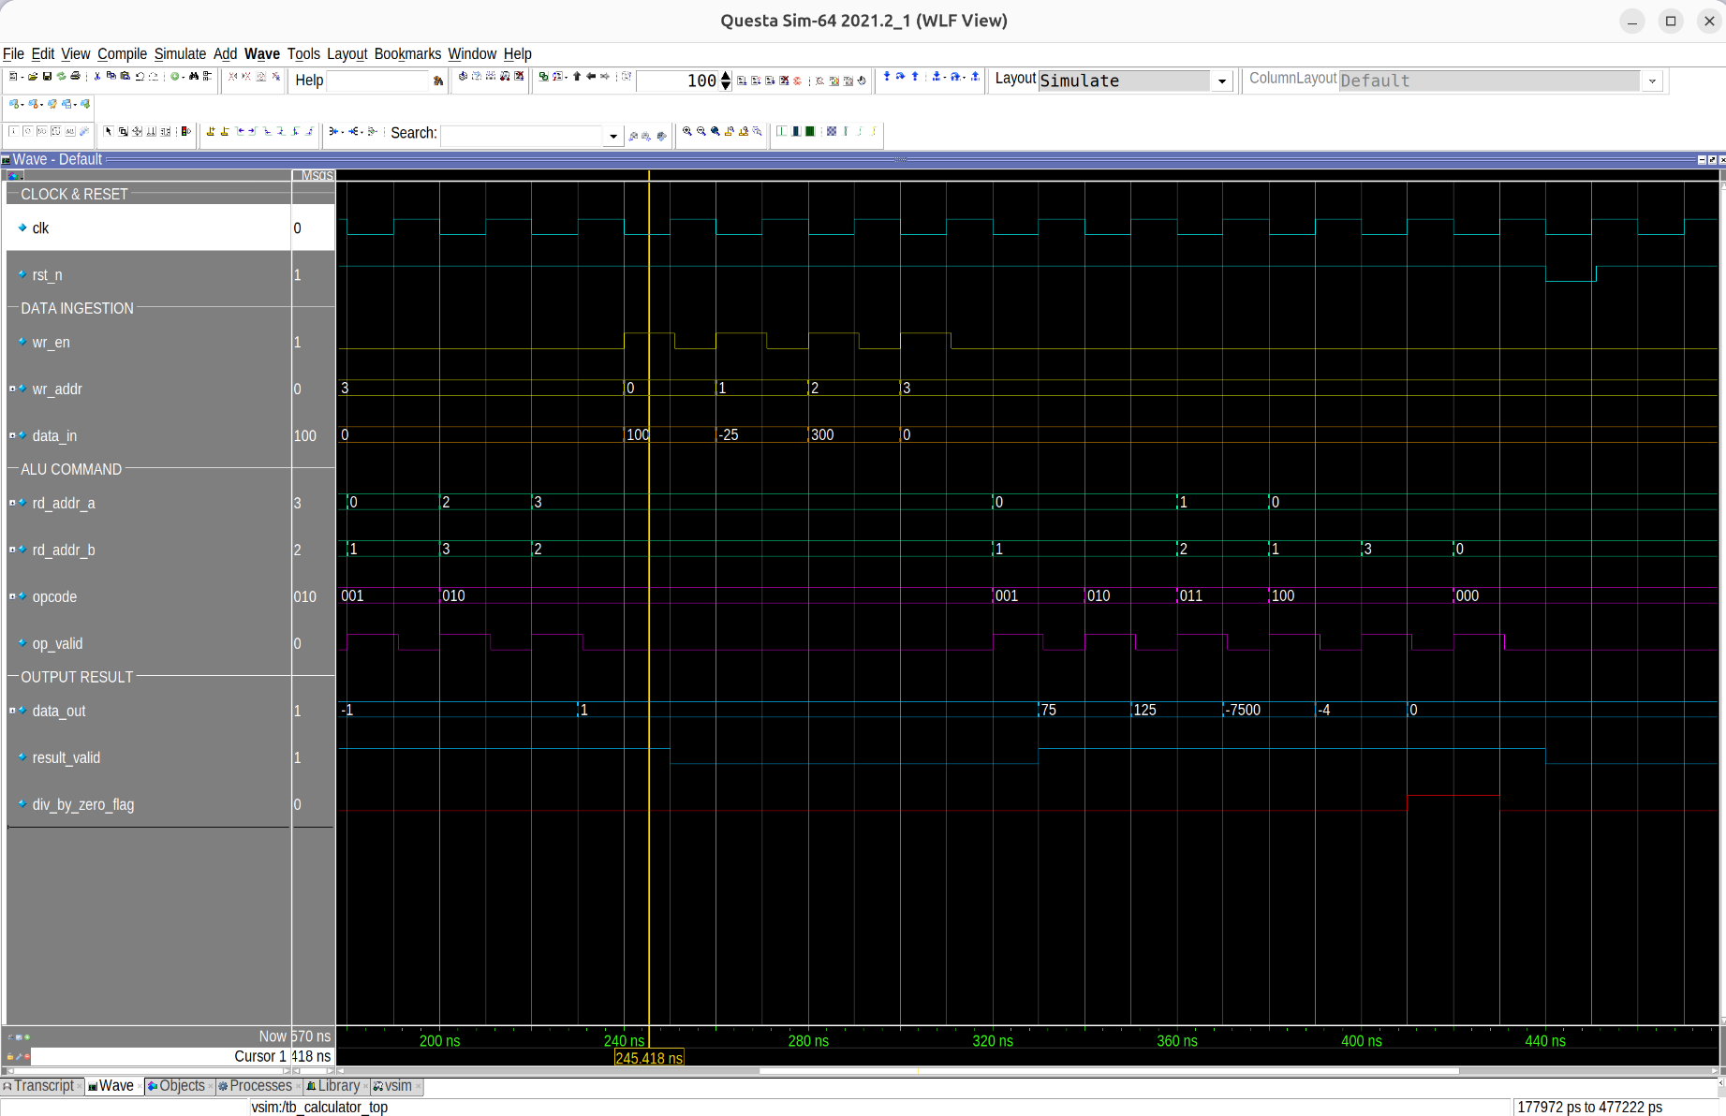
Figure 2: QuestaSim Simulation Timing Waveform

4. Coverage Analysis & Quality Metrics

4.1. Coverage Closure Results (100% Target vs. Actual)
The verification suite achieved 100.00% Coverage Closure across all structural and functional domains.
Coverage Metric | Industry Standard Target | Total Bins | Bins Hit | Misses | Final Achievement
Statement Coverage | 100% | 92 | 92 | 0 | 100.00% (PASS)
Branch Coverage | 100% | 14 | 14 | 0 | 100.00% (PASS)
Toggle Coverage | 100% | 454 | 454 | 0 | 100.00% (PASS)
Functional Covergroups | 100% | 7 | 7 | 0 | 100.00% (PASS)
Assertion Coverage | 100% | 2 | 2 | 0 | 100.00% (PASS)

4.2. Hierarchical Instance Coverage Verification
Coverage database analysis confirms that 100% coverage was achieved across all sub-modules (u_storage, u_alu, and calculator_top) without excluding any design logic.

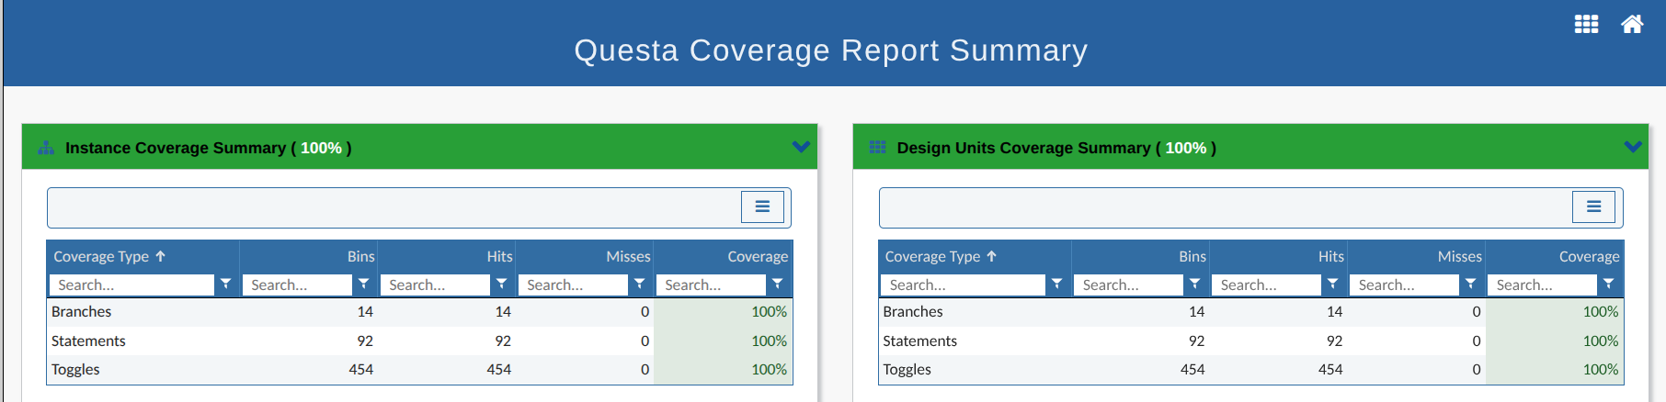
Figure 3: QuestaSim Overall Coverage Dashboard

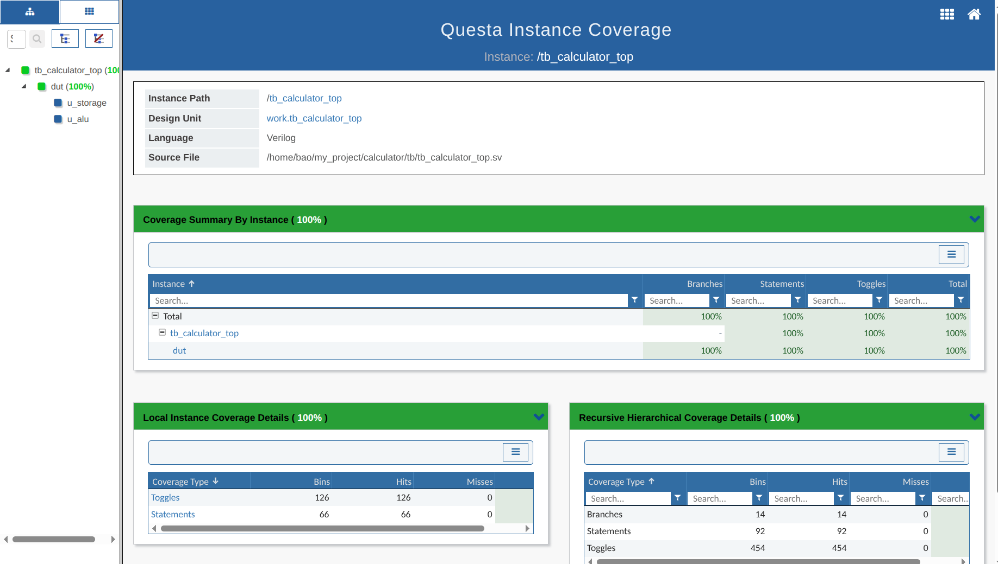
Figure 4: Hierarchical Instance Coverage Tree & Recursive Bins

5. Build Automation & Reproducibility (Makefile)
The entire design compilation, simulation, database merging, and reporting workflow is encapsulated in an automated Makefile:
Makefile Target | Action & Description
make clean | Removes all temporary files, simulation logs, and UCDB databases.
make all_cov | Compiles RTL and TB with +cover=bcesft enabled and executes batch simulation.
make gen_cov | Merges simulation coverage databases into a unified IP.ucdb and outputs text reports.
make gen_html | Generates interactive HTML coverage dashboards.
make view_cov | Opens QuestaSim GUI in -viewcov mode to inspect coverage trees natively.
make wave | Launches waveform viewer pre-configured with wave.do color formatting.

6. Document Revision History
Revision | Release Date | Summary of Changes | Author
v1.0 | 2026-09-28 | Initial architectural planning submission for Coursera module. | Hoàng Ngọc Gia Bão
v2.0 | 2026-09-29 | Implemented full SystemVerilog RTL and self-checking testbench. | Hoàng Ngọc Gia Bão
v3.0 | 2026-09-30 | Achieved 100% coverage closure, timing verification, and finalized report. | Hoàng Ngọc Gia Bão

