DESIGN SPECIFICATION REVIEW

TEAM 271

ENED 1120 – 021

Dr. Cedrick Kwuimy

Project 5: Autonomous Record Retriever

**Team members:**

John Cummings | cummijh

Nathan Damas |  damasnj

Bao Huynh | huynhlbg

Triet Pham | phamt7

Table of Contents

PROJECT MANAGEMENT INFORMATION 1

MAJOR SUB-COMPONENTS 3

SPECIFICATIONS LIST: 4

ESTIMATED BUDGET 5

# PROJECT MANAGEMENT INFORMATION

Team 271 decided to break Project 5 into 18 different tasks, under three phases: Researching, Building and Testing, and Presentation/Post-demonstration

The Work breakdown structure, Work precedence network, and Gantt Chart of team 271 for Project 5 is detailed below:

Work breakdown structure:

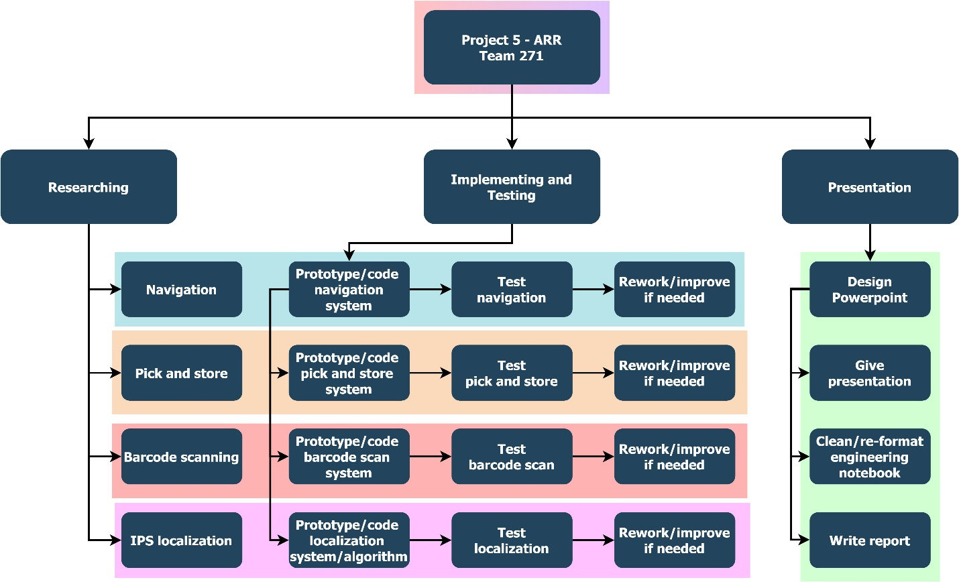

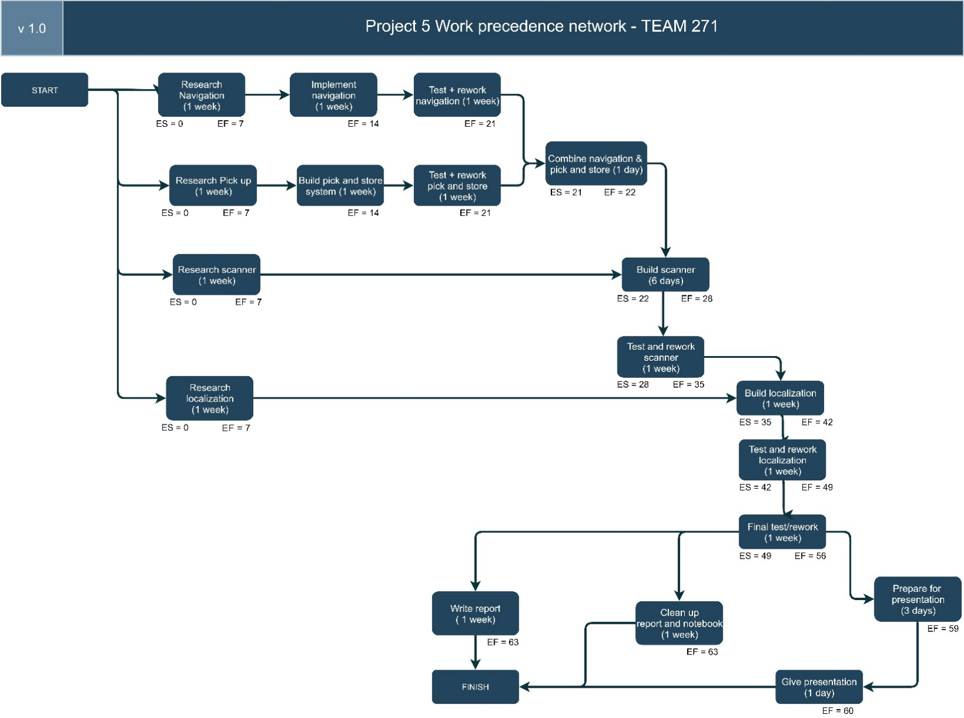Precedence network:

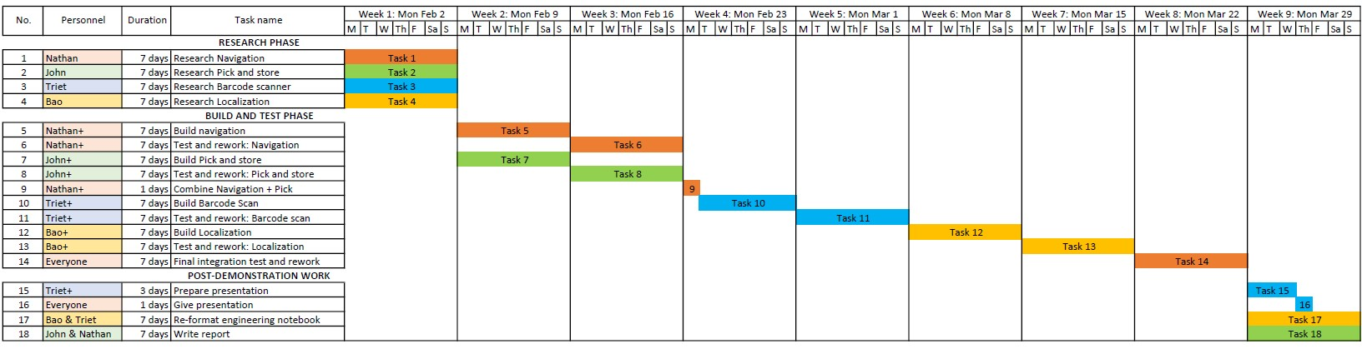Gantt chart:

# MAJOR SUB-COMPONENTS

For project 5’s Autonomous Record Retriever, Team 271 envisioned that it will have 5 major   
sub-components, as detailed below:

1. Navigation system: The robot must first the able to move smoothly in the arena, so a navigation with wheels or treads is necessary
2. Barcode scanning system: The robot must be able to read the barcode correctly to get the right box
3. Pick up system: A good pick up system helps the robot retrieve a box surely (not dropping the box half-way) and in a timely manner. The system also manages dropping off the box when going back to the HOME location
4. Storage system: A storage system is necessary to ensure that the box is safe when transporting between location no matter how far. The system also ensures if anything happens, the box’s content shall remain intact
5. Localization system: A localization system with Bluetooth receiver helps the robot triangulate its position to navigate the field.

# SPECIFICATIONS LIST:

The following is the metrics and specifications that Team 271 has decided to use to test out the proper working of each sub-component:

1. Navigation system

* Minimum speed: 1 ft/s
* Be able to go forward perfectly straight – for 5 times in a row; will test with different distances from 1 to 10ft
* Be able to go backward perfectly straight – for 5 times in a row; will test with different distances from 1 to 10ft
* Be able to turn precisely with a displacement less than 3 inches – for 5 times in a row; will test with different angle from 45 to 270 degrees
* Each test above will be replicated on difference surface: carpet, paper, and tile

1. Barcode scanning system

* Barcode scanning maximum speed: less than 10s
* Be able to determine the right barcode type out of the 4 types – for 15 times in a row
* Be able to determine additional made-up barcodes as INVALID – for 15 times in a row

1. Pick up system:

* Be able to pick up maximum of 250g
* Be able to pick up boxes without dropping half-way successfully – for 10 times in a row, with boxes of different weights
* Be able to pick up boxes and put correctly in storage system and still able to move a small distance after that successfully – for 10 times in row; maximum time for this test must be less 10s for each repetition

1. Storage system

* Be able to carry object of maximum 250g without making the robot malfunction
* Be able to carry the object safely through a minimum distance 5 ft successfully – for 10 times in a row; will test for different speed: 1ft/s to 3 ft/s
* Be able to keep the object safe while robot spins at high speed for 10s

1. Localization

* Be able to display the correct (x, y) position of the robot – for 20 times in a row
* Be able to navigate between two coordinates precisely (with error < 5%) – for 15 times in a row; will test for different distances, including edge cases like corners

# ESTIMATED BUDGET

From details from our Gantt Chart, we estimated project 5’s budget as below:

1. Nathan Damas:

* Total hour: 37 hours
* Billing rate: $40 / hour
* Total cost: $1480

1. John Cummings:

* Total hour: 36 hours
* Billing rate: $40 / hour
* Total cost: $1440

1. Triet Pham:

* Total hour: 36 hours
* Billing rate: $40 / hour
* Total cost: $1440

1. Bao Huynh:

* Total hours: 36 hours
* Billing rate: $40 / hour
* Total cost: $1440

🡪 **PROJECT’S ESTIMATED TOTAL COST:** 1480 + 1440 + 1440 + 1440 = $5800