A Proposal for Collaborative Ontology Editor for Animal Trait Ontology

Jie Bao
2005-05-26

- Problem Description
Animal Trait Ontology (ATO) is an ontology to describe animal trait on several aspects, such as meat, health, exterior, production and reproduction. The ontology has following properties:
- The ontology has DAG (Directed Acyclic Graph) structure.
- Each term has a unique name.
- Relations between terms include isa, part-of and possibly more.
- Each term, in additional to hierarchical information, may have other properties
- The ontology is specie-dependent, each specie may need it specific ontology; however, those different specie ontologies share some common upper level structure and terms.
There is a need for tool to create and manipulate the ontology. Intended features of such tool include:
- The ontology will be stored on a database server; the editor can connect to the server and “check-out” part of the ontology, do editing on the checked-out part, and “check it in” when finished editing.
- The editor should ensure the consistency of submitted ontology.
- The editor should support multiple users to concurrently edit the ontology. Mechanism should be provided to avoid conflict and abnormalities.
- There should be user profile management. Different user, such as administrator and common user, has different privileges on reading/writing.
- The editor should provide a handy user interface to edit a DAG.
- The editor can import and export ontology in standard format, such as OBO and OWL.
- The editor should have good scalability, that can manipulate ontology of 10⁵ terms (the order of Gene Ontology)

- Existing Work

There are many public available ontology editors. Mostly important examples are DAG-Edit[2] (where is used by Gene Ontology and many other life science ontologies) and Protege[1] of Stanford University. However, such tools cannot meet ATO requirement.

Limitation of DAG-Edit
- No support database storage
- No support for collaboration
- No support for detailed information of term. User can only edit hierarchy
- No support for user profile
Limitation of Protege
- No support for collaboration
- No support for partial loading, thus limits the scalability
- Protege is intended for heavy-weight ontology described by expressive knowledge representation (KR) languages such as description logics, it requires background knowledge on KR and not efficient for lite-weight ontologies such as GO and ATO.

In the preparatory research[3], we (Jie Bao, Swetha Gottimukkula, LaRon Hughes, Jialin Le, and Jia Tao) has developed a set of tools to create and browse ATO. They include:
- Two database servers (one on MySQL and another on PostgreSQL) to test database storage.
- A preliminary ontology editor
- A web browser for the ontology

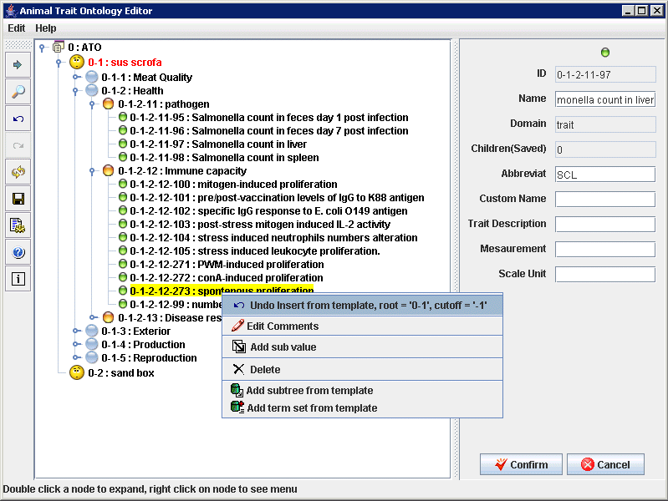
Picture 1 The GUI of the preliminary ATO editor

The existing ATO ontology can do (refer to user manual for more details)
- Create connecting to the database and remembers the configuration
- Load all of part of the ontology into the interface.
- All modification of existing terms, including changing comments, changing details, deleting, deleting the subtree under this term.
- Insert new terms
- Find terms on the tree
- Take records of editing actions and enable undo and redo
The editor is based on INDUS ontology editor[4] developed by Artificial Intelligence Research Lab, Computer Science Department, Iowa State University. System diagram of the editor is shown in figure 2.
DB
AtoOntology
In-memory
Partial Ontology
ATO2Tree
Tree2ATO
ATOEditorGUI
ATOEditor
ATOTreeEditor
ATOTreeNode
….
ATOTreeRender
DetailsPane
SettingPanel
Trait
Figure 2: Design of the preliminary ATO editor

- Planned Work
The planned work will be based the existing tool, with extra modules for unimplemented requirements.

- Knowledge representation: the ontology will adopt modular ontology representation[5]. The whole ontology will be composed by multiple “packages”. Each package contains a set of highly related terms. Packages can be nested in another package, and form a package hierarchy. Reasons to use package include:
- Package servers as organization unit. User can check out one or more packages f or editing, while other packages is still open to other users.
- Package can be reused. For example, if pig component and horse component of ATO shares information on “production”, the shared part can be organized in a package and be reused by the pig component and the horse component.
- Package has localized semantics, thus an error in a package can be more easily controlled and traced.
- During the editing, ontology may evolve. To reduce the risk of unwanted coupling and inconsistency diffusion, package can be used with “visible interface” (a set of terms that can be used by other packages) and “invisible” inner contents. The inner contents can be changed (for example, insert new node between exiting node, or merge two inner nodes) while the visible interface is still unchanged.
- Database storage: There are tables
- Package: to store information of packages
- Term: to store id, name, package membership and visibility
- Relation: to store relations among terms
- User: to store user profiles and privileges
- Details: to store trait details
- Ontology editor: will add features as
- Editing
- Load, save, create, split, merge package
- Create terms in package and define its visibility (public, private, protected).
- Obsoleting, Deleting, and Destroying Terms
- Working with Term Relationships
- Changing the Relationship Type
- Term Relationship Namespaces
- Moving a Term to a Different Parent
- Copying a Term to a New Parent
- Merging Two Terms
- Splitting a Term
- Managing Relationship Types
- Managing Obsolete Terms
- IO
- Saving packages
- Saving OBO Files
- Saving OWL File
- Loading packages
- Loading OBO Files
- Loading OWL File
- User Management
- Create user profile, include id, password,
- Assign privilege for different packages
- Concurrent Management
- Lock a package/term if it is under editing upon user requirment
- Lock subpackages / superpackages when necessary
- Lock related terms/ package on the DAG when necessary
- Reasoning: ensure consistency. For example, find cycle definition when a user submits a edited package.

- Planned Schedule
To be scheduled in a later version of this proposal.

References
[1]Protege: http://protege.stanford.edu/
[2]DAG-Edit http://www.godatabase.org/dev/java/dagedit/docs/index.html
[3]Animal Trait Ontology Editor Website: http://boole.cs.iastate.edu/indus/ato/ato.html
[4] INDUS: http://www.cs.iastate.edu/~dcaragea/INDUS/documentation.htm
[5] Bao, Jie and Honavar, Vasant (2004) Ontology Language Extensions to Support Localized Semantics, Modular Reasoning, and Collaborative Ontology Design and Ontology Reuse. Technical Report, Computer Sicence, Iowa State University.

