[master]



[slave]



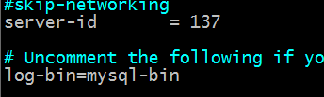

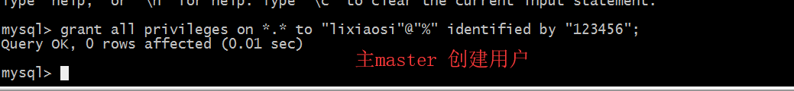

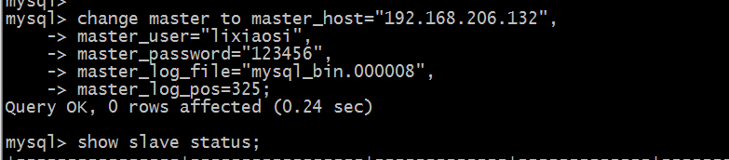

Shwo master status; 显示二进制文件

grant all on *.* to 'xiaosi'@'%' identified by '123456';增加用户给其他服务器连接

flush privileges ;权限重启

change master to master_host="192.168.218.143",

master_user="xiaosi",

master_password="123456",

master_log_file="mysql_bin.000004",

master_log_pos=40946;

表清除数据:truncate 表名