读取未提交

mysql> set session transaction isolation level read uncommitted;

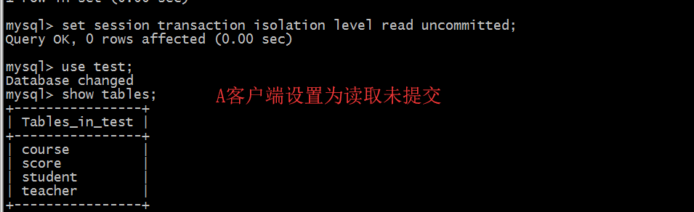

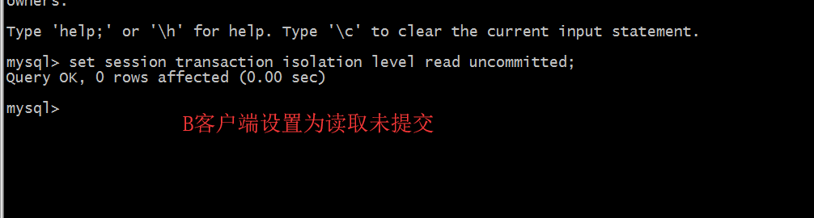

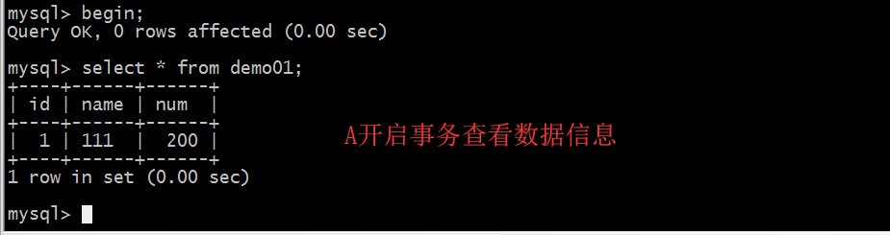

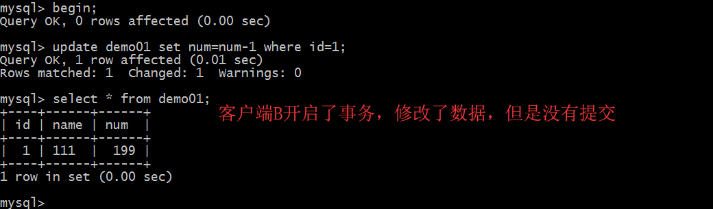

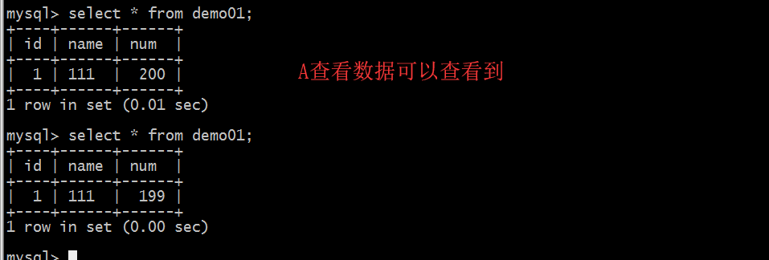

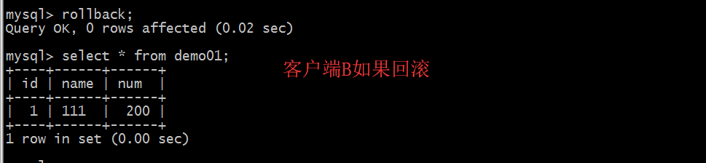

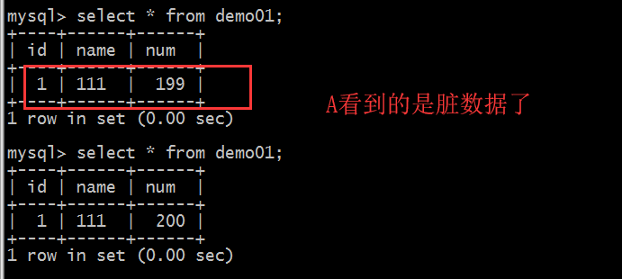

读已提交

mysql> set session transaction isolation level read committed;

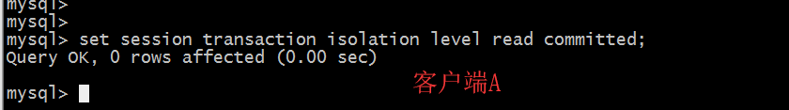

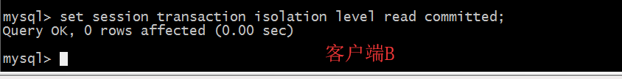

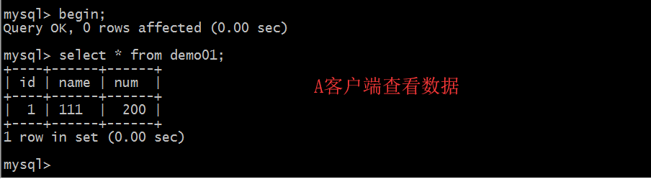

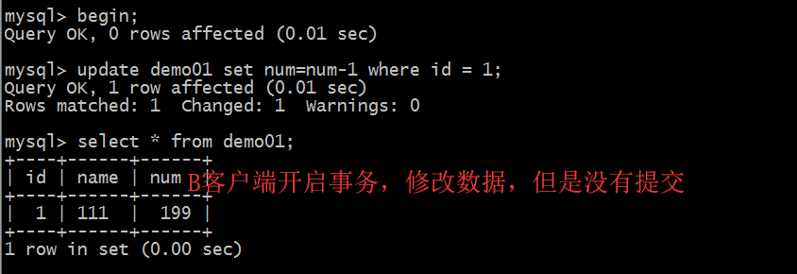

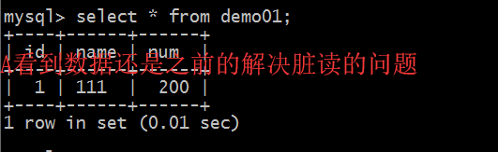

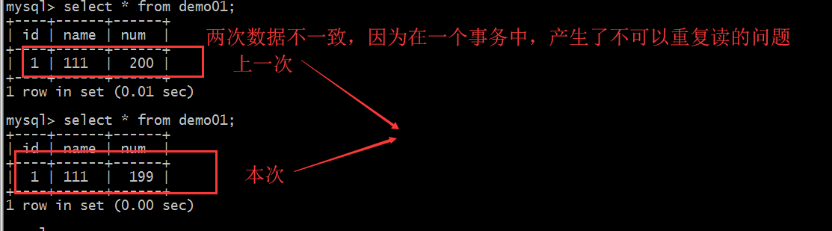

1. 可重复读mysql> set session transaction isolation level repeatable read;

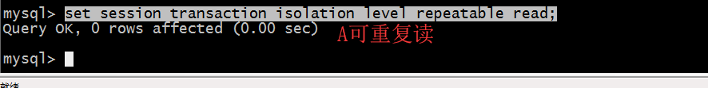

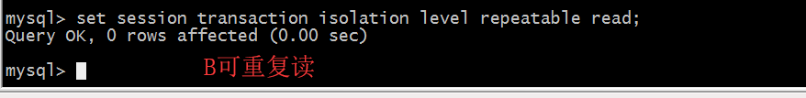

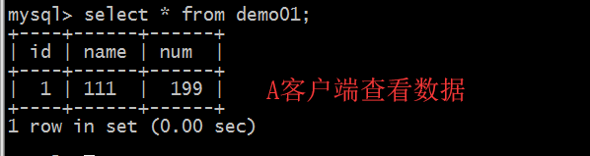

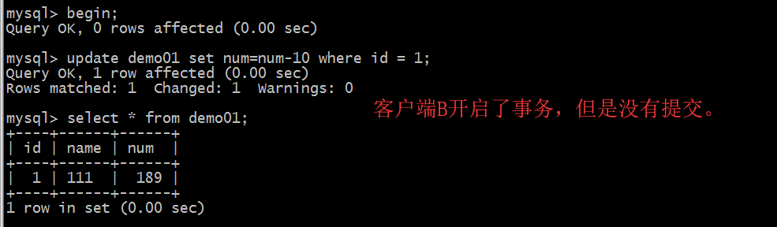

客户端A

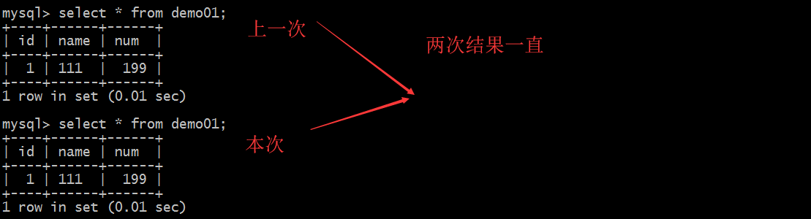

串行化

基本不用所以不用考虑