Câu 1:

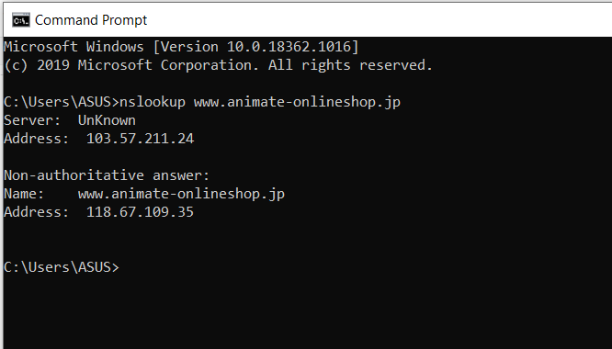

The IP address of that server was 118.67.109.35.

Câu 2:

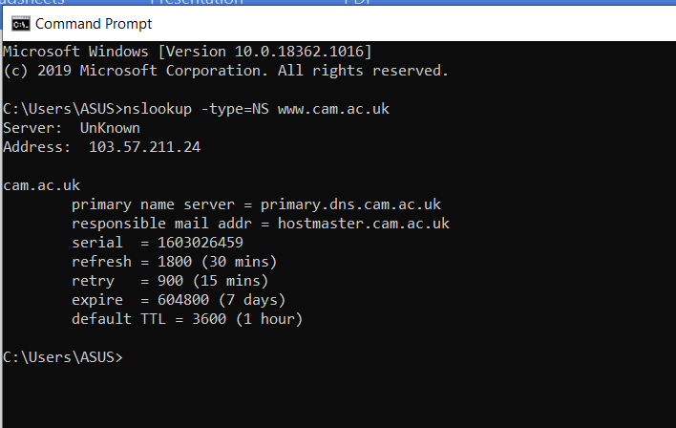

The authoritative DNS server is

primary.dns.cam.ac.uk

Câu 3:

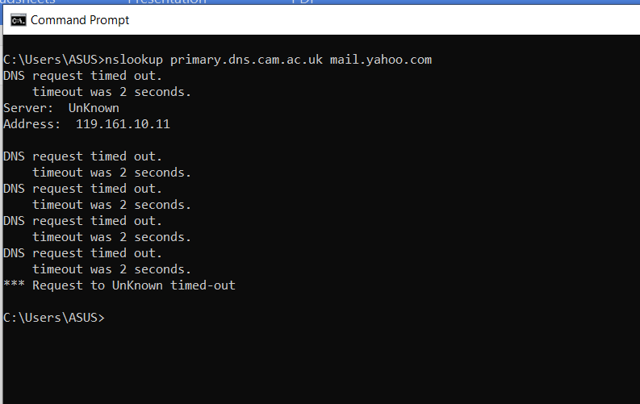

The IP addreess for the DNS server if queried for the Yahoo! mail server is 119.161.10.11

Câu 4:

The DNS query and response messages are sent over UDP.

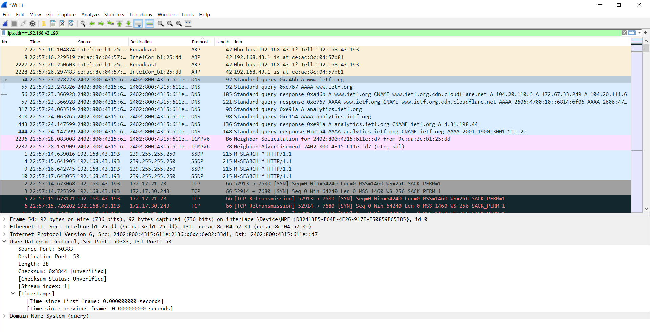

Câu 5:

The destination port is 53

The source port is 50383

Câu 6:

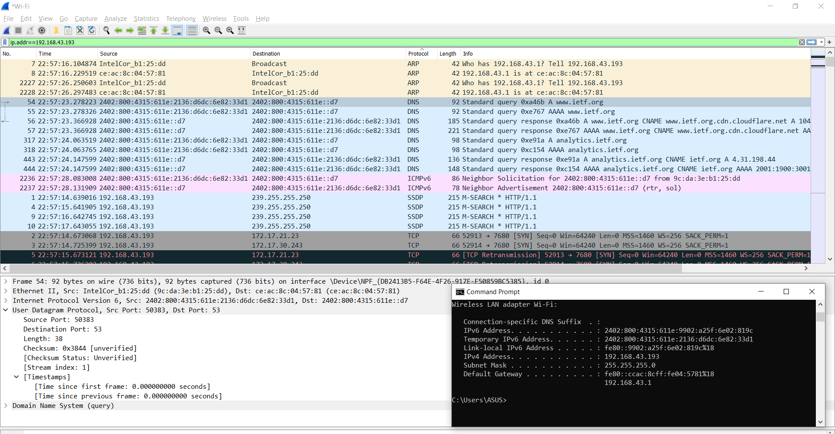

Câu 7:

The query message was a type “A” query, but the message did not contain any “answers.”

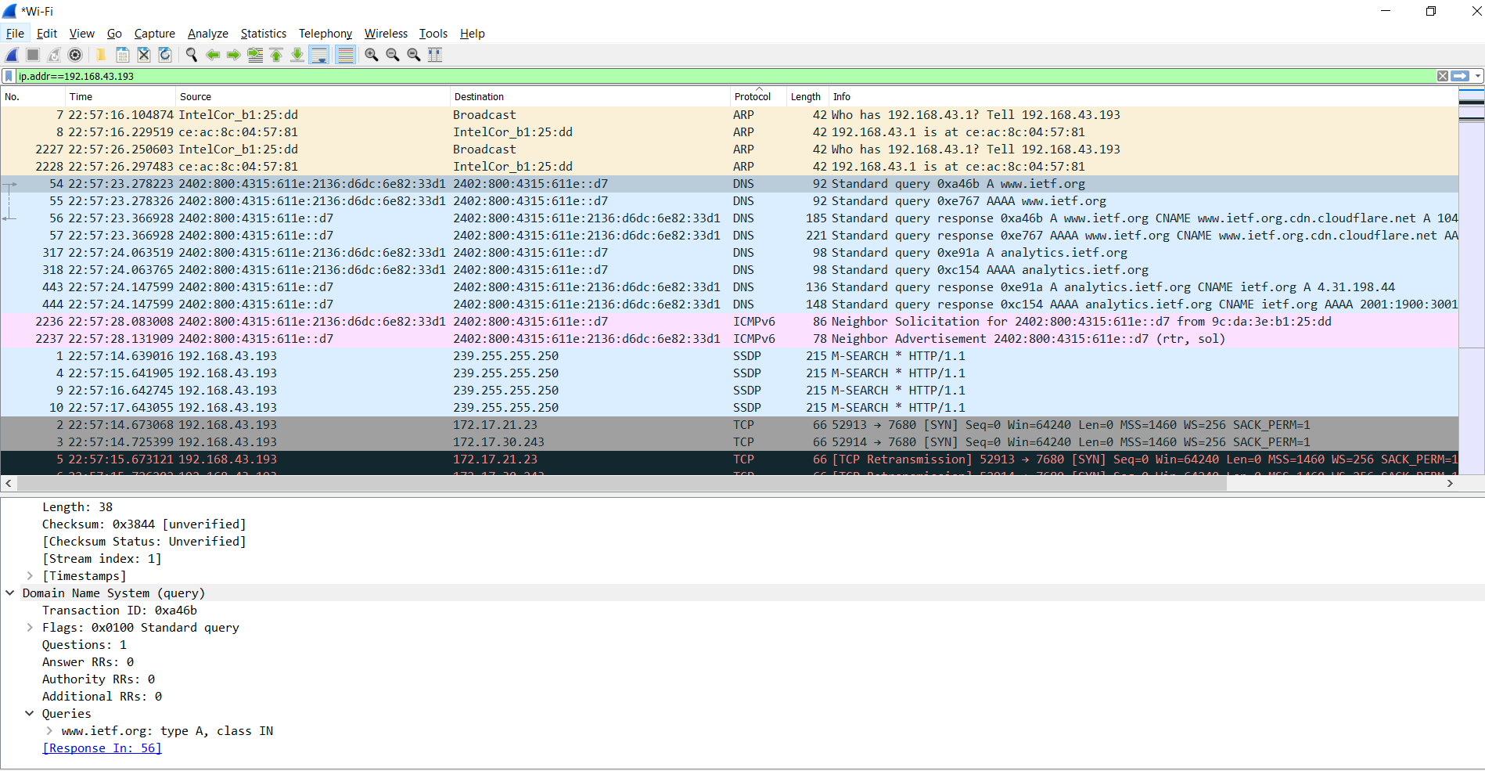

Câu 8:

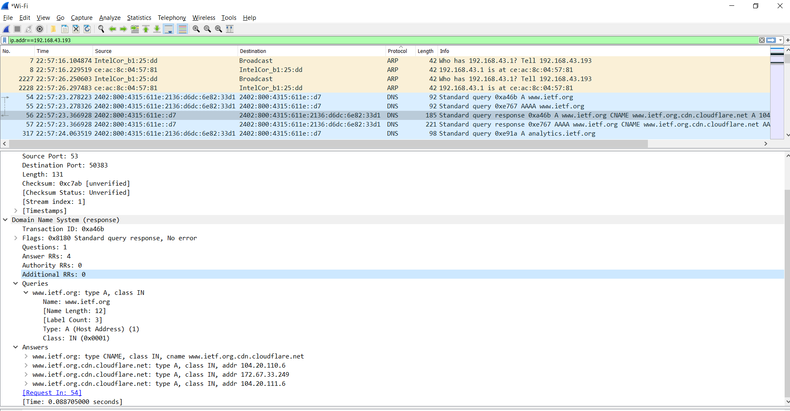

Câu 11:

Destination Port: 53

Source Port: 51870

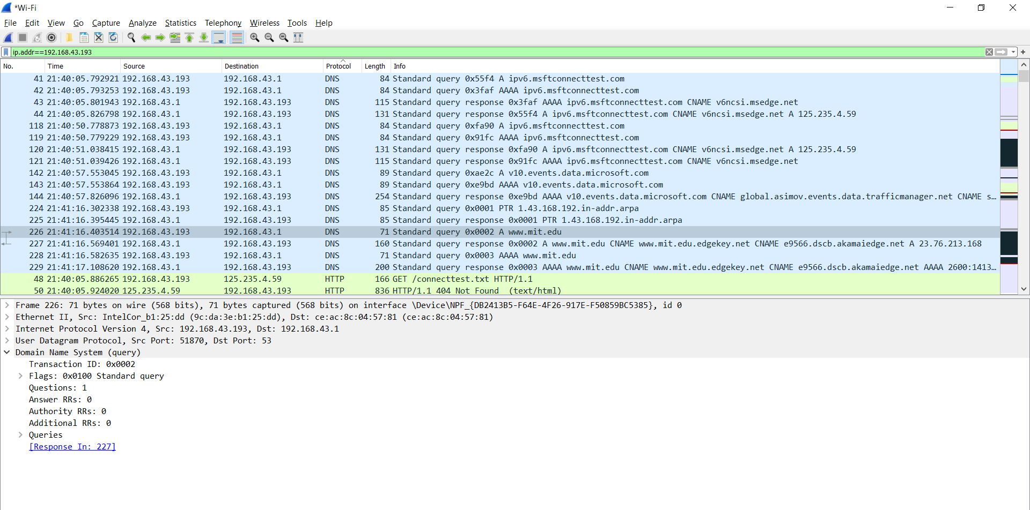

Câu 12:

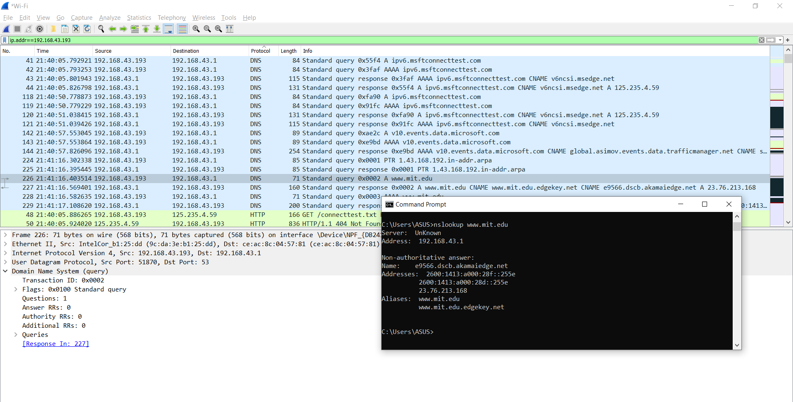

The DNS query message is sent to IP address 192.168.43.1, the same address as my default local DNS server.

Câu 13:

The DNS query message is a type “A” query, containing only one question and not containing any answers.

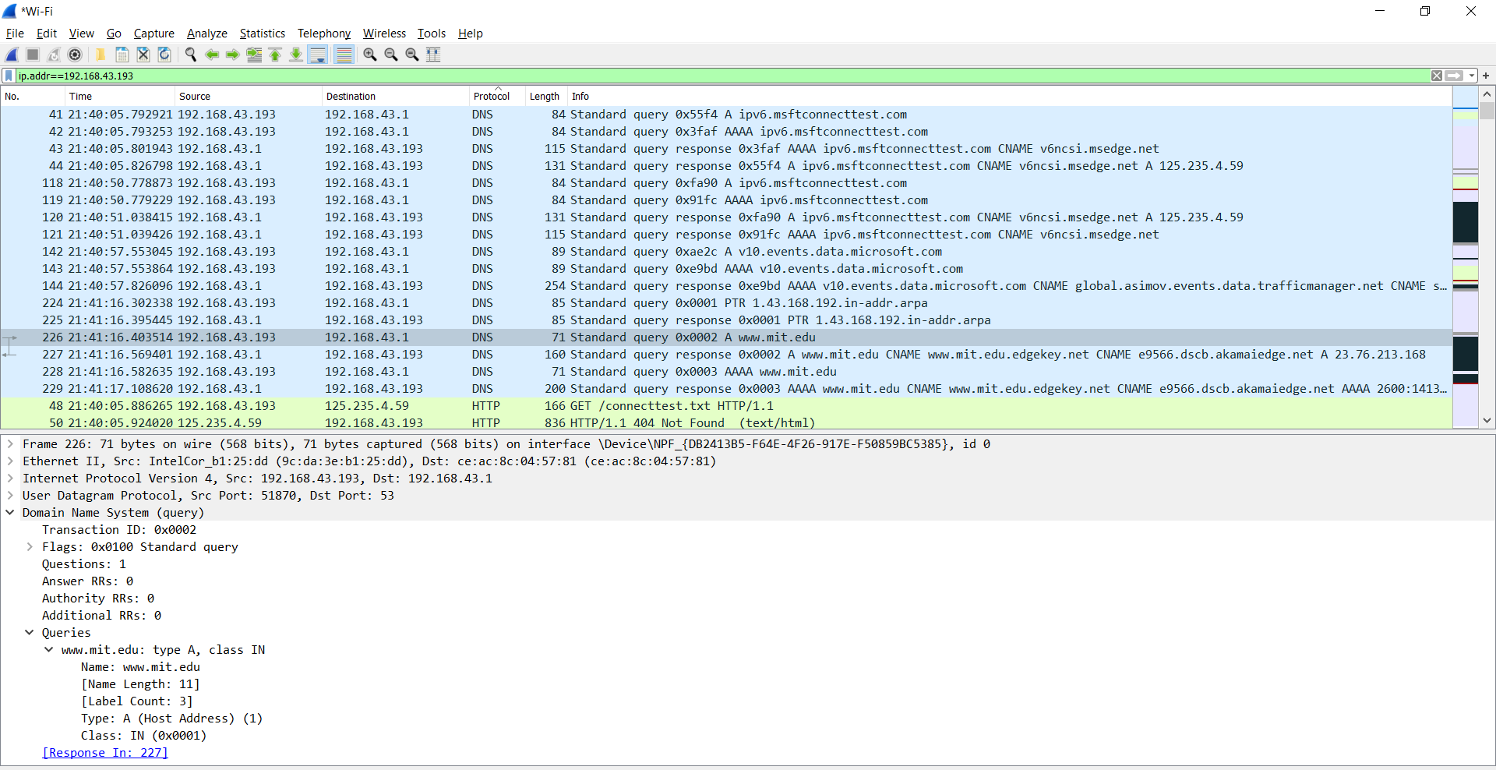

Câu 14:

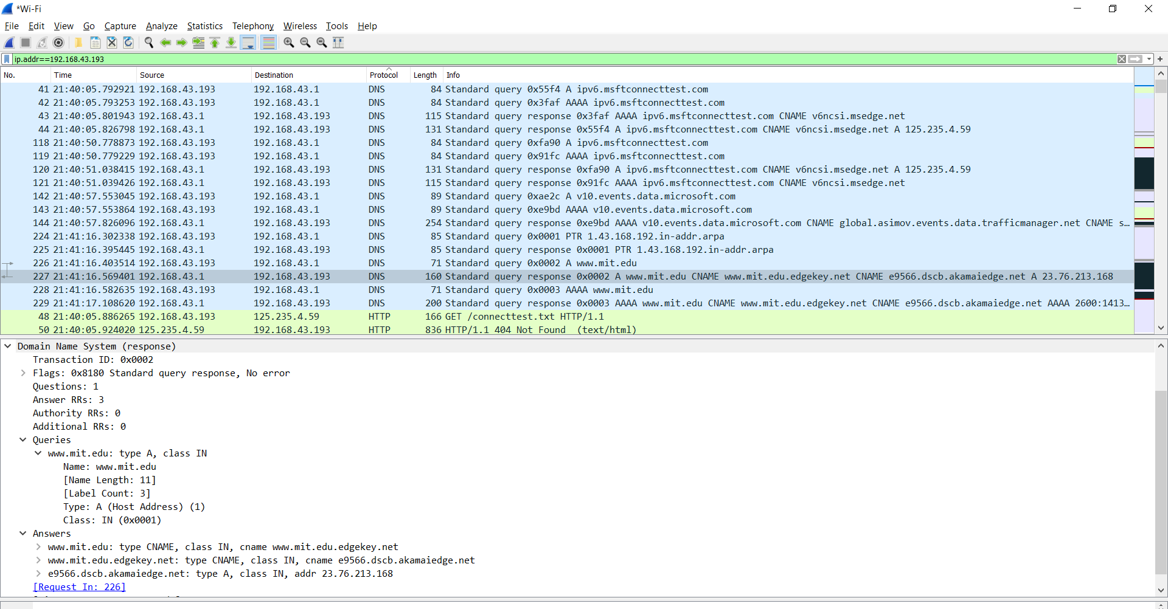

Câu 16:

The query is sent to 192.168.43.1, the same IP address as that of my default local DNS server.

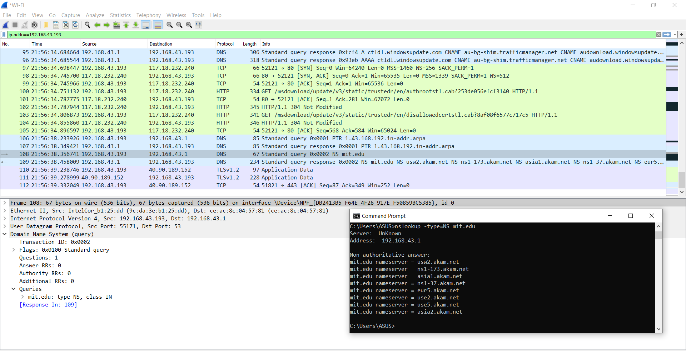

Câu 17:

The DNS query is a type “NS” message including one question. The query message did not contain any

answers.

Câu 18:

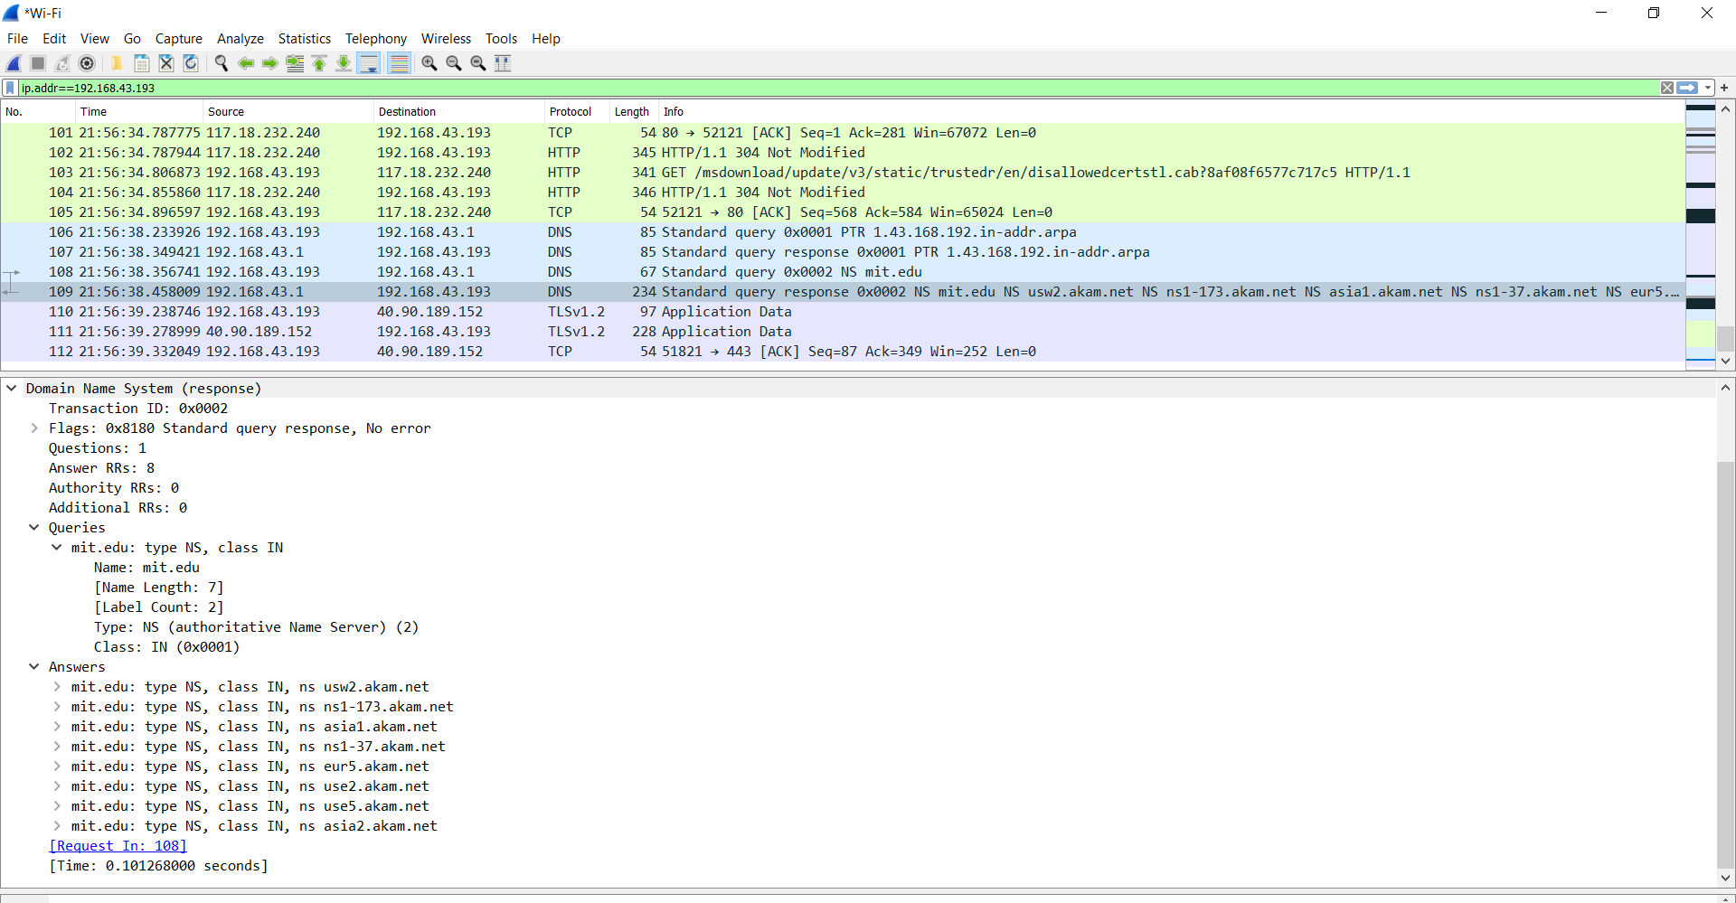

Câu 20:

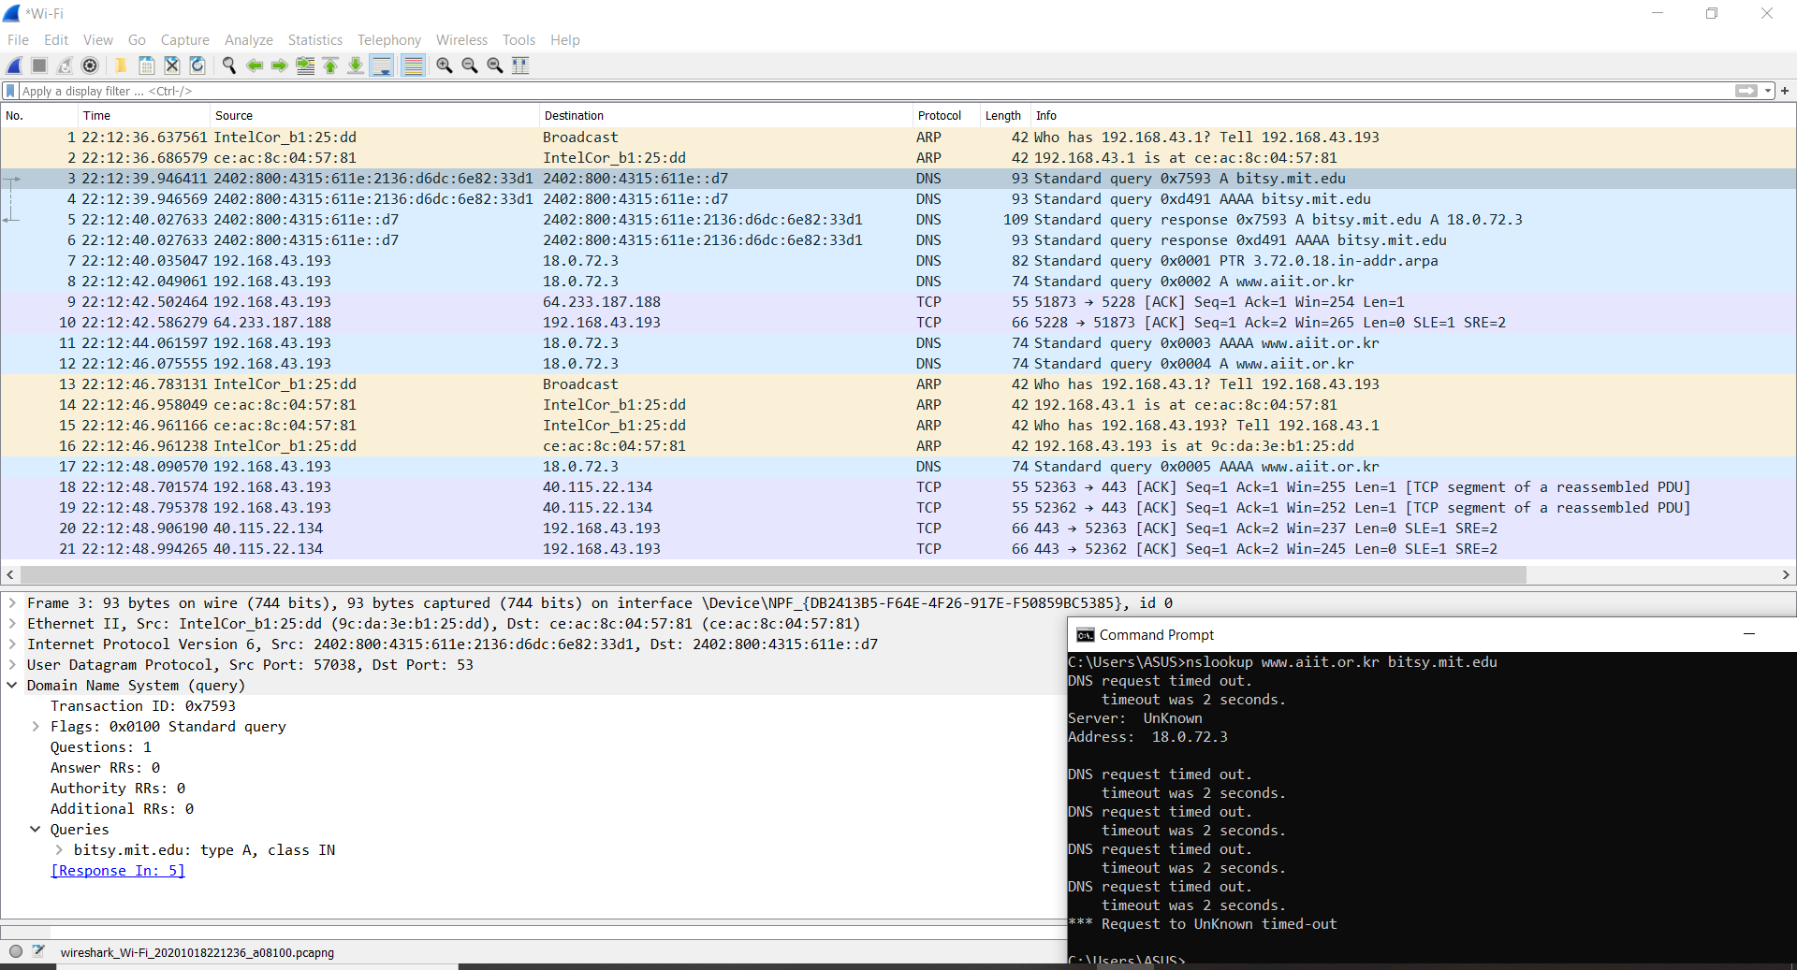

Câu 21:

This DNS query is a type “A” query. The message does not contain any answers

Câu 22:

It provided 1 answer containing the servers IP addres. The server returned a flag that stated that it could complete a recursive query.

