Câu 1:

There are 4 fields in UDP header:

1. Source port;
2. Destination port;
3. Length;
4. Checksum

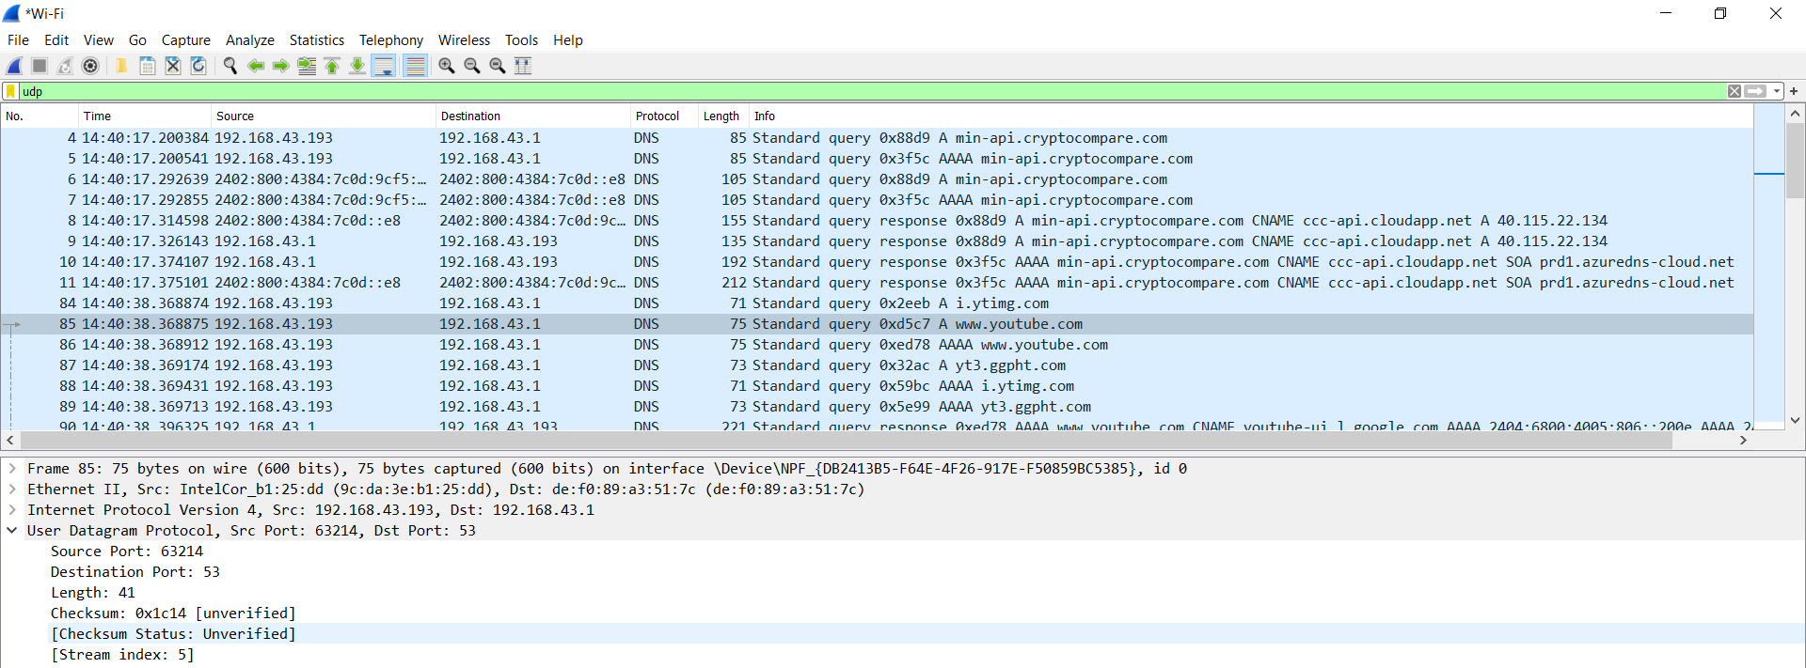

Câu 2:

The UDP header has a fixed length of 8 bytes. Each of these 4 header fields is 2 bytes long.

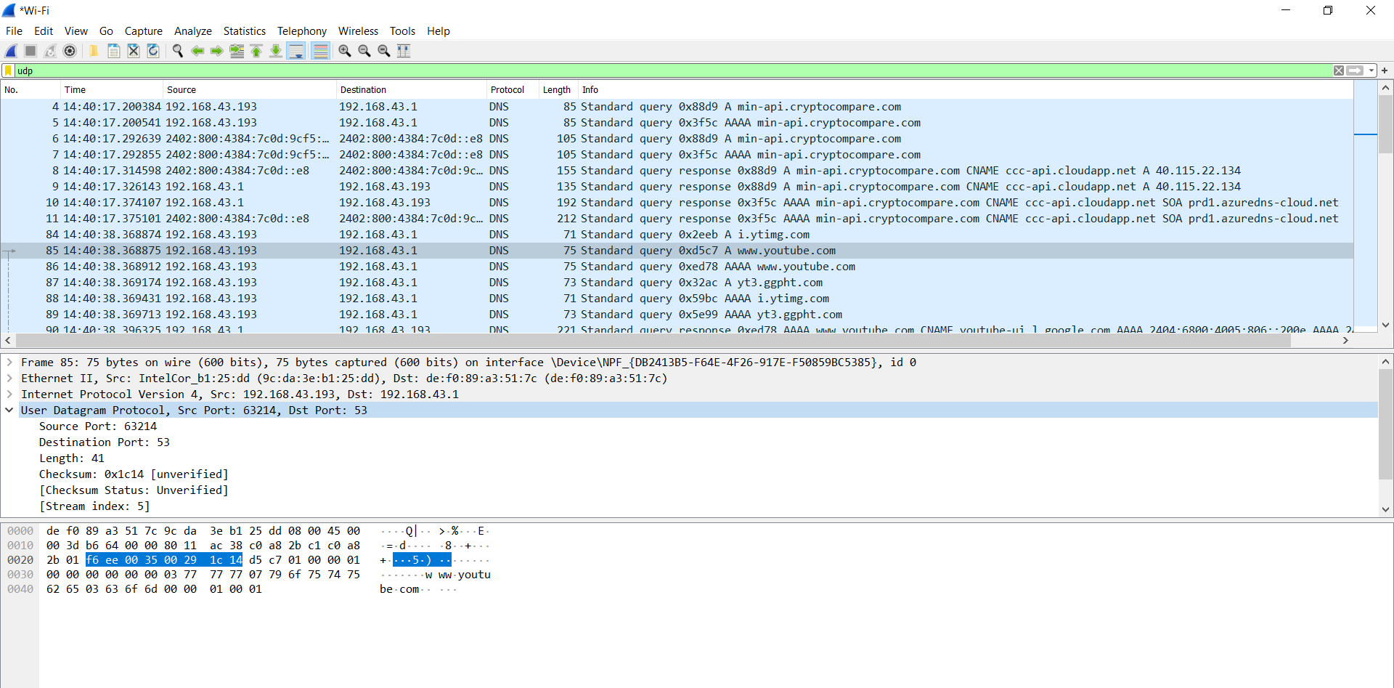

Câu 3:

The length field specifies the number of bytes in the UDP segment (header + data). An explicit length value is needed since the size of the data field may differ from one UDP segment to the next. The length of UDP payload for selected packet is 33 bytes. 41 bytes - 8 bytes = 33 bytes.

Câu 4:

The maximum number of bytes that can be included in a UDP payload

= the maximum number of bytes in the UDP segment - the number of bytes being used by header field = (2^16 - 1) - 8 = 65527 bytes.

Câu 5:

The largest possible source port number is (2^16 – 1) = 65535.

Câu 6:

The IP protocol number for UDP is 0x11 hex, which is 17 in decimal value.

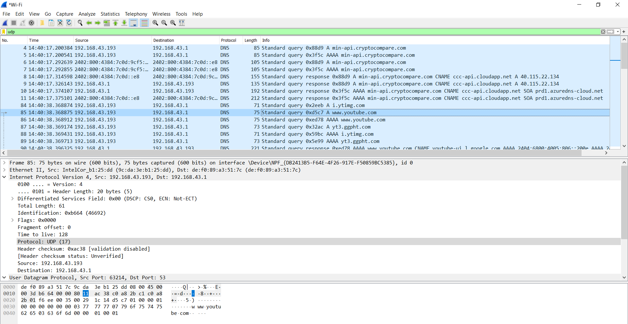

Câu 7:

The source port of the UDP packet sent by the host is the same as the destination port of the reply packet, and conversely the destination port of the UDP packet sent by the host is the same as the source port of the reply packet.

UDP sent by my host

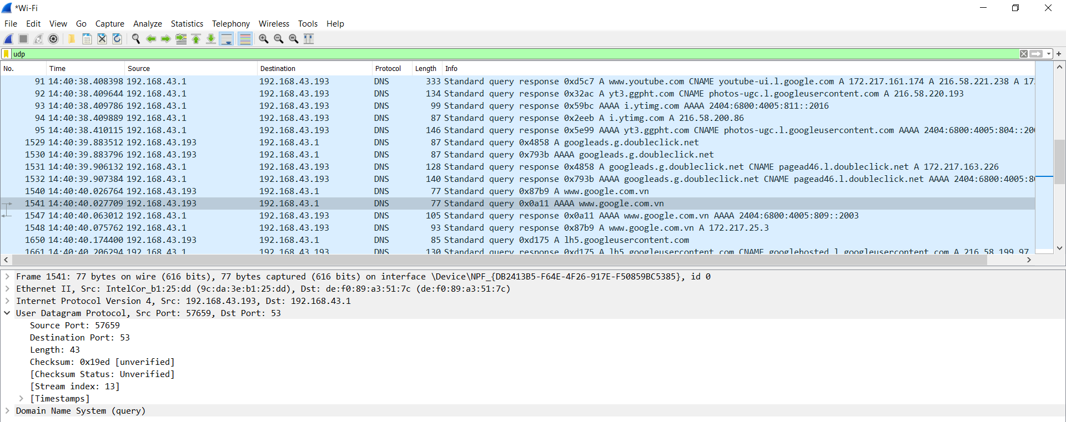

UDP reply to host

