Câu 1:

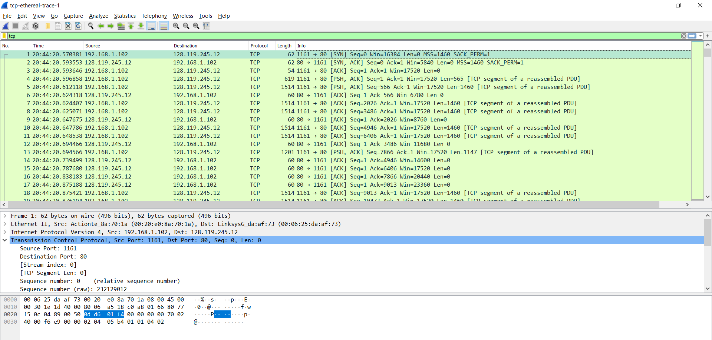

The IP address used by the client computer: 192.168.1.102

The TCP port number used by the client computer:1161

Câu 2:

IP address of gaia.cs.umass.edu: 128.119.245.12

Port number is it sending and receiving TCP segments for this connection: 80

Câu 3:

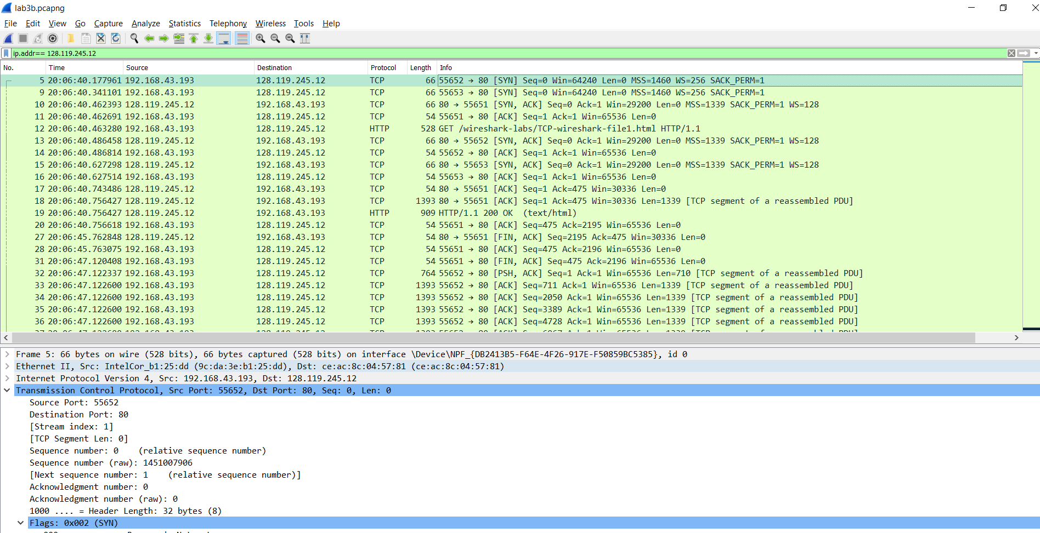

My IP Address: 192.168.43.193

Source Port: 55652

Câu 4:

Sequence number: 0

We can see that the message contains a SYN flag indicating that it is a SYN segment.

Câu 5:

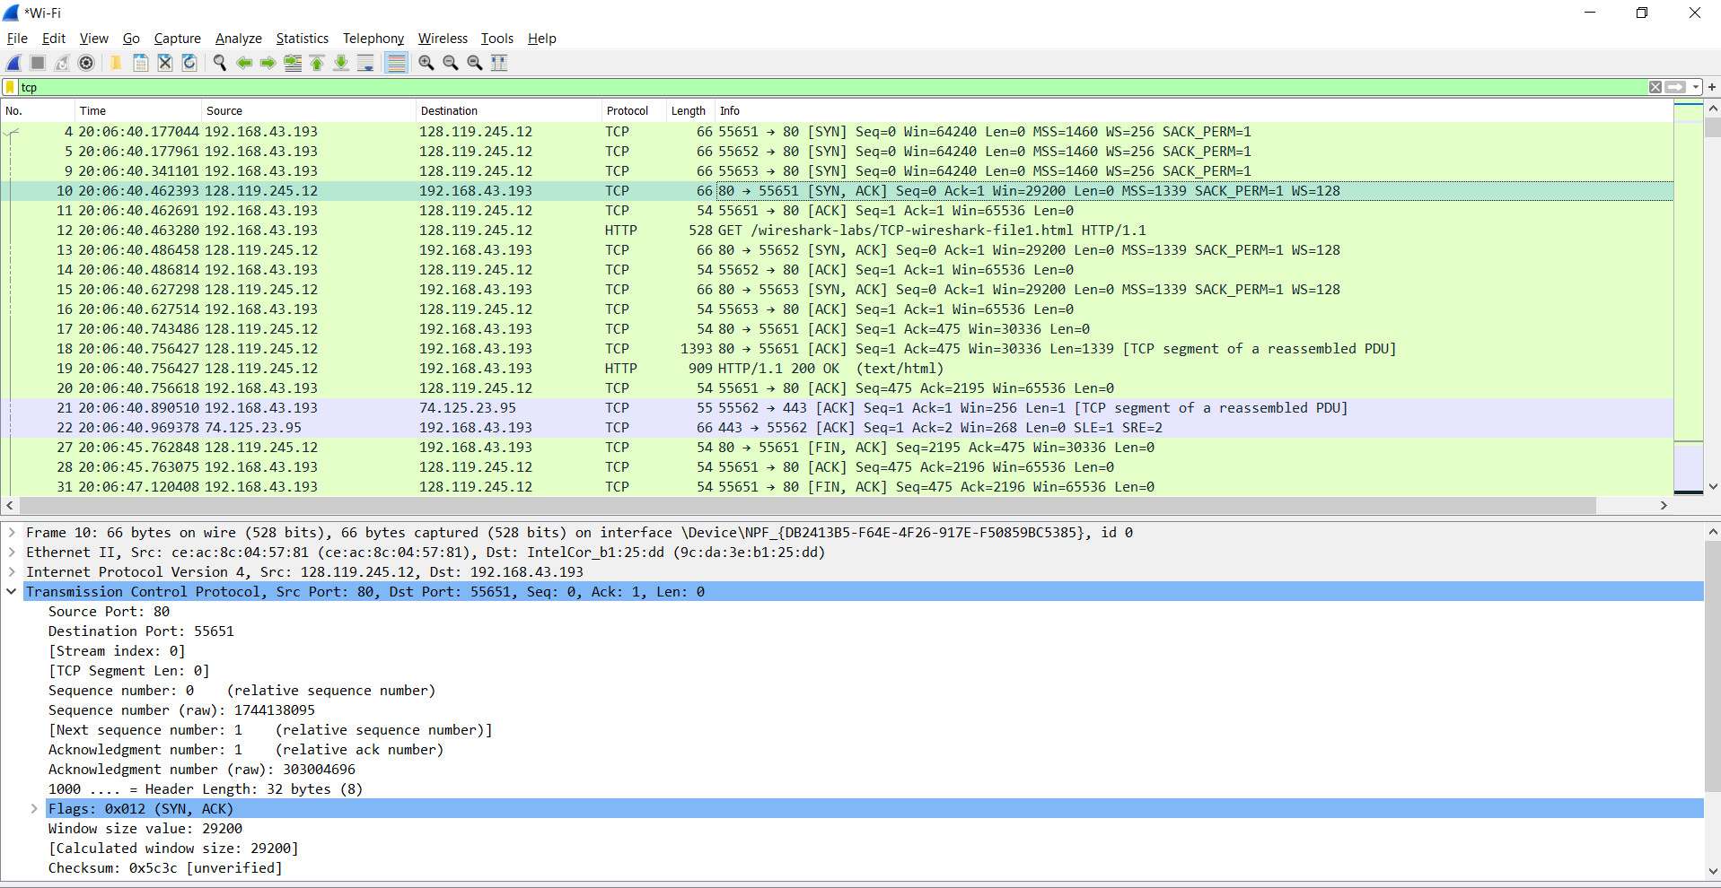

The sequence number of the SYNACK segment: 0

The value of the acknowledgement field in the SYNACK is 1.

It is determined by gaia.cs.umass.edu by adding 1 to the initial sequence number of SYN segment from the client computer (In this case, the sequence number of the SYN segment initiated by the client computer is 0.).

We can see that the message contains a SYN ACK flag indicating that it is a SYN ACKsegment.

Câu 6:

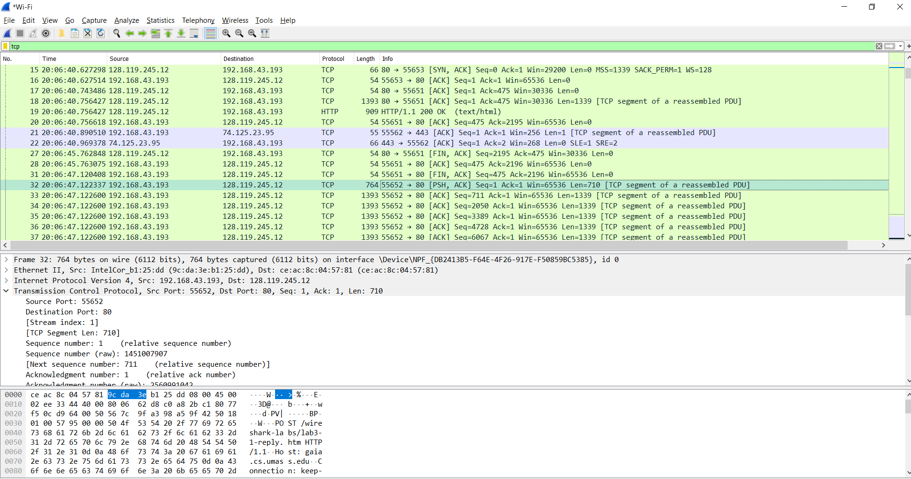

The sequence number of the TCP segment containing the HTTP POST command is 1.

Câu 7:

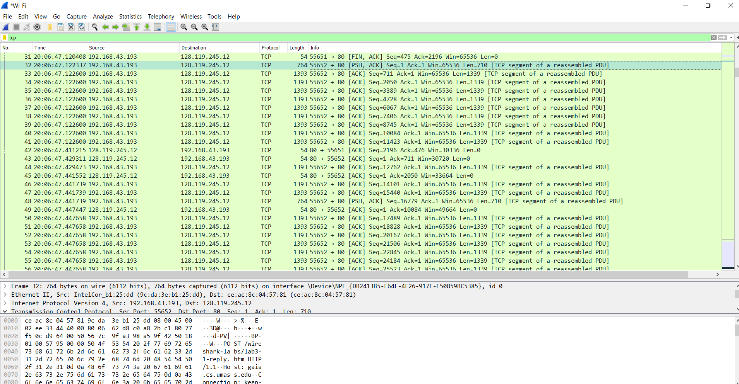

According to above figures, the segments 1‐6 are No. 32, 33, 34, 35, 36 and 37. The ACK of segments 1‐6 are No. 43, 45, ko tìm thấy, ko tìm thấy,ko tìm thấy, ko tìm thấy

Segment 1 : Sequence Number :1 Sent time: 0.122337 ACK received time: 0.429311 RTT: 0.306974

Segment 2 : Sequence Number : 711 Sent time:0.122600 ACK received time: 0.441552 RTT:0.318952

Segment 3 : Sequence Number : 2050

Segment 4 : Sequence Number : 3389

Segment 5 : Sequence Number : 4728

Segment 6 : Sequence Number : 6067

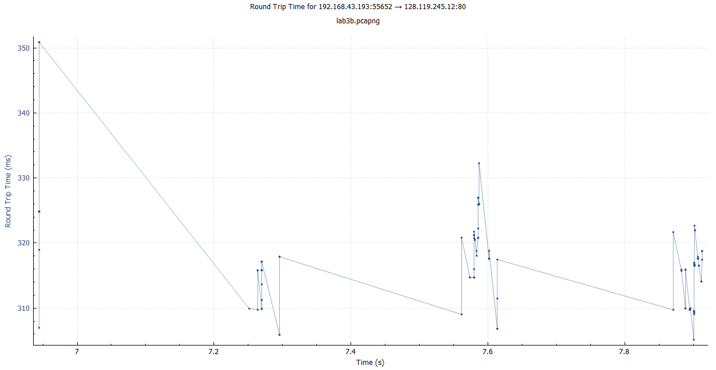

Câu 8:

Segment 1: [TCP Segment Len: 710]

Segment 2: [TCP Segment Len: 1339]

Segment 3: [TCP Segment Len: 1339]

Segment 4: [TCP Segment Len: 1339]

Segment 5: [TCP Segment Len: 1339]

Segment 6: [TCP Segment Len: 1339]

Câu 9:

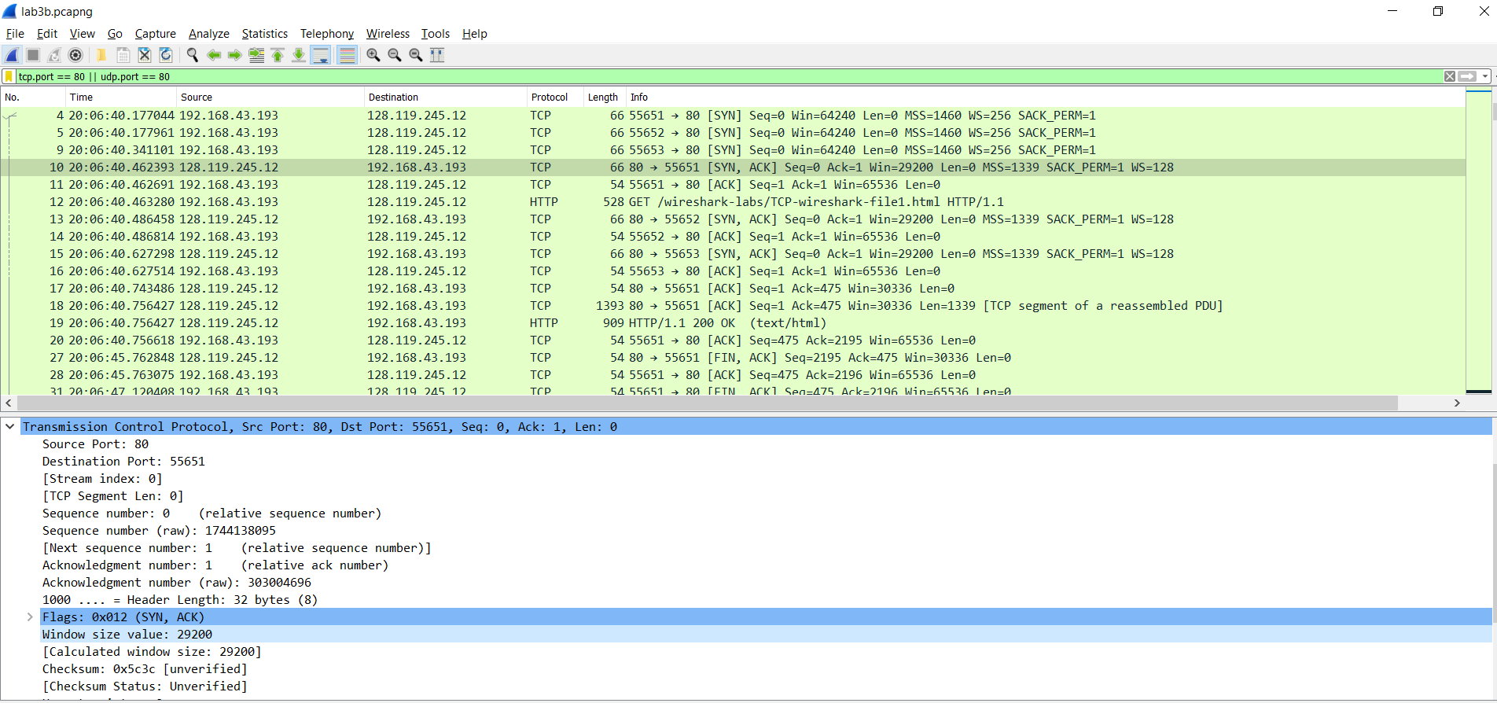

The minimum amount of available buffer space advertised at the received for the entire trace is

indicated first ACK from the server, its value is 29200 bytes (shown in above figure).

According to the trace, the sender is never throttled due to lacking of receiver buffer space.

Câu 10:

There are no retransmitted segments in the trace file. We can verify this by checking the sequence numbers of the TCP segments in the trace file. In the TimeSequence-Graph (Stevens) of this trace, all sequence numbers from the source (192.168.43.193) to the destination (128.119.245.12) are increasing monotonically with respect to time. If there is a retransmitted segment, the sequence number of this retransmitted segment should be smaller than those of its neighboring segments.

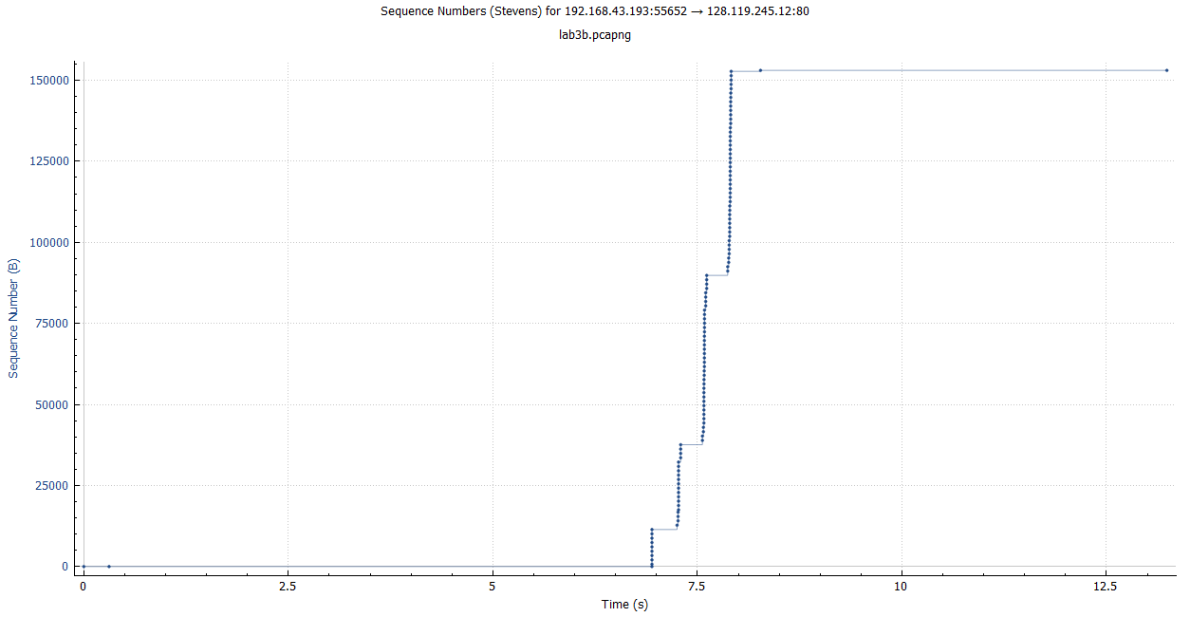

Câu 12:

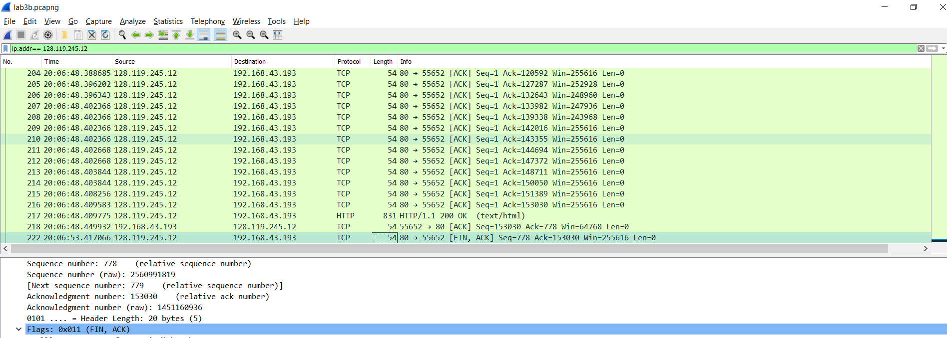

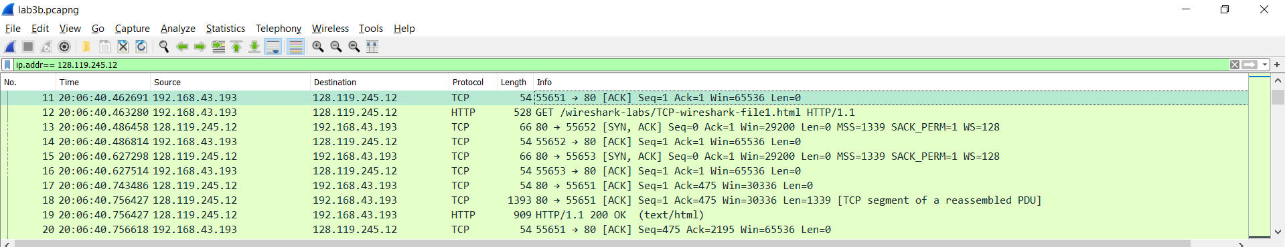

The throughput for the TCP connection is computed as the ratio of total amount of data to the total transmission time.

The total amount data transmitted can be computed by the difference between the sequence number of the first TCP segment (i.e. 1 byte for No. 11 segment) and the acknowledged sequence number of the last ACK (153030 bytes for No. 222 segment). Therefore, the total data are 153030 - 1 = 153029 bytes.

The total transmission time is the difference between the time of first TCP segments transmitted and the time of the last ACK (Fin ACK) received. Then T=53.417066-40.462691=12.954375 s.Then average Troughput=153029 bytes/12.954375 s =11813 bytes/s