Câu 1:

DHCP messages are sent over UDP

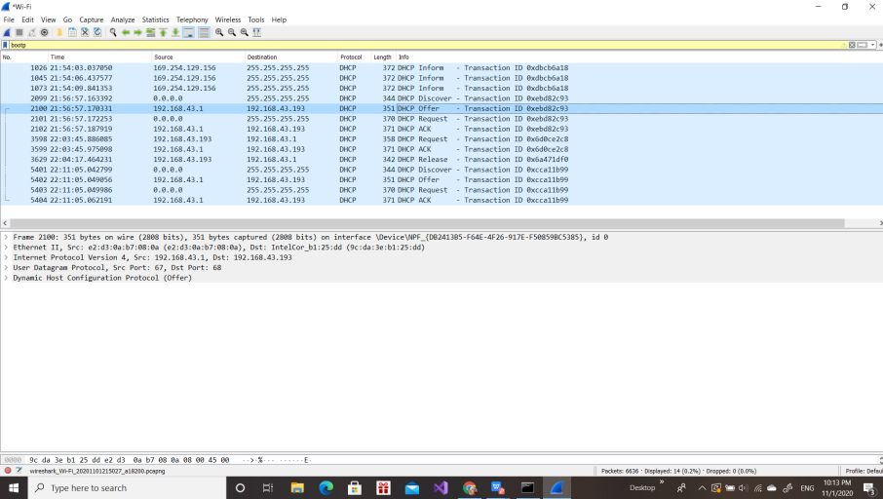

Câu 2:

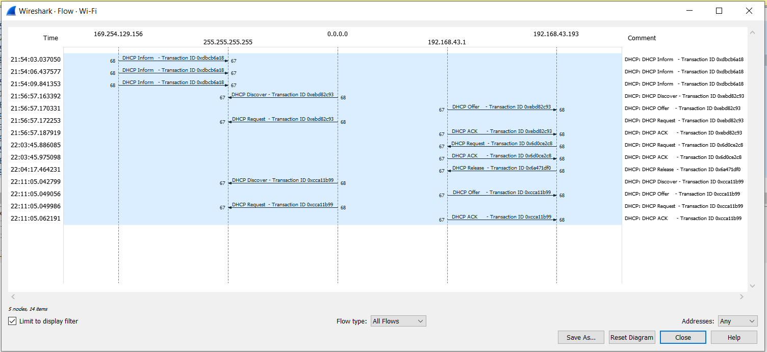

Câu 3:

The ethernet address of my host is: e2:d3:0a:b7:08:0a (e2:d3:0a:b7:08:0a)

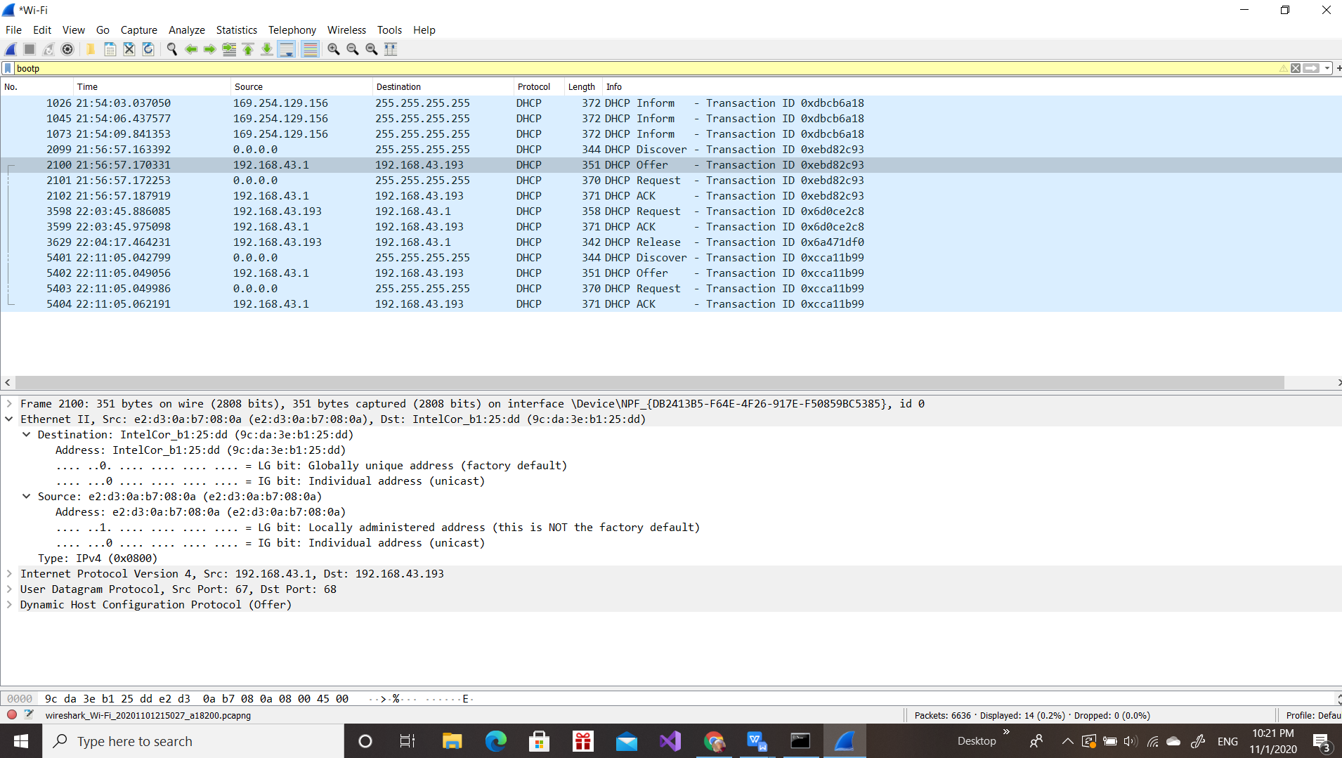

Câu 4:

The values which differentiate the Discover message from the Request message are in

Option: (53) DHCP Message Type (Discover)

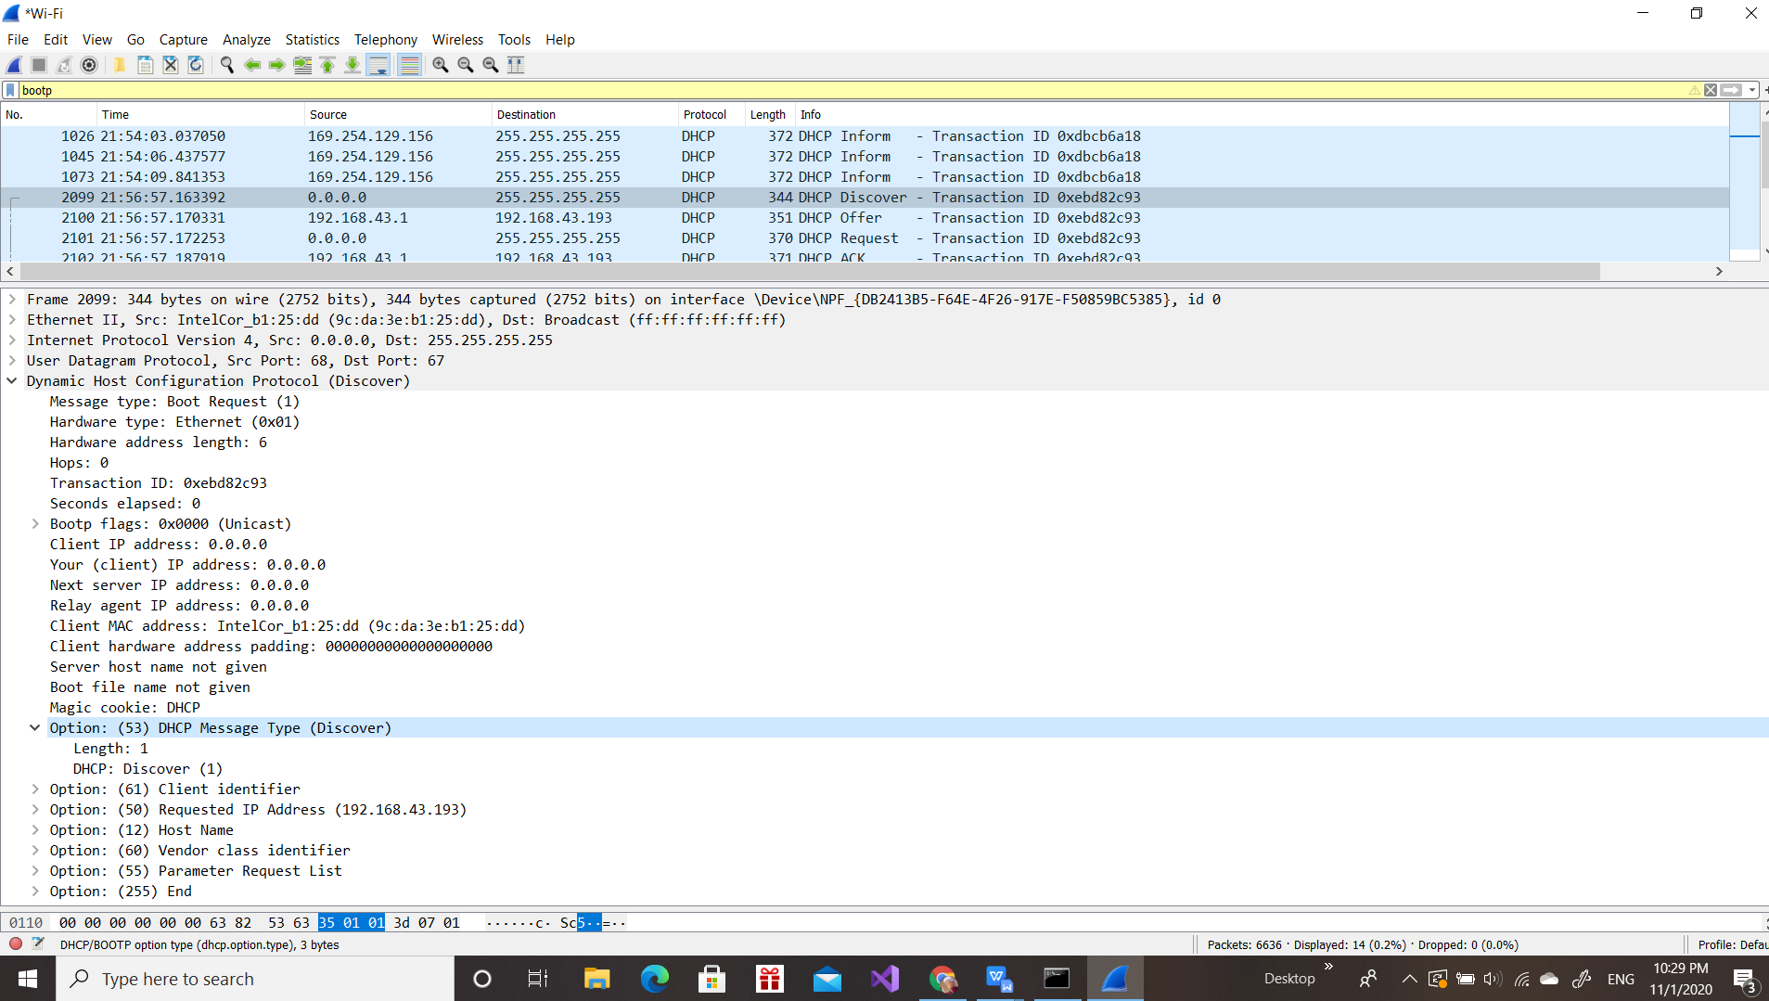

Câu 5:

The value of the transaction id in the first four DHCP messages is: [Transaction ID: 0xebd82c93]

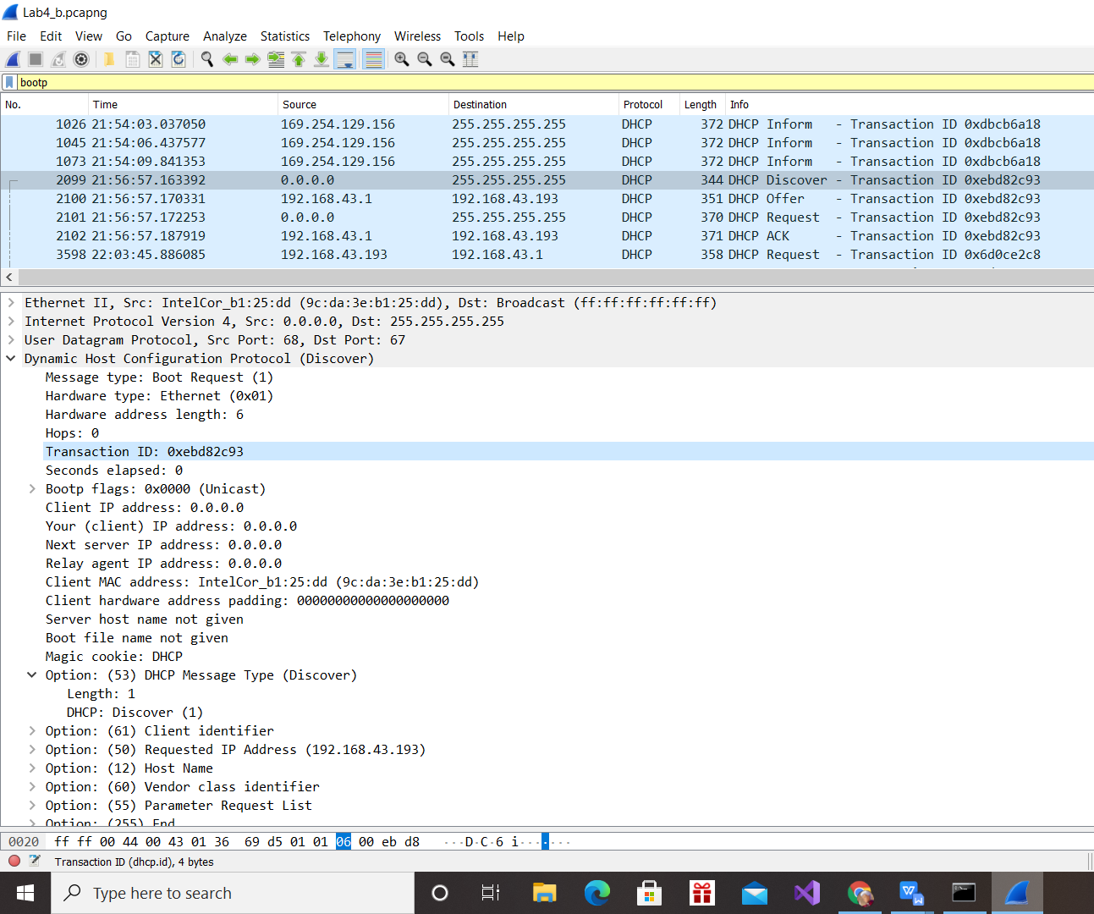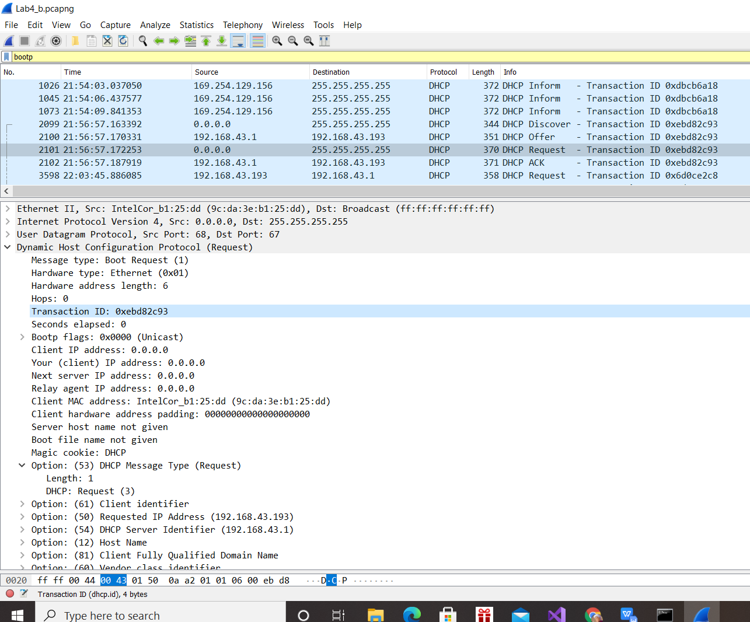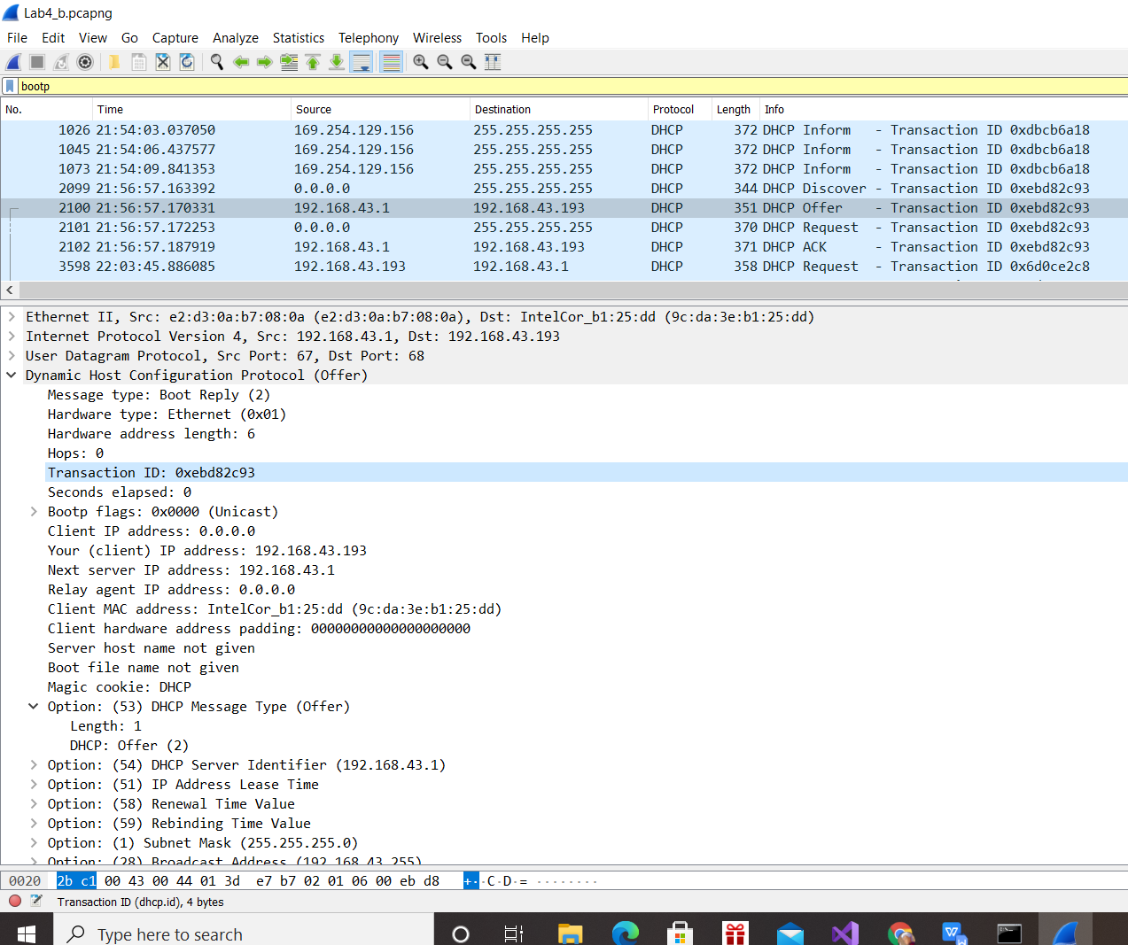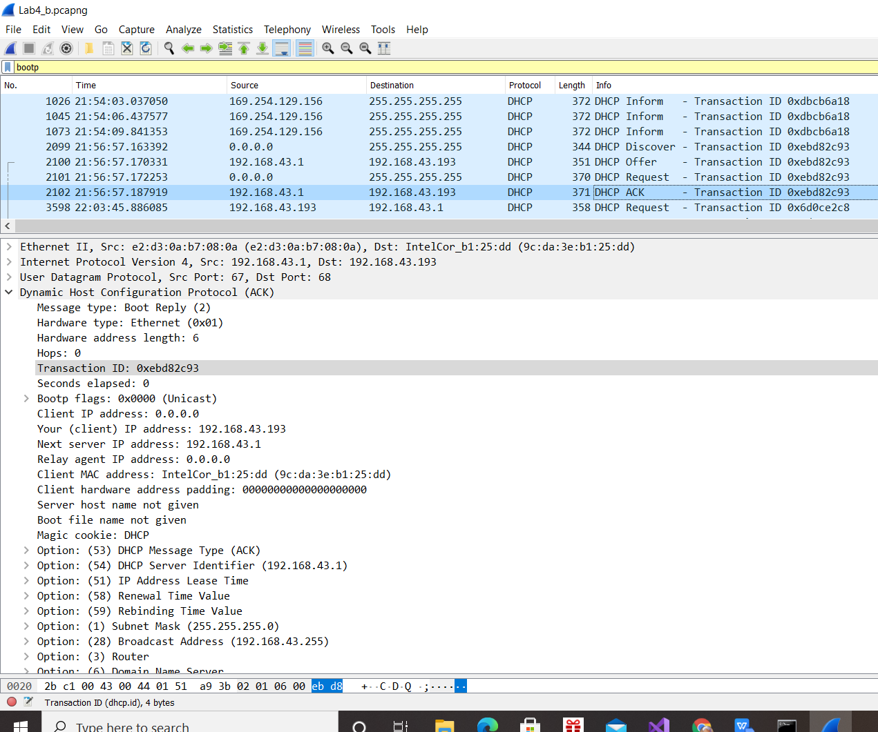

The value of the transaction id in the second set is [Transaction ID: 0x6d0ce2c8]

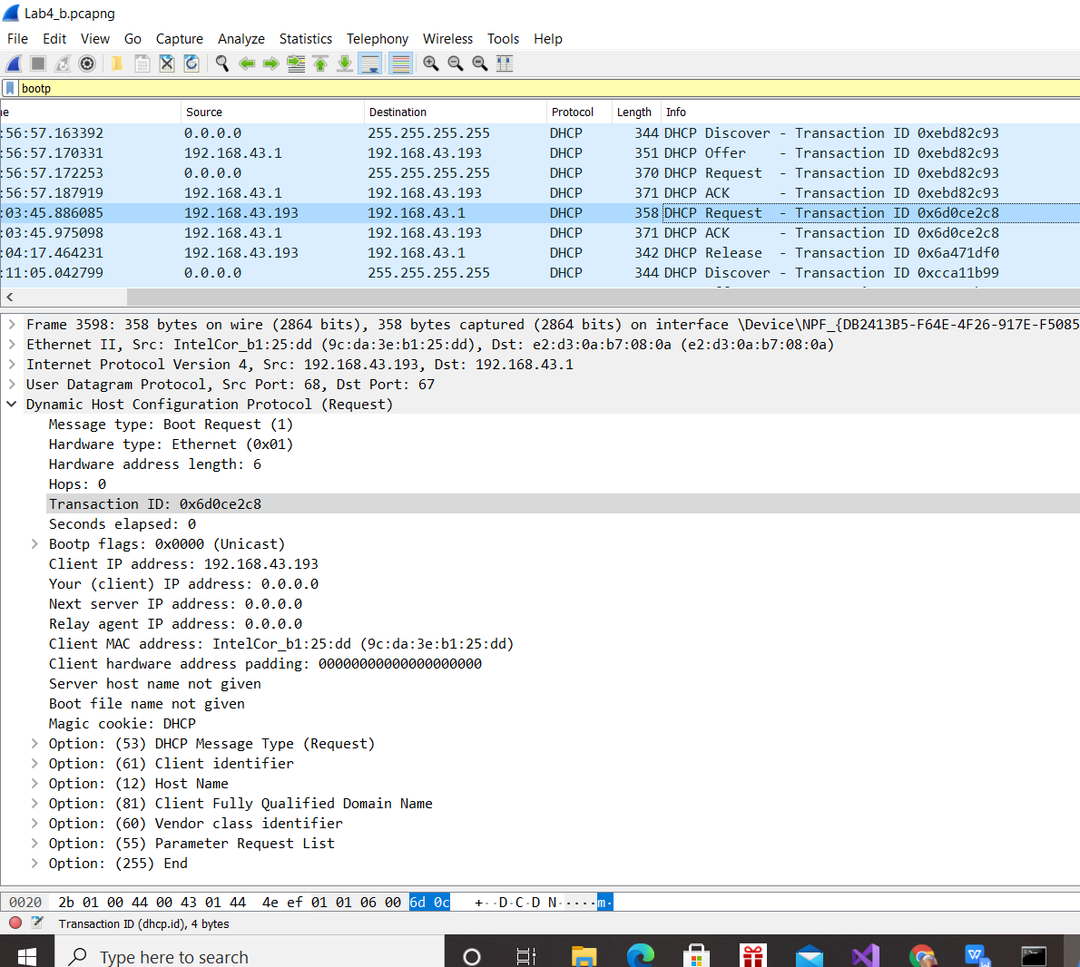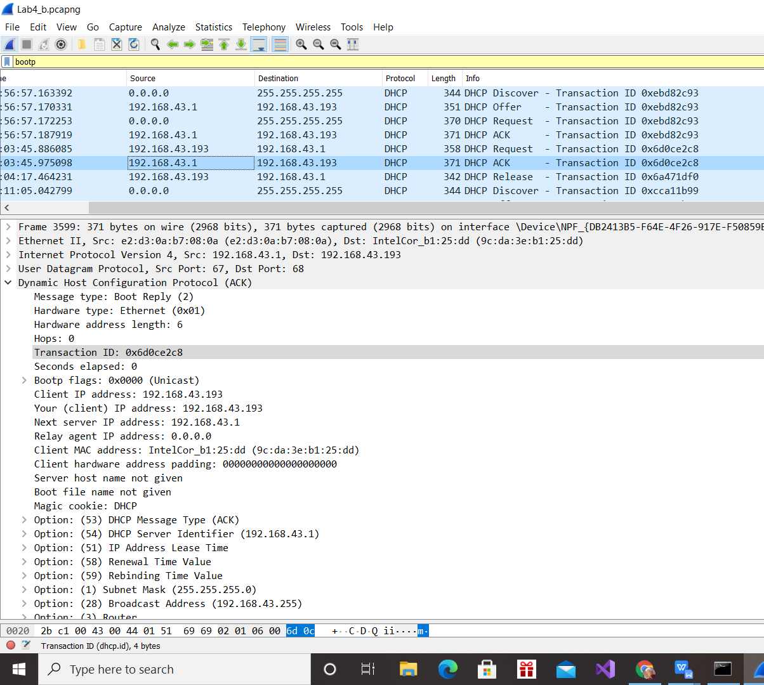

Purpose: The transaction ID is different so that the host can differentiate between different requests made by the user.

Câu 6:

The DCHP client and server both use 255.255.255.255 as the destination address. The client uses source IP address 0.0.0.0, while the server uses its actual IP address as the source.

Discover Src – 0.0.0.0, Dst – 255.255.255.255

Offer Src – 192.168.43.1, Dst – 255.255.255.255

Request Src – 0.0.0.0, Dst – 255.255.255.255

ACK DHCP – 192.168.43.1, Dst – 255.255.255.255

Câu 7:

The IP address of my DHCP server is: 192.168.43.1

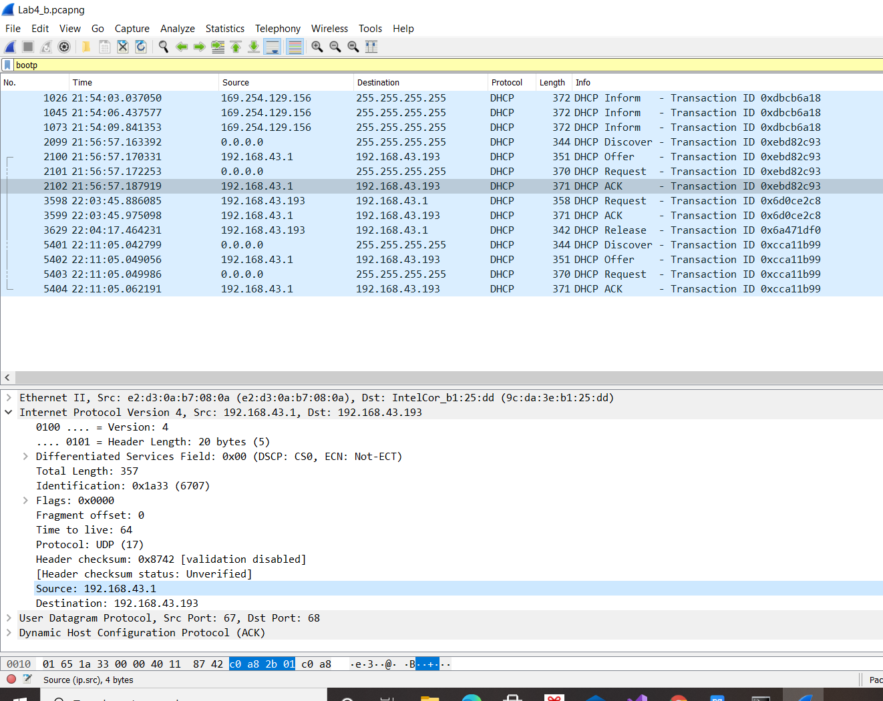

Câu 8:

The IP address in which the DHCP server is offering to my host in the DHCP Offer message is 192.168.43.193.

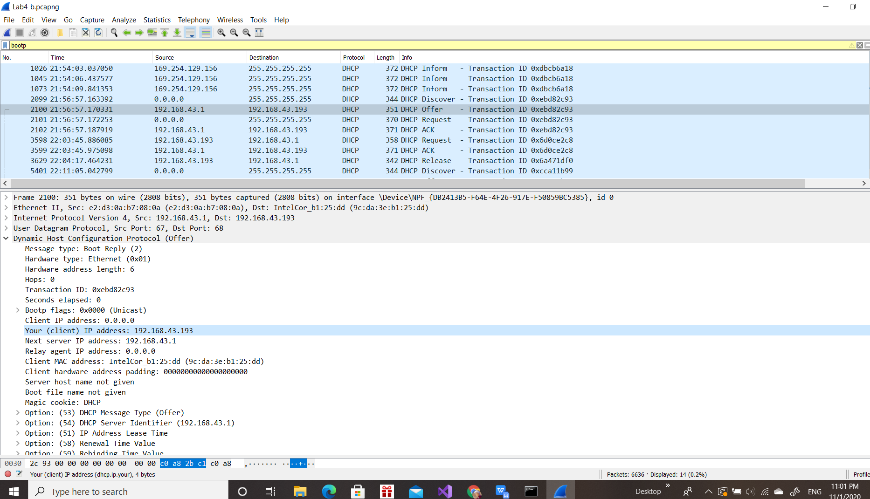

Câu 9:

Since the IP is 0.0.0.0 it is telling us that there is no relay agent. If there were an IP there then we could give values in the trace

Câu 10:

The router line indicates to the client what its default gateway should be. The subnet mask line tells the client which subnet mask it should use.

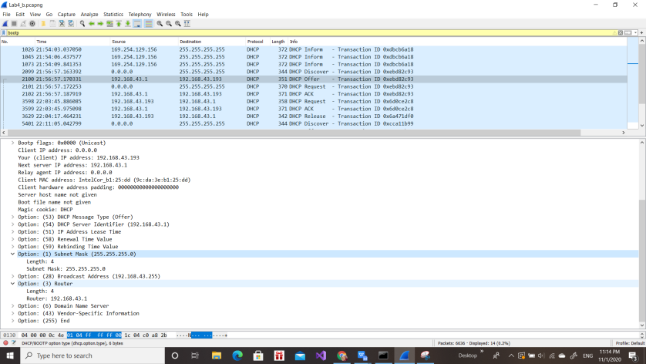

Câu 11:

The client accepts the IP address given in the offer message within the request message. After being offered the IP address 192.168.43.193 in the offer message, my client sent back a message further requesting that specific IP address.

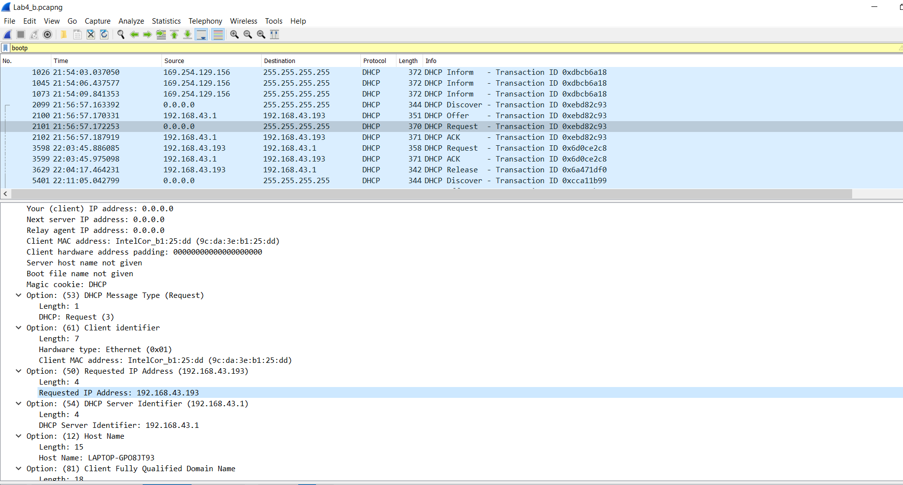

Câu 12:

The purpose of lease time is to tell the client how long they can use the specific IP address assigned by the server before they will have to be assigned a new one.

The lease time in my experiment is [IP Address Lease Time: (3600s) 1 hour]

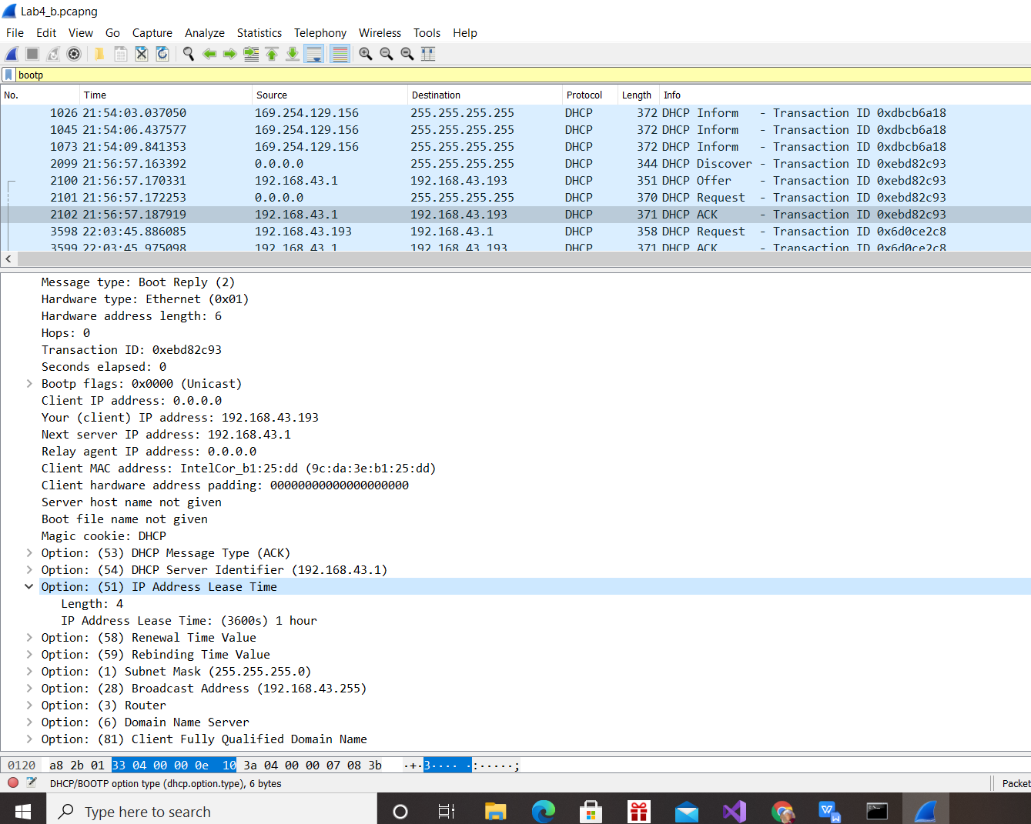

Câu 13:

The purpose of the release message is to release the IP address back to the server.

The DHCP server does not send a message back to the client acknowledging the DHCP Release message.

If the message is lost, the client releases the IP address, but the server will not reassign that address until the clients lease on the address expires.

Câu 14:

Yes, there was arp packets sent and received to map the mac address with the ip address

////Command Prompt

