Câu 1:

The IP address of the client is 192.168.1.100

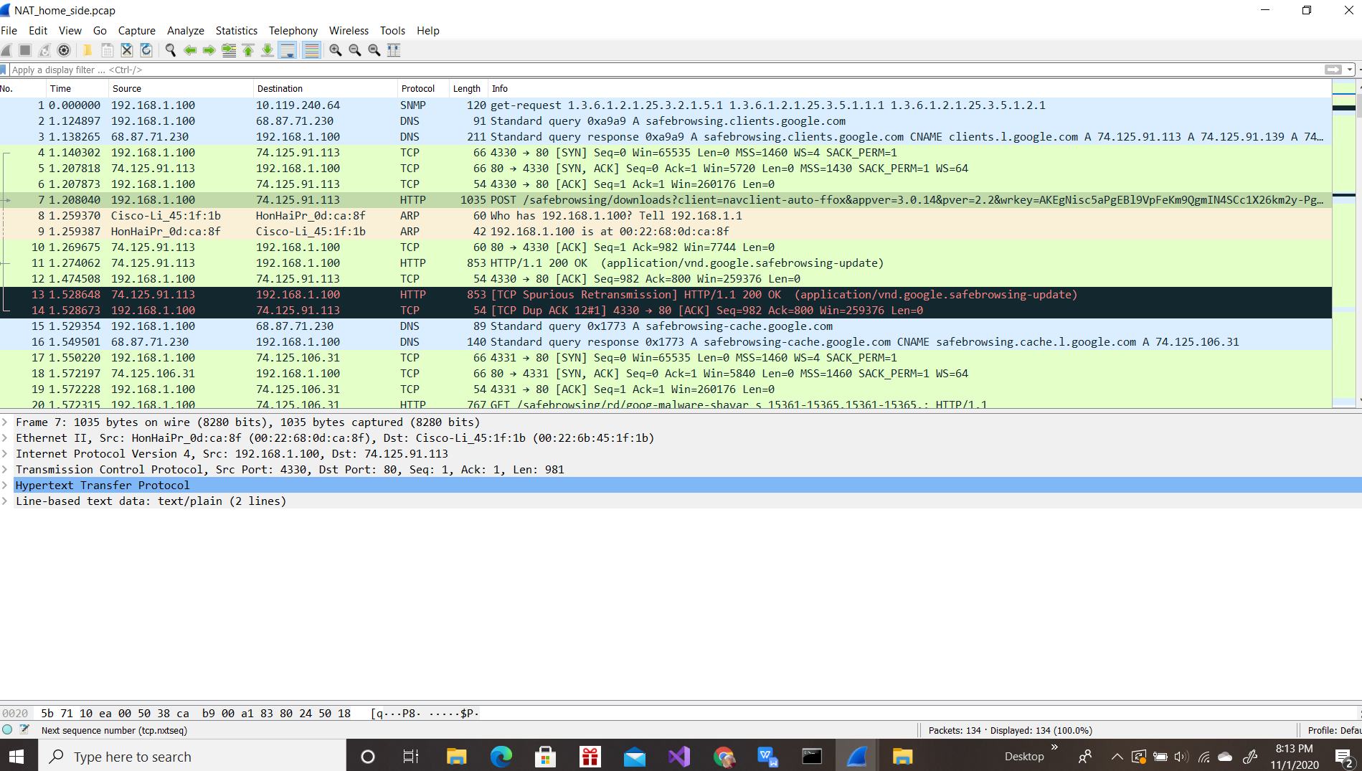

Câu 2:

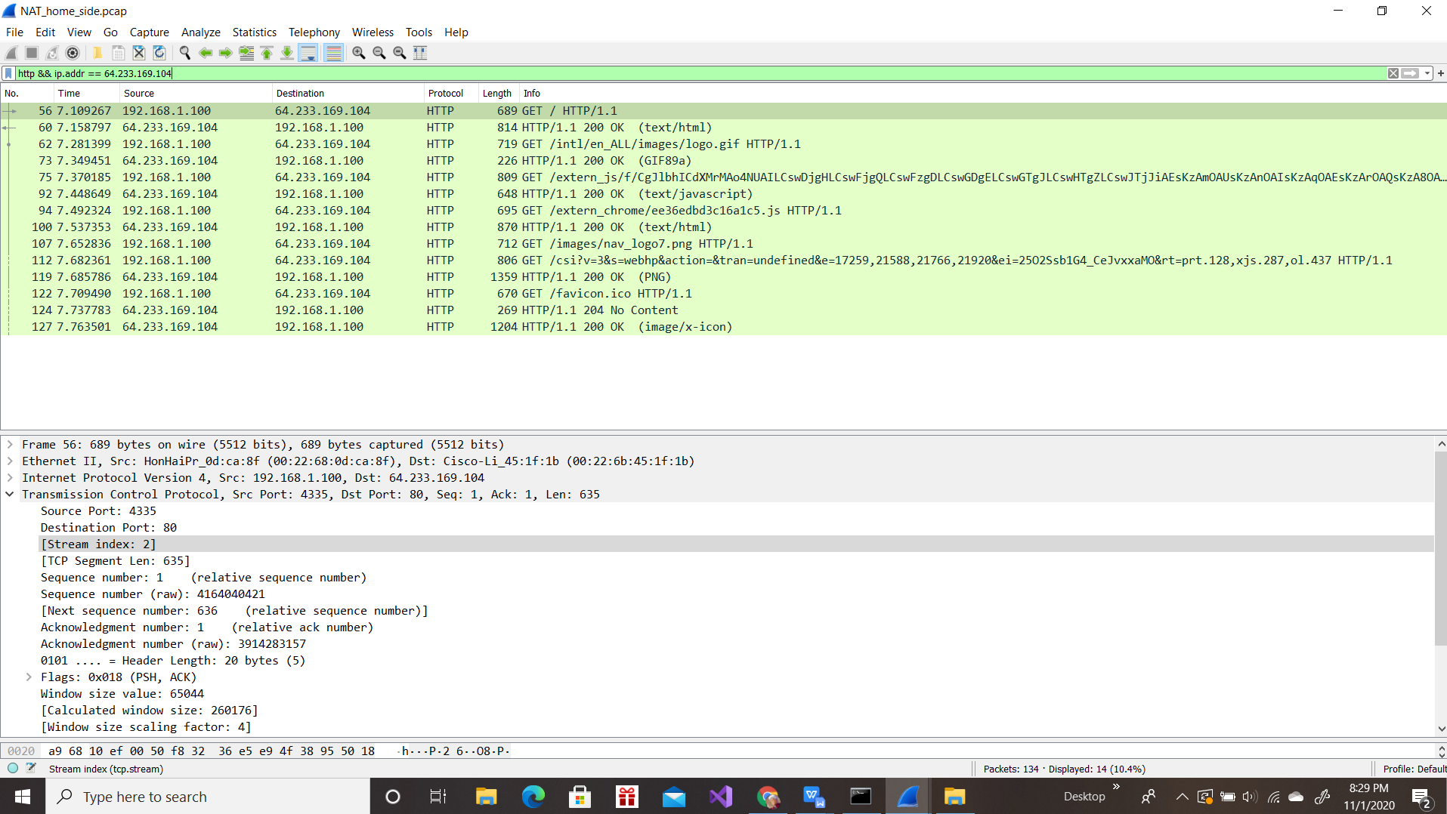

Câu 3:

Source IP address: 192.168.1.100

Source port: 4335

Destination IP address: 64.233.169.104

Destination port: 80

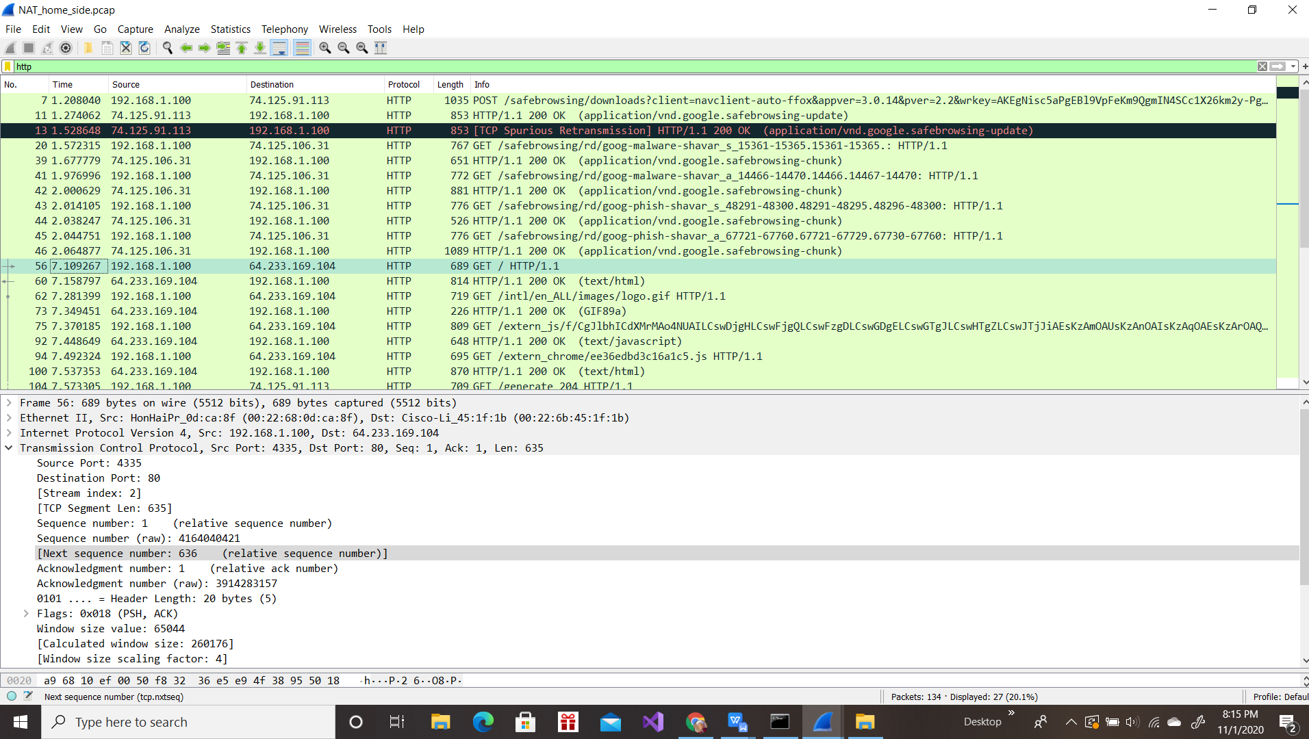

Câu 4:

Time: 7.158797

Source IP address: 64.233.169.104

Source port: 80

Destination IP address: 192.168.1.100

Destination port: 4335

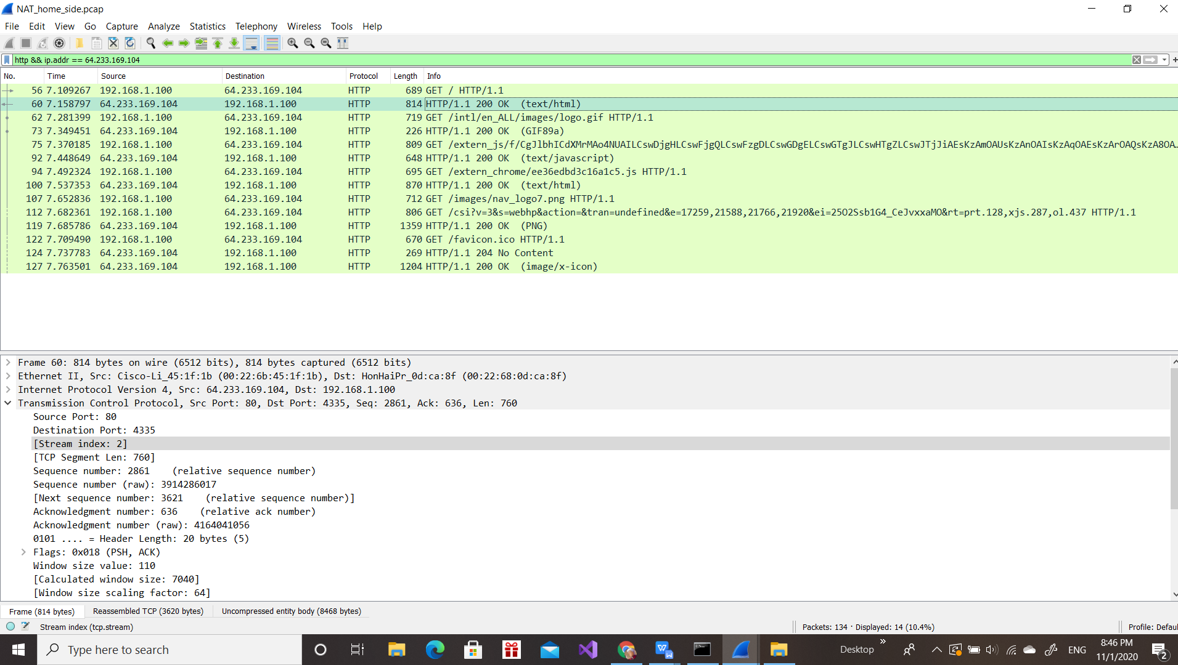

Câu 5:

The client-to-server TCP SYN segment is sent at 7.075657

Source IP of SYN: 192.168.1.100

Destination IP of SYN: 64.233.169.104

Source Port of SYN: 4335

Destination Port of SYN: 80

Source IP of ACK: 64.233.169.104

Destination IP of ACK: 192.168.1.100

Source Port of ACK: Port: 80

Destination Port of ACK: 4335

This ACK was received at the client at 7.108986

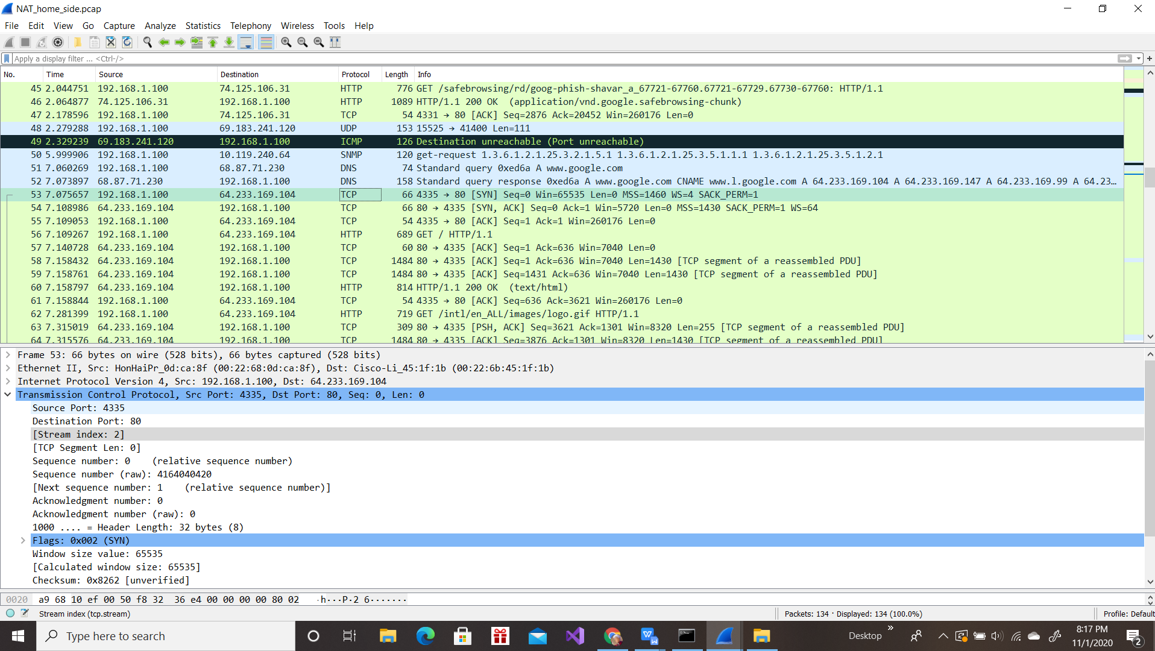

Câu 6:

Time at 6.069168

Source IP: 71.192.34.104

Destination IP: 64.233.169.104

Source Port: 4335

Destination Port: 80

Only the source IP address has changed

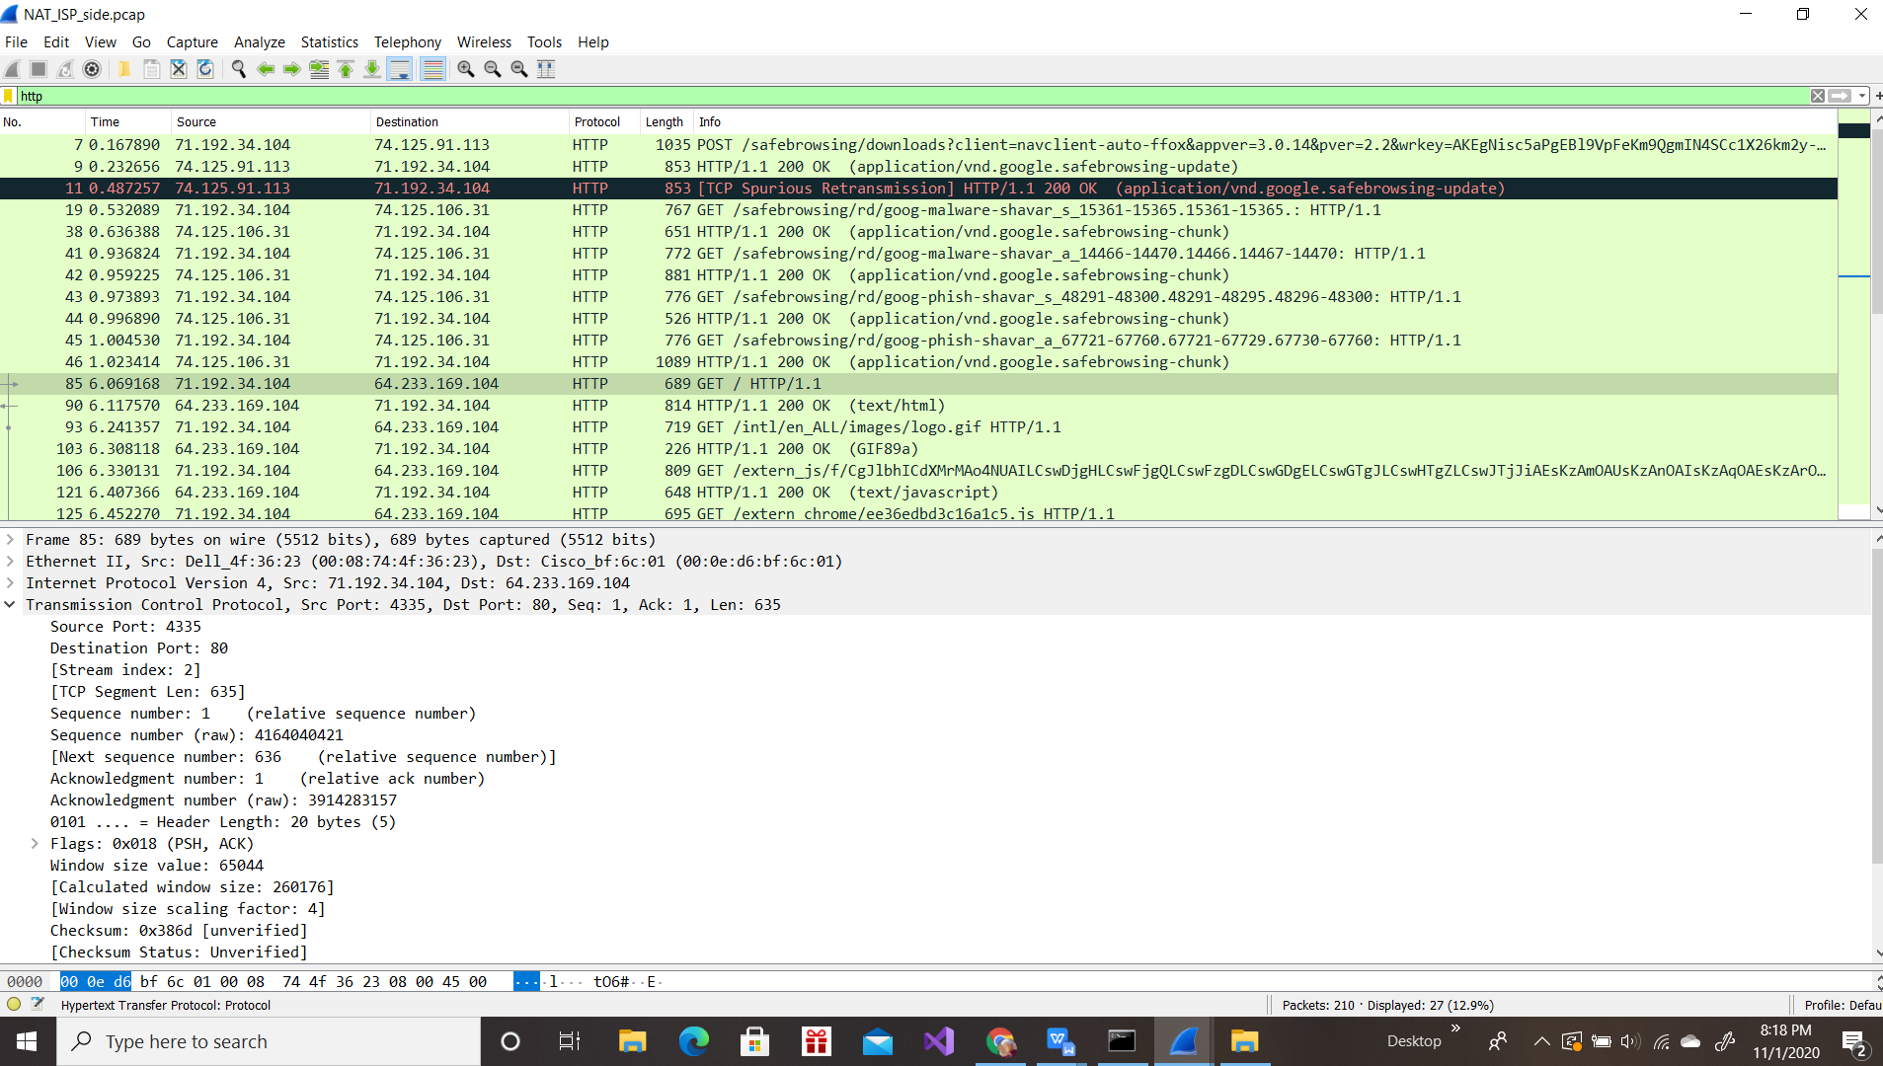

Câu 7:

Unchanged fields: HTTP, Version, Header length, Flags.

Changed fields: Checksum.

The IP source address has changed

The checksum includes the value of the source IP address

=> the checksum has changed.

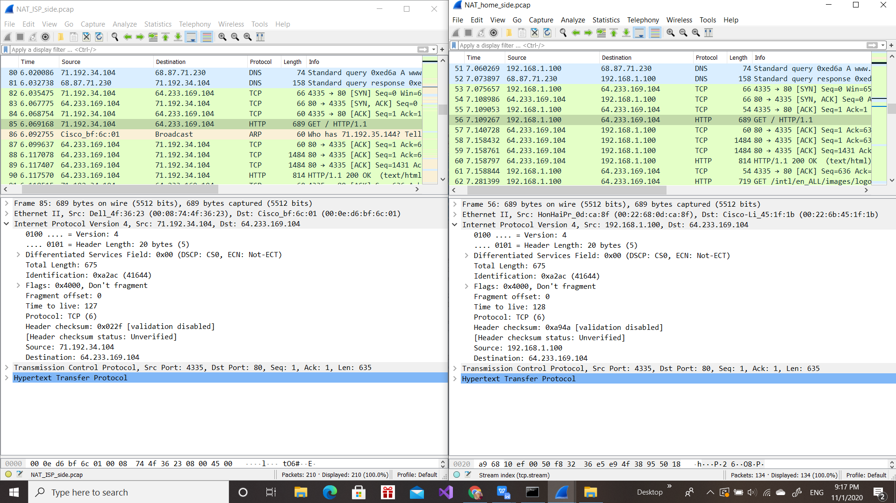

Câu 8:

HTTP 200 OK message first time: 6.117078

Source IP: 64.233.169.104, Port: 80

Destination IP: 71.192.34.104, Port: 4335

Version and Flag is the same.

Time to live and Header checksum changed.

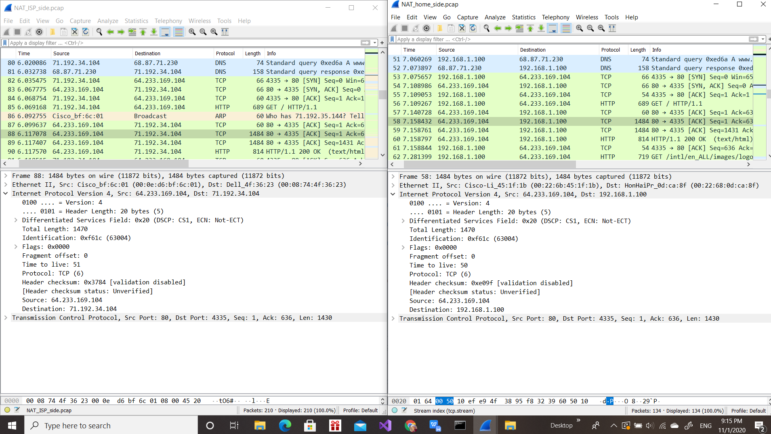

Câu 9:

Time: 6.035475 and 6.067775 respectively

[SYN]:

SYN Source: 71.192.34.104, Port: 4335

SYN Destination: 64.233.169.104, Port: 80

Time to live changed.

[ACK]:

ACK Source: 64.233.169.104, Port: 80

ACK Destination: 71.192.34.104, Port: 4335

Identification, Time to live, Flags, Source and Destination IP changed.

[SYN]

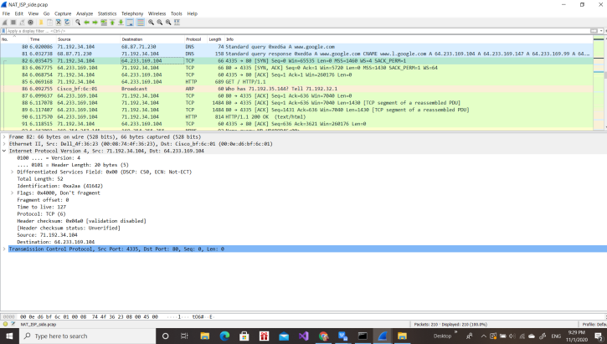

[ACK]

