Câu 1:

The IP address of my computer: 192.168.43.193

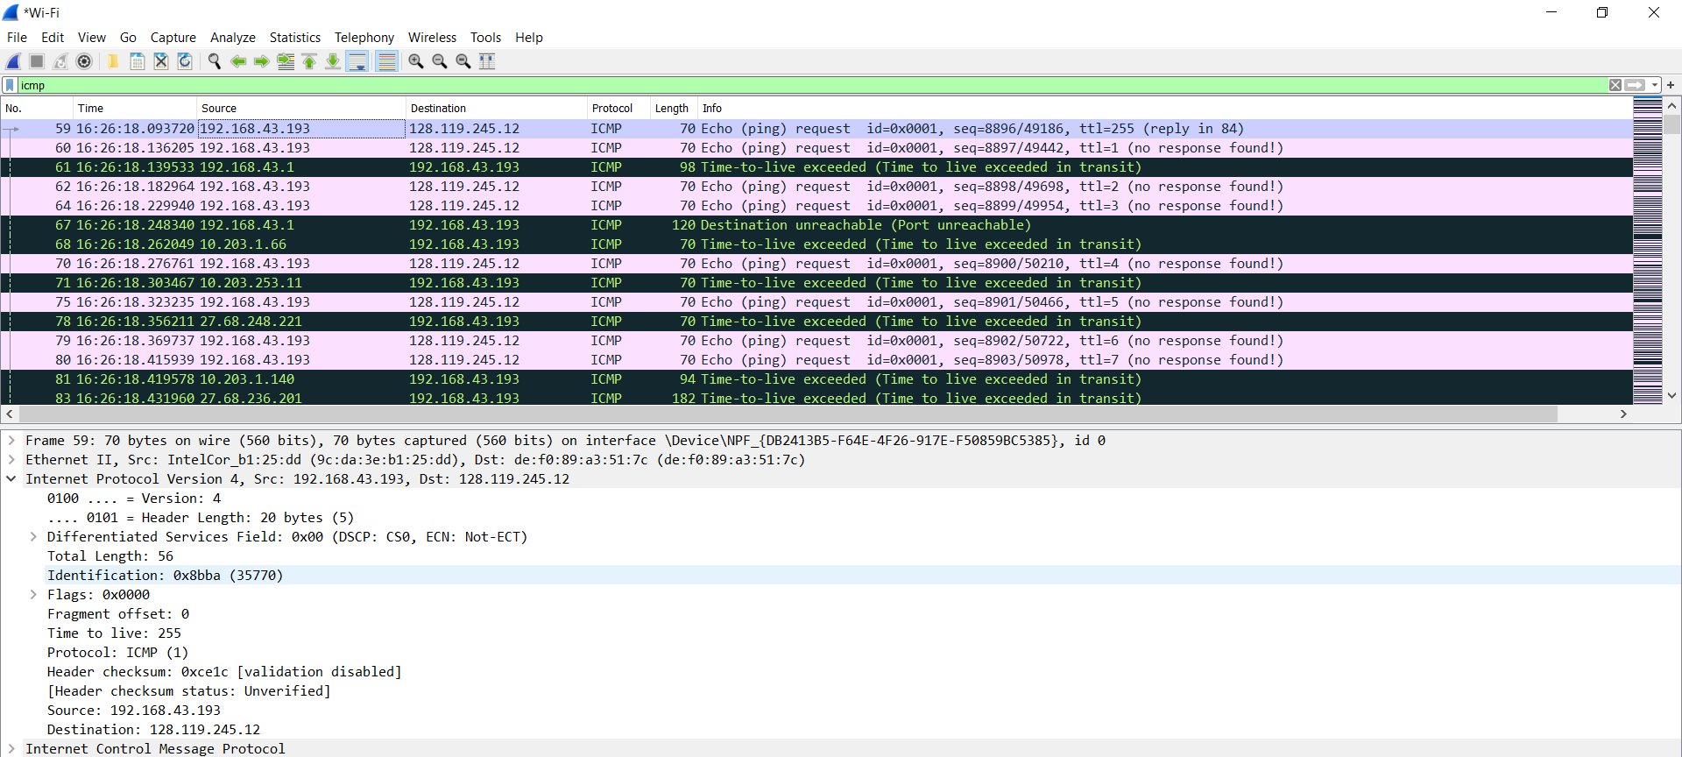

Câu 2:

the value in the upper layer protocol field is: 0x01(in hex) or 1(in dec).

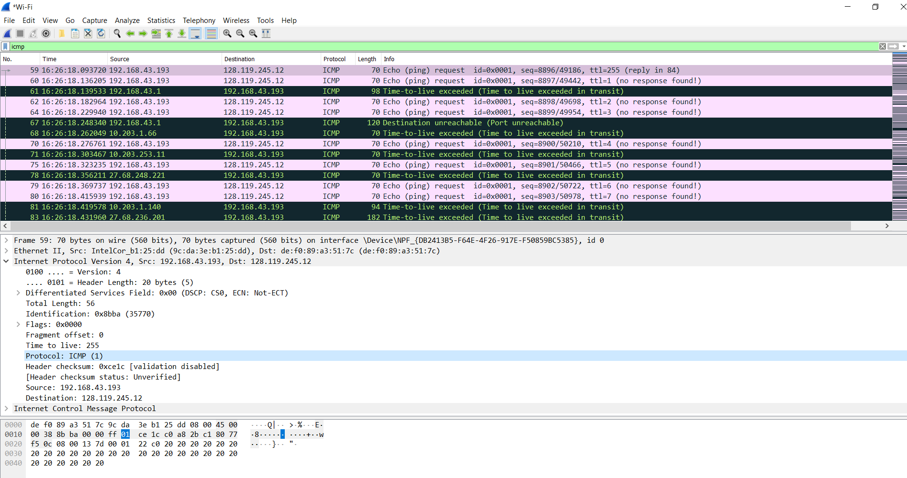

Câu 3:

Header Length: 20 bytes.

Total Length: 56 bytes.

=> The number of bytes in the payload of the IP datagram = Total Length - Header Length

= 56 - 20 = 36 bytes.

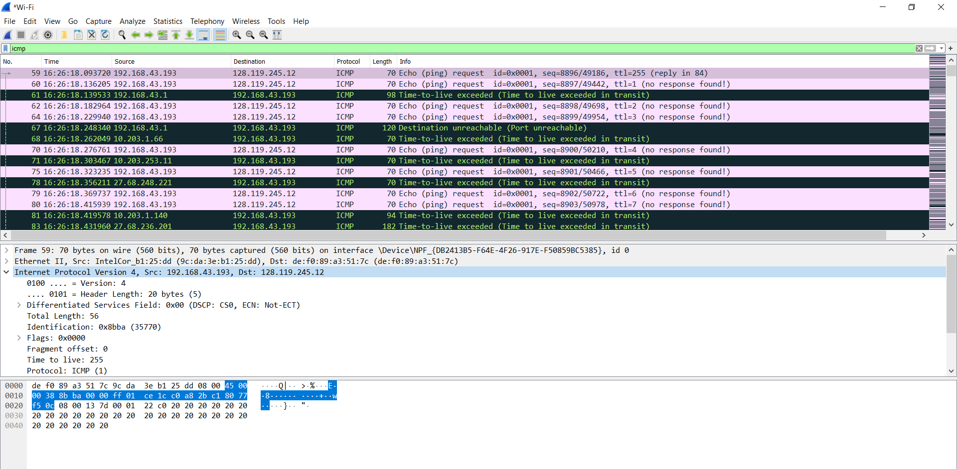

Câu 4:

NO, this IP datagram hasn’t been fragmented because we can see in the screenshot that **[Fragment offset: 0]**.

Câu 5:

There are 3 fields that are always change:

Identification

Time to live

Header checksum

Câu 6:

The fields that stay constant are:

• Version (since we are using IPv4 for all packets)

• Header length (since these are ICMP packets)

• Differentiated Services (since all packets are ICMP they use the same

Type of Service class)

• Source IP (since we are sending from the same source)

• Destination IP (since we are sending to the same dest)

• Upper Layer Protocol (since these are ICMP packets)

The fields that must stay constant are: Same as above.

The fields that must change:

• Identification(IP packets must have different ids)

• Time to live (traceroute increments each subsequent packet)

• Header checksum (since header changes, so must checksum)

Câu 7:

**the pattern I see in the values in the Identification field of the IP datagram is that the field increases by 1 with each ICMP Echo (ping) request.**

Câu 8:

Series of ICMP TTL exceeded replies sent to your computer by the nearest (first hop) router.

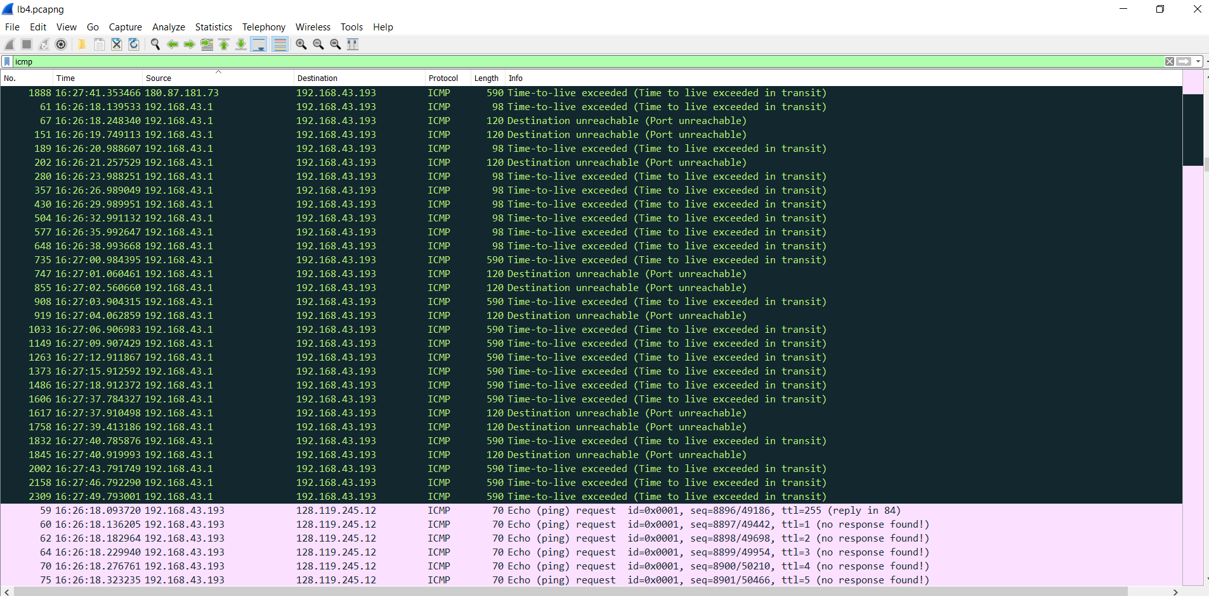

My nearest hop router was 192.168.43.1, which can be seen from the screenshot above

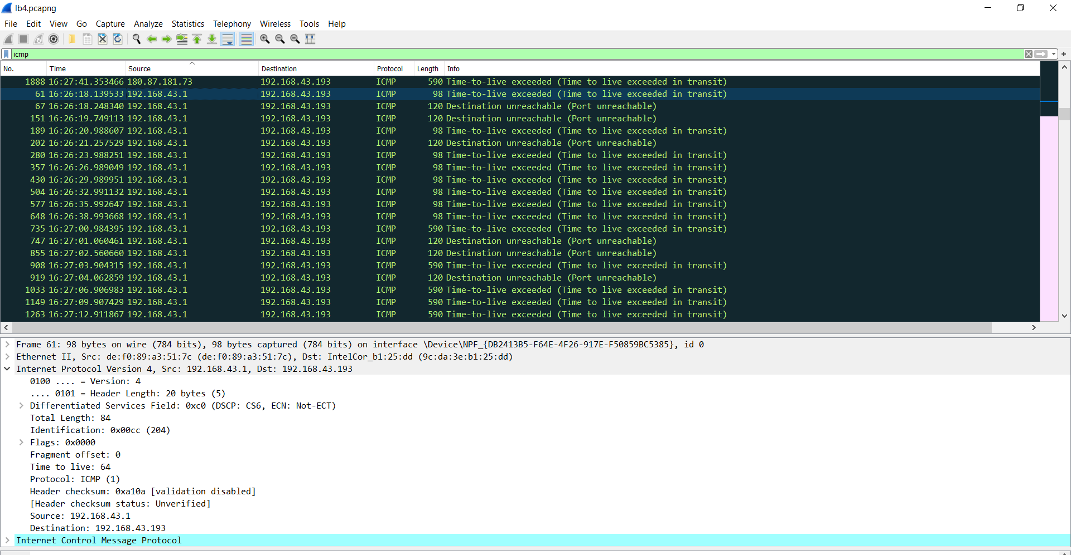

Identification: 204, TTL: 64

Câu 9:

* The identification field changes for all the ICMP TTL-exceeded repliesbecause the identification field is a unique value. When two or more IPdatagrams have the same identification value, then it means that these IPdatagrams are fragments of a single large IP datagram.

* The TLL field does not change because the time to live to the first hop router is always the same.

Câu 10:

Yes, that message has been fragmented across more than one IP datagram.

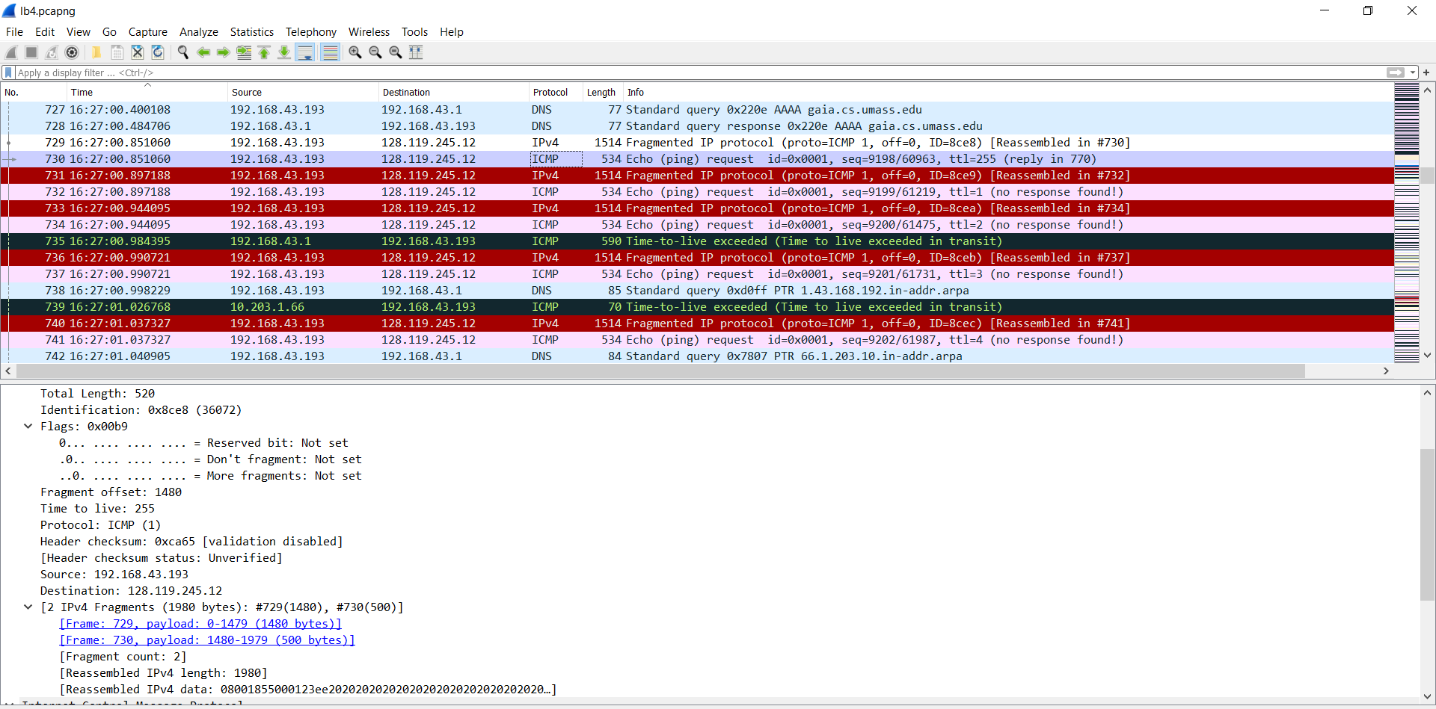

Câu 11:

* The flag is set for more segments shows that the the datagram has been fragmented

* The fragment offset is set to 0 indicating that this is the first fragment rather than a latter fragment where that value is is set to (1480).

* The datagram has a total length of 1500.

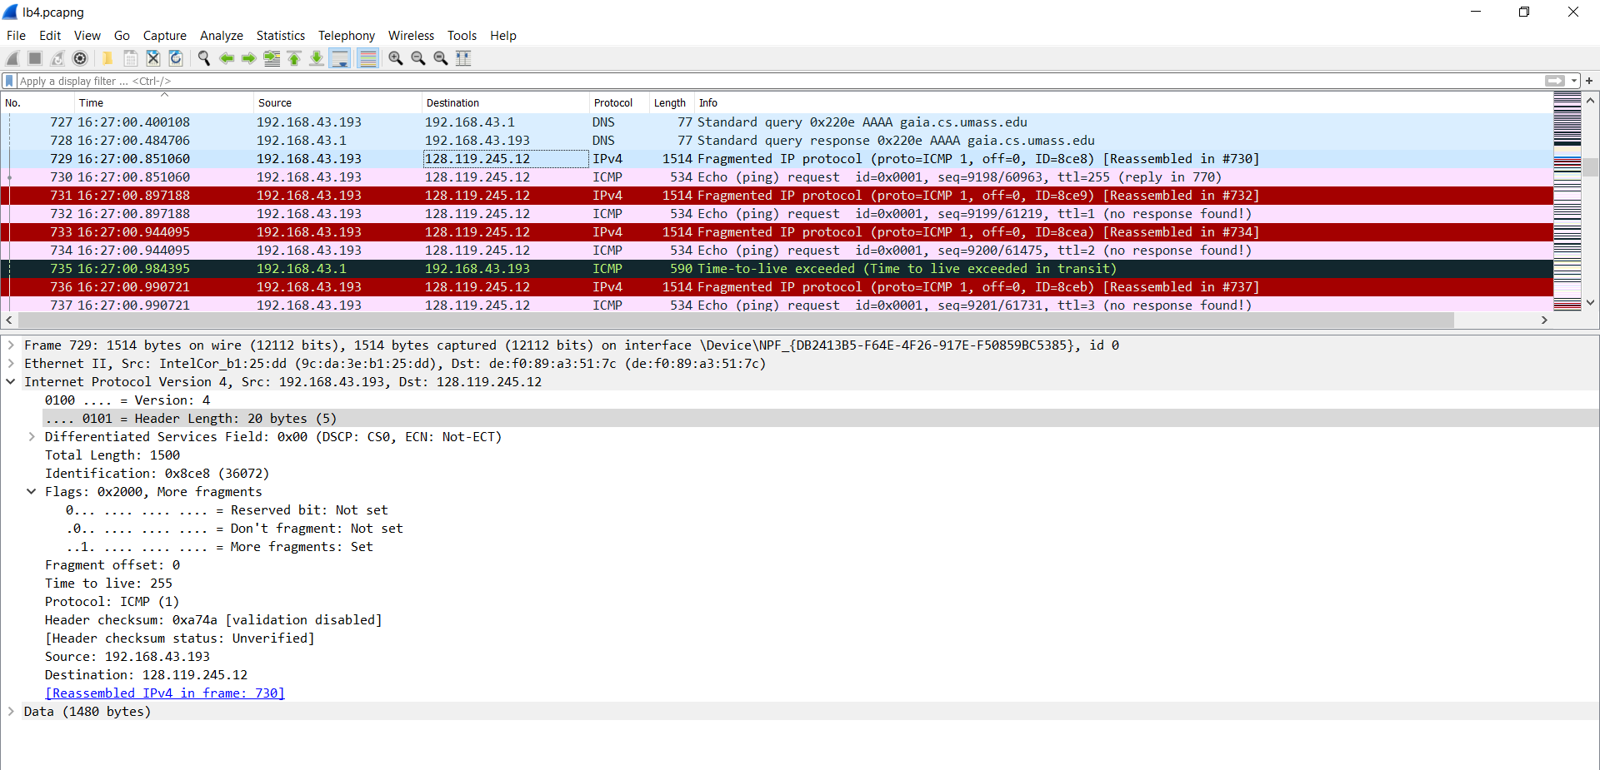

Câu 12:

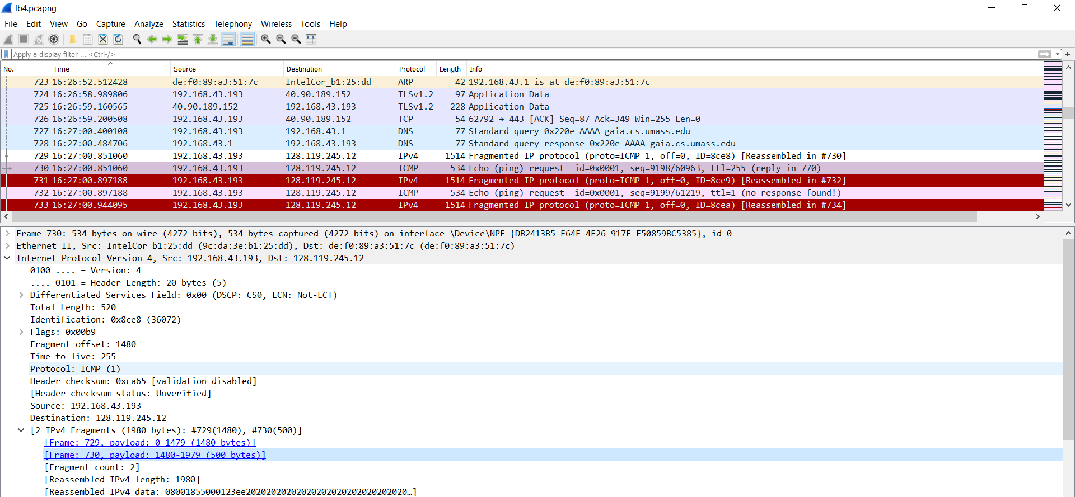

The second fragment is obvious because it now has a a fragment offset of 1480. There are no more fragments because it no longer has a flag set for more fragments

Câu 13:

Length

Flags Set

Fragment offset

header checksum

Câu 14:

Three fragments were created from the original datagram in this case.

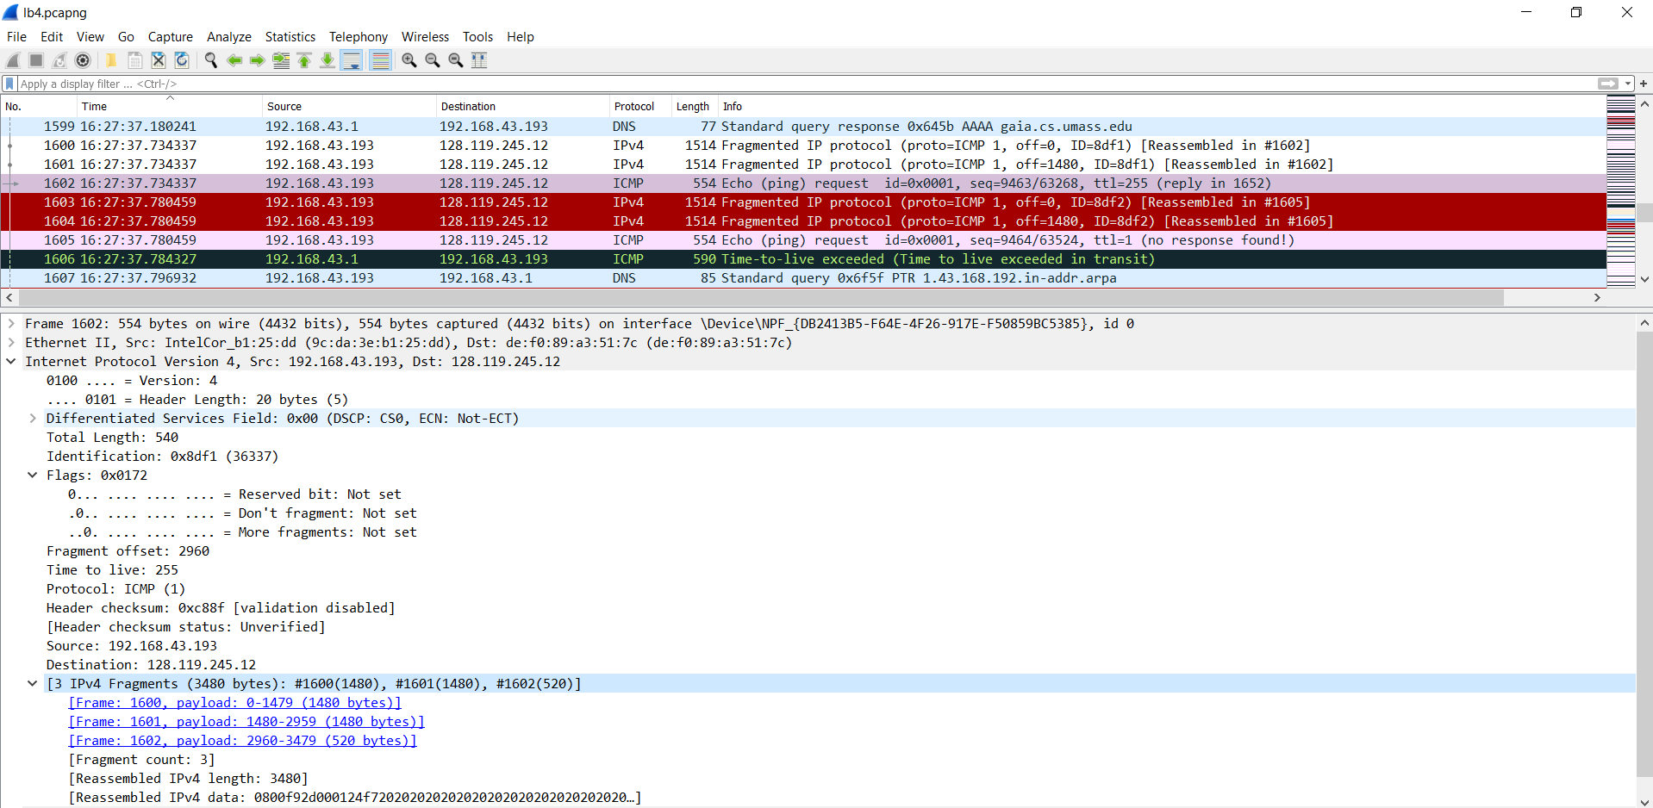

Câu 15:

+ Between fragments 1 and 2: fragment offset and checksum changes

+ Between fragments 2 and 3: total length, the more fragments bit, fragment offset, checksum .