Câu 1:

My 48-bit Ethernet address is 9c:da:3e:b1:25:dd

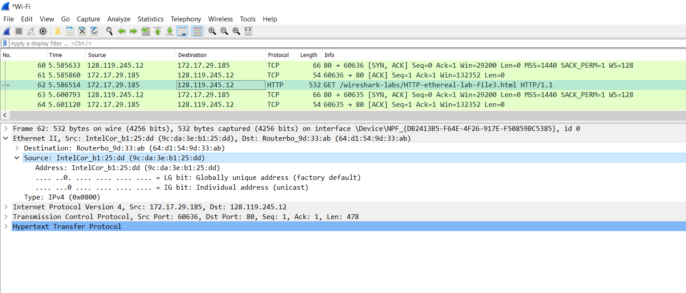

Câu 2:

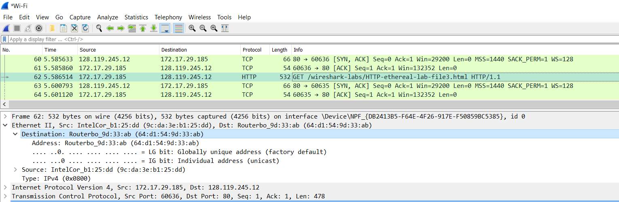

The 48-bit destination address: 64:d1:54:9d:33:ab  
This is not the Ethernet address of gaia.cs.umass.edu.

It is the address of my router which my computer has to go through in order to reach the destination. (internet gateway address)

Câu 3:

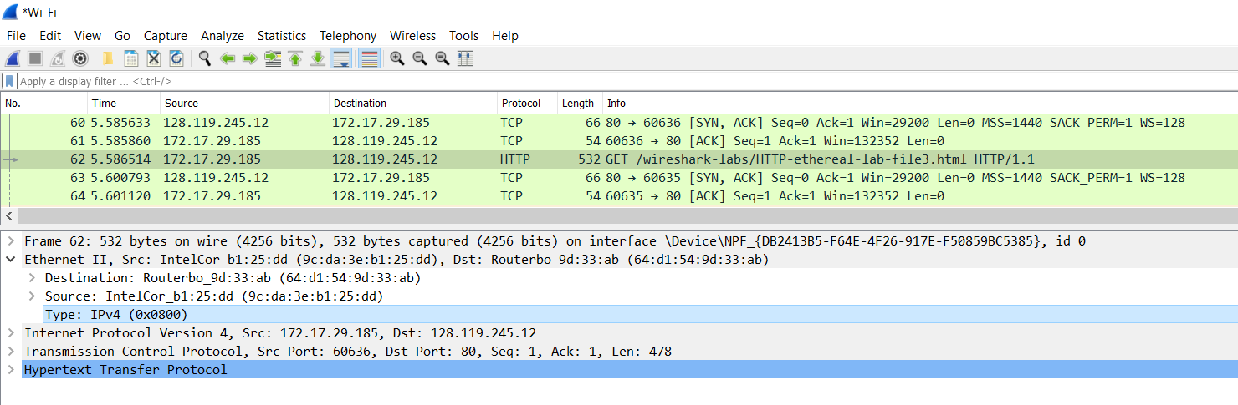

The hexadecimal value for the two-byte Frame type field: 0x0800

This is correspond to IP protocol

Câu 4:

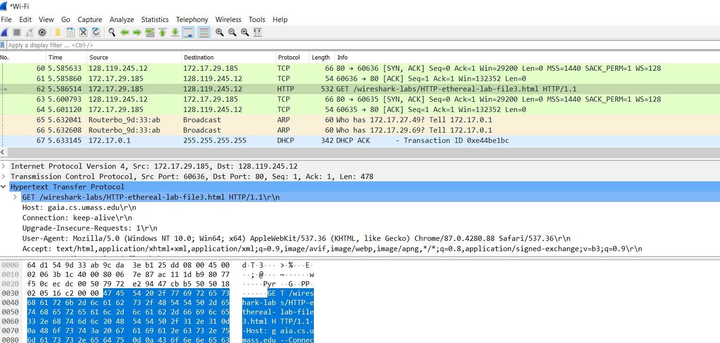

After 54 bytes the G in ‘GET’ appears.

Câu 5:

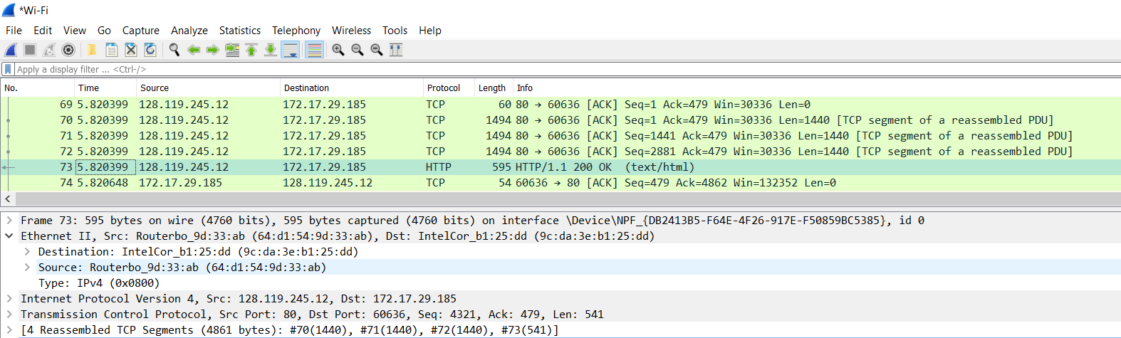The value of the Ethernet source address: (64:d1:54:9d:33:ab)

This is not the address of my computer, or of gaia.cs.umass.edu,

This is the address of my router

Câu 6:

The destination address in the Ethernet frame is (9c:da:3e:b1:25:dd)

This is the Ethernet address of my computer

Câu 7:

The hex value of this field is 0x0800.

It corresponds to the IP protocol

Câu 8:

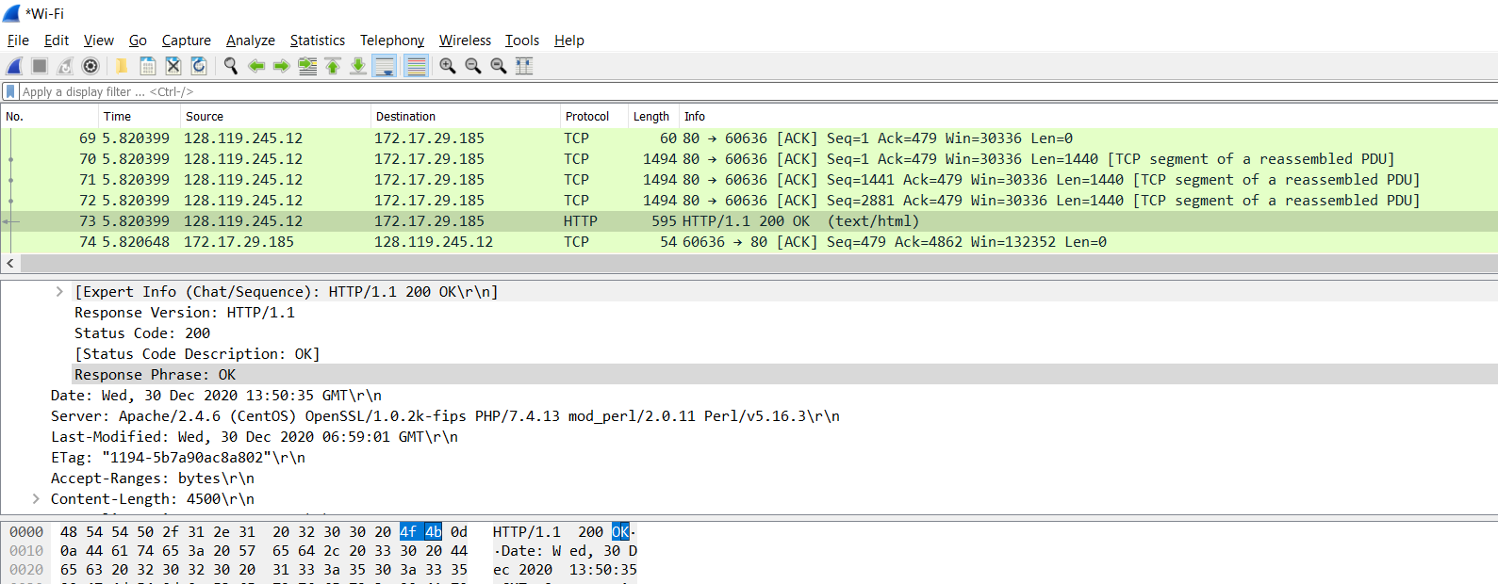

The O in the ‘OK’ starts after 13 bytes.

Câu 9:

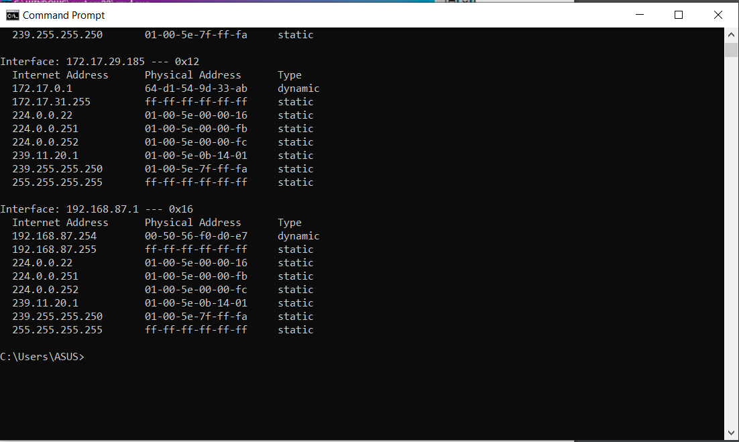

The Internet Address column contains the IP address

the Physical Address column contains the MAC address,

the type indicates the protocol type.

Câu 10:

The Source address is (9c:da:3e:b1:25:dd)  
The Destination address is (ff:ff:ff:ff:ff:ff)

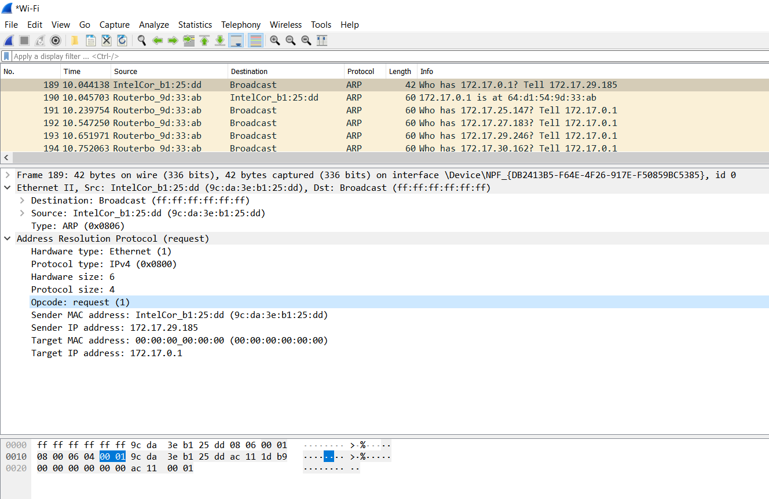

Câu 11:

The hex value for the two byte Ethernet frame is (0x0806)

The corresponding upper layer protocol is ARP

Câu 12:

a ) 20 bytes

b ) The hex value for opcode field withing the ARP-payload of the request is 0x0001

c ) Yes, the ARP message containing the IP address 172.17.29.185

d ) The "question" is in the field Target MAC address (00:00:00:00:00:00)

Câu 13:

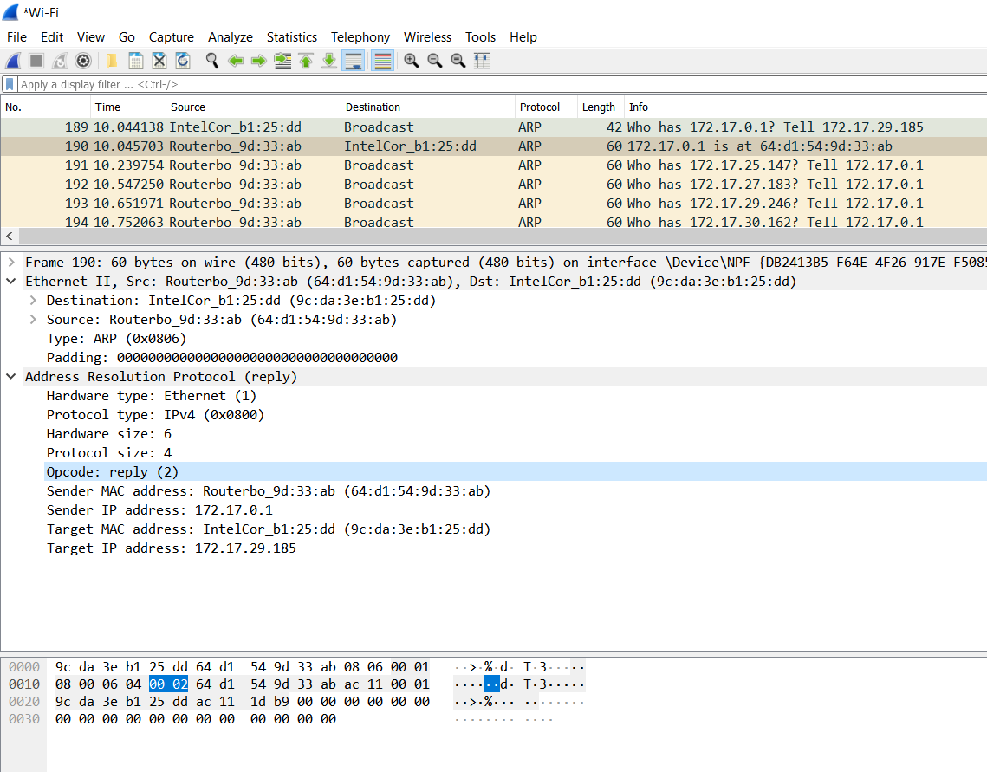

a ) 20 bytes

b ) The hex value for opcode field withing the ARP-payload of the response

is 0x0002

c ) The "answer" appears in the Sender MAC Address field.

Câu 14:

Destination: (9c:da:3e:b1:25:dd)

Source: (64:d1:54:9d:33:ab)

Câu 15:

Because we are not at the machine that sent the request.The ARP request is broadcast, but the ARP reply is not broadcast. The reply will be sent to the computer who made the request directly.