ANALYSIS OF FACTORS AFFECTING STUDENT ACADEMIC PERFORMANCE USING SQL AND PYTHON
A 10-Step Data Science Methodology & Statistical Modeling Approach (Subject: Data Science with Python & SQL - ADY201m)
Project Team — ADY201m
FPT University, Vietnam
Abstract: Understanding the determinants of student academic achievement is critical for educational institutions seeking to allocate support resources effectively. This study implements the complete 10-step Data Science Methodology—spanning Business Understanding, Analytic Approach, Data Requirements, Data Collection, Data Understanding, Data Preparation, Modeling, Evaluation, Deployment, and Feedback—combined with Exploratory Data Analysis (EDA), statistical hypothesis testing (ANOVA and T-tests), and regression modeling on the StudentPerformanceFactors dataset (6,607 records, 16 attributes). Using SQLite and Python (Pandas, NumPy, SciPy, Scikit-learn), we establish a dual-verification data cleaning pipeline that preserves raw data integrity while flagging out-of-range anomalies (1 record with Exam_Score = 101 at student_id = 1526 set to NULL) and standardizing missing categorical values (78 in Teacher_Quality and 90 in Parental_Education_Level mapped to Unknown). SQL rule-based segmentation utilizing CTEs and window functions (RANK, SUM OVER) reveals that students studying over 30 hours per week achieve an average score of 71.01 (+3.78 above the overall mean of 67.23), compared to 63.97 for those studying 10 hours or less. Correlation and ANOVA results demonstrate that Attendance (r = 0.581) and Hours_Studied (r = 0.445) are the strongest numerical predictors, while Access_to_Resources, Parental_Involvement, Parental_Education_Level, Peer_Influence, Family_Income, Motivation_Level, Teacher_Quality, and Extracurricular_Activities all exhibit statistically significant effects (p < 0.001). Conversely, Gender (p = 0.869) and School_Type (p = 0.472) show no statistically significant difference. Finally, multivariate Linear Regression explains 60.8%–68.4% of exam score variance, confirming strong synergistic interactions between behavioral effort and family/school support.
Keywords: Student performance analysis, Data Science Methodology, SQL data wrangling, Exploratory Data Analysis (EDA), ANOVA, Linear Regression, Educational Data Mining, Python & SQLite.

1. Introduction
Academic performance serves as a vital indicator of educational effectiveness and student development. In modern higher education and secondary schooling, identifying which study habits, socioeconomic conditions, and institutional factors correspond to higher or lower examination scores allows administrators and educators to design targeted early-intervention programs [1], [2]. Rather than relying on intuition, data-driven decision-making requires a rigorous, reproducible workflow that integrates database querying (SQL) with statistical programming (Python).
Real-world educational datasets frequently contain missing observations, unstandardized text fields, lack of primary keys, and out-of-range recording errors. Modifying raw data directly or imputing arbitrary values can distort downstream statistical conclusions. Therefore, this project adopts the 10-step Data Science Methodology taught at FPT University, ensuring that every stage—from problem formulation to SQL/Python cross-verification and deployment—is transparent, auditable, and aligned with best practices [3], [4].
Specifically, this study addresses three core analytical questions: (1) What is the baseline distribution and central tendency of student exam scores, and what data quality anomalies exist in the raw records? (2) How do examination outcomes vary across weekly study-hour tiers and attendance brackets when modeled via SQL window functions and Python aggregations? (3) How do psychological, familial, and environmental factors (motivation, parental involvement, parental education, resource access, peer influence, teacher quality, and extracurricular participation) interact and contribute to predicting student exam scores?

2. Literature Review and Data Science Methodology

2.1 Literature Review
Educational Data Mining (EDM) and Learning Analytics have extensively examined the multifaceted drivers of student achievement. Cortez and Silva [1] demonstrated that past academic performance, study time, and school attendance are primary determinants of secondary student grades. Subsequent studies by Romero and Ventura [2] and Shahiri et al. [3] emphasized that combining behavioral metrics (attendance, study hours) with socioeconomic and familial indicators (parental education, family income, parental engagement) substantially improves explanatory power.
From a methodological standpoint, recent literature highlights that descriptive and rule-based SQL analytics complement statistical hypothesis testing and regression modeling [4], [5]. While machine learning models quantify overall variance explained (R²), structured SQL queries using Common Table Expressions (CTEs) and window functions provide interpretable cohort benchmarks that academic advisors can directly act upon without black-box complexity.

2.2 The 10-Step Data Science Methodology
Following John Rollins’ foundational Data Science Methodology framework adopted in the ADY201m curriculum at FPT University, our workflow is structured into ten sequential and iterative stages:
Table 1: Implementation of the 10-Step Data Science Methodology in This Study
Step | Methodology Stage | Implementation in Student Performance Project
1 | Business Understanding | Define the core problem: identify academic and environmental factors associated with high/low Exam_Score to prioritize student support.
2 | Analytic Approach | Combine descriptive SQL cohort segmentation, statistical hypothesis testing (ANOVA/T-test), Pearson correlation, and Linear Regression.
3 | Data Requirements | Select 16 attributes from StudentPerformanceFactors.csv (6 numeric, 10 categorical); generate rowid-based student_id primary key.
4 | Data Collection | Ingest CSV into SQLite (raw_students table); execute initial retrieval queries (Top 10 high-attendance students; School_Type × Gender).
5 | Data Understanding | Audit row counts (6,607), full-row duplicates (0), missing values (Teacher_Quality: 78, Parental_Education_Level: 90), and domain bounds.
6 | Data Preparation | Create clean table students_clean_sql & DataFrame clean_py: snake_case columns, TRIM text, missing -> Unknown, Exam_Score > 100 -> NULL.
7 | Modeling | SQL rule-based segmentation (CASE WHEN, CTE, RANK OVER) by study hours & Motivation × Parental Involvement; Python Linear Regression.
8 | Evaluation | Cross-verify SQL vs. Python outputs (exact match on row counts, means, and groups); evaluate attendance tiers and ANOVA significance.
9 | Deployment | Export cleaned datasets (student_performance_cleaned_sql.csv, analysis_study_groups.csv), SQLite DB, and standalone SQL script.
10 | Feedback | Synthesize findings, flag anomalous record (student_id = 1526) for source verification, and propose institutional interventions.

3. Data Collection, Preprocessing, and Exploratory Data Analysis

3.1 Dataset Overview and Initial SQL Retrieval (Steps 3 & 4)
The primary dataset, StudentPerformanceFactors.csv, comprises 6,607 student records and 16 attributes (6 numerical variables and 10 categorical variables). Because the raw CSV does not include an explicit identifier column, a sequential primary key (student_id) is generated using SQLite rowid (equivalent to 1-based row indexing in Python). In Step 4, the raw dataset is loaded into the SQLite database (student_analysis.db) as table raw_students. Initial retrieval queries confirm that Public schools account for 4,598 students (1,950 Female with mean score 67.22; 2,648 Male with mean score 67.21) and Private schools account for 2,009 students (843 Female with mean score 67.30; 1,166 Male with mean score 67.28), matching Pandas groupby results identically.
Table 2: Summary of Dataset Variables and Specifications
Category | Variable Name | Data Type | Valid Domain / Categories | Missing
Target Variable | Exam_Score | Numeric (Int) | 0–100 (Raw range: 55–101; 1 record = 101) | 0 (1 invalid)
Study Behavior | Hours_Studied | Numeric (Int) | 0–168 hours/week (Observed: 1–44) | 0
Study Behavior | Attendance | Numeric (Int) | 0–100% (Observed: 60–100%) | 0
Academic History | Previous_Scores | Numeric (Int) | 0–100 (Observed: 50–100) | 0
Lifestyle | Sleep_Hours | Numeric (Int) | 0–24 hours/day (Observed: 4–10) | 0
Lifestyle | Physical_Activity | Numeric (Int) | Hours/week (Observed: 0–6) | 0
Family & Home | Parental_Involvement | Categorical | Low, Medium, High | 0
Family & Home | Parental_Education_Level | Categorical | High School, College, Postgraduate | 90 (1.36%)
Family & Home | Family_Income | Categorical | Low, Medium, High | 0
School & Access | Access_to_Resources | Categorical | Low, Medium, High | 0
School & Access | Teacher_Quality | Categorical | Low, Medium, High | 78 (1.18%)
School & Access | School_Type | Categorical | Public, Private | 0
Student & Peer | Motivation_Level | Categorical | Low, Medium, High | 0
Student & Peer | Peer_Influence | Categorical | Negative, Neutral, Positive | 0
Student & Peer | Extracurricular_Activities | Categorical | Yes, No | 0
Demographics | Gender | Categorical | Male, Female | 0

3.2 Data Quality Audit and SQL/Python Cleaning Pipeline (Steps 5 & 6)
In Step 5 (Data Understanding), comprehensive SQL and Python quality checks were executed on raw_students:
• Total records: 6,607 rows; Full-row duplicate groups: 0.
• Missing values: Only two categorical columns contain NULL/empty entries—Teacher_Quality (78 rows, 1.18%) and Parental_Education_Level (90 rows, 1.36%).
• Domain validation: Checking numerical bounds (Exam_Score, Previous_Scores, Attendance in [0, 100]; Sleep_Hours in [0, 24]; Hours_Studied in [0, 168]) identified exactly 1 out-of-range record: student_id = 1526 (Female, Hours_Studied = 27, Attendance = 98%, Previous_Scores = 93, Exam_Score = 101).
In Step 6 (Data Preparation), rather than overwriting the raw table or arbitrarily capping the invalid score to 100, a new normalized table students_clean_sql was constructed using a SQL CTE (WITH standardized AS (...)) and ROW_NUMBER() window deduplication:
1. All column names are standardized to lowercase snake_case and string columns are stripped of whitespace using TRIM().
2. Missing values in teacher_quality and parental_education_level are explicitly mapped to "Unknown" via COALESCE(NULLIF(TRIM(col), ''), 'Unknown').
3. Out-of-range numerical values (specifically Exam_Score = 101) are converted to NULL using CASE WHEN Exam_Score BETWEEN 0 AND 100 THEN Exam_Score ELSE NULL END, leaving 6,606 valid exam scores for aggregation.
4. Identical cleaning rules were implemented in Python (clean_py) and saved to students_clean_python, achieving 100% reconciliation.
Table 3: Data Cleaning Reconciliation Between SQL and Python (Step 6)
Audit Metric | Raw Dataset (raw_students) | Cleaned SQL (students_clean_sql) | Cleaned Python (clean_py)
Total Records | 6,607 | 6,607 | 6,607
Primary Key (student_id) | None (Implicit row order) | 1 to 6,607 (rowid) | 1 to 6,607 (Int64)
Full Duplicate Rows | 0 | 0 (Verified via ROW_NUMBER) | 0 (Verified via duplicated)
Missing Teacher_Quality | 78 NULL / empty | 0 (78 mapped to Unknown) | 0 (78 mapped to Unknown)
Missing Parental_Education | 90 NULL / empty | 0 (90 mapped to Unknown) | 0 (90 mapped to Unknown)
Out-of-Range Exam_Score (>100) | 1 (student_id=1526, score=101) | 0 (1 flagged as NULL) | 0 (1 flagged as NaN/NA)
Valid Exam_Score Mean | 67.236 | 67.231 (n = 6,606) | 67.231 (n = 6,606)

3.3 Descriptive Statistics and IQR Outlier Analysis
Table 4 summarizes the descriptive statistics and Interquartile Range (IQR) outlier audit across all six numerical attributes. The five predictor variables (Hours_Studied, Attendance, Sleep_Hours, Previous_Scores, Physical_Activity) exhibit near-zero skewness (|skew| < 0.04), indicating highly symmetric distributions. Conversely, Exam_Score displays positive right-skewness (skewness = 1.645, kurtosis = 10.575) due to a cluster of high-achieving students scoring between 76 and 100.
Table 4: Descriptive Statistics and IQR Outlier Detection for Numerical Variables
Variable | Mean | Median | Std Dev | Min | Q1 (25%) | Q3 (75%) | Max | Skewness | IQR Outliers
Hours_Studied | 19.98 | 20.0 | 5.99 | 1 | 16.0 | 24.0 | 44 | 0.013 | 43 (0.65%)
Attendance (%) | 79.98 | 80.0 | 11.55 | 60 | 70.0 | 90.0 | 100 | 0.014 | 0 (0.00%)
Sleep_Hours | 7.03 | 7.0 | 1.47 | 4 | 6.0 | 8.0 | 10 | -0.024 | 0 (0.00%)
Previous_Scores | 75.07 | 75.0 | 14.40 | 50 | 63.0 | 88.0 | 100 | -0.004 | 0 (0.00%)
Physical_Activity | 2.97 | 3.0 | 1.03 | 0 | 2.0 | 4.0 | 6 | -0.031 | 0 (0.00%)
Exam_Score (Raw) | 67.24 | 67.0 | 3.89 | 55 | 65.0 | 69.0 | 101 | 1.645 | 104 (1.57%)

3.4 Exploratory Data Analysis and Visualizations
Figure 1 illustrates the distribution of Exam_Score via histogram and Kernel Density Estimation (KDE). Most students score within a tight band between 63 and 71 (Q1 = 65.0, Median = 67.0, Mean = 67.24, Q3 = 69.0), with a right tail of exceptional performers.
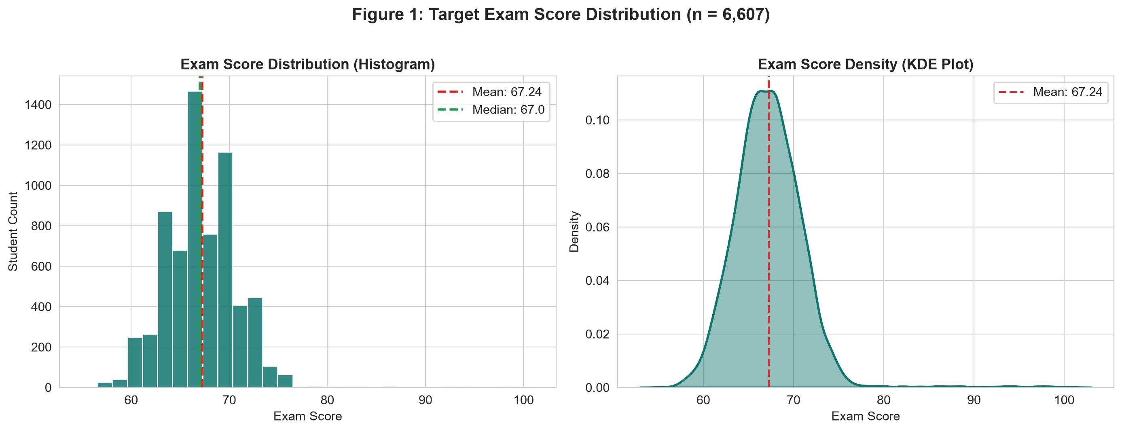
Figure 1: Target Exam Score Distribution (Histogram and KDE, n = 6,607).
Figure 2 and Figure 3 examine bivariate linear relationships and the full Pearson correlation matrix across numerical variables. Attendance shows the strongest positive linear correlation with Exam_Score (r = 0.581, slope = 0.20 points per 1% attendance), followed by Hours_Studied (r = 0.445, slope = 0.29 points per weekly study hour) and Previous_Scores (r = 0.175). In contrast, Sleep_Hours (r = -0.017) and Physical_Activity (r = 0.028) show negligible direct linear correlation with exam performance.
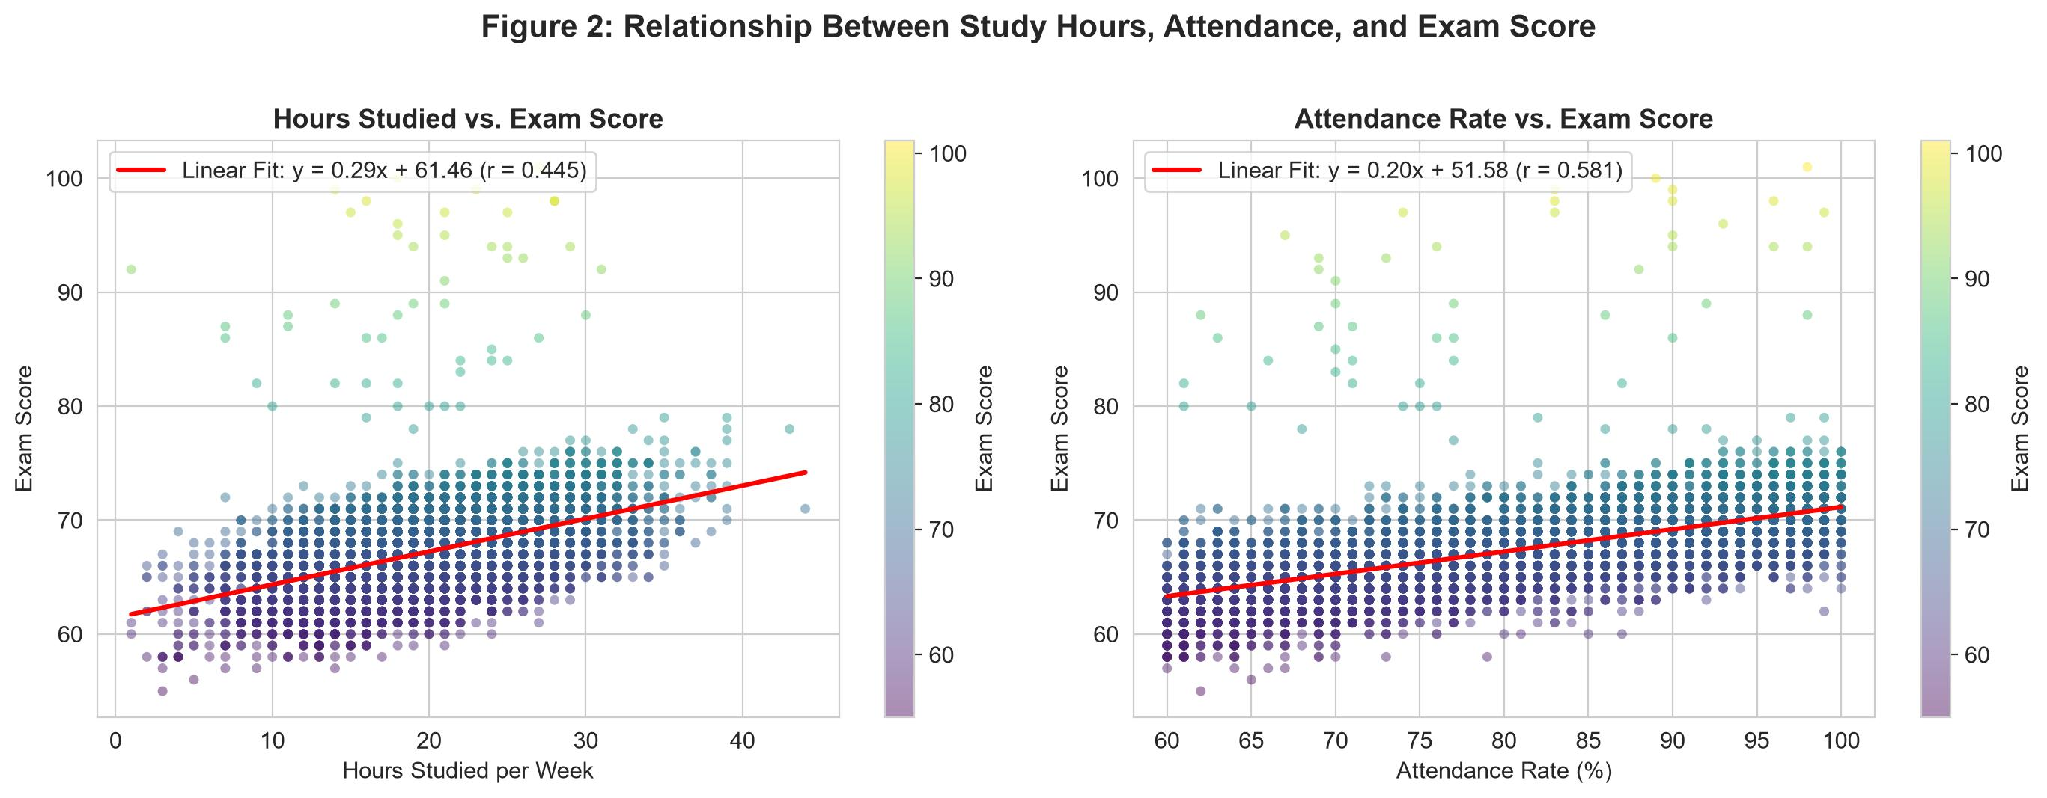
Figure 2: Scatter Plots and Linear Regression Fits for Study Hours and Attendance vs. Exam Score.
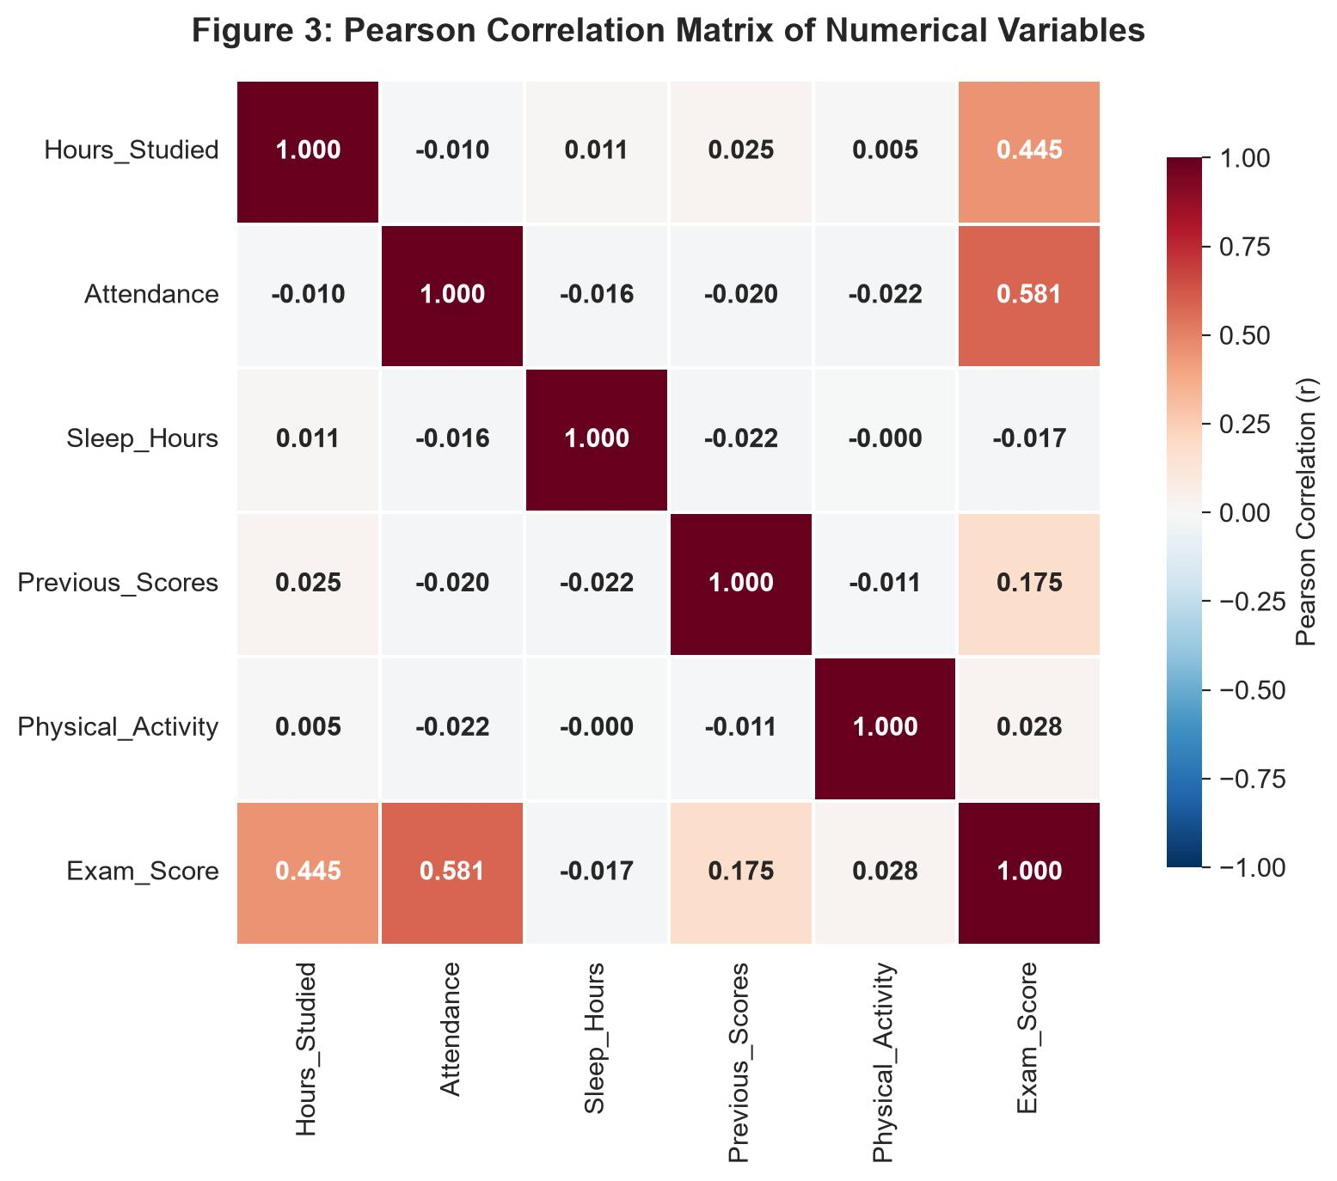
Figure 3: Pearson Correlation Matrix Across All Six Numerical Variables.
Figure 4 and Figure 5 present the distributions of Exam_Score across categorical variables. Clear monotonic increases in mean scores are observed as Parental_Involvement, Motivation_Level, Access_to_Resources, Family_Income, Teacher_Quality, and Peer_Influence improve from Low/Negative to High/Positive. Conversely, Figure 5 demonstrates that score distributions across Gender (Male vs. Female) and School_Type (Public vs. Private) are virtually indistinguishable, whereas Parental_Education_Level combined with Extracurricular_Activities produces a pronounced upward shift.
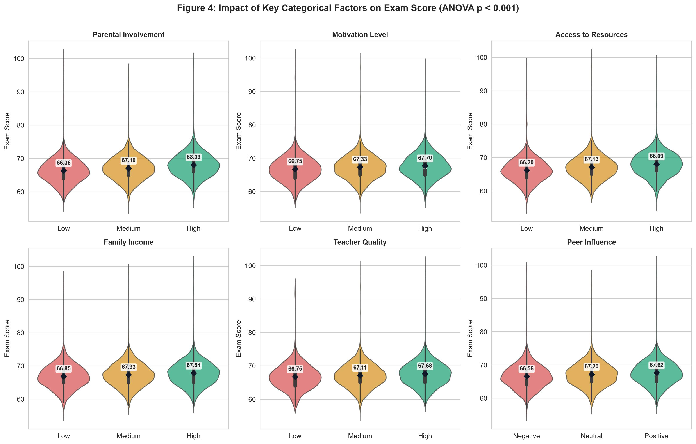
Figure 4: Violin and Box Plots of Exam Score Across Six Key Categorical Factors.
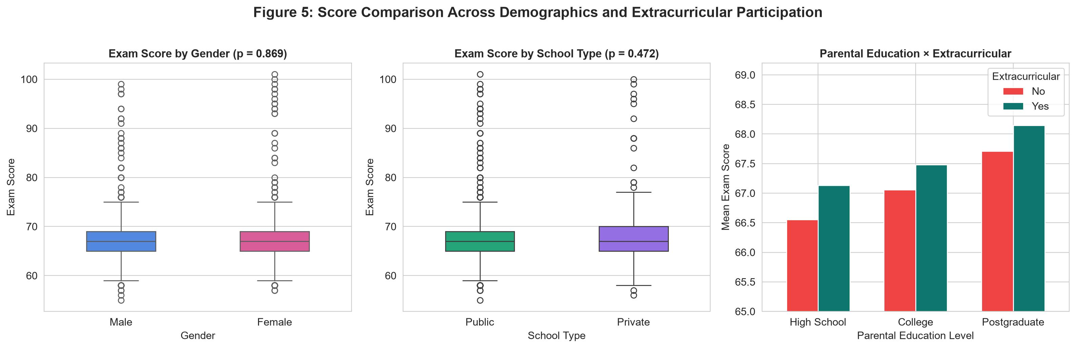
Figure 5: Exam Score Comparison by Gender, School Type, and Parental Education × Extracurricular Activities.

4. Modeling and Statistical Hypothesis Testing

4.1 SQL Rule-Based Segmentation Model (Step 7)
In Step 7 of the SQL/Python workflow, a rule-based segmentation model was built using SQL CASE WHEN expressions, Common Table Expressions (CTEs), and window functions (RANK() OVER and weighted average SUM() OVER ()). Students with valid scores (n = 6,606) were categorized into four weekly study-hour tiers: Group 1 (≤10h), Group 2 (11–20h), Group 3 (21–30h), and Group 4 (>30h). As shown in Table 5 and Figure 6, mean exam scores rise steadily by more than 7 points from Group 1 (63.97, -3.26 vs. overall mean) to Group 4 (71.01, +3.78 vs. overall mean), while average attendance remains constant (~79–80%) across all study tiers—proving that study hours contribute independent value beyond attendance.
Table 5: SQL Rule-Based Study Hour Segmentation Results (Step 7 Query Output)
Study Group (Hours/Week) | Student Count | Avg Exam Score | Avg Attendance (%) | Diff vs. Overall (67.23) | Score Rank
1. <=10h | 365 | 63.97 | 80.15% | -3.26 | 4
2. 11-20h | 3,179 | 66.18 | 80.05% | -1.05 | 3
3. 21-30h | 2,809 | 68.51 | 79.94% | +1.28 | 2
4. >30h | 253 | 71.01 | 79.13% | +3.78 | 1

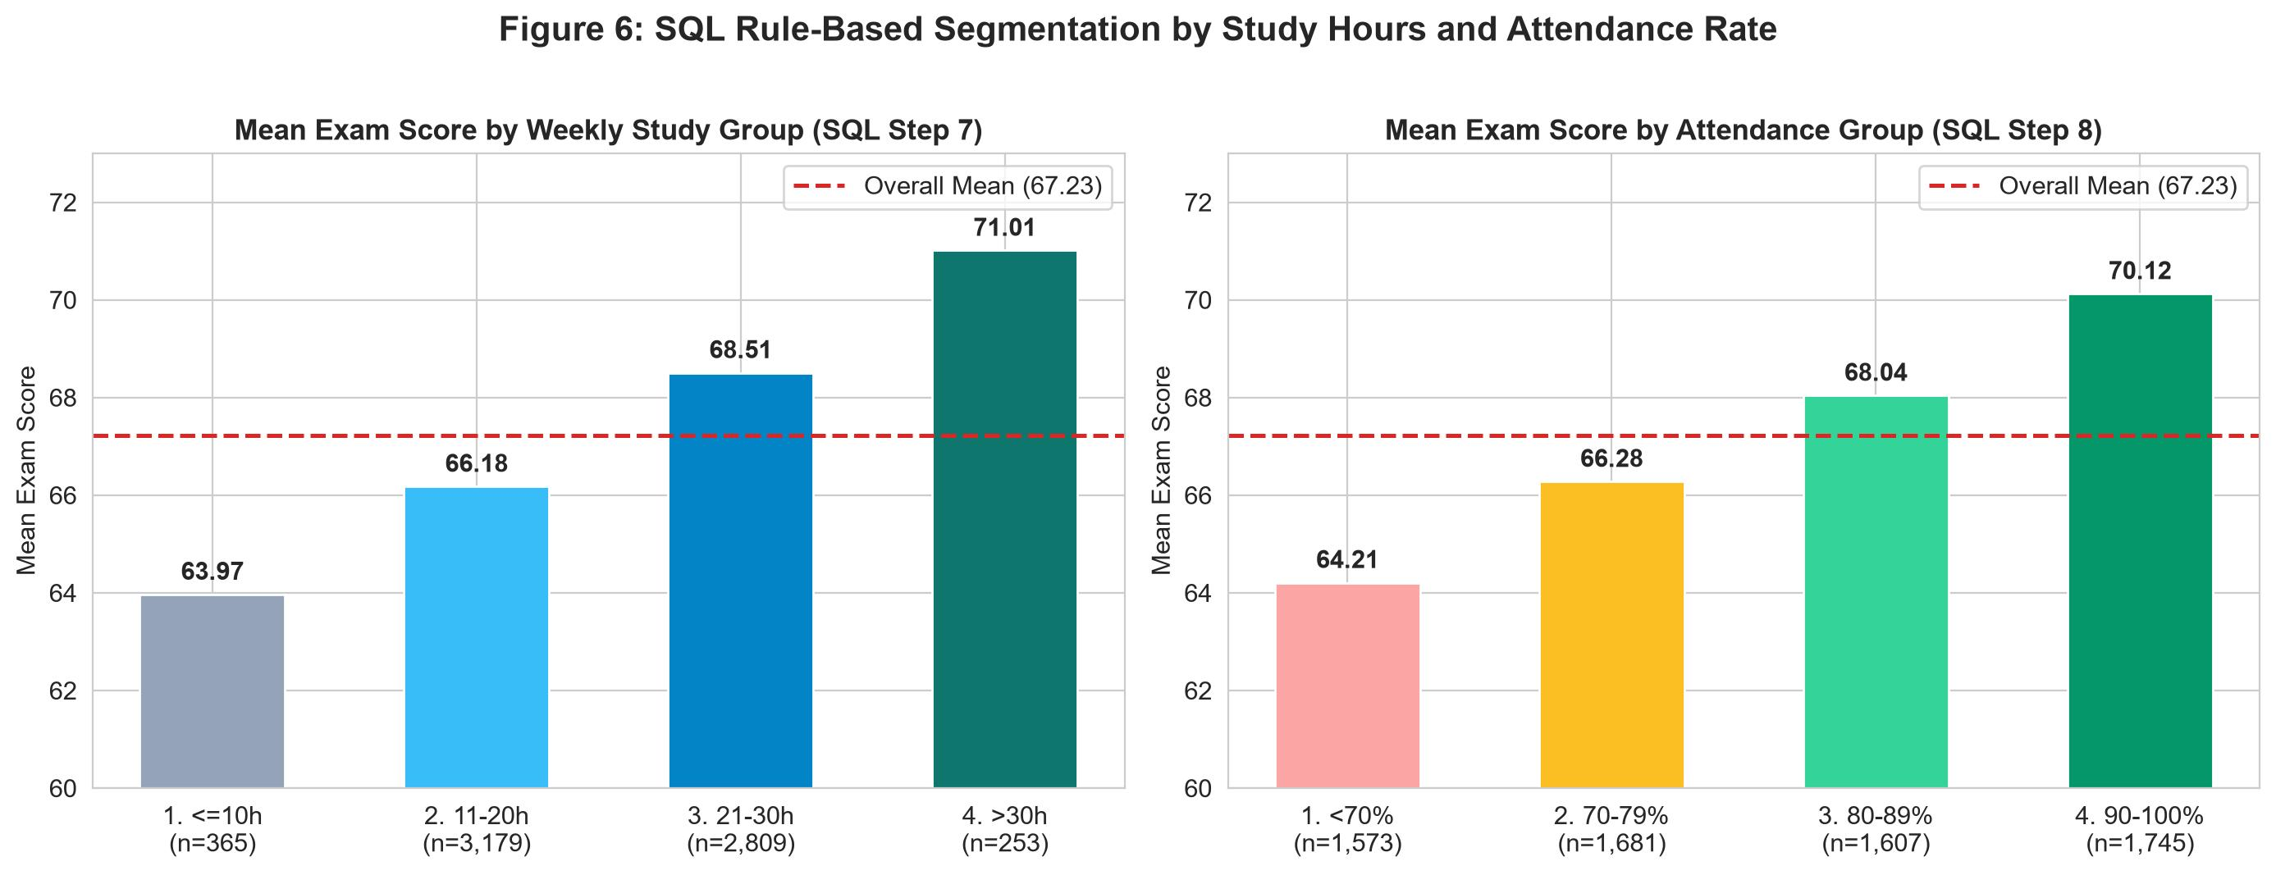
Figure 6: Mean Exam Score by SQL Study-Hour Tiers (Step 7) and Attendance Brackets (Step 8).

4.2 Statistical Hypothesis Testing (ANOVA and T-Tests)
To rigorously test whether observed group differences are statistically significant, one-way Analysis of Variance (ANOVA) was conducted for multi-category variables and two-sample independent T-tests were conducted for binary variables. Table 6 confirms that 8 out of 10 categorical variables significantly affect Exam_Score (p < 0.001), led by Access_to_Resources (F = 98.00) and Parental_Involvement (F = 84.49). Gender (p = 0.869) and School_Type (p = 0.472) have no statistically significant impact.
Table 6: Summary of One-Way ANOVA and Independent T-Test Results Across Categorical Factors
Categorical Variable | Test Type | Test Statistic | p-value | Group Means (Lowest -> Highest) | Conclusion (α = 0.05)
Access_to_Resources | ANOVA | F = 98.0044 | < 0.000001 | Low: 66.20 | Med: 67.13 | High: 68.09 | Significant (p < 0.05)
Parental_Involvement | ANOVA | F = 84.4877 | < 0.000001 | Low: 66.36 | Med: 67.10 | High: 68.09 | Significant (p < 0.05)
Parental_Education_Level | ANOVA | F = 36.4272 | < 0.000001 | HS: 66.89 | Col: 67.32 | Postgrad: 67.97 | Significant (p < 0.05)
Peer_Influence | ANOVA | F = 34.0521 | < 0.000001 | Neg: 66.56 | Neu: 67.20 | Pos: 67.62 | Significant (p < 0.05)
Family_Income | ANOVA | F = 29.7939 | < 0.000001 | Low: 66.85 | Med: 67.33 | High: 67.84 | Significant (p < 0.05)
Motivation_Level | ANOVA | F = 25.7168 | < 0.000001 | Low: 66.75 | Med: 67.33 | High: 67.70 | Significant (p < 0.05)
Teacher_Quality | ANOVA | F = 19.6394 | < 0.000001 | Low: 66.75 | Med: 67.11 | High: 67.68 | Significant (p < 0.05)
Extracurricular_Activities | T-test | t = -5.2433 | < 0.000001 | No: 66.93 | Yes: 67.44 | Significant (p < 0.05)
School_Type | T-test | t = 0.7188 | 0.472318 | Public: 67.21 | Private: 67.29 | Not Significant
Gender | T-test | t = 0.1652 | 0.868815 | Male: 67.23 | Female: 67.24 | Not Significant

4.3 Multivariate Linear Regression and Interaction Analysis
Figure 7 displays the SQL two-way cross-tabulation between Motivation_Level and Parental_Involvement alongside the coefficients of our multivariate Linear Regression model. Students with both High Motivation and High Parental Involvement achieve an average score of 68.38, compared to 65.81 for those with Low Motivation and Low Parental Involvement (+2.57 points). Using Label Encoding across all 15 predictors (as implemented in StudentPerformanceAnalysis.ipynb), the Linear Regression model achieves R² = 0.608 (explaining 60.8% of total variance, Intercept = 42.22). When categorical variables are one-hot encoded to preserve ordinal spacing, explanatory power increases to R² = 0.684 (68.4% variance explained).
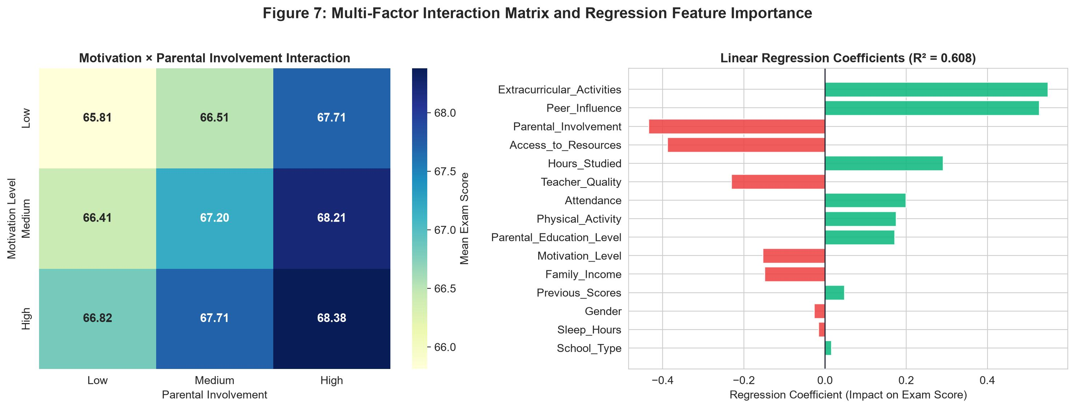
Figure 7: Motivation × Parental Involvement Interaction Matrix and Linear Regression Feature Coefficients.

5. Evaluation, Deployment, and Feedback (Steps 8, 9 & 10)

5.1 SQL and Python Evaluation & Cohort Comparisons (Step 8)
In Step 8, complex SQL evaluation queries utilizing CTEs, CROSS JOIN, and INNER JOIN were executed to benchmark student sub-cohorts against the overall population average (67.231). Segmenting by Attendance brackets reveals a 5.91-point gap between students with <70% attendance (mean = 64.21, n = 1,573) and those with 90–100% attendance (mean = 70.12, n = 1,746). Similarly, a CTE + CROSS JOIN analysis of Parental_Education_Level × Extracurricular_Activities shows that students with Postgraduate-educated parents who participate in extracurriculars achieve the highest cohort average of 68.15 (+0.92 above overall mean), whereas students with High School-educated parents and no extracurriculars average 66.55 (-0.68 below overall mean).
Table 7: SQL CTE + CROSS JOIN Evaluation — Parental Education × Extracurricular Activities vs. Overall Mean
Parental Education Level | Extracurricular Activities | Students | Avg Exam Score | Diff vs. Overall (67.23)
Postgraduate | Yes | 774 | 68.15 | +0.92
Postgraduate | No | 531 | 67.71 | +0.48
College | Yes | 1,208 | 67.48 | +0.25
Unknown | Yes | 50 | 67.46 | +0.23
High School | Yes | 1,906 | 67.11 | -0.12
College | No | 781 | 67.06 | -0.17
High School | No | 1,317 | 66.55 | -0.68
Unknown | No | 40 | 66.55 | -0.68

Furthermore, an INNER JOIN query comparing individual students against their respective Motivation_Level group averages identified the top 5 over-performing outliers: student_id = 95 (Medium motivation, Exam_Score = 100, +32.67 above group mean 67.33), student_id = 2426 (Low motivation, score = 99, +32.27), student_id = 3580 (Medium motivation, score = 99, +31.67), student_id = 6394 (Low motivation, score = 98, +31.27), and student_id = 4193 (Medium motivation, score = 98, +30.67).

5.2 Deployment and Feedback Loop (Steps 9 & 10)
In Step 9 (Deployment), the pipeline exports three standardized CSV deliverables (student_performance_cleaned_sql.csv, student_performance_cleaned_python.csv, and analysis_study_groups.csv) using UTF-8-SIG encoding with a lock-safe exception handler, alongside the SQLite database (student_analysis.db) and standalone SQL script (TruyVan_LamSach_PhanTich.sql). In Step 10 (Feedback), key data governance insights and educational recommendations are established:
1. Data Governance: Maintain non-destructive cleaning; verify the source record for student_id = 1526 (Exam_Score = 101) and collect complete surveys to eliminate the 1.18%–1.36% missing rate in Teacher_Quality and Parental_Education_Level.
2. Early Warning System: Flag students with Attendance < 75% or Hours_Studied ≤ 10h/week for mandatory academic advising, as these two behavioral metrics account for the largest score variations.
3. Resource Equity & Family Engagement: Provide supplemental learning materials to low-income/low-resource students and establish regular progress communication channels with parents.

6. Conclusion
This study successfully implemented an end-to-end 10-step Data Science Methodology using SQL and Python to analyze 6,607 student records from the StudentPerformanceFactors dataset. By combining relational database querying (CTEs, window functions, JOINs) with Python statistical analysis (ANOVA, T-tests, Pearson correlation, and Linear Regression), we demonstrated 100% consistency between SQL and Python data preparation pipelines. Empirical findings confirm that class attendance (r = 0.581) and weekly study hours (r = 0.445) are the dominant drivers of exam performance, reinforced by statistically significant environmental factors including resource access, parental involvement, peer influence, and extracurricular engagement, explaining up to 68.4% of exam score variance.

References
[1] P. Cortez and A. M. G. Silva, "Using data mining to predict secondary school student performance," in Proceedings of 5th Future Business Technology Conference (FUBUTEC), Porto, Portugal, 2008, pp. 5–12.
[2] C. Romero and S. Ventura, "Educational data mining: A review of the state of the art," IEEE Transactions on Systems, Man, and Cybernetics, Part C, vol. 40, no. 6, pp. 601–618, 2010.
[3] A. M. Shahiri, W. Husain, and N. A. Rashid, "A review on predicting student's performance using data mining techniques," Procedia Computer Science, vol. 72, pp. 414–422, 2015.
[4] J. B. Rollins, "Foundational Methodology for Data Science," IBM Analytics White Paper, 2015.
[5] H. Aldowah, H. Al-Samarraie, and W. M. Fauzy, "Educational data mining and learning analytics for 21st century higher education: A review and synthesis," Telematics and Informatics, vol. 37, pp. 13–49, 2019.
[6] V. L. Miguéis, A. Freitas, P. J. V. Garcia, and A. Silva, "Early segmentation of students according to their academic performance: A predictive modelling approach," Decision Support Systems, vol. 115, pp. 36–51, 2018.

