START

AGENT:13 12

TURN 1

HINT 1

12

0 0

15 8

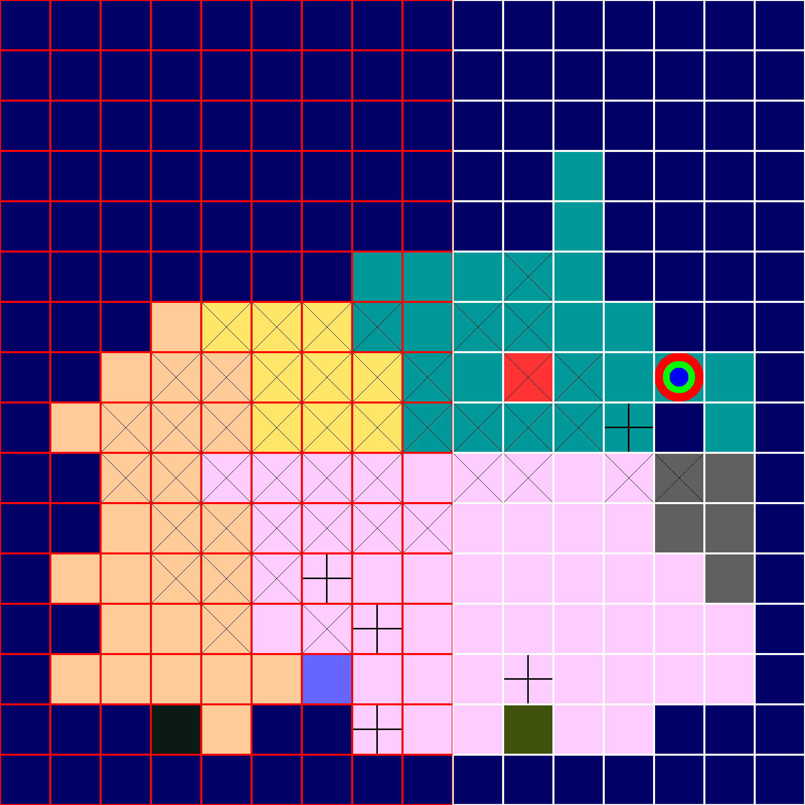

AGENT

VERIFY

1

True

MASK

1 1 1 1 1 1 1 1 1 0 0 0 0 0 0 0

1 1 1 1 1 1 1 1 1 0 0 0 0 0 0 0

1 1 1 1 1 1 1 1 1 0 0 0 0 0 0 0

1 1 1 1 1 1 1 1 1 0 0 0 0 0 0 0

1 1 1 1 1 1 1 1 1 0 0 0 0 0 0 0

1 1 1 1 1 1 1 1 1 0 0 0 0 0 0 0

1 1 1 1 1 1 1 1 1 0 0 0 0 0 0 0

1 1 1 1 1 1 1 1 1 0 0 0 0 0 0 0

1 1 1 1 1 1 1 1 1 0 0 0 0 0 0 0

1 1 1 1 1 1 1 1 1 0 0 0 0 0 0 0

1 1 1 1 1 1 1 1 1 0 0 0 0 0 0 0

1 1 1 1 1 1 1 1 1 0 0 0 0 0 0 0

1 1 1 1 1 1 1 1 1 0 0 0 0 0 0 0

1 1 1 1 1 1 1 1 1 0 0 0 0 0 0 0

1 1 1 1 1 1 1 1 1 0 0 0 0 0 0 0

1 1 1 1 1 1 1 1 1 0 0 0 0 0 0 0

AGENT

LARGE SCAN

MASK

1 1 1 1 1 1 1 1 1 0 0 0 0 0 0 0

1 1 1 1 1 1 1 1 1 0 0 0 0 0 0 0

1 1 1 1 1 1 1 1 1 0 0 0 0 0 0 0

1 1 1 1 1 1 1 1 1 0 0 0 0 0 0 0

1 1 1 1 1 1 1 1 1 0 0 0 0 0 0 0

1 1 1 1 1 1 1 1 1 0 0 0 0 0 0 0

1 1 1 1 1 1 1 1 1 0 0 0 0 0 0 0

1 1 1 1 1 1 1 1 1 0 0 0 0 0 0 0

1 1 1 1 1 1 1 1 1 0 0 0 0 0 0 0

1 1 1 1 1 1 1 1 1 0 0 0 0 0 0 0

1 1 1 1 1 1 1 1 1 0 0 0 0 0 0 0

1 1 1 1 1 1 1 1 1 0 0 0 0 0 0 0

1 1 1 1 1 1 1 1 1 0 0 0 0 0 0 0

1 1 1 1 1 1 1 1 1 0 0 0 0 0 0 0

1 1 1 1 1 1 1 1 1 0 0 0 0 0 0 0

1 1 1 1 1 1 1 1 1 0 0 0 0 0 0 0

TURN 2

HINT 2

5

5 11

9 15

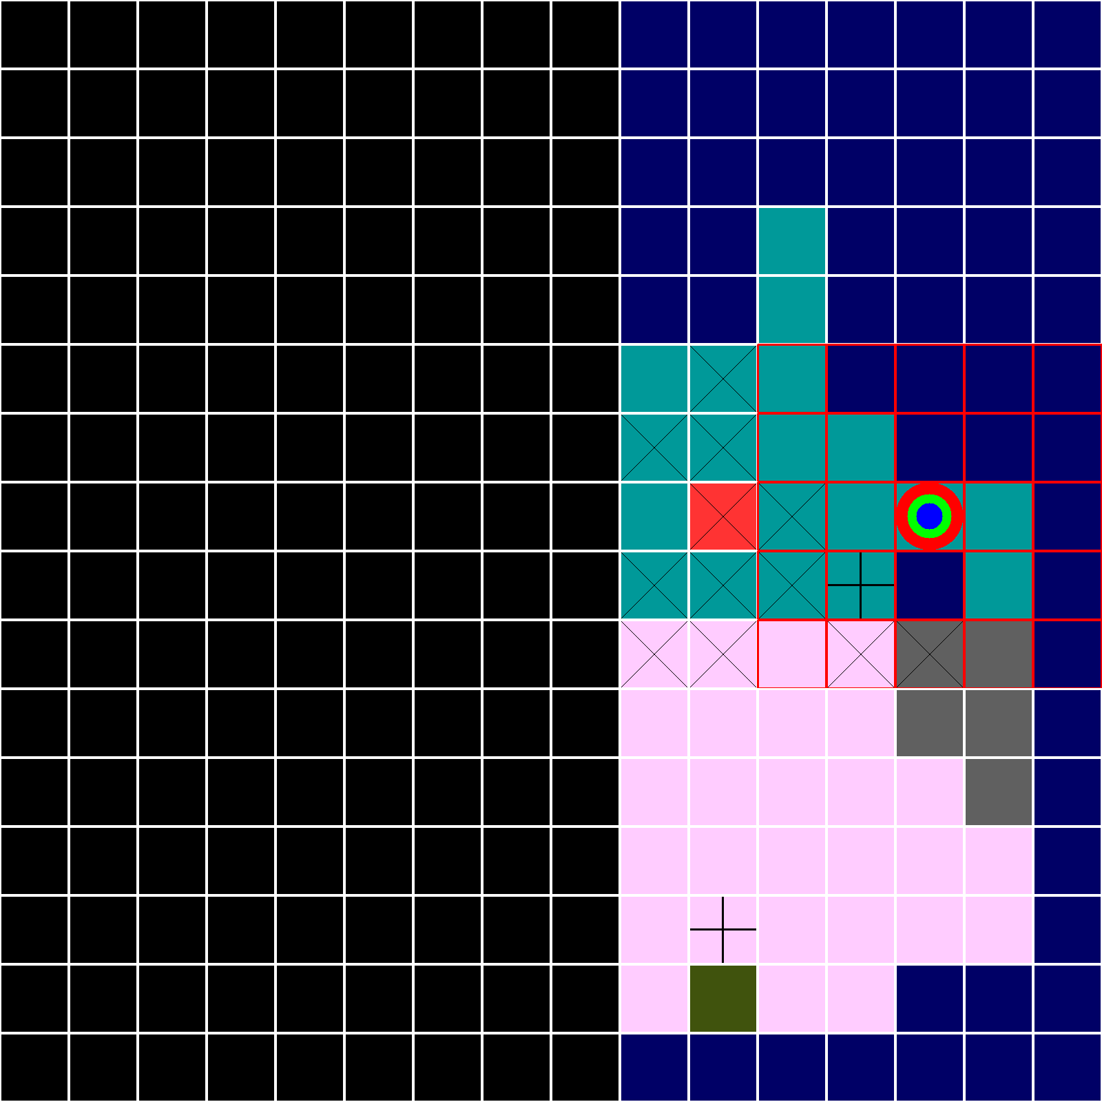

TURN 3

HINT 3

6

YOU

TURN 4

Reveal 11 6

HINT 4

4

3 9

10 15

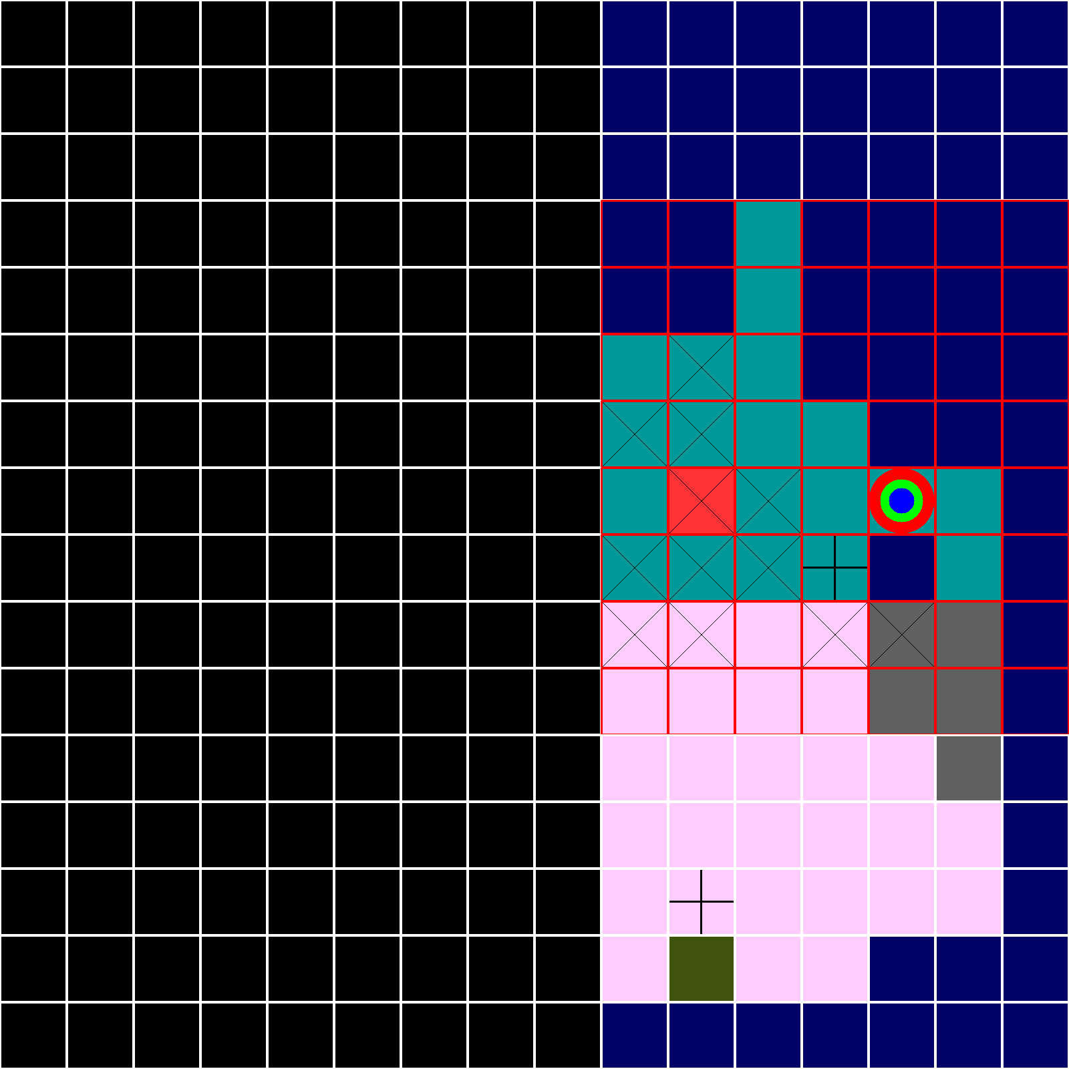

TURN 5

HINT 5

8

ROW

5

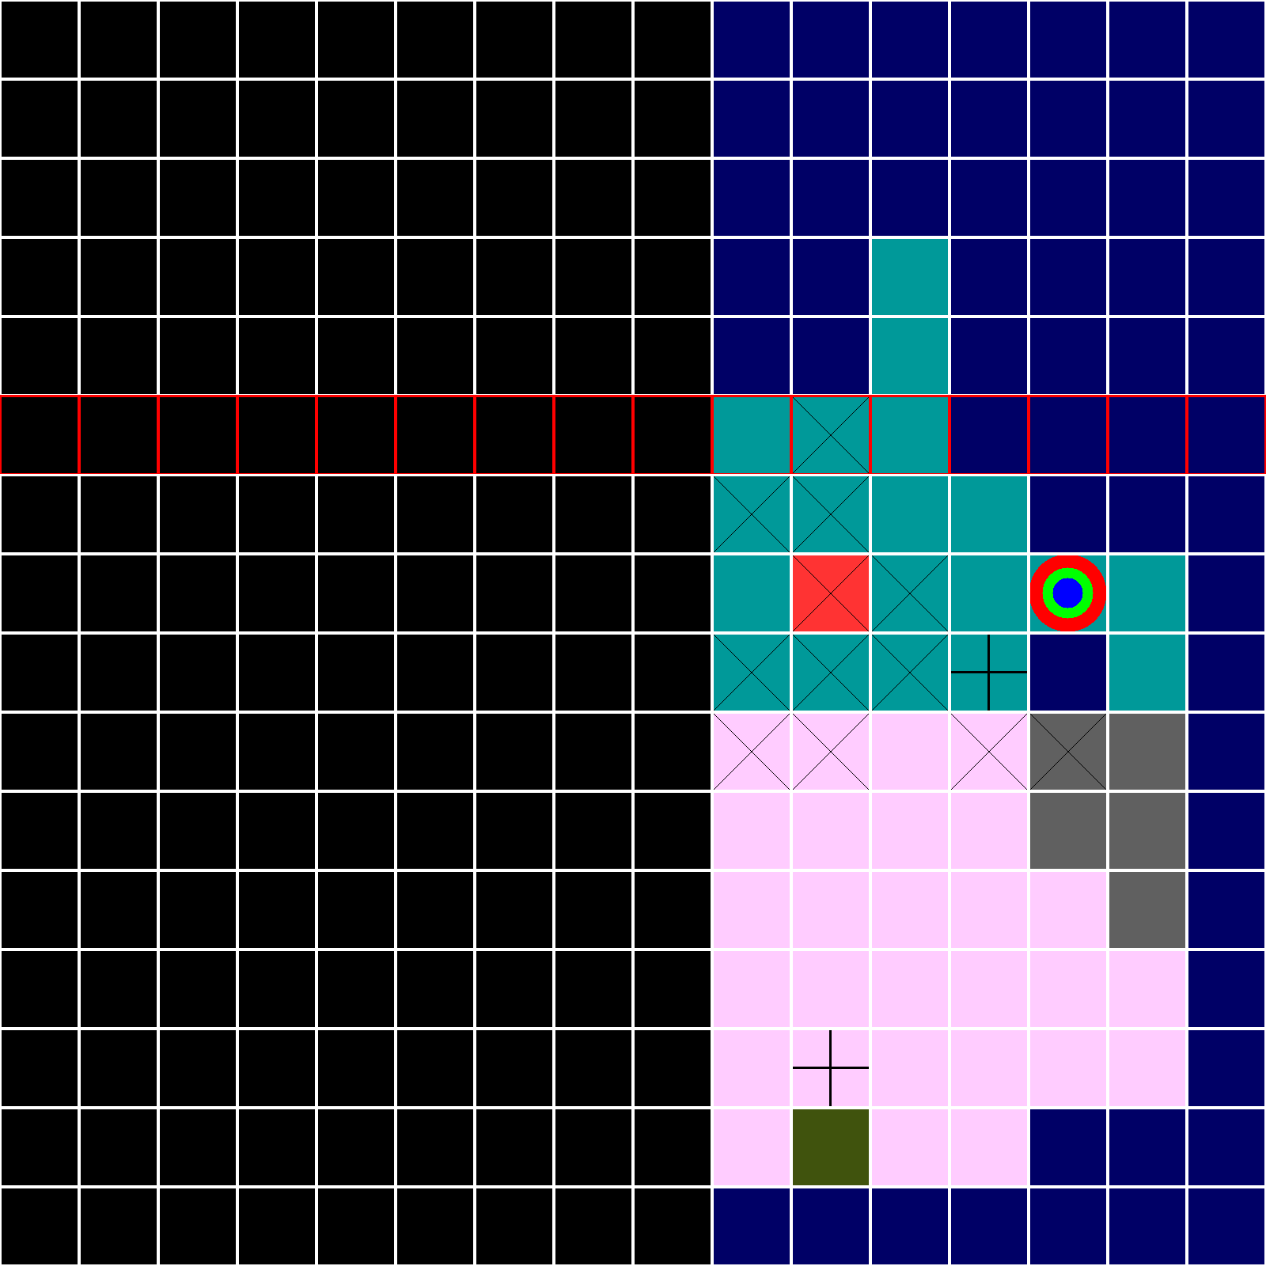

TURN 6

HINT 6

8

COL

7

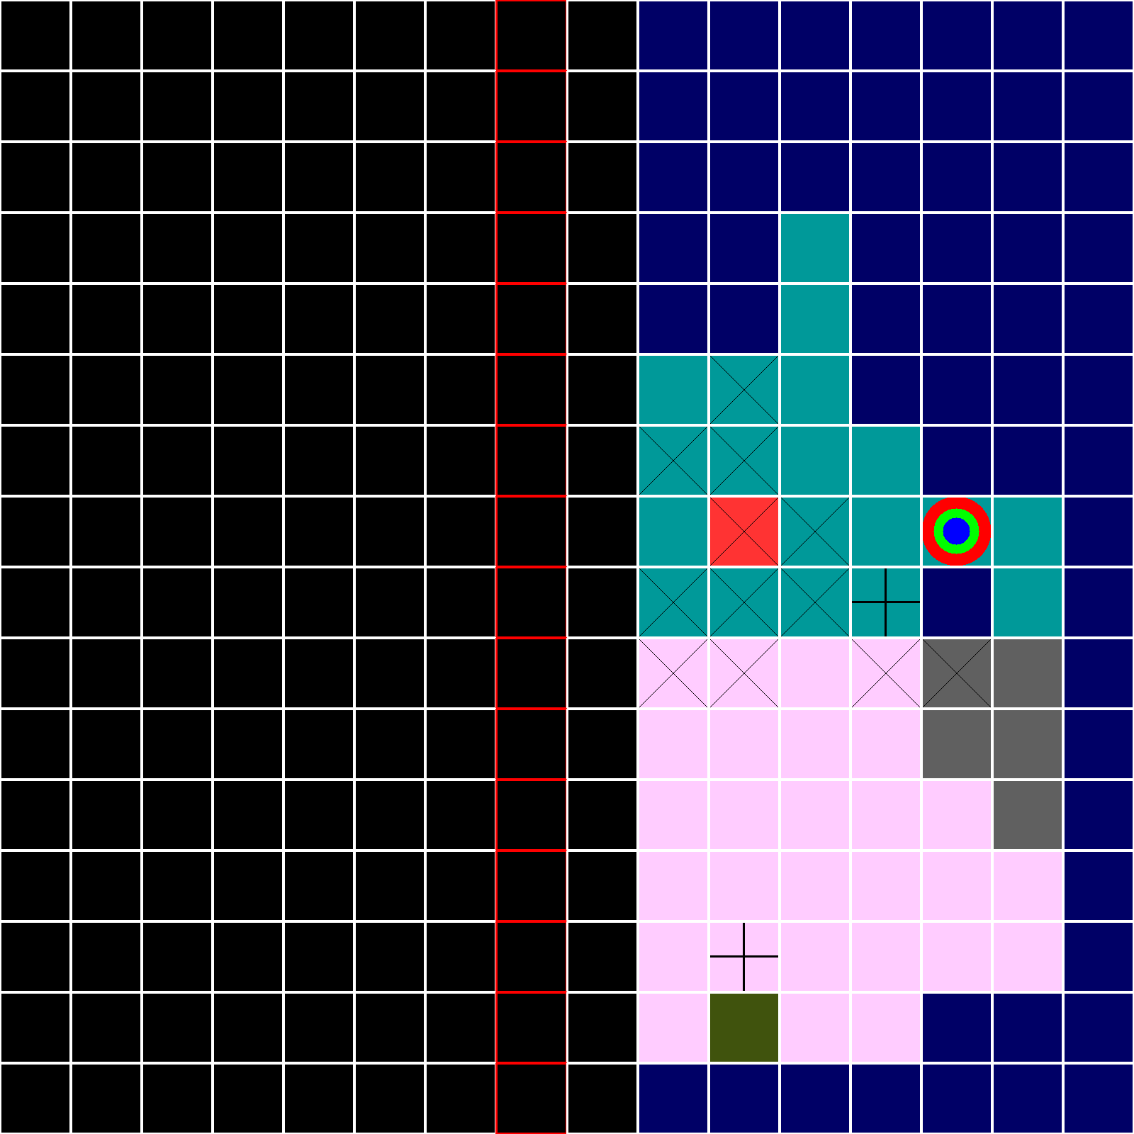

TURN 7

HINT 7

2

4

2 3 3 1

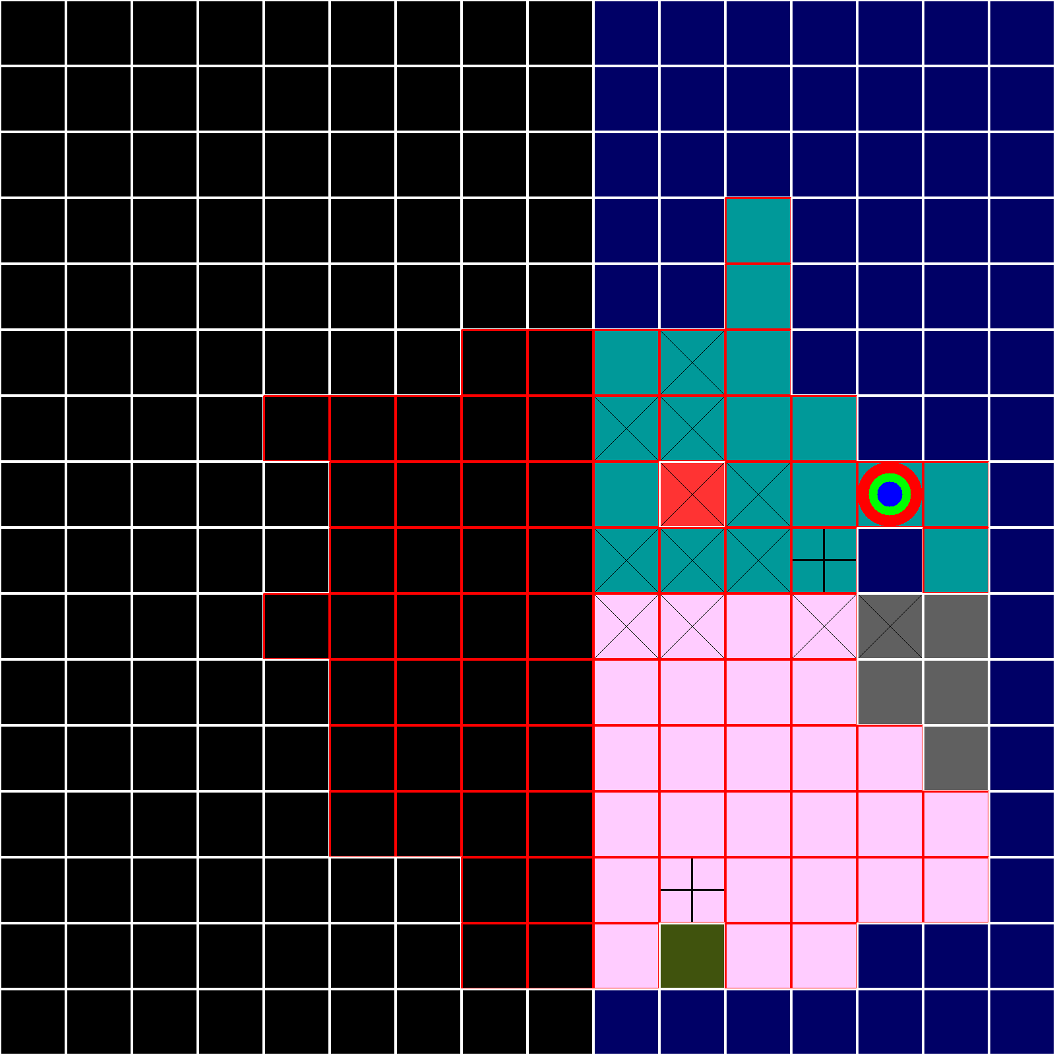

TURN 8 : 6 turns left to pirate to the treasure

FREE PIRATE

HINT 8

1

15

4 3

14 14

7 11

6 9

8 5

8 12

0 7

11 6

5 14

0 2

3 4

3 2

6 11

12 1

9 12

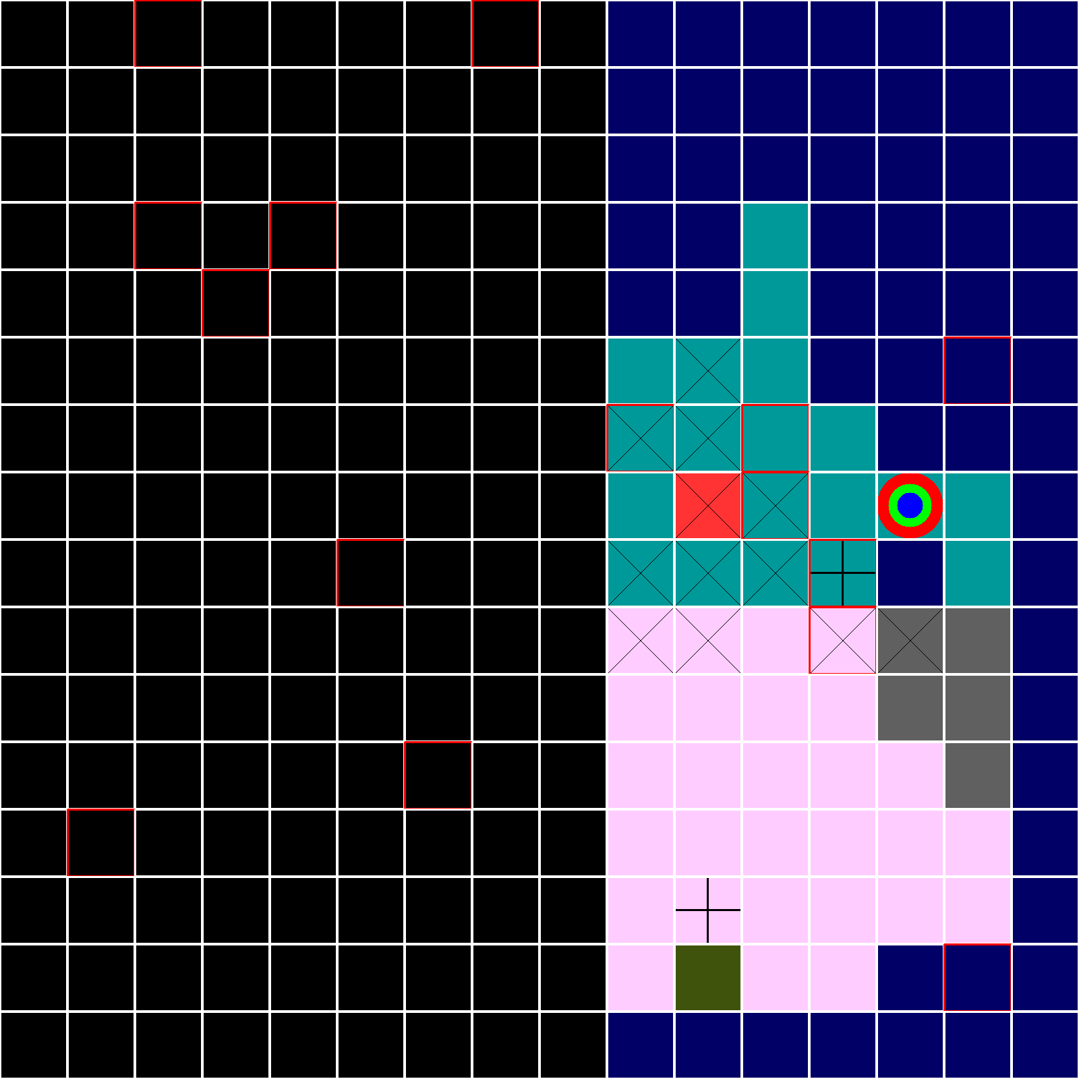

AGENT

VERIFY

2

False

MASK

1 1 1 1 1 1 1 1 1 1 1 1 1 1 1 1

1 1 1 1 1 1 1 1 1 1 1 1 1 1 1 1

1 1 1 1 1 1 1 1 1 1 1 1 1 1 1 1

1 1 1 1 1 1 1 1 1 1 1 1 1 1 1 1

1 1 1 1 1 1 1 1 1 1 1 1 1 1 1 1

1 1 1 1 1 1 1 1 1 1 1 0 0 0 0 0

1 1 1 1 1 1 1 1 1 1 1 0 0 0 0 0

1 1 1 1 1 1 1 1 1 1 1 0 0 0 0 0

1 1 1 1 1 1 1 1 1 1 1 0 0 0 0 0

1 1 1 1 1 1 1 1 1 1 1 0 0 0 0 0

1 1 1 1 1 1 1 1 1 1 1 1 1 1 1 1

1 1 1 1 1 1 1 1 1 1 1 1 1 1 1 1

1 1 1 1 1 1 1 1 1 1 1 1 1 1 1 1

1 1 1 1 1 1 1 1 1 1 1 1 1 1 1 1

1 1 1 1 1 1 1 1 1 1 1 1 1 1 1 1

1 1 1 1 1 1 1 1 1 1 1 1 1 1 1 1

AGENT

VERIFY

3

True

MASK

1 1 1 1 1 1 1 1 1 1 1 1 1 1 1 1

1 1 1 1 1 1 1 1 1 1 1 1 1 1 1 1

1 1 1 1 1 1 1 1 1 1 1 1 1 1 1 1

1 1 1 1 1 1 1 1 1 1 1 1 1 1 1 1

1 1 1 1 1 1 1 1 1 1 1 1 1 1 1 1

1 1 1 1 1 1 1 1 1 1 1 0 0 0 0 0

1 1 1 1 1 1 1 1 1 1 1 0 0 0 0 0

1 1 1 1 1 1 1 1 1 1 1 0 0 0 0 0

1 1 1 1 1 1 1 1 1 1 1 0 0 0 0 0

1 1 1 1 1 1 1 1 1 1 1 0 0 0 0 0

1 1 1 1 1 1 1 1 1 1 1 1 1 1 1 1

1 1 1 1 1 1 1 1 1 1 1 1 1 1 1 1

1 1 1 1 1 1 1 1 1 1 1 1 1 1 1 1

1 1 1 1 1 1 1 1 1 1 1 1 1 1 1 1

1 1 1 1 1 1 1 1 1 1 1 1 1 1 1 1

1 1 1 1 1 1 1 1 1 1 1 1 1 1 1 1

TURN 9 : 5 turns left to pirate to the treasure

HINT 9

2

4

7 8 7 6

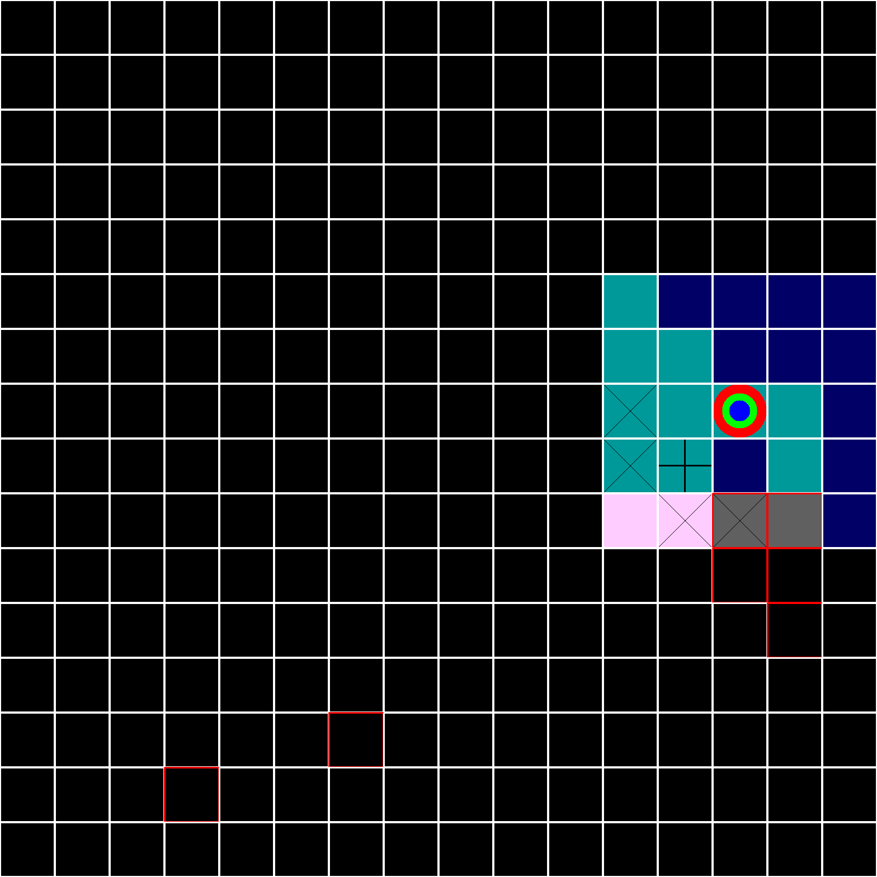

AGENT

VERIFY

4

True

MASK

1 1 1 1 1 1 1 1 1 1 1 1 1 1 1 1

1 1 1 1 1 1 1 1 1 1 1 1 1 1 1 1

1 1 1 1 1 1 1 1 1 1 1 1 1 1 1 1

1 1 1 1 1 1 1 1 1 1 1 1 1 1 1 1

1 1 1 1 1 1 1 1 1 1 1 1 1 1 1 1

1 1 1 1 1 1 1 1 1 1 1 0 0 0 0 0

1 1 1 1 1 1 1 1 1 1 1 0 0 0 0 0

1 1 1 1 1 1 1 1 1 1 1 0 0 0 0 0

1 1 1 1 1 1 1 1 1 1 1 0 0 0 0 0

1 1 1 1 1 1 1 1 1 1 1 0 0 0 0 0

1 1 1 1 1 1 1 1 1 1 1 1 1 1 1 1

1 1 1 1 1 1 1 1 1 1 1 1 1 1 1 1

1 1 1 1 1 1 1 1 1 1 1 1 1 1 1 1

1 1 1 1 1 1 1 1 1 1 1 1 1 1 1 1

1 1 1 1 1 1 1 1 1 1 1 1 1 1 1 1

1 1 1 1 1 1 1 1 1 1 1 1 1 1 1 1

AGENT

VERIFY

5

True

MASK

1 1 1 1 1 1 1 1 1 1 1 1 1 1 1 1

1 1 1 1 1 1 1 1 1 1 1 1 1 1 1 1

1 1 1 1 1 1 1 1 1 1 1 1 1 1 1 1

1 1 1 1 1 1 1 1 1 1 1 1 1 1 1 1

1 1 1 1 1 1 1 1 1 1 1 1 1 1 1 1

1 1 1 1 1 1 1 1 1 1 1 1 1 1 1 1

1 1 1 1 1 1 1 1 1 1 1 0 0 0 0 0

1 1 1 1 1 1 1 1 1 1 1 0 0 0 0 0

1 1 1 1 1 1 1 1 1 1 1 0 0 0 0 0

1 1 1 1 1 1 1 1 1 1 1 0 0 0 0 0

1 1 1 1 1 1 1 1 1 1 1 1 1 1 1 1

1 1 1 1 1 1 1 1 1 1 1 1 1 1 1 1

1 1 1 1 1 1 1 1 1 1 1 1 1 1 1 1

1 1 1 1 1 1 1 1 1 1 1 1 1 1 1 1

1 1 1 1 1 1 1 1 1 1 1 1 1 1 1 1

1 1 1 1 1 1 1 1 1 1 1 1 1 1 1 1

TURN 10 : 4 turns left to pirate to the treasure

HINT 10

14

4 13

9 14

1 10

13 15

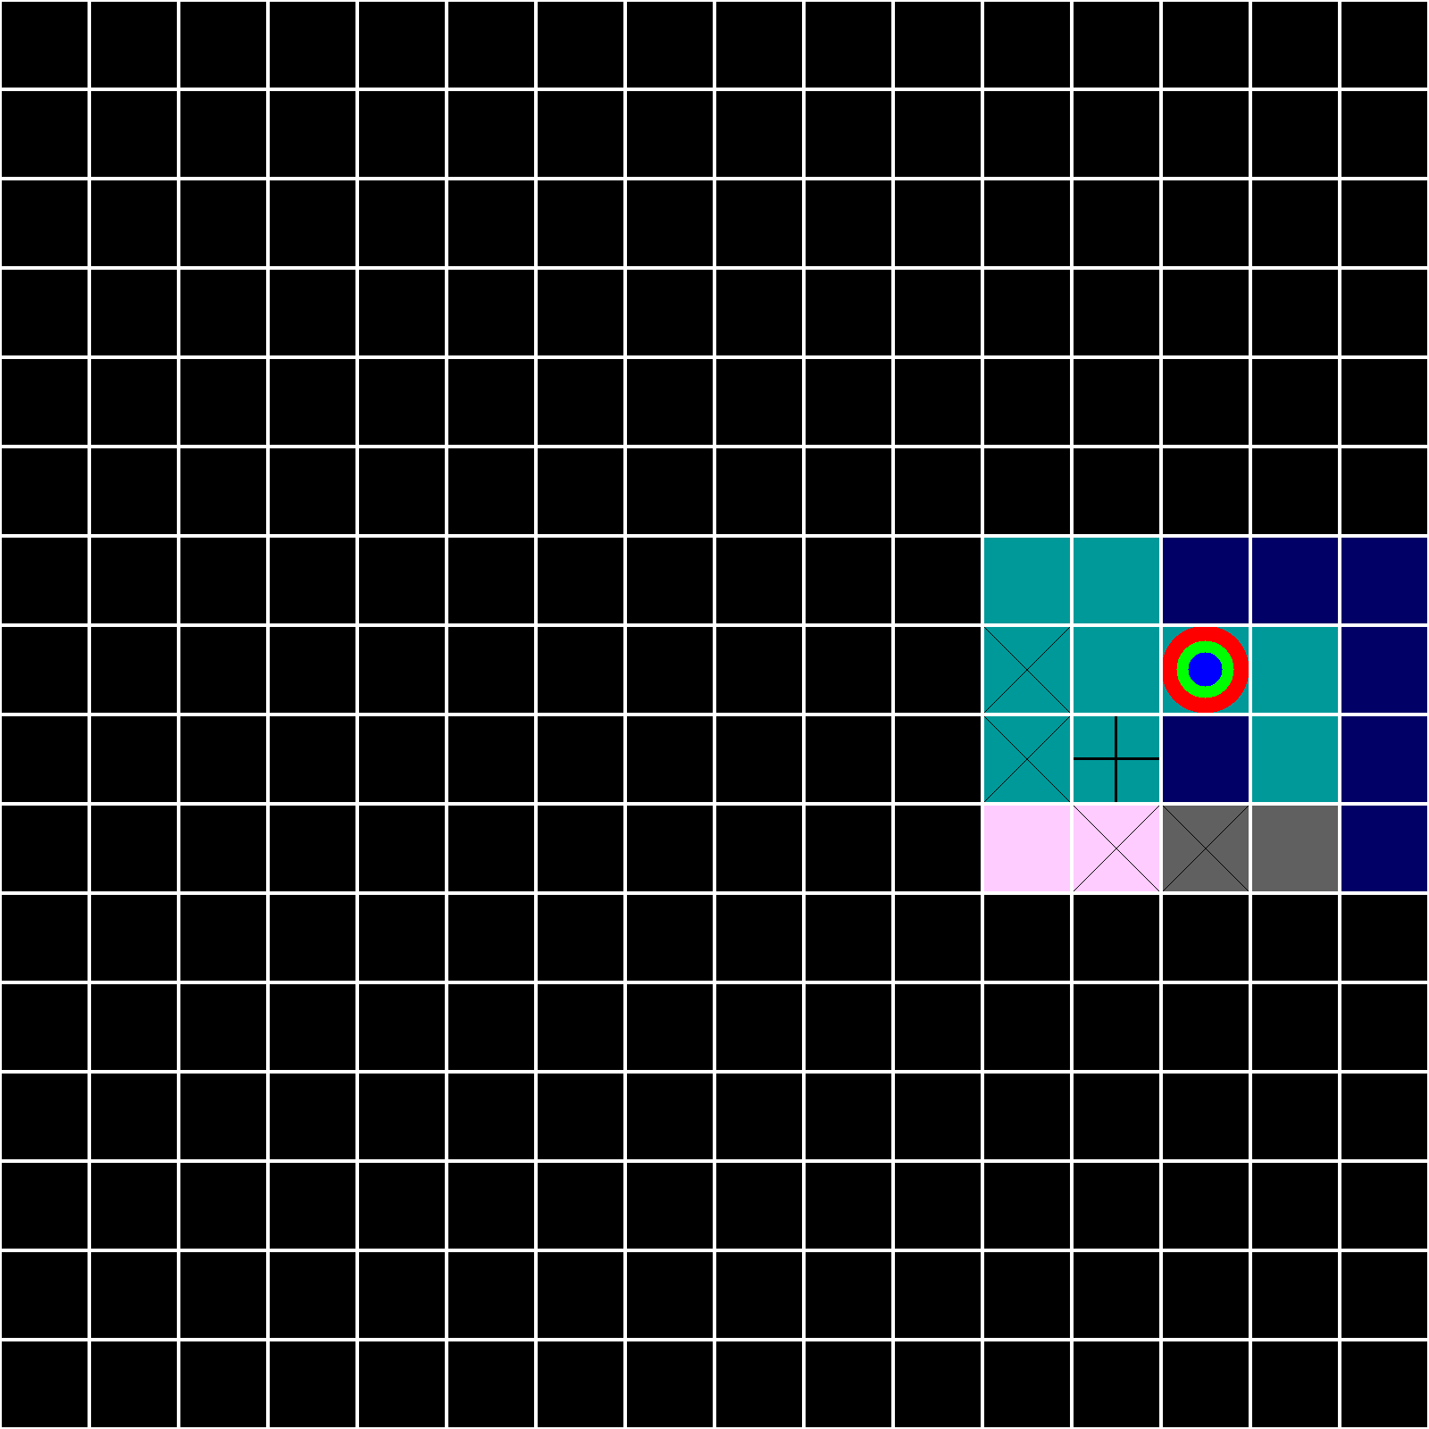

AGENT

VERIFY

6

True

MASK

1 1 1 1 1 1 1 1 1 1 1 1 1 1 1 1

1 1 1 1 1 1 1 1 1 1 1 1 1 1 1 1

1 1 1 1 1 1 1 1 1 1 1 1 1 1 1 1

1 1 1 1 1 1 1 1 1 1 1 1 1 1 1 1

1 1 1 1 1 1 1 1 1 1 1 1 1 1 1 1

1 1 1 1 1 1 1 1 1 1 1 1 1 1 1 1

1 1 1 1 1 1 1 1 1 1 1 0 0 0 0 0

1 1 1 1 1 1 1 1 1 1 1 0 0 0 0 0

1 1 1 1 1 1 1 1 1 1 1 0 0 0 0 0

1 1 1 1 1 1 1 1 1 1 1 0 0 0 0 0

1 1 1 1 1 1 1 1 1 1 1 1 1 1 1 1

1 1 1 1 1 1 1 1 1 1 1 1 1 1 1 1

1 1 1 1 1 1 1 1 1 1 1 1 1 1 1 1

1 1 1 1 1 1 1 1 1 1 1 1 1 1 1 1

1 1 1 1 1 1 1 1 1 1 1 1 1 1 1 1

1 1 1 1 1 1 1 1 1 1 1 1 1 1 1 1

AGENT

VERIFY

7

True

MASK

1 1 1 1 1 1 1 1 1 1 1 1 1 1 1 1

1 1 1 1 1 1 1 1 1 1 1 1 1 1 1 1

1 1 1 1 1 1 1 1 1 1 1 1 1 1 1 1

1 1 1 1 1 1 1 1 1 1 1 1 1 1 1 1

1 1 1 1 1 1 1 1 1 1 1 1 1 1 1 1

1 1 1 1 1 1 1 1 1 1 1 1 1 1 1 1

1 1 1 1 1 1 1 1 1 1 1 0 0 1 1 1

1 1 1 1 1 1 1 1 1 1 1 0 0 0 0 1

1 1 1 1 1 1 1 1 1 1 1 0 0 1 0 1

1 1 1 1 1 1 1 1 1 1 1 0 0 1 1 1

1 1 1 1 1 1 1 1 1 1 1 1 1 1 1 1

1 1 1 1 1 1 1 1 1 1 1 1 1 1 1 1

1 1 1 1 1 1 1 1 1 1 1 1 1 1 1 1

1 1 1 1 1 1 1 1 1 1 1 1 1 1 1 1

1 1 1 1 1 1 1 1 1 1 1 1 1 1 1 1

1 1 1 1 1 1 1 1 1 1 1 1 1 1 1 1

TURN 11 : 3 turns left to pirate to the treasure

Reveal 11 6

HINT 11

3

3

9 9 1

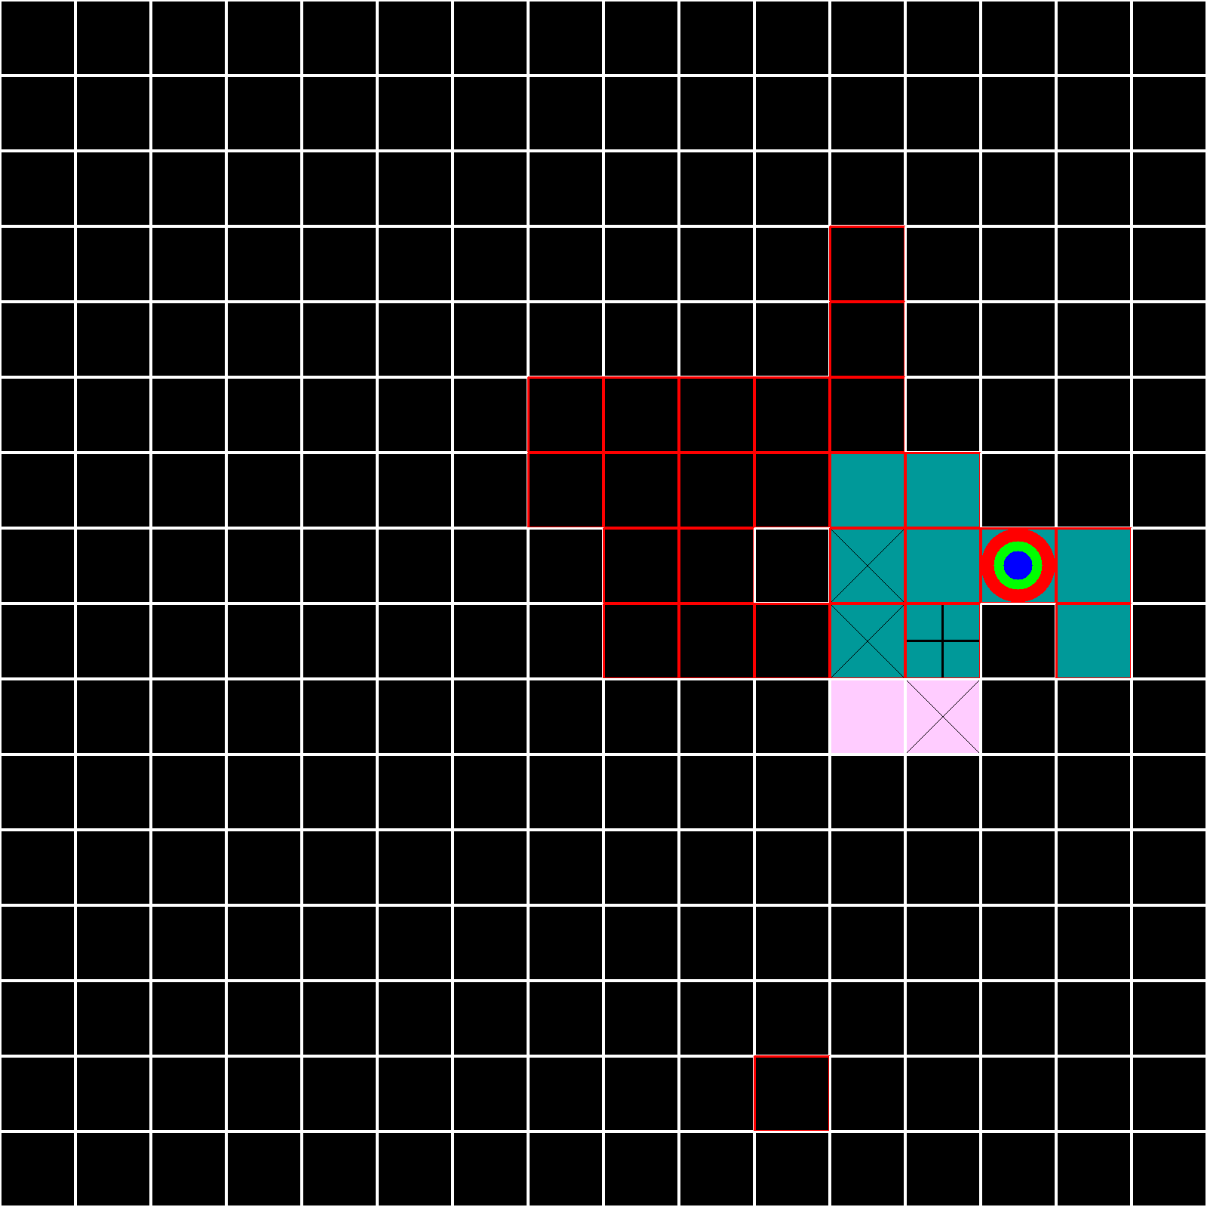

AGENT

VERIFY

8

True

MASK

1 1 1 1 1 1 1 1 1 1 1 1 1 1 1 1

1 1 1 1 1 1 1 1 1 1 1 1 1 1 1 1

1 1 1 1 1 1 1 1 1 1 1 1 1 1 1 1

1 1 1 1 1 1 1 1 1 1 1 1 1 1 1 1

1 1 1 1 1 1 1 1 1 1 1 1 1 1 1 1

1 1 1 1 1 1 1 1 1 1 1 1 1 1 1 1

1 1 1 1 1 1 1 1 1 1 1 1 0 1 1 1

1 1 1 1 1 1 1 1 1 1 1 1 0 0 0 1

1 1 1 1 1 1 1 1 1 1 1 0 1 1 0 1

1 1 1 1 1 1 1 1 1 1 1 0 1 1 1 1

1 1 1 1 1 1 1 1 1 1 1 1 1 1 1 1

1 1 1 1 1 1 1 1 1 1 1 1 1 1 1 1

1 1 1 1 1 1 1 1 1 1 1 1 1 1 1 1

1 1 1 1 1 1 1 1 1 1 1 1 1 1 1 1

1 1 1 1 1 1 1 1 1 1 1 1 1 1 1 1

1 1 1 1 1 1 1 1 1 1 1 1 1 1 1 1

AGENT

VERIFY

9

False

MASK

1 1 1 1 1 1 1 1 1 1 1 1 1 1 1 1

1 1 1 1 1 1 1 1 1 1 1 1 1 1 1 1

1 1 1 1 1 1 1 1 1 1 1 1 1 1 1 1

1 1 1 1 1 1 1 1 1 1 1 1 1 1 1 1

1 1 1 1 1 1 1 1 1 1 1 1 1 1 1 1

1 1 1 1 1 1 1 1 1 1 1 1 1 1 1 1

1 1 1 1 1 1 1 1 1 1 1 1 0 1 1 1

1 1 1 1 1 1 1 1 1 1 1 1 0 0 0 1

1 1 1 1 1 1 1 1 1 1 1 0 1 1 0 1

1 1 1 1 1 1 1 1 1 1 1 0 1 1 1 1

1 1 1 1 1 1 1 1 1 1 1 1 1 1 1 1

1 1 1 1 1 1 1 1 1 1 1 1 1 1 1 1

1 1 1 1 1 1 1 1 1 1 1 1 1 1 1 1

1 1 1 1 1 1 1 1 1 1 1 1 1 1 1 1

1 1 1 1 1 1 1 1 1 1 1 1 1 1 1 1

1 1 1 1 1 1 1 1 1 1 1 1 1 1 1 1

TURN 12 : 2 turns left to pirate to the treasure

HINT 12

13

8 8

NW

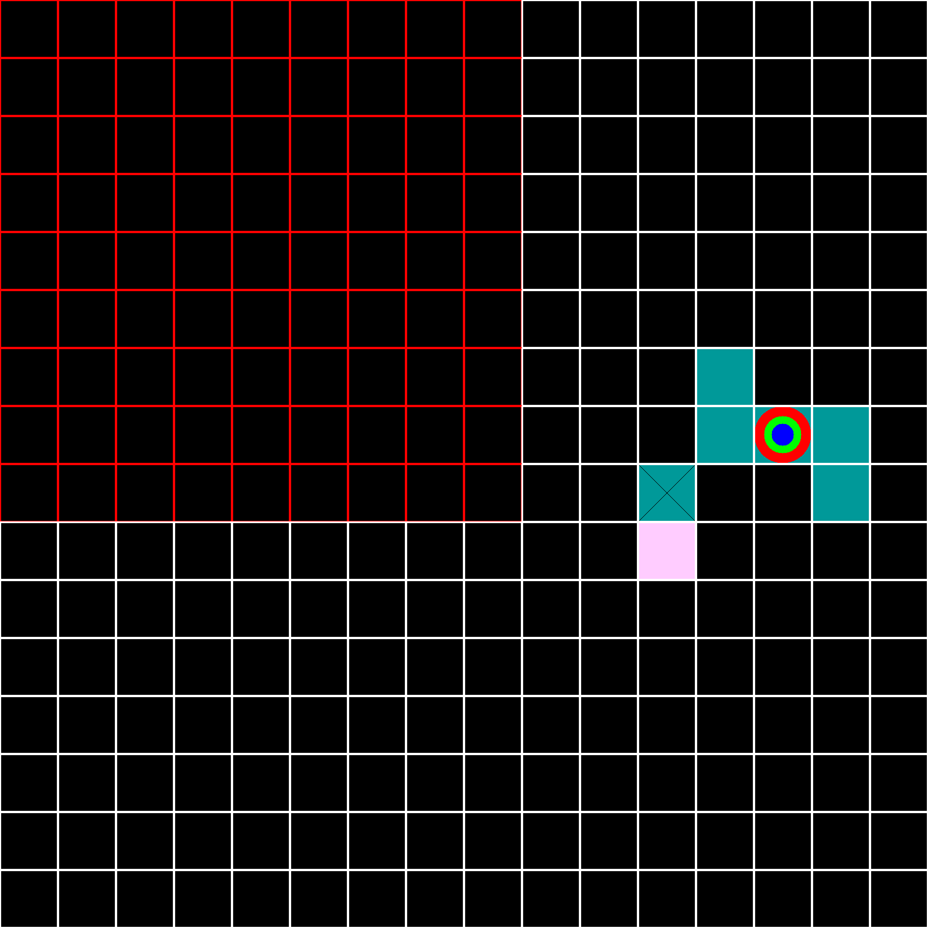

AGENT

VERIFY

10

False

MASK

1 1 1 1 1 1 1 1 1 1 1 1 1 1 1 1

1 1 1 1 1 1 1 1 1 1 1 1 1 1 1 1

1 1 1 1 1 1 1 1 1 1 1 1 1 1 1 1

1 1 1 1 1 1 1 1 1 1 1 1 1 1 1 1

1 1 1 1 1 1 1 1 1 1 1 1 1 1 1 1

1 1 1 1 1 1 1 1 1 1 1 1 1 1 1 1

1 1 1 1 1 1 1 1 1 1 1 1 0 1 1 1

1 1 1 1 1 1 1 1 1 1 1 1 0 0 0 1

1 1 1 1 1 1 1 1 1 1 1 0 1 1 0 1

1 1 1 1 1 1 1 1 1 1 1 0 1 1 1 1

1 1 1 1 1 1 1 1 1 1 1 1 1 1 1 1

1 1 1 1 1 1 1 1 1 1 1 1 1 1 1 1

1 1 1 1 1 1 1 1 1 1 1 1 1 1 1 1

1 1 1 1 1 1 1 1 1 1 1 1 1 1 1 1

1 1 1 1 1 1 1 1 1 1 1 1 1 1 1 1

1 1 1 1 1 1 1 1 1 1 1 1 1 1 1 1

AGENT

VERIFY

11

False

MASK

1 1 1 1 1 1 1 1 1 1 1 1 1 1 1 1

1 1 1 1 1 1 1 1 1 1 1 1 1 1 1 1

1 1 1 1 1 1 1 1 1 1 1 1 1 1 1 1

1 1 1 1 1 1 1 1 1 1 1 1 1 1 1 1

1 1 1 1 1 1 1 1 1 1 1 1 1 1 1 1

1 1 1 1 1 1 1 1 1 1 1 1 1 1 1 1

1 1 1 1 1 1 1 1 1 1 1 1 0 1 1 1

1 1 1 1 1 1 1 1 1 1 1 1 0 0 0 1

1 1 1 1 1 1 1 1 1 1 1 0 1 1 0 1

1 1 1 1 1 1 1 1 1 1 1 1 1 1 1 1

1 1 1 1 1 1 1 1 1 1 1 1 1 1 1 1

1 1 1 1 1 1 1 1 1 1 1 1 1 1 1 1

1 1 1 1 1 1 1 1 1 1 1 1 1 1 1 1

1 1 1 1 1 1 1 1 1 1 1 1 1 1 1 1

1 1 1 1 1 1 1 1 1 1 1 1 1 1 1 1

1 1 1 1 1 1 1 1 1 1 1 1 1 1 1 1

TURN 13 : 1 turns left to pirate to the treasure

HINT 13

13

11 6

W

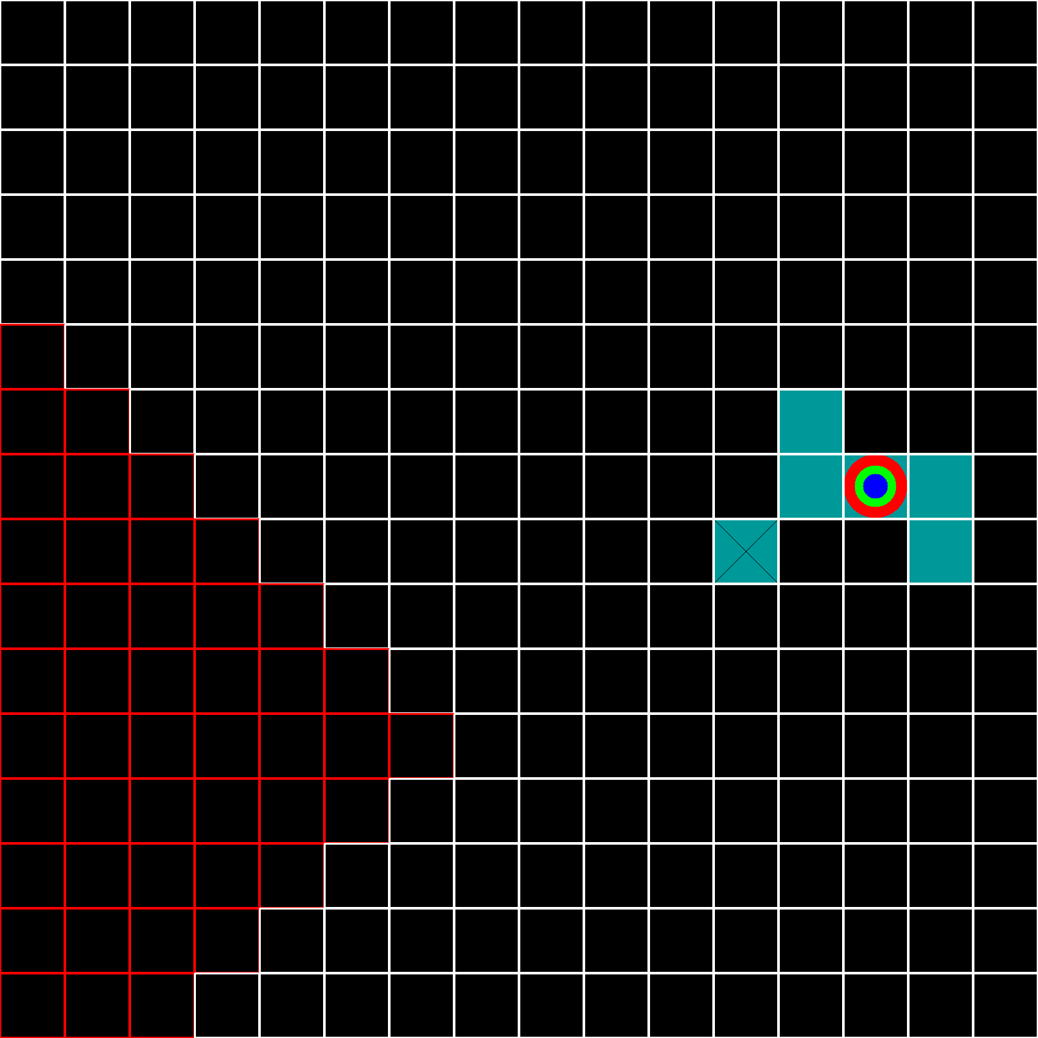

AGENT

VERIFY

12

False

MASK

1 1 1 1 1 1 1 1 1 1 1 1 1 1 1 1

1 1 1 1 1 1 1 1 1 1 1 1 1 1 1 1

1 1 1 1 1 1 1 1 1 1 1 1 1 1 1 1

1 1 1 1 1 1 1 1 1 1 1 1 1 1 1 1

1 1 1 1 1 1 1 1 1 1 1 1 1 1 1 1

1 1 1 1 1 1 1 1 1 1 1 1 1 1 1 1

1 1 1 1 1 1 1 1 1 1 1 1 0 1 1 1

1 1 1 1 1 1 1 1 1 1 1 1 0 0 0 1

1 1 1 1 1 1 1 1 1 1 1 0 1 1 0 1

1 1 1 1 1 1 1 1 1 1 1 1 1 1 1 1

1 1 1 1 1 1 1 1 1 1 1 1 1 1 1 1

1 1 1 1 1 1 1 1 1 1 1 1 1 1 1 1

1 1 1 1 1 1 1 1 1 1 1 1 1 1 1 1

1 1 1 1 1 1 1 1 1 1 1 1 1 1 1 1

1 1 1 1 1 1 1 1 1 1 1 1 1 1 1 1

1 1 1 1 1 1 1 1 1 1 1 1 1 1 1 1

AGENT

VERIFY

13

False

MASK

1 1 1 1 1 1 1 1 1 1 1 1 1 1 1 1

1 1 1 1 1 1 1 1 1 1 1 1 1 1 1 1

1 1 1 1 1 1 1 1 1 1 1 1 1 1 1 1

1 1 1 1 1 1 1 1 1 1 1 1 1 1 1 1

1 1 1 1 1 1 1 1 1 1 1 1 1 1 1 1

1 1 1 1 1 1 1 1 1 1 1 1 1 1 1 1

1 1 1 1 1 1 1 1 1 1 1 1 0 1 1 1

1 1 1 1 1 1 1 1 1 1 1 1 0 0 0 1

1 1 1 1 1 1 1 1 1 1 1 0 1 1 0 1

1 1 1 1 1 1 1 1 1 1 1 1 1 1 1 1

1 1 1 1 1 1 1 1 1 1 1 1 1 1 1 1

1 1 1 1 1 1 1 1 1 1 1 1 1 1 1 1

1 1 1 1 1 1 1 1 1 1 1 1 1 1 1 1

1 1 1 1 1 1 1 1 1 1 1 1 1 1 1 1

1 1 1 1 1 1 1 1 1 1 1 1 1 1 1 1

1 1 1 1 1 1 1 1 1 1 1 1 1 1 1 1

TURN 14 : 0 turns left to pirate to the treasure

HINT 14

1

15

8 5

5 4

8 15

15 14

8 2

5 4

0 2

5 8

1 2

7 7

7 9

14 3

0 10

5 6

11 8

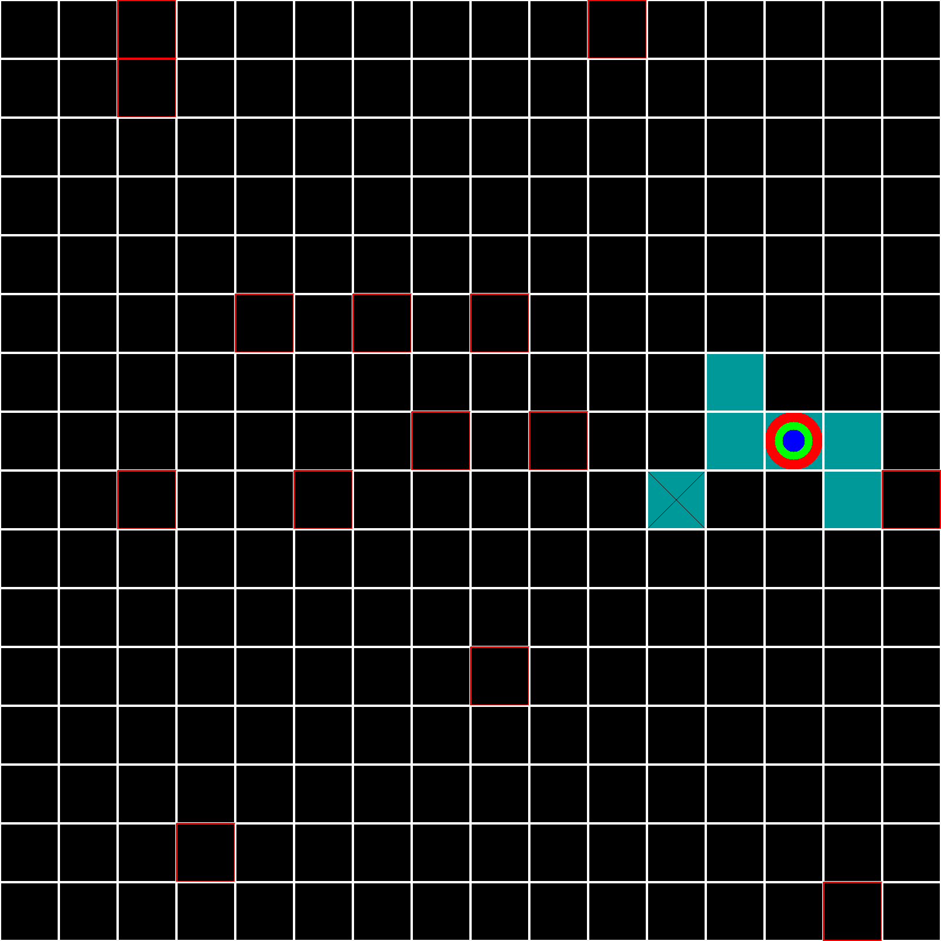

AGENT

VERIFY

14

True

MASK

1 1 1 1 1 1 1 1 1 1 1 1 1 1 1 1

1 1 1 1 1 1 1 1 1 1 1 1 1 1 1 1

1 1 1 1 1 1 1 1 1 1 1 1 1 1 1 1

1 1 1 1 1 1 1 1 1 1 1 1 1 1 1 1

1 1 1 1 1 1 1 1 1 1 1 1 1 1 1 1

1 1 1 1 1 1 1 1 1 1 1 1 1 1 1 1

1 1 1 1 1 1 1 1 1 1 1 1 0 1 1 1

1 1 1 1 1 1 1 1 1 1 1 1 0 0 0 1

1 1 1 1 1 1 1 1 1 1 1 0 1 1 0 1

1 1 1 1 1 1 1 1 1 1 1 1 1 1 1 1

1 1 1 1 1 1 1 1 1 1 1 1 1 1 1 1

1 1 1 1 1 1 1 1 1 1 1 1 1 1 1 1

1 1 1 1 1 1 1 1 1 1 1 1 1 1 1 1

1 1 1 1 1 1 1 1 1 1 1 1 1 1 1 1

1 1 1 1 1 1 1 1 1 1 1 1 1 1 1 1

1 1 1 1 1 1 1 1 1 1 1 1 1 1 1 1

AGENT

LARGE SCAN

MASK

1 1 1 1 1 1 1 1 1 1 1 1 1 1 1 1

1 1 1 1 1 1 1 1 1 1 1 1 1 1 1 1

1 1 1 1 1 1 1 1 1 1 1 1 1 1 1 1

1 1 1 1 1 1 1 1 1 1 1 1 1 1 1 1

1 1 1 1 1 1 1 1 1 1 1 1 1 1 1 1

1 1 1 1 1 1 1 1 1 1 1 1 1 1 1 1

1 1 1 1 1 1 1 1 1 1 1 1 0 1 1 1

1 1 1 1 1 1 1 1 1 1 1 1 0 0 0 1

1 1 1 1 1 1 1 1 1 1 1 0 1 1 0 1

1 1 1 1 1 1 1 1 1 1 1 1 1 1 1 1

1 1 1 1 1 1 1 1 1 1 1 1 1 1 1 1

1 1 1 1 1 1 1 1 1 1 1 1 1 1 1 1

1 1 1 1 1 1 1 1 1 1 1 1 1 1 1 1

1 1 1 1 1 1 1 1 1 1 1 1 1 1 1 1

1 1 1 1 1 1 1 1 1 1 1 1 1 1 1 1

1 1 1 1 1 1 1 1 1 1 1 1 1 1 1 1