START
AGENT: 35 12
TURN 1**********************************************************
HINT 1
9
6 7

AGENT
2 MOVE 1 steps, direction N
[-1, 0]
1
SMALL SCAN
MASK
34 12

AGENT
3 MOVE 4 steps, direction E
[0, 1]
4
MASK
34 16

TURN 2**********************************************************
HINT 2
15
False
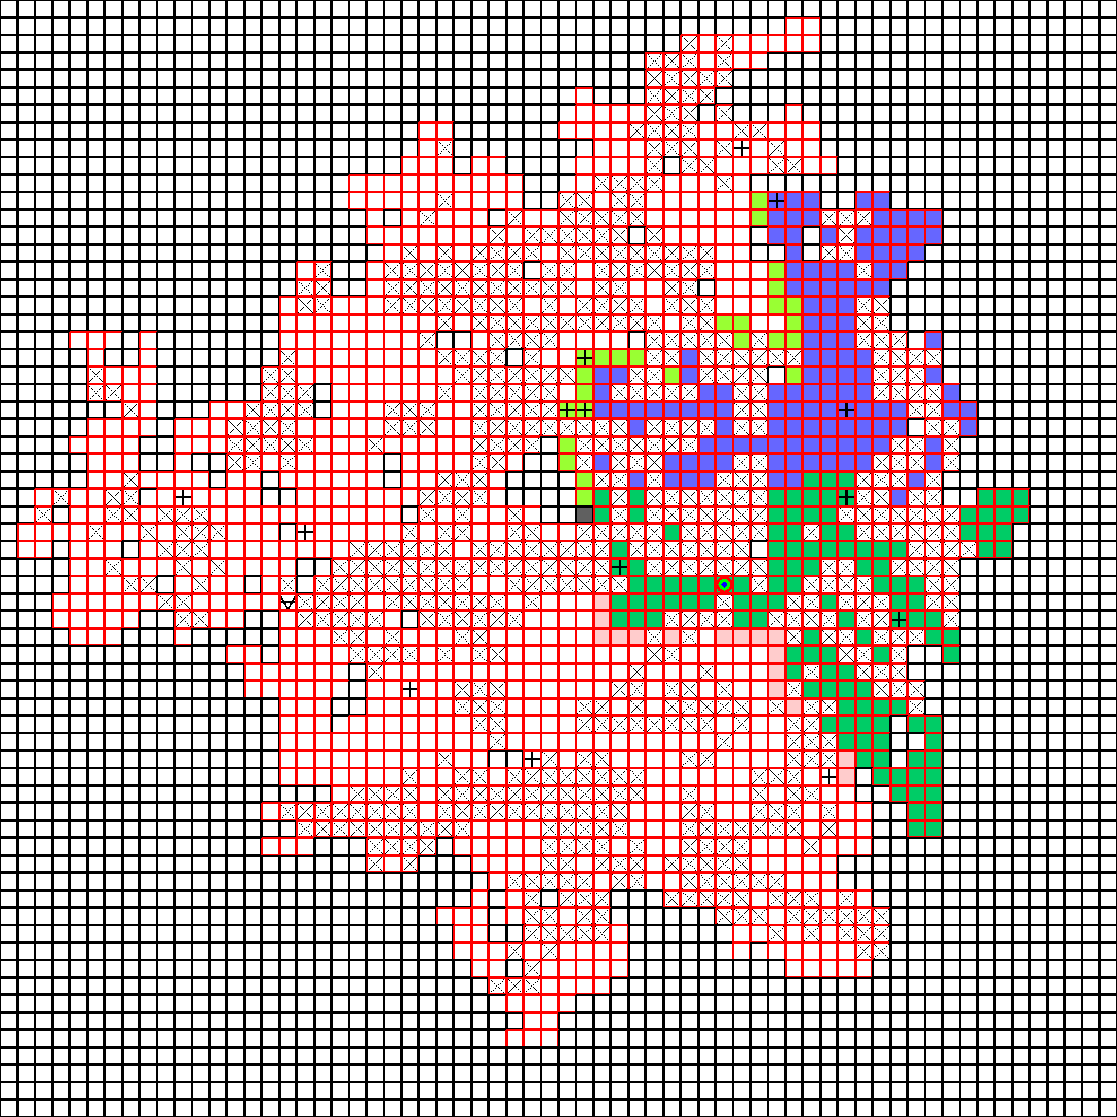
AGENT
VERIFY
2
False
MASK
34 16

AGENT
3 MOVE 4 steps, direction S
[1, 0]
4
MASK
38 16

TURN 3**********************************************************
Reveal 39 23
HINT 3
8
COL
45
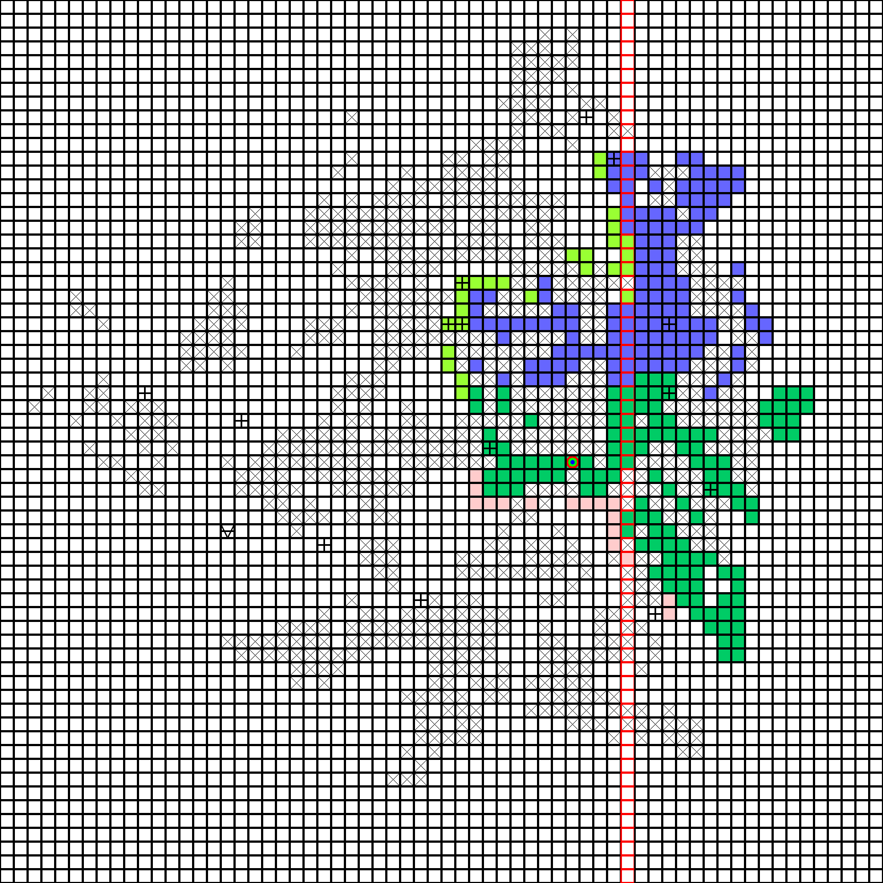
AGENT
VERIFY
3
True
MASK
38 16

AGENT
3 MOVE 4 steps, direction S
[1, 0]
4
MASK
42 16

TURN 4 : 11 turns left to pirate to the treasure **********************************************************
FREE PIRATE
HINT 4
8
ROW
33
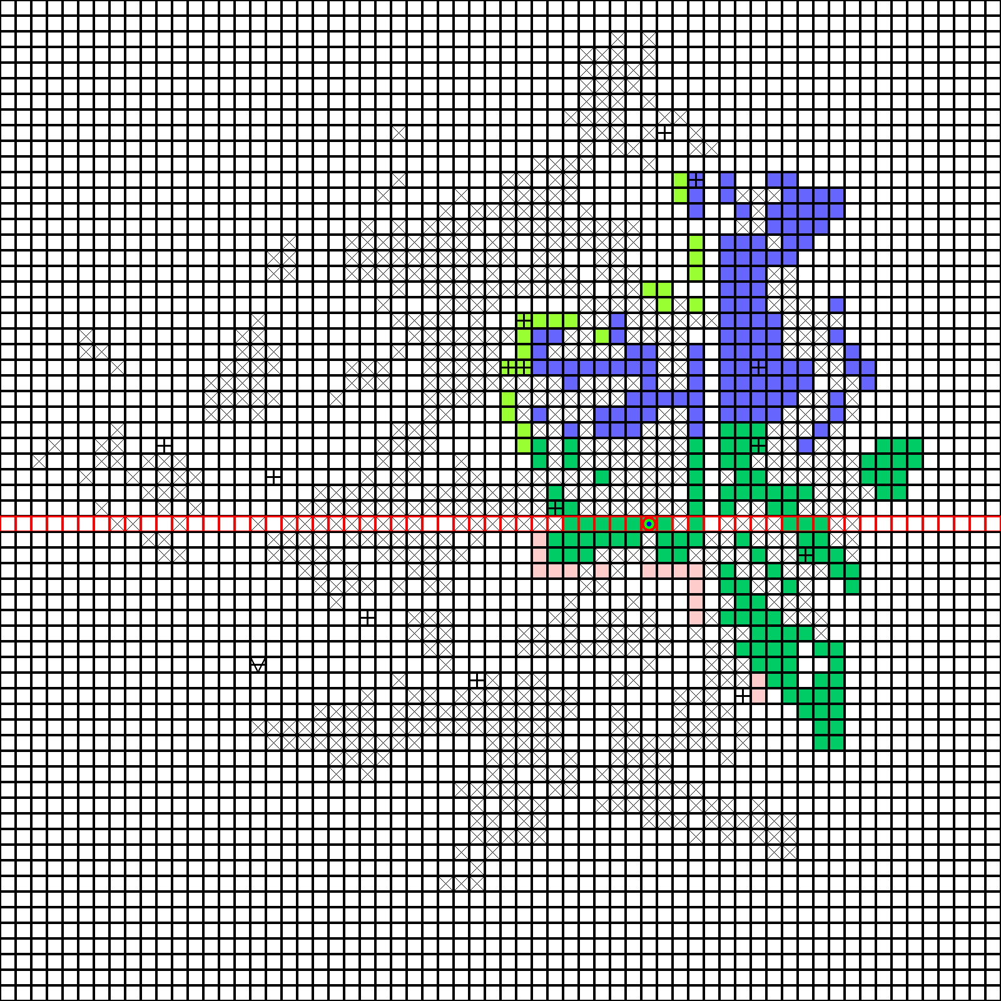
AGENT
VERIFY
4
False
MASK
42 16

AGENT
3 MOVE 4 steps, direction E
[0, 1]
4
MASK
42 20

TURN 5 : 10 turns left to pirate to the treasure **********************************************************
HINT 5
13
32 32
E

AGENT
VERIFY
5
True
MASK
42 20
AGENT
3 MOVE 4 steps, direction E
[0, 1]
4
MASK
42 24

TURN 6 : 9 turns left to pirate to the treasure **********************************************************
HINT 6
2
4
13 2 3 16
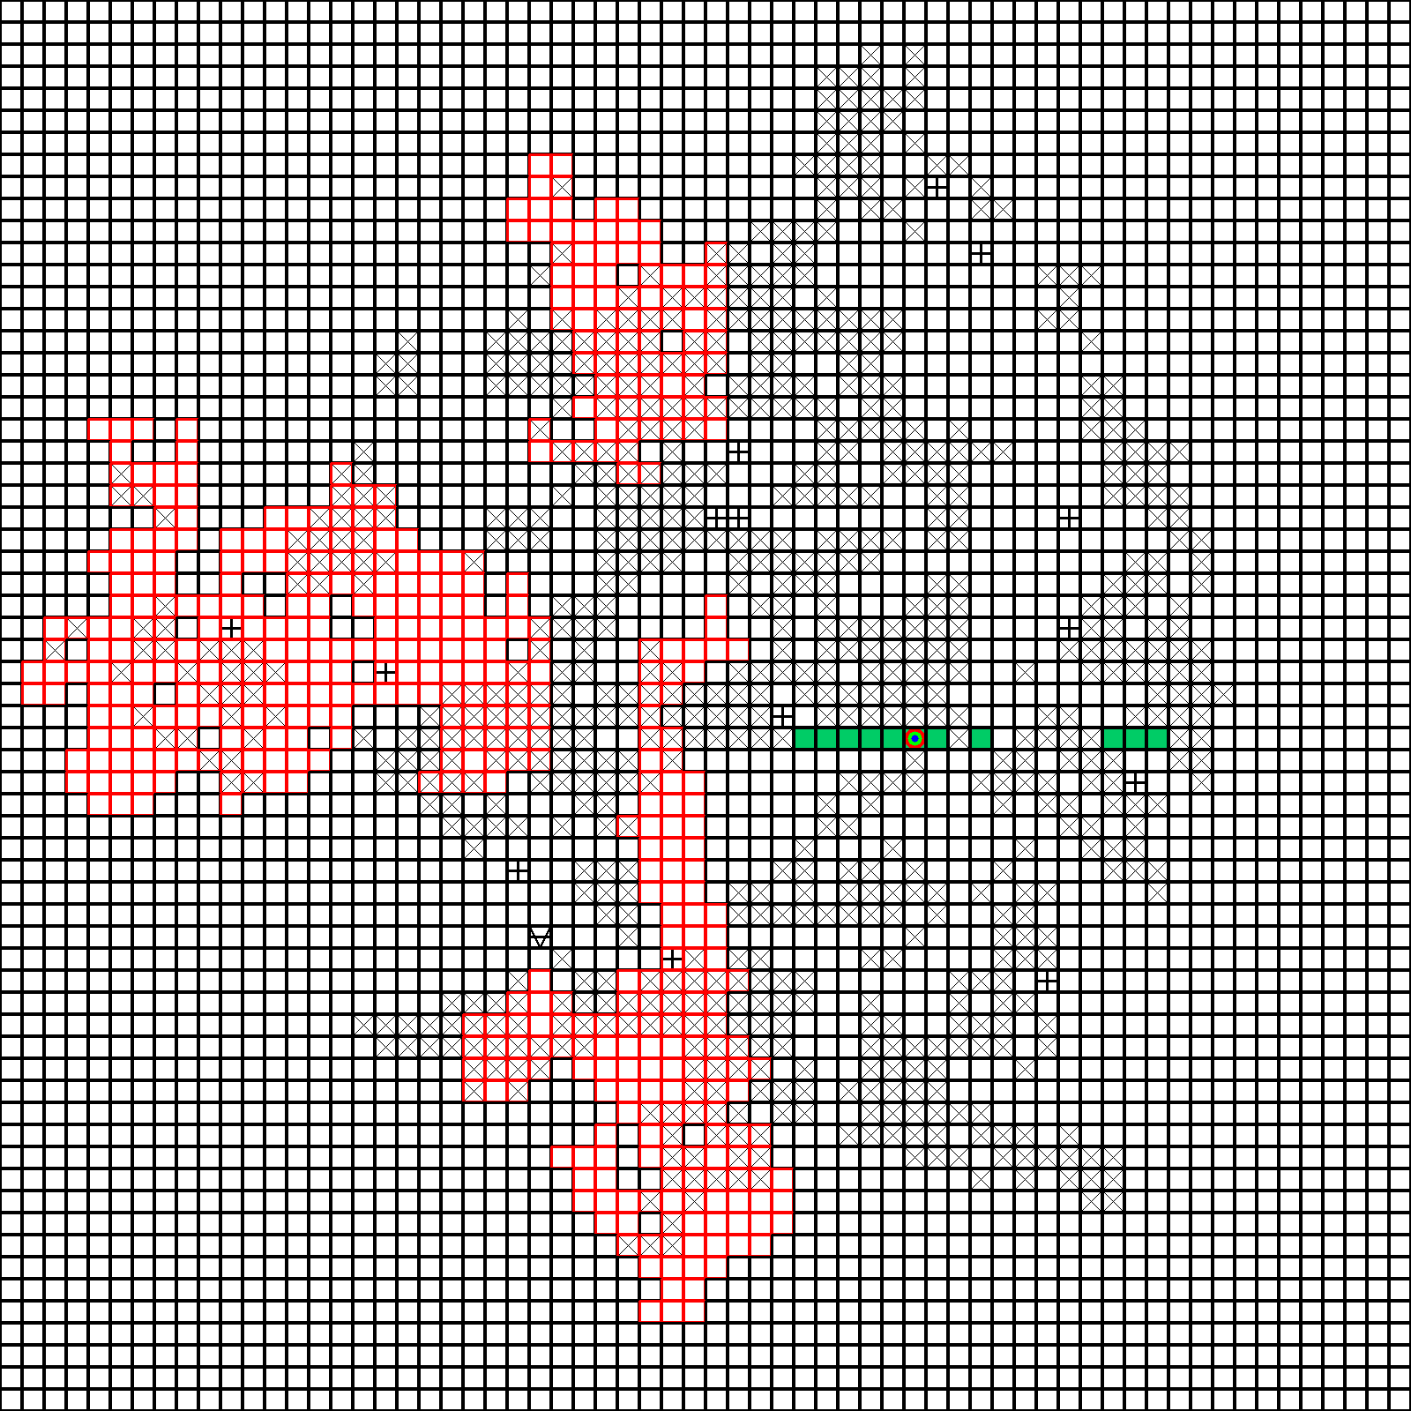
AGENT
VERIFY
6
False
MASK
42 24
AGENT
3 MOVE 4 steps, direction N
[-1, 0]
4
MASK
38 24

TURN 7 : 8 turns left to pirate to the treasure **********************************************************
HINT 7
7
COL
41
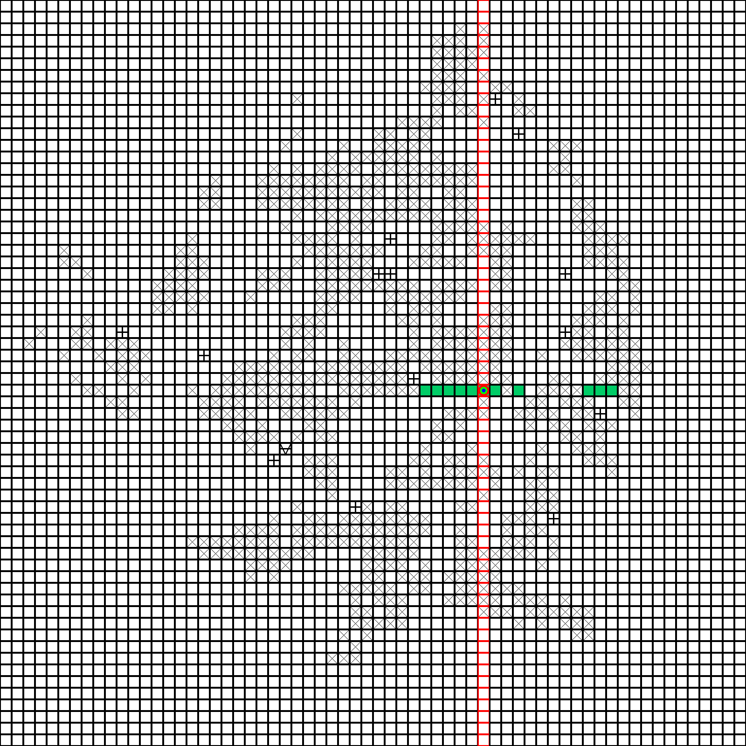
AGENT
VERIFY
7
True
MASK
38 24

AGENT
TELEPORT
30 38
MASK
30 38

AGENT
LARGE SCAN
MASK
30 38
WIN

