Audit trail from Jul 01, 2008 until today, Aug 30, 2018

**LDMS ‘Application Default Criteria’ was changed on Jul 25, 2018:**

LLOQ from 20 to 25,

QC from 15 to 25

All projects created after Jul 25 are using this set of criteria as their defaults.

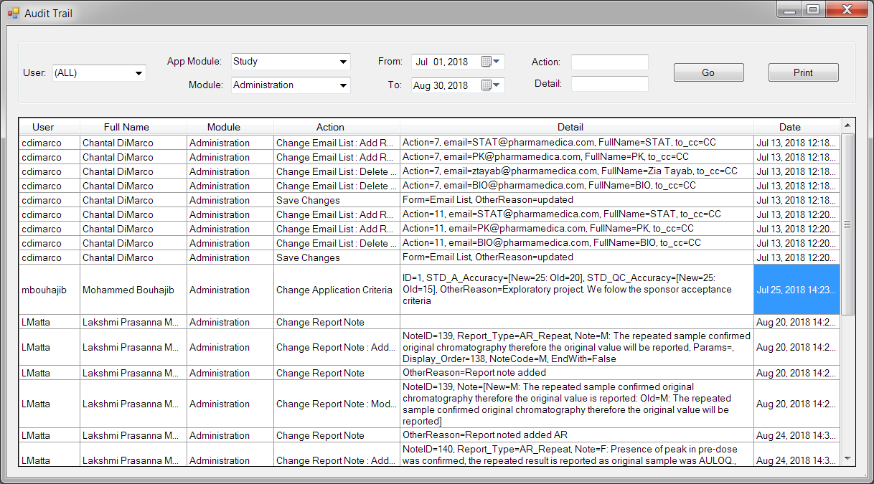

The ‘Default Application Criteria’ is still this way today:

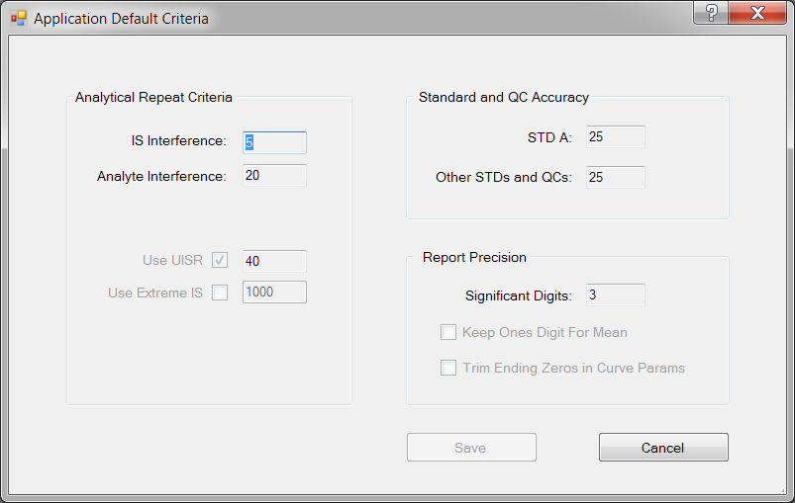

Here are the projects created using this criteria:

|  |  |  |
| --- | --- | --- |
| Drug_Name | Project_Name | Created On |
| Teriflunomide | 2018-4476 | 8/14/18 11:58 AM |
| Mirabegron | 2018-4480 | 8/8/18 1:35 PM |
| Ketoprofen | 2018-4491 | 7/31/18 2:17 PM |
| Carbidopa and Levodopa | 2018-4498 | 8/7/18 11:42 AM |
| Carbidopa and Levodopa | 2018-4499 | 8/7/18 8:30 AM |
| Carbidopa and Levodopa | 2018-4500 | 8/7/18 12:13 PM |
| Ezetimibe | 2018-4505F | 8/21/18 12:14 PM |
| Ezetimibe | 2018-4505T | 8/21/18 12:24 PM |
| Dexmethylphenidate | 2018-4511 | 8/2/18 4:14 PM |
| Selexipag | 2018-4518 | 7/30/18 12:34 PM |
| MK-8189 | 2018-4522 | 8/8/18 10:00 AM |
| MK-4334 | 2018-4528 | 7/31/18 11:51 AM |
| MK-8189 | 2018-4531 | 8/22/18 3:22 PM |